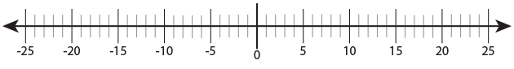

1. Put these temperatures in order from highest to lowest.

130C -4oC -8oC 8oC 00C -100C

1. Circle the temperature that is colder.

a) 60C or -80C b) -60C or -40C

c) -280C or -290C

1. Circle the temperature that is warmer.

a) 120C or 160C b) -10C or -20C

c) -80C or -180C

1. What is the difference between -50C and 100C
2. If the temperature is 30C and it falls by 140C, what is the temperature now?
3. What is the difference between 180C and -90C
4. If the temperature is -210C how much must it rise to reach 120C?
5. If the temperature rises from 00C to 80C then falls 50C, what is the temperature now?
6. Below is a table showing the average temperatures, measured I degrees, on different planets in different months of the year,

|  |  |  |  |  |  |  |  |  |  |  |  |  |
| --- | --- | --- | --- | --- | --- | --- | --- | --- | --- | --- | --- | --- |
|  | Jan | Feb | Mar | Apr | May | Jun | Jul | Aug | Sep | Oct | Nov | Dec |
| Zog | 9 | 4 | -2 | 5 | 11 | 17 | 1 | 5 | 8 | 10 | 10 | 6 |
| Silversty | -20 | -19 | -15 | -11 | -10 | -2 | 0 | -1 | -9 | -13 | -17 | -21 |
| Kartian | -5 | 4 | 9 | 13 | 16 | 19 | 20 | 24 | 19 | 11 | 2 | -1 |
| Sulsbury | 15 | 16 | 16 | 18 | 21 | 27 | 36 | 39 | 38 | 22 | 14 | 8 |
| Utophosis | -18 | -15 | -8 | -2 | 0 | 3 | 5 | 6 | 9 | 1 | -6 | -10 |

1. Overall which is the coldest planet?
2. Overall which is the warmest planet?
3. What is the difference in temperature between planet Zog and planet Sulsbury in March?
4. Which planet had the greatest difference in temperature throughout the year?
5. Between which two months is there the greatest difference between the warmest and coldest temperatures on planet Utophosis?