**RECORDER CHALLENGE – SKYE BOAT SONG**

Hi Primary Fives,

This week’s challenge is a traditional Scottish song which lends itself well to the recorder and the notes we have been learning. The Skye Boat song describes how Bonnie Prince Charlie, disguised as an Irish woman, was rowed over the Minch (stretch of water in North -West Highlands) to the Island of Skye to hide from the British soldiers.

The song begins on low D (see below)

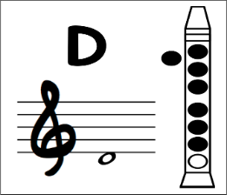

***Low D - Use three fingers of the left hand and three fingers of the right hand. Blow very gently to create the sound and cover the hole at the back with your thumb. Leave the very bottom hole uncovered.***

Please remember to repeat bars 1 – 8 and bars 9 – 16. I have included the lyrics to help you with the melody.

Have fun and enjoy your music making.

Mrs Allan

*LYRICS*

Speed, bonnie boat, like a bird on the wing

Onward, the sailors cry!

Carry the lad that born to be King

Over the sea to Skye.

Loud the winds cry, loud the waves roar

Thunderclaps rend the air

Baffled our foes, stand by the shore.

Follow they will not dare