Literacy ideas
Spelling
Write sentences for your spelling words, showing an understanding of their meaning. | Use scrabble tiles to write your words out. Challenge: can you join them like a crossword? | Write your words using newspaper letters. | Write out you r words with your vowels in a different colour.  a e i o u | Write a story using your spelling words.
Write your words in squiggly letters. | Write your words forwards and backwards  words sdrow | Try to think of words that rhyme with your words. Do they use the same spelling? | Scramble your words up and then unscramble them  dorws words | Write your words in fancy lettering.
Use your finger to trace your words on someone’s back. Do they know what you wrote? | Write your words with the hand you don’t normally use! | Throw or roll a ball back and forth spelling out the letters of your words.  w-o-r-d-s words! | Write your words in a list and then look at a telephone keypad. Translate each letter for the correct number:  Words 9 6 7 3 7 | Write out your words and trace a neat bubble closely around them. Look at the shape of your words. Are any similar?  words

Writing
It is better for young writers to write fewer sentences but write them independently. You may have to help them with some words, a whiteboard or scrap paper is helpful for showing them how to spell tricky words. It is good to get them to tell you how they think it is spelled. At this stage it’s important that children start with a capital letter, use finger spacing, end with a full stop (or other punctuation mark) and read back to make sure it makes sense. Sometimes they are so excited about what they are writing that they forget these points but with a little help they should be able to edit.
Here are some ideas for writing. We do lots of discussion before writing and usually make a plan for our writing. As they become more confident they are including joining words like and, so or but to make longer sentences. They should be encouraged to use adjectives and adverbs to give more detail to their writing and consider the reader’s needs. Older pupils have been taught techniques like alliteration, similes and metaphors to give their writing more flair.
On the next page you will find some ideas to help with writing but feel free to be creative and follow your child’s personal interests. Self-study projects involving research, note taking, presentation of information both written and through a talk ensure a well-rounded and meaningful task and it would be a good idea for your child to write about what they are interested in.

Retell a story you have read recently or know well.  Make sure it is in the correct sequence and include detail.  Think about adapting the story in some way. | Write a description of a family member or pet and draw a picture. Make this detailed as possible.  Be kind! | Write about your day. Use first, then, next and finally. Go into some detail sharing how you felt. What are you finding difficult, fun or frustrating about being off school. | Create a new superhero. Write the story about how they became a superhero and met their sidekick, if they have one. Use descriptive writing to let us know about their appearance, strengths and weaknesses.
If your parents think it is appropriate send some fun post to an elderly neighbour or family member.  This should be a short letter asking how they are, saying what you think about being off school and things that have made you feel happy. You could include a nice picture. | Create a mystery in your house- missing chocolate or lost glasses. Leave clues for your child. Encourage them to take notes on a pad and think of questions to ask like a detective. Once they have solved the mystery they should write up a brief report. | If needed, this is a great time to practice handwriting and getting your letter formation correct.  Make sure your pencil grip and letter size is correct. | Write about a Scottish animal. You could write about where it lives, key features, what it eats and things that can harm it.  You could make a poster encouraging people to protect any endangered animals.
Write a newspaper style recount of something that happened recently to you or in the news. | You can keep a short diary about your days off school. Think about what you have done, ways you have helped others and your feelings. | Write about your favourite place in your home or garden. Use lots of adjectives and techniques- think about what you can see, hear, smell and feel there. Why do you like it? | Think about ideas you have for improving Milne’s Primary School.  Write a list and try to make them things that are possible to change. Write a letter to persuade Miss Karam to to make the improvements.
If you found a genie in a lamp what would you do? What would you wish for?  This can be broken into two writing activities one about finding the lamp with a description and one about making wishes. | Write a poster to encourage people to be kind.  Think about different ways we can be kind. How can kindness change the world? | Write a book report. Give all the basic details about the book including a brief summary.  Who would you recommend it to and why? Were there any disappointing parts? | Give your child a simple sentence and ask them to improve it. Give it back to them several times to make it better. Compare the final sentence to the first one.  This encourages positive editing.

Reading
Use this time to go over all jolly phonic sounds if needed. The more confident your child is the better. Focus on the harder two letter sounds. You can check how they are sounded here https://www.jollylearning.co.uk/resource-bank/learn-the-letter-sounds/ | Your child should be reading for 30 minutes per day with support. | Help your child to blend. This is when you take a breath and sound out a word. Treat is broken into t r ea t. By taking one breath this helps them hear the sounds blend together into the word. Some words don’t work using the phonic sounds. These are the tricky words and there is a list of these attached. They have to be learned. | Tricky words- make snap cards with the words your child is finding hardest and play the game briefly and often. You can use the same cards to play pairs.
Read a story and find all the describing words (use the word adjectives, if you want). Examples: red, big, old, smelly, etc. | Play noughts and crosses but use two tricky words instead of the noughts and crosses. Short ones might be better. | Read a book together. Ask your child to look for certain tricky words in the book.  They can also look for words that rhyme, have the same sound (ai, oo, ay) or begin with a certain letter.  Ask them to search for verbs or nouns. | After reading a story try to ask your child questions that make them think. How do we know that…?  Who did a good deed in the story? What words tell us that…? Why do you think that was/wasn’t a good ending?
Read a non-fiction (fact based) book or piece. See if they can locate the answers to some questions. Encourage skim reading. For example, if you ask how many rows of teeth a shark has they should skim read looking for the word teeth and then look for a number. | Whilst reading a story stop and both make a prediction. You can do this more than once. | After reading a book ask your child to come up with questions about the story. Some should start with how or why. | After reading a story retell it using first, then/next and finally.
 | Reading will happen naturally in what you do. Encourage them to use their phonics knowledge and blending skills to read recipes, game instructions, etc.  Keep it positive and fun. Use older siblings if appropriate. | After reading a story can they link it to another story? Discuss what the main theme was and ask if this is like another story. How is it the same and how is it different? | With your child or children create a cosy reading corner for them to enjoy looking through books independently. Maybe add cushions and a favourite blanket.
Listening and talking:
Listening to stories (either from adults or BBC Teach has some great audios) and retell ask/ answer questions.
Ask your child to use one of their writing pieces to turn into a talk or have them look up and share a poem or even jokes. They could give a talk on something new they have learned or get them to teach you something! Hope it’s not a tik-tok dance!
Listen for instructions- to make something or draw a picture, e.g. draw a large tree in the middle, and put a nest in the tree. Draw a tractor in a field to the right. Put a rainbow in the sky…
Follow online instructions to make something like origami.

Numeracy Ideas
There are lots of great websites with fun maths games that teach number concepts whilst having fun. You will find a list of websites in this pack.
In everyday activities practise rounding to the nearest ten or one hundred.  If the oven has to be set at 170 degrees which hundred is that nearest to?  Practise rounding with given numbers remembering that 4 or below it stays at that ten or hundred, five or above it rounds up. “Five or above give it a shove!” | Practise counting in twos, fives, tens and hundreds up to 1000.  Count forwards and backwards, starting at different places. | Keep knowledge of number families up to speed.  For example  6 + 3 = 3 + 6  2 × 4 = 4 × 2.  Take these as high as your child is comfortable to go.  Links between  7+3=10 and 70+30=100 | Investigate money up to £20.  Use real money if you can.  Make the same amount with different coin/note combinations.  Like 60p  50p+10p  50p+5p+5p  20p+20p+20p  Practise giving change.
Make your paper plate clock by folding the plate into quarters and using the card to make hand. An adult should attach these with the fastener, putting the hour hand closest to the clock face. With help add in all your numbers equally round the clock face. | Using your clock reinforce learned times. These could be o’clock, half past quarter past and to. Remind your child which hand is which. The hour hand is small to keep out the way of the minute hand which tells us how to say our times. | Ask your child to put the clock to certain times. You can take turns.  Ask your child to put the clock to the times they do something.  What time do we get up/ have lunch/ go to bed? | You can also practise telling the time on digital clocks. Discuss the differences.  What is 24 hour time?  Note what it looks like. Two numbers for the hours up to 23 and then two dots : followed by 2 dots for the minutes. HH:MM  23:19
Make your metre tape for measuring. This might be tricky so take your time with the cutting and stick it carefully so it is the correct length. | Use your metre tape to measure items like furniture around the house. Measure smaller items with greater accuracy up to millimetres. | Learn the order of the months of the year and use the attached poem and diagram to tell the number of days in each month. | Use a bus or train timetable to plan a journey.  When might you use this skill in your future?
Make patterns during play and when practising times tables.  If you are making a necklace or laying out cutlery for example. Look for patterns in your times tables and use different coloured pens to point them out. This will help you to remember. | When helping with baking use metric measurements and different instruments to measure accurately.  Using:  g grams kg kilograms  m millilitres and l litres  Try estimating: I think 25g will be four spoons. | Use timers effectively when baking, cooking or sharing technology!  Estimate how long will take you to complete an activity and time yourself. How close was your guess? | Look at areas and perimeters of shapes.  Draw shapes on your squared paper staying on the lines. Each line is 1cm and each box is 1cm squared.  To find out the perimeter count the lines of each box that make up the continuous line round the outside of the shape. Count the squares inside to get the area.

How to Remember How Many Days Are in Each Month
Rhyme to remember number of days in each month:
30 days hath September,
April, June and November,
All the rest have 31,
Excepting February alone.
Which only has but 28 days clear
And 29 in each leap year
Use your Knuckles!
Make a fist.
If the month is on a knuckle, it has 31 days. Otherwise is has 30 or less days.
Starting with the 1st knuckle as January,
The space between knuckles as February,
2nd Knuckle is March... etc.
Once you get to the fourth knuckle, July, start over at the first knuckle for August.
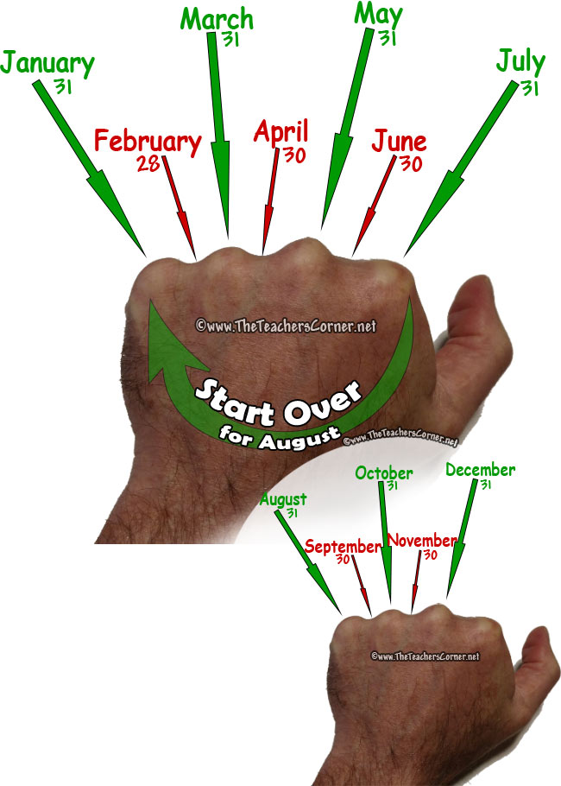

Other Ideas
Here are some other ideas to help you learn in fun ways at home.
Pick a personal project to investigate. Go into lots of detail and be creative in how you share your new knowledge. You can use lots of ways to share your understanding- video, presentation, dance, PowerPoint, poster, etc. You might want to have a couple of investigations going on at once- One on Da Vinci’s inventions and one on wolves. Let your mind wander, get lost in new facts and ideas. | Look into a job that interests you. Are there any videos that you can watch to learn more? Do you know anyone who does this? What kind of skills and attitude would help with this job? Why do you think you would like it? Why do you think you would be good at it?  Draw a picture of you doing this job, where would you be what would you be doing? | Investigate your garden (or a safe place outside) can you find any mini-beasts? What do they look like? Draw pictures and label them. Find out which ones are common (lots of them) and which ones are rarer. Where do they like to live? This is their habitat. Observe their habitat from a distance; do birds try to eat them?  Put all your findings in a poster or leaflet. | Make a den if you are allowed. How are you going to build it? It has to be safe and use safe materials for building. Make sure you put it somewhere quiet so people won’t knock it down by accident.  What did you use for height? What did you use to attach and join parts? Which bits needed to be strong and which were soft and cosy?
Investigate ice and how it melts and refreezes. Use 4 tubs to freeze some water. Put the ice on plates and investigate what kitchen items make it melt quicker- salt, baking powder, sugar or nothing. Add the same amount of each item to the ice and put the timer on for 10 minutes. With a measuring spoon see how much ice has melted into water. Repeat for all blocks of ice using the different ingredient. Set the timer for 10 more minutes and measure the results again. What did you find out?  Time a cube of ice melting and put it back in the freezer and time how long it takes to refreeze. |  | Write reports on your experiment with labelled diagrams and a table with your results. | Observe the different types of weather out of the same window for 5 days. Do it at the same time in the morning, lunch time and afternoon each day. Draw pictures of the clouds if there are any and name them? How is the weather impacting on plants and animals and you? Are there any patterns in the weather?
Create a careful drawing of a pet or family member. Try to look more than you draw and only draw what you see not what you think you see. Take a break from your picture for a while. Go back and look at it and your pet or family member again. What did you miss? Can you add more detail?  You could draw objects in the same way and see how your drawings improve with practise. | If you have a Ziploc bag and sticky tape, put a small amount of water in your bag, close it tightly and tape it to a sunny window. Draw your experiment. Draw how it has changed the next day. What do you notice? What do you think has happened? Have you seen this happen anywhere else in the house? Bathroom? Kettle in the kitchen? Find out about condensation. | Learn about someone famous that you admire. What have they achieved? Find out what they did to get there. Now they are successful do they do anything to help people in need?  Do you believe in talent or is it just hard work?  If you can, print out pictures and share your famous person’s positive messages. | Think about chores you could do to help your family.  Plan 15 minutes of chores and see how your parents smile!  Some ideas:  Help put washing on  Dry and put away dishes,  Hoover,  Feed pets  Dust the living room  Lay or clear the table
Do a daily act of kindness. There is no need to record this because the person will have a lasting memory. | Listen to your favourite piece of music, do breathing exercises and/or some yoga stretches to feed your growth mindset. | Design your dream bedroom. Think of colours, furniture you need, and decorations. If you can, look up costings. | Watch Newsround, take notes and practise being a news reader for your family!

