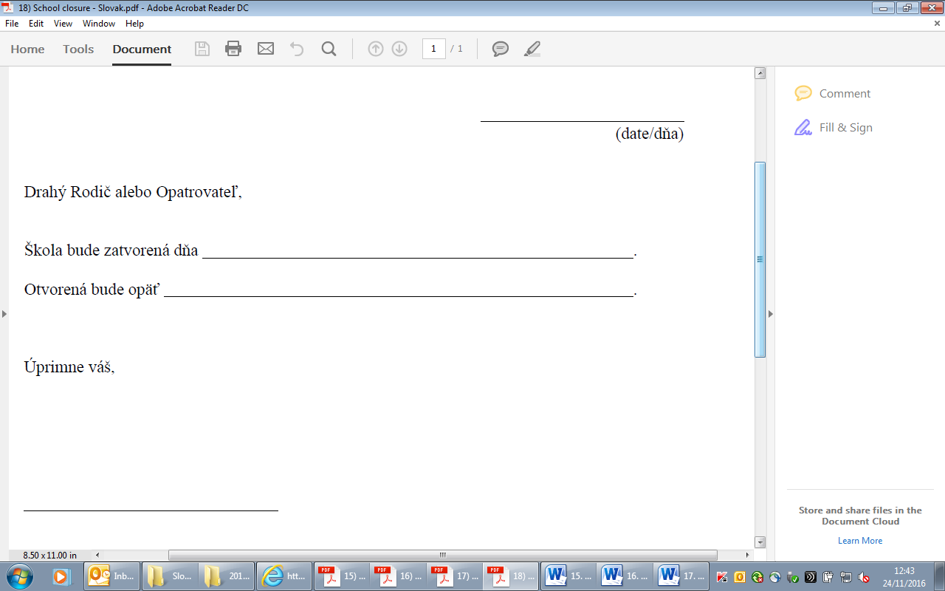

Letter for school to give to parents

18. School closure - **Slovak**