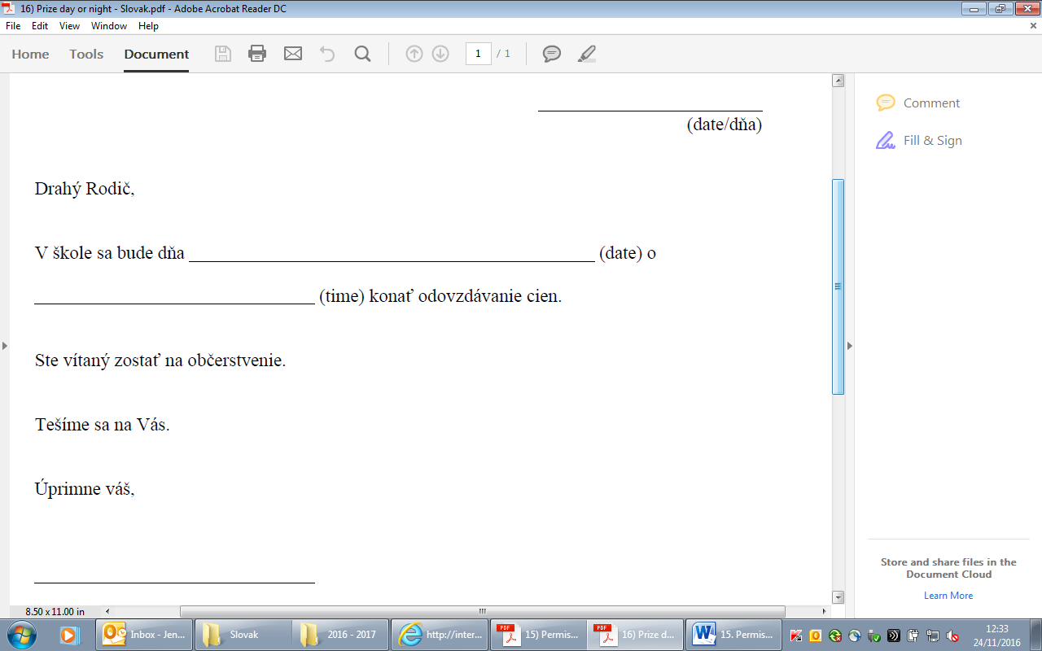

Letter for school to give to parents

16. Prize day/night - **Slovak**