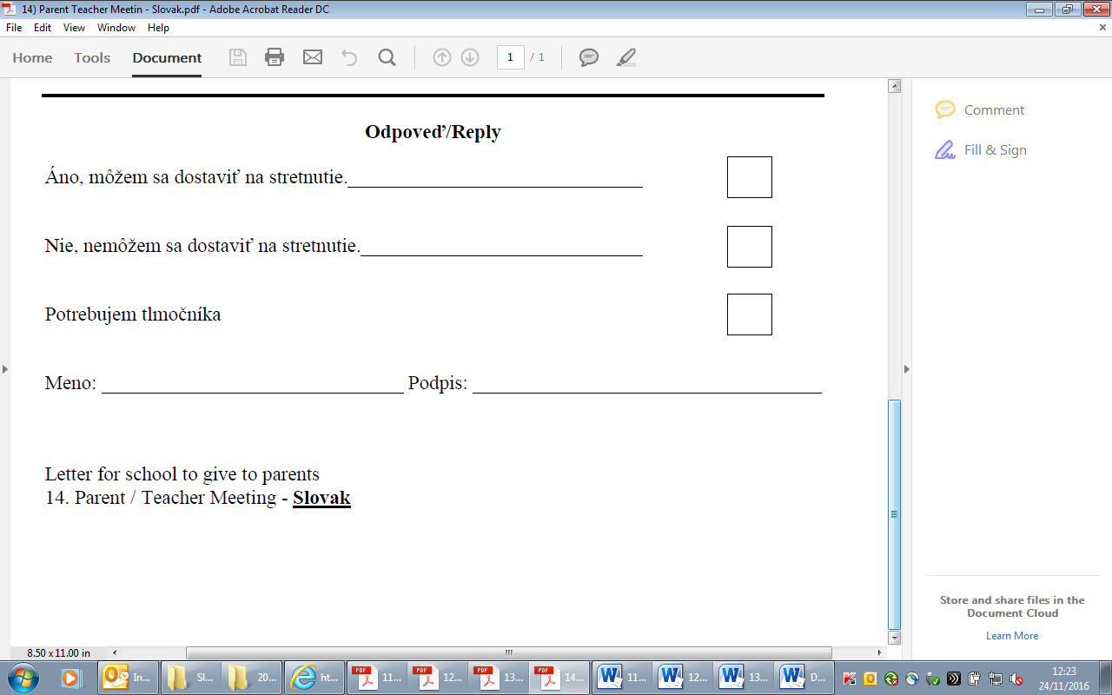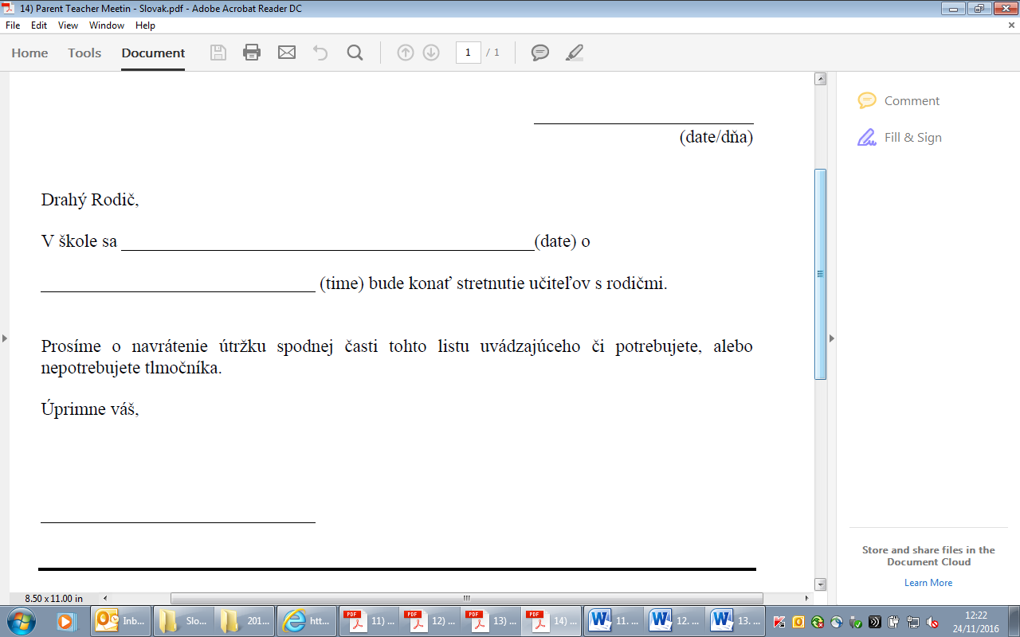

Letter for school to give to parents

14. Parent teacher meeting - **Slovak**