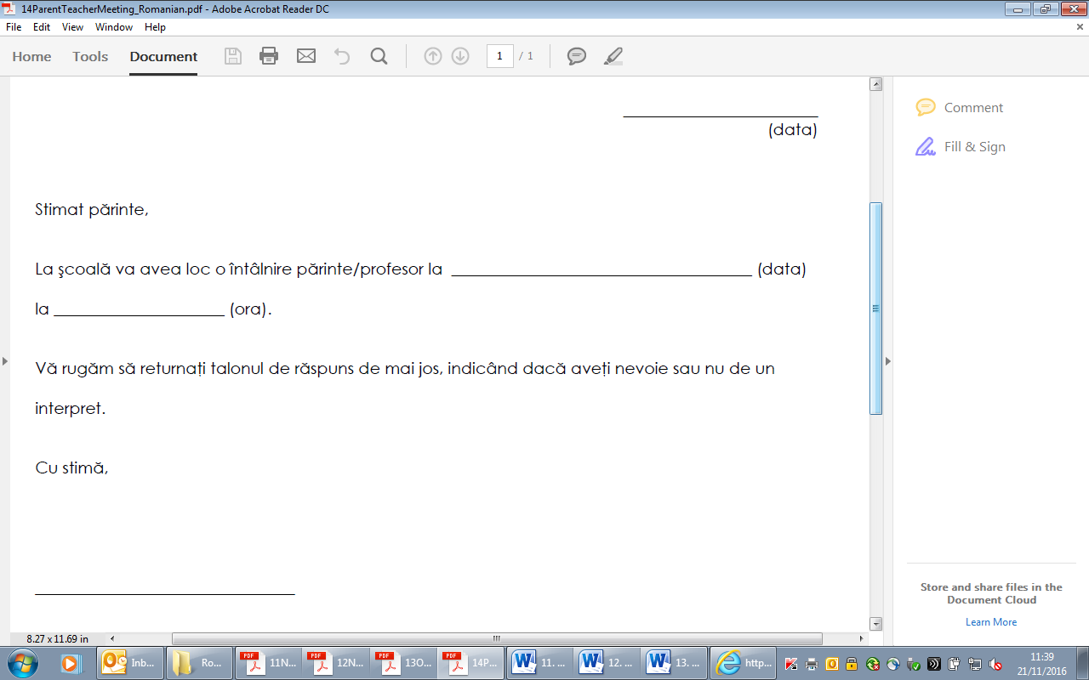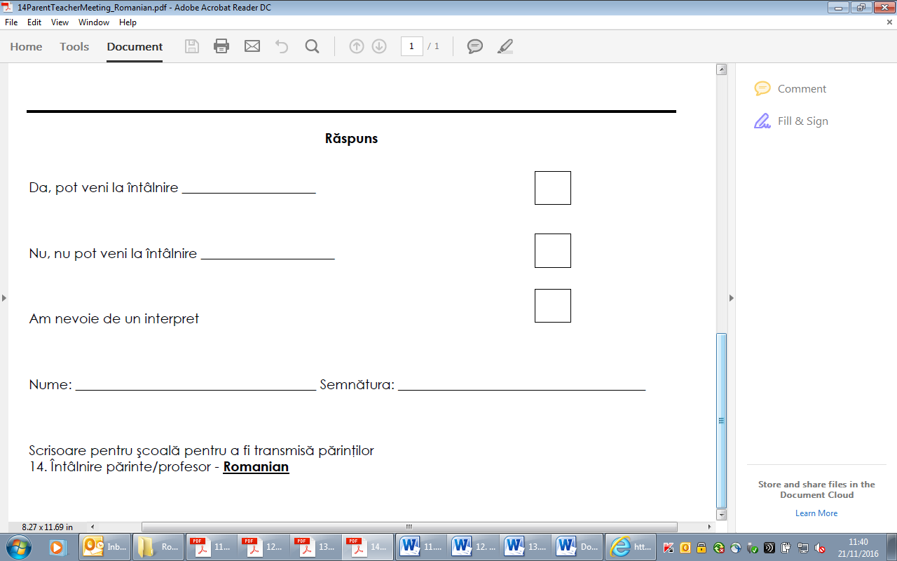

Letters for schools to give to parents

14. Parent/teacher meeting - **Romanian**