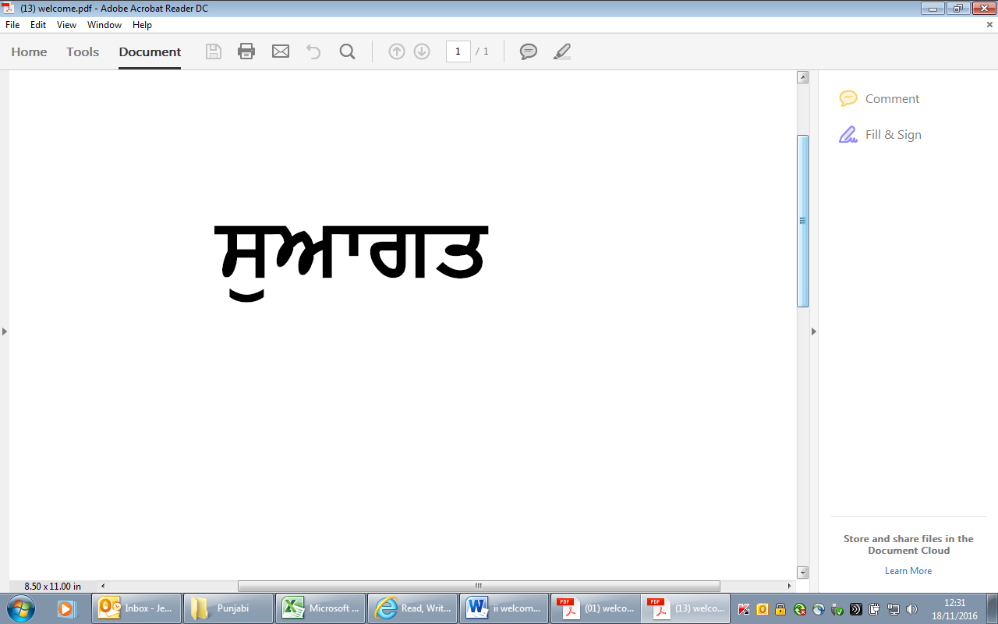

(i). Welcome - **Punjabi**