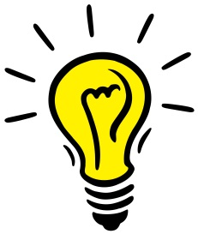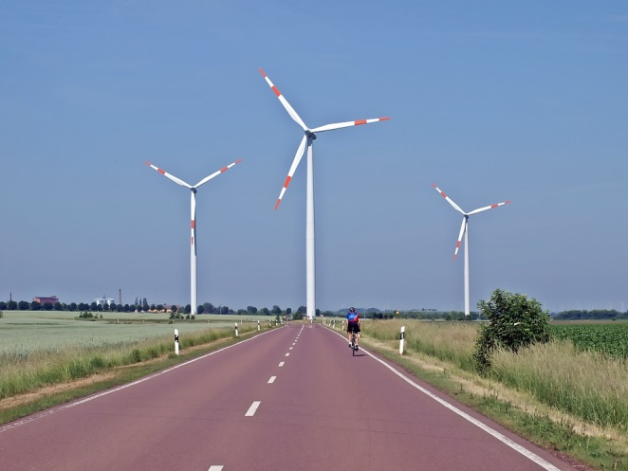

S2

Science

Glossary

ENGLISH/TURKISH

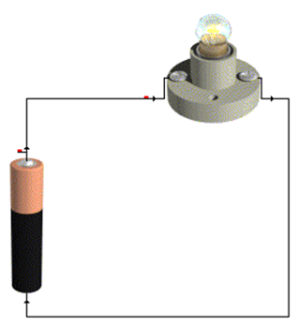

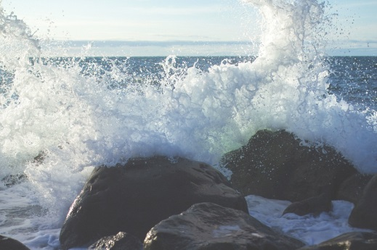

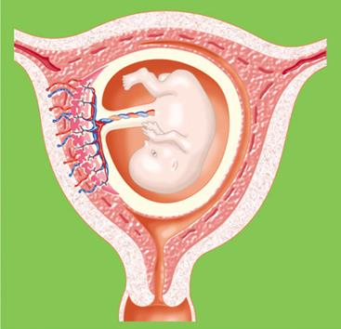

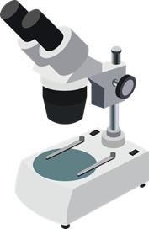

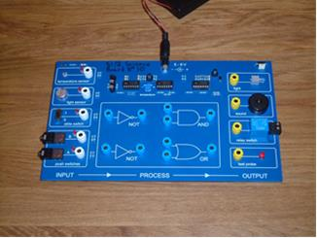

**Electricity and Electronics**

**Electricity**

Ammeter/

Ampermetre: An instrument for measuring current if it is connected in series

Amps/

Amper: The unit for electric current

Appliance/

Cihaz: A device which changes electrical energy into some other form of energy.  
 It is usually plugged into the mains e.g. television, washing machine

Battery/

Batarya

(Pil veya Akü): A device consisting of one or more electrochemical cells with external connections provided to power electrical devices

Broken circuit/

Açık devre: A circuit with a gap in it

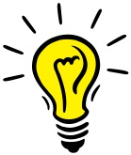

Bulb/ Ampul: A component which changes electrical energy to light energy

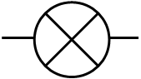

Buzzer/ Zil: A component which changes electrical energy to sound energy



Cell/ Hücre: A power supply that uses chemical energy to make electrical

energy. (Often called a battery).

Circuit/ Devre: A path round which electricity can flow

Circuit breaker/

Devre kesici: An automatic switch which breaks a circuit when a fault develops

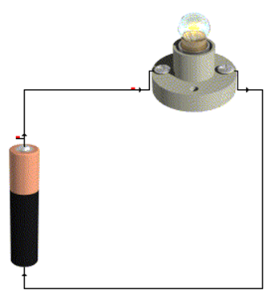

Complete circuit/

Tam devre: A circuit with no gaps in it so current can flow

Current/ Akım: The flow of electrical charges round a circuit

Electricity/

Elektrik: A phenomena

Fuse/Sigorta: A safety component, a thin wire in a holder which melts and breaks the circuit if the current is too high

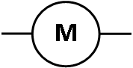Mains electricity/

Şebeke elektriği: Electrical energy supplied at 230 volts to homes in Britain

and Europe.

Motor/Motor: A component which changes electrical energy to kinetic energy

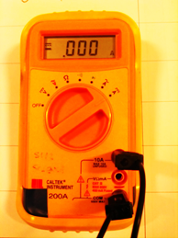

Multi meter/

Multimetre

(Avometre): A meter which can be set to be used as an ammeter, a voltmeter or a resistance meter

Ohms/ Ohm: The units of resistance

Parallel circuit/

Paralel devre: Current splits when going into a junction and joins when coming out, choice of paths for the current. There is more than one path for electrical current.

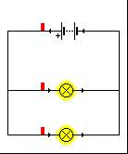

Power/Güç: The amount of energy used or changed per second.

It is measured in Watts (W)

Power pack/

Akım kaynağı: A device which gives out variable voltage

Power supply/

Güç kaynağı: Another name for a power pack

Resistance/

Direnç: The opposition to electrical current, it is measured in ohms(Ω)

Resistor/

Direnç

(Devre elemanı): A component which restricts the current in a circuit

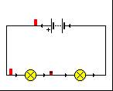

Series circuit/

Seri devre: Current has only one path in a series circuit. Current is the same at all points in a circuit

Switch/ Anahtar: A device for making and breaking the connection

in an electric circuit.

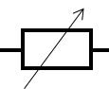

Variable resistor/

Değişken direnç: A resistor whose value can be changed

Voltage/Voltaj: The electrical push of a supply

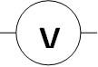

Volts/Volt: Unit of voltage

Volt meter/

Voltmetre: device which measures the voltage across any supply or component

Watts/Watt: Unit of power

Wire/

Elektrik teli: Component through which current flows

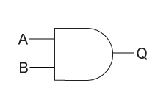**Electronics**

AND Gate/

VE Kapısı: Alogic gate where the output is only logic 1 if both the inputs are at logic 1 otherwise the output logic is 0

Block diagram/

Blok diyagram: An easy way to draw a system

Buzzer/Zil: Switches sounds on or off, changes electrical energy to sound

Component/

Bileşen: Part of an electronic system

Device/Aygıt: Component

Digital signals/

Dijital sinyaller: Electrical signals which can only have specific values.

They are either on( logic 1) or off (logic 0)

Electronic system/

Elektronik sistem: A system made up of electronic components.

It has three parts. INPUT, PROCESS OUTPUT.

|  |  |
| --- | --- |
|  |  |

Input/Girdi: Detects some type on energy and changes it in to electrical energy or a switch to change a logic 0 to a 1 or vice versa.

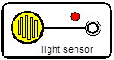Intruder alarm/

Hırsız alarmı: An alarm which warns that someone has entered your house without permission

Light dependent

resistor/

LDR (Foto direnç): A special resistor which changes resistance as the light

level changes

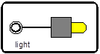Light emitting

diode/

LED

(Işık yayan diyot): voltage across it makes it light, used to indicate when

something is on or off

Logic circuit/

Mantık devresi: A circuit which is made up of logic gates

Logic gate/

Mantık geçidi: Used to combine or change electronic signals

Microphone/

Mikrofon: Changes sound energy into electrical energy

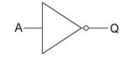NOT gate/

DEĞİL kapısı: The simplest logic gate it has one input and one output, the output is always the opposite of the input

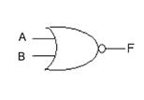

OR gate/

VEYA kapısı: The logic gate is where the output is a logic 1 if either inputs are logic 1, if both the inputs are at logic 0 the output is logic 0

Output/Çıktı: Converts the electrical energy from the process subsystem into an energy that can be used

Process/Proses: Changes the electrical energy from the input so that the system can do its job

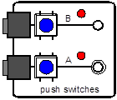

Push Switch/

Düğme anahtar: Switches are probably the simplest inputs. They let you tell an electronic system to do something.

Relay Switch/



Röle anahtarı: The relay switch is an electromagnetic switch which allows electronic circuits to control other circuits.

Sensor/ Sensör: Part of the input which detects changes around it

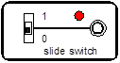

Slide switch/

Slayt anahtar: Switches are probably the simplest inputs. They let you tell an electronic system to do something.

Sub system/

Alt sistem: Small part of a larger system

System/Sistem: Something made up of lots of parts which are put together to do a job

Thermistor/

Isıl direnç: A special resistor which changes resistance when the temperature changes

Truth table/

Doğruluk çizelgesi: Gives the outputs for the different combinations of the inputs of a logic gate

|  |  |  |
| --- | --- | --- |
| Light Sensor | Logic | Output |
| Dark | 0 | Off |
| Light | 1 | On |

**DNA and Inheritance**

**Microscopes**

Eye Piece/

Göz merceği

(Oküler): The lens at the top that you look through. They are

usually 10X or 15X power.

Magnification/

Büyütme oranı: We can calculate the length of a magnified object by using the magnification of the lens. Length of object = length of magnified object ÷ magnification

Micrometre/

Mikrometre: One millionth of a metre. It has the symbol µm

Microscope/

Mikroskop: A microscope allows scientists to see things such as cells in much greater detail. As a result our understanding of their structure and function has improved

Millimetres/

Milimetre: One thousandth of a metre (mm)

Objective Lens/

Objektif mercek: Usually you will find 3 or 4 objective lenses on a microscope. They almost

always consist of 4X, 10X, 40X and 100X powers.

Stage/

Nesne tablası: The flat platform where you place your slides.

Stains/

Renklendirme: Artificial coloration of a substance to help look at cells under the microscope

**Animal and Plant Cells**

1. **Animal Cells**

Basal Cell/

Bazal hücre: A type of cell found in the deepest layer of the epithelium

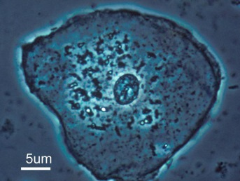

Ciliated Cell/

Kirpikli hücre: Cilia are tiny hair like structures on the surface of the cell. The hairs sweep hair, mucus, trapped dust and bacteria up to the back of the throat where it can be swallowed.

Epithelial Cell/

Epitel hücre: Epithelial cells make up the body’s skin

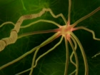

Motor Nerve/

Motor sinir: A motor nerve is a nerve that carries command information out of the central nervous system (CNS) and toward effectors (muscles or glands) that will execute the commands.

Nerve Cell/

Sinir hücresi: Nerve cells are the primary cells in the nervous

system

Neuron/Nöron: A cell that transmits information through electrical and chemical signals

1. **Plant Cells**

Cuticle/Kütikül: An outer covering of an organism that provides protection

Epidermis/

Üst deri: The outermost layer of skin cells

Guard cells/

Koruyucu hücre: To open and close the stomata depending on the conditions

Palisade Cells/

Palizat parankiması: Palisade cells are plant cells found within the mesophyll in leaves, right below the upper epidermis and cuticle

Phloem/Floem: They are involved in translocation. This is the movement of food substances from the stems to growing tissues and storage tissues.

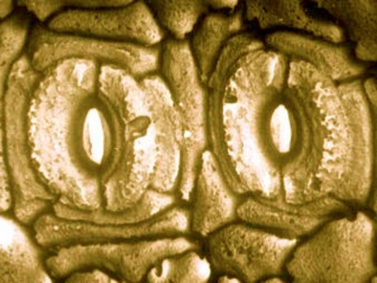Root Hair Cell/

Emici tüy hücresi: Long 'finger-like' process with very thin wall, which gives a large surface area. Soak up water and minerals from the soil.

Spongy Mesophyll/

Sünger mezofil: They capture light and makes food. Spongy mesophyll cells have air spaces between them to allow easy gas exchange.

Xylem/

Odun borusu

(ksilem): They are involved in the movement of water

through a plant from its roots to its leaves.

**Reproductive System**

1. **Female**

Amniocentesis/

Amniyosentez: A process in which amniotic fluid is sampled using a hollow needle inserted into the uterus, to screen for abnormalities in the developing foetus.

Amnion/

Amniyon: The foetus is protected by the uterus and the amniotic fluid, a liquid contained in a bag called the amnion.

Blastocysts/

Blastokist: A young embryo/fertilised egg cell approximately 4 days old

Cervix/

Rahim ağzı

(Serviks): The cervix is a ring of muscle at the lower end of the uterus. It keeps the baby in place while the woman is pregnant.

Embryo/Embriyo: The fertilised egg divides to form a ball of cells called an embryo.

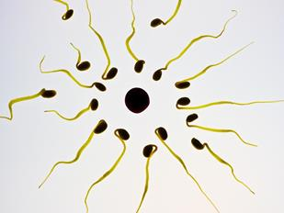

Fallopian Tubes/

Fallop tüpleri

(Yumurtalık kanalları): A pair of tubes along which eggs travel from the ovaries to the uterus.

Fertilisation/

Dölleme: Fertilisation happens when an egg cell meets with a sperm cell and joins with it.

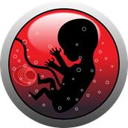

Foetus/Fetüs: This attaches to the lining of the uterus and begins to develop into a foetus (pronounced "fee-tuss") and finally a baby.

Menstruation/

Aybaşı: This is when bleeding from the vagina begins. This is caused by the loss of the lining of the uterus, with a little blood. This is also called a Period

Ovaries/

Yumurtalıklar: The two ovaries contain hundreds of undeveloped female sex cells called egg cells or ova

Ovulation/

Ovülasyon

(Yumurtlama): At about day 14, the mature egg cell is released from the ovary. This is called ovulation.

Placenta/

Plasenta: The placenta is responsible for providing oxygen and nutrients, and removing waste substances

Uterus/Döl yatağı: The uterus is also called the womb. It is a muscular bag with a soft lining. The uterus is where a baby develops until its birth.

Vagina/Vajina: The vagina is a muscular tube that leads from the cervix to the outside of the woman's body.

Womb/Rahim: The uterus of the human female

1. **Male**

Bladder/

İdrar kesesi: A sac which fills with urine until it is discharged from the body.

Gland/

Salgı bezi: An organ that produces a secretion (e.g. hormones).

Penis/Penis: The penis has two functions: to pass urine out of the man's body; to pass semen into the vagina of a woman during sexual intercourse.

Sperm Ducts/

Sperm kanalları: The sperm pass through the sperm ducts, and mix with fluids produced by the glands.

Testis/Testis: The two testes (one of them is called a testis) are contained in a bag of skin called the scrotum

Urethra/

İdrar yolu (üretra): The urethra is the tube inside the penis that can carry urine or semen.

**DNA**

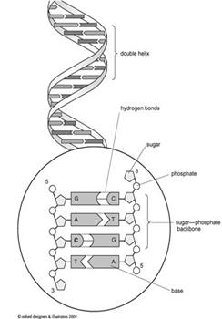

Chromosome/

Kromozom: DNA molecules are very long but are packed into compact structures called chromosomes

Downs Syndrome/

Down sendromu: This is a genetic condition that typically causes some level of learning disability and characteristic physical features.

DNA/DNA: DNA is a long molecule made up of twisted strands of the bases A, T, C and G.

Gene/Gen: Genes are segments of DNA located on

chromosomes.

Karyogram/

Karyogram: A diagram or photograph of the chromosomes of a cell, arranged in homologous pairs and in a numbered sequence.

Genetic Disorder/

Genetik bozukluk: A genetic disorder is a disease that is caused by an abnormality in an individual's DNA

RNA/RNA: RNA molecules are single stranded nucleic acids composed of nucleotides. RNA bases include adenine (A), guanine (G), cytosine (C) and uracil (U).

**Chemistry and Crime**

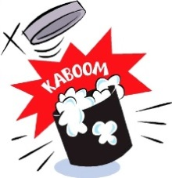Catalyst/Katalizör: A substance which speeds up a chemical reaction

Chemical Reaction/

Kimyasal tepkime: A process by which one set of chemicals is transformed into

another set.

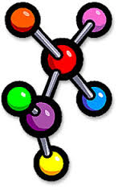

Compound/Bileşim: A substance made up of 2 or more elements chemically

combined.

Concentration/

Derişim: Measure of how much of a substance is dissolved.

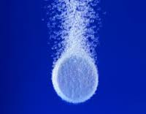

Effervescence/

Köpürgenlik: Bubbling caused by production of gas.

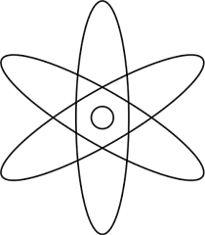

Element/Element: A substance made up of only 1 type of atom.

pH/pH: A scale indicating how acidic or alkaline a substance is.

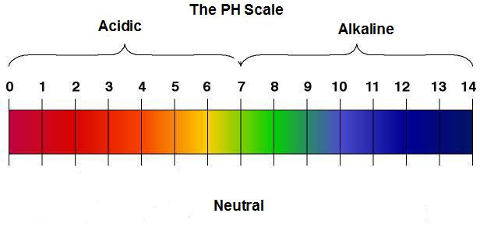

Acid/Asit: A substance with a pH less than 7.

Alkali/Alkali: A substance with a pH more than 7.

Neutral/Nötr: A substance which is neither acid or alkaline and has a pH of 7.

Neutralisation/

Nötrleştirme: Reaction between an acid and an alkali which produces a salt

Salt/Tuz: A substance formed by a neutralisation reaction.

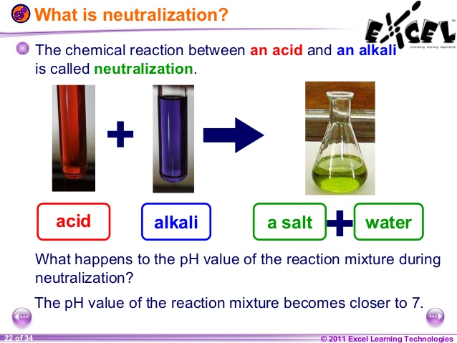

Product/Ürün: What is made in a chemical reaction.

Rate of Reaction/

Tepkime hızı: How fast or slow a chemical reaction is.

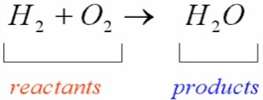

Reactant/

Tepkiyen madde: The starting materials in a chemical reaction.

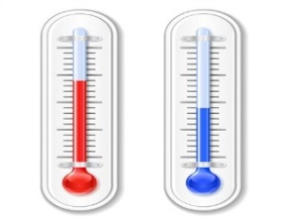

Surface Area/

Yüzey alanı The sum of all the areas of an object.

Temperature/

Sıcaklık: Measure of how hot or cold an object is.

**Planet Earth**

**Heat and temperature**

Bimetallic strip/

Bimetal şerit: A metal strip made of two metals that expand at different rates

Conduction/

Isı iletimi

(Kondüksiyon): Movement of heat through solids

Convection/

Isı yayımı

(Konveksiyon): Movement of heat through fluids

Current/Akım: Movement in air or water

Expand/Genişleme: Particles move apart due to having more energy

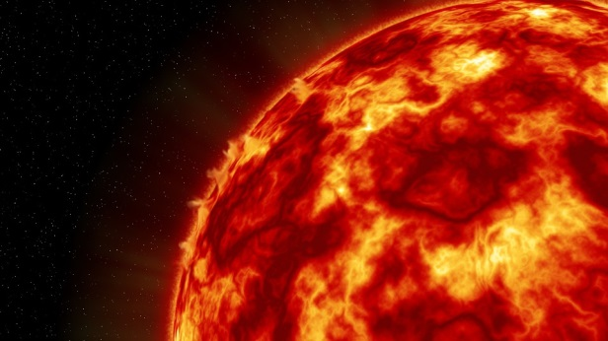

Heat/Isı: The energy an object contains

Infra red radiation/

Kızılötesi radyasyon: A type of electromagnetic radiation. It is invisible to human eyes, but people can feel it as heat.

Insulator/Yalıtkan: Material that does not conduct heat or electricity

Radiation/

Radyasyon

(Işınım): Movement of heat through gases and space (no particles required)

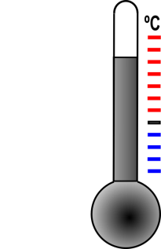Temperature/

Isı derecesi: Is a measure of particle movement

Thermocouple/

Isıl çift (Termokupl): Uses two metals to measure temperature

Thermometer/

Termometre: Measures temperature

Water tank/

Su deposu: Stores household supply of water

**Global warming and Climate change**

Biomass power/

Biyokütle enerji: Power that is developed from organic materials, waste organic materials or wood to create electricity or other forms of power

Climate change/

İklim değişikliği: Long term change in in climate linked to temperature and rainfall

Eco house/

Ekolojik ev: A house designed to be energy efficient with a low carbon footprint

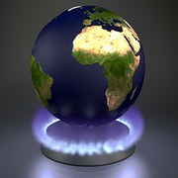

Glacier/Buzul: A mass of ice moving slowly down from mountains in valleys

Global warming/

Küresel ısınma: Increase in Earths average surface temperature

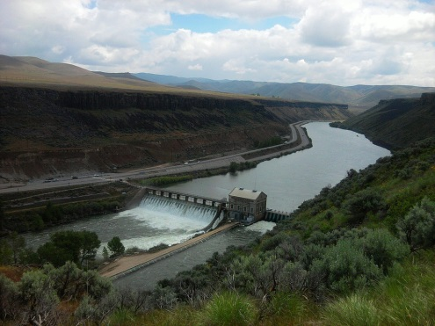

Hydro power/

Hidroelektrik enerji: Power extracted from use of the energy from falling water in hydroelectric power stations

Ice core/

Buz çekirdeği: Samples of ice that are thousands of years

old



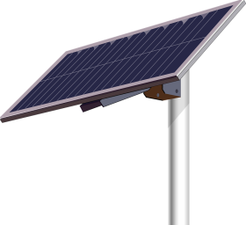Renewable energy/

Yenilenebilir enerji: Energy that will not run out is not finite in supply

Solar power/

Güneş enerjisi: Heat radiation from the sun converted into electrical power

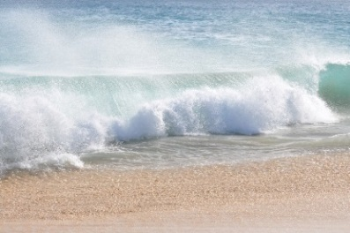Tidal power/

Gelgit enerjisi: The use of the rise and fall of tides involving very large volumes of water at low heads to generate electric power

Wave power/

Dalga enerjisi: Power extracted from the motion of sea waves at

the coast

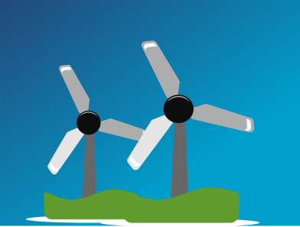

Wind power/

Rüzgar enerjisi: Power derived from wind: used to generate

electricity or mechanical power.