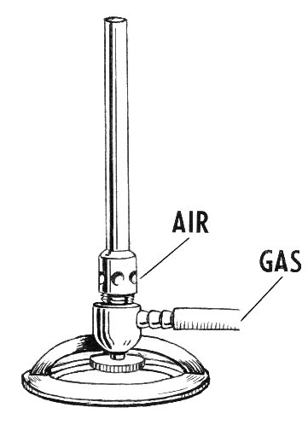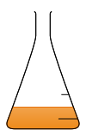

**Science Word Book**

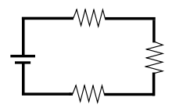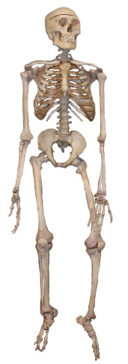**HungarianC:\Users\jenny.sanderson\AppData\Local\Microsoft\Windows\Temporary Internet Files\Content.IE5\RLRP72ET\200-ruler[1].gif**