$$×$$

**Multiply Times**

**ضرب**

**Lots of**

$$-$$

**Minus Subtract**

**ناقص**

**Take away Difference**

$$+$$

**Plus Addition Total**

**مجموع**

**Sum Altogether**

$$÷$$

**Divide Share**

قسم

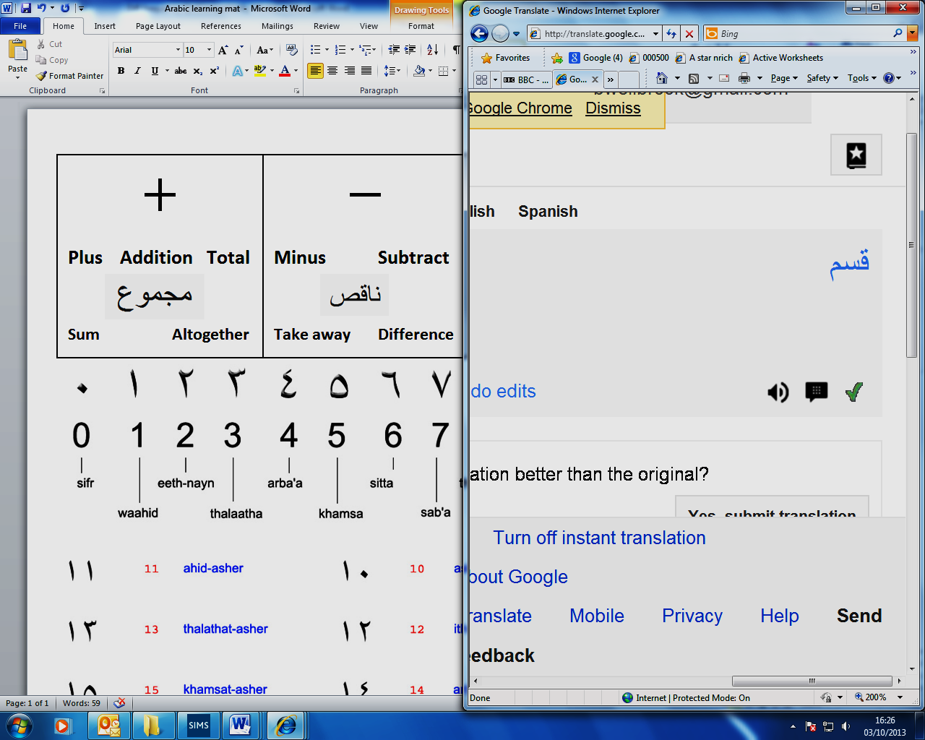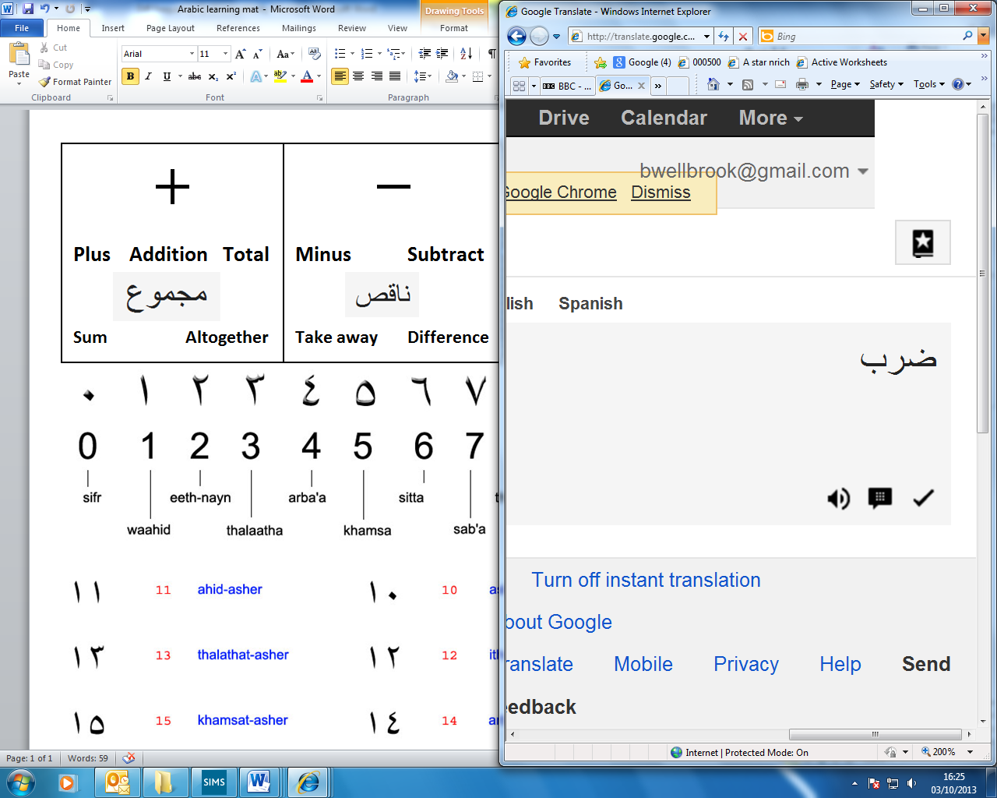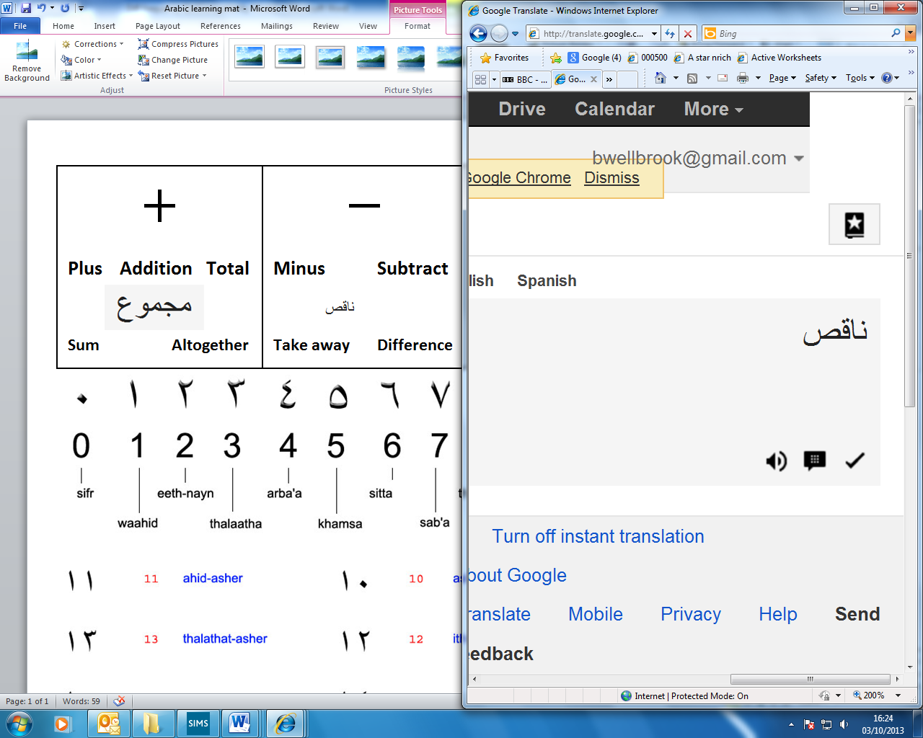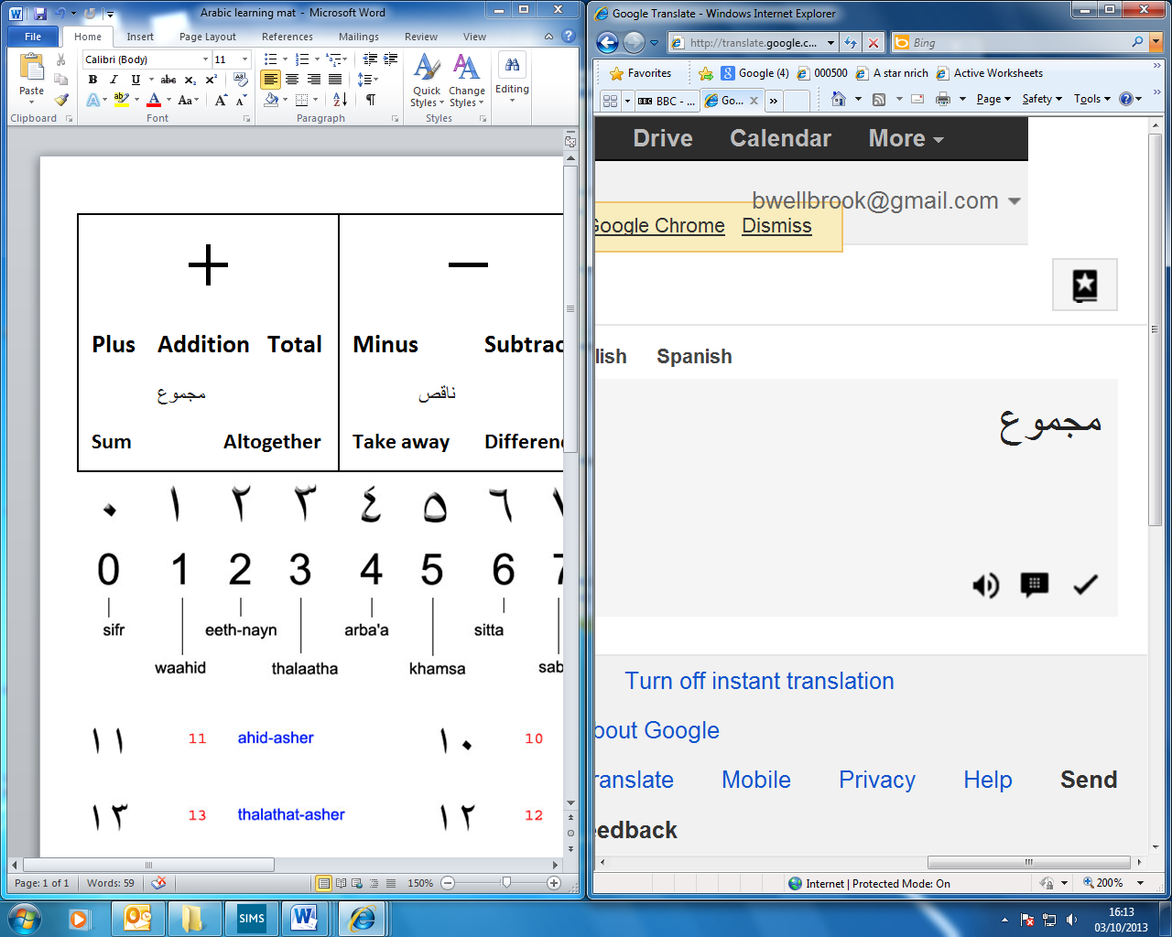

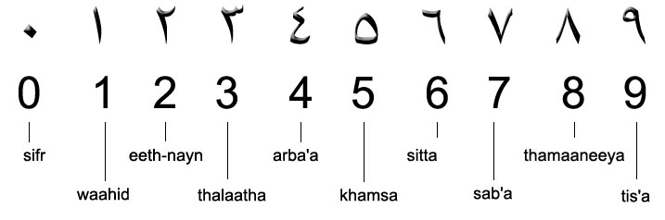

**Odd Numbers**

**1 3 5 7 9**

**Even Numbers**

**0 2 4 6 8**

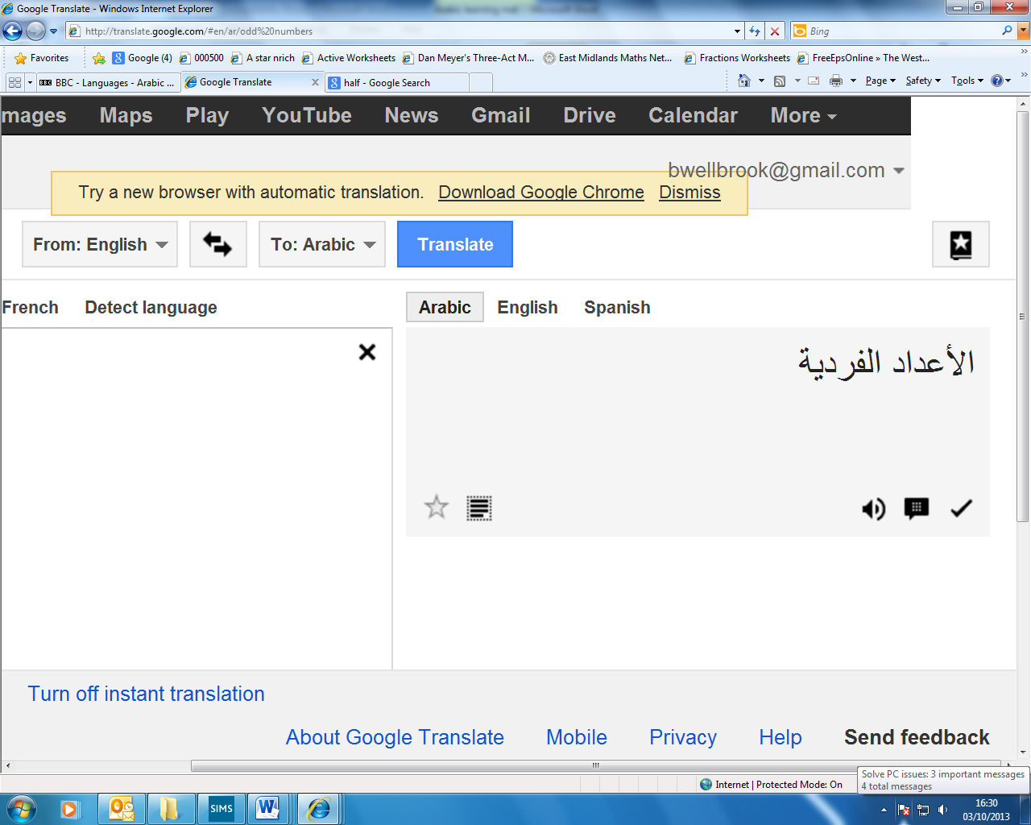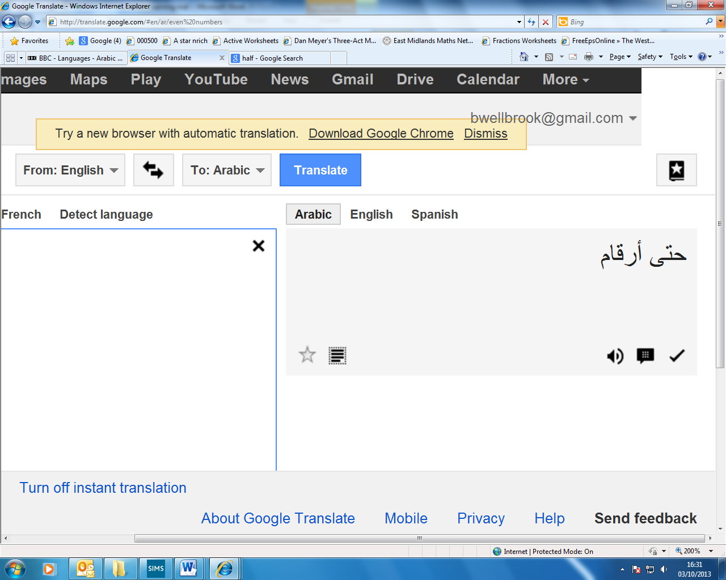

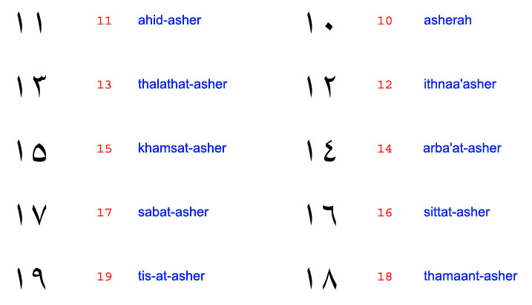

Ten

Twelve

Fourteen

Sixteen

Eighteen

Twenty

Twenty Two

Thirty

Fifty

Seventy

Ninety

Eleven

Thirteen

Fifteen

Seventeen

Nineteen

Twenty One

Twenty Three

Forty

Sixty

Eighty

One Hundred

**Mean Average**

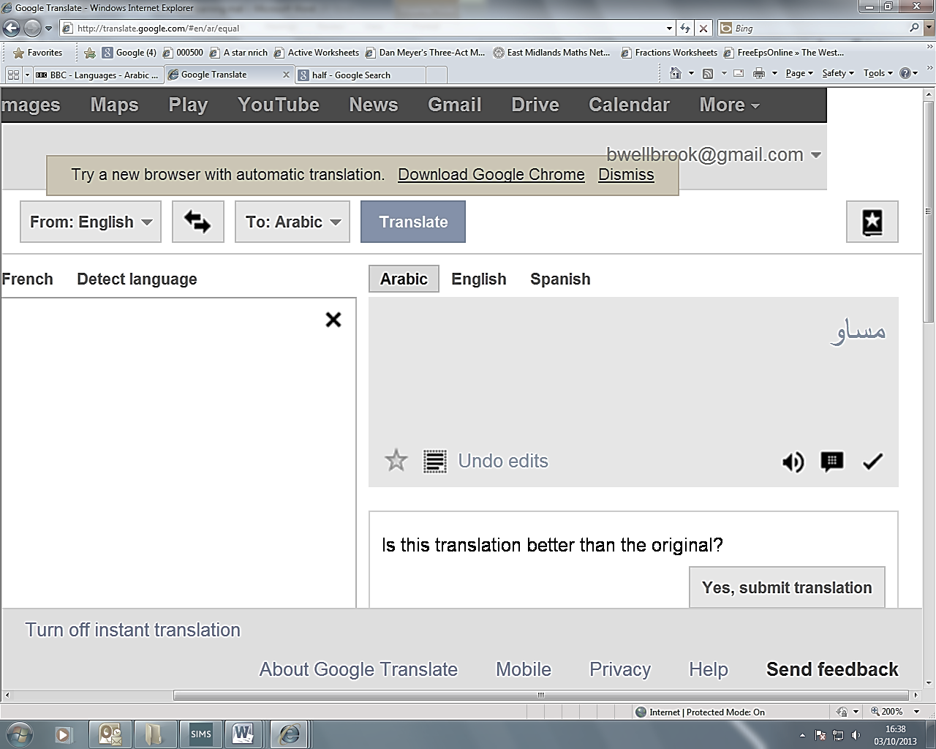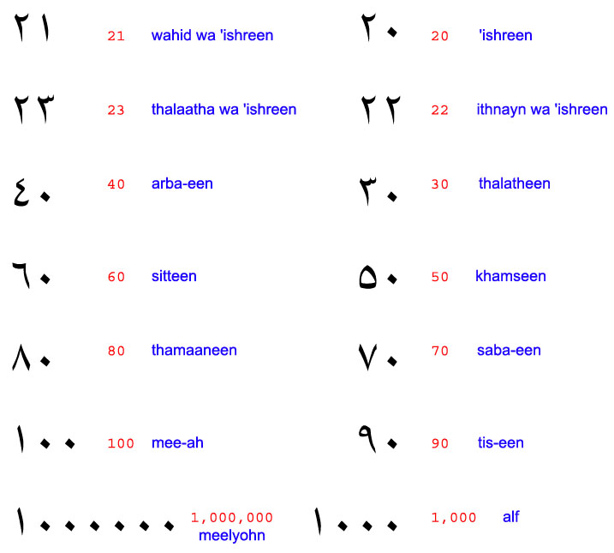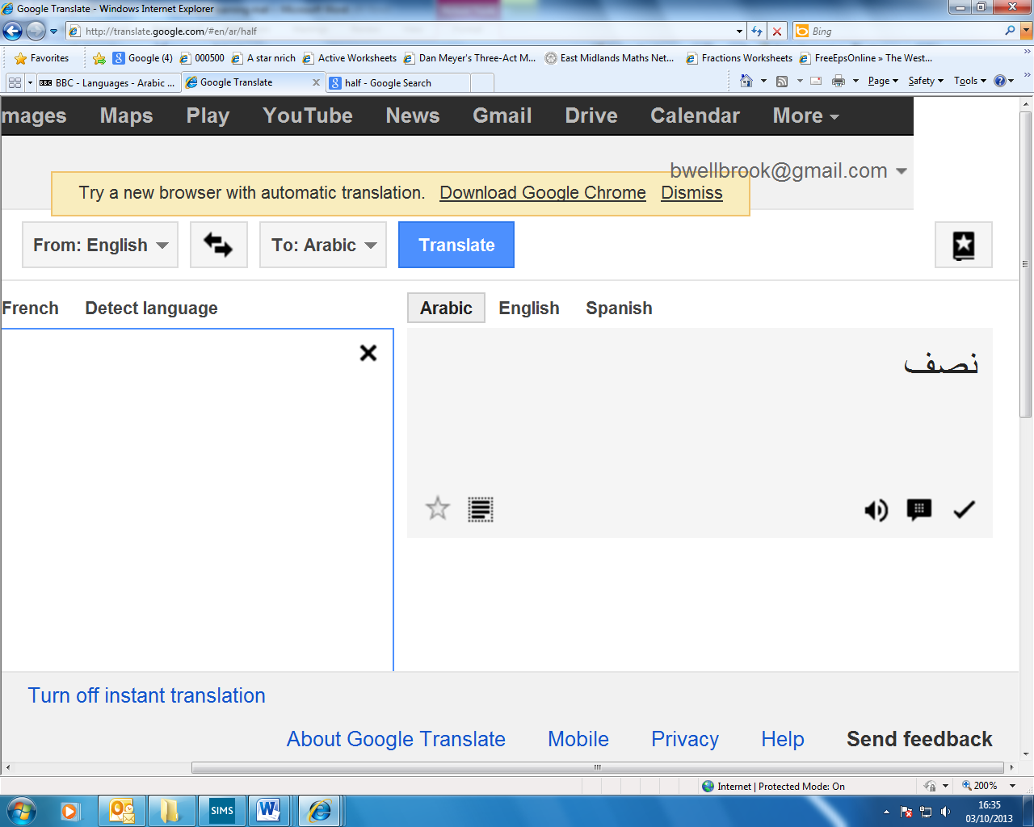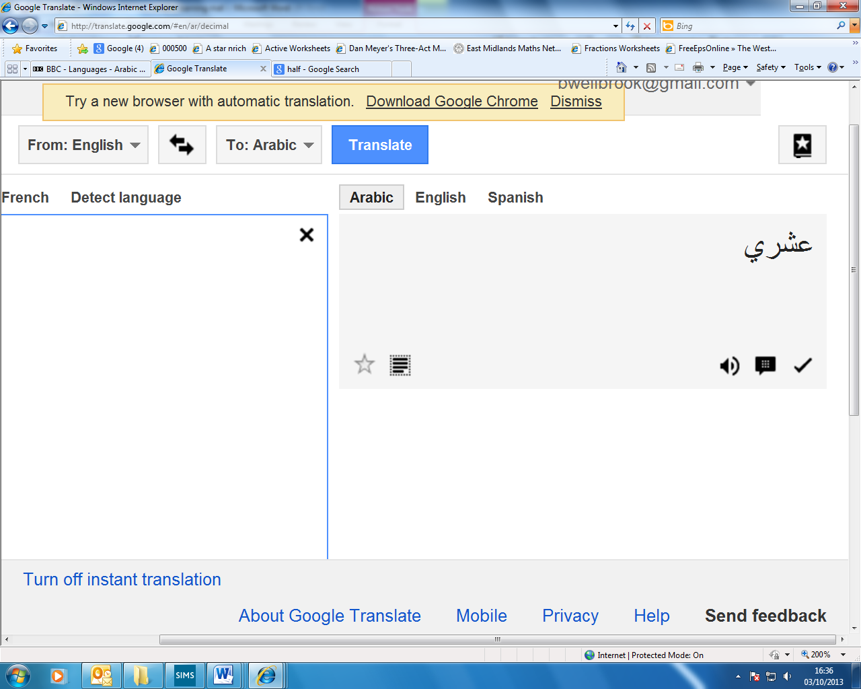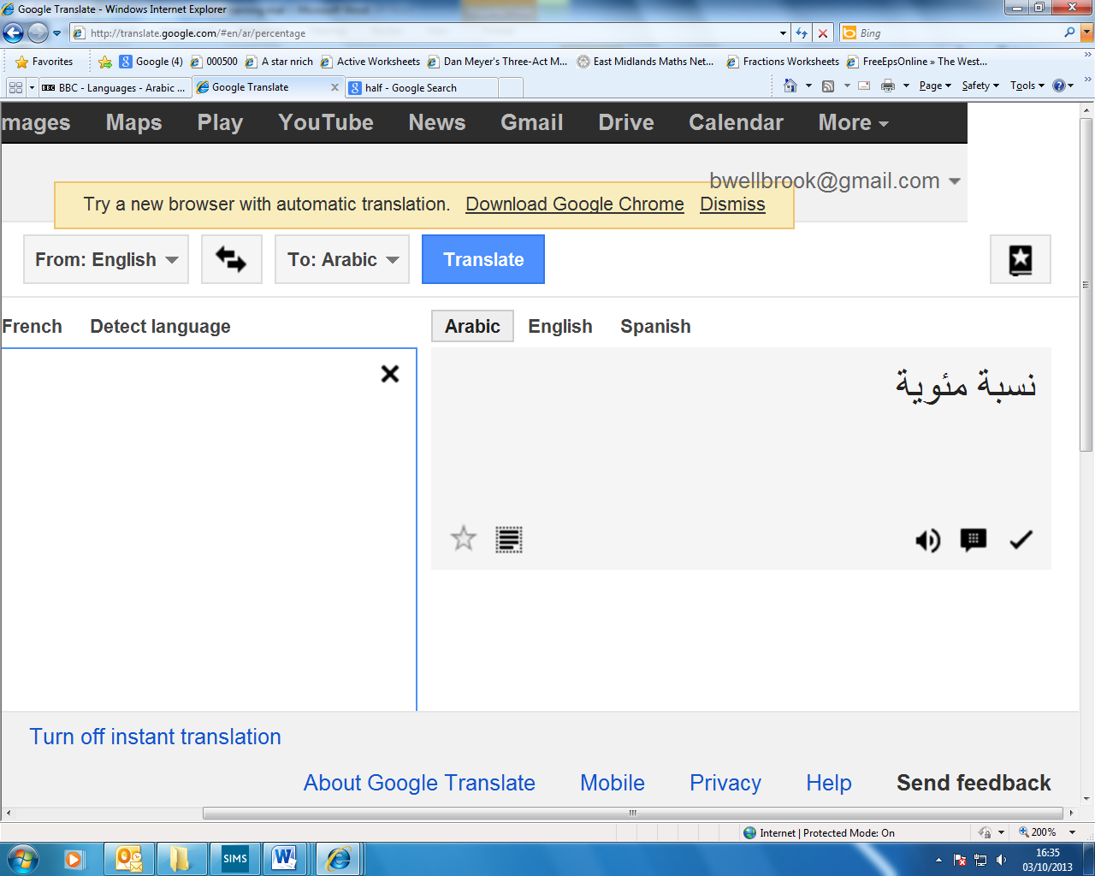[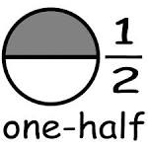](http://www.google.co.uk/imgres?imgurl=http://ed101.bu.edu/StudentDoc/Archives/ED101sp10/elpogson/Images/fractions_1half_gs.jpg&imgrefurl=http://ed101.bu.edu/StudentDoc/Archives/ED101sp10/elpogson/One%20Half.html&usg=__GOEhnxdptUlGM2YZrxfiukBaogE=&h=1200&w=1200&sz=103&hl=en&start=3&sig2=YLh5oS2Fs2nJdLzuEQPKow&zoom=1&tbnid=-iV7HmbnsfhXJM:&tbnh=150&tbnw=150&ei=hIRNUojdG4jR7Abog4CoAw&prev=/search?q%3Dhalf%26um%3D1%26safe%3Dvss%26sa%3DN%26hl%3Den%26sout%3D1%26tbm%3Disch&um=1&itbs=1&sa=X&ved=0CDAQrQMwAg)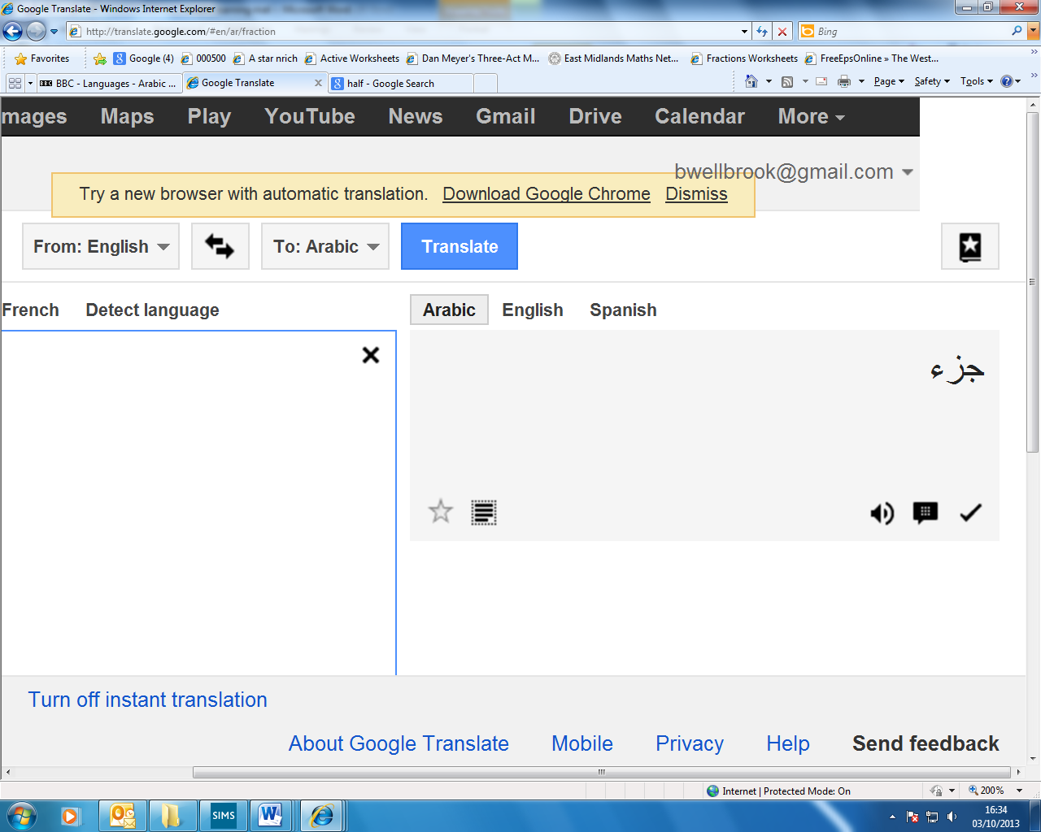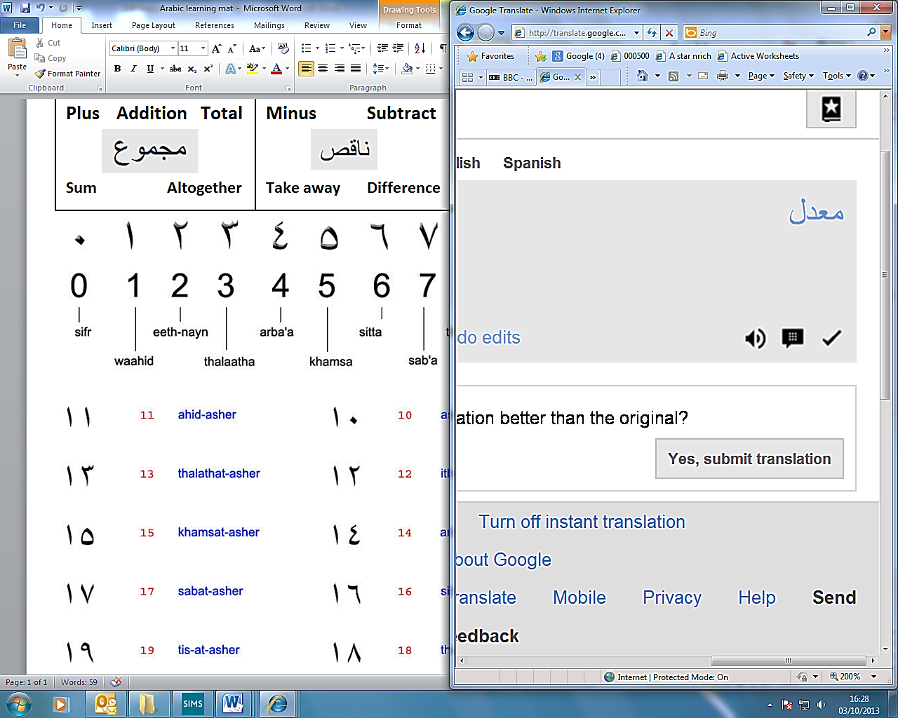

One Thousand

One million

$$=$$

**Equal The same as**

**Fraction**

نصف

**Percentage %**

**Decimal**