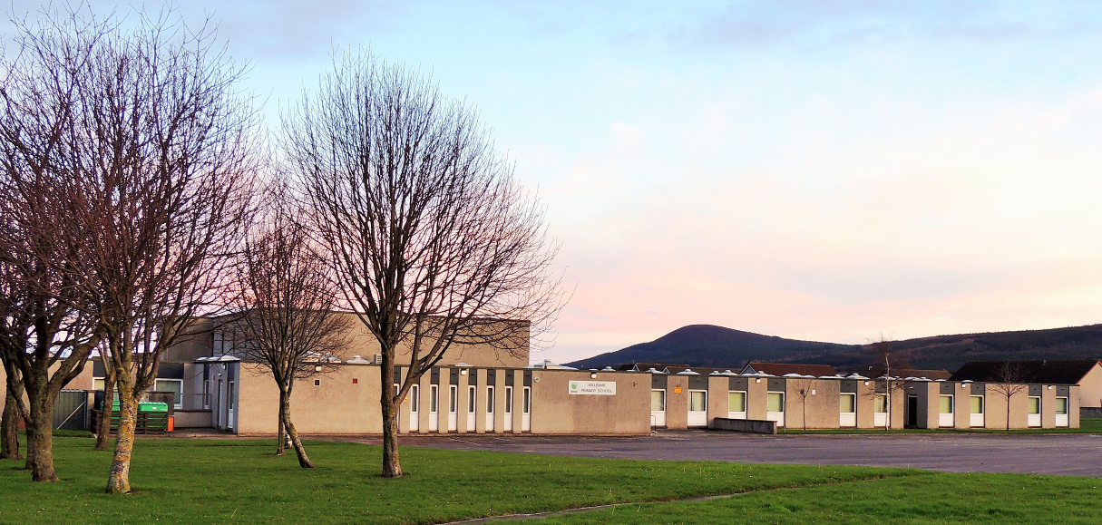

School Handbook
Session 2015 – 2016

The information contained within this handbook is correct at the time of publication and is updated annually.

INTRODUCTION

Head Teacher Mrs Rosemary Garrity

Depute Head Teacher Mrs Heather Reid

Principal Teacher
(Additional Support Needs) Mrs Karen Ramsay

School Telephone Number 01542 831113
E-mail admin.millbankp@moray-edunet.gov.uk
School Website www.millbank.moray.sch.uk
School Address McWilliam Crescent
Buckie, AB56 1LU

Opening Times:

NURSERY | Starts | Finishes
Nursery am | 08.50am | 12.00 noon
Nursery pm | 12.30pm | 3.40pm

PRIMARY | Morning | Interval | Lunch | Afternoon
Primary 1,2 &3 | 08.50am | 10.30-10.50am | 12.10-1.00pm | 2.30pm
Primary 4,5,6 & 7 | 08.50am | 10.30-10.50am | 12.30-1.20pm | 3.00pm

House Captains – 2015-2016

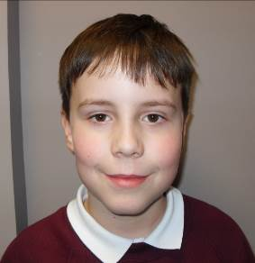

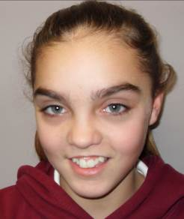
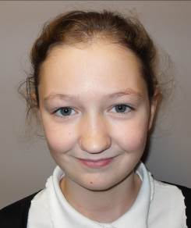
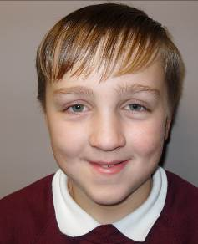
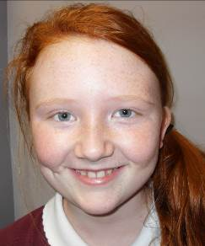

WELCOME TO

MILLBANK PRIMARY SCHOOL
Millbank Primary School provides an educational service to children from Nursery through to Primary 7 (ages 3 years – 12 years). We are a non-denominational primary school with a current role of 242 primary and 58 nursery children.

Refurbishment
Millbank Primary School is currently undergoing an extensive refurbishment. The project is due for completion in March 2017. We appreciate everyone’s understanding during this time. Plans are available for parents to view in the school entrance.

School Catchment Area
The school is designated by the Moray Council to serve children living within the following territorial boundaries: High Street, March Road, Low Street, Commercial Road, and South of the A98 Cullen – Fochabers from a west of Connage to the east side of the Gollachy Burn, and south as far as Hill of Stonyslacks.

The Education (Scotland) Act 1981, gives parents the right to choose the school they wish for their children to attend, regardless of designated catchment areas. If you would like to enrol your child out with your catchment area please complete a Placement Request form and send this to Moray Council Educational Services. You will be informed of their decision by letter with regard to your request as soon as possible.

Our school is a busy, working community where everybody’s contributions are valued and respected. Everyone is encouraged and supported to reach their full potential through effort and hard work.

We aim for high standards and we work in partnership with parents to encourage responsible citizens, successful learners, effective contributors and confident individuals.

We have strong links with our community.

Pupils are in mixed ability, according to their ages throughout the school. Schools in Scotland are staffed to a formula that relates to the school roll. Hence the size and distribution of the classes means that we may have to form composite classes, a feature in most schools.

At the start of each session parents are given a list of holiday dates and the names and roles of all staff in school.

School newsletters are sent home regularly with children to ensure that parents are kept up-to-date with all school activities, holidays etc.

Contents

INTRODUCTION 2
TERM DATES 6
New pupils 7
Transfer from other schools 7
Absence 9
Family Holidays During Term-time 9
School Telephone Information Line 9
Parent Involvement Opportunities 10
Parent Consultations 10
Millbank School Parent Council 11
INFORMATION FOR PARENTS AND CARERS 12
School Information 12
School Improvement Plan 12
School Ethos 14
Aims 14
Golden Tickets 15
Fundraising 15
Assemblies 15
Religious and Moral Education 16
Solution Oriented School (SOS) 17
Sanctions 18
CURRICULUM FOR EXCELLENCE 19
HEALTH AND WELLBEING 24
Personal and Social Development 24
Varied Learning Methods 24
Personalisation, Choice and Achievement 25
Assessment 25
Reporting 26
Practical Information 28
School lunches 28
Uniform 28
Transport 29
Travelling to School by Car 29
Contact numbers 29
Homework 29
Extra Curricular and After School Activities 30
Child Protection 30
Head Lice 30
First Aid 31

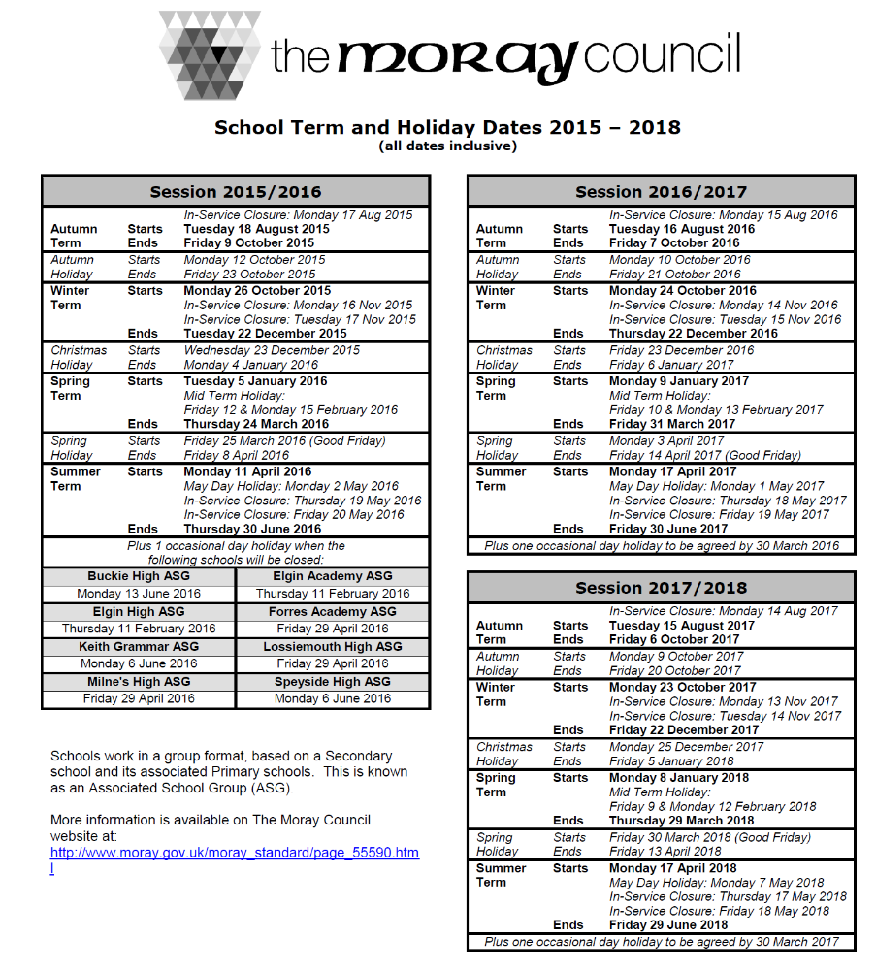
TERM DATES

Enrolment Procedures
Parents wishing to enrol their children at Millbank Primary School are welcome to contact us. The Head Teacher along with senior pupils, if available, will be happy to show prospective pupils and parents around the school.

Normally, children of suitable primary school age who live in or who move in to our
catchment area are admitted immediately upon the request of their parents. The only enrolment formalities are the completion of an admission form and the production of the original birth certificate of the child starting school for the first time. Parents are also asked to complete forms relating to issues such as media filming consent, access to the Internet, the school’s behaviour code and a homework contract.

Under Scottish Government regulations, children may start school in August, the beginning of the school session, of the year in which the child reaches the age of 5 years. To be eligible for entry to school in any August, a child’s fifth birthday must fall between the previous March 1st and the following February 28th/29th. There is a full induction programme for parents and children, which includes a variety of meetings and visits to the P1 classroom.

Enrolment for prospective P1 pupils takes place in January for next session. An
advertisement will appear in the local paper in January, before enrolment is due, inviting parents to contact their local primary school to register their child. Parents may then enrol their child at the school, or request a placement request form if they wish their child to enrol at a school out with the catchment area. Decisions about placement requests are made by an Education Officer.

New pupils
We are very happy to welcome new pupils and their families. Anyone considering placing their child at Millbank Primary School should telephone the school office, or call in to the school reception, to request an appointment to visit the school. You will be shown around the school building so that you are familiar with the layout. You will have the opportunity to visit classes at work and also meet some of the teachers, adult helpers and other staff members who work at Millbank Primary.

Transfer from other schools
It is helpful if records and work from previous schools are available for your child’s new teacher so that we can try to ensure that continuity of learning takes place. We also advise that children should be allowed to settle over a few weeks, unless there are major concerns, and then parents should arrange to meet the teacher to discuss how the transfer has gone.
Nursery
We have a very busy nursery at Millbank, during refurbishment the nursery is located at Lady Cathcart, catering for 80 children. Children can be enrolled during the month of January for joining the nursery class at the start of the next school session. Places are allocated according to the criteria laid down by The Moray Council with priority being given to children in their immediate pre-school year.

The parents of children who have been allocated a place are invited to participate in the induction procedures during the summer term. A separate nursery handbook with additional information is available on request.

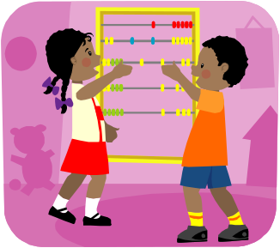
Play
Play is acknowledged as an essential part of the primary curriculum, particularly at the early stages where it could be described as a child’s ‘work’. It provides a focus for children to explore, and to learn about sharing materials and ideas. Encouraging children to be curious helps them to gain an understanding of their world, and through play this is non-threatening. The ways in which children learn through play are discussed more fully at the nursery and P1 induction evenings.

Moving onto Secondary Education
At the end of Primary 7, pupils move onto their secondary education. Most children at Millbank move onto Buckie Community High School. There are a series of information meetings for parents and pupils held during the latter part of Primary 7. There are also induction days at the High School so that pupils become familiar with the school, its layout and some of their new teachers. It is also an opportunity for pupils to meet children from other schools who will be starting their first year at High School with them. There are enhanced transition opportunities scheduled for pupils who have additional needs which need to be supported.

The contact details for Buckie Community High School are:
Head Teacher: Mr N Johnston, Tel: 01542 832605 Fax: 01542 935758
Address: West Cathcart Street, Buckie
Email: admin.buckiehigh@moray-edunet.gov.uk

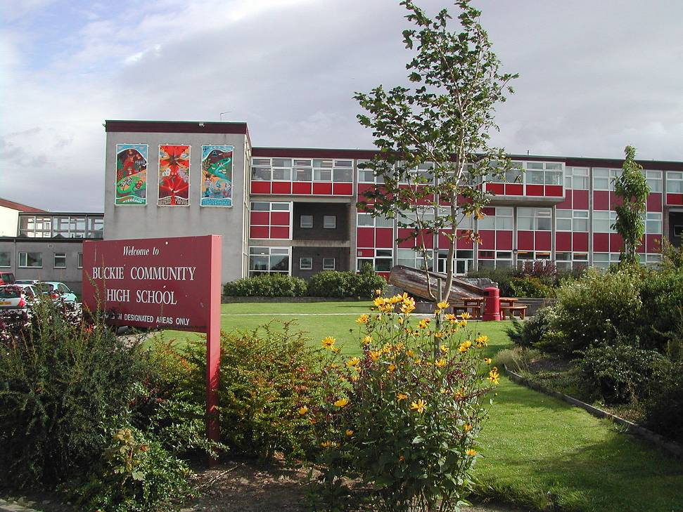

Procedures for Contacting the School
Parents can contact Mrs Stronach, the School Administrator, on 01542 831113 who will deal with any enquiries or advise the school of your child’s absence. The School Administrator is in the office from 8.30 am – 4.00pm and there is always a member of staff in school between 8.30am and 4pm.

You can use the school telephone information line to hear about any school
announcements e.g. in the event of severe weather closing the school. Additionally, you can use the school information line to leave any non-urgent message when the school is not open.

Absence
If your child is unable to attend school, e.g. due to illness or medical appointments, please contact the school office in the morning to explain the reason for absence.

Family Holidays During Term-time
Advice from the Scottish Executive is that holidays taken during the school session, other than in exceptional circumstances, should be considered as unauthorised absences. Parents need to inform the school about such holidays, and each case will be considered on its merits. The Head Teacher reserves the right to decide whether or not the absence will be authorised up to ten days in any consecutive twelve months. If pupils are absent from school due to holidays, the school does not provide work for the pupil to complete whilst on holiday.


School Telephone Information Line
Parents can access an information line for the school
• Dial 0870 050 9999
• Enter school pin: 031 3406521
• You will get confirmation message “Selected Millbank Primary School”
• Enter the menu system
- Press 1 - severe weather information *
- Press 2 - to leave a non urgent message (when school not open)
- Press 3 - to hear general school information
- Press 4 - to enter a different school PIN
- Press # - to end call
* (A ‘Severe Weather’ advice booklet is available from the office.)

“Calls to this number will be charged a 2p per minute service charge plus your call providers access charge”

Concerns and Complaints
Millbank has an open door policy, which means that parents are welcome in the school at any time, signing in at reception first. If, however, parents wish to discuss something in depth it is better to make an appointment for a time when the teacher is free from class commitment. If issues remain unresolved then an appointment can be made (through the school administrator) with Mrs Garrity, the school’s Head Teacher, or Mrs Reid, Depute Head Teacher.

Parent Involvement Opportunities
At the start of each session parents are informed about the arrangements made for the formal reporting of each child’s progress. Reports are undertaken in the following ways – a written report, parents’ interview evenings and when necessary, regular meetings.

We wish to fully involve parents in their child’s education. In October we have teacher/parent appointments with the purpose of discussing how well the children have settled and to discuss possible targets throughout the school year.

We have an ‘open door’ policy, which means you are welcome to approach the school office to request an appointment, to speak to a teacher or other member of staff at a mutually convenient time.

Parents and friends are welcome helpers around the school and in classes. This enables us to foster positive home and school links and to broaden the curriculum. We aim to communicate effectively with parents, and to work in partnership with them.

Parents, teachers, and friends of the school share their interests and expertise with children in a variety of extra-curricular activities. The programme for these is organised at the start of each session and depends on the availability of support. We believe that it is important for children to participate in school concerts, educational trips, local activities and inter-school competitions, etc. We very much appreciate the help we receive from our parent volunteers.

We ask you, as parents, to take an active interest in all that your child does and support us in maintaining the high standards set by the school. We also offer open afternoons for parents to see their child’s learning and achievements.

Please continue to support your child’s learning at home. Allow time to complete reading and other homework in an environment that is free from distractions. Discuss their learning with them, and do not hesitate to add any comments you have about their learning, when you sign their reading records.

Parent Consultations
At Millbank, we value the opinions of our parents and members of the community. We consult with a sample of people before making important changes and putting new policies in place. E.g. parents and community members were consulted for their opinions towards our change of school time arrangements.

Millbank School Parent Council
The school has an elected Parent Council, which meets once per term, with the AGM held in September each year. The council aims to provide parents with an effective link with the school, to represent their views and to promote good relations between the school, the parents and the community. The Parent Council has formed a Sub-group to organise fund-raising events and social activities. This group works extremely hard to raise money to contribute towards many valuable resources and experiences used to enrich learning. The Parent Council will inform parents as to what funds are being raised for.

We recognise that parents are the first and foremost educators of their children and know them best. We aim towards promoting strong links between parents and the school.

The Parent Council aims to:

- support the school in its work with pupils
- represent the views of parents
- promote contact between the school, parents, pupils and the local community
- report annually to the parent forum.

All parents are entitled and welcome to attend Parent Council Meetings. Please contact the school or Chairperson, Mrs Cumming, knabllim@hotmail.com, for further details.

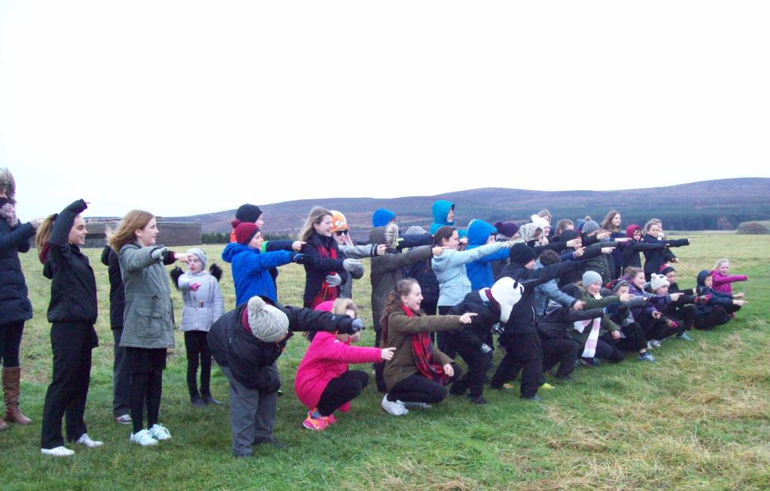

INFORMATION FOR PARENTS AND CARERS
A series of leaflets have been produced by Education and Social Care for parents and carers. These leaflets are available from the school, or from the Moray Council Internet site. The “Information for Parents and Carers” leaflet is available in other languages.

A “Notes for Parents and Carers” booklet in pdf form is also available.

Please see Appendix A at the rear of this handbook for information on links to The Moray Council’s internet site web pages.

School Information
Parents can have access to the School Improvement Plan and bi-annual Standards and Quality Report at the school office.

If you wish further information, please do not hesitate to contact the school personally or by telephone.

School Improvement Plan
Full details are available in the school’s ‘School Improvement Plan’.
(refer to Appendix B)

At Millbank Primary, we aim to improve educational experiences for all of our pupils. We have identified a number of improvement priorities. These are:
- To enhance pupils’ experiences, progress, attainment and achievement, within the four contexts of Curriculum for Excellence, incorporating the design principles and entitlements
- To embed HWB entitlement for all learners at Millbank to encourage every teacher to contribute to learning in development in this area. This is linked to the “Children and Young People (Scotland) Act 2014”.
- Develop a shared understanding of the 10 key components on the Wellbeing Wheel and the set of values and principles linked to GIRFEC.
- Become a Rights Respecting School recognising achievement in putting the United Nations Convention on the Rights of the Child at the heart of a school’s planning, policies, practice and ethos.

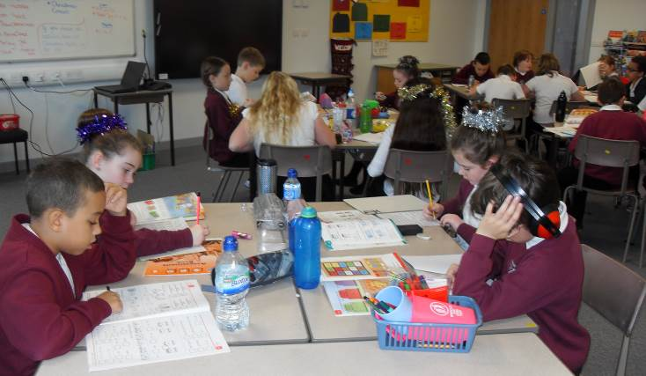

The Schools Successes Over The Year
Full details of the school’s successes and achievements are available in ‘Standards and Quality Report’ – Millbank Primary School. (refer to Appendix C)

Achievements continue to be celebrated regularly through weekly assemblies, presentation of certificates and golden ticket awards, out of school achievements are displayed in our school and celebration of events in local newspapers. This year we have continued to experience many successes and achievements; some of these are:

- Taking part in local sporting competitions, namely, cross country, orienteering and badminton. We performed very well at our Kwik cricket ASG competition
- We are once again looking forward to our 4-day residential outdoor experience trip to Ardeonaig focusing on education and citizenship
- House competitions throughout the year organised by the pupils
- A special Harvest Assembly collecting tins for the Food Bank
- Pupil participation in Christmas nativity and concert.
- Pupils participated and excelled in the Buckie Bletherers Competition
- Two classes have been responsible for lucrative Christmas Enterprise Projects resulting in money being collected for Rachel House Charity
- An extensive extra-curricular programme was available to pupils throughout the session with activities such as Bikeability, Scottish Country Dancing, Running Club and Club-golf.
- School choir participated successfully in the Buckie Kracker

Information on Millbank (and other schools) performance can be obtained at
http://www.educationscotland.gov.uk/inspectionandreview/reports/school/index.asp

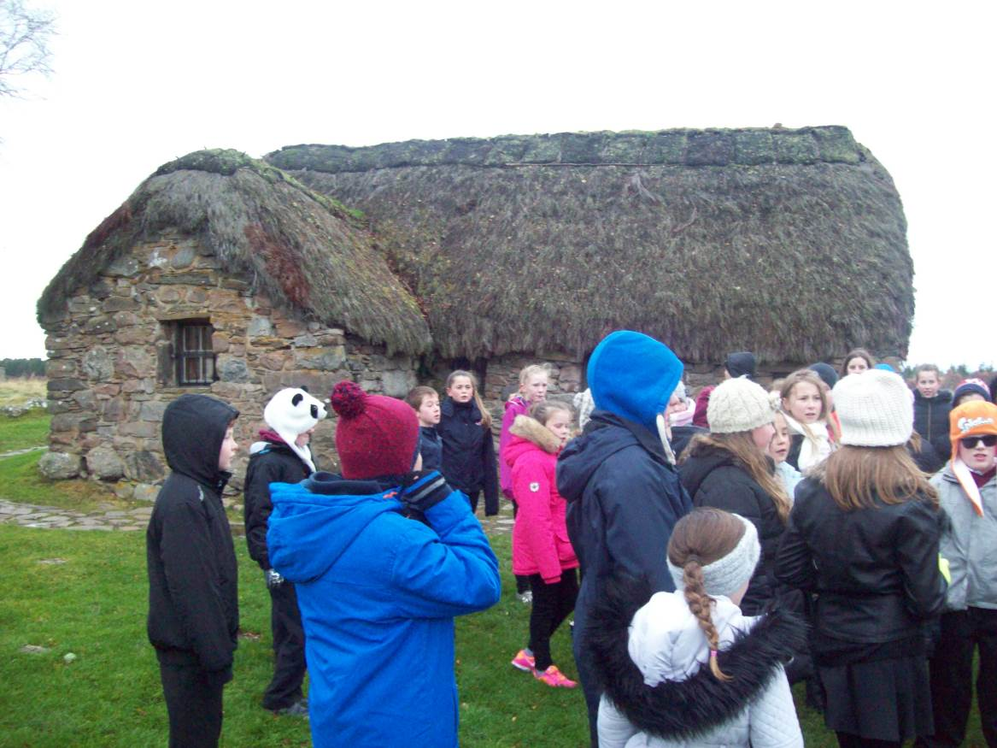
School Ethos
At Millbank we aim to inspire, include and improve educational experiences for all of our pupils and we promote our vision of Open Minds, Open Arms, Open Door.

Every child in this school is important with particular interests and needs. To ensure that the school is a happy, secure and successful place for our children we need the support, understanding and interest from parents. The purpose of the school handbook is to give an overview of the school and the education it seeks to provide.

Aims
At Millbank Primary School we want to enable our children to be ‘successful learners’, ‘confident individuals’, responsible citizens’ and ‘effective contributors’. We do this in a variety of ways:

Successful Learners  Confident Individuals | Confident Individuals
Plan a structured and balanced  ‘Curriculum for Excellence’.  Varied teaching methods and activities. e.g. ‘active learning’.  Encourage pupil responsibility for self/peer assessment and target setting.  Monitor, progress, record achievement and attainment to ensure each child  reaches their potential. | Identify the emotional, physical and  social needs of pupils and help them  develop positive attitudes, personal  and social skills.  Provide appropriate support for  children with additional needs.  Celebrating success in the classroom, the school and in ‘out of school’ life.  Encourage a healthy and active lifestyle.  Create within the school a warm, caring and supportive atmosphere in which children, staff and parents feel secure and valued.
Responsible Citizens  Effective Contributors | Effective Contributors
Encourage children to enrich the school and its community by acting responsibly and by valuing the unique culture and traditions of the past.  Ensure that individual differences of  race, culture and belief will be  respected and celebrated as an  enriching factor in the school  community. Equal opportunities will  exist for all.  Enable children to take part in decision making in the school through the pupil council and class circle time activities. | Promote attitudes of enterprise and  self-reliance.  Encourage pupils to work on their  own, and in teams to apply their  thinking skills, to create and develop  ideas, and to solve problems.

Golden Tickets
Every child has the opportunity to be awarded a Golden Ticket by any member of staff. Tickets are presented for: completing work on time, polite attitudes, consistently good application to work, playground behaviour, keeping out of squabbles, offering help, careful presentation of work, being kind or helpful, trying hard etc.
All Golden Tickets are collected by Primary 7 pupils and one ticket is drawn out at assembly during a little ceremony, where a small prize is selected.

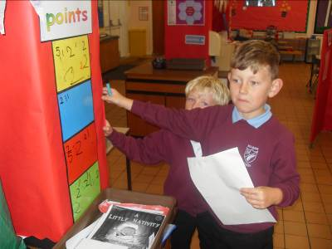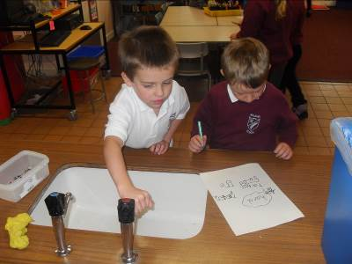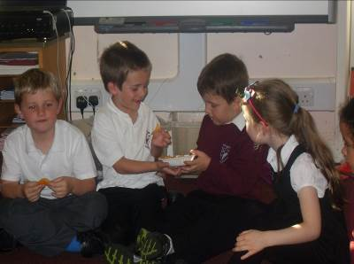

Fundraising
Fundraising activities are undertaken on an annual basis through enterprise initiative.
Various classes are involved on a two year cycle and money raised is offered their chosen charities.

Assemblies
Assemblies are held on a weekly basis in our school and the Head Teacher, Depute Head Teacher, some classes and a school chaplain all present assemblies.

We use our assemblies not only for religious observance but also to promote sound moral values. Special assemblies, open for anyone to attend, are held in the South and West Church at Christmas and Easter.

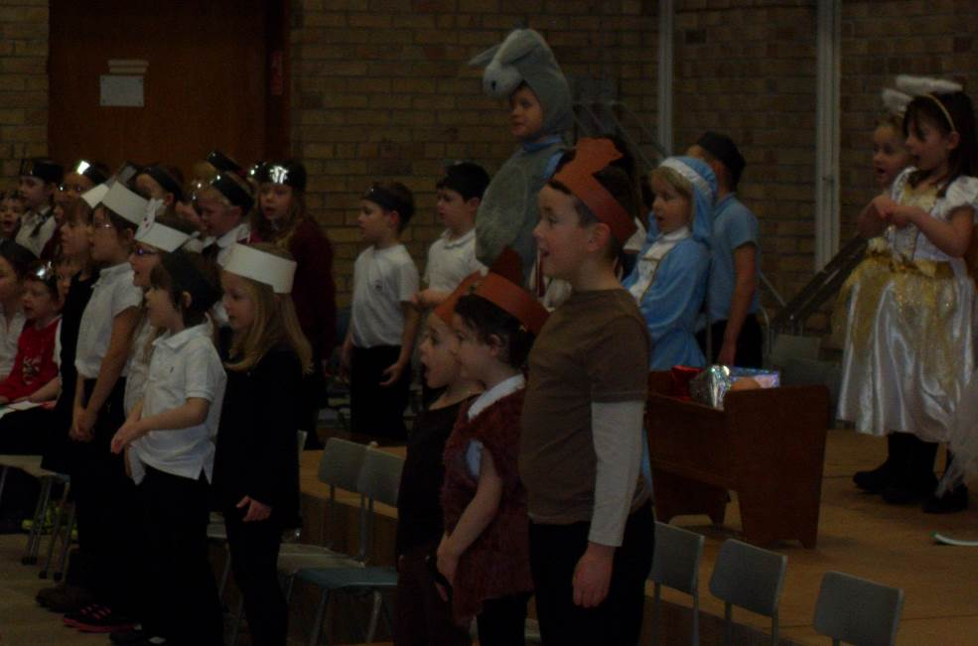

Religious and Moral Education
Christianity and Other World Religions are taught so that pupils learn about:
- Beliefs
- Values and Issues
- Practices and Traditions

Where parents exercise their legal rights to withdraw their children from RME Observance, their wishes will be respected and the children will be treated sensitively. To make these arrangements, please forward a letter to the Head Teacher stating your reasons for this request.

At the end of session a closing ceremony is held. This is a celebration of the school’s work over that year. It is an opportunity to celebrate the effort and achievement of our pupils and staff. A variety of people from the community are invited to attend this ceremony. During this assembly, awards for the winning House from Sports Day, the winning House overall and the
following awards are presented:

- Mrs Shand Achievement award (P1-3)
- Mrs Blackhall Citizen Award
- Bank of Scotland Achievement Award (P7)
- Inter House Shield

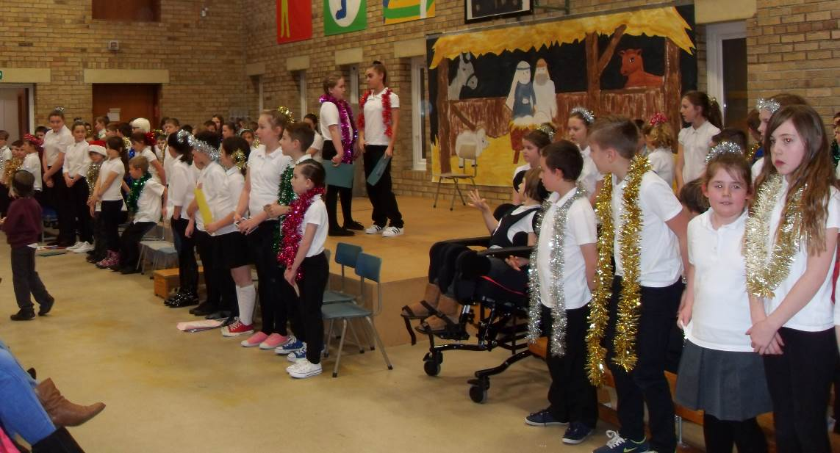
BEHAVIOUR AT MILLBANK PRIMARY

Solution Oriented School (SOS)
Millbank Primary is a ‘solution oriented’ school. We encourage children to treat others as they would like to be treated themselves. Positive playground play and behaviour is emphasised.

There are adult supervisors in the playground who reinforce the positive play message and monitor behaviour. Pupils are asked to talk to an adult or teacher about matters that are not resolved or causing distress.

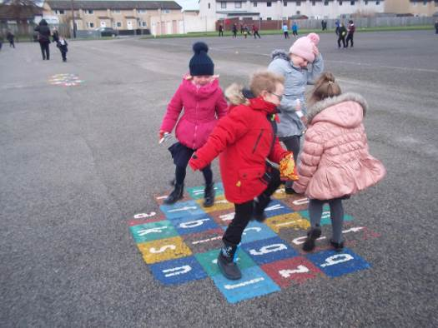

Rules
To achieve our aim of promoting good working attitudes, self discipline and effective learning, a calm and purposeful atmosphere in and around the school is essential.

We expect children to observe the following:
- Politeness to each other, members of staff and visitors is the first step towards becoming acceptable members of society
- Care of, and respect for school property and materials ensures that everyone benefits fully from school resources
- Following instructions and behaving responsibly in rooms, corridors and the playground are necessary to ensure the safety of everyone
- It is reasonable to expect children to walk at all times within the building and to behave in such a way that they are not interfering with or distracting others
- Bullying, kicking, throwing stones and any other kinds of anti-social behaviour which may cause injury, are dangerous and unacceptable. The school operates a zero tolerance policy for inappropriate behaviour, including bullying.

Our policy is to encourage children to be honest about their role in any situation and we emphasise that if we withhold the truth we can only make a bad situation worse for everyone involved.

We believe in a positive approach towards behaviour management but where this fails sanctions will be enforced.

When a child’s attitude or behaviour is giving cause for concern parents will be contacted at an early stage to discuss possible strategies to support the pupil.

Sanctions
Children are expected to follow the school rules. Generally, children are made aware that they are responsible for their own actions and that breaking rules will lead to sanctions, or may in serious cases of indiscipline, lead to exclusion.

Sanctions:
- warnings and time outs
- reported to the Head Teacher or Depute Head Teacher
- withdrawal of privileges
- parents / carers asked to discuss behaviour and agree next steps
- support in school and from other agencies
- exclusion from school

You should also note that any incidents involving violence, dangerous weapons, drugs or alcohol are reported immediately to Education and Social Care, and the Police.

Bullying
Our school does not tolerate bullying and pupils are encouraged to talk openly about unacceptable behaviour. Incidents of bullying and anti-social behaviour in the playground are investigated, dealt with quickly and fairly, with parents informed and consulted where appropriate. We encourage parents to contact the school if they are concerned about incidents of possible bullying. Bullying can be carried out discreetly and the school can only respond if pupils and parents are confident enough to bring it to our attention. Be assured that we will respond.

When there are cases of persistent misbehaviour by a pupil, parents are always consulted. Serious misconduct is rare, but where a child’s conduct seriously threatens the educational well-being and security of himself and/or others, exclusion from school may result. There is a system of agreed responses with escalating sanctions employed where necessary. If misbehaviour is persistent and all avenues of bringing the pupil back ‘online’ to acceptable behaviour fails, or if there is a single very serious incident, the misconduct may result in exclusion.

Parents are expected to make good any damage caused to items of school equipment including books or instruments whilst in their child’s care. We encourage pupils from the beginning to look after their property and that of the school and recognise that although accidents do occur, the cost of deliberate breakage of school property and vandalism will be passed on to parents.

We ask parents to support the school’s behaviour policies and the use of considered sanctions if considered appropriate.

Leaflets and fuller information on Bullying, Disability Discrimination and Race Relations is available from The Moray Council by telephoning the respective number, emailing or accessing the web page on the council website. (See Appendix A for these contact details.)

CURRICULUM FOR EXCELLENCE

Curriculum for Excellence (often shortened to CfE) is the curriculum in Scotland which applies to all children and young people aged 3-18, wherever they are learning. It aims to raise achievement for all, enabling young people to develop the skills, knowledge and understanding they need to succeed in learning, life and work. It aims to raise standards, prepare our children for a future they do not yet know and equip them for jobs of tomorrow in a fast changing world. All children and young people have an entitlement to provision of an excellent education so that they develop skills for learning, life and work.

Curriculum for Excellence is not a 'one size fits all' curriculum. It provides greater personalisation and choice so that learning is more challenging, enjoyable and relevant to each child’s needs, strengths and interests. Curriculum for Excellence enables professionals to teach subjects creatively, to work together across the school and with other schools, to share best practice and explore learning together. Glow, Scotland’s unique, world-leading, online network will support learners and teachers in this and there are plans already in place for parents across the country to have access to Glow in due time.

A factfile about the ‘Curriculum for Excellence’ for parents/carers which provides a more comprehensive overview of CfE (and an explanation of the terms used) is available from the office. You can also access further information about the curriculum and supporting your child on:

http://www.LTScotland.org.uk/Parentzone
http://www.educationscotland.gov.uk/parentzone/cfe/index.asp
http://www.educationscotland.gov.uk/parentzone/resources/index.asp

Curriculum for Excellence develops skills for learning, life and work to help young people go on to further study, secure work and navigate life. It brings real life into the classroom, making learning relevant and helps young people apply lessons to their life beyond the classroom. It links knowledge in one subject area to another, helping children understand the world and make connections. It develops skills so that children can think for themselves, make sound judgements, challenge, enquire and find solutions.

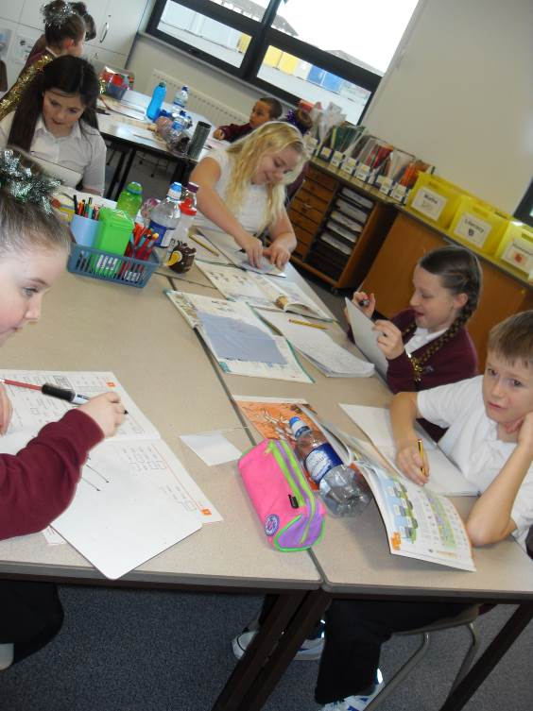

CURRICULUM LEVELS

These describe the progression in learning and development of children and young people from age 3-18 years. In brief, these are:
- Early Level - pre-school through to end of Primary 1
- First Level - through to the end of Primary 4
- Second Level - through to the end of Primary 7
- Third and Fourth Levels - Secondary 1 - 3
- Senior Phase - Secondary 4 - 6

As a very general guide, children are expected to be at Second Level, and beginning to learn and develop at Third Level, as they make the transition from Primary into Secondary Education.

Children and young people progress through these levels at their own pace; and naturally some do so more quickly, or a little later than expected, dependant on individual circumstances and needs.

Experiences and Outcomes (Es and Os)
Each learning experience will provide the opportunity for children to learn a number of outcomes throughout a range of curriculum areas. We use detailed planning to deliver inter-disciplinary learning opportunities using interesting topics e.g. Victorians, World War 2, Minibeasts, etc. Not only do children learn more about the topic, but they are continuously developing their literacy, numeracy and team working skills.

The ability to transfer knowledge and skills over a wide range of learning experiences from the different curriculum areas is desired.

Key areas of Education
- Literacy across learning,
- Numeracy across learning and
- Health and Wellbeing across learning

- Experience - describes the learning activity taking place.
- Outcome - describes what the learning will achieve.
E.g. Knowledge, understanding, skills, awareness and attitudes.

Curriculum for Excellence is all about bringing real life into the classroom and taking
lessons beyond it. Learning and teaching will still focus on subjects and knowledge in addition to developing skills and understanding. The following website page has more information on other subjects and knowledge covered by the curriculum:
http://www.educationscotland.gov.uk/parentzone/cfe/subjectsandknowledge/index.asp

The Seven Principles- | The Eight Curriculum Areas -
all learning must take account of these  principles:  - Challenge and Enjoyment  - Breadth  - Progression  - Depth  - Personalisation and Choice  - Coherence  - Relevance  This is to ensure children's development is useful and meaningful | containing a range of subjects:  - Expressive Arts  Art, Drama, Music and Dance  - Health & Wellbeing  Personal, social and emotional health. Also P.E.  - Literacy and English  Communicating with others. Reading, Writing and Modern Languages  - Numeracy and Mathematics  Number work, Problem Solving  - Religious and Moral Education  Religions, values and beliefs.  - Sciences  Understanding our planet  - Social Studies  Scotland and the World; past, present and future.  - Technologies  Food, Design and Computing.

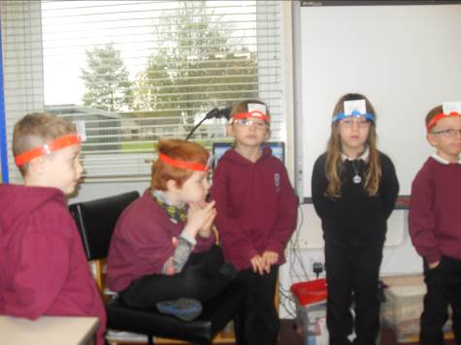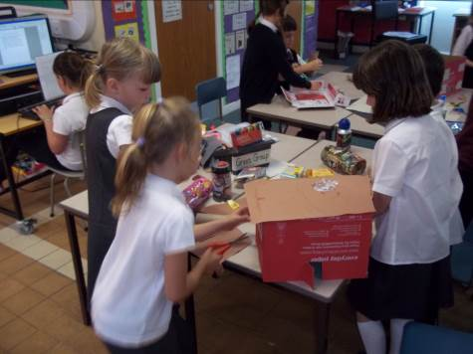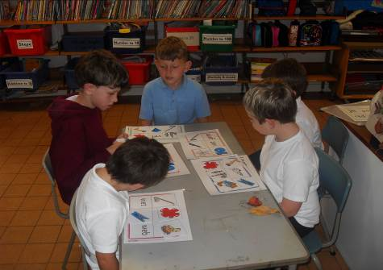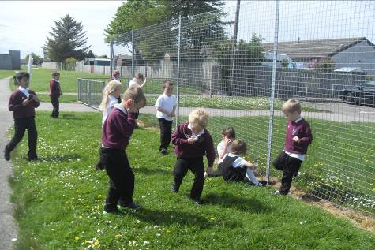

MORE ABOUT LITERACY AND NUMERACY

Literacy
The skills required for communication are fundamental to the curriculum and to the needs of our society. In our every changing world CfE includes teaching about digital literacies. This is included in the Literacy element of the curriculum.

1. Listening - Children need to be taught to listen well, especially to the opinions of others if they are to fit in socially. We help children to increase their concentration span.

2. Reading - The ability to read is one of the basic requirements of an education for life. There is a high emphasis placed on developing good reading and comprehension skills. There is also the requirement to read and comprehend Scots texts. Digital literacy is an important skill in today’s world. Children will be taught how to navigate websites safely. Children will also looking at comprehension of Moving Images.

3. Writing – In CfE writing encapsulates different genres of writing which include both functional and imaginative. The individual components of writing are also taught, sometimes as discrete lessons or combined in to a writing lesson.

4. Talking - We aim to encourage good articulation skills so that the children have the ability and confidence to express appropriately their ideas, opinions, questions and answers in any situation or company. In addition to this we require children to work collaboratively with their peers.

Numeracy and Mathematics
Numeracy and Mathematics is important in our everyday life. It equips us with the skills we need to interpret and analyse information, simplify and solve problems, assess risk and make informed decisions.

Numeracy and Mathematics plays an important role in areas such as science or technologies, and is vital to research and development in fields such as engineering, computing science, medicine and finance. Learning mathematics gives children and young people access to the wider curriculum and the opportunity to pursue further studies and interests.

Because mathematics is rich and stimulating, it engages and fascinates learners of all ages, interests and abilities. Learning mathematics develops logical reasoning, analysis, problem-solving skills, creativity and the ability to think in abstract ways. It uses a universal language of numbers and symbols which allows us to communicate ideas in a concise, unambiguous and rigorous way.




French Language Provision
During the course of P5-P7, pupils are introduced to the French language, traditions and culture, by either their class teacher, or another teacher who will have been trained to deliver a modern language in the primary curriculum. This introduction to the language is intended to focus on the spoken language and developing a vocabulary of simple words and phrases through enjoyable and practical activities which can be reinforced where appropriate in the course of the school day.

Expressive Arts
- Art and Design
- Drama
- Music
- Dance

Through the expressive arts we allow children to explore, express and create aesthetically in ways that are satisfying to the individual.

We encourage children to achieve high standards by displaying work around the school and by holding public performances, which allow the children to demonstrate their skills, abilities and talents.

We have visiting specialist teachers who come to Millbank weekly. Primary 4-7 children benefit from specialised teaching in Art, Music and P.E.

Technologies
Learning in the technologies enables children and young people to be informed, skilled, thoughtful, adaptable and enterprising citizens. The technologies framework has been organised to offer opportunities for personalisation and choice using diverse contexts for learning.

These are:
• Technological development in society
• ICT to enhance learning
• Business
• Computing science
• Food and textiles
• Craft, design, engineering and graphics

HEALTH AND WELLBEING

Learning in health and wellbeing ensures that children and young people develop the knowledge and understanding, skills, capabilities and attributes which they need for mental, emotional, social and physical wellbeing now and in the future. Learning through health and wellbeing enables children and young people to:

- Make informed decisions in order to improve their mental, emotional, social and physical wellbeing
- experience challenge and enjoyment
- experience positive aspects of healthy living and activity for themselves
- apply their mental, emotional, social and physical skills to pursue a healthy lifestyle
- make a successful move to the next stage of education or work
- establish a pattern of health and wellbeing which will be sustained into adult life, and which will help to promote the next generation of healthy children.

Personal and Social Development
We aim to foster positive self-esteem and an awareness of the rights and responsibilities of themselves and others, in every child. The physical, social and mental well-being of pupils is developed and maintained through our policies on Promoting Positive Behaviour, Anti-Bullying, Citizenship and Moral Education. Every member of our school community has undertaken to maintain high standards of courtesy, respect and consideration for others, which is central to the whole ethos of the school.

Varied Learning Methods
There are a variety of ways in which learning opportunities may be presented to children. The CfE represents a different approach to learning in schools intended to help learners develop skills, knowledge and understanding in more depth.

Examples of how children will learn differently are:

- Using technologies
Find, research, communicate, create and present
- Active Learning
Being actively engaged in the learning task, whether mentally or physically
- Cooperative Learning
Encouraging thinking, talking together to discuss ideas and solve problems
Learning from each other
- Interdisciplinary Learning
Using links between different areas of learning to develop, reinforce and deepen understanding
- Outdoor Learning
Making use of the outdoor environment and surrounding community

Personalisation, Choice and Achievement
Planning of learning contexts and methods may be personalised according to an individual's learning and development priorities. Thus, there may be different expectations of learning achieved for different children.

It is not only the academic achievements of children that are recognised. We celebrate a range of achievements reached by children in and out of the school community e.g. Progress in personal development, participation in events, extra-curricular and personal interest activities.

Skills
The CfE emphasises the development of skills for learning, life and work. These are wide ranging and include:

- Higher order skills | thinking about complex issues, problem solving, analysis and evaluation and creativity.
- Critical thinking skills | making judgements and decisions, communicating, cooperating with others, self organisation.

Important themes are Enterprise, Global Citizenship and Sustainable Development.

Pupils can also become involved in the school’s ‘Pupil Council’ and ‘Eco Committee’. Some are chosen to become House Captains, canteen helpers and become involved in the role of classroom monitor. In addition there are numerous voluntary extra-curricular activities which children can take part in. E.g. spade club, young science and engineering club and a variety of sports clubs.

Assessment
Assessment is the cornerstone of good teaching practice and it is important that information about children’s progress is collected systematically and used for appropriate action. To this end we conduct start of year class assessments of the child’s stage of development in reading, spelling, writing and maths in every class. Regular tracking of all children’s’ progress takes place.

PIPS testing of Primary 1 pupils takes place at the start and end of the school year. Primary 3 and 6 pupils complete InCAS tests in Reading and Maths. These diagnostic assessments are used as an internal tool in the school to confirm the teacher’s assessment of the children’s’ learning needs. It also checks the child’s progress over the year.

Assessment is crucial to tracking progress and planning next steps to enable quality learning to take place. Learners are greatly involved in this process so that they can take ownership of learning progression.

- Self assessment | what has been successful and what needs improvement
- Peer assessment | help others appreciate what is good about their work and what needs developing
- Personal learning planning | pupils, teachers and parents will work together to develop planning for the child's next steps in learning.

Reporting
Reporting informs parents/carers of their child's progress. This can be in the form of written reports and parent appointments. The written report in May will advise how much progress has been made throughout the year. Learning and achievements are also reported more informally at 'open afternoons' or via 'learning wall' displays.

Teaching staff and school management may also get in touch with parents/carers to discuss any learning, personal or behaviour matter as issues arise.

SUPPORT FOR LEARNING / ADDITIONAL NEEDS
Children do not all progress at the same rate and provision is made within the school for children who, for a variety of reasons, are experiencing any difficulties. When a child has been identified as requiring additional support, parents will be notified and invited to come in to school to discuss the matter with the class teacher and/or the Support for Learning teacher.

A programme of work may be initiated to help to overcome the difficulties being experienced by the child and this programme may involve a request for additional home support. Some children will have an IEP (Individualised Educational Programme) devised for them. This will be devised by the class teacher and support for learning staff. The IEP will be shared with parents and the programme will be monitored and updated on a regular basis. Staff also work in partnership with other agencies. E.g. Speech and Language Therapy, Educational Psychology Department.

Support for Learning teachers may work with a child, or group of children, in the classroom and sometimes children are withdrawn for specific tasks. Some children may only need additional help for a short period of time whereas others may have a longer term requirement. Children requiring extra help, may also be supported in the additional support needs base. Extra help can be provided for literacy, numeracy, personal, social and emotional, and behavioural needs.

Parents who have concerns about their child’s progress should make an appointment to discuss the matter with the class teacher in the first instance.

The Education (Additional Support for Learning) (Scotland) Act 2009 came into force on 14 November 2010. More information can be found on The Moray Council’s website regarding this and the council’s provision for additional support needs in Moray. There are also internet links to other potentially useful organisations via The Moray Council’s website.

Please refer to Appendix A for how to access this.

Information on GIRFEC (“Getting it Right for Every Child”) is available at:
http://www.scotland.gov.uk/Topics/People/Young-People/gettingitright

Practical Information
All Visitors to the school must report to the school reception and sign in before proceeding further into the building. All volunteer helpers in the school are required to complete a PVG (Protection of Vulnerable Groups Scheme) form.

No child is allowed to leave the playground without permission. If your child is going to be absent please inform the school as soon as possible so that safety is assured.

School lunches

Meals are cooked on the school premises and, at the start of session; parents are advised about the cost of school meals. Six weekly meal plans are available. The weekly menu is displayed at the hall door. Children can purchase tickets before the start of the day at the service hatch in the hall.

Children entitled to free meals collect their book of tickets from the school office at the start of the day. If you think your household income may mean you child is eligible for free school lunches, then refer to Appendix A to access information and a claim form from The Moray Council.

Auxiliaries are in attendance at lunchtime, supervising the dining hall for those having school lunches and packed lunches.

Uniform
With the support of parents, we strongly recommend the wearing of school uniform. This doesn’t only look smart but it also gives a sense of belonging to the Millbank Primary School Community. Children should wear burgundy school sweatshirts/cardigans/ hooded sweatshirts with white or blue polo shirts. Grey, navy or black skirts/pinafores or trousers are encouraged. A school tie is also available. School waterproof jackets/reversible fleece are also available which sport the school logo and are available from the school office, which keeps a limited number of items in stock.

To allow us to maintain the school’s high standards and ensure the safety of children and prevent possible disagreements, we ask that you do not put your child to school wearing designer clothing or sports team colours.

Some households may be entitled to clothing grants. Please refer to Appendix A for access to information and application forms.

Transport

Any child living more than two miles from the school is entitled to transport if the family live in the school’s catchment area. Children living outwith the catchment area are not entitled to transport.

To claim, please refer to Appendix A for information on how to request an application form.

Travelling to School by Car
Milton Drive is a busy road that becomes quickly congested if parents block or impede driver and pedestrian vision through careless parking. McWilliam Crescent is easily blocked during busy periods. Cars should not come in to the school car park in the morning, as this blocks access for school buses and taxis, deliveries and disabled drivers, as well as taking car spaces intended for staff working in the building. Please be aware of your responsibilities in ensuring the safety of your children and others.

Contact numbers
We would ask parents to ensure that contact numbers for themselves and emergency contacts are kept up to date. This is a very important obligation to your child and the school - unforeseen events do happen and your support ensures that the best possible action can be taken on behalf of your children.

Homework
Homework is provided in school from Primary 1 to Primary 7 for a number of reasons:

- To provide more practice and consolidate work taught in class.
- To encourage children to develop independent learning skills.
- To provide parents with the opportunity to share in and support their children’s learning.

Pupils from Primary 1 to 7 will be given regular reading homework, phonic/spelling activities, occasional Interdisciplinary Learning and one-off research items. Maths homework may also be given, but only if the skill has been taught in class and the teacher feels that immediate further consolidation would be beneficial to the child.

Please note that uncompleted work sent home is not homework, but a means by which a pupil can catch up on his/her group work.

Please refer to our Parent Guide on Homework for further information.

Extra Curricular and After School Activities
There are many opportunities for children to become involved in extra-curricular activities after school. We offer a wide range of activities and clubs that are run by members of staff, sports coaches or parent volunteers.

Some of the recent activities that children have been involved in are:

Athletics Football club Badminton Running club
Basketball
Scottish Country Dancing Club-Golf Lego Club

Parents are always asked to give permission for their child to attend an after school activity and children sign the permission slip to agree to abide by school rules whilst attending these groups.

Child Protection
Staff at Millbank Primary undertake to:
- Treat children with respect
- Act with good intentions towards all children
- Respect the child’s right to personal privacy
- Encourage children to approach a staff member if they have any concerns or worries in school.

If a child talks to a member of staff about concerns, that staff member must inform the child that the information will be passed on in order to take action in order to help the child.

If you would like to speak to someone in confidence regarding an issue, please contact the Head Teacher.

If an allegation is made against the Head Teacher, Educational and Social Care will be contacted and an investigation carried out.

A copy of the Child Protection Guidelines can be viewed by parents, by contacting the school office.

Named Person

Getting right for every child is a national policy to help all children and young people grow, develop and reach their full potential. It aims to improve outcomes for children and their families based on a shared understanding of their wellbeing. Most children will receive all the support they need from their own families and community.

As part of the GIRFEC approach each child or young person is allocated a Named Person. In Primary the Head Teacher is usually the Named Person and will remain throughout their primary school career. On transition to Secondary School, Guidance teachers become the Named Person.

Head Lice
In the event of a child being found to have head lice or nits (the eggs), parents of the child are notified and advised to treat the infection prior to returning the child to school. It is very important to follow up any treatment given with a second treatment a week later, to ensure that all lice and emerging eggs are killed. A comb may be used to check your children's hair on a regular basis, even if the child has never been infected. The school operates the Moray Council Guidelines on Head Lice Infection and follows their recommended procedures in contacting parents.

If you check your child's hair and discover lice or eggs, please contact the school to inform us. It is important to keep the school informed, especially in instances where there may be several family members in different classes. As soon as the child has been treated, he or she may return straight to school. The responsibility for checking hair regularly and treating infection lies with parents.

First Aid

Minor cuts, grazes, bumps and bruises, stings, etc. are treated in school by trained First Aiders. Any action taken is recorded in the school office and the school will inform parents if there is further concern that the injury should be monitored.

Pupil Emergency
Occasionally, a child is involved in an incident in school or on the way to school, and may sustain a more serious injury or examination by medical personnel. In this case, parents are contacted to accompany their child to the doctor or to the hospital. If parents are not immediately available, a child may be taken to the local Medical Centre or the hospital and parents can meet their child there. In cases where a parent cannot be contacted, the child will be accompanied at all times either by school staff or NHS staff until parents arrive.

When children become ill in school and need to be sent home, parents will be contacted. If parents are not available, the emergency contact is notified. A child who is ill must always be collected from school by a parent or designated adult.

APPENDIX A

MORAY COUNCIL WEBSITE / The Moray Council http://www.moray.gov.uk/index.html

Contact: Education and Social Care

Address: The Moray Council, Council Office, High Street, Elgin IV30 1BX

Telephone: 01343 563374 Fax: 01343 563478

Email: EducationalServices@moray.gov.uk

Hours: 8.45am - 5.00pm Monday to Friday

Moray Council A-Z |  | Control and click to follow link for Information |  | Web page address:
A
Active Schools  Tel: 01343 557145  Email: active.schools@moray.gov.uk |  | Active Schools  sportscotland |  | http://www.moray.gov.uk/moray_standard/page_42597.html  Link to Sport Scotland website  http://www.sportscotland.org.uk/
Adverse Weather Procedures |  | Adverse Weather Procedures |  | http://www.moray.gov.uk/moray_standard/page_53021.html
Additional Support |  | Additional Support  Community Learning and Development  Inclusion and Support Services |  | http://www.moray.gov.uk/moray_services/page_40186.html http://www.moray.gov.uk/moray_standard/page_39860.html  http://www.moray.gov.uk/moray_standard/page_43019.html
Additional Support for Learning (and needs ASN) |  | Additional Support for Learning  ASN Information Leaflets (Updated May 2011)  Administration of Medicines  Central Support Services for Children with Additional Support Needs  Educational Psychology Service  For Moray's Children  Moray Inclusion Files |  | http://www.moray.gov.uk/moray_standard/page_43857.html  http://www.moray.gov.uk/moray_standard/page_42567.html  -----------------------------------------------------------------------------------  http://www.moray.gov.uk/moray_standard/page_42787.html http://www.moray.gov.uk/moray_standard/page_53352.html  http://www.moray.gov.uk/moray_standard/page_55663.html  http://www.moray.gov.uk/moray_standard/page_42045.html http://www.moray.gov.uk/moray_standard/page_43019.html
Additional Support for Learning Act 2004 |  | Additional Support for Learning Act 2004 |  | http://www.moray.gov.uk/moray_standard/page_42567.html (including Publications, ASN Information leaflets and internet links)
After School Clubs |  | After School Clubs |  | http://www.moray.gov.uk/moray_services/page_44889.html
B
Bullying |  | Bullying |  | http://www.moray.gov.uk/moray_standard/page_52988.html
C
Child Protection |  | Child Protection |  | http://www.moray.gov.uk/moray_standard/page_55497.html
Child Care |  | Childcare |  | http://www.moray.gov.uk/moray_services/page_45683.html
Clothing Grant |  | Clothing Grant |  | http://www.moray.gov.uk/moray_standard/page_55486.html
D
Data Protection |  | Data Protection Statement - Schools |  | http://www.moray.gov.uk/moray_standard/page_75569.html
Disability Discrimination |  | Telephone 01343 563374, email EducationalServices@moray.gov.uk  for copy of The Moray  Inclusion File – ‘Accessibility for All’ |  | www.moray.gov.uk/moray_standard/page_43019.html
E
Education & Social Care – Educational Services  Responsible for: |  | Education & Social Care  ----------------------------------  Additional Support for Learning Community Learning & Development  Libraries & Information Services  Museums  Pre-School Provision  Schools  ----------------------------------  Also for:  Sports and Arts Development  Sports Facilities and Swimming Pools |  | http://www.moray.gov.uk/moray_standard/page_43612.html  -----------------------------------------------------------------------------------  http://www.moray.gov.uk/moray_standard/page_43857.html  http://www.moray.gov.uk/moray_standard/page_39860.html  http://www.moray.gov.uk/moray_standard/page_1472.html  http://www.moray.gov.uk/moray_standard/page_572.html  http://www.moray.gov.uk/moray_standard/page_42682.html  http://www.moray.gov.uk/moray_standard/page_39857.html  -----------------------------------------------------------------------------------  http://www.moray.gov.uk/moray_standard/page_52055.html  http://www.moray.gov.uk/moray_standard/page_1472.html  http://www.moray.gov.uk/moray_standard/page_74674.html  http://www.moray.gov.uk/moray_standard/page_2237.html
Education & Social Care –  Consultations, Strategies & Policies  (including performance & statistics) |  | Consultations, Strategies and Policies  Educational Services Mission and Aims  Service Improvement Plan 2009-2012  Service Improvement Plan 2009-2012 Appendix 1 |  | http://www.moray.gov.uk/moray_standard/page_2069.html  http://www.moray.gov.uk/downloads/file49040.pdf  http://www.moray.gov.uk/downloads/file43283.pdf  http://www.moray.gov.uk/downloads/file76030.pdf
Education Maintenance Allowances (EMAs)  (including financial assistance, free meals and clothes grants) |  | Education Maintenance Allowances  Apply online  Grants and Bursaries including  Financial Assistance for Parents and Carers Leaflet  Free school meals / clothing grants |  | http://www.moray.gov.uk/moray_services/page_45986.html  https://secure.moray.gov.uk/formserver/EMA/ema201213.form  http://www.moray.gov.uk/moray_standard/page_43903.html  http://www.moray.gov.uk/downloads/file65554.pdf http://www.moray.gov.uk/moray_standard/page_55486.html
Education Resources  (including Instrumental Instruction) |  | Education Resources  Instrumental Instruction |  | http://www.moray.gov.uk/moray_services/page_40184.html  http://www.moray.gov.uk/moray_standard/page_53005.html
Educational Psychology Service  Tel: 01343 550999  Email: educ_psychology@moray.gov.uk |  | Educational Psychology Service  Learning and Education |  | http://www.moray.gov.uk/moray_standard/page_55663.html  http://www.moray.gov.uk/moray_section/section_2027.html
Educational Trusts |  | more information |  | http://www.moray.gov.uk/moray_standard/page_43903.html
Exclusion |  | Exclusion from School  Exclusion from School: Appeal Against Exclusion |  | http://www.moray.gov.uk/moray_standard/page_53001.html http://www.moray.gov.uk/moray_standard/page_76325.html
F
Free School Meals |  | Free School Meals |  | http://www.moray.gov.uk/moray_services/page_48013.html
Free School Transport |  | Free School Transport  School Transport |  | http://www.moray.gov.uk/moray_services/page_54441.html  http://www.moray.gov.uk/moray_standard/page_1680.html
H
Home Education |  | teaching your child at home.  Home Education: An Outline  Home Education: Withdrawing from School |  | http://www.moray.gov.uk/moray_standard/page_53000.html  http://www.moray.gov.uk/moray_standard/page_56920.html
I
Information for Parents |  | Notes for Parents & Carers Booklet  Information for Parents and Carers Leaflets  other languages. |  | http://www.moray.gov.uk/moray_standard/page_47236.html  http://www.moray.gov.uk/downloads/file54203.pdf  http://www.moray.gov.uk/moray_standard/page_42708.html  http://www.moray.gov.uk/moray_standard/page_42708.html#OtherLanguages
Instrumental Instruction (MUSIC) |  | Instrumental instruction |  | http://www.moray.gov.uk/moray_standard/page_53005.html
P
Parent Councils |  | Parent Councils  parental involvement |  | http://www.moray.gov.uk/moray_services/page_54591.html http://www.moray.gov.uk/moray_standard/page_55068.html
Placing Requests | Placing Requests  Placing Requests Guidance Leaflet  Placing Requests PR1 Form |  | http://www.moray.gov.uk/moray_standard/page_49601.html  http://www.moray.gov.uk/downloads/file69008.pdf  http://www.moray.gov.uk/downloads/file68975.pdf
Pre-School Education (including early and deferred entry to primary school) | Pre-School Education  funded places,  Early Entry to School  Deferred Entry to Primary School |  | http://www.moray.gov.uk/moray_services/page_46645.html http://www.moray.gov.uk/moray_standard/page_42682.html http://www.moray.gov.uk/moray_standard/page_56925.html http://www.moray.gov.uk/moray_standard/page_52991.html
Primary Schools | Primary Schools |  | http://www.moray.gov.uk/moray_services/page_46647.html http://www.moray.gov.uk/moray_standard/page_40556.html
L
Learning and Education - Schools | Schools  Frequently Asked Questions |  | http://www.moray.gov.uk/moray_standard/page_39857.html  http://www.moray.gov.uk/moray_standard/page_44028.html
R
Race Equality (Race Relations Act) | Telephone 01343 563374, email EducationalServices@moray.gov.uk  for copies of ‘Race Equality Policy’  The Moray Inclusion File – ‘Race Equality’ |  | www.moray.gov.uk/downloads/file41628.doc  www.moray.gov.uk/moray_standard/page_43019.html
S | See also: Primary Schools  Secondary Schools  Schools Information |  | http://www.moray.gov.uk/moray_standard/page_40556.html  http://www.moray.gov.uk/moray_standard/page_40555.html  http://www.moray.gov.uk/moray_standard/page_39857.html
School Admissions  Pre-school admissions | admission to Primary School  Pre school admissions |  | http://www.moray.gov.uk/moray_standard/page_52987.html  http://www.moray.gov.uk/moray_standard/page_42682.html
School Attendance and Absence | School Attendance and Absence |  | http://www.moray.gov.uk/moray_standard/page_55580.html
School Catchment Areas | school catchment areas |  | Online tool  http://webmap.moray.gov.uk/imf/imf.jsp?site=boundaries
School Closures | School Closures  Information for Parents |  | http://www.moray.gov.uk/moray_services/page_54665.html  http://tellus.moray.gov.uk/webapps/school%20closures/schoolclosures.asp  http://www.moray.gov.uk/moray_standard/page_42708.html
School Information Line | School Information Line |  | http://www.moray.gov.uk/moray_standard/page_40560.html
Schools – List by area (based on a Secondary school and its associated Primary schools) | Schools - List by ASG area |  | http://www.moray.gov.uk/moray_standard/page_55590.html
School Meals | School Meals  Information for Parents and Carers |  | http://www.moray.gov.uk/moray_standard/page_55540.html  http://www.moray.gov.uk/moray_standard/page_42708.html
School Opening Times | School Opening Times |  | Excel spreadsheet can be viewed and downloaded.
School Rolls | School roll statistics |  | http://www.moray.gov.uk/moray_standard/page_58530.html
School Term and Holiday Dates | school term and holiday dates |  | http://www.moray.gov.uk/moray_standard/page_55829.html
School Transport (Pupils) | School Transport  Public Transport |  | http://www.moray.gov.uk/moray_services/page_56926.html http://www.moray.gov.uk/moray_standard/page_56922.html  http://www.moray.gov.uk/moray_standard/page_1677.html
School Travel | school travel plans |  | http://www.moray.gov.uk/moray_standard/page_47797.html
Schools – Learning and Development | Curriculum for Excellence,  Policy formulation and strategic planning |  | http://www.moray.gov.uk/moray_standard/page_76320.html  http://www.moray.gov.uk/moray_standard/page_2069.html
Sensory Education Service  Tel: 01343 557921  Email: mses@moray.gov.uk | Moray Sensory Education Service |  | http://www.moray.gov.uk/moray_standard/page_59423.html
Structure of Primary Classes | Structure of Primary Classes |  | http://www.moray.gov.uk/moray_standard/page_53022.html
T
Travelling People | Travelling People Scottish Traveller Education Programme |  | http://www.moray.gov.uk/moray_services/page_40313.html  Link to website  http://www.education.ed.ac.uk/step/

SCHOOL | MILLBANK PRIMARY SCHOOL---session 2015-2016
VISION & VALUES
Millbank is a place where everyone matters, where we all work together to do our best. Our school is a place where we understand, accept and trust each other.
Open Minds, Open Arms, Open Door Successful learners who: enjoy school, have good ideas, do well in and out of school; Confident Individuals who: are positive,
have self respect, aim high; Effective Contributors who: work together, respect others, are responsible; Responsible Citizens who: are fair and honest, include everyone, look after ourselves and our world.
(The development worked outlined in this plan is the responsibility of all members of staff, as appropriate)
IMPROVEMENT PRIORITES AS  OUTCOMES FOR LEARNERS | OUTCOMES | ACTIONS | LED BY | TIME  SCALE | EVALUATION OF IMPACT
1. To enhance pupils’ experiences, progress, attainment and achievement, within the four contexts of Curriculum for Excellence, incorporating the design principles and entitlements. In line with  Linked to:  Child at the Centre 2: 1.1, 2.1, 5.1, 5.2, 5.4  HGIOS 3: 1.1, 2.1, 5.1, 5.2, 5.4  2. To embed HWB entitlement for all learners at Millbank to encourage every teacher to contribute to learning in development in this area. This is linked to the “Children and Young People (Scotland) Act 2014”.  3. Develop a shared understanding of the 10 key components on the Wellbeing Wheel and the set of values and principles linked to GIRFEC.  4. Become a Rights Respecting School recognising achievement in putting the United nations Convention on the Rights of the Child at the heart of a school’s planning, policies, practice and ethos.  Recognising & Realising Children's Rights. This is in line with both Scottish Government Policy, Scottish Government Priorities and Local Authority directives for 2013 - 2018. | - In line with Moray Raising Attainment Document, engage all stakeholders to develop pupils skills, knowledge, and attributes, in core curricular areas, leading to a raising of attainment and achievement for all.  - Teachers will have an enhanced knowledge and awareness of their children's progress, attainment and development, across all  a) Pupils will develop their skills, knowledge, and attributes, in the curricular area of Health and Well-being, leading to increased confidence, independent thinking, attitudes and dispositions.  a) Build solutions with and around young people and their families.  b) Support a positive shift in culture systems and practice.  c) Work together to improve life chances for children and their families.  - RRS will provide an overarching set of values that improve the climate for learning.  - Improved levels of mutual respect and self-esteem will lead to better relationships between pupils and staff.  - Pupils will have increased understanding and respect of religions, cultures, beliefs and abilities different to their own.  - Collaborative working within staff will be increased  - Staff and pupils will feel empowered in that the whole school is working towards a common goal.  - A platform for parental engagement and discussion will be developed. | - 1) Review and evaluate current provision, against Authority progression of skills involving all stakeholders.  2) Complete progressive skills-based Literacy programme (Writing)  3)review timetabling of numeracy and literacy  - 1) Develop and implement tracking and assessment procedures, in Literacy, Numeracy, Health and Well-being, and within interdisciplinary contexts  2) Use of this information as a means of raising pupil attainment  a) 1) Using the Wellbeing Progression, review and evaluate current provision in Health and Well-being.  2) Complete progressive skills-based PE programme, involving ASG initiative, and partners, as appropriate, eg Active School  3) Compile progressive PSD programme, incorporating ‘Being Cool in School’  a) Use the school’s Incident Report and Pupil Concern Log Sheets to identify children in need of support. Focus on improving outcomes for children, young people and their families based on a shared understanding of “wellbeing”.  b) Promote a shared understanding of A Named Person for every child and a Lead Professional where necessary  c) Work towards consistent high standards of joint working and communication where more than one agency is involved.  a) The SMT commit to becoming a right- respecting school  b) Pupils work with adults to decide how to develop a whole-school rights-respecting approach  c) Young people and the school community will learn about children’s rights by putting them into practice every day. |  | From November Inset  Term 3 2015 / 2016  2016 / 2017  From May 2016  On-going from February 2015  Staff Meeting – August 2015  Ongoing from 2015 - 2018

Education and Social Care


MILLBANK PRIMARY SCHOOL

STANDARDS AND QUALITY REPORT

SESSION 2013-2014



Once again, we come to the end of another successful session at Millbank Primary School. The purpose of this report is to briefly summarise and evaluate our performance this session and to state our proposed developments for next session. Evidence for our evaluations has been gathered in a number of ways: observation of daily practice within the school, discussions with pupils and staff members, monitoring teachers' plans and practice in classrooms, gathering opinions of parents/carers and pupils via questionnaires, and other stakeholders, connected with the school, checking data on pupils' abilities and celebrating pupils' achievements.

The report is written in three sections –
- Vision and Leadership;
- Continuous Improvement and the Work & Life of the School:
- Successes & Achievements

Vision and Leadership
‘Millbank is a place where everyone matters, where we all work together to do our best. Our school is a place where we understand, accept and trust each other.
‘Open Minds, Open Arms, Open Door’.

Successful learners: who enjoy school, have good ideas, and who do well in and out of school;
- Confident Individuals: who are positive, have self-respect, and who aim high;
- Effective Contributors: who work together; respect others, and who are responsible;
- Responsible Citizens: who are fair and honest, include everyone, and who look after ourselves and our world.’

Again this session, we have worked within the school community to promote this common vision for our school, which is based on outcomes for learners. This results in a strong sense of common purpose throughout the school community. Positive, friendly, and well-mannered pupils have been complimented by both visitors to the school and by members of the community who have been associated with our pupils. We are strongly committed to including everyone and treating everyone equally and fairly. This has been visible this session, for example, by including a number of pupils with additional support needs into class activities, class trips and outings, assemblies, sports’ activities and community activities.

Our development work will continue to be shaped by this vision, and these values and aims. During the session, within each class, and at the weekly school assemblies, pupils were praised for their individual and group achievements both in school and out of school in the community. For example, by donating fruit and flowers from the Harvest Thanksgiving table to old peoples’ residences in Buckie; also a team of 6 P7 pupils showed their enterprising skills and their ability to work as a team, thus being effective contributors and successful learners, by participating successfully in the Gordonstoun Challenge for Primary Schools in September, 2013.

Our pupils are proud to be recognised for their success and they enjoy being presented with Golden Stickers, Class Certificates and Special Mentions at weekly assemblies.

Pupils enjoying baking

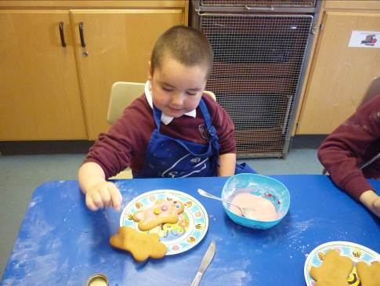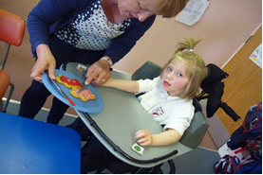

The senior management team of the Head Teacher and the Depute Head Teacher in the school, along with the Principal Teacher, ASN, work very well together in a mutually supportive way, constantly striving to improve and develop the curriculum provision in school for all pupils, providing appropriate staff development opportunities, and updating and improving resources within available budgets. There are very good opportunities for all staff to take leadership roles in the life and work of the school. For example, in the school garden three members of staff have supported pupils weekly in ‘The Spade Club’; a class teacher has conducted Bikeability Level 2 training; two class teachers ran a highly successful Young Engineers’ & Science Club; and three support staff members led the Running Club, preparing pupils for the Buckie ASG Cross-Country Championships and for the Moray Cross Country Championships. All these activities have provided pupils with the opportunities to develop their interests and skills and to excel in a range of ways, raising their self-esteem and self-confidence.

Continuous Improvement and the Work & Life of the School:
All members of the school staff team are dedicated to their work and are fully committed to continually improving the teaching and learning for, and the care and welfare of, all our pupils. Morale continues to be very high in the school. There is a very positive ethos and everyone works together in a mutually supportive manner. This is evident in our daily work, in conversations with staff, and is remarked on by staff members of outside agencies who come in to Millbank Primary to work with pupils.
This session, one of our main development areas was the compilation of a whole school programme for Religious Education which will be implemented as from August 2014. This programme meets fully the requirements of Curriculum for Excellence and will ensure a coherent, progressive, experience for our pupils in this area of the curriculum as they move through the school.

As stated in our School Strategic Improvement Plan, teachers have continued to implement the experiences and outcomes of Curriculum for Excellence through a range of interdisciplinary learning contexts. For example, the pupils in P2 thoroughly enjoyed the interdisciplinary learning context of ‘Farming’, at the end of which they held an open afternoon for parents/carers, their ‘Soup Kitchen’, when many of the skills they had been taught and had been practising were put to good use. This work was highly complemented by parents/carers as they enjoyed their afternoon with their children. The pupils of P5 and P5/6 presented their ‘Australia’ open afternoon for parents/carers who were delighted at how the pupils dressed up and offered a variety of informative and fun activities; also the pupils of P3 and P4 invited their parents/carers to their ‘Castles’ afternoon; the pupils of P6 and P7 presented an enjoyable session for their parents/carers based on their context on ‘Japan’; and the pupils of P1 organised a range of activities to involve parents/carers in their ‘The Garden Centre’ context. The pupils in the Nursery invited parents in to their Pancake Day celebrations. They also had fun with their parents and carers at their ‘Commonwealth Games’.

Increasingly more events and activities are being sought by teachers to give pupils the opportunities to plan by themselves, develop and practise a range of skills, transfer their learning between the various areas of the curriculum, and to involve parents/carers in their children’s learning in a practical and meaningful way, all of which results in improved outcomes for all children. Active learning is also experienced in a variety of ways by pupils in the Early, First and Second Levels: a range of critical skills’ challenges and homework challenges result in pupils being much more fully engaged with their learning, being more aware of reasons for their learning.

The Nursery pupils piloted the programme entitled ‘Grow Well Choices for Early Stages’ which highlighted Healthy Eating, the importance of exercise and fitness, and making positive health choices. This work has resulted in pupils becoming more aware of managing their own health at a very early age.

During their Primary 7 year, pupils are offered a number of opportunities and activities which help improve their self-discipline, social awareness and personal maturity. For example, extended transition opportunities were offered for Primary 7 pupils to Buckie High School. All Primary 7 pupils enjoyed the Buckie Thistle Community Alert Day when they had experiences of different sports and talks from different community groups who highlighted a range of important messages. A group of Primary 7 pupils benefitted greatly from their involvement in the ‘Keen Readers’ Group’ who met regularly with the Senior Librarian at Buckie High School to discuss their favourite reading materials.

As stated in our School Strategic Improvement Plan for this session, development work has focussed on developing the literacy programme throughout the school which included updating programmes for spelling, phonics, grammar, comprehension and personal writing in line with the requirements of Curriculum for Excellence. These programmes will be implemented as from August 2014, and it is anticipated that pupils’ abilities in these areas of literacy will be improved through more coherent and progressive provision. Regular monitoring of children’s progression in these areas will be undertaken and it is anticipated also that improvements in pupils’ assessment results will confirm this. Our work also included developing teacher training in Physical Education, in the curricular area of Health and Wellbeing. This allowed teachers to engage effectively in the programme ‘Better Movers and Thinkers’, helping pupils to become more aware of the connection between thinking and moving. We also further developed, for specific classes, the interdisciplinary learning context programme, ensuring appropriate coverage of Experiences and Outcomes for each level as stated in Curriculum for Excellence. For example, P5 pupils experienced a literacy based context entitled ‘Roald Dahl’, a science based context entitled, ‘Earth and Space’; a geography and social justice based context entitled ‘Australia’, a technology based context entitled ‘The Puppet Show’, and a Health and Wellbeing context entitled ‘Seafood Scotland’, which also incorporated a strong local element.

A programme such as this enables pupils to gain a wide field of knowledge, to learn, practise and apply a range of important skills, to build on previous learning, and to transfer their skills to other curricular areas when and where appropriate.

Members of our Support Staff attended training on the ‘Role of the Auxiliary’ during an In-Service Day and this has given them more confidence in their ability to carry out their work supporting pupils with their learning and welfare. During the May In-Service days teachers discussed the advice as stated in the HMIe document ‘School Inspections—Raised Expectations’ and this has informed them as to the higher standards expected of our provision.

In order to inform our parents / carers more effectively on the work and life of the school, we constructed a website for the school through which all stages were able to post blogs and photographs of their weekly class work and experiences. Our initial feedback from parents / carers has been very positive and they have enjoyed being informed about their children’s learning in an easily accessible manner.

Assessment of pupils’ work and tracking the progress of pupils as they move through the school continues to be a priority. This will be done, electronically where possible, by using data collected on pupils’ abilities in literacy and numeracy along with other sources of evidence, for example, the use of photographs and observation of pupils at work.

Teachers are keen to give pupils as many opportunities as possible to be engaged in and responsible for their own learning: through homework and critical skills challenges, through using the class blog to inform their parents/carers about what they have been learning, and how they have felt about it: and by personal learning planning through research projects in connection with class contexts for learning.
Pupils all enjoy using technology for enhancing their learning through interactive games, for research using the internet, and for communication in a variety of ways.
All members of staff will work hard to include all pupils in the life and work of the school as they are able and to ensure equality and fairness across our provision.
The Pupil Council, made up of two representatives from each year group, meets at least twice per term to discuss improvements suggested by their peers thus making the school a happier environment for learners.

Successes & Achievements:
Now that we are embedding the Experiences and Outcomes of the curricular areas of Curriculum for Excellence, we have statistical data which we have used to check on pupils' progress and to predict where pupils should be at specific times of the year. Using this data, along with teachers' professional judgements, we can state that almost all pupils are making the progress we would have expected them to during the session. Now, our emphasis is on providing a broad, progressive and coherent curriculum, where pupils have personalisation and choice, and challenge and enjoyment. Although a steady pace in teaching and learning is ensured, we must allow time for pupils to deepen their learning. This is now taking place in all our classes.

The following is a selection of our main successes and achievements from this session.
- We were delighted to have been awarded our second Green Flag in September 2013. The ECO Committee, with help from staff members and parents, have successfully maintained the ECO garden again this year.
- During the session we also achieved Gold Accreditation from the Royal Scottish Country Dancing Society with 14 pupils receiving their gold badges.
- A school team of 20 P4 to P7 pupils competed successfully in the Active Schools' Primary Cross Country Competition at Buckie High School. The team also took part the Buckie ASG Cross-Country Run at Portknockie with a first, a third, two fourths and a fifth place.
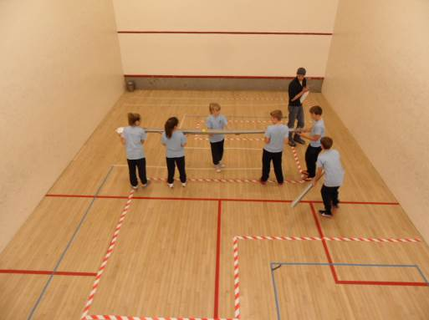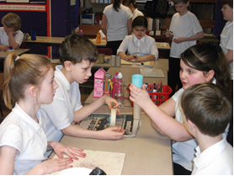
Pupils enjoying challenges at Gordonstoun and in P6

- In September, a team of six Primary 7 pupils came third in the Gordonstoun Primary School Challenge.
- In March, a team of 3 P7 pupils came second in the Enterprising Mathematics Challenge for Primary Schools in Moray.
- In June, a team of13 P5, P6 and P7 pupils took part in the Moray Primary Schools' Inter-School Sports at Elgin High School with 3 silver medals and 1 bronze medal being won.
- In February, 27 P7 pupils took part in the residential skiing trip to Abernethy which was thoroughly enjoyed by everyone and allowed pupils to experience a level of independence.
- A number of our pupils took part in the Buckie ASG Doric competition with one of our P6 pupils winning the overall trophy for best recitation.
- All pupils in the school and Nursery took part in successful potted sports' days during the last term, including a Commonwealth Games theme for the infant sports. Pupils in P1 to P3, and in P4 to P7, also enjoyed their competitive sports’ days which were deemed a great success and highlighted individual talents.
- The school was very well represented at the Moray Music Festival. Pupils participated in Scots Poetry, Action Songs, Scottish Country Dancing, recorder and violin solos.
- An extensive extra-curricular programme was well supported by pupils throughout the session: boys’ football, basketball, Bikeability Level 2, Scottish Country Dancing, Running Club, The Spade Club and Young Engineers' and Science Club.
- Two teams of Scottish Country Dancers took part in the Buckie ASG Scottish Ceilidh.
- All classes took part in the Carnival of Dance which was held in the school hall.
- Pupils took part in a number of fund-raising activities during the session such as, ‘Come as You Please’ days, and a Children's Sale for local charities; and enterprise activities, such as baking by the Nursery pupils, for the Christmas Fayre. The pupils of Primary 2 raised money for the Buckie Lifeboat at their Soup Kitchen for parents/carers.
- During the session, all classes in the school hosted an Open Afternoon for parents/ carers and friends.
- All pupils celebrated our Harvest Thanksgiving and donated a selection of fruit and flowers to the Old Peoples' Residences in Buckie.
- All pupils in the school took part in a St Andrew's Day special assembly when we had singing, poetry recitation, fiddle music, and Scottish Country Dancing from a large number of our pupils.
- Many class trips this session have been in connection with their class work. For example, the pupils of P3 and P4 visited Spynie Palace and Duffus Castle, near Elgin.
- Following six weeks of training, the Kwik Cricket team of 12 P6 pupils participated in the Buckie ASG Kwik Cricket Festival.
- Teams of P6 and P7 pupils took part in the Buckie ASG Rugby and Orienteering Festival.
- A group of P6 and P7 pupils successfully completed the Bikeability Training Scheme
- A team of 6 P6 and P7 pupils successfully represented the school at the Young Engineers' and Science Club showcase event at Eden Court Theatre, Inverness.
- A team of P6 and P7 pupils took part in the Buckie ASG Basketball tournament.
- Two classes enjoyed cooking sessions in the Cooking Bus facilitated by Tesco. They also experienced the Countryside Classroom on Wheels.
- A team of four P7 pupils participated in the Buckie Rotary Quiz.
- A number of our pupils took part in the Moray Schools’ Boccia Festival.

These events allowed pupils to show their strengths, talents and interests in a variety of curricular opportunities and they have been encouraged to do their best at all times during the session, fostering in them an 'I can …...' attitude.

We look forward to another successful session in 2014-2015.

