

Lossiemouth High School Modern Studies

National 5

Enquiry Skills Questions

The Decision-Making Question

Use the information in this booklet to help you answer the decision-making question in the exam.

Complete the practice questions as study and in your wider aspects classes to help you prepare for the prelim.

The Decision-Making Question

Need to Know:

In this question you need to choose an option to recommend and use the evidence provided to justify this recommendation.

For full marks you must also show why you rejected the other option.
To do this you must present arguments for the other option and provide a ‘counter point’ to these arguments.

It is worth 10 marks, on average you will gain 2 marks per paragraph, so should aim for 5 paragraphs.

If you successfully combine evidence from different sources and evaluate it well you could gain 3 marks for a paragraph.

How to approach this question:

- Read the sources and as you do so highlight whether they support option 1 or 2.

- Identify evidence that can be ‘linked’ by drawing lines between them.
  - You are looking for 3 linked pieces of evidence to create your 3 main arguments in support of your option.
  - You are also looking for 2 pieces of evidence that support that other option that you can link to evidence for your option that provides a linked counterpoint.

- Write up your answer.


How to write up your answer:

Your first sentence should state which option you are recommending.
Then follow the below structure.

Arguments in Support of your Option

In this section write 3 paragraphs to support your option. Each should contain:
- Reason – Your first sentence should provide a specific reason to support your option.
- Evidence – Then go on to quote your 2 pieces of evidence – remember to show the source you are using.
- Evaluation – this can be slotted in between your evidence or afterwards, but should be where you evaluate why the evidence supports your option.

Top Tip: You should be aware of how much ‘evaluation’ of the evidence you are doing. If you have 2 -3 pieces of evidence in a paragraph with clear evaluation you will be awarded 3 marks for it. If you do this in 2 of your support paragraphs you can skip the 3rd paragraph!

Sample answer (taken from the ‘Single Police Force’ question)

I have chosen option 1 because having one national headquarters would be more efficient (S1). 25% of the policing budget is spent on headquarters so combining these into one would result in savings from being able to share resources. (S2) Furthermore source 2 shows that Total savings after 5 years from doing this could be as much as £351,937,000. (2 marks)

I have also chosen option 1 because a single police force could result in better crime prevention. Source 1 says that ‘many people do not have full confidence in the policing of their local area’, if there was a single police force they could work together to reduce all levels of crime. Robbery and Housebreaking are crimes that are still rising, by 2% and 5% (S2), which shows that not all policing is currently effective so a single police force should be introduced. (3 marks)

Arguments to reject the other option

To do this you could EITHER use new evidence to criticise the other option, OR, you could recognise evidence that might support the other option and then explain why you don’t agree with this.

2 marks are available for each paragraph here. You can provide less evaluation of the evidence and focus instead on clear and concise paragraphs which link 2 pieces of evidence.

Sample Answer:

I did not choose the other option, because although Luke Robertson says that‘it is unfair that the regions of Scotland should have to contribute to big sporting events that take place in the central belt’ (S3) David Craig argues that ‘Scotland is a small country which could easily be policed by one force.’

I also reject option 2 to not have a single police force because there are currently big differences between Scotland’s eight forces and many have different resources available (s1). This is not fair, a single police force would make sure that more money could be spent on frontline services, and that they could be shared to response to large scale emergencies and terrorism more effectively.(S3)


In the exam you will need to answer ONE of this type of question. It could be in the context of any of the three units you have studied.

If it is in the third context ‘World Powers’ in which you have studied the USA you will find that the question might refer to an imaginary country/region. You still follow the same technique as above to answer it.

Practice Questions
Answer the below questions as part of your extra study and exam practice.
Use the checklist to tick off as you complete each one.
You should where possible do these in timed conditions.

Question | Study Theme | Complete | Time Taken | Marks | Feedback
1:  Rockford City | World Powers:  USA
2:  Inverdon | Democracy in Scotland
3: California | World Powers:  USA
4:  Gleninch | Democracy in Scotland
5:  Police powers to deal with terrorists | Crime and Law
6: Community Warden | Crime and Law

Question 1: Rockford City Study Theme: World Powers: USA

There are two Interest Groups hoping to represent Rockford City at a Presidential Conference on “Solving City Problems.” You have been asked to recommend which group would be most suitable to represent the city.

Option 1:
Interest Group A: Save our City
Option 2:
Interest Group B: Put People First

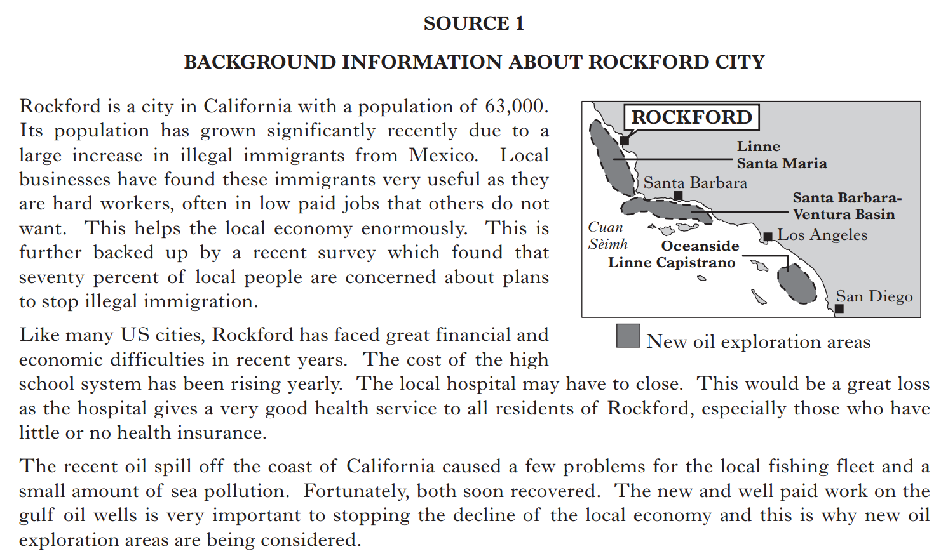
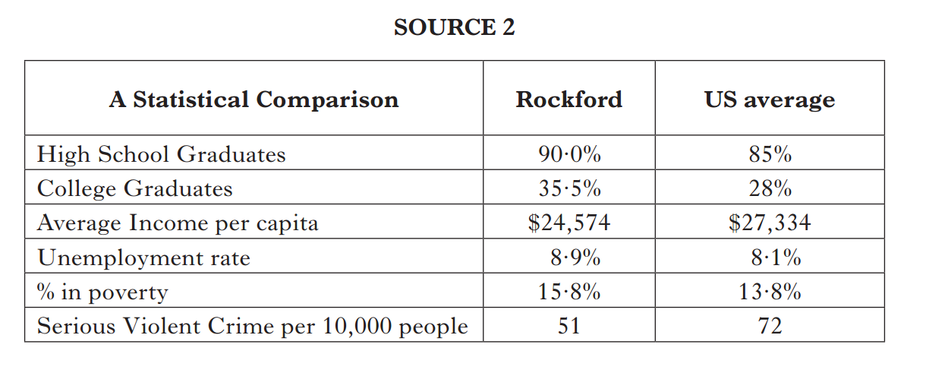

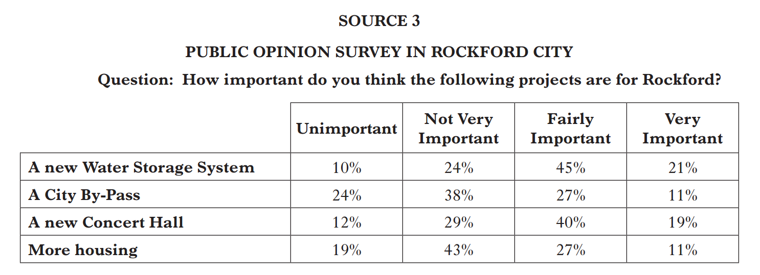


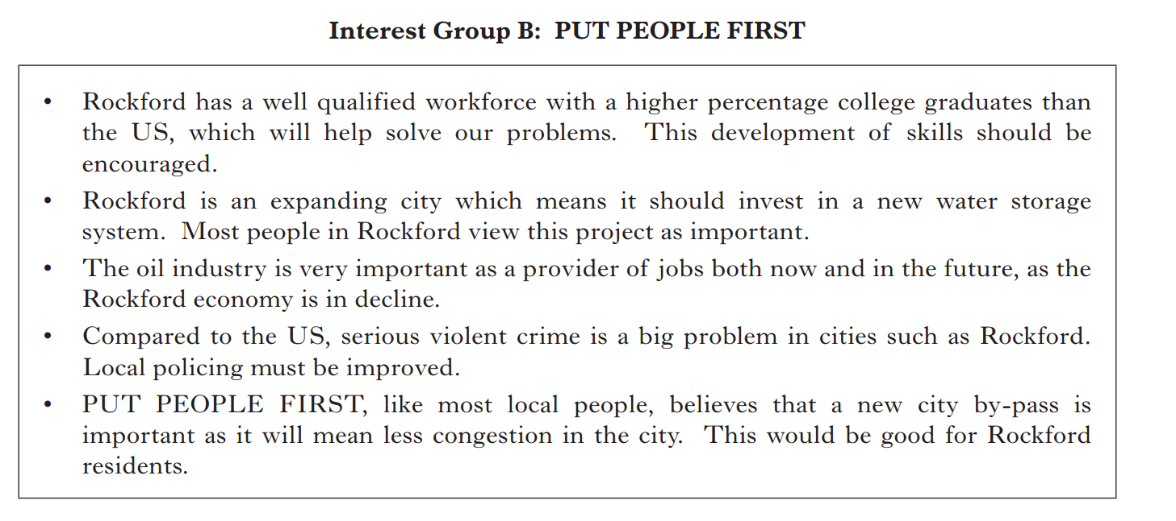
You must decide which option to recommend, either Interest Group A: Save Our City (Option 1)
or Interest Group B: Put People First (Option 2).

(i) Using Sources 1, 2 and 3 above and opposite, which option would you choose?
(ii) Give reasons to support your choice.
(iii) Explain why you did not choose the other option.

Your answer must be based on all three sources. 10
Question 2: Inverdon Study Theme: Democracy in Scotland

You have been asked to decide which candidate would make the best councillor for Inverdon.
Option 1:
Candidate A
Ian McKay
Option 2:
Candidate B
Sally Anderson

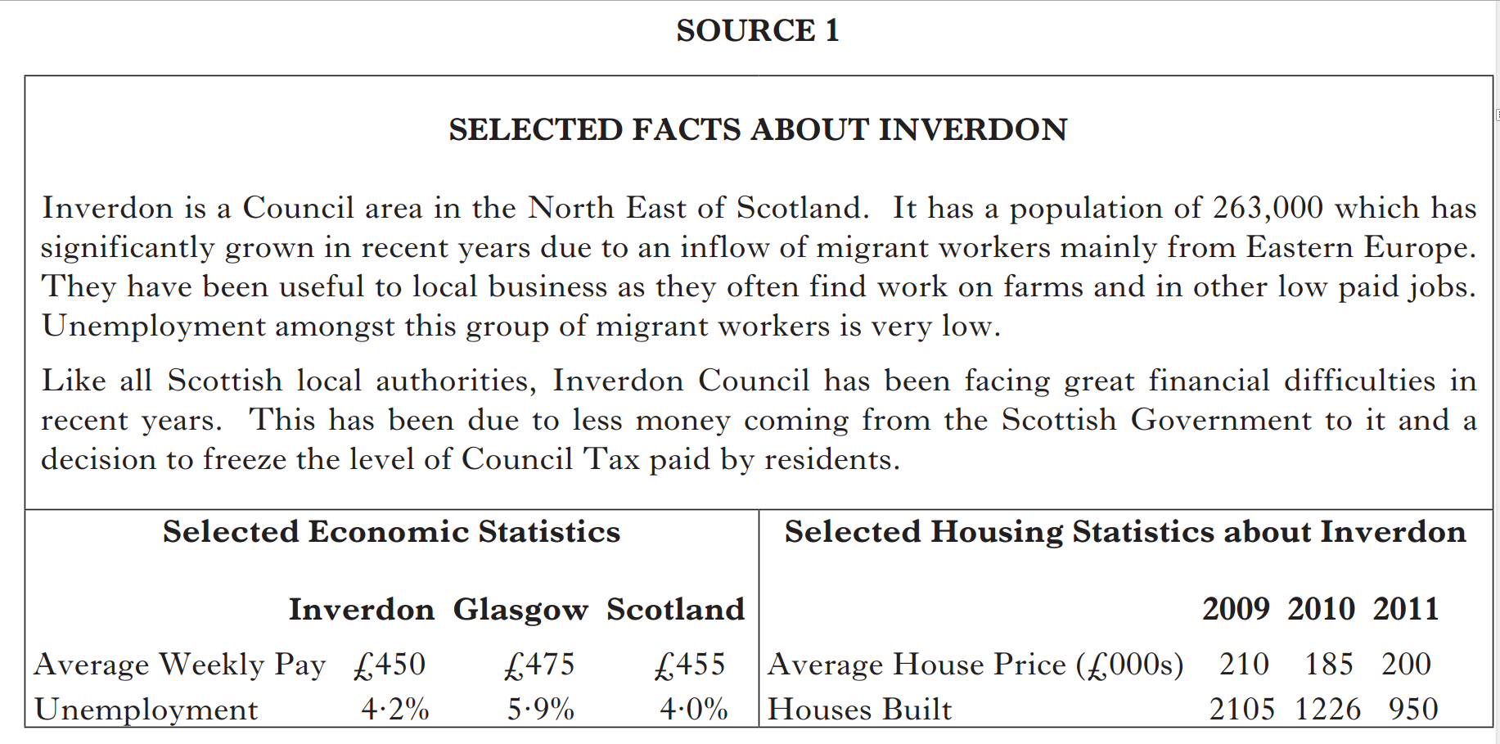



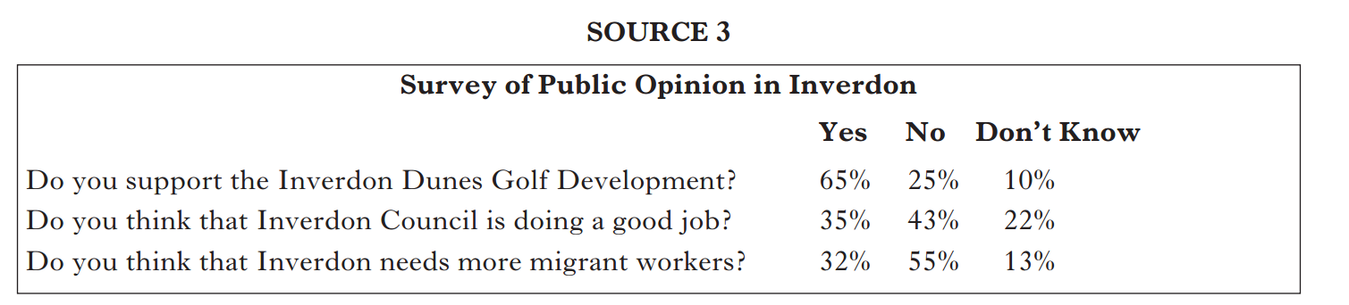

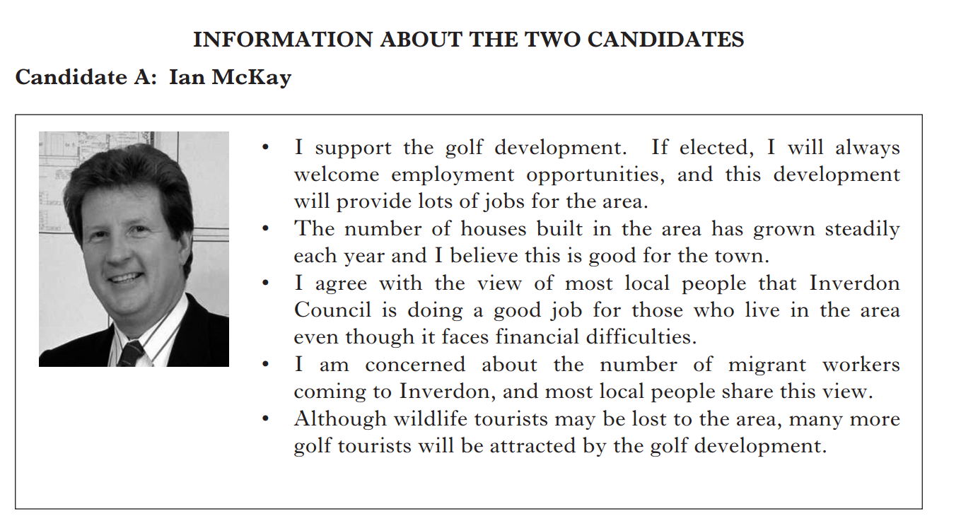


You must decide which option to recommend, either Candidate A: Ian McKay (Option 1)
or Candidate B: Sally Anderson (Option 2).

(i) Using Sources 1, 2 and 3 above and opposite, which option would you choose?
(ii) Give reasons to support your choice.
(iii) Explain why you did not choose the other option.

Your answer must be based on all three sources.

10
Question 3: The Illegal Immigration Debate Study Theme: World Powers

You have been asked to decide which candidate is more suitable to become Governor of California.
Study the information on The Illegal Immigration Debate and in Sources 1 and 2 to answer make your decision.
Option 2:
Peter Head
Option 1:
Corrine Padilla

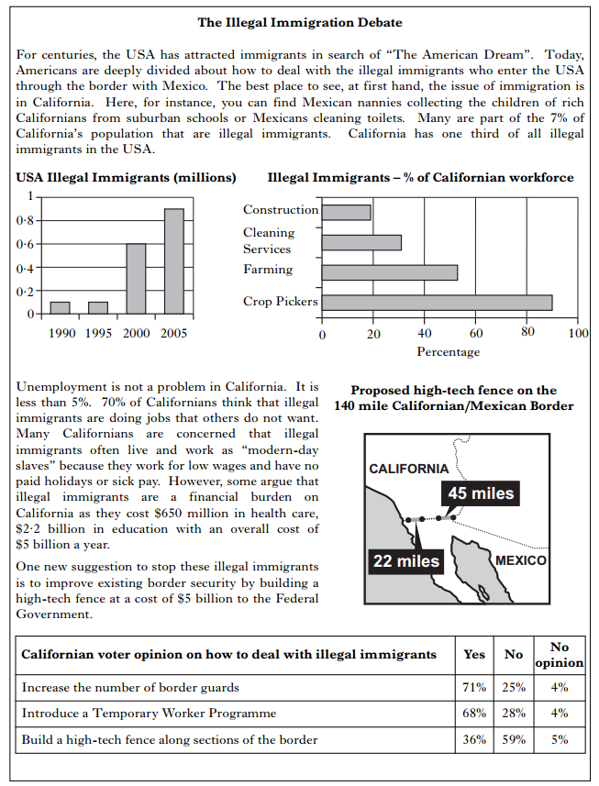


You must decide which option to recommend, either Corrine Padilla (Option 1)
or Peter Head (Option 2).

(i) Using Sources 1, 2 and 3 above and opposite, which option would you choose?
(ii) Give reasons to support your choice.
(iii) Explain why you did not choose the other option.

Your answer must be based on all three sources. 10

Question 4: Gleninch Study Theme: Democracy in Scotland
You have been asked to decide which person would be the more suitable to represent the Liberal Democrat Party as their candidate for the Gleninch constituency at the next General Election.
Option 1:
Kirsty Reid
Option 2:
Robbie McKay

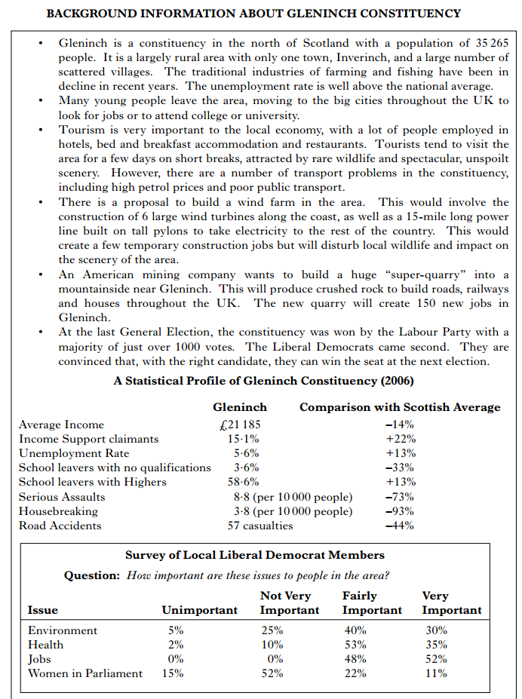

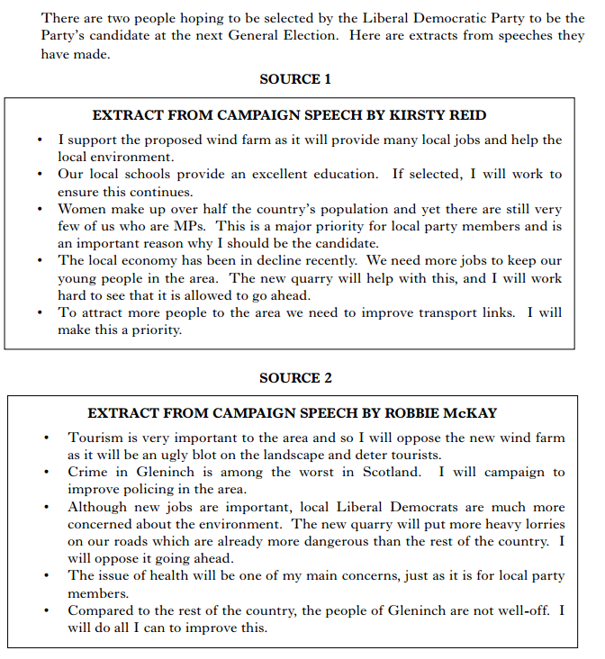

You must decide which option to recommend, either Kirsty Reid (Option 1)
or Robbie McKay (Option 2).

(i) Using Sources 1, 2 and 3 above and opposite, which option would you choose?
(ii) Give reasons to support your choice.
(iii) Explain why you did not choose the other option.

Your answer must be based on all sources. 10

Question 5: Detaining Terrorist Suspects Study Theme: Crime and Law

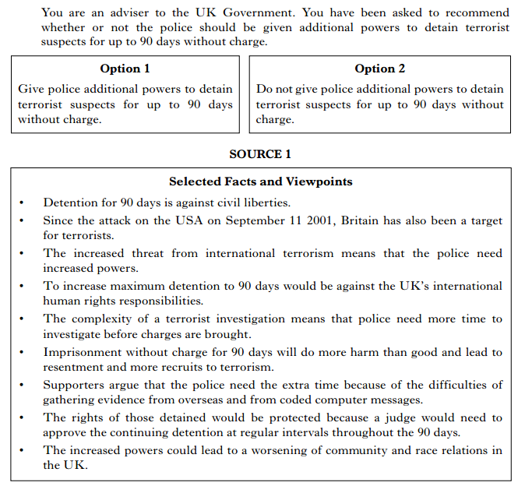

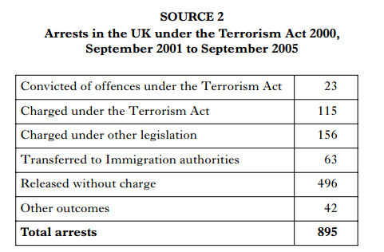

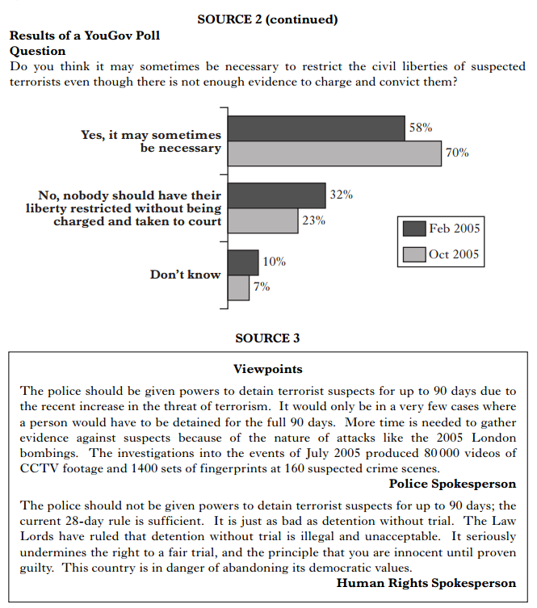

You must decide which option to recommend, either to give police additional powers to detain terrorist suspects for up to 90 days without charge (Option 1) or do not give police additional powers. (Option 2).

(i) Using Sources 1, 2 and 3 above and opposite, which option would you choose?
(ii) Give reasons to support your choice.
(iii) Explain why you did not choose the other option.

Your answer must be based on all sources. 10

Question 6: Community Wardens Study Theme: Crime and Law

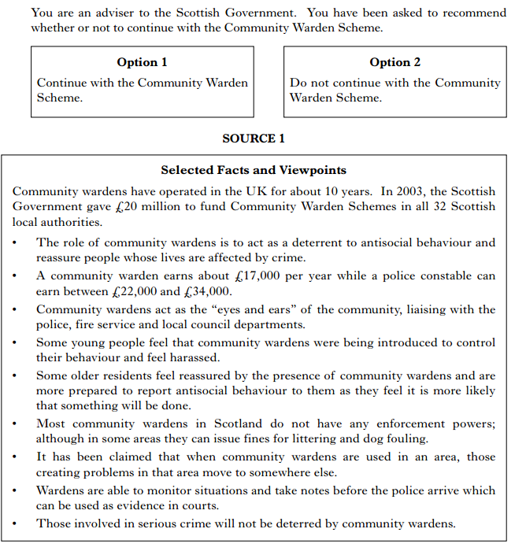
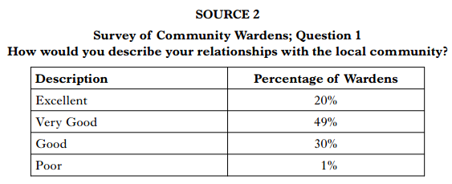

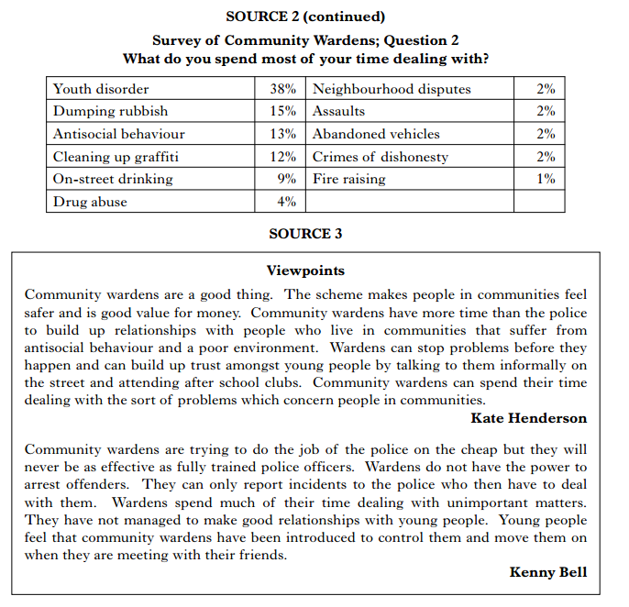

You must decide which option to recommend to the Scottish Government, either continue with the Community Warden Scheme (option 1) or do not continue with the Community Warden Scheme (option 2).

(i) Using Sources 1, 2 and 3 above and opposite, which option would you choose?
(ii) Give reasons to support your choice.
(iii) Explain why you did not choose the other option.

Your answer must be based on all sources. 10

