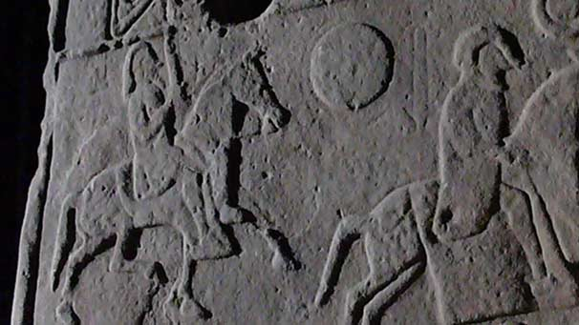
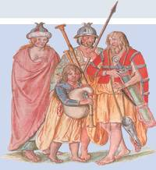


THE ANGLES
THE GAELS

LOCATION:
Dawstane near Liddesdale
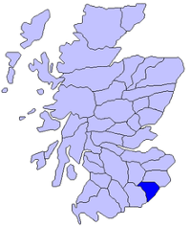
The Battle of Degsastan was fought in c. 603 between the Angles and the Gaels. The Angles were led by King Æthelfrith, while the Gaels were led by Áedán mac Gabráin, King of Dál Riada.
Account by Bede in his Historia ecclesiastica gentis Anglorum Book I, chapter 34:

Æthelfrith had won many victories against the Britons and was expanding his power and territory, and this concerned Áedán, who led "an immense and mighty army" against Æthelfrith. Although Æthelfrith had the smaller army, almost all of Áedán's army was slain, and Áedán himself fled.

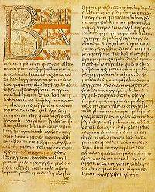
Áedán's army included some Angles (at this time sometimes known as Bernicians) who had been exiled. Despite this it was the Angles who were victorious. Æthelfrith won a decisive victory, although his brother Theodbald was killed in battle.
Áedán survived as King of Dál Riata until 608 when he was succeeded by his youngest son Eochaid Buide. Æthelfrith died in battle in 616.

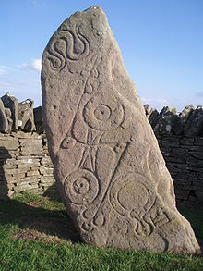

THE PICTS
THE ANGLES

LOCATION:
Dunnichen, Angus OR
Dunachton, Badenoch
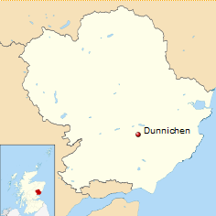
The Battle of Nechtansmere or Dun Nechtain was a battle between the Picts, led by King Bridei Mac Bili and the Angles led by King Ecgfrith in 685.
The Angles control over Northern Britain was beginning to crumble and lots of battles against groups including the Picts, Mercians and Irish were fought. Following sieges by the Picts, Ecgfrith decided to lead his armies against them. He had been advised not to, but did so anyway in an attempt to reassert his dominance over the Pictish nations.

Bede's account of battle from his Ecclesiastical History of England:
"[T]he very next year [685AD], that same king [Egfrid], rashly leading his army to ravage the province of the Picts, much against the advice of his friends...the enemy made show as if they fled, and the king was drawn into the straits of inaccessible mountains, and slain with the greatest part of his forces, on the 20th of May, in the fortieth year of his age, and the fifteenth of his reign."

The Picts tricked the Angles by pretending to retreat and then ambushing them at Dun Nechtain near the lake of Linn Garan. The battle ended in a Pictish victory, which severely weakened the Angles’ power in northern Britain. Ecgfrith was killed in battle along with a large part of his army.

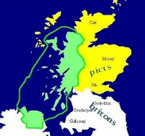
THE PICTS &
ANGLES

THE BRITONS

LOCATION: Dumbarton
In the Dark Ages, the Kingdom of Strathclyde, home to the Britons, had Dumbarton as its capital. “Dun Breatann” or Dumbarton means fortess of the Britons. It is also known as “Alcluith”, meaning Clyde Rock. The Kingdom of Strathclyde spread south from the River Clyde to cover much of the south west of Scotland.
In 756 AD the Picts, with the help of the Angles, attempted to defeat and subdue the Britons. However, after forcing the Britons to accept terms on August 1, the Picts and Angles alliance suffered defeat nine days later in unexplained circumstances, possibly due to a trick by the Britons, and was forced to retreat.
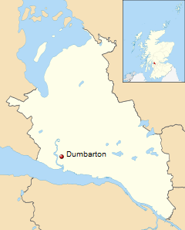

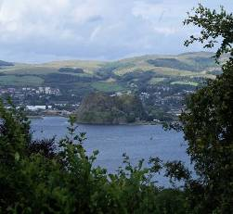
Historian, Forsyth writes:
In the year of the Lord's incarnation 756, king Eadberht in the eighteenth year of his reign, and Unust, king of Picts led armies to the town of Dumbarton. And hence the Britons accepted terms there, on the first day of the month of August. But on the tenth day of the same month perished almost the whole army which he led from Ouania to Niwanbirig.

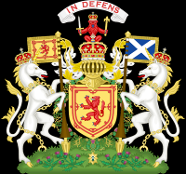
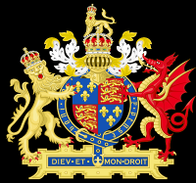

KINGDOM OF SCOTLAND
THE ANGLES OF NORTHUMBRIA

LOCATION: River Tweed
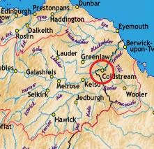
The area north of the Clyde and Forth, ruled by the Picts and the Scots, had been united under Kenneth MacAlpin in 843 AD. The area of Strathclyde was still ruled by the Britons until 1100, while the Lothians and Borders were ruled by the Angles until the Battle of Carham in c. 1018.

The Battle of Carham, sometimes known as the Battle of Coldstream was a battle between the Kingdom of Scotland and the Angles of Northumbria.

Symeon of Durham, in the 'Historia Regum' (History of the Kings) entry for 1018, writes:
"A great battle between the Scots and Angles was fought at Carrum [Carham] between Huctred [Uhtred], son of Waldef [Waltheof], earl of the Northumbrians, and Malcolm [Malcolm II], son of Cyneth [Kenneth II], king of the Scots, with whom there was in the battle Eugenius [Owen] the Bald, king of the men of Clyde [Strathclyde]."

The battle was a Scottish victory for Malcolm II and his ally, Owain the Bald. The Battle of Carham helped to secure the Scots ownership of the Lothians. Some say that the Lothians were not won in 1018, but had been given to King Kenneth MacAlpin in 973 by Edgar, King of England. Either way Lothian was recognised as an area of Scotland by King Canute of England, Denmark and Norway in 1029.

