Wemyss Bay Primary School & Nursery Class
Anti Bullying Policy
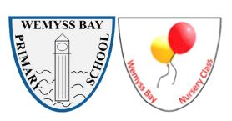
May 2026
Created: May 2026 in consultation with pupils, parents and partners
Updated: August 2026 to include next review date

Review: May 2029 or sooner, if required

Contents

- Introduction

- Definition of Bullying Behaviour – Respect Me (2024), adopted by Inverclyde Council
  - What Bullying Is
  - What Bullying Is Not
  - Differentiating Bullying from Potentially Criminal Behaviours

- Inverclyde’s Stance, Scope and Aims of the Council Policy

- Preventing Bullying and Positive Ethos

- Children’s Rights and Equality Duties

- Roles and Responsibilities

- Respectful Behaviour

- Labelling

- Reporting, Recording and Investigating

- Our Pupil Anti Bullying Charter

- Supporting Children

- Monitoring, Evaluation and Training

- Related Policies

- Appendices
  - Reporting and Response Flowchart
  - Prejudice-Based Bullying Examples
  - Useful contacts and resources

1. Introduction

This Anti-Bullying Policy has been developed using the Inverclyde Education Service Anti-Bullying Policy (2025) and the national guidance Respect for All (2024). Inverclyde Council is committed to embed trauma informed and responsive practices, which builds on a long history of supporting relationally based approaches within the local authority. This is the wider context within which Inverclyde’s strategy for anti-bullying exists.
At Wemyss Bay Primary and Nursery Class, we believe that every child has the right to feel safe, respected, and included at all times. We are committed to providing a safe, inclusive, and nurturing environment for all. Our school values Kindness, Respect, Equity, and Ambition underpin everything we do and guide how we treat one another.

This policy reflects the principles of Getting It Right For Every Child (GIRFEC), the United Nations Convention on the Rights of the Child (UNCRC), The Equality Act 2010 and Curriculum for Excellence. It aims to ensure all children feel safe, respected and included.

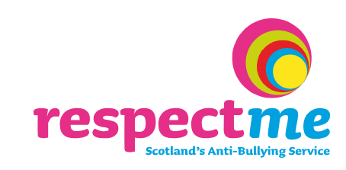
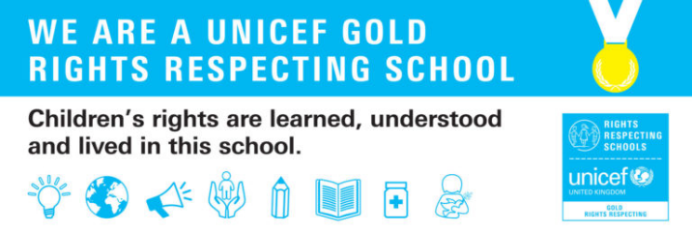
2. The agreed national definition of Bullying Behaviour as set out in ‘Respect for all’ – adopted by Inverclyde Council

Inverclyde Council considers that bullying should never be viewed as a normal or inevitable part of growing up. Adults are not expected to be the subject of abuse by colleagues or friends; therefore, it should not be any different for children and young people.

Inverclyde has adopted the national definition of bullying, as set out in Respect for All (2024), which is laid out below:

“Bullying is face-to-face and/or online behaviour which impacts on a person’s sense of physical and emotional safety, their capacity to feel in control of their life and their ability to respond effectively to the situation they are in.”

“The behaviour does not need to be repeated, or intended to cause harm, for it to have an impact. Bullying behaviour can be physical, emotional or verbal and can cause people to feel hurt, threatened, frightened and left out.”

Examples of bullying behaviour in a school setting include (Respect for All, 2024):
- Being called names, teased, put down or threatened (face to face and/or online).
- Being hit, tripped, pushed or kicked.
- Having belongings taken or damaged.
- Being ignored, left out or having rumours spread about you (face-to-face and/or online).
- Sending abusive messages, pictures or images on social media, online gaming platforms or phones/tablets.
- Behaviour which makes people feel like they are not in control of themselves or their lives (face-to-face and/or online).
- Being targeted because of who you are or who you are perceived to be (face to face and/or online).
- Increasing the reach and impact of bullying or prejudice through the recruitment and/or involvement of a wider group.

What bullying is not.
It is important to distinguish between bullying and other types of behaviour. Not all conflict should be viewed as bullying. As children and young people grow and build relationships, it is natural for them to experience disagreements, fall-outs, and misunderstandings. At times, they may say or do things without intending to cause harm. These experiences are a normal part of development and are not regarded as bullying. While such situations may still require adult guidance and support, they are addressed in different ways.

Disagreements can occur within healthy, respectful, and balanced relationships. In these situations, those involved will often want to resolve the issue and may take steps to put things right. This kind of conflict is different from bullying and is unlikely to develop into it, as individuals usually value the relationship and want to restore a sense of fairness and connection. It is important to support children and young people in expressing their feelings and to help them build the communication and social skills needed to manage relationships and resolve conflicts in a positive way.

Examples of behaviour that would not be considered bullying include:
- Friends having an argument or disagreement but later make up.
- A single incident where someone says something unkind in the heat of the moment.
- Rough play, where all participants are enjoying themselves and no one is hurt, upset, or left out.

All concerns are taken seriously; however, responses will vary depending on whether the situation involves bullying, conflict, or another welfare issue.

Differentiating Bullying from Potentially Criminal Behaviours
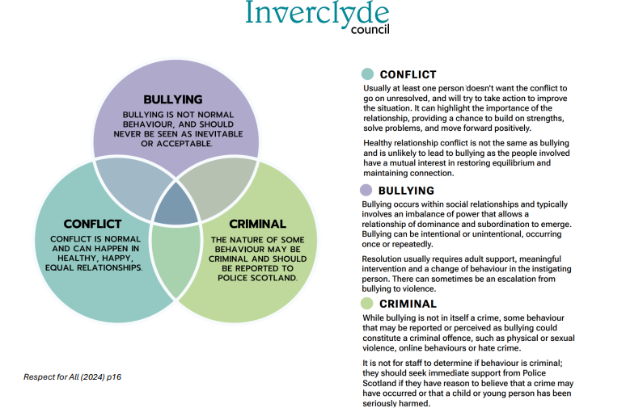
Certain behaviours that could be perceived as, or reported as, bullying may include behaviour that is criminal in nature. Criminal behaviour such as assault, theft, or harassment is not bullying - it may require police involvement. It is important to consider the individual facts of each situation to distinguish between bullying and behaviour that may require a legal response. A few further examples are noted below.

Sexual behaviour: when someone is coerced or pressurised to do something sexual or is touched inappropriately, this is not bullying. This is sexual assault or abuse and a form of gender-based violence (GBV).

Online behaviour: there are various legal provisions designed to protect individuals from online harassment, abuse, and harm. Some online behaviour may therefore be illegal

Hate Crime: bullying can be motivated by prejudice similar to hate crime. The distinction between bullying and hate crime is that for hate crime, the behaviour aggravated by prejudice must be motivated by malice and ill-will towards a group of people due to a relevant characteristic or intended to stir up hatred, and be criminal in nature, such as assault, graffiti or a breach of the peace.

3. Inverclyde’s Stance, Scope and Aims of the Council Policy

Inverclyde Council considers bullying behaviour in its schools to be unacceptable in all circumstances. All children and young people have the right to access learning environments in which they feel safe and free from all forms of abuse, bullying or discrimination. It has been recognised that the most effective intervention in tackling the issue of bullying behaviour is prevention. Resultingly, the importance of prevention will form a key strand that will be threaded throughout this policy. The policy also recognises that bullying behaviour is a violation of rights as set out in the United Nations Convention on the Rights of the Child, notably Articles 3, 12, 13, 19, 29 and 39.

The 2025 version of Inverclyde’s Anti-Bullying policy applies to Inverclyde’s schools; however, it does not apply to early years establishments. It is recognised that early years establishments play a significant role in creating the building blocks of the preventative approaches required irrespective of an anti-bullying strategy through their work on social skill-building around compromise, sharing, taking turns and showing respect. It is, however, not considered helpful to introduce bullying as a concept in the early years.

Our goal at Wemyss Bay Primary School and Nursery Class is to ensure that every child and family understands what bullying is, how it is addressed in our school, and what support is available. We want children to feel confident in speaking out, staff to feel empowered to take action, and parents to feel reassured that any concerns about bullying will always be taken seriously.

We are also committed to achieving the goals of The Promise. This is an agenda that emphasises Scotland’s ambition and commitment to ensure that care experienced children and young people children grow up loved, safe and respected so that they realise their full potential.

4. Preventing Bullying and Positive Ethos

Prevention is the most effective intervention when it comes to bullying and is supported by the development of inclusive learning environments. At Wemyss Bay Primary School and Nursery Class we aim to create an ethos where kindness, respect and inclusion are the norm. In order to support this, we:
- Teach respect and empathy through our Health and Wellbeing curriculum, including RSHP
- Host whole school assemblies and class discussion/activities about kindness, diversity, celebrating differences and safety
- Embed our school values in our practice to allow children to see these in action
- Use restorative conversations to support children to resolve disagreements
- Participate in anti-bullying events and campaigns
- Encourage learner participation through buddy systems, peer mediation and pupil leadership opportunities
- Ensure every child has trusted adults in school and nursery who they know will listen to them
- Work with families to reinforce positive behaviour and respectful relationships
At Wemyss Bay Primary School and Nursery Class, we take a restorative approach to relationships and behaviour. This means that when something goes wrong, we focus on repairing the harm, rebuilding trust, and helping children learn for the future.
Restorative practice involves:
- Giving everyone involved the chance to share what happened, how they felt, and what the impact was.
- Encouraging children to listen to one another’s point of view.
- Supporting children to recognise the consequences of their behaviour.
- Agreeing on actions to put things right and prevent the behaviour happening again.
This approach is not about ignoring harmful behaviour or avoiding consequences. It is about ensuring that consequences are meaningful, fair, and lead to positive change. Children are held accountable for their actions, but in a way that helps them learn and grow.
Why we use this approach
We adopt restorative practice because:
- It helps children develop empathy, problem-solving, and conflict resolution skills.
- It reduces repeated incidents of bullying and poor behaviour by addressing the root causes.
- It helps relationships recover rather than break down completely.
- It keeps children included in the community, rather than pushing them out.
- It matches our values as a Rights Respecting School, where every child’s voice matters.
Sometimes children may hear from adults that if someone hits you, you should hit back. In Wemyss Bay Primary School and Nursery Class, we do not encourage this approach. Retaliation usually makes the situation worse, leading to further conflict, injuries, or blame on both sides.
Instead, we teach children to:
- Seek help from a trusted adult immediately.
- Use their words to express how they feel, rather than using physical actions.
- Trust that adults in the school or nursery will listen and act to keep them safe.
We ask parents and carers to support this approach at home, so that children receive a clear and consistent message. By working together, we can show children that problems are best solved through communication, respect and repair - not by fighting back.

5. Children’s Rights and Equality Duties
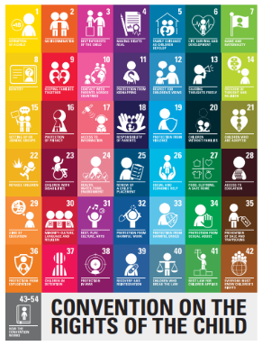
The United Nations Convention on the Rights of the Child (UNCRC) is an international treaty that protects children and young people’s rights. It is based on equality, dignity, respect, protection, development and participation. The UNCRC is now enacted in Scots’ Law. Inverclyde Council considers bullying behaviour to be a violation of children’s rights and to be incompatible with the UNCRC.

Our policy is grounded in Children’s Rights from the UNCRC. We particularly focus on:

- Article 2: All children have the right not to be discriminated against.
- Article 12: All children have the right to be listened to and taken seriously.
- Article 13: All children have the Right to freedom of expression.
- Article 19: All children have the right to be safe from violence and harm.
- Article 28 and 29: All children have the right to education in a safe and respectful environment.
- Article 39: All children have the right to help when inappropriately treated.

We also follow the Equality Act 2010. This means we actively prevent bullying and discrimination based on age, disability, gender, race, religion or belief, sexual orientation, or gender reassignment. We also recognise that bullying can occur because of poverty, body image, or being care experienced.

Our policy recognises the equality duties that are placed on Inverclyde Council. The Public Sector Equality Duty (PSED) in the Equality Act (2010) requires organisations such as schools, to have due regard to the need to eliminate unlawful discrimination, advance equality of opportunity and foster good relations in the exercise of those functions. As a result of this staff at Wemyss Bay Primary School and Nursery Class are aware of the ‘Protected Characteristics’ set out in law and, through their actions, seek to eliminate unlawful discrimination and advance equality of opportunity.
These Protected Characteristics are as follows:
- age
- disability
- gender reassignment
- marriage and civil partnership
- pregnancy and maternity
- race
- religion or belief
- sex
- sexual orientation

As well as these characteristics, we do not condone bullying behaviour against people for the following reasons that are not covered by equalities legislation, which is in line with Respect for All (2024):
- Additional support needs
- Asylum seekers and refugees
- Body image and physical appearance
- Care experienced children and young people
- Family and household circumstances
- Family imprisonment
- Forces children
- Mental health stigma and discrimination
- Sectarianism
- Socio-economic/poverty prejudice
- Young carers

6. Roles and Responsibilities

We believe everyone in our school and nursery community has a role to play in preventing and addressing bullying behaviours.

Children will:
- Treat others with kindness and respect in the classroom, playground, nursery, and online.
- Speak to a trusted adult if they are worried about bullying or if they see bullying behaviours.
- Know that Wemyss Bay has an anti-bullying policy and that pupil voice was involved in creating the policy.
- Have an understanding that bullying behaviour is a violation of children’s rights.
- Support their peers by including them in games and standing up against unkind behaviour.
- Take part in restorative conversations to help repair relationships when things go wrong.
- Represent their peers through groups like the Peer Mediators, Play Leaders and Rights Respecting Schools, helping to promote respect across the school.
Parents and Carers will:
- Contact the school quickly if they are concerned about bullying.
- Encourage their child to talk openly about their feelings and experiences.
- Be a role model by demonstrating respect and positive, respectful relationships in their own interactions with children, staff, and other families.
- Work with staff to follow agreed processes and solutions.
- Avoid discussing incidents on social media, and instead raise concerns directly with the school.
- Support our restorative approach by encouraging children not to retaliate but to seek adult help.
Staff and volunteers will:
- Know and use this policy consistently in their daily work and know to refer to Inverclyde Council’s policy in addition to this.
- Take all reports seriously, whether they come from a child, parent, or colleague.
- Notice signs of distress or changes in behaviour that may suggest bullying.
- Respond quickly and sensitively to concerns, reassuring children that they will be supported.
- Record all incidents accurately and confidentially.
- Use restorative approaches to help children learn and repair harm.
- Role model respect and inclusion in all their interactions with children and adults.
School Leaders will:
- Ensure this policy is put into practice across the school and nursery.
- Provide staff with training, resources, and support on anti-bullying and restorative practice.
- Monitor records in SEEMIS to identify patterns and trends.
- Ensure parents are informed and involved in investigations and outcomes.
- Consult with pupils, parents/ carers and staff as part of regular policy reviews.

Inverclyde Council and Education Services
Although this is a school level policy, we are supported by Inverclyde Council and Education Services who:
- Provide the overarching Inverclyde Anti-Bullying Policy as a framework for schools.
- Offer professional learning opportunities and resources for staff.
- Analyse SEEMIS data at authority level to monitor trends.
- Support schools where complex or persistent bullying concerns arise.
- Ensure that anti-bullying work links with wider strategies for inclusion, wellbeing, and equalities.

Partner Agencies
Sometimes it is important to work with partner agencies, such as:
- Police Scotland - if behaviour may be criminal or if children are at risk of harm.
- Health professionals - to support children whose wellbeing or mental health has been affected.
- Third sector organisations - such as charities that support children experiencing prejudice or bullying.

7. Respectful Behaviour
At Wemyss Bay Primary School and Nursery Class we strive to create an ethos that is warm and welcoming to all. There is a strong commitment from all staff to ensure positive relationships are at the heart of what we do. Positive role modelling from key adults is central to our approaches. This is encouraged and is part of the Standard for Registration as a teacher in Scotland.
The General Teaching Council for Scotland emphasises teachers should:
- Promote health and wellbeing of self, colleagues and the children and young people in their care.
- Build and foster positive relationships in their learning community that are respectful of individuals.
- Respect the rights of all learners as outlined in the United Nations Convention on the Rights of the Child (UNCRC) and their entitlement to be included in decisions regarding their learning experiences and have all aspects of their wellbeing developed and supported.
- Commit to social justice through fair, transparent, inclusive, and sustainable policies and practices in relation to protected characteristics, (age, disability, gender reassignment, marriage and civil partnership, pregnancy and maternity, race, religion and belief, sex, sexual orientation) and intersectionality.
- Value and respect social, ecological, cultural, religious, and racial diversity and promote the principles and practices of sustainable development and local and global citizenship for all learners.
- Demonstrate a commitment to motivating, and including all learners, understanding the influence of gender, social, cultural, racial, ethnic, religious and economic backgrounds on experiences of learning, taking account of specific learning needs and seeking to reduce barriers to learning.
- Demonstrate a commitment to supporting learners who are experiencing or who have experienced trauma, children and young people from a care experienced background and understanding responsibilities as a corporate parent.
- Understand and challenge discrimination in all its forms, particularly that which is defined by the Equality Act 2010.
Adapted from Respect for All (2024)

8. Labelling

Labelling children as ‘bullies’ or ‘victims’ or ‘perpetrators’ is disempowering and is unhelpful in supporting children to change their behaviour, or to recover from the impacts of bullying.
When discussing bullying behaviours, adults will focus on the behaviour itself and the impact it has had, rather than applying labels. This will assist children’s understanding of their behaviour and impact and help to understand what is expected from them. This is used as part of our restorative approaches.
When adults record incidents on SEEMIS, they will avoid labelling language and focus on behaviours and impact.

9. Reporting, Recording and Investigating

In Wemyss Bay Primary and Nursery Class, we want children, parents/carers, and staff to feel confident that any concerns about bullying will be taken seriously and acted upon. Clear procedures help everyone know what to expect and ensure consistency across our school. Records are handled in line with data protection law. We keep information confidential and share it only with staff and partners who need it to support the children involved.

Reporting bullying
Bullying can be reported in several ways:
- Children can tell any trusted adult in school or nursery - their class teacher, PSA, or nursery key worker.
- Children can also use worry boxes in classrooms.
- Parents and carers can contact the school by phone, email, or in person.
We encourage children to report concerns as soon as possible. All staff are trained to respond calmly, listen carefully and reassure children that they will be supported.
Recording bullying
All concerns and incidents are recorded so that we can track patterns and ensure appropriate action.
- Staff record incidents in SEEMIS, using the Bullying and Equalities system for recording incidents.
- For nursery and other situations where SEEMIS is not used directly, records are kept in the school’s bullying log.
- Prejudice based incidents are specifically recorded so that the school and Inverclyde Council can monitor trends.
- Confidentiality is respected, but relevant staff are informed so they can support the children involved.
- Consideration is given of any personal or additional support needs and wellbeing concerns when incidents are recorded.
- Actions, including resolution, are recorded as part of the incident.
Investigating bullying
Investigations are led by the Head Teacher or Depute Head Teacher. The process is as follows:
- Initial concern logged – the member of staff who hears the concern makes an immediate note and informs the HT/DHT.
- Gathering information – the HT/DHT speaks separately with the child who reported the bullying behaviours, the child experiencing bullying behaviours, and the child/children whose behaviour caused harm.
- Speaking with witnesses – if others saw what happened, their accounts are also gathered.
- Collecting evidence – where online behaviour is involved, screenshots or messages may be gathered with parental support.
- Communication with parents – parents of all children involved are informed that the school is investigating.
- Assessment – the HT/DHT decides whether the behaviour meets the definition of bullying, conflict, or another concern, and records this appropriately.
- Agreeing actions – steps are agreed to support the child impacted and to address the behaviour of the child who caused harm.
- Restorative meeting – where appropriate, a restorative conversation is held to repair relationships.
- Follow-up – staff check in with the children involved regularly, and the HT/DHT reviews progress.
Timescales
- Investigations normally begin within 24 hours of the concern being raised.
- Parents are informed within the first few days.
- Investigations are usually completed within 5 school days.
- Follow-up checks are made after 2 weeks, 1 month, and 3 months to ensure the situation has improved.
Escalation
If bullying concerns are not resolved or if the behaviour is persistent, the school may:
- Arrange further meetings with parents to review support.
- Involve partner agencies (such as Educational Psychology, CLD, or Police Scotland).
- Seek support from Inverclyde Education Services for complex cases.
This clear process helps ensure that bullying is always taken seriously, recorded consistently and addressed quickly. If a parent or carer remains dissatisfied after the school’s investigation and follow-up, they may raise a complaint via the school’s complaints procedure or Inverclyde Council’s complaints process

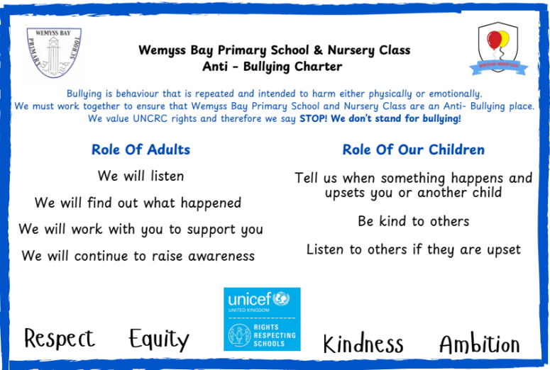
- Our Pupil Anti-Bullying Charter
At Wemyss Bay Primary and Nursery, pupils have worked together to create a child friendly Anti-Bullying Charter. This helps everyone understand their responsibilities and the actions we can all take to keep our school safe and welcoming.
*This requires to be reviewed in line with the refreshed council and school policy.
Why do we have this charter?
We know that bullying behaviour can take many forms. At Wemyss Bay Primary School and Nursery Class we want everyone to feel safe, included, and nurtured. It is the responsibility of us all to make sure that no one is being harmed by bullying behaviours.
We will make sure that we:
- Check in on our friends to make sure they are okay.
- Listen when someone has something to say.
- Take responsibility for our actions.
- Be respectful to everyone.
We understand that bullying is when someone does something unkind on purpose.
If we see bullying behaviours happening, we will report it. We will tell a teacher or a trusted adult and show kindness to the person affected.

- Supporting Children

We know that bullying can have a serious impact on a child’s wellbeing, learning, and relationships. At Wemyss Bay Primary School and Nursery Class, we are committed to supporting all children involved in a bullying incident - both the child who has experienced bullying and the child whose behaviour has caused harm. Our approach is always restorative, rights-based and solution-focused.

Support for children who experience bullying
When a child reports bullying, we will:
- Listen carefully to what they say and reassure them that it will be taken seriously.
- Contact parents or carers promptly so that they are fully informed and can work with us on next steps.
- Make sure the child feels safe in school or nursery, for example by providing increased supervision, a buddy system, or changes to seating or groups.
- Keep in regular contact with them to check how things are going and whether the bullying has stopped.
- Provide access to additional wellbeing supports if needed, such pastoral care or a referrals to specialist services.
- Celebrate the child’s strengths and successes to help rebuild their confidence.

Support for children whose behaviour has caused harm
We also recognise that children who display bullying behaviour often need help to understand and change their actions. When this happens, we will:
- Hold restorative conversations to help them reflect on the impact of their behaviour and agree positive next steps.
- Record the agreed actions in the class restorative discussion logbook, so that there is a clear record of what has been decided.
- Arrange a follow up meeting within an agreed timeline (usually within two weeks) so that children can check whether actions have been followed and relationships are improving.
- Support them to develop empathy and social skills.
- Provide mentoring or targeted interventions if needed (for example, nurture strategies).
- Involve parents and carers to ensure consistent messages at home and school.
- Apply consequences where appropriate, but always alongside support to change the behaviour.
- Monitor progress through ongoing check-ins and further restorative discussions if required.

Why this matters
Our approach is solution-focused: we do not want incidents to simply be “closed” and forgotten, but to lead to genuine change and improved relationships. Restorative conversations, written records in class log books, and agreed timelines for follow-up all help children to take responsibility and to build safer kinder relationships.
By supporting both sides, we are aiming not just to stop the behaviour in the short term, but to help all children develop the skills they need for healthy, respectful relationships in the future.

12. Monitoring, Evaluation and Training

To make sure this policy is effective, we do not just respond to bullying incidents as they arise - we also monitor, evaluate, and review our practice regularly. This helps us identify patterns, check that our actions are working and make improvements where needed.
Evaluation and review
- We check the impact of our anti-bullying work through pupil surveys, focus groups, and informal feedback.
- We involve parents and carers through policy consultations.
- We ask staff to reflect on the use of restorative approaches and share good practice across classes.
- The policy is formally reviewed every three years, or sooner if required, in consultation with children, staff, parents/ carers and partners.
- Findings feed into the School Improvement Plan and the Standards & Quality Report.

Training and professional learning
We know that staff confidence and consistency are key to tackling bullying effectively. For that reason:
- All staff receive training on this policy and on the use of restorative approaches.
- Anti-bullying practice is included in staff induction for new colleagues, supply staff and students.
- Staff are given opportunities to update their knowledge through Inverclyde Education Service training, Respect Me resources, and other national guidance.
- Staff meetings are used to reflect on practice and share strategies.

By monitoring incidents carefully, involving children and parents in evaluation, and investing in staff training, we make sure that our anti-bullying policy is not just a document but a living practice in our school and nursery.

13. Related Policies

This Anti-Bullying Policy should not be read in isolation. It works alongside a range of other school and council policies that together support children’s wellbeing, safety, and rights. Key related Inverclyde policies include:
- Child Protection and Safeguarding Policy: ensuring children are protected from harm and that all concerns are acted on quickly.
- Relationships, Sexual Health and Parenthood (RSHP) Policy: teaching children about respect, consent, equality, and healthy relationships.
- Equalities and Diversity Policy: meeting our duties under the Equality Act 2010 and promoting an inclusive culture.
- Digital Learning and Online Safety Policy: helping children use technology responsibly and safely.
- Positive Behaviour and Restorative Practice Policy: outlining our whole-school approach to promoting positive behaviour and repairing harm when things go wrong.
- Additional Support for Learning Policy: supporting children with barriers to learning, including those affected by bullying.

Together, these policies set out our commitment to ensuring that Wemyss Bay Primary and Nursery is a safe, nurturing, and respectful place for every child.

14. Appendices

Appendix 1: Reporting and Response Flowchart

Step 1: Concern Raised
- Child tells a trusted adult (teacher, PSA, nursery worker, playground supervisor)
- OR parent/carer contacts school
- OR staff notice signs of bullying behaviours

Step 2: Immediate Response
- Adult listens carefully and reassures the child that their concern will be taken seriously
- Note initial details including any possible witnesses
- Passes information to HT/DHT or Nursery Depute

Step 3: Recording
- Incident is logged in SEEMIS (Bullying and Equalities module)
- If in nursery, recorded in EY pastoral notes
- Prejudice-based incidents flagged separately

Step 4: Investigation
- HT/DHT gathers information from all parties involved (children, witnesses, staff)
- Parents/carers of all children involved are contacted
- Evidence (including digital messages/screenshots if relevant) gathered

Step 5: Decision and Action
- HT/DHT assesses whether it is bullying, conflict, or another concern
- Agreed actions are recorded
- Actions to support all children put in place (e.g. supervision, buddy, seating adjustments)
- Restorative conversation held if appropriate

Step 6: Follow-Up
- HT/DHT checks progress after 2 weeks, 1 month, and 3 months
- Pupils meet again to review agreed actions (solution-focused follow-up)
- Records updated

Step 7: Escalation (if needed)
- Further parent meetings arranged if issue not resolved
- Support from partner agencies (e.g. Educational Psychology, Police, CLD) if appropriate
- Information shared with Inverclyde Education Services for authority monitoring
Appendix 2: Prejudice-Based Bullying Examples
Bullying can sometimes be based on prejudice against particular groups of people. At Wemyss Bay Primary School & Nursery Class, we record and respond to all incidents of prejudice-based bullying. Below are examples of the different types of prejudice-based bullying that may occur:
Racist Bullying
- Name-calling, insults, or jokes based on skin colour, ethnicity, accent, or culture.
- Excluding someone because of their race or cultural background.
- Making fun of languages or religious practices.
Homophobic Bullying
- Using 'gay' as an insult or making jokes about same-sex relationships.
- Excluding or mocking someone because they are, or are thought to be, gay.
Transphobic Bullying
- Deliberately using the wrong name or pronouns for someone.
- Mocking or excluding someone because they are transgender or questioning their gender identity.
Disability Related Bullying
- Making fun of someone’s physical disability or additional support need.
- Excluding a child from activities because of their disability.
- Mocking the way someone moves, speaks, or learns.
Sexist Bullying
- Comments or actions that suggest one gender is less able or valued.
- Excluding or ridiculing someone because of their gender.
Religion or Belief
- Mocking religious clothing, practices, or beliefs.
- Excluding someone because of their faith or beliefs.
Poverty-Related Bullying
- Making fun of children because of clothing, packed lunches, or possessions.
- Judging or excluding children based on family income.
Body Image Bullying
- Making comments about weight, size, or appearance.
- Spreading rumours or mocking how someone looks.
Care-Experienced Children
- Making fun of a child for being in foster care or living with carers.
- Excluding or stigmatising a child because of their care experience.

Appendix 3: Useful contacts and resources

Wemyss Bay Primary School and Nursery Class
Address: Ardgowan Road, Wemyss Bay, PA18 6AT
Telephone: 01475 715976
Email: office@wemyssbay.inverclyde.sch.uk
Head Teacher: Mrs. Claire Coggins
Depute Head Teacher: Miss Emma Morris
Nursery Depute: Mrs Helen Milligan

Inverclyde Council Education Services
Education HQ, Wallace Place, Greenock
Website: https://www.inverclyde.gov.uk
Admissions (general enquiries): 01475 712850
admissions.educationhq@inverclyde.gov.uk

National Organisations
Respect Me: www.respectme.org.uk
Childline: 0800 1111 www.childline.org.uk
Young Scot: www.young.scot
Police Scotland (non-emergency): 101 www.scotland.police.uk
CEOP: www.ceop.police.uk

Useful Resources for Parents and Carers
NSPCC: www.nspcc.org.uk
Parentzone Scotland: education.gov.scot/parentzone
ThinkUKNow: www.thinkuknow.co.uk

