Ftreestr

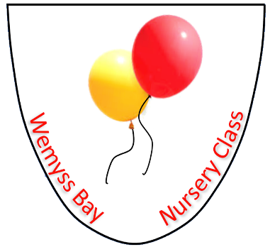

Nursery
Healthy Eating Policy

UNCRC Article – 6, 24, 27

GIRFEC – Respected, Included, Healthy, Responsible, Achieving

Health & Social Care Standard – 1.2, 1.33-1.39, 2.21, 5.11, 5.16

Wemyss Bay Primary School
and
Nursery Class

Professional Learning
Rationale: why do we need this policy?

Rational: why do we need this policy?
At Wemyss Bay Nursery we aim to educate our children with the skills, knowledge and understanding to enable them to make informed healthy lifestyle choices. To do that effectively we need to work in partnership with parents and carers in securing the best for every child.

Aims: What do we want to achieve?
To work alongside parents/carers to ensure children have a suitable and healthy diet.

Policy: how are we going to do this?
To provide a safe, healthy and appealing eating environment for children and ensure that free, fresh drinking water is available at all times

The Scottish Milk and Healthy Snack Scheme will provide a daily portion of milk (or approved non-dairy alternative) and healthy snack (fruit or vegetables) for children who spend 2 hours or more in our nursery setting.

In addition, fruit, toast and other healthy options are provided daily.

As the above are all provided, we discourage additional snacks.

We help children develop an understanding of healthy eating through play, stories, UNCRC characters, conversation and interactions.

We promote Setting the Table guidelines and national standards for healthier eating.

Nursery lunches are available for all children. These are prepared daily in accordance with national guidance. We also support parents and carers in providing a healthy packed lunch that meets the same standards as food provided in school dinners.

We ask parents to avoid sending packed lunches with chocolate bars, sweets or fizzy juice.

WE ARE AN ALLERGY AWARE NURSERY/SCHOOL

We fully respect individual parent’s food choices for their children and understand that there are many different needs and tastes. However, if lunchbox contents regularly fall short of the expectations in this policy, we will send a reminder home to parents. We want to work with parents to educate our children about healthy dietary choices so that the children, through the understanding of a balanced diet, will develop a greater appreciation of a healthy lifestyle.

Version | Date | Author
V1 | 29/10/2021 | AG / HM
V2 | 22/08/2025 | HM/ST

