Ftreestr

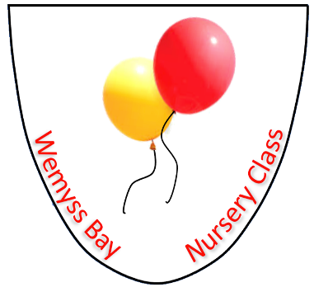

Nursery
Admissions & Settling In Procedure

UNCRC Article – 3, 4, 28

GIRFEC – Included, Respected, Nurtured

Health & Social Care Standard – 3.1, 3.3, 4.19-4.23

Wemyss Bay Primary School
and
Nursery Class

Professional Learning
Rationale: why do we need this policy?

Admissions

At Wemyss Bay, practitioners and managers aim to ensure that the admission of children is fair, equitable and responsive to the needs and preferences of individual children and their parents. This procedure ensures that early learning and childcare places are allocated fairly and equitably in accordance with national legislation and policy.
The nursery application form is available from any Inverclyde Council nursery school/class or partner establishment and on Inverclyde Council Website. All children who are eligible for a nursery place are asked to list, in order of priority, up to three nursery choices. Only one application form must be submitted. Although children are guaranteed a place within either a council establishment or within a partnership establishment we cannot guarantee choices or pattern of attendance. Once completed forms should be submitted to the first choice nursery.
Proof of your child’s date of birth in the form of their birth certificate and address must be produced when submitting the application. Forms submitted without this evidence will not be accepted at any establishment.
The process the nursery will follow

- HQ informs the nursery of children that have been granted a placement.

- Nursery Secretary sends out an Accept/Decline letter (Appendix 1) with a date of return.

- Once the letter has been returned and the parents have accepted their child’s placement, secretary accepts their request on NAMS and emails the parents an Induction letter. The email contains information regarding start times and dates, the name of their keyworker and where to go on their first day. The letter also has a link to a Sway document which has general information about the nursery.

- The secretary informs Depute/Senior of who has accepted their placement

- Depute/Senior with staff allocate children into groups and phone parents to arrange a visit.

Transfers

In January we make a phone call to all the anti pre-school parents that had Wemyss Bay as a second choice to find out if they want the option to request a transfer for their pre-school year. If they wish to transfer, they will be asked to fill in an Amendments/Transfer form

Settling In

Settling in is an important stage in the transition between home and the ELC setting, or between one setting and another. We aim to make this a smooth transition by following this procedure.

- Once the parents have returned their Accept/Decline letter and confirm their placement, the secretary will email an Induction letter to the parents. The email contains information regarding start times and dates, the name of their keyworker and where to go on their first day. The letter also has a link to a Sway document which has general information about the nursery.

- The Depute/senior will then call parents to arrange a visit and to discuss any concerns or answer any questions.

- Visits will take place after 3pm on a date which suits. The families will have the opportunity to meet the child’s keyworker, have a tour of the facilities and fill in a data pack.

- The child will attend nursery for an hour on the first day and then through consultation with the child’s keyworker, parents and information on how the child has settled the session times will be extended until they have fully settled into the nursery environment.

- Once the child has been in the nursery for 3-4 weeks the child’s keyworker will fill in a settling in sheet and we will arrange for meeting to discuss how the child has settled and discuss personal learning targets.

Version | Date | Author
V1 | 05/12/2021 | AG / HM
V2 | 08/09/2022 | AG/HM
V3 | 05/09/2023 | HM/ST

