Ftreestr

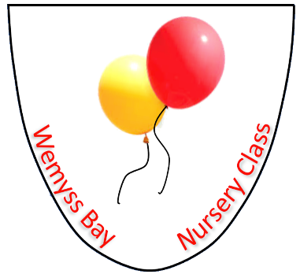

Nursery
Sickness and Illness Policy

UNCRC Article – 3, 12, 24

GIRFEC – Safe, Nurtured, Respected, Included, Healthy, Responsible

Health & Social Care Standard – 1.19, 2.12, 2.13, 2.23, 3.1, 3.8-3.14, 3.18, 4.11, 4.27

Wemyss Bay Primary School
and
Nursery Class

Professional Learning
Rationale: why do we need this policy?

Rationale: why do we need this policy?
At Wemyss Bay Nursery, we promote the good health of children attending nursery and take the necessary steps to prevent the spread of infection.
This policy has been devised to ensure that children who become unwell at nursery are treated sensitively and with respect. It also helps us to protect other children and staff from illness and the spread of infection.
If a child requires medicine, we will obtain information about the child’s needs (see Administration of Medication Policy)
Our aim: what do we hope to achieve?
To work alongside parents/carers to treat unwell children with respect, compassion and dignity and to safeguard all children and staff from infection.

Policy: how we are going to do this?
We will assess each child individually and look not only at physical symptoms but behaviours, their emotional wellbeing and what the child has communicated to us. If we have concerns, we will contact parents, inform them of the child's condition or complaint and seek initial guidance. We will at all times keep the child comfortable and reassured. Only if we feel that the child is unable to be in the nursery environment without being upset or needing a one to one for an extended period of time will we ask a parent to collect a child without any physical symptoms.
The Depute is not allowed to admit any children into the premises who appear to be suffering from an infectious or contagious illness or disease. We follow local authority guidance and want to communicate with parents to work towards the best outcomes for children. We do reserve the right to refuse children into nursery if they have an illness that is contagious and will have an impact on the other children and staff.
Parents are required to inform the nursery/school where they can be reached in the event of an accident/sudden illness. However, on occasions it may be impossible to contact a parent/career in an emergency, we will make every effort to contact every named person on the child’s emergency contact list, failing this, and parents are required to provide the Manager with signed permission for the setting to act in their absence.
If a child becomes seriously ill or injured during his/her attendance at the nursery, the nursery reserves the right to call for emergency assistance and, if necessary, remove him/her to hospital and give permission for emergency treatment to be administered. If we must take your child to hospital because of an illness or accident, we will do our utmost to inform you immediately (using the details on your Application Form). It is therefore vital that this information is kept up to date and that you inform us of your timetable/whereabouts. Please inform the nursery/school of any changes to these details as soon as possible. Please inform us as soon as possible if your child will be absent for a long period due to illness.
Local Authority regulations state that parents are required to give the following information to the nursery: name, address and date of birth of each child; name, home address and place of work with respective telephone numbers of the parents of each child and the name, address and telephone number of each child’s doctor and the state of immunisation and infectious diseases suffered by each child.
All accidents/incidents are recorded on the child’s Learning Journal. Parents will also be notified of any accidents/incidents via a phone call or through communication with keyworker at the end of the session.

Version | Date | Author
V1 | 29.10.2021 | AG / HM
V2 | 21.05.2024 | HM/ST

