
Wemyss Bay Primary School
and Nursery Class
Standards and Quality 2024-25

Context of the Establishment

Our Establishment

Our school is a non-denominational primary school situated in the village of Wemyss Bay in Inverclyde.

Our school roll at the conclusion of session 2024 / 25 was 82 pupils, organised in 4 school classes from P1- P7. We also have a nursery class with 40 children attending in session 2024 / 25. Our core nursery hours are 9.00 – 3.00, with Chargeable Childcare available.

We have a large campus, which includes 10 classrooms, one of which is dedicated to Wellbeing, one to Learning support, one to STEM and one to Expressive Arts. We have 2 large halls, a library and a suite of offices.

We have an indoor nursery playroom and an outdoor nursery facility. Both have free flow access to outdoor play space. We have a large Early level garden, a large level playground space and a multi-use games area for all ages, and a quiet garden area. Within our playground we have recently installed a small trim trail and refreshed playground markings.

Our associated secondary schools are Inverclyde Academy, Greenock and St Columba’s High School, Gourock.

Vision as in June 2025

We aspire to create a nurturing, inclusive and purposeful environment where all experience irresistible learning opportunities, enabling us to be skilled and successful in our learning, life and work, within our community and beyond.

Values as in June 2025

- Respect
- Equity
- Ambition
- Kindness

Aims as in June 2025

- To intentionally develop our mindsets, skills and knowledge to enable us all to be successful learners.

- To provide purposeful and engaging opportunities across the whole curriculum for all learners to become confident individuals.

- To encourage all members of our school community to be effective contributors to all aspects of school life.

- To inspire all learners to be responsible citizens by being change makers in our school, local community and beyond.

- To create an environment where everyone is safe, nurtured and respected, is encouraged to be healthy, active and responsible, is challenged to achieve and where equity of opportunity is a priority to enable everyone to be included.

School Profile

Almost all of our school pupils live in SIMD bands 3 - 9, with 78% residing in SIMD band 9. We have 3% of our pupils residing in SIMD bands 1 – 2.

17% of our pupils are entitled to free school meals.

43% of our pupils have additional support needs.

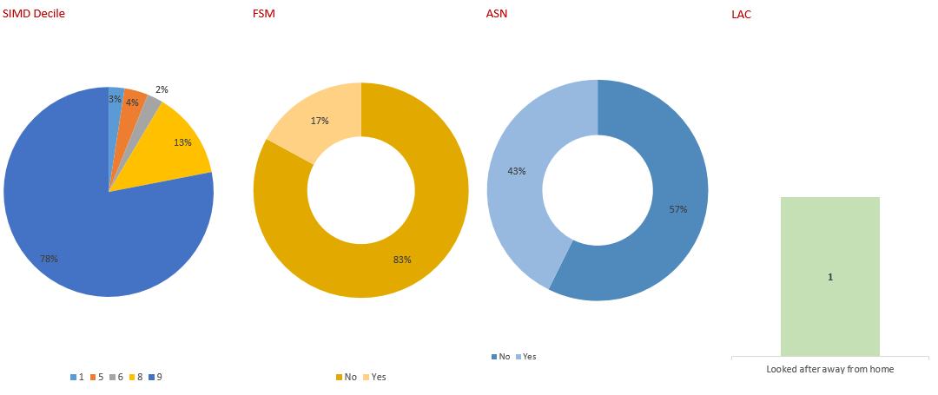

Establishment priority 1

NIF Priority  Improvements in attainment, particularly in literacy and numeracy  Choose an item  NIF Driver  School Improvement  Assessment of children's progress | HGIOS/ELC QIs  2.3 Learning, teaching and assessment  3.2 Raising attainment and achievement  UNCRC  Article 28: (Right to education):  Article 12 (Respect for the views of the child):
Outcomes:
- By May 2025, 50% of learners at second level will have a reading and spelling age in excess of at least four months of their chronological age.
- By May 2025, the majority of learners at First level will make at least 10 months progress in reading.
- By May 2025, the number of pupils across the establishment beyond expectation in writing will increase from 7% to 12%.
- By May 2025, the number of learners across the establishment beyond expectation in listening and talking will be sustained at 19%.
- By May 2025, 20% of leaners at second level will be able to confidently articulate effective numeracy strategies in relation to problem solving.
- By May 2025, the majority of nursery families will make contributions to learning journals.
- By May 2025, almost all learners will have engaged with at least one new Social Studies context with a focus on diversity.

PEF used to support closing the gap:
£1000: decodeable readers
£1000: continuation of library refresh

Progress and impact of outcomes for learners:

Whilst our school role has remained steady, we have had a number of children move out of the school and transfer in. This has impacted on the level of attainment at certain stages. Our recent authority review highlighted a number of actions which overtook many of our original priorities. We have shared progress against the original outcomes alongside progress and impact since our review in November.

- Spelling – children with a spelling age in excess of 4 months of their chronological age
P7 – 60%
P6 – 50%
P5 – 41%

P6 & P7 pupils have achieved this outcome, however P5 still needs further focus on this.

Reading – children with a reading age in excess of 4 months of their chronological age
P7 – 50%
P6 – 66%
P5 – 54%
At least 50% of all children across second level have achieved a reading age in excess of 4 months of their chronological age.

- Learners at First level making at least 10 months progress in reading:
P3 – 52%
P4 – 44%

These outcomes have been achieved through a continued review of learning and teaching and a fresh focus on self evaluation. We are continued to develop the refreshed library and it has continued to be used more readily throughout the school.

- 7.3% of children across the establishment are beyond expectation in writing with 68% being on track.

- 15.9% of children across the establishment are beyond expectation in listening and talking with 76.8% being on track.

Due to an increased staff awareness of achievement of a level, this data has not met the original
target however the accuracy of the data continues to improve.

- This is an outcome that has been overtaken by review priorities.

- Our data shows that parents are well engaged and contribute to learning journals. Recent figures show 132 parental interactions per month and 30 parental contributions per month. Acting HT and Acting DHT have both received training on the learning journals and the early years tracker.

- In term 4, all classes developed their understanding of diversity through class novels and IDL.

Following the authority review in November 2024 we have:
- Moderated writing from within the cluster to given staff an increased awareness of the expectations of the achievement of a level.
- Renewed focus on jotter monitoring being clear of expecations to improve consistence and pride for pupils. Improvements can be clearly seen in most jotters.
- Strategic Pedagogical Leads have launched the Literacy Framework with all teaching staff, making staff more aware of the resources available to support learning and teaching.
- Revisited the purpose of Outdoor Learning and created progression pathways across all levels to ensure skills development are age and stage appropriate and build on prior learning.
- Started to create ‘The Wemyss Bay Lesson’ setting out expecations of learning and teaching at Wemyss Bay. This is in the early stages however a renewed focus on learning intentions, success criteria and target setting is evident.
- Developed the planning format for teaching staff to have more of a focus on the progression pathways. This is increasing staff confidence in planning next steps in learning in a progressive manner.
- New resources have been purchased for the nursery to provide more opportunities and provocations.
- Started using the ‘I can’ toolkit to support development in speech and language

Next steps (Green – whole establishment, Blue – nursery specific)

- Continue to create a learning and teaching guidance for all staff to improve consistency in high-quality pedagogical approaches that effectively meet the diverse needs of all children across the school.
- Develop a clear strategic overview of Quality Assurance within the school and nursery class which links clearly with School Improvement Plan priorities including:
  - A review of processes around triangulation between teacher professional judgements, assessments and evidence of pupil’s learning.
  - A re-newed focus of moderation activities to included achievement of a level as well as the learning and teaching cycle.
  - Continuing to review planning as part of the learning and teaching cycle, ensuring lessons and learning opportunities are informed by assessment to maximise progression and relevance.
  - An ongoing review of learning journals and target setting to ensure the journey towards achieving a target is recorded and monitored.
- Increase the pace and challenge of learning activities to extend children’s thinking, deepen their engagement, and support them in achieving their full potential.
- Develop leadership at all levels, with staff taking greater ownership of leading and driving improvement in line with the school’s improvement priorities.
- Engage in Improving Our School West Partnership programme.
- Develop the use of floorbooks as a planning, monitoring and evaluation tool within the nursery.
- Further develop the use of the ‘I can’ toolkit to measure impact.

Establishment priority 2

NIF Priority  Closing the attainment gap between the most and least disadvantaged children and young people  Improvements in attainment, particularly in literacy and numeracy  NIF Driver  Assessment of children's progress  Teacher professionalism | HGIOS/ELC QIs  2.4 Personalised support  3.2 Raising attainment and achievement  UNCRC  Article 28: (Right to education):  Article 3 (Best interests of the child):
Outcomes:
- By May 2025, 50% of identified children within equity groups will make at least 8 months progress in their spelling age
- By May 2025, identified children within equity groups will make at least 8 months progress in their reading age
- By May 2025, numeracy assessments will show progress against individual targets
- Throughout the session, families at risk of being unable to access wider curricular activities will have accessed and benefitted from financial and practical assistance.

PEF used to support closing the gap:
£15,000: Pupil Support Assistant 17.36 hours per week.
£500: family support
£1400: to enhance personalised support provision including wellbeing

Progress and impact of outcomes for learners:

- 50% of children in receipt of free school meals have made at least 8 months progress in their spelling age.
- 58% of children in receipt of free school meals have increased their reading age by at least 8 months, with 17% of children in receipt of free school meals having a reading age of at least 3 years and 8 months above their chronological age.
- 78% of children across the school are on track or beyond expectation for numeracy.
- We have supported our families throughout the year through helping to fund the P7 residential trip, purchasing new tracksuits for sports events, recycling uniforms, soup and fruit bags in the nursery and generally aiming to minimise the cost of the school day.

Following the authority review in November 2024 we have:
- Introduced Fact, Story, Action approach to tracking attainment, which has allowed us to identify children who require support and most importantly, plan for interventions to close the attainment gap.
- Refreshed the Support for Learning approach to ensure robust tracking and monitoring of interventions. This has allowed us to give more targeted support to the right children at the right time.
- Introduced staff to the data dashboard allowing them to have more ownership of their class data and building their confidence in their professional judgements.
- Within the nursery targeted intervention was implemented based on early years tracker
Next steps

- Implement rigorous tracking systems to ensure early identification and intervention for children requiring support with learning.
- Implement procedures to track interventions effectively to evidence impact and progression.
- Continue to use a Fact, Story, Action approach to develop staff confidence in analysing data from the data dashboard.
- Identify children in the nursery requiring support and challenge using the early years tracker and provide targeted provocations and learning opportunities.
- Use learning journals, early years tracker, BGE tracker and I can toolkit to monitor progress of children within the nursery.

Establishment priority 3

NIF Priority  Improvement in children and young people's health and wellbeing  Placing the human rights and needs of every child and young person at the centre of education  NIF Driver  Assessment of children's progress  Teacher professionalism | HGIOS/ELC QIs  3.1 Ensuring wellbeing, equality and inclusion  3.2 Securing Children's Progress  UNCRC  Article 28: (Right to education):  Article 3 (Best interests of the child):
Outcome:
- By May 2025, all bullying and racist incidents will be recorded correctly ensuring all learners feel safe in school
- By May 2025, all staff will be aware of and compliant with the refreshed Child Protection protocols and The Promise so that all learners feel safe and heard in school / nursery.
- Pre and post GWMP questionnaires will show increasingly positive attitudes to health and wellbeing
- By May 2025, almost all learners will be aware of The Promise and how to live this out.
- By May 2025, almost all children in the school and nursery will be aware of, and be increasingly able to use appropriate language in regard to racism.
- By May 2025, almost all staff will use trauma informed approaches in their interactions with children

PEF used to support closing the gap:
£780: JIGSAW to support transition to Health School Framework
£2500: Outdoor Learning CLPL and resources

Progress and impact of outcomes for learners:

- Bullying and racist incidents are recorded on the SEEMiS system and the appropriate actions taken to ensure all learners feel safe in school.
- All school and nursery staff have participated in Child Protection and The Promise training sessions. This has given staff an increased awareness of CEYP and made them more focussed on these young people in their care.
- Results from pre and post GMWP results show a fairly static picture of attitudes towards health and wellbeing, with a slight increase in the P6/7 class across all areas.
- This had been a cluster priority and children from all cluster schools have been working with Susan Chambers to develop a child friendly version of the Promise which will be presented by the pupils in the new school session.
- This year the focus has been building staff confidence in racial literacy, which will support the development of this with pupils next year. Pupil and staff questionnaires have been completed.
- All staff have completed the Trauma Informed Practices training and are implementing this in practice.

Following the authority review in November 2024 we have:
- Continued to work within the cluster to develop a child friendly approach to The Promise.
- Engaged in staff continuous professional development based on racial literacy to build staff confidence in speaking to children about this.
Next steps
- Further develop racial literacy within the school and nursery, increasing staff confidence and developing curriculuar experiences, opportunities and provocations for all children.
- Investigate and make further use of toolkits to capture the views of children’s wellbeing
- Continue to develop children’s leadership roles on Equity and The Promise, taking part in activities within and out with their school community to give them a sense of their place in the Global Community.
- All staff to participate in bereavement training to support children and families experiencing loss.
- Investigate Healthy Schools in line with Early Years tracker.

Establishment priority 4

NIF Priority  Improvement in skills and sustained, positive school-leaver destinations for all young people  Placing the human rights and needs of every child and young person at the centre of education  NIF Driver  School leadership  Assessment of children's progress | HGIOS/ELC QIs  1.3 Leadership of change  3.2 Raising attainment and achievement  UNCRC  Article 3 (Best interests of the child):  Article 28: (Right to education):
Outcome:
- By May 2025, almost all pupils will have had regular opportunities to increase their participation in school development and improvement projects, developing key employability skills through their participation
- By May 2025, all pupils will have had the opportunity to share their wider achievements with the learning community through newsletters and Bay Radio, with an increased focus on the link between their achievements and the skills they have developed, and their relevance to their learning and the world of work.
- By May 2025, tracking will show that the majority of pupils are engaging in wider learning opportunities

Progress and impact of outcomes for learners:

- All school pupils have participated in pupil groups throughout the year and have developed employability skills e.g. communication, presentation and team work. As a result of their work, we have engaged in local litter packs, made improvements in the lunch hall, and engaged with HGIOurS
- All pupils have the opportunity to celebrate success at regular school assemblies and are recognised for their contribution to living the school values and the four capacities.
- Every child in the school has participated in at least one activity from Active Schools
- Nursery children have been involved in developing the garden areas building their team work, resilience and communication skills.

Next steps

- Further develop the use of achievement tracking to ensure no child is in danger of missing out.
- Further develop use of skills language within the classroom to allow children to identify skills.
- Further develop the use of floorbooks and learning journeys to identify skills and demonstrate progress towards targets

Data

Key Strengths:
School/Nursery class

During session 2024-2025, our attendance data has shown a slight dip in attendance levels across the school with the attendance sitting at 93.7%. Attendance across all stages is above 92%.
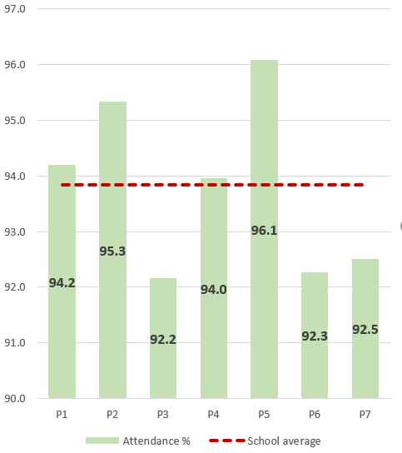

Attendance within the nursery sits at 90.4% which is an increase of 1.9%.

During session 2024-2025, there has been an increase in staff awareness of BGE levels and achievement of a level, which has increased the accuracy of the data this session. The increased use of progression pathways and more rigourous interrogation of data, as well as effective and reposonsive planning, has supported this.

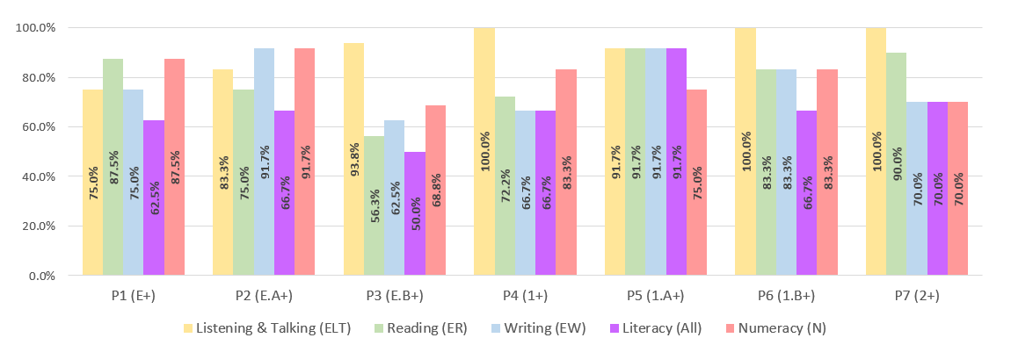

From analysis of the data, writing will continue to be a focus next year, with improvements being embedded in practice across the school. Reading will also be a focus area from improvement next year.

Analysis of available data for cohorts across the school, confirms that the majority of children are on track or beyond expectation in their learning across literacy and numeracy. Listening and talking is identified as a strength with most children being assessed as on track or beyond expectation. Attainment within first level has been a focus this year and the comparison of data shows a significant increase of those achieving literacy overall at P3 (from 29.4% to 50%). Attainment within the P3 cohort has increased in all areas.

The use of learning journals in the Nursery has provided a collaborative and digital record of learning throughout the session with almost all parents engaging in this. Staff have also increased their confidence and skills in tracking progress using the BGE tracker with the learning journals. Analysis of this data shows that almost all learners are on track or beyond across all areas with the following figures:
Numeracy – 95%
Listening and Talking – 90%
Reading – 92.5%
Writing – 90%
Health and Wellbeing – 92.5%

Through deep analysis of available data, we have identified a gap related to Free School Meals Entitlement, particularly looking at those beyond expectation. 50% of those children entitled to Free School Meals are behind expectation in at least one area of literacy. This group will continue to be a focus group for the next session.

Key Priorities:
School / Nursery class / whole establishment

- Develop and embed a school based attendance policy based on the authority policy.
- Further increase the use of the data dashboard and fact, story, action approach to analyse data.
- Ensure rigourous interrogation of data to identify areas for support and challenge and track this effectively.
- Continue to develop the use of floorbooks to track learning within the nursery.
- Further develop the use of observations within the learning journals to track progress towards targets.

National Improvement Framework Quality Indicators
1.3 Leadership of change
Satisfactory
Nursery - Good
Key Strengths:

- Our recently refreshed vision, values and aims are relevant to the school, nursery and community and are becoming embedded.
- Children talk confidently about their leadership roles and are proud to be “Changemakers” in their school.
- The strong partnership working is used effectively to contribute to improvements within the school community.
- As a staff team, we have an understanding of the school’s social, economic and cultural context in the local community. We understand that although a large percentage of the children reside in SIMD 8 or above, this does not equate to financial comfort. All staff have an awareness of the impact of the cost of living on their families and strive to maintain a focus on the cost of the school day.
- This session we have enaged in a cluster intiative where senior pupils have joined with peers across the cluster to collaborate and develop a child friendly version of The Promise – The Pinkie Promise. The children have created a poster to exemplify the Pinkie Promise and, next session, will share this within the cluster with the possiblility to share this wider within the authority.
- Leadership at all levels is developing acoss the school and nursery. This year children have began to use HGIOurS to evaluate and identify areas for improvement.
- Nursery staff have completed accredited professional learning and all staff have responsibility for curricular developments.
- School staff have the responsibility for leading on priorities for improvement and on areas of interest.
- Staff have a good understanding of the individual needs of children and families.

Key Priorities:
School / Nursery / Whole Establishment

- Develop a clear strategic overview of Quality Assurance within the school and nursery class which links clearly with School Improvement Plan priorities.
- Leadership at all levels will be further developed, with staff taking greater ownership of leading and driving improvement in line with the school’s improvement priorities. The use of HGIOurS will be further developed and included within the Quality Assuarance calendar.
- Develop self-evaluation and moderation procedures across the nursery and school to identify progress and areas for development.

2.3 Learning, teaching and assessment
Satisfactory
Nursery - Good
Key Strengths:

- Children benefit from a nurturing and supportive learning environment that reflects an ethos of care and a positive culture.
- Staff make good use of the wide variety of learning spaces within and outside the school to engage and motivate children.
- There is a shared ethos of the importance of learning, with everyone being a learner and where all learners matter. This philosophy of shared learning and the understanding that staff and pupils can learn from each other contributes to the respect and positive ethos between staff and pupils.
- The majority of children demonstrate a good level of motivation and engagement in their learning. They display positive attitudes, enthusiasm and a willingness to actively participate in tasks and activities.
- In the nursery class, children are provided with meaningful opportunities to lead their learning through carefully planned play experiences. Across the school, children are beginning to engage in a play-based learning journey that aims to balance direct teaching with opportunities to explore and interact with selected play resources
- Explanations and instructions for learning tasks are clear and support children in engaging with their learning. Learning intentions and success criteria are shared and made visible, enabling children to understand the purpose of the learning and the steps required to achieve success. SLT have utilised collegiate time to explore research and share effective strategies to enhance good practice, with a focus on improving the consistency of learner experiences across the school.
- In the nursery, a variety of learning and teaching approaches are effectively implemented, alongside the use of higher-order thinking questions to promote curiosity and deeper engagement in learning.
- There are shared expectations for assessment practices, as outlined in the annual overview calendar. A range of assessments are strategically planned throughout the year to support and validate teachers' professional judgments (TPJ). These assessments are tracked and documented in the digital assessment tracking folder, ensuring a supported approach to monitoring learner progress.

Key Priorities:
School / Nursery / Whole Establishment

- Review processes around triangulation between teacher professional judgements, assessments and evidence of pupil’s learning.
- Develop regular and robust moderation activities to included achievement of a level as well as the learning and teaching cycle.
- Continuing to review planning as part of the learning and teaching cycle, ensuring lessons and learning opportunities are informed by assessment to maximise progression and relevance.
- Further enhance high quality learning and teaching experiences to ensure appropriate pace and challenge are evident. These experiences should also foster independence in learning, allowing children to take a more active role in their learning.
- An ongoing review of learning journals and target setting to ensure the journey towards achieving a target is recorded and monitored.
- Develop the use of floorbooks within the nursery to plan, implement and evaluate learning, including pupil voice.
- Develop consistency in high-quality pedagogical approaches that effectively meet the diverse needs of all children.
- Develop and plan for opportunities for challenge and application of skill across the curriculum to stretch thinking and deepen enagagment.

3.1 Ensuring wellbeing, equity and inclusion
Good
Nursery - Good
Key Strengths:
- Staff in the school and nursery know children and families well and as a result are able to target support which enables all children to be included in wider experiences.
- Staff and other agencies work collaboratively to ensure support is in place for all children and there are strong partnerships evident.
- From P3-P7, children’s views are gathered using the Glasgow Motivation and Wellbeing Profile (GMWP). Targeted support is offered for those who need it in a designated space with a designated member of staff.
- Staff are developing children’s understanding of the United Nations Convention on the Rights of the Child (UNCRC) at an age and stage appropriate level.
- Partners highlighted the very close working relationships with not only the SLT but the whole school team. Partners are made to feel very welcome and their input valued and there is very much a sense of working together. They describe a culture of SLT being open to suggestions and seeking advice which ensures changes are sustainable
- Wellbeing Assessments are used to ensure early identification of children’s needs, resulting in interventions as required. Staff are knowledgeable and have experience of working with children with ASD, ADHD, dyslexia and dyscalculia. They are also Trauma Informed which enables them to understand that children’s behaviour is communication and have strategies to support children to regulate their emotions.
- Children in the nursery class experience a very nurturing environment both indoors, outdoors and at lunch time in the canteen. Interactions between staff and children are warm and skilled, demonstrating positive relationships.
- The SLT’s knowledge of children’s wellbeing needs and abilities underpins their transition programme and ensures that there are consistent strategies in place to support children to their next learning environment, be it to another early years’ setting or school.
- The SLT track children in Equity Groups using a whole school overview and specific tracking of particular groups, such as children who are Care Experienced, Young Carers and those who live in SIMD 1 or 2
- Engagement with the cluster work on The Pinkie Promise has developed understanding of CEYP. This will be launched next session in all cluster school.

Key Priorities:
School / Nursery / Whole Establishment

- Continue to develop leadership roles within the school, with a developing focus on global citizenship.
- Continue to work within the cluster to develop the Pinkie Promise and to launch this within the school.
- Ensure chronologies are used appropriately within care plans and recording of additional support needs.
- Make further use of toolkits to capture the views of younger children’s wellbeing and continue sharing information with parents about GIRFEC
- Further develop Building Racial Literacy through training and developing curricular experiences for children.

3.2 Raising attainment and achievement
School – Satisfactoy

Key Strengths:
School

- This session, a fact, story, action approach has been introduced, with staff taking more ownership of the data for their class and becoming more data literate. This is used to identify areas for support and challenge within the classes.
- Clear planning for support for learning interventions has been implemented with regular tracking and monitoring procedures in place.
- Planning formats have been developed to make planning more efficient and coherent. The use of progression pathways is becoming more evident in planning.
- There has been an increased focus on high expecations and consistency in written work with the implementation of presentation and correction codes across the school.
- Teaching staff have all received CLPL input on the literacy framework and numeracy strategy and are being to use this to support teaching in these areas.
- Play pedagogy and playful approaches are being developed across the school
- The school works well with partners to ensure that they seek the correct support for children as and when it is appropriate.
- The school is beginning to track achievements alongside attainment to ensure each child is known holistically, ensuring support can be targeted.
- Literacy and Numeracy attainment across the school is good. Almost all children are achieving appropriately in Listening and Talking with a few children exceeding these expectations. Most children are achieving appropriately in Reading and Numeracy.
- All children’s successes and strengths are effectively recognised through regular assemblies and whole establishment recognition awards. Staff celebrate achievements against Wellbeing Indicators, values and experiences outside of school and nursery.
- We have worked collaboratively with Active School to ensure that the children have access to a range of sporting and wellbeing activities both within and beyond the school day. Every child in the school has had access to a lunchtime club, curricular input or after school club through Active Schools.
- Staff have worked to develop outdoor learning pathways to link learning to skills development as well as ensuring progression.
Key Priorities:
School

- Review processes around triangulation between teacher professional judgements, assessments and evidence of pupil’s learning. Assessment data will be used to inform planning and target setting for children. Further develop staff confidence in the use of data to inform TPJs
- Develop regular and robust moderation activities to included achievement of a level as well as the learning and teaching cycle.
- Further develop tracking systems to ensure progress is monitored effectively.
- Continue to implement robust tracking systems for those children receiving learning interventions.

3.2 Securing children’s progress
Good
Key Strengths:
Nursery

- Learning journals are used to track children’s progress and to communicate this effectively with parents. Almost all parents access learning journals regularly.
- Children’s achievement in and out of the nursery are celebrated through learning journals and displayed in the nursery.
- Attainment data shows clear progression for all children with almost all children on track or beyond expectation in all areas.
- Nursery staff are using data to inform planning and can adapt exeriences to support and challenge children at their own level.
- Staff have built positive relationships with children and their families. Parents report that they feel welcome and supported in the nursery.
- Staff make use of all areas of the nursery, outdoor spaces and outdoor classroom to provide a range of learning opportunities for children.
- We make use of our local community with visits to shops, the wood and the beach. This allows children to learn about areas in their community and apply learning to real life situations.
- Children’s Rights are embedded in the nursery and children are able to confidently discuss these at their own level. We have introduced our Rights Respecting Characters in the nursery to all children to access this in an age and stage appropriate way.
- Children are able to access resources independently and have choice in their learning activities.

Key Priorities:

- Continue to use learning journals to track a child’s journey towards a target.
- Develop the use of floorbooks to plan, implement, track and evaluate progress.
- Further develop observations of children to include a more skills based language, ensuring opportunities for application of skills.

Key Achievements of the Establishment

Curriculum

- We had a very success whole school project in term 3 based around the question – What makes Wemyss Bay special? Each class investigated a different aspect and we host a sharing the learning event in the community centre to celebrate the learning. This was very successful and well attended by members of the community.
- We have developed Outdoor Learning progression pathways linked to skills language and have purchased new resources to support this.
- All classes have taken part in educational visits this year. P1/2 and P3/4 attending the outdoor centre in Millport and took part in a number of workshops. P4/5 visited Kelvingrove Museum and took part in workshops realted to their Egyptians topic. P6/7 went to Bellahouston Ski Centre and learned new skills, whilst developing their resilience.
- Our Primary 4, 5, 6 and 7 pupils all took part in STEM workshops in conjuction with the Navy.
- All children participated in our Christmas Cracker, a whole school and nursery enterprise event within the school.
- All school pupils took part in a successful Health Day organised in conjuction with Active School. Children were able to try new sports as well as have a fruit tasting.
- Our P7 pupils went on a residential trip to Dounans in Stirling. This was a successful trip with all children enjoying new outdoor and indoor activities and increasing their confidence and self esteem.
- The nursery hosted well attended Stay and Play events for families throughout the year.
- We have supported transitions from nursery to primary 1 throughout the year in our own school but also at Inverkip Primary and St. Ninian’s Primary School.
- Our P7 pupils have attened events at Inverclyde Academy to support transition and took part in sessions from the home link woker.
- Our P4-7 pupils participated in a Mental Health Workshop organised by Saint PHNX. The children enjoyed learning different strategies to support their emotion and particulary enjoyed singing with the band.

School and Nursery Grounds
This year we have worked hard to develop grounds in both the school and nursery.
- We held a Grow and Glow day one Saturday, where members of the school community and partners helped develop areas of the school grounds. This included:
  - Clearing the small garden area at the front of the school
  - Building planters for the nursery and the school
  - Cleaning and freshing up equipment
  - Weeding and clearing pathways
  - Cutting back bushes in the playground
  - Refreshing the tyres in the playground
  - Planting bulbs in the planters at the entrance to the school.
- The nursery have created a successful allotment area in the gardens and worked with Inverclyde Food Share to plant and grow a range of vegetables.
- Children in the school have planted a range of items in planters in the playground. Vegetables grown and harvested by our P6/7 pupils have been served in the canteen during lunchtime – something that has encouraged children to try new foods.
- We have had new playground markings and a small trim trail installed in the playground, which has been a great success with all the children from the school and nursery.
- We have purchased new playground resources including a mud kitchen and loose parts.

Expressive Arts
- All school pupils took part in our school show – Disney Magic Showcase. This was a fabulous success with two sell out performances.
- Our P5 pupils have taken part in drumming workshops with Amanda Currie from Yoth Music Initiative. They performed for other pupils and also created a soundtrack for a short film.
- P4 pupils participated in immersive storytelling workshops with Reely Jiggered.
- Our nursery, P1 and P2 pupils performed in our joint Nativity this year.
- We hosted a nursery and school talent show this year, where children were able to showcase their talents to their peers.
- Our nursery children successfully took part in their Celebration of Learning assembly, which resulted in positive parental feedback.
- All classes performed assemblies to their peer and family members based around our new school values.

Sports
- All children in the school experienced an input from Active Schools this year through curriculum inputs, lunchtime clubs and after school clubs.
- Our school athletics team competed in the Sportshall athletics tournaments throughout the year.
- Children successfully took part in the Cross Country events at Tower Hill this year.
- All P4 children attended swimming lessons at the Waterfront Complex. All children improved their skills.
- Our school was represented at the Gourock Highland Games, with our team taking part in a range of different events.
- Our Sports’ Day this year was supported by Active Schools, who provided potted sports events to accompany the traditional races. This was enjoyed by pupils and families.
- Our athletics team took part in the Primary Heptathalon event at Ravenscraig stadium.

School and Wider Community Events
- Our P6 pupils partipated in the Euro Quiz this year, competing against teams across Inverclyde.
- The whole school took part in a sponsored walk to the beach to raising £888.85 for school funds.
- The nursery children were supported by P6 pupils to complete their sponsored walk with the MUGA pitch and raised £673.50.
- The nursery children and P6/7 pupils took part in a community litter pick at the beach.
- Our school choir sang at the Christmas Light Switch on at the Community Centre.
- Working with our Parent Partnership, we have successful introduced nursery discos before the school disco which has helped nursery families feel more included in the school.
- Two of our senior pupils have taken on cluster leadership opportunities to develop the Pinkie Promise.
- One of our P7 pupils has represented the school at the pupil consultation meetings throughout the year.

