Wemyss Bay Primary School
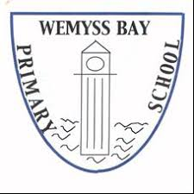
and
Nursery Class
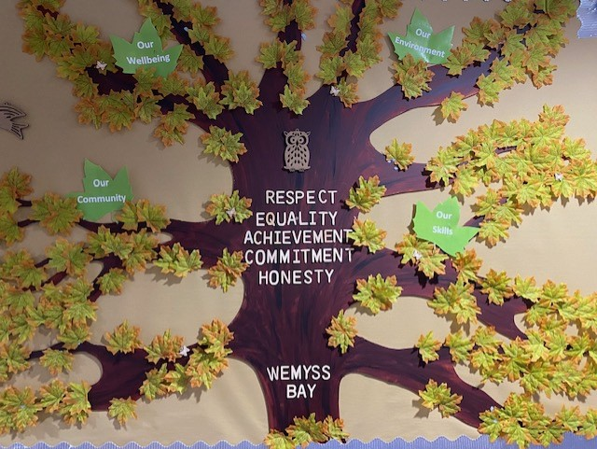

Handbook
Session 2024 / 2025
WELCOME FROM THE HEAD TEACHER 4
AUTHORITY STRATEGIC STATEMENT 5
THE VALUES AND VISION OF THE HEAD TEACHER…………………………………………………………………………………………………………………….6
WEMYSS BAY - OUR VISION, VALUES AND AIMS 8
SCHOOL INFORMATION 9
STAFF 10
SCHOOL CALENDAR 11
THE SCHOOL, THE COMMUNITY AND FAMILY ENGAGEMENT 12
SCHOOL CLUSTER 15
WEMYSS BAY NURSERY CLASS……………………………………………………………………………………………………………………………………………….16
ENROLMENT OF PUPILS TO PRIMARY 1 19
TRANSFER FROM PRIMARY SCHOOL TO SECONDARY SCHOOL 19
SCHOOL IMPROVEMENT AND ACHIEVEMENT 20
CURRICULUM FOR EXCELLENCE 21
OUTDOOR LEARNING…………………………………………………………………………………………………………………………………………………………….29
EXTRA-CURRICULAR ACTIVITIES 28
ASSESSMENT AND PROGRESS 31
REPORTING TO PARENTS 31
HOMEWORK 31
SUPPORT FOR PUPILS 32
PASTORAL CARE 33
SUPERVISION OF PLAYGROUNDS 34
PROMOTING POSITIVE RELATIONSHIPS AND BEHAVIOUR 34
BASIC SECURITY PRACTICES 34
CLOTHING & UNIFORM 35
MEDICAL AND HEALTH CARE 36
ATTENDANCE AT SCHOOL 37
MEALS 39
PARENT FORUM AND PARENT COUNCIL 40
TRANSPORT 41
INFORMATION IN EMERGENCIES 41
CHILD PROTECTION 42
INCLUSION AND EQUALITY 42
EQUALITIES 42
USEFUL ADDRESSES AND CONTACTS 42
PARENTZONE…………………………………………………………………………………………………………………………………………………………………………43
READ, WRITE COUNT……………………………………………………………………………………………………………………………………………………………..44
FIRST MINISTER'S READING CHALLENGE………………………………………………………………………………………………………………………………..44
LOCAL COUNCILLORS 44
INVERCLYDE COMPLAINT PROCEDURE 45
GENERAL DATA PROTECTION REGULATION AND DATA PROTECTION ACT 2018 45

Wemyss Bay Primary School and Nursery Class
Ardgowan road
Wemyss Bay
PA18 6AS
Telephone: 01475 715796
Email address: INWemyss Bay@glowscotland.onmicrosoft.com
Website: https://blogs.glowscotland.org.uk/in/wemyssbayps/
Twitter: @WemyssBaySchool
@WemyssBayNC

Head Teacher: Mrs Alison Gillespie
Depute Head Teacher: Mrs Lynne Cushnahan
Nursery Depute: Mrs Helen Milligan
WELCOME FROM THE HEAD TEACHER

December 2023

Dear Parents,

Welcome to the Wemyss Bay Primary School and Nursery Class Handbook. We offer you and your child(ren) a warm welcome to the school. Whether you are an existing member of our learning community or a prospective parent, I hope you find our Handbook helpful and informative.

Our school and nursery are very much at the heart of our village community and we pride ourselves on the strong relationships we share with our families. This begins with a warm welcome and continues with encouragement to be involved in the life and learning of our school.

We work hard to really get to know all of our children so that we can provide rich and engaging learning opportunities, continually encouraging every child to reach their full potential. We cannot do this on our own however, and so we look forward to working with you on our shared learning journey so that we can achieve the best possible outcomes for our children, and equip them with the knowledge, skills and attributes which will enable them to lead fulfilling lives in the 21st century, with the capacity to make positive life choices.

We strive to keep our parents up-to-date using Twitter, email and regular newsletters, but should you require further information, wish to discuss any matter, or arrange a visit to the school or nursery, please contact the school office.

Thankyou.

Yours sincerely,

Mrs Alison Gillespie
Head Teacher

AUTHORITY STRATEGIC STATEMENT

Building Inverclyde through excellence, ambition and regeneration.

Goals and Values

Our Core values are: Respect, Honesty and Tolerance.

Our vision for the children and young people of Inverclyde is that they should be ambitious for themselves and be successful learners, confident individuals, responsible citizens and effective contributors.

To achieve our ambition of building Inverclyde through excellence, ambition and regeneration our children must be:

Safe: protected from abuse, neglect and harm by others at home, school and in the community.

Healthy: enjoy the highest attainable standards of physical and mental health, with access to healthy lifestyles.

Achieving: have access to positive learning environments and opportunities to develop their skills, confidence and self-esteem to the fullest potential.

Nurtured: educated within a supportive setting.
Active: active with opportunities and encouragement to participate in play and recreation including sport.

Respected and responsible: involved in decisions that affect them, have their voices heard and be encouraged to play an active and responsible role in their communities.

Included: have access to high quality services when required and should be assisted to overcome the social, educational, physical, environmental and economic barriers that create inequality.

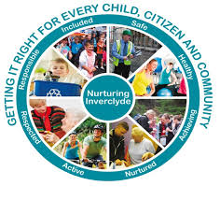

THE VALUES AND VISION OF THE HEAD TEACHER

A clear vision is critical to the ongoing growth and success of our nursery and school. In order this vision to be effective, it must reflect my own personal values and the values of our school.

The school values are:

- Respect
- Equality
- Achievement
- Commitment
- Honesty

But what of my own personal values? I have taken time to really delve into these over the last couple of years, and I am confident in what is important to me:

- Growth
- Potential
- Compassion

These values guide me personally and professionally, and, together with our school values, underpin my vision for our school and nursery:

My vision is that Wemyss Bay Primary School and Nursery Class will be the heartbeat of the community, where all are welcomed, nurtured, supported and challenged to achieve their potential, and become curious, creative, confident citizens, through irresistible learning experiences.

If you google a map of our village, our school and nursery lie right under the teardrop symbol; geographically, we appear at the centre – the heart - of the village. My vision is that we are more than a geographical symbol however; I see our school and nursery as the vibrant, energetic, beating heart of Wemyss Bay, where, like a continuous pulse, there is always something going on. I see our school as a place that welcomes the community in, reaches out to access and be involved in the community and works in partnership to improve our community.

Everyone is welcome in our school. We are aiming to get it right for every child - indeed, every citizen. So it follows that our school must be inclusive, welcoming diversity and embracing the richness that it brings. It is so important to me that all children, their families, our staff and our partners know that no matter what, when they come here, they have a place, they have a space, and they know they are welcome in our nursery and school.

Everyone also need to know that they will be nurtured, supported and challenged. These three concepts are encompassed within the broader sphere of wellbeing. Wellbeing has always been important but in some ways, never more important than now. We are committed to supporting our children and prioritising wellbeing in its most holistic and child centred form is essential to creating a positive caring culture within which all can fulfil their potential.

Only then can we develop our children to become curious, creative, confident citizens. We need to offer a bespoke curriculum that nurtures the skills that in turn unleash potential. We need to ensure that our children know how to learn with a focus on metacognition, consciously and intentionally planning for the development of skills as well as knowledge. This is essential in order to equip our children for life in an increasingly complex and interconnected world: we all need skills that cross national and cultural borders.

This will be achieved through increasingly skilled and effective pedagogy, application of learning in real life contexts and raising the level of pupil participation and leadership, are all part of our strategy. These approaches will help us to develop a strong, high quality, universal curriculum offer that will benefit our whole learning community.

This curriculum must be delivered through highly engaging learning experiences – irresistible learning. High quality teaching and learning depends upon highly skilled practitioners and it is critical to ensure our whole staff team feel confident and empowered to improve their delivery of our curriculum.

We may be a small school but we have big ambitions!

We aim to work in partnership with families and agencies to realis these ambitions, with the child’s holistic wellbeing at the heart of all we do.

In Wemyss Bay, we are dreaming with determination – determination to get it right for every child.

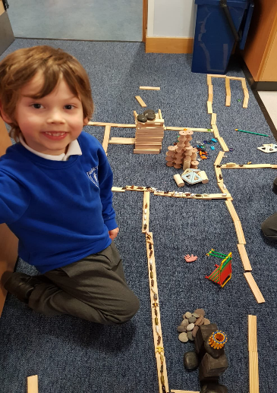
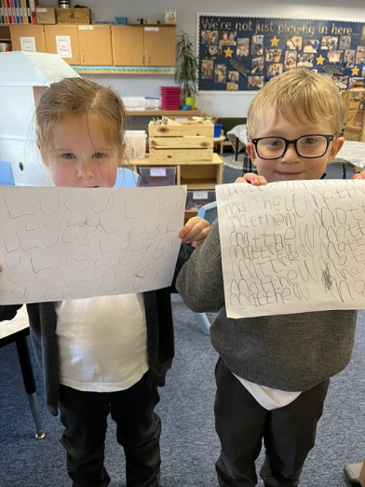

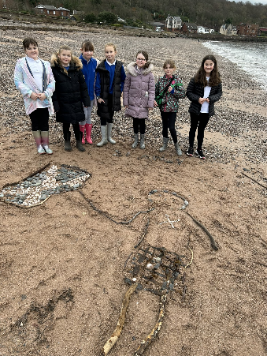

WEMYSS BAY – COLLECTIVE VISION, VALUES AND AIMS

Our Vision
Our vision is that Wemyss Bay Primary School and Nursery Class will be a happy, ambitious and effective learning community where everyone works together to ‘Get it Right for Every Child’.
Our Values
- Respect
• Equality
• Achievement
• Commitment
• Honesty

Our Aims
To actively develop our children’s attitudes, skills and knowledge to enable them to become successful learners.
To provide regular, planned opportunities for our learners to gain confidence in their learning and abilities.
To support all members of our school community to make effective contributions within their learning and to all aspects of school life.
To provide our children with the knowledge and social skills to enable them to be responsible citizens within our school, local community and beyond.
To create an environment where everyone is safe, nurtured and respected, is encouraged to be healthy, active and responsible, is challenged to achieve and where equity of opportunity is a priority to enable everyone to be included.

Our Curriculum Drivers
- Our wellbeing
• Our community
• Our environment
• Our skills
SCHOOL INFORMATION
Wemyss Bay Primary School and Nursery Class
Ardgowan road
Wemyss Bay
PA18 6AS

Tel: 01475 715696

Website: https://blogs.glowscotland.org.uk/in/wemyssbayps/

Twitter: Twitter: @WemyssBaySchool
@WemyssBayNC

Email: INWemyss Bay@glowscotland.onmicrosoft.com

Capacity: 300 Present Roll: 100 (school) 32 (nursery)

Working Capacity: The working capacity of the school may vary dependent upon the number of pupils at each stage and the way in which the classes are organised. The working capacity of the nursery is 48.

Wemyss Bay Primary school and Nursery Class is a non-denominational primary school which serves the village of Wemyss Bay for pupils from age 3 (nursery) to Primary 7. The school is a fairly modern building which opened in 1980. It is a bright, stimulating environment for children to learn with extensive campus grounds and easy access to the local woods and beach. Accommodation includes ten indoor classrooms (some of which are repurposed for specific learning experiences) and one outdoor classroom, the nursery playroom and outdoor shelter, a PE hall, a separate lunch hall, an ICT suite, a library area, a meeting room, 2 playground areas and a floodlit astro-turf Multi Use Games Area. All areas of the school are accessible and the school has a lift which serves the upper floor.
School Hours
08:15 – 09:00 Breakfast Club (Tuesday and Thursday)
09:00 School Opens
10:30 – 10:45 Interval
12:15 – 13:15 Lunch
15:15 School Closes

A system of staggered breaks and lunchtimes can be implemented to ensure we are Covid compliant should the need present.

Punctuality
We strive to achieve a high standard of punctuality and expect all pupils to be on time.
Attendance
Good attendance is important for children’s progress in learning and we follow Inverclyde Council’s Policy on maximising attendance.
STAFF

Head Teacher Mrs A Gillespie
Depute Head Teacher Mrs L Cushnahan

Janitor Mrs S Hair

Clerical Staff Mrs A Gallacher
Mrs I Martin

Teaching Staff P1/2 Ms J Molloy
P2/3 Miss A Giambattista
P4/5 Mr M Pollock
P6/7 Mrs J Guiller and Mr C McGrath
P7 Mrs A Arthur
Support for Learning / Recovery Mrs A Kaur and Mrs L Vass

Pupil Support Assistants Mrs A Moffat
Mrs H Canata
Mrs C Parker
Miss J Barr
Mrs S Houston
Mr G McCallum

Nursery Depute Ms H Milligan
Senior EYECO Mrs S Thomson

EYECOs Mrs V Miller
Miss A Thomson (seconded)
Mrs S Combe
Mrs F Robertson

EYSAs Mrs J Henderson and Miss A Gillan

Catering Manager Mrs C McPherson

Educational Psychologist Ms T Moir

Home Link Worker Ms Gaynor Wylie

School Crossing Patrol Mr G McGlashan

School Chaplain Rev A Spiers

Parent Partnership Chair Mrs L Gibson

SCHOOL CALENDAR
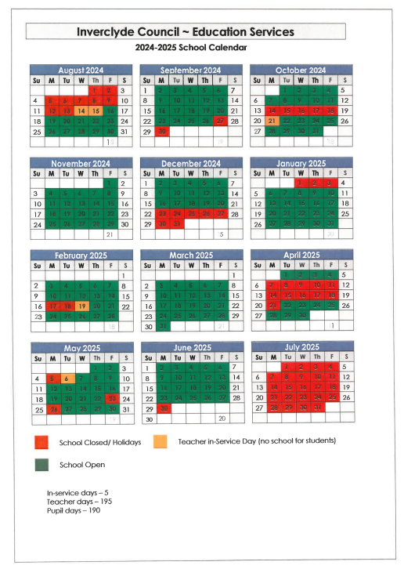
THE SCHOOL, THE COMMUNITY AND FAMILY ENGAGEMENT
Aspirational Statement
There are three interrelated spaces within our school and nursery. The relationship between these spaces influence the experiences of our community when engaging with us. When growing our school and nursery, we intentionally consider these spaces and their relationships.
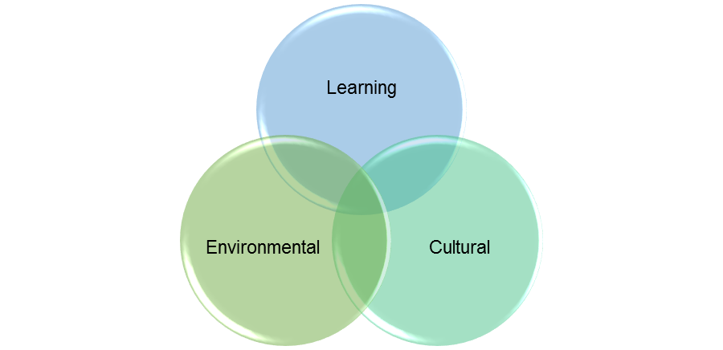

This is what we are constantly striving for:

The Learning Space (our play and learning experiences)
Pupils:
- develop fundamental skills of literacy and numeracy
- develop contemporary skills such as creativity and problem solving that will benefit
- them professionally and personally throughout their lives
- learn and pursue passions through authentic, multi-disciplinary projects, outdoor
- learning and play
- dive deeply into work that matters to them and the world outside the school walls
- create prototypes, products and artefacts that demonstrate and describe their learning journey

Teachers:

- work to address inequities and help all pupils reach their potential
- include feedforward as part of assessment for opportunities to improve
- provide tasks that are visible so that pupils understand the purpose of their learning
- and how they can succeed
- dive deeply into data and self-evaluation to develop their understanding of learners, their practice and their future direction
- partner with pupils and families to develop a love of learning that will last a lifetime

The Environmental Space (our play and learning spaces)
Learning environments:
• promote and support collaboration, comfort and choice
• feature small-group, large-group and individual learning areas
• are learner-centred and functionally designed
• feature natural light, muted tones, clutter-free organisation and limited displays to promote
wellbeing
• are both indoor and outdoor
• encourage play and creativity
• create community and connection through an exploration of local woodlands and coasts
• offer experiences in controlled risk and resilience building

Facilities include:
• project areas
• technology tools
• writeable surfaces to encourage risk taking and prototyping
• shared spaces where artwork, prototypes, and other artefacts of and for student thinking are
created, celebrated and displayed
• community spaces that focus on hospitality, connection and tribe-making
Cultural Space (our interactions)
The community:
• is engaged
• believes their abilities can be developed through dedication and hard work
• views challenges and failures as opportunities to improve their learning and skills
• demonstrates a love for learning and growth fostered through reflective thinking practices
• values and promotes deep connection and empathy through supportive and interlinked tribes
• develops trust through brave and vulnerable conversations and behaviours
• has wellbeing and nurture at the heart of everything they do

Community members:
• have healthy boundaries that make it clear what’s okay and what’s not okay
• can be relied on to do what they say they’ll do
• own their mistakes, apologise, and make amends
• don’t share information or experiences that are not theirs to share
• choose courage over comfort, choose what is right over what is fun, fast, or easy and choose to
practice their values rather than simply professing them
• can ask for what they need and can support others to ask for what they need without judgement.
They can talk about how they feel.
• extend the most generous interpretation possible to the intentions, words, and actions of others

Organisational structures
All children in our nursery and school classes are allocated to a house when they enrol. During special events, pupils wear coloured bibs relating to their house group (siblings will be placed in the same house). The house system helps to promote a sense of belonging for our pupils and also provides an opportunity for cross class friendships and support to develop. House Captains and Vice Captains are elected from our Primary 7 class by our pupils each year, fostering leadership skills.

House colours: Arran red
Bute blue
Cumbrae yellow
Iona green

As well as developing a sense of identity within our school community, we want our children to understand their place in the wider world and to develop ways of contributing to society. One if the ways in which we do this is through fund raising, which is always accompanied by time exploring the need for support and the potential benefits their fundraising can bring. We aim to support one local, one national and one international charity each school session.
Local Community
Wemyss Bay Primary School and Nursery Class serves the local community and provides facilities for community organisations. Under usual operating conditions, a number of activities are available for adults and children throughout the week, including football, Beavers, Cubs and Scouts. We make frequent use of our neighbouring woodlands and beach and have been involved in community beach clean ups and litter picks.
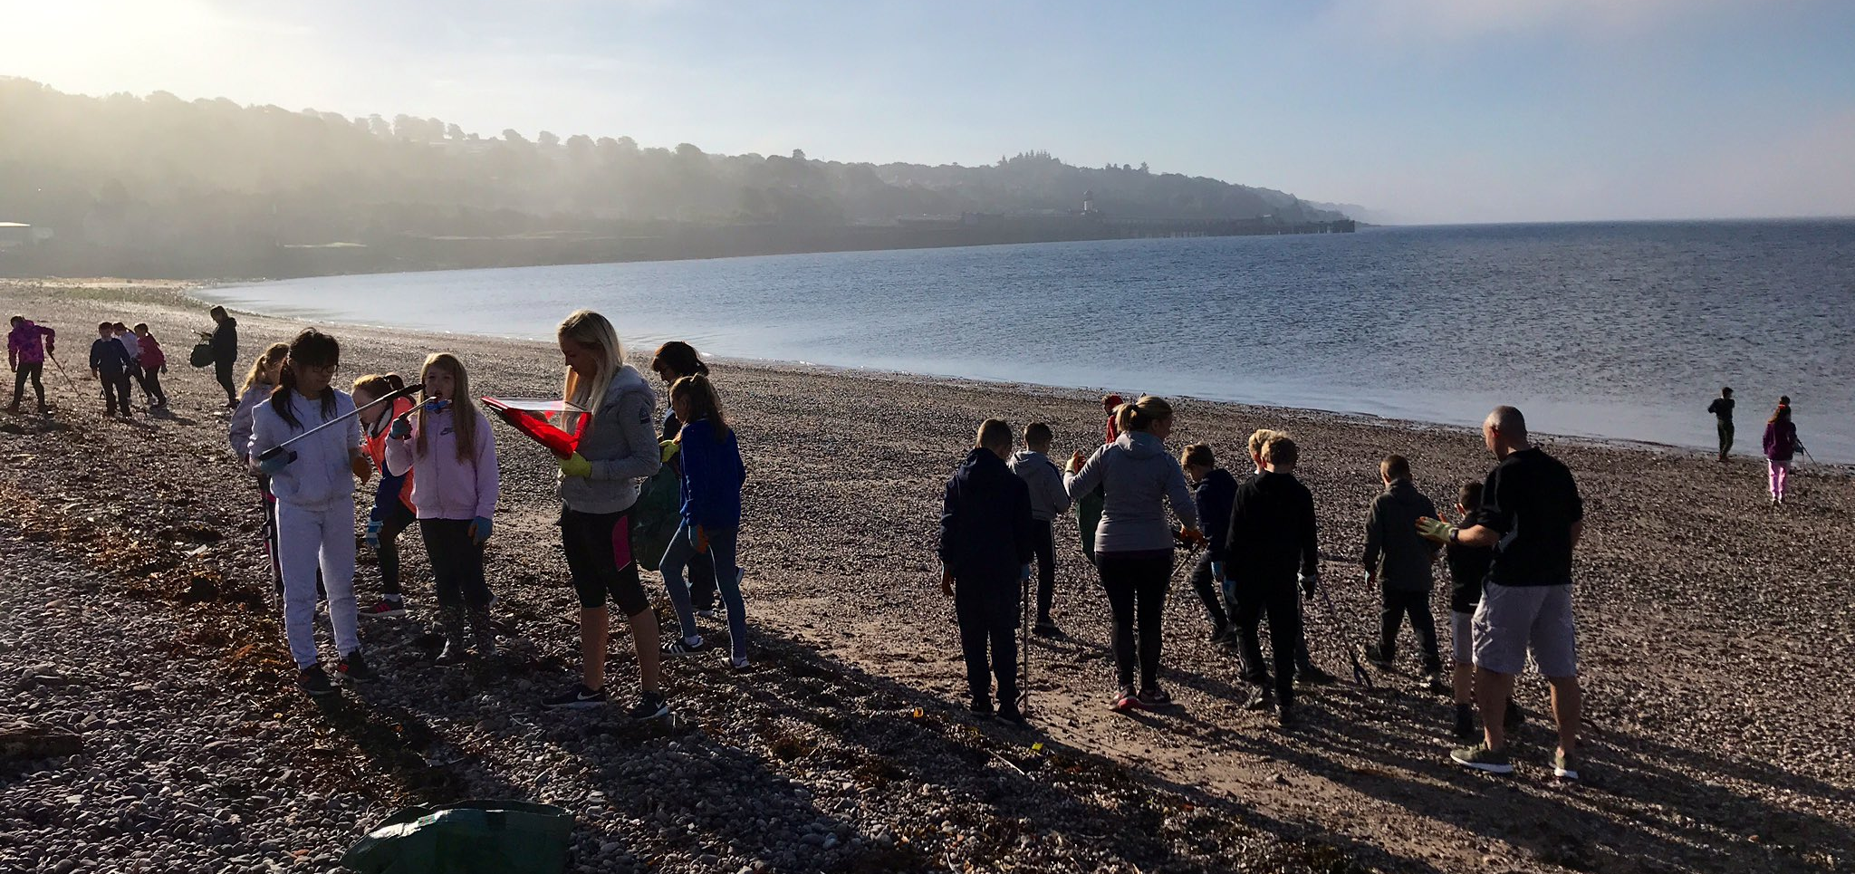

We have strong relationships with our community Police and Community Wardens who help us deliver key safety messages.

Family Engagement
We are keen to promote family engagement and would encourage you to be active participants in the life of the school and in your child’s education and learning. To help families access these opportunities, we aim to notify parents of key dates at the beginning of each school year, and thereafter issue reminders throughout the session via our newsletter (Community Connections), email, text and Twitter. Working with our partners, we hope to increase opportunities for parents to engage in learning with their children. To date, workshops designed to facilitate shared learning experiences have been very positively received, though the current pandemic has impacted on this.
Families can also become involved in our Parent Partnership, which supports our school and nursery in practical and financial way. The opportunity to be part of this group is open to all parents. Please contact the school for further information.
Family engagement is important to our school and our families and children really benefit from positive relationships between home and school.
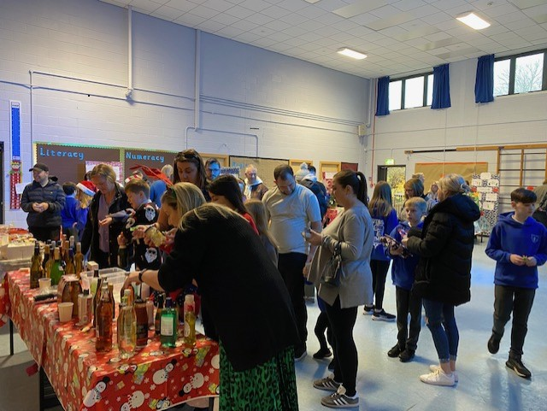

SCHOOL CLUSTER
Whilst each school in Inverclyde is managed by its own Head Teacher and Senior Staff, we are also part of a cluster of schools and establishments, and work together with them to continually improve and develop. Our cluster involves our neighbouring Primary Schools and the associated Secondary School.
Our Cluster consists of:
- Aileymill Primary School
- Inverkip Primary School
- King’s Oak Primary School
- Lady Alice Primary School
- Whinhill Primary School
- Inverclyde Academy
WEMYSS BAY NURSERY CLASS

Wemyss Bay Primary Nursery Class provides pre-school education for children aged 3-5 years in a safe, nurturing and motivating learning environment.
Curriculum
We structure our play experiences within the Curriculum for Excellence framework, and cover experiences and outcomes within the Early Level. We also intentionally consider Realising the Ambition, Setting the Table and My World Outdoors to help guide our provision. Further information and key areas of learning, are discussed further in the “Curriculum” section of our handbook.

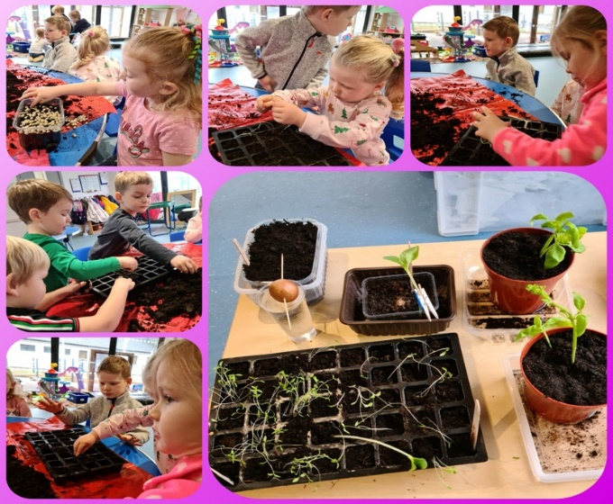

Assessment and Reporting
Every child has a personal profile which is a digital record of their learning, achievements and progress within the nursery class. We call this a learning journal. Staff record observations and learning conversations with children to validate their judgements as to the level of support and additional challenge required by each learner. These profiles can be viewed at any time by parents and parents can contribute to them too.
Parent Meetings and Personal Plans
Within 28 days of your child beginning their placement at our nursery, we will work together to formulate a Personal Care Plan which will ensure we are meeting all personal, social and learning needs of the children in our care. With your support, we will meet either in person, virtually or through a telephone call, to update these plans every 6 months.

Attendance
As in keeping with school arrangements we ask parents to contact the school office on the morning of any
absence.

Nursery Clothing
Nursery uniform is available for those who would like to purchase but please note that this is not a requirement. Please remember that our nursery children are outdoors a lot so clothes will get wet and dirty!

Snacks
We are a health promoting establishment and adhere to guidelines regarding Early Years Nutrition offering
Snacks such as fruit, toast, ceral and crackers with cheese, along with a choice of water or milk. It is important any allergies are relayed to staff at the earliest point. As is the case within our school, our nursery is strictly a nut free zone. Lunches are available for all nursery children. Alternatively, children may bring a packed lunch.

Arrival and departure from nursery
Children should be brought to and collected from nursery by an adult over the age of 16. Please let nursery staff know if you have made alternative arrangements for your child and the adult collecting is not someone known by nursery staff.

Nursery Session Times
Entry from 9.00am
Finish from 3.00pm
Slight adjustments to these times are possible and can be negotiated with the Nursery Depute.

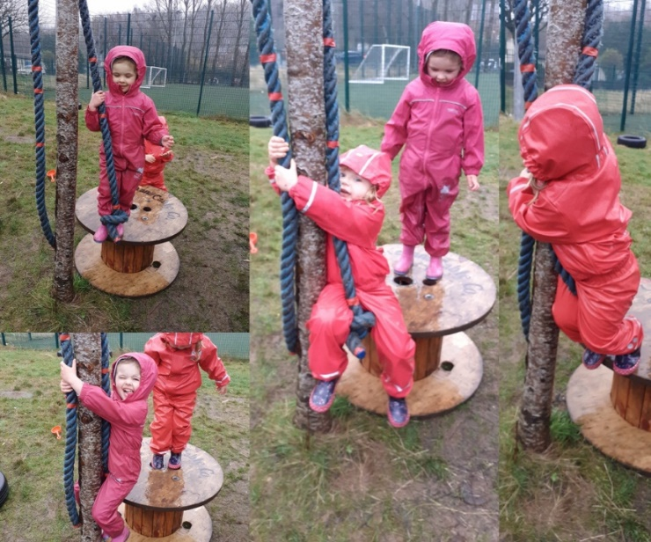

1140 Hours Early Learning and Childcare
From August 2020, families are entitled to 1140 hours of funded childcare where there is a child of 3 or 4 year old. This is on a pro-rata basis depending on the child’s birthday and intake. In Inverclyde your child will be entitled to start the first available Monday in the month after their birthday, e.g. if your child turns three in September they will receive their funded hours from the October.
All early learning and childcare places are allocated by using the Early Year’s Admission policy. Inverclyde Council uses defined areas rather than school catchment areas and priority will always be higher for applications in the defined area of the establishments. There is no guarantee of places within any defined area. For local authority establishments the application form is set out in defined areas. If there are more applications than places available the banding policy is applied to each application and a ballot conducted to allocate places when required. We will always work from your choices form. If you cannot be placed in one of your choices, you may be offered an ELC place with the availability from an establishment within your defined area that you may not have chosen or a model you may not have indicated on your form.

Nursery entry dates:
Wemyss Bay Nursery Class offers sessions for children in their ante pre-school and pre-school year. Nursery application forms are available from the school office and should be returned there when completed.

Birth date Admission Date

1st March – 31st August: At start of term in August and before the last day of August
September: October
October: November
November: December
December: January
January: February
February: March
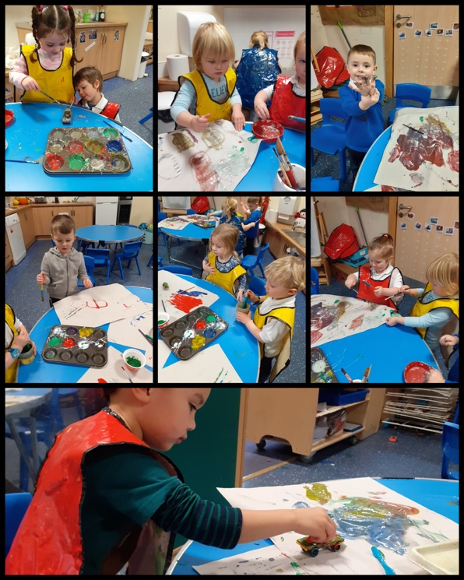

ENROLMENT OF PUPILS TO PRIMARY 1
Children by law are entitled to start their formal education at the beginning of the session in August if they are five years of age on or before the last day of February of the same school session.
Inverclyde Council has changed the way in which children register for primary school. This process will now be undertaken by completing an online application form which can be found on the Inverclyde Council website at http://www.inverclyde.gov.uk/p1-registration
It’s vitally important that parents follow the online registration process to register their child for a Primary 1 place in an Inverclyde school.
Children who reach the age of five years between 1 March 2024 and 28 February 2025 are due to start Primary 1 at the beginning of the new school term in August 2024. Parents are asked to register their child in their chosen denominational or non-denominational catchment primary school, from Monday 8th January 2024 - Friday 12th January 2024.
Once parents have completed the Primary 1 registration, they will have the choice to complete a placing request application to a school other than the catchment primary (This includes Primary 1 Gaelic Medium education at Whinhill Primary School). A deferred entry application is also available to parents considering deferring their child’s entry to Primary 1 in August 2024.
No documents will be required at this stage; however, we may have to contact you, should we require further information.
Parents will be notified by 30 April 2024 confirming their child’s place in school and information regarding induction days will follow from the school after this date.
Parents who do not have internet access to apply online, are asked to contact their child’s current Early Years Establishment for assistance.
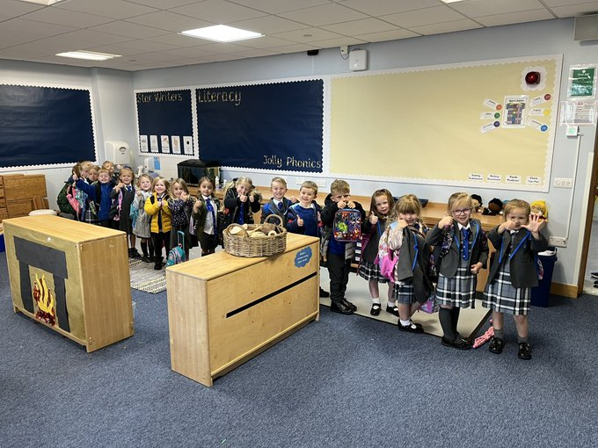
Our transition programme from early years to Primary 1 ensures that the change from nursery to primary school is as smooth as possible and supports continued learning and progress.

We invite the new P1 entrants and their parents to visit the school on a number of occasions during the summer term. This allows the children to get to know each other, as well as the school staff, and to become familiar with the Primary School environment. At this time, we give parents more information about Wemyss Bay Primary school and about Primary 1 in particular.

TRANSFER FROM PRIMARY SCHOOL TO SECONDARY SCHOOL
Pupils are normally transferred between the ages of 11 ½ and 12 ½, so that they will have the opportunity to complete at least 4 years of secondary education. Parents will be informed of the arrangements no later than December of the year preceding the date of transfer at the start of the new season.

The secondary school associated with Wemyss Bay Primary School is:
Inverclyde Academy
Cumberland Rd,
Greenock
PA16 0FB
Tel: 01475 715100

There is no denominational primary school within the areas of Wemyss Bay. Parents often choose to send their children to the local non-denominational primary school because of the travelling distance to their nearest denominational primary school but wish their child to attend a denominational secondary school. In such circumstances the following admission arrangements will apply:
Only those children who have a certificate of baptism into the Roman Catholic faith before entry to primary school, whose parents have selected to send their child to the nondenominational school serving the defined catchment area assigned to their address rather than to their assigned denominational primary school because of travelling distance, will have the choice at Primary 7 of seeking admission to the denominational school assigned to their address.
The local denominational secondary school is:
St. Columba’s High School
Fletcher Ave,
Gourock
PA19 1TP
Tel: 01475 715250
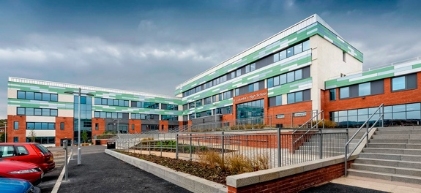
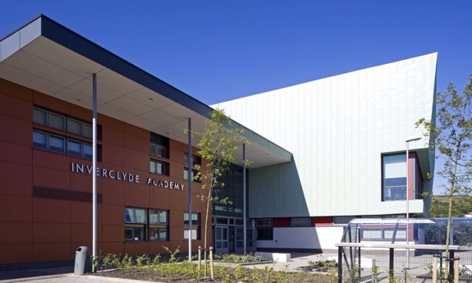
The strong links we have with both Inverclyde Academy and St. Columba’s High School ensure that the progression to secondary education is as smooth as possible and supports continued learning and progress. There are a number of opportunities for our Primary 7 pupils to become familiar with the staff and building of their chosen secondary school during their Primary 7 year.

SCHOOL IMPROVEMENT AND ACHIEVEMENT
Information about the main achievements and successes of the school over the past year can be found in our Standards and Quality Report 2022-2023, which can be accessed from our school website, and details our successes and achievements. Our School Improvement Plan can also be accessed from our school website, and details our priorities for planning for improvement.
Through our consistent approaches to self-evaluation for continued improvement there is an ethos of shared commitment to collaborative working in Wemyss Bay Primary School and Nursery Class. All staff are highly committed to school improvement and the raising of standards to ensure equity and excellence for our learners. This commitment and focus means that throughout the school most of our children are on track to achieve the expected Curriculum for Excellence levels.
Our parents and pupils are fully involved in the evaluation of how well we are doing as a school and how we can continue to improve. They are often asked to contribute their views at various times - during meetings, at parents’ events, and by survey. The Parent Council, known as our Parent Partnership, is a great asset to the school in terms of consultation, often acting as an initial sounding board for ideas and improvement planning. We have been working hard to enhance the contributions of our pupils to improving the school. There are various Pupil Voice Groups who contribute to the improvements planned for the school, including our Pupil Partnership, the Rights Respecting School Group, our STEM group, our Wellbeing Group and our Outdoor Learning / Eco Team. We value partnership working and the views of all our school community to help us continue to improve as a school serving our community.
CURRICULUM FOR EXCELLENCE
The curriculum framework for all Scottish educational establishments 3-18 is called Curriculum for Excellence. It is designed to provide the breadth and depth of education to develop flexible and adaptable young people with the knowledge and skills they will need to thrive now and in the future. It aims to support young people in achieving and attaining the best they possibly can to become successful learners, confident individuals, responsible citizens and effective contributors.
During the broad general education, children and young people should:
• achieve the highest possible levels of literacy, numeracy and cognitive skills.
• develop skills for learning, skills for life and skills for work.
• develop knowledge and understanding of society, the world and Scotland's place in it.
• experience challenge and success so that they can develop well-informed views and the four capacities.

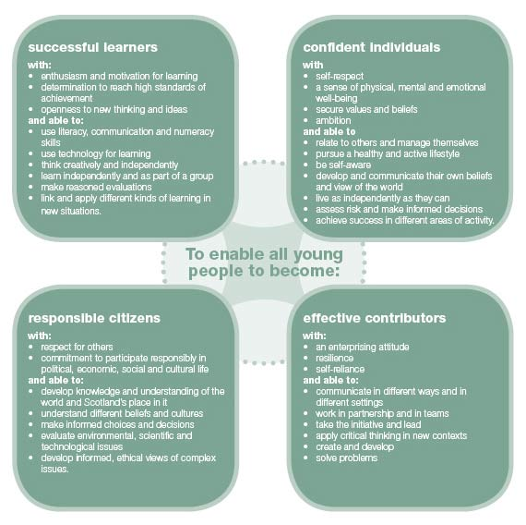

The experiences and outcomes under Curriculum for Excellence are written at five levels, with progression to qualifications described under the senior phase.
- Early Level – the pre-school years and P1, or later for some
- First Level – to the end of P4, but earlier for some
- Second Level – to the end of P7, but earlier for some
- Third and Fourth – S1 to S3, but earlier for some
- Senior phase – S4 – S6 and college or other means of study
In Wemyss Bay Primary School and Nursery Class, learning is organised to encourage progression from one stage of learning to another. Teachers begin from where the child is and build upon his/her existing knowledge and skills. Active learning, with a focus on play pedagogy in the early years, is very important. Children work in groups, pairs and individually. When pupils change classes, teachers liaise with one another to ensure children progress from year to year.
The following sections outline the eight main curriculum areas, through which learning and teaching are planned to meet the principles for curriculum design: challenge and enjoyment, breadth, progression, depth, personalisation and choice, coherence and relevance.

The curriculum areas:
- Literacy and English
- Numeracy and Mathematics
- Health and Wellbeing
- Expressive Arts
- Sciences
- Social Studies
- Technologies
- Religious and Moral Education (Religious Education in Roman Catholic Schools)

The focussed areas of learning are detailed for each class in a termly bulletin issued by class teachers.

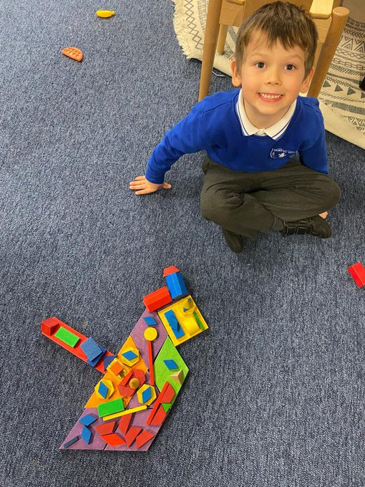
Languages
Literacy and English
“Language and Literacy are of personal, social and economic importance. Our ability to use language lies at the centre of the development and expression of our emotions, our thinking, our learning and our sense of personal identity”
Curriculum for Excellence, May 2009

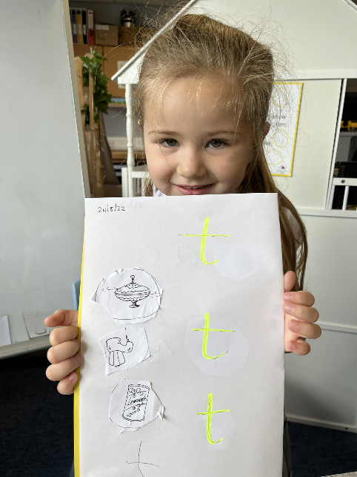
There are two main aspects of the languages area of the curriculum. The first aspect covers experiences and outcomes in the language a young person needs to engage fully in their learning and in society - whether that is English, Gaelic or, for young people who need additional support, the means of communication which enables them to communicate most effectively. The second aspect covers experiences and outcomes in a modern language. In Wemyss Bay, French is taught throughout the school, with Spanish being introduced at Second Level. French and Spanish words and phrases are used across the curriculum and children learn through listening and talking, games and songs.
Language is at the core of thinking. We develop our ideas, communicate and reflect through language. Language and the development of literacy skills help young people achieve their potential and become active members of society who can contribute through their ideas and work. In Wemyss Bay, we foster a love of reading. Literature opens up new horizons, and a love of reading can be an important starting point for lifelong learning. We have a range of books available to children in class and in the school library. Talking and listening for thinking is developed across all stages in the school and is used in every curricular area. The teaching of writing takes place within the area of language but also in many other curricular areas. We develop skills in spelling, punctuation and grammar as well as creative and expressive language. Pupils re encouraged to write with an increasing degree of independence, improved organisation and audience awareness.

Numeracy and Mathematics
“Mathematics is important in our everyday life, allowing us to make sense of the world around us and to manage our lives. Using mathematics enables us to model real-life situations and make connections and informed predictions. It equips us with the skills we need to interpret and analyse information, simplify and solve problems, assess risk and make informed decisions.”
Curriculum for Excellence, May 2009
Pupils progress through activities designed to equip children with skills required for life, learning and work. At all stages, we aim to make learning in numeracy and maths as active possible and linked to real-life, practical situations.

Mathematics includes specific aspects of numeracy which will be developed both in mathematics and through activities in other areas of the curriculum. Learning in numeracy and mathematics involves a variety of topics organised under 3 main headings:

- Number and number processes
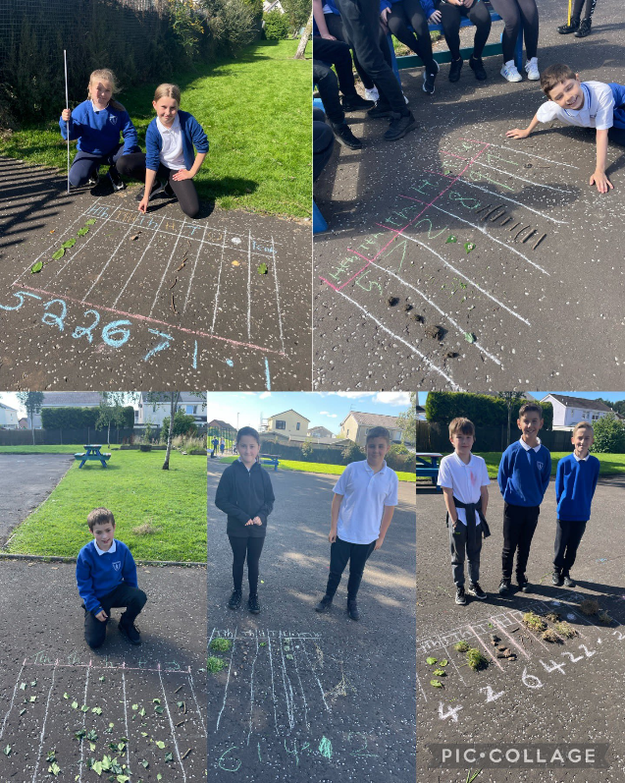
- Multiples, factors and primes
- Powers and roots
- Fractions, decimal fractions and percentages
- Money
- Time
- Measurement
- Mathematics – its impact on the world, past, present and future
- Patterns and relationships
- Expressions and equations
- Shape, position and movement
- Properties of 2D shapes and 3D objects
- Angle, symmetry and transformation
- Information handling
- Data and analysis
- Ideas of chance and uncertainty

Active Learning opportunities are provided, to allow pupils to improve and deepen their understanding of mathematical concepts. Pupils have the chance every day to engage with Number Talks, allowing them to articulate their strategies for solving number based problems in both familiar and unfamiliar contexts.

Health & Wellbeing
“Learning in Health and Wellbeing ensures that children and young people develop the knowledge and understanding, skills, capabilities and attributes that the need for positive mental, emotional, social and physical wellbeing, now and in the future.”
Curriculum for Excellence, May 2009
Health and wellbeing includes experiences and outcomes for personal, emotional, mental and social development, physical education, physical activity and sport, food and health, substance misuse, planning for choices and change and relationships, sexual health and parenthood.
In Physical Education a balanced programme in Gymnastics, Games Skills and Active Health is provided. At various times in the year the children’s physical education is enhanced by visiting coaches in a number of areas, for example; football, cricket, rugby, tennis, hockey and basketball, supported by our close working with Active Schools. In addition, Primary 4 pupils experience a ten week block of swimming lessons. Parents should note that health and safety requirements state that jewellery of any kind must not be worn where pupils are undertaking games or physical activities. This includes jewellery worn as a result of body piercing. We would ask that parents discourage pupils from having body piercing during term time to ensure full participation in physical education.
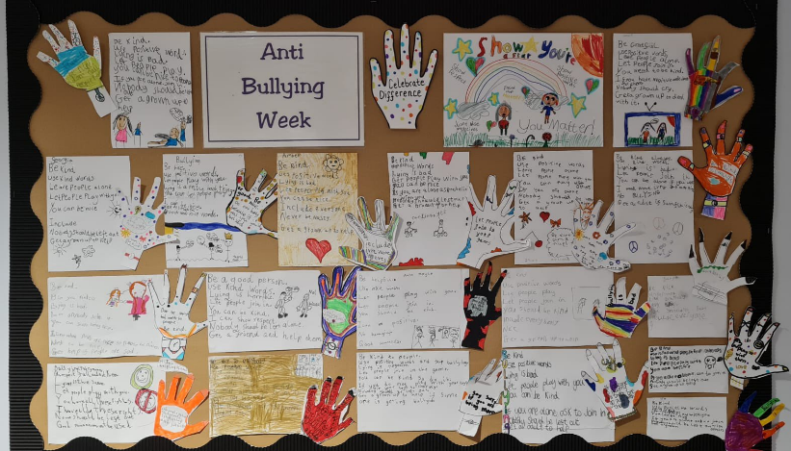
Children and young people need to experience what it feels like to develop, enjoy and live a healthy lifestyle. A healthy lifestyle supports physical, social and emotional wellbeing, and underpins successful learning. Learning in health and wellbeing ensures that children and young people develop the knowledge and understanding, skills, capabilities and attributes which they need for mental, emotional, social and physical wellbeing now and in the future.
We benefit from close working with our partners who enhance the learning experiences of our pupils by delivering workshops in Drug Awareness, Healthy Eating and Cyber Safety.
Sexual Health and Relationships Education is an integral part of our programme. Teachers are central to the delivery of the sessions with parents fully informed of the content of the lessons.
Expressive Arts
“The inspiration and power of the arts play a vital role in enabling our children and young people to enhance their creative talent and develop their artistic skills”
Curriculum for Excellence, May 2009
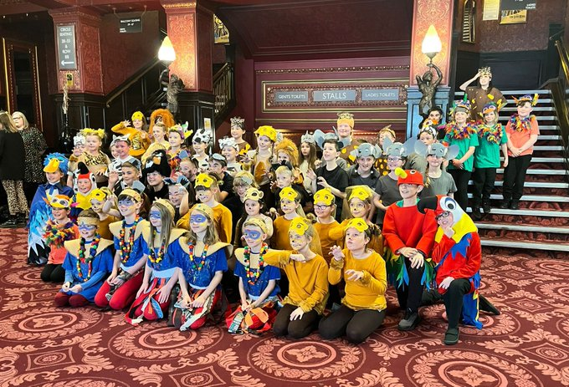
The expressive arts include experiences and outcomes in art and design, drama, dance and music. Through the expressive arts, children and young people have rich opportunities to be creative and imaginative.
The music programme for the school is based upon the ABC music resource. In addition to this, we are fortunate to have three music specialists who teach strings, brass and signing to selected groups of pupils.
Art and design includes drawing, painting and using a variety of materials, media and techniques to investigate visually and record.
Within drama, children are encouraged to participate in improvisation, role play, characterisation, simulation and creative movement.
Children experience a range of dance styles, including Scottish Country Dance.
Sciences
“Through learning in the sciences, children and young people develop their interest in and understanding of the living, material and physical. They engage in a wide range of collaborative investigative tasks, which allows them to develop important skills to become creative, inventive and enterprising adults in a world where the skills and knowledge of the sciences are needed across all sectors of the economy.”
Curriculum for Excellence, May 2009
Science includes experiences and outcomes in biological, chemical, physical and environmental contexts. We aim to stimulate, nurture and sustain the curiosity, wonder and questioning of children, supporting children in their endeavour to make sense of the world. They develop ideas through play, investigation, first-hand experience and discussion. Children are encouraged to ask searching questions based on their everyday observations and experiences of living things, the environment, materials, and objects and devices they interact with.
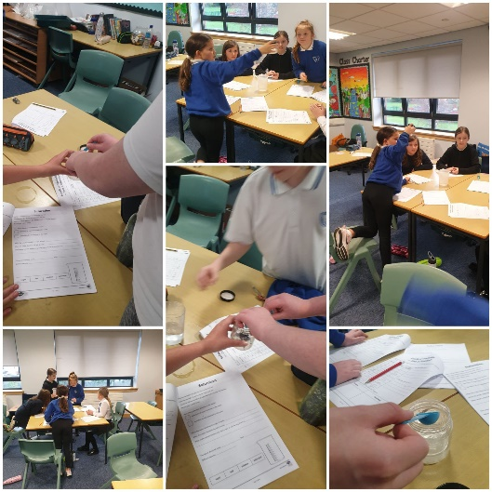
Social Studies

“Through Social Studies, children and young people develop their understanding of the world by learning about other people and their values, indifferent times, places and circumstances; they also develop their understanding of their environment and of how it has been shaped.”
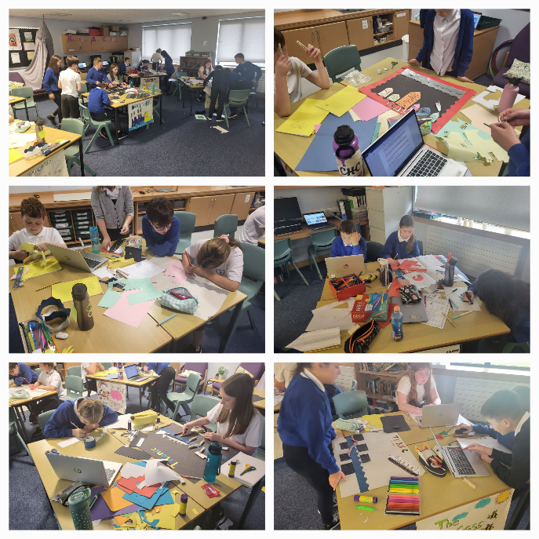
Curriculum for Excellence, May 2009
Social studies include experiences and outcomes in historical, geographical, social, political, economic and business contexts. It is important for children and young people to understand the place where they live and the heritage of their family and community. They learn about human achievements and to make sense of changes in society, conflicts and environmental issues. With greater understanding comes the opportunity to influence events by exercising informed and responsibe citizenship. This area of the curriculum is supported by educational visits to linked experiences. Teachers use Social Studies topics to build inter-disciplinary links across subjects and to make learning more relevant and coherent.

Technologies
“Learning in the technologies enables children and young people to be informed, skilled, thoughtful, adaptable and enterprising citizens.”
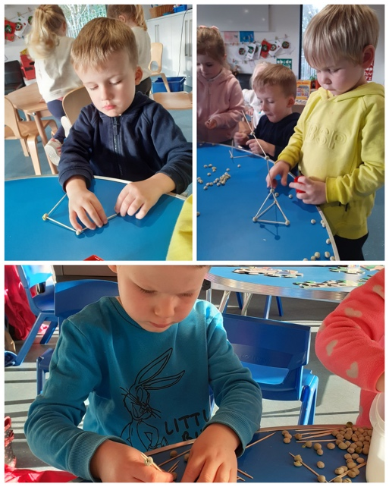
Curriculum for Excellence, May 2009
This curriculum area includes creative, practical and work-related experiences and outcomes in craft, design, engineering, graphics, food, textile, and information technologies. To participate fully in modern life, children and young people need to be skilled and knowledgeable users of technologies and be ready to embrace further developments in the future. The technologies consider how knowledge can be applied for practical purposes. They provide exciting opportunities to develop children’s creativity and the enterprising attitudes which Scotland needs, not least to compete in a global economy. Technologies are developing at an unprecedented rate. Such dramatic change brings risks as well as benefits, and children and young people need to be able to assess the impact of technologies so that they can take action in an informed way.

Religious and Moral Education
“Religious and moral education enables children and young people to explore the world’s major religions and views which are independent of religious belief, and to consider the challenges posed by these beliefs and values.”
Curriculum for Excellence, May 2009
In Wemyss Bay Primary School, pupils are encouraged to recognise faith as an important expression of the human experience and are helped to become aware of the values, beliefs and practices of various religious traditions within and beyond our community. We celebrate major festivals together and invite representatives of faith groups to share their experiences with us.
Parents have the right to withdraw their children from instruction or assemblies if they so wish by informing the Head Teacher.
Parents from specific religious communities may requests that their children be permitted to be absent from school in order to celebrate reconsider religious events. Written requests detailing the proposed arrangements will be considered and granted on no more than three occasions in one school session and the child shall be noted as an authorized absence in the register.

OUTDOOR LEARNING
Outdoor Learning is an important and integral part of our curriculum offer.
Why Outdoor Learning?
Research clearly shows that Outdoor Learning had the following benefits to human health:

• enhanced personal and social communication skills
• increased physical health
• enhanced mental health
• enhanced sensory and aesthetic awareness
• the ability to assert personal control and increased sensitivity to one's own well-being
Outdoor learning also helps young people to:
• develop self-esteem, take personal responsibility, cooperate with and respect the needs of others
• extend their personal horizons through greater appreciation and understanding of the world
• understand the need for sustainable relationships between people and their environment
• enhance practical problem solving and team-work skills
• promote a positive and knowledgeable response towards personal health and well being

Most importantly, Outdoor Learning can significantly improve pupil attainment in literacy and numeracy. First, it improves pupil engagement in school. Children love to play and learn outdoors. When pupils are more engaged, they learn more effectively and as a result increase their attainment. Secondly, Outdoor Learning provides a much-needed context for literacy and numeracy tasks. When pupils complete tasks related to real-life, authentic contexts, they perform better. For example, pupils will perform better when writing about an Outdoor Learning experience (a recount), or preparing for an Outdoor Learning Experience (an instructional text) than if they were to complete a written task without an authentic context. Thirdly, Outdoor Learning improves physical and mental health. Children learn less effectively when they are experiencing health issues or are feeling anxious or uncomfortable.

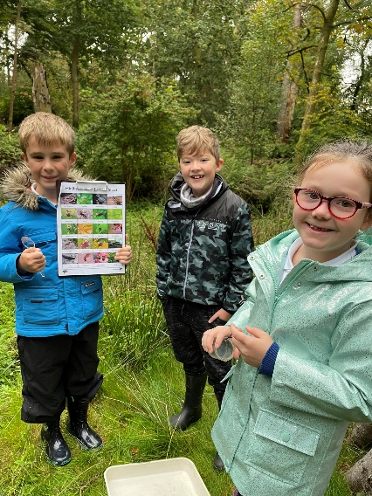
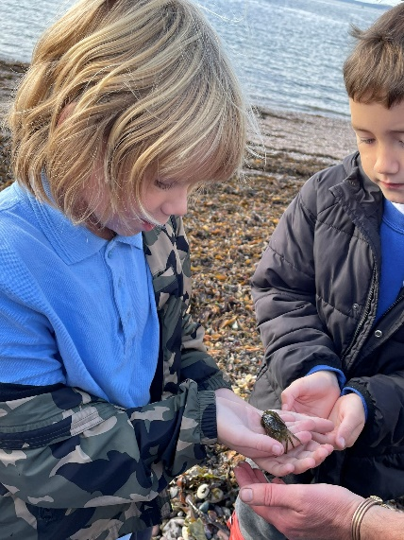
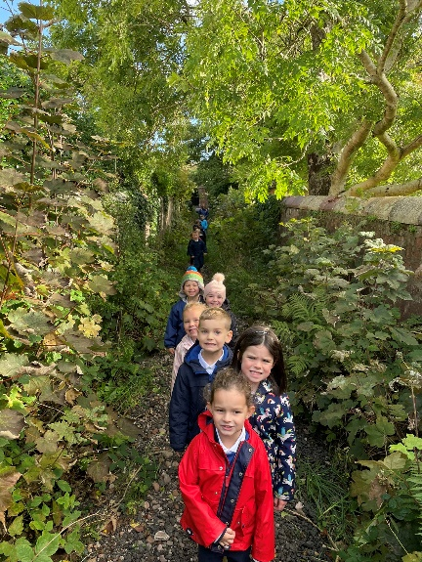

What can Outdoor Learning look like?
In the early years, Outdoor Learning is directed by leaders and teachers for a specific purpose. The children have freedom to explore within these boundaries. Children may explore an environment to learn a concept around relationships or as a provocation for a writing task. They can also engage in many hands-on numeracy activities in these locations. Children can also engage in play, an essential part of development and the foundation to effective learning and attainment.

In the older years, children may also participate in directed experiences, but they also may be able to learn independence through less structured activities. They may be able to use some of their Outdoor Learning time to complete a task of their own choosing. They will negotiate this task with their teacher to ensure that it improves their learning in the curriculum areas the class is focusing on.

Our staff regularly engage in professional learning and dialogue around Outdoor Learning and we evaluate our offering to support our ongoing improvement.
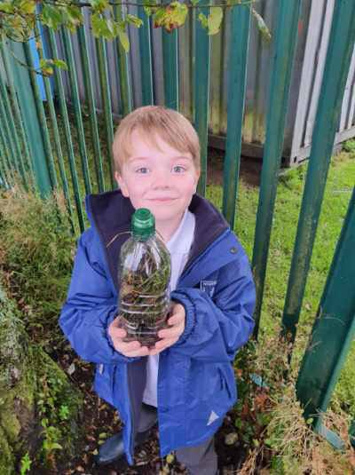
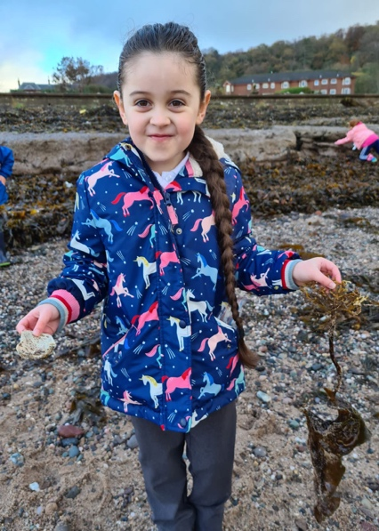

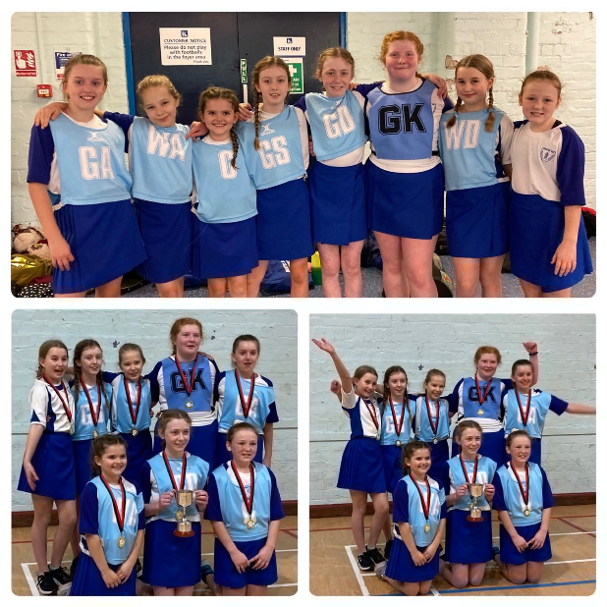
EXTRA-CURRICULAR ACTIVITIES
The school is involved in various extra-curricular activities throughout the year with opportunities for our pupils to attend after-school coaching in a variety of activities run by Active Schools, school staff or volunteers. These include football, netball and athletics. The School Athletics Team and Netball Team participate most successfully in various local competitions. Active Schools also run multi-skills classes during lunch times for our infant classes.
At various times throughout the year, there can also be opportunities to develop skills in other areas such as singing, craft and drama. We also delight in the achievements of our pupils outside of school, recognising their contribution to the overall development of our pupils.
ASSESSMENT AND PROGRESS
Teachers carry out continuous assessment in all subjects. Teachers use their professional judgement to assess pupils on a daily basis to help plan for next steps in learning and teaching. Pupils are fully involved in identifying and setting targets. Most assessment takes place through formative assessment where teachers involve pupils in thinking about their own learning and progress. Teachers are constantly monitoring and assessing the progress of pupils through:
- Observations
- Oral tasks and feedback
- Written tasks and feedback
- Practical activities
- Standardised tests
A variety of other diagnostic tools are used to identify and support any challenges that may arise for some children at times in their education. Our aim is for all pupils to make appropriate progress.
Pupils in P1, P4 and P7 are also assessed using a computer-based programme called the Scottish National Standardised Assessments (SNSA). These assessments are completed online, as part of everyday learning and teaching, in reading, writing and numeracy. SNSAs provide additional information to help support teachers’ professional judgement about how well children are progressing. They also help us to track our pupils’ progress from P1 through to P7. Data from across Scotland on achievement of the Curriculum for Excellence levels is reported to the Scottish Government annually. More details of this can be found on the Parentzone website: https://education.gov.scot/parentzone/.
REPORTING TO PARENTS
Written reports are issued to parents in the March or April each year. Reports are also given orally twice a year during parents’ evenings (ordinarily in October and March). Children also showcase their learning at various times throughout the year during which parents are welcomed into school as restrictions allow. Parents are able to make an appointment to discuss their child’s progress at any time. Parents of children with an additional support need also have additional review meetings at appropriate times throughout the year.
HOMEWORK
Homework is given to reinforce and enhance aspects of learning in a variety of subjects. We believe homework is valuable for creating and maintaining a successful partnership between home and school and so we encourage parents to participate in homework activities with children. The suggested time spent on homework activities depends on the age of your child. Homework should take no more than 20 minutes per night in the P1-P3 classes, and no more than half an hour in the P4-P7 classes. Each Class Teacher will make sure that children and parents/carers understand the homework activities given. Homework as currently set on Teams for P4 – P7, with hard copies for younger children and where this is preferable for families.
SUPPORT FOR PUPILS
All children and young people need support to help them learn. The main sources of support in schools are the staff who, through their normal practice, are able to meet a diverse range of needs. With good quality teaching and learning and an appropriate curriculum, most children and young people are able to benefit appropriately from education without the need for additional support. Some children require additional support at different stages through school. The definition of additional support is a wide one and it is not possible to provide an exhaustive list of all possible forms of additional support, but could include:

- children who have a disability
- children with social, emotional and behavioural needs
- children with learning needs of a specific or general nature
- children who require challenge
- those who demonstrate underachievement relating to gender issues
- children whose learning has been interrupted through absence or illness
- children who have English as an additional language
- children from travelling families
- children whose family circumstances impact on attendance and learning.

Our Depute Head Teacher is our Additional Support Needs Leader whom parents should speak to if they think that their child requires additional support in school.
As with all local authority schools in Scotland, Wemyss Bay operates under the terms of the Additional Support for Learning Act (2009) and the accompanying Code of Practice. These procedures have been strengthened through the Children and Young People Act (2014). Therefore, a child or young person’s needs are identified at the earliest possible stage and can be met in a number of ways, for example by adaptations to the curriculum or learning environment, as well as input from the Support for Learning Teachers and, on occasion, support from visiting specialists such as our Educational Psychologist, School Health or the Inverclyde communication Outreach team. The appropriateness of the support is determined through a process of assessment, planning and monitoring, working jointly with children, parents and teachers and is reviewed regularly.
Learning outcomes for children and young people with additional support needs are set out in a plan and then reviewed at meetings with parents to determine any needs and the most appropriate supports. Everyone’s views, including the child’s, are equally important in order to consider what is currently working and how to determine next steps.

Children’s needs are identified in a number of ways, and the process of assessment is an ongoing, shared process in partnership with parents at the forefront. On some occasions, health service staff or other partner agencies will make children known to Education Services. Other additional support needs may be notified to Education Services by parents themselves or identified by one of a range of staff working closely with the child.
Some children will have additional support needs that arise from complex or multiple factors and require a high degree of co-ordination of support from both education and other agencies in order that their needs can be met. In these cases, the school will hold a meeting to decide whether the child or young person meets the criteria for a co-ordinated support plan. The coordinated support plan is a statutory document which ensures regular monitoring and review for children and young people who have one.

You have the right to ask the education authority to establish whether your child needs a coordinated support plan. You and your child, if they want to, will attend a meeting with staff at school. Other professionals from different agencies who may be involved in providing support for your child will also attend. If your child does not want to attend meetings or feels unable to, their views must still be sought and considered. Further information about additional support needs can be found on the Parentzone website: https://education.gov.scot/parentzone/additional-support/.

Inverclyde’s mediation service can be accessed by contacting Mr Michael Roach, Head of Education, at the address below.

For further advice please telephone 01475 712850.
Or write to:
Education Services
Wallace Place
GREENOCK, PA15 1JB

These organisations can supply further information and support to parents of children and young people with Additional Support Needs

(a) Children in Scotland: Working for Children and Their Families, trading as “Enquire – the Scottish advice and information service for additional support for learning”, a charitable body registered in Scotland under registration number SC003527; www.enquire.org.uk
(b) Scottish Independent Advocacy Alliance, a charitable body registered in Scotland under registration number SC033576; www.siaa.org.uk
(c) Scottish Child Law Centre, a charitable body registered in Scotland under registration number SCO12741.” www.sclc.org.uk/

PASTORAL CARE
The school has a strong tradition of pastoral care for pupils and for their families. The ethos of the school is such that caring is a natural element in our daily interaction with our pupils. All our staff members make time to get to know pupils and their families and we make every effort to be an inclusive school.
We work closely with our associated nurseries and secondary school to support our children in the transition period from nursery to primary, and from primary to secondary. Our Home Link worker helps families who require additional support. She also works with groups of children in school to support them in the transition to secondary school. There are also other agencies who work with our school from time to time to help pupils and parents, for example, Barnardo’s and Action for Children.
SUPERVISION OF PLAYGROUNDS
The safety of our pupils is our priority. An adult presence is provided in playgrounds at break times in terms of the schools (Safety and Supervision of Pupils) (Scotland) Regulations, 1990. The Janitor and Support Staff carry out these duties to help keep children safe and to deal with any injuries that may occur while children are playing. The playground is currently supervised from 8.55am and during all intervals and lunch breaks.
PROMOTING POSITIVE RELATIONSHIPS AND BEHAVIOUR
We strive at all times to promote positive relationships and behaviour across the school. This is highlighted in and promoted through our School Values. Respectful standards of behaviour are necessary for a pleasant and safe environment for our children to get the best from their education. We therefore expect our children to strive for the standards of behaviour that are necessary to promote this pleasant and safe environment. In encouraging our children to show respect for themselves for others and for property, we are promoting positive relationships and positive behaviour. School rules are made in the interest of, and for the well-being and safety of all of our children. We rely on our parents to support us in this endeavour so please encourage your child to respect and respect our values and adhere to our rules. Strong partnership working between home and school is essential to allow our children to continue to learn in the positive environment that Wemyss Bay enjoys.
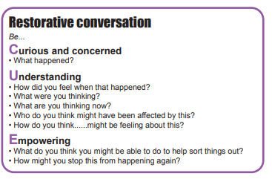
Our school uses restorative approaches to handle any issues of conflict where children are encouraged to take responsibility for their actions and support one another in moving forward with respect. We aim to seek solutions to any conflicts which may arise. Our school follows Inverclyde’s Positive Relationship Policy. Instances of inappropriate or challenging behaviour are dealt with in line with Inverclyde policy and parents are kept fully informed.

BASIC SECURITY PRACTICES
In the interest of security, the following practices have been adopted:
- After pressing the security buzzer for reception all visitors should use the main entrance only and must report to the school office on arrival. Other school entrances are for pupil or staff use only.
- All visitors are required to sign the Visitors’ Book – both in and out – and are asked to wear a visitors’ badge during their visit.

CLOTHING & UNIFORM
In Wemyss Bay, there is substantial parental support for school uniform. Given that there is substantial parental and public approval of uniform, schools in Inverclyde are free to encourage the wearing of school uniform. In encouraging the wearing of uniform, account is taken of any proposals to prevent any direct or indirect discrimination on the grounds of race or gender. Any proposals will be the subject of widespread consultation with the parents and pupils. Against this background it should be noted that it is the policy of the Education & Lifelong Learning Committee not to insist on pupils wearing uniform or having specialist items of clothing as a prerequisite of their attending and engaging in all of the activities of the curriculum.

There are forms of dress which are unacceptable in school, such as items of clothing which:
- potentially, encourage faction (such as football colours)
- could cause offence (such as anti-religious symbolism or political slogans)
- could cause health and safety difficulties, such as loose fitting clothing, dangling earrings or clothing made from flammable material for example shell suits in practical classes
- could cause damage to flooring
- carry advertising, particularly for alcohol or tobacco
- could be used to inflict damage on other pupils or be used by others to do so

The Council is concerned at the level of claims being received regarding the loss of pupils’ clothing and/or personal belongings. Parents are asked to assist in this area by ensuring that valuable items and unnecessarily expensive items of clothing are not brought to school. Parents should note that the Authority does not carry insurance to cover the loss of such items and any claims submitted are likely to be met only where the Authority can be shown to have been negligent.
Parents should note that the activities the children may become involved in may be restricted because health and safety requirements state that jewellery of any kind must not be worn where children are undertaking physical activities. This includes jewellery worn as a result of body piercing.
Parents of children receiving one or the following benefits will normally be entitled to monetary grants for footwear and clothing for their children:
- Income Support (IS)
- Income Based Job Seekers Allowance (JSA)
- Income related Employment and Support Allowance (ESA)
- Child Tax Credit, but not Working Tax Credit and have an income of less than £16,105 in 2020/2021 as assessed by HMRC
- Parent is in receipt of Working Tax Credit and/or Child Tax Credit with annual gross earnings of no more than £11,665
- Universal Credit, where your take home pay does not exceed £951, as shown on your most recent monthly Universal Credit statement
- An asylum seeker, receiving support under Part VI of the Immigration and Asylum Seekers Act 1999
or
- You look after a child/children as part of a FORMAL Kinship Care agreement, registered by Social Work Services.
Although all children are entitled to receive a free school meal, parents who are entitled to a grant to assist with clothing still have to apply for a clothing grant. An application form will still require to be completed and the appropriate household income evidence submitted.
Approval of requests for such grants made by parents in different circumstances is at the discretion of the Corporate Director Education and Social Care. Information and application forms may be obtained from schools and from Education Services, 105 Dalrymple Street, Greenock, PA15 1HU.
A list of uniform for your reference is shown below:

White Shirt/Blouse or Polo Shirt
Grey Trousers or Skirt/Pinafore
School tie
Royal Blue Pullover/Jumper/Sweatshirt/Cardigan
(Please note that hoodies may only be worn by Primary 7 pupils and the school will issue information on this to P7 families during the school year).

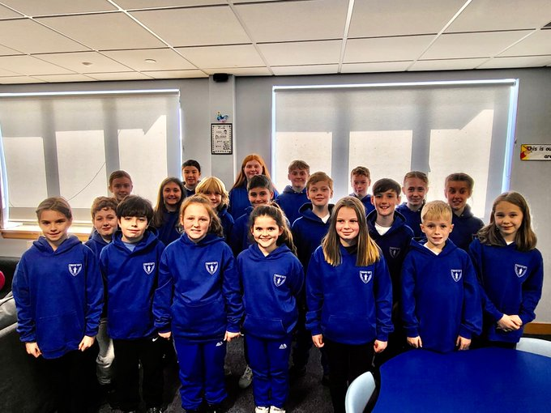

PE

White T-Shirt
Royal blue shorts
Sandshoes / Trainers
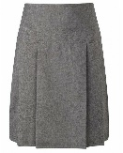

MEDICAL AND HEALTH CARE
Routine medical checks are carried throughout the child’s life in school by the School Health Service.
Minor accidents are attended to in the school, but in more serious cases, parents or emergency contacts are informed, so that the child may be taken to hospital. If no one can be contacted, the child will be transported immediately to Inverclyde Royal Hospital by a member of staff. If a child becomes ill and cannot remain in school, parents or emergency contacts will be telephoned to come and take the child home. It is essential to keep the school informed of any change in the emergency contact telephone number or your home or work telephone number so that contact can be made as quickly as possible.
If there are any medical requirements for a child, parents should inform the school in writing. Parents of children requiring medication during school hours are welcome to come into the school office to administer the medication. If parents would like a member of staff to administer medication, they must bring prescribed medication, with a pharmacy dispensing label clearly readable, to the school office and complete the appropriate consent form.
Allergies/Peanut Free Zone
As some pupils can be allergic to peanuts and peanut products and could suffer an anaphylactic reaction if exposed to them, we ask that children do not bring nuts or nut products to nursery or school.
Child absent from school through ill health
Children may be unable to attend school for a wide range of reasons including illness, accidents or long-term medical conditions. In general there will be an automatic referral by the school for education outwith school after 15 days of continuous or 20 working days of intermittent absence, within a reasonable timeframe.
ATTENDANCE AT SCHOOL
Parents must inform the school of any absence before 9.15am each day. If no contact is made, the school office will contact the pupil’s family and, thereafter, other emergency contacts beginning at 9.30am on the first morning of an absence and early after the restart after lunch in the case of an afternoon absence. Other agencies may be contacted if no contact with the pupil’s family can be achieved and if there are continuing or emerging concerns about a pupil’s safety or wellbeing. On return to school, parents should provide a note explaining the reasons for absence. If the school is not provided with a reason for absence, the absence will be recorded as “unauthorised”. It is essential for the safety of our children that parents keep the school informed about every absence. It is also essential that parents keep the school informed of any changes of address or telephone numbers, both their own and those of the emergency contacts.
Section 30 of the 1980 Education Act lays a duty on every parent of a child of ‘school age’ to ensure that their child attends school regularly. Attendance must be recorded twice a day, morning and afternoon. Regulation 7 of The Education (School and Placing Information) (Scotland) Amendment etc Regulations 1993 requires each child’s absence from school to be recorded in the Wemyss Bay Primary school register as either authorised: ie approved by the authority or unauthorised: ie unexplained by the parent (truancy) or temporarily excluded from school. The Scottish Government has provided guidance on the management of attendance and absence in Scottish schools in its publication Included, Engaged and Involved - part 2:
% | Days missed equivalent to | Impact
100% | 0 | Excellent  Gives your child the best chance of success and gets them off to a flying
95% | 9 days  1 week & 4 days | Good  Gives your child the best chance of success and gets them off to a flying start
90% | 19 days  3 weeks & 4 days | Poor  Less chance of success. Makes it harder to progress.
85% | 27 days  5 weeks & 2 days (Almost half a term ) | Very Poor  Serious implications
80% | 36 days  7 weeks & 1 days (Half a term) | Unacceptable  Serious implications on learning and progress.
75% | 45 days  9 weeks Almost a whole term)
Attendance in Scottish Schools. Every effort should be made to avoid family holidays during term time, as this both disrupts the child’s education and reduces learning time. It has been clarified that family holidays should not be recorded as authorised absence, except in exceptional domestic circumstances, where a family needs time together to recover from distress, or where a parent's employment is of a nature where school holiday leave cannot be accommodated (e.g. armed services or emergency services). It is for local authorities to judge when these circumstances apply and authorise absence, accordingly. The categorisation of most term-time holidays as unauthorised absence has been a contentious issue for some families, many of whom are concerned at the higher cost of holidays during school holiday periods. The Scottish Government has no control over the pricing decisions of holiday companies or flight operators. Our main focus is to encourage parents and pupils to recognise the value of learning and the pitfalls of disrupting learning for the pupil, the rest of the class and the teacher. Clearly, where an absence occurs with no explanation from the parent the absence is unauthorised. Schools investigate unexplained absence, and Education Services has the power to write to, interview or prosecute parents, or to refer pupils to the Children’s Reporter, if necessary.
Absence Rates
Absence rates are calculated as a percentage of the total number of possible attendances for all pupils in the school, each morning and afternoon of each school day being a separate possible attendance.
Inverclyde Absence Policy
Step 1 Parents are informed of attendance record by letter if attendance falls below 90% in any given six-week period.
Step 2 Parents are invited to attend a maximising attendance meeting if there is no sustained improvement in attendance within four weeks, or no improvement at all within two weeks.
Step 3 Referral for multi-agency case conference if no sustained improvement in attendance within four weeks, or no improvement at all within two weeks.
Step 4 Referral to Attendance Review Committee if failure to cooperate with multi-agency recommendations.
MEALS
School meals are provided on a cafeteria basis. All children in the nursery and P1-7 are entitled to a free school meal. Hot meals, snacks, sandwiches, fruit, drinks etc are available daily. Mrs McPherson, our Catering Manager, can also cater for children who require a special diet, so please inform the school if this is necessary. The school dinner menu can be viewed on the Inverclyde Council website:
https://www.inverclyde.gov.uk/education-and-learning/schools/school-lunch/school-lunches-in-primary-school
Children can bring a packed lunch to eat if they prefer. There are adults present, in a supervisory capacity, in the school dining hall for children’s safety.
There is, in Inverclyde, an Education Services Health Policy and using this we have succeeded in making our school a “Health Promoting School”. This was achieved through improved health awareness in the curriculum, greater opportunities for physical activity – as shown by our after-school activities, healthier school meals and by giving out fruit as a snack.

Parents of children receiving one of the benefits as outlined on page 25 will normally be entitled to monetary grants for free school meals. Information and application forms for free school meals may be obtained from schools and Education Services, Wallace Place, Greenock, PA15 1JB. Children entitled to free meals are also entitled to free milk with their lunch.
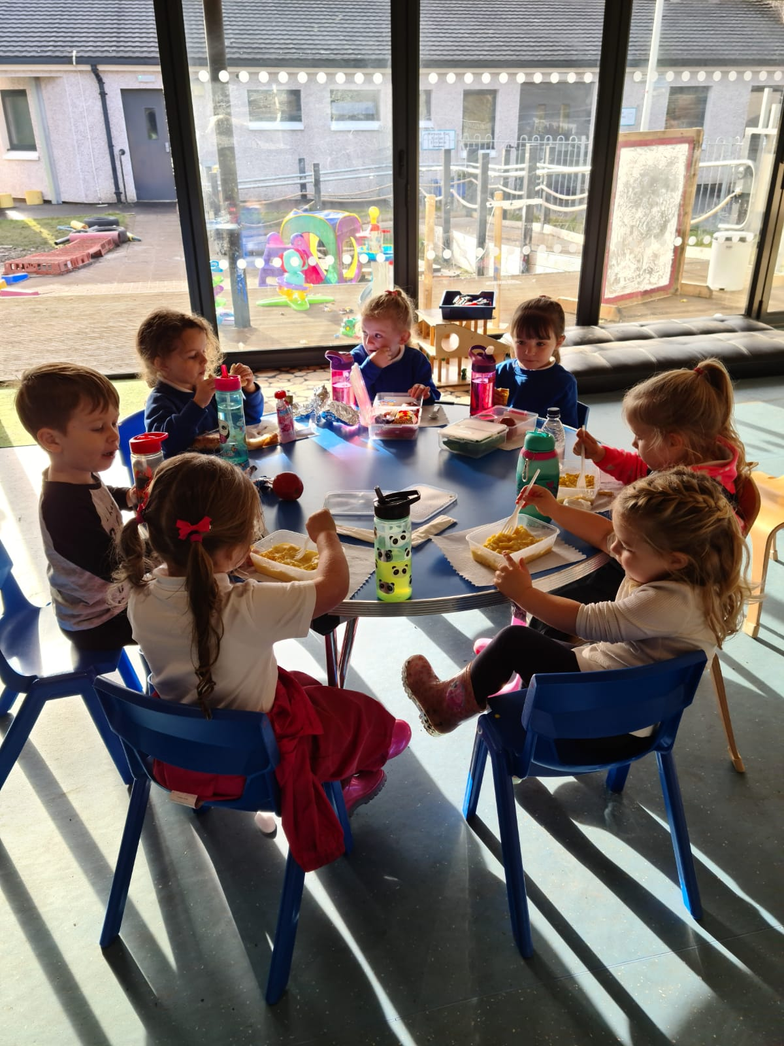
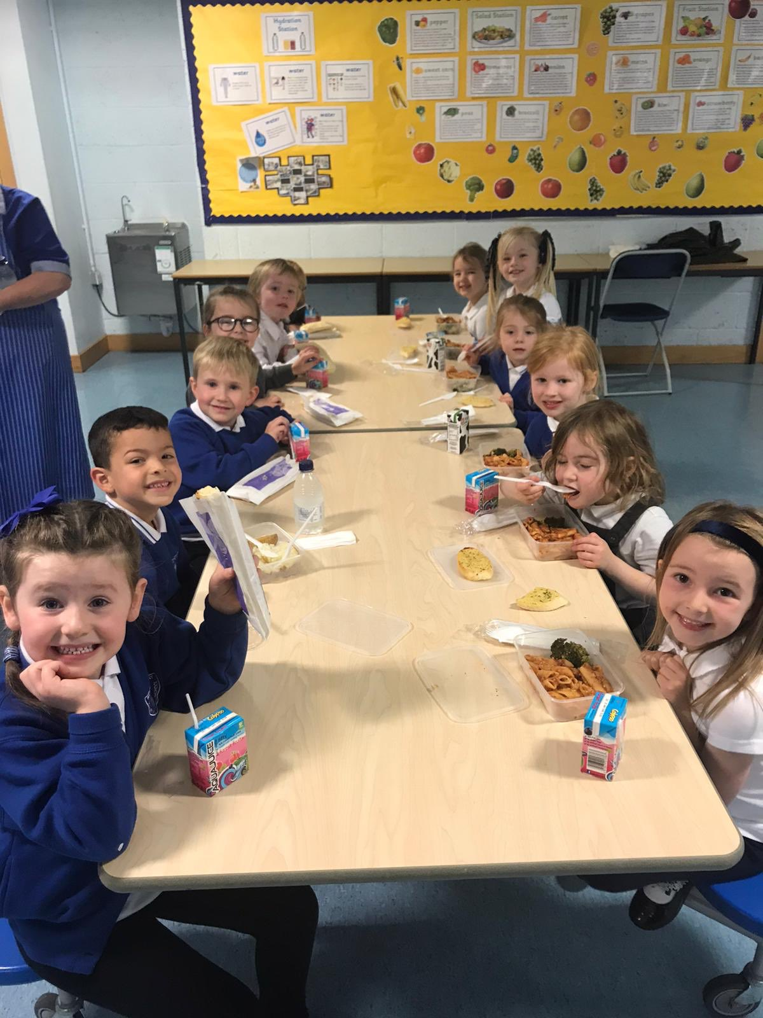

PARENT FORUM AND PARENT COUNCIL
Scottish Schools (Parental Involvement) Act 2006 led to the establishment of Parent Councils in primary, secondary and special schools. The Act recognises the vital role that parents play in supporting their children’s learning. It places a duty on authorities to promote the involvement of parents in children’s education and the wider life of the school. It aims to help parents to be:
- Involved with their child’s education and learning
- Welcomed as an active participant in the life of the school
- Encouraged to express their views on school education generally

As a statutory body, it has the right to information and advice on matters which affect children’s education.
Parents who are involved on a regular basis in schools should undertake an enhanced disclosure through Disclosure Scotland.

Wemyss Bay Parent Council
Our Parent Council is known as the Parent Partnership. This is a very active group which has an excellent relationship with the school. There is a very successful sub-group of the council that holds various fundraising events throughout the year to support the work of the school.
Meetings are held regularly and dates are given in our newsletters and via Twitter.
Events are publicised by emails, Twitter and the local Wemyss Bay Community Facebook Group. New members are always welcome - the school office can be contacted for more information.
Committee Members are:

Mrs L Gibson
Chairperson

Mrs W Wilson
Vice chairpersons
Mrs G Williams
Treasurer

TRANSPORT
The Council currently has a policy of providing free transport to all primary pupils who live more than one mile from their local school by the recognised shortest walking route. This policy is more generous than the law requires. This means that the provision of transport could be reviewed at any time. Parents who consider they are eligible should obtain an application form from the school or Education Services at Wallace Place, Greenock, PA15 1JB. These forms should be completed and returned before the end of February for those pupils beginning school in August to enable the appropriate arrangements to be made.
Applications may be submitted at any time throughout the year but may be subject to delay whilst arrangements are made. The appropriate officer has discretion in special circumstances to grant permission for pupils to travel in transport provided by the authority, where spare places are available and no additional costs are incurred.

Pick up Points
Where free transport is provided it may be necessary for pupils to walk a certain distance to the vehicle pick-up point. Walking distance in total including the distance from home to the pick-up point and from the drop-off point to the school in any one direction will not exceed the authority’s limits (see above paragraph). It is the parent’s responsibility to ensure that their child arrives at the pick-up point in time. It is also the parent’s responsibility to ensure the child behaves in a safe and acceptable manner while boarding, travelling in and alighting from the vehicle. Misbehaviour could result in a child losing the right to free transport.

Placing Requests
Education Services does not provide transport for those pupils in receipt of a placing request other than in exceptional circumstances. In the case of under-age placing requests if the child is offered a place in his/her catchment area school, transport will be provided in accordance with Council policy stated above.
INFORMATION IN EMERGENCIES
We make every effort to maintain a full educational service, but on some occasions, circumstances arise which lead to disruption. Schools may be affected by, for example, severe weather, temporary interruption of transport, power failures or difficulties of fuel supply. In such cases we will do all we can to let you know about the details of closure or re-opening.
We will keep you in touch by using email, Inverclyde Council Website, Social Media and announcements in the press and on local radio.
https://www.inverclyde.gov.uk/

CHILD PROTECTION
Inverclyde Council Education Services has Child Protection Guidelines and Procedures which all schools are required to follow. Education Services work very closely with other agencies namely Strathclyde Police, Social Work Services, NHS Greater Glasgow and Clyde and the Children’s Reporter to support children. Common responsibilities of all staff are to protect children from abuse and exploitation, to respond appropriately when abuse is identified, and to ensure whenever possible that all children are able to exercise their right to be raised in a warm, stimulating and safe environment, supported by their families or carers.
In Wemyss Bay Primary School and Nursery Class, all staff have a responsibility to safeguard and protect our children. Safety is our first priority in our responsibility in Getting It Right For Every Child. Staff with any concerns about a child’s safety or welfare report directly to Mrs Gillespie or Mrs Cushnahan who undertake the role of Child Protection Officers.
INCLUSION AND EQUALITY
Inverclyde Council Education Service aims to:
- Offer education of the highest quality to all young people within a developing culture of inclusion
- Endorse the principles of inclusion, entitlement and equality of opportunity in the development of best practice.
- Value the diversity of interests, qualities and abilities of every learner
- Believe that every child and young person is entitled to educational opportunities which enable the achievement of success and further development of the individual’s learning potential within the least restrictive environment
- Affirm the right of all young people to have access to the highest quality of educational provision which is appropriate to learning needs, is supportive of the young person and is delivered in partnership with young people, parents and the wider community.

In meeting the needs of all of our pupils we will demonstrate no discrimination on the basis of race, gender, disability, sexual orientation, religion or belief. This encompasses curricular, extra-curricular and classroom activities and is foremost in the attitudes which we develop in our pupils.
EQUALITIES

‘Inverclyde Education Service is committed to ensuring that no children or members of staff or service users receive less favourable treatment on any ground including age, gender reassignment, pregnancy and maternity, race, disability, sex, sexual orientation, marriage and civil partnership, religion or belief. We have a moral, social and legal obligation to mainstream and put equality at the heart of everything we do. We aim to promote a culture in which equality of opportunity exists for all. We are opposed to all forms of discrimination, direct or indirect, and aim to eliminate all discriminatory practices. We will ensure that, in our schools and other educational establishments, equality permeates the curriculum and underpins all our policies and practices in terms of access to education. We must ensure that all our children achieve their full potential to develop physically, emotionally and academically. Finally, we believe that equality and inclusion should be a given right, where everyone is valued and treated with respect.’

USEFUL ADDRESSES AND CONTACTS

CORPORATE DIRECTOR OF EDUCATION, COMMUNITIES & ORGANISATIONAL DEVELOPMENT

Ms Ruth Binks
Municipal Buildings
Clyde Square
GREENOCK
PA15 1LX
Phone: 01475 712761

LOCAL AUTHORITY EDUCATION OFFICE

Inverclyde Council
Wallace Place
GREENOCK
PA15 1JB
Phone: 01475 712850

Head of Education: Michael Roach

Head of Inclusive Education, Culture & Corporate Policy: Tony McEwan

CONVENER EDUCATION & COMMUNITIES COMMITTEE

Councillor Jim Clocherty

Education Services Committee
Municipal Buildings
GREENOCK
Phone: 01475 712727

SKILLS DEVELOPMENT SCOTLAND

112 West Blackhall Street,
GREENOCK
Phone: 01475 553710

COMMUNITY LEARNING & DEVELOPMENT

James Watt Building

105 Dalrymple Street

Greenock

PA15 1HU
Phone: 01475 715450

PARENTZONE
Parentzone Scotland is a unique website for parents and carers in Scotland, from early years to beyond school. The website provides up-to-date information about learning in Scotland, and practical advice and ideas to support children’s learning at home in literacy, numeracy, health and wellbeing and science. Information is also available on Parentzone Scotland regarding additional support needs, how parents can get involved in their child’s school and education.

Parentzone Scotland also has details about schools, including performance data for school leavers from S4-S6 and links to the national, local authority and school level data on the achievement of Curriculum for Excellence levels.

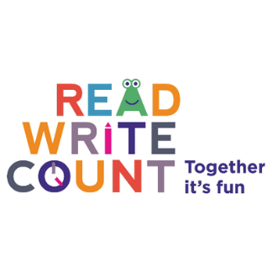
READ, WRITE, COUNT

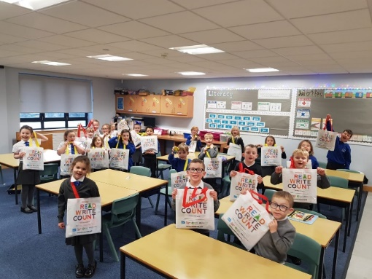
The Read, Write, Count programme aims to support parental engagement in literacy and numeracy. Gift bags are distributed annually to all P2 and P3 pupils in Scotland by Scottish Book Trust. The gift bags contain essential literacy and numeracy materials to support children’s learning, as well as advice and support to parents.

Studies show a direct link between a strong family learning environment and progress in reading, writing and counting. In addition to the activity booklet included in the bag Scottish Book Trust offers a range of hints, tips and advice to help parents engage in their child’s learning on the website.

BOOKBUG
Bookbug is Scotland’s universal early years book gifting programme and aims to inspire a love of stories, songs and rhymes from birth. Bookbug gives every child in Scotland four free bags of books as babies, toddlers, three and five year olds. The bags contain books and other resources for sharing songs and rhymes that are suited to their age. Gaelic Bookbug Bags are also available.
The Bookbug Explorer Bag is gifted to all 3 year olds at their childcare setting. It includes three lovely books, an activity book, pencils, and postcards to encourage mark making. Every year, The Bookbug Picture Book Prize celebrates the best new Scottish picture books, and the winner of the prize is chosen by children across Scotland. All Primary 1 pupils receive the three shortlisted books in the Bookbug P1 Family Bag, given out in November during Book Week Scotland, and can vote for their favourite in school or at home with their families.
Check out the website for booklists, book sharing videos, activity ideas and much more.

LOCAL COUNCILLORS

Ward 6
Mr Paul Cassidy
Mr James Daisley
Mr Innes Nelson

INVERCLYDE COMPLAINT PROCEDURE
Inverclyde Council is committed to providing high quality customer services. We value complaints and use information from them to help us improve our services. If something goes wrong, or you are dissatisfied with our services, please tell us. Details can be found using the link below;
https://www.inverclyde.gov.uk/health-and-social-care/information-advice/complaints-procedure

GENERAL DATA PROTECTION REGULATION AND DATA PROTECTION ACT 2018
Information on children, parents and guardian is stored on a computer system and may be used for teaching, registration, assessment and other administrative duties. In processing personal information, Inverclyde Council must comply with the General Data Protection Regulation and Data Protection Act 2018. For further information please refer to:

https://www.inverclyde.gov.uk/site-basic/privacy

A range of authority policies relating to education can be found on the Inverclyde Council website;
https://www.inverclyde.gov.uk/education-and-learning/schools

Although the information contained in this Handbook is correct at time of writing (December 2022), there could be changes affecting any of the matters dealt with in the document;

- before the commencement or during the course of the school year in question
- in relation to subsequent school years

