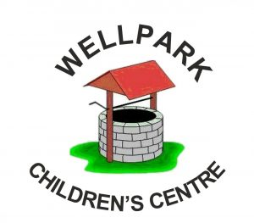

Wellpark Children’s Centre
Handbook
2026

Contents

Introduction Pg 3
Vision & Aims Pg4
Staff Information Pg 5
Opening Hours & Session Times Pg 5
Establishment Information , Security, Car Park & No Smoking Policy Pg 6
Holidays Pg 7
Registration, Admissions & Chargeable Childcare Pg 8
Attendance, Absence & Groupcall Pg 9
Services Provided for Families Pg 10
Child Protection Pg 10
Community Partnerships & Eco Schools Pg 11
Transition from Pre 5 to Primary School Pg 12
Assessment & Reporting to Parents Pg 12
Getting it Right for Every Child Pg 13
Support for Pupils cont. Pg 14/15
Equal Opportunities Pg 16
Caterpillar Room 2-3 Pg 17
Butterfly Room 3-5 Pg 18
Positive Relationships Pg 19
Parents as Partners Pg 20
Home Links Pg 21
Clothing Pg 22
Snacks & Meals Pg 23
Medical & Health Care Pg 24
Information on Emergencies Pg 25
Complaints Procedure Pg 26
Care Inspectorate Pg 26
Useful Information Pg 26/27

THROUGHOUT THE HANDBOOK THERE ARE QR CODES WHICH CAN BE SCANNED USING YOUR MOBILE PHONES QR READER. THIS WILL TAKE YOU DIRECTLY TO WEB PAGE FOR YOUR CONVENIENCE

Introduction

Dear Parents and Families,

A very warm welcome to Wellpark Children’s Centre. We are delighted to have you and your child join our nursery family. At Wellpark we believe that every child deserves the very best start in life, and we are committed to providing a nurturing, inspiring, and safe environment where your child can thrive.

Our nursery is built on a strong sense of community and partnership. We value working closely with you as parents and carers, knowing that together we can help every child achieve their full potential. We have high expectations for all our children and support each unique learner to grow in confidence, independence, and curiosity.

Wellbeing is at the heart of everything we do. We are dedicated to helping children understand and manage their feelings, relationships, and experiences in a positive way, equipping them with the resilience and skills they need to be ready to learn and flourish in the wider world.

We pride ourselves on our open-door policy, and you are always welcome to come and talk to us. Your views, ideas, and involvement are highly valued and we look forward to working together to make your child’s early years truly special.

Thank you for entrusting us with your child’s care, learning, and development. We look forward to sharing this exciting journey with you.

Warmest wishes,
Ann-Marie Cunningham

Ann-Marie Cunningham
Head of Centre

Vision and Aims of Wellpark Children’s Centre

Vision
To provide and deliver an inclusive and inviting high quality service, which supports children and families in the community and gives them a positive sense of responsibility for themselves and others as well as a sense of acceptance and belonging.

We aim to do this by:

Providing a fun, nurturing and inspiring environment which motivates our children to become independent learners who aspire to be confident and successful; learners who achieve their full potential. We encourage our children to show kindness and respect, be curious and develop a joy for learning through play.

By ensuring a collaborative approach is in place with a staff team who feel valued and listened to, and have a commitment to providing an excellent service, fostering an ethos of positive wellbeing and respect

Ensuring our service builds upon our well established community links and partnerships with other agencies to work productively together to encourage innovative and forward thinking ideas to continually improve the service and support our families to thrive

Provide a service for parents and families in which they have a sense of belonging and develop trusting relationships, where their life experiences are valued and they are provided opportunities to engage with the service to promote learning at home

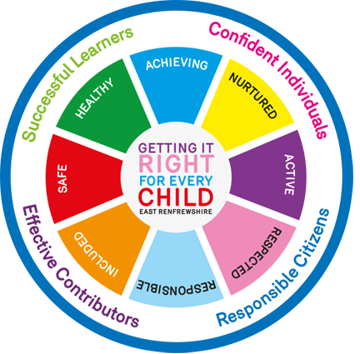

Staff Information

- Head of Centre Ann-Marie Cunningham
- Depute Head Joan McKenna
- Senior EYECO Lynne Logan

Early Years Education and Childcare Officers
Lucy Alysha Gillian M Maureen
Niamh Gemma Heather Danielle Alyssa

- Excellence & Equity Lead Rachel & Suzanne
- Clerical Staff Cathy
- Caretaker Robert & Sandra
- Catering Assistant Lorraine & Suzi

Opening Hours and Session Times
The centre is open 50 weeks per year, closing for school / public holidays and staff
In-service training days.
The nursery is opened from 8am-6pm Monday to Friday.
Additional hours may be arranged to meet individual and family’s needs and are subject to availability; wrap round charge may apply. Times and placement will be discussed when you come along for enrolment.
Our model times are:
Model 1 | TERM TIME | MON-FRI | 6 hours per day between operational hours
Model 2 | EXTENDED YEAR | MON/TUE | 8.05-17.45
 |  | WED | 8.10-12.55
Model 3 | EXTENDED YEAR | WED | 13.00-17.45
 |  | THU/FRI | 8.05-17.45
MODEL 4 | EXTENDED YEAR | MON-FRI | 8.05-12.55
MODEL 5 | EXTENDED YEAR | MON-FRI | 13.00-17.45

Establishment Information
Scan the QR Code for our website
Wellpark Children’s Centre
45 Mearns Street

Greenock
PA15 4BN
Tel: 01475 715730
E-mail: office@wellpark-nur.inverclyde.sch.uk
Website: https://blogs.glowscotland.org.uk/in/wellparkchildrenscentre/

Twitter:@wellparkcc—This is a private account and you will need to alert us to provide access

Wellpark Children’s Centre is non-denominational and caters for up to a maximum of 47 children over 50 weeks of the year

47 Children 2-3 yrs. - 15 children
3-5 yrs. - 32 children

CENTRE SECURITY
A security system operates at all times. Please press 1 then the button for reception, or follow the instruction at the door and someone will open it for you.

CAR PARK
The car park is for staff cars only. This is also our emergency exit if the building needs to be evacuated.

NO SMOKING POLICY
Inverclyde Council operates a NO SMOKING POLICY in all establishments in line with the new ‘Smoking Law 2006’ therefore smoking is not permitted in any area of the Centre.

HOLIDAY AND IN-SERVICE DAY INFORMATION

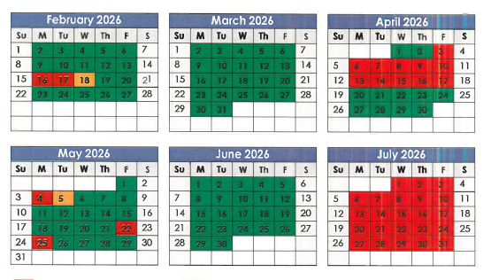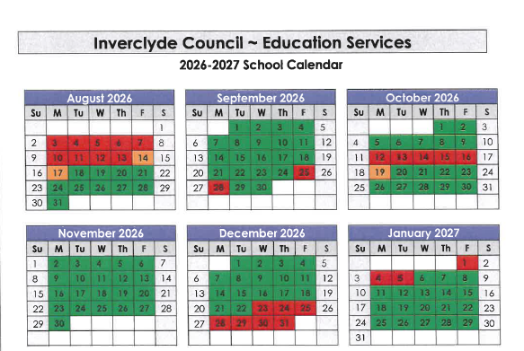
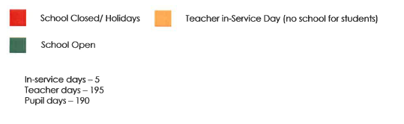

REGISTRATION AND ADMISSIONS

To apply for an Early Learning and Childcare place, you should complete an application form, around the time your child turns two years old or before 31st January each year. The nursery application form is available from any Inverclyde Council nursery school/class or partner establishment. All children who are eligible for a nursery place are asked to list, in order of priority, up to three nursery choices. Only one application form must be submitted. Although children are guaranteed a place within either a council establishment or within a partnership establishment we cannot guarantee your choices or your pattern of attendance.
Once completed forms should be submitted to your first choice nursery. Proof of your child’s date of birth in the form of their birth certificate and address must be produced when submitting your application. Forms submitted without this evidence will not be accepted at any establishment.
ADMISSION INTAKE TIMELINE
Birthday Dates | Intake – first available Monday in the month
1st March – 31st August | August / September
1st September – 31st December | January
1st January—28th February | March

CHARGEABLE CHILDCARE
Chargeable childcare is a service that can be purchased by parents or carers who are in employment, education or training for employment which is additional to the child’s Early Learning and Childcare entitled place. Wellpark operates chargeable childcare however it is not possible to vary the daily hours from a week to week basis. e.g. to accommodate shift patterns, unless a full time place is purchased.

The total number of hours used over the week will always be rounded up to a full hour when invoices are being calculated. e.g. 3 hours 10 min will be charged at 4 hours.
If you would like to know if we have availability or to discuss chargeable childcare further please speak with AnnMarie or Joan.

Scan the code for more information on Chargeable Childcare
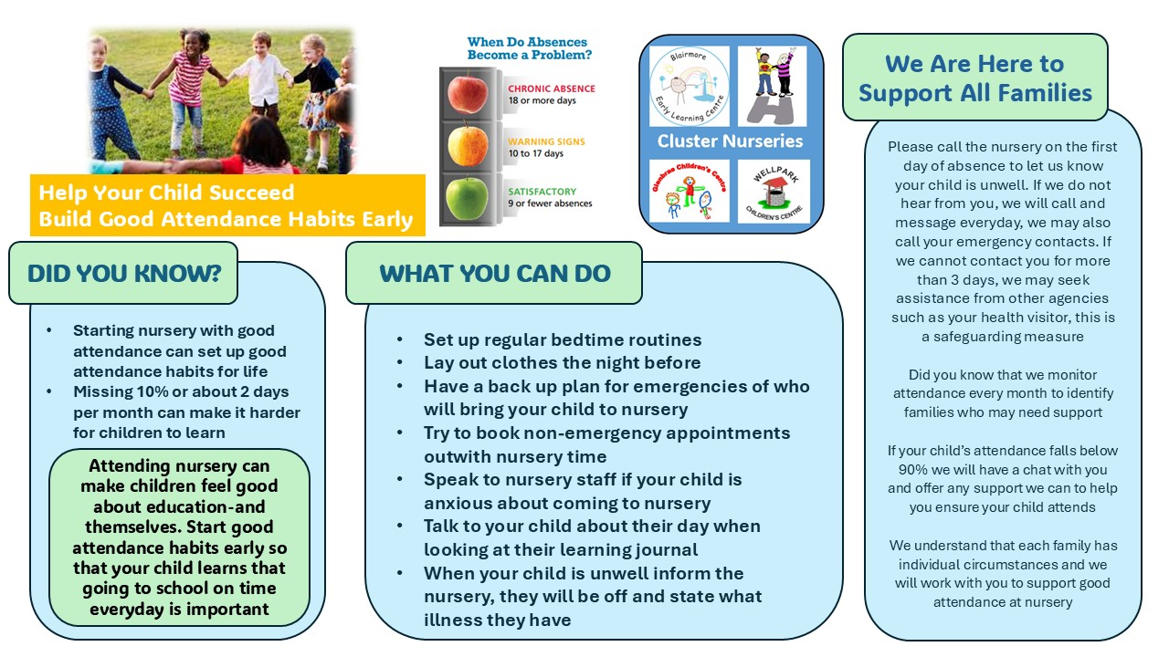

ATTENDANCE
Every day there are different experiences on offer to your child. In order to ensure that your child gains maximum benefit of these and the education and care provided it is vitally important that he/she attends regularly. Whilst we understand sickness is a part of life attendance is monitored and if attendance falls below 90% parents may receive a letter or have an informal chat on ways to support you to help your child attend.

ABSENCE OR SICKNESS
If your child was unable to attend the nursery, parents/carers must contact the nursery as soon as possible. You can do this by telephoning the nursery and speaking to a member of staff. If on occasions there was no one available to take your call you are welcome to leave a message on our answering machine. The machine is checked regularly. You can also contact us by using our APP for free.
If you do not contact nursery regarding absence then we will contact you on day 1. This is part of our safeguarding measures.


GROUPCALL APP EDUSPOT

At Wellpark we communicate with parents in many ways but the easiest way is using our APP. The APP is called Groupcall Eduspot. You will be given a leaflet when your child starts and you can start using the app straight away. You can contact the nursery for free and receive all your newsletters and important updates to your phone.

SERVICES PROVIDED FOR FAMILIES

- The Centre provides learning experiences for 2-5 year olds.
- We have access to partner agencies and work closely with Barnardos.
- We have a parents group and hold parents stay and play sessions every year.
- Transition to primary school programme.
- Story Grammar & Numicon /SEAL Maths programmes
- Eco Committee, Memory Lane Group, PATHS & Woodwork Programme
- Home links e.g. Maths and literacy themed home learning bags
- Outdoor Learning
- Active start, oral health and healthy eating programmes
- Children’s Rights Programme
- National Toothbrushing Initiative

SAFEGUARDING AND CHILD PROTECTION

Inverclyde Council Education Services has Child Protection Guidelines and Procedures which all schools and establishments are required to follow. Education Services work very closely with other agencies namely Strathclyde Police, Social Work Services, NHS Greater Glasgow and Clyde and the Children’s Reporter to support children.

Common responsibilities of all staff are to protect children from abuse and exploitation. To respond appropriately when abuse is identified and to ensure whenever possible, that all children are able to exercise their right to be raised in a warm, stimulating and safe environment with the support of staff, their families and carers.

If a member of staff has any concerns regarding a child’s safety and protection it is our statutory duty to report these concerns to the appropriate agency. All actions taken are in the interest of the child. Further information leaflets for parents regarding Child Protection are available from the Centre.

Ann-Marie is the Safeguarding & PREVENT lead for the Centre.



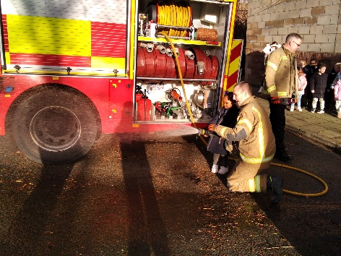
COMMUNITY PARTNERSHIPS

At the nursery we recognise that the local area and community are a valuable resource. We are working together with a variety of agencies.

Some of these include:-
Other early year’s establishments, local primary and high schools. We also work closely with social work department, health visitors, dental services and physiotherapists.

Local issues i.e. local amenities or changes within the community are raised and discussed at our parent staff group meetings, thus allowing for concerns to be directed to the appropriate departments.

We support the local community by having placements for work experience pupils from all secondary schools in Inverclyde and students from West College Scotland. The children and staff also support local and national charities through fund raising events held during the year.

OUT AND ABOUT IN THE COMMUNITY
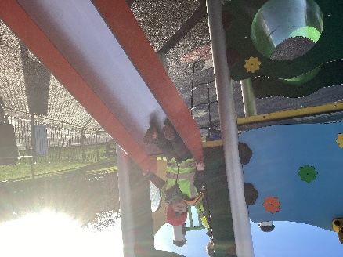
The children spend lots of time in the community. They visit local parks, the library, shops and many more other places. This is a wonderful learning opportunity. We have regular trips to the forest which provides children with the opportunity to learn new skills in a different environment such as adventurous play, assessing risk and developing large motor skills.

ECO SCHOOLS


The aim of the Eco-Schools programme is to make environmental awareness and action a part of the life and ethos of the nursery for both children, parents and staff, and to engage the wider community. We have been awarded our Green Flag status and our children are warriors on litter and learn about lots of different topics which help them understand the environment and sustainable living such as energy, biodiversity and waste minimisation.

TRANSITION FROM NURSERY TO PRIMARY SCHOOL

At Wellpark we understand how important it is to support our families during times of transition. Our main transitions are beginning nursery, moving between playrooms and starting school. The key to a successful transition is effective communication between the early year’s establishment, school and parents.

The transition process begins when you first contact us about your child’s place. You will be welcomed into nursery for a tour and a chat about our service, parents are an integral part of transitions and we have many different ways to share all the important information about your child such as our All about Me Booklet and our settling in procedures which allow parents to spend time in the Centre whilst their child builds positive relationships with staff. This ensures we can effectively support your child’s individual needs. Transition to Primary school support starts early in the pre-school year and continue into primary 1.
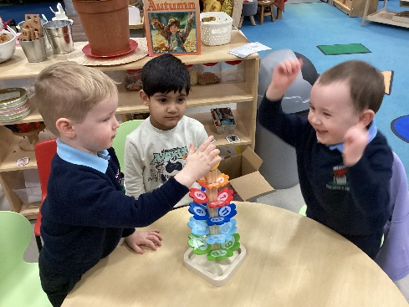
Children are normally transferred between the ages of 4 ½ and 5 ½ years. The nursery has strong links with local primary schools and work together by arranging “play dates” to the classrooms, inviting teachers into the nursery to meet the children and their keyworker to share information on the child as a learner.
Further information regarding your child’s feeder school can be found in the registration for infant beginner’s page of our website.

ASSESSMENT AND REPORTING TO PARENTS
Observations of the children are continuous and enable staff and parents to plan appropriate effective learning programmes for each child. The first part of this process is the “All about Me’’ booklet which you will be given at your child’s enrolment.

Children’s achievements are recorded on an electronic profile which parents can access securely at any time and are encouraged to comment and include learning and achievements from home. Parents are asked to meet with their child’s keyworker to set targets and discuss their development throughout the year.

When children are starting school, parents are given a transition report at the end of the school year. This will contain information regarding their progress which will be passed on to school. Parents are also given a report when children transfer from the Caterpillar room to the Butterfly room. Staff will use this report to ensure a seamless transition as children move on and plan for their next steps in their learning.

GETTING IT RIGHT FOR EVERY CHILD

As children and young people progress in their journey through life, some may have temporary difficulties, some may live with challenges and some may experience more complex issues. The Getting it Right for Every Child approach ensures that anyone providing support puts the child or young person – and their family – at the centre.
The Scottish Government

Nurturing Inverclyde aims to make Inverclyde a place which nurtures citizens of all ages, ensuring that everyone has the opportunity to have a good quality of life and good mental and physical well-being.


Staff in the Centre use the GIRFEC approach to ensure that all children’s needs are being met and that the needs of the family are put first when we work with our partner agencies.

An Information leaflet about GIRFEC is available in the Centre.

SUPPORT FOR PUPILS
WELLBEING PATHWAYS

A child or young person’s needs are identified at the earliest possible stage and can be met in a number of ways, for example by adaptions to the curriculum or learning environment, as well as input from visiting specialists. The appropriateness of the support is determined through a process of assessment, planning and monitoring, working jointly with parents and carers, and is regularly reviewed.

Learning outcomes for children and young people with additional support needs are set out in a plan and all we will hold regular review meetings with parents and carers to determine needs and the most appropriate supports. Everyone’s views are equally important in order to consider what is currently working and how to determine next steps.

Children needs are identified in a number of ways, and the process of assessment is an ongoing. On some occasions health service staff or other partner agencies make children known to Education Services. Other additional support needs may be notified to Educational Services by parents themselves or identified by one of a range of staff working closely with the child.

Some children and young people will have additional support needs arising from complex or multiple factors which require a high degree of co-ordination of support from both education and other agencies in order that their needs can be met. In these cases, the school will hold a meeting to decide whether the child or young person meets the criteria for a co-ordinated support plan. The co-ordinated support plan is a statutory document which ensures regular monitoring and review for those children and young people who have one.

If your child is identified as requiring additional support you will be involved in all aspects of planning. We use Inverclyde Wellbeing Pathways to plan and record support.

Support for Pupils cont.
Education (Additional Support for Learning) (Scotland) Act 2009

(a) the authority’s policy in relation to provision for additional support needs,
A child or young person’s needs are identified at the earliest possible stage and can be met in a number of ways, for example by adaptations to the curriculum or learning environment, as well as input from the Support for Learning Teacher and on occasion support from visiting specialists. The appropriateness of the support is determined through a process of assessment, planning and monitoring, working jointly with parents and carers, and is regularly reviewed.

(b) the arrangements made by the authority in making appropriate arrangement for keeping under consideration the additional support needs of each such child and young person and the particular additional support needs of the children and young person’s so identified.
Learning outcomes for children and young people with additional support needs are set out in a plan and all educational establishments hold regular review meetings with parents and carers to determine needs and the most appropriate supports. Everyone’s views are equally important in order to consider what is currently working and how to determine next steps

c) the other opportunities available under this Act for the identification of children and young persons who -
a) have additional support needs,
Children and young person’s needs are identified in a number of ways, and the process of assessment is an ongoing, shared process with partnerships with parents and carers at the forefront. On some occasions health service staff or other partner agencies make children known to Education Services. Other additional support needs may be notified to Education Services by parents themselves or identified by one of a range of staff working closely with the child.
b) require, or would require, a co-ordinated support plan,
Some children and young people will have additional support needs arising from complex or multiple factors which require a high degree of co-ordination of support from both education and other agencies in order that their needs can be met. In these cases, the school will hold a meeting to decide whether the child or young person meets the criteria for a co-ordinated support plan.
The coordinated support plan is a statutory document which ensures regular monitoring and review for those children and young people who have one.
c) the role of parents, children and young persons in the arrangements referred to in paragraph (b),
You have the right to ask the education authority to establish whether your child needs a coordinated support plan. Your child can make this request themselves, if they are aged 16 or over. You and your child, if they want to, will attend a meeting with staff at their school. Other professionals from different agencies who may be involved in providing support for your child will also attend. If your child does not want to attend meetings or feels unable to, their views must still be sought and considered.
d) the mediation services provided
Inverclyde’s mediation service can be accessed by contacting Michael Roach, Head of Education at the address below
e) the officer or officers of the authority from whom parents of children having additional support needs, and young persons having such needs, can obtain advice and further information about provision for such needs.

For further advice please telephone 01475 712850
Or write to;
Education Services
Wallace Place
GREENOCK PA15 1JB

More information is available at www.enquire.co.uk / www.siaa.org.uk / www.sclc.org.uk
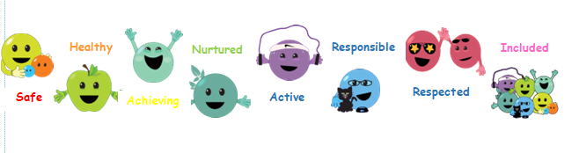

EQUALITIES STATEMENT

‘Inverclyde Education Service is committed to ensuring that no children or members of staff or service users receive less favourable treatment on any ground including age, gender reassignment, pregnancy and maternity, race, disability, sex, sexual orientation, marriage and civil partnership, religion or belief. We have a moral, social and legal obligation to mainstream and put equality at the heart of everything we do.

We aim to promote a culture in which equality of opportunity exists for all. We are opposed to all forms of discrimination, direct or indirect, and aim to eliminate all discriminatory practices. We will ensure that, in our schools and other educational establishments, equality permeates the curriculum and underpins all our policies and practices in terms of access to education. We must ensure that all our children achieve their full potential to develop physically, emotionally and academically. Finally, we believe that equality and inclusion should be a given right, where everyone is valued and treated with respect.’

In meeting the needs of all our pupils we will demonstrate no discrimination on the basis of race, gender, disability, sexual orientation, religion or belief. This encompasses curricular, extracurricular and playroom activities and is foremost in the attitudes which we develop in our pupils



THE CATERPILLAR ROOM
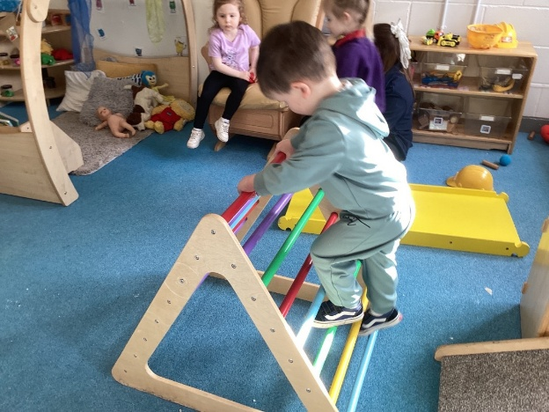
The Caterpillar room offers high quality care and education for children aged 2 to 3 years, in an exciting, stimulating and caring environment. This may be your child’s first experience of an early years setting or being away from home, each child has a ‘special person’ called a keyworker. Your child’s keyworker will develop a caring and nurturing relationship with your child. They will work alongside you to ensure that your child’s individual needs are supported and enable your child to thrive in meeting the challenges of early learning. The Caterpillar playroom is bright and airy and provides lots of exciting opportunities for your child to explore, experiment and investigate. Children are encouraged to be independent, making their own choices about their learning. A variety of natural resources are provided to stimulate your child’s natural curiosity when making sense of the world around them.


OUTDOOR LEARNING
Children in the Caterpillar room access our outdoor space every day. This helps develop important physical skills, confidence and the ability to take and manage risks in a safe environment. The children also have many opportunities to explore the local community. They often visit the library and local parks. Having these opportunities develops their communication and social skills and helps to increase their understanding of the world around them.

HEURISTIC PLAY
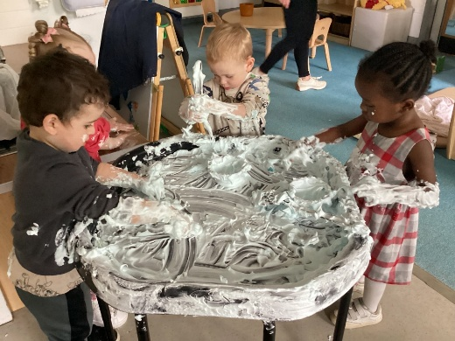
When young children begin to walk and gain independence they are driven by a natural curiosity and urged to handle things and find out what objects can do. Heuristic play allows toddlers to freely discover how things work, exploring concepts like posting, stacking and sequencing. The children have opportunities to explore this kind of play frequently within the Caterpillar room

THE BUTTERFLY ROOM
The Butterfly Room provides children aged 3-5 with experiences which help them learn & develop friendships very naturally through play. Play brings about opportunities for children to develop their language, creativity and co-ordination skills.
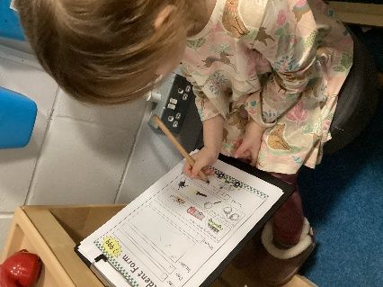
All children in the playroom will be partners in the learning process; actively participating in the planning of their own learning. With sensitive adult support they’ll learn how to make informed choices, take responsibility for their own learning and offer ideas for improvements. Staff will use children’s interests to inspire our learning environment. We know that children are more actively engaged when they are learning about topics that interest them
Staff use outcomes from the Curriculum for Excellence to ensure all children are making progress in their learning at a pace which suits them.

OUTDOOR PLAY AND LOOSE PARTS

Outdoor learning is an important part of the curriculum and provides children with an opportunity to experience different learning in a new environment. It helps develop children's physical skills and provides them with ample space to learn and grow.
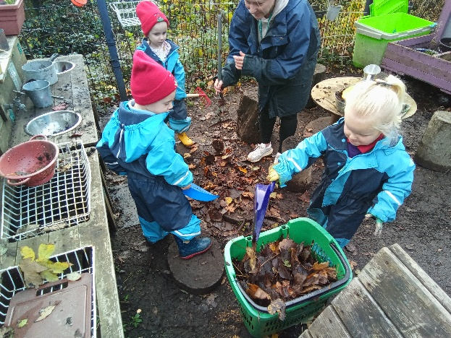
At Wellpark children access outdoors daily. We have a well-equipped garden where children enjoy learning about bugs, weather and many other topics.
Children explore loose parts like tyres, pallets and rope to develop their imagination and problem solving skills. This helps children to learn about risk taking and how to keep themselves safe.
The children also access many areas of the community including the library, local parks and the woods.
The children enjoy a variety of different experiences in the outdoor area depending on their interests and the weather. We have full waterproof outfits and welly boots for all children and adults accessing outdoors

PROMOTING POSITIVE RELATIONSHIPS

In Wellpark we use Inverclyde Councils Positive Relationships policy to support the children to have positive, respectful relationships.
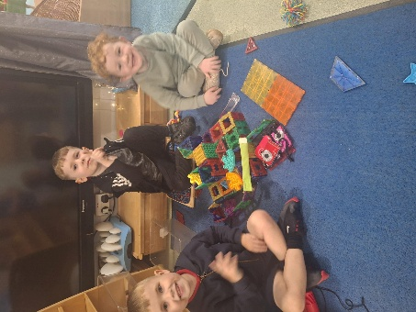
Children are encouraged to take part in respectful interactions and staff foster this by providing a calm and stimulating environment. Children are encouraged to develop an understanding of their emotions and an understanding of how this can affect their behaviour.

Staff use a nurturing approach alongside learning about children's rights to promote positive interactions with an emphasis on feelings, respect and fairness.

PATHS PROGRAMME

We use the PATHS programme to help children understand their emotions and develop the ability to recognise and manage these emotions. PATHS helps children understand how their behaviour is linked to their emotions.
The Program uses puppets to help the children understand their own emotions and helps them behave in a positive way.
Children engage in learning using the PATHS programme every week. This helps them to manage and understand their emotions and how it can affect their wellbeing.







PARENT PARTNER GROUP

Scottish Schools (Parental Involvement Act 2006) led to the establishment of Parent Councils in primary, secondary and specialist schools.

The Act recognises the vital role that parents play in supporting their children’s learning. It places a duty on authorities to promote the involvement of parents in children’s education and the wider life of the school.

It aims to help parents to be:-
  - Involved with their child’s education and learning.
  - Welcomes them as an active participant in the life of the school.
  - Encouraged to express their views on school education generally.

As we are an Early Years service we have a Parent/Staff group. The aims of this group are the same as above. We encourage parents to be involved with the life of the centre and to be aware of improvements, initiatives and programmes in place for their child’s learning. The group is relaxed and meet five times per year .The minutes of these meetings are displayed in the front hall and on our website.


If you have an idea or viewpoint you wish to be taken for discussion please come along and join us or talk to a member of staff or a member of the parent group.

Parents who wish to be involved on a regular basis within the nursery playrooms need to have a PVG (protecting vulnerable groups) disclosure completed.

HOME LINKS

Families are encouraged to get involved within the life of the nursery. There are many opportunities for them to become involved including

· Home Learning Bags
· Eco Committee
· Parent Partner Group

’MORE VOLUNTEERS ARE ALWAYS WELCOME!’

We have a Parent/staff group and Eco School committee and you are
welcome to be part of these groups.

Notification of these are published in the Newsletters, emailed and placed on the notice board.

In the 3-5 playroom (Butterflies) Home learning bags are regularly lent to children which support their progress in maths, literacy and wellbeing.

The 2-3 playroom (Caterpillars) are lent “Bonding/Rhyme Bags “which
offer a nurturing experience for both children and adults.

Monthly newsletters are issued to inform families about events within the nursery. Home learning ideas are also regularly shared with parents along with links to our suite of home learning videos to support parents with home learning.

We hold a variety of parent events regularly including walk and talk, one to one support sessions, trips in the community and stay and play in the nursery

Throughout the year we invite partner agencies to share information and advice to support parents with a variety of issues.



Scan the code to view some of our home learning videos

CLOTHING
As you are aware all children have the best time when they are involved in ‘messy play’!

At the nursery we do try to make sure that they wear aprons to protect their clothes. Unfortunately though, accidents can happen! Because of this, we do ask that you dress your child in suitable clothes for example something that’s comfortable and easily washed! We also encourage the children to be involved in outdoor play activities. Please make sure that your child has suitable outdoor clothing in case this type of play or an outing is planned. The nursery has waterproof clothing and some sizes of wellington boots available for wet days.

To avoid the loss of jewellery or accidents
happening e.g.; - Chains tightened around neck, drop earrings, etc.; we do ask parents not to wear items of jewellery on the children. We ask for your co-operation with this issue and for parents/carers to ensure that all items of value are not worn or left in the nursery.

There are forms of dress which are unacceptable in establishments, such as items of clothing which:
1. Potentially, encourage faction ( such as football colours)
2. Could cause offence ( such as anti –religious symbolism or political
slogans)
3. Could cause health & safety difficulties, such as loose fitting clothing, dangling earrings, or clothing made from flammable material for example shell suits in practical activities
4. Could cause damage to flooring
5. Carry advertising, particularly for alcohol or tobacco; and
Could be used to inflict damage on other pupils or be used by others to do so.

The council is concerned at the level of claims being received regarding the loss of children’s clothing and /or personal belongings. Parents are asked to assist in this area by ensuring that valuable items and unnecessarily expensive items of clothing are not brought to the establishment. Parents should note that the authority does not carry insurance to cover the loss of such items and any claims submitted are likely to be met only where the authority can be shown to have been negligent.

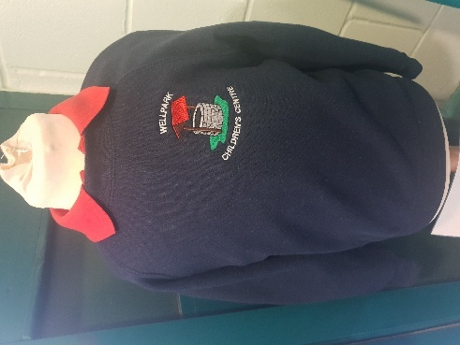
Parents should note that the activities the children may become involved in may be restricted because health and safety requirements state that jewellery of any kind must not be worn where children are undertaking physical activities. This includes jewellery worn as a result of body piercing
Uniforms are not compulsory but polo shirts and sweatshirts are available for Smiths School wear in West Blackhall St, Greenock

SNACKS, MEALS AND BAKING

The children who attend the nursery are offered a snack at each session. This consists of fruit and a drink of milk or water
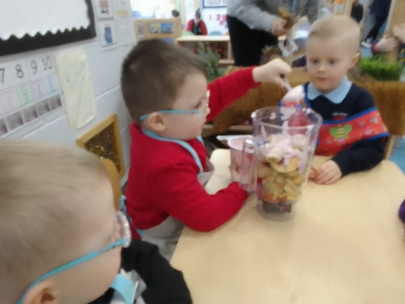
The children are encouraged to taste many different foods and drinks. They are given the opportunity to prepare and taste samples of ‘healthier food options’ -raw carrots, celery, brown bread, fruit salad etc. Staff will be made aware of any food allergies your child may have and offer alternatives. Children have opportunities throughout the year to bake, make and explore all kinds of foods

In conjunction with our Oral Health Programme the children are encouraged to participate in planned activities promoting healthy eating and the advantages to be gained from doing so. Examples of these are “Eat Well to Play Well” games, baking area, recognising different festivals throughout the year, Chinese New Year, Diwali, Christmas parties etc.

Staff monitor the children’s physical activities and work hard to promote awareness of the importance of health & fitness by offering appropriate learning experiences. Children take part in ‘Active Start’, a physical education program. They also have visiting coaches who come and work with the children to promote a love of physical exercise and develop their physical skills.

Children receive a healthy lunch from St Patrick’s Primary School. A lunch menu will be provided. Parents can also choose to bring a packed lunch if they wish.

MEDICAL CARE AND EMERGENCIES

Medication
If your child is in need of medication during his/her time at the nursery you should discuss their requirements with the Head of Centre. Medicines will be given as prescribed at the discretion of the Head. In order to administer the medicine you will need to complete the necessary medical forms. If your child suffers from a recurring illness please give us information on how to manage emergency treatment should the need arise. The nursery can only administer medicines prescribed by a GP or minor ailments service.

Minor Accidents
The centre has a qualified First Aider who would be able to offer treatment to minor injuries. In the event your child requiring further treatment we will inform you or an emergency contact immediately.

Oral Health
At the centre the children are currently involved in an Oral Health Programme. The children are encouraged to brush their teeth regularly at nursery and are supported in this by staff. The children’s progress will be monitored closely and on occasions the dentist will check the children’s teeth. Parents will be informed of this prior to visits. Consent is assumed, parents can withdraw consent from the programme if they wish.

If your Child Becomes Ill
If your child becomes ill at the centre we would make him/her as comfortable as possible and if necessary every effort will be made to contact you. If we can’t reach you we will get in touch with one of your emergency contacts.

If your child is unable to attend the nursery due to illness it is important you contact us and let us know, stating the type of illness. This helps us to safeguard others and spot any outbreaks. It is important that if he/she is unwell you keep him/her at home. This assists your child to make a quick recovery and also minimises the spread of infection.

INFORMATION ON EMERGENCIES
We make every effort to maintain a full educational service, but on some occasions circumstances arise which lead to disruption. Establishments may be affected by, for example, severe weather, and temporary interruption of transport, power failures or difficulties of fuel supply.

In such cases, we shall do all we can to let you know about the details of closures or re-opening. We shall keep you in touch by using letters, notices in local shops and community centres, announcements in the press and on local radio. Please also check our website and twitter. Our main contact method will be using our APP.

COMPLAINTS PROCEDURE

All users of the centre should be confident that any complaint or concern will be treated confidential and with sensitively. If you wish to make a complaint you may do verbally to the Head of Centre or Depute.

If you feel that the complaint was not dealt with appropriately you can contact Education Services by letter or by telephoning 01475 712815. If you wish your complaint to be dealt by the Care Inspectorate you will find leaflets in the entrance hall which will give full details on what action you should take. Our local Care Inspectorate office can be contacted on 0141 843 6840. You can also scan the code to go directly to Inverclyde Councils complaint information.

CARE INSPECTORATE


We are inspected on a bi-annual basis by the Care Inspectorate who ensures that standards are met for all service users. The Care Inspectorate issues questionnaires to parents /carers to help them to gather views to help with their evaluation of the service. You may view our Care Inspectorate report which is placed in our front hall or by going online to: www.careinspectorate.com or scan the code


Useful Websites for Parents


Parentzone Scotland is a unique website for parents and carers in Scotland, from early years to beyond school. The website provides up-to-date information about learning in Scotland, and practical advice and ideas to support children’s learning at home in literacy, numeracy, health and wellbeing and science. Information is also available on Parentzone Scotland regarding additional support needs, how parents can get involved in their child’s school and education.

Parentzone Scotland also has details about schools, including performance data for school leavers from S4-S6 and links to the national, local authority and school level data on the achievement of Curriculum for Excellence levels.

Bookbug

Bookbug is Scotland's universal early years book gifting programme which supports families to read, sing, and play with their little ones from birth to give them the best start in life. Starting school is an exciting and challenging time for your child and your support at home makes a real difference to their learning. Look out for your Bookbug Primary 1 Family Bag, a free bag of books and activities your child will receive at school in November from Bookbug, to help support their reading, writing and counting skills

General Data Protection Regulations and Data Protection Act 2018

Information on children, parents and guardian is stored on a computer system and may be used for teaching, registration, assessment and other administrative duties. In processing personal information, Inverclyde
Council must comply with the General Data Protection Regulation and Data Protection Act 2018.

For further information please refer to
https://www.inverclyde.gov.uk/site-basics/privacy

Useful Addresses

You may wish to be aware of the following names, addresses and
telephone numbers.

Director of Education : Ruth Binks
Education Services
Inverclyde Council
105 Dalrymple St
Greenock .
PA15IHT
Tel- 712850
Councillors- Colin Jackson
Michael McCormick
Pamela Armstrong
Care Inspectorate (Paisley Office)
Renfrewshire House
Cotton Street
Paisley
PA1 1BF
Tel: 0345 600 9527

