


Attendance & Latecoming
Procedures

Contents

Role of Registration Teacher…………………………………………………………….2

Assembly………………………………………………………………………………………….2

Class Teacher Responsibilities…………………………………………………………..3

Pupil responsibilities………………………………………………………………………..3

Parental responsibilities…………………………………………………………………..3

Pupil Support – Guidance Teacher’s responsibility…………………………..4

Role of Year Head…………………………………………………………………………….4

Role of Wellbeing Officer (Admin)……………………………………………………4

Role of DHT – Pupil Support (Attendance co-ordinator)…………………...5

Role of Head Teacher……………………………………………………………………….5

Attendance Management – Daily Procedures………………………………….5

Attendance Management – Weekly Procedures………………………………6

Flexible Timetables………………………………………………………………………….6

Be Inn Unity – The Bothy…………………………………………………………………6
The Hub…………………………………………………………………………………………..7
Maximising Attendance………………………………..…………………………………7
Attendance Monthly House Meetings……………………………………………..7
Staged Interventions……………………………………………………………………….8

Appendix 1-7 Staged Letters

Role of Registration Teacher

Register teachers have an important pastoral role. Daily contact provides an opportunity to build positive, trusting relationships with young people and to notice if there are changes in a young person’s wellbeing. This also sets the tone for the whole school day. Any pastoral information or concerns should be passed to the young person’s Guidance teacher.

Register teachers should ensure that the register is completed accurately. Registration is a legal requirement, and records of authorised and unauthorised absence may be used at Children’s Panels, the ASN Monitoring Forum or to justify EMA bursaries etc.

Each day, it is the Register Teacher’s responsibility to:

- create a safe, calm and welcoming ethos at Registration with the intention of preparing young people for the day ahead. Teachers should also ensure we are following the Mobile Phone Policy;
- record an accurate register of class attendance and alert PT Guidance immediately about any discrepancies/ concerns;
- mark pupils who are not present as To Be Confirmed (TBC) on SEEMIS;
- speak to pupils about previous day(s) absences and collect notes for Principal Teachers of Guidance;
- discuss RRS weekly themes and wider achievement with young people;
- ensure pupils have all the relevant info they require for the week.

Assembly
Each year group attends a fortnightly assembly in the hall on the same day each week. Registration takes place at the beginning of the assembly, and the registration is completed on a paper copy which is returned to the office. Register teachers stay with their classes in the assembly hall until the 9.00am bell. Period 1 class teachers should ensure that they complete a register upon the pupils’ arrival at class as this will be used as the official attendance mark for the morning session.

Class Teacher Responsibilities

- Class teachers will register their class on SEEMiS Click and Go within the first 10 minutes of the period. It is a legal requirement that this takes place each and every period as a failure to do so creates anomalies in individual pupil’s attendance figures.
- If a pupil is not present, then they should be marked as TBC on the register.
- Anomaly sheets should be completed and sent to the office for pupils who were present earlier in the day but who are now TBC. The exceptions to this are Period 1 and Period 5, when a TBC initiates an alert and a truancy call home.
- Pupils who arrive late will have their register mark updated to LATE.
- Pupils who are working out with the classroom setting will be accurately registered on SEEMIS.
- Incomplete registers will be monitored period by period and if a member of staff is regularly not completing registers this will be followed up by the Head Teacher.

Pupil responsibilities
- Pupils have a responsibility to attend school on time.
- Pupils who are feeling unwell should report to the Guidance Office or a member of SLT. If the pupil needs to be sent home, a member of the office staff or Guidance will arrange for pupils to be collected from school. Pupils should not leave school without permission, nor should they text parents themselves to request collection from school. This must be done through the Guidance Teacher.
- Pupils have a responsibility to be at school on time in the morning, after lunch and for each period.
- S6 pupils must ensure they sign in/out at the office if they have appointments.

Parental responsibilities

- Parents have a responsibility to ensure their child attends school.
- Contact made by 8.45am if your child is not going to be in school by calling 01475 715 300 or reporting via Parent Portal.
- If you do not do this, you will receive an absence query via Parent Portal between 10am and 10.30am. It is important that you respond to this promptly.
- Pupil appointments during the school day should be minimised as much as possible.
- If an appointment is necessary, contact should be made with the school and the time recorded as a permission (PER).

Pupil Support – Guidance Teacher’s responsibility
- Principal Teachers of Guidance will visit their registration classes each morning to discuss any discrepancies from the previous day(s).
- Issue attendance letters as appropriate to parent/ carer.
- Arrange meetings with pupils, families and partner agencies to support attendance.
- It is the responsibility of the Guidance Teacher to review the attendance for their caseload. TBCs for individual periods or unexplained absences should be addressed with individual students and subsequent contact made with parents/carers as to the reason for non-attendance. On a weekly basis, TBCs should be removed and the appropriate code marked on the system.
- On a monthly basis each student’s attendance percentage should be reviewed using the Attendance Tracker Spreadsheet. If attendance falls below 90% or continues to decline, appropriate interventions should be made to help improve a young person’s attendance. The intervention should be noted on the Attendance Tracker spreadsheet. It is essential that attendance is monitored closely, and an early intervention approach applied.

Role of Year Head
- All Year Heads should review the Attendance Tracker spreadsheet regularly.
- Each month, Year Heads should meet with each Guidance teacher at the House Meetings to review interventions to ensure that the appropriate support is in place for any young person whose attendance falls below 90% (see maximising attendance).

Role of Wellbeing Officer (Admin)

- Absence alerts sent via GroupCall for tbc from 9.20am.
- A GroupCall will also be sent after lunch for pupils who were present in the morning but absent in the afternoon with no contact from home.
- To Be Confirmed (TBC) entries updated following parent response to text/ call.
- No replies passed to Office Wellbeing Officer who will begin making calls from 10am.

Role of DHT – Pupil Support (Attendance co-ordinator)
The DHT with responsibility for Pupil Support should ensure that the Attendance Tracker Spreadsheet is updated each month to be accessed by Guidance staff and Year Heads. Each month, the DHT Support will report on current trends in attendance. The DHT Support will also monitor the impact of strategies in place on improving attendance. The DHT Support will also track the attendance of targeted groups to identify any concerns and monitor the effectiveness of interventions. Any concerns in relation to individual young people should be passed to the relevant Guidance teacher.

Role of Head Teacher
Each month, the Head Teacher should ensure that attendance is discussed at House meetings and regularly at SLT to review and examine the impact of the interventions put in place and discuss trends in particular groups.

Attendance Management – Daily Procedures
- For the purpose of attendance management, Period 1 will be used rather than Registration. All class registers should be completed by 9.10am. Paola Eardley (Wellbeing Admin) will check on incomplete registers and alert staff to complete immediately (initially by contacting PTs or departmental bases).

- Truancy call should be sent by 9.30am. Parent/Carers and all contacts of those young people on the High-Risk list should be telephoned immediately and repeatedly until contact is made.

- At 10 am Paola should run an anomalies report and begin calls for unexplained absence and change codes as appropriate. This should continue until all phone calls are completed.

- If by 11.30am a reason for absence cannot be obtained for any student on the High-Risk list, the name should be passed to SLT or Principal Teacher of Guidance and agencies (SW/Police Scotland) contacted.

- At 1.25pm office staff will check on incomplete Period 5 registers and alert staff to complete immediately.

- Truancy groupcall/text should be sent by 1.35pm

- At 1.45pm office staff should run an anomalies report and begin calls for unexplained absence and change codes as appropriate.

- If contact has not been possible for two consecutive days and all contacts have been telephoned with messages left, the name should be emailed to the appropriate member of SLT.

Attendance Management – Weekly Procedures

- Guidance staff will continue to follow up on TBCs throughout the week at registration and during PSE time. TBCs will be updated with the appropriate registrations mark on Seemis using the anomalies report.

- Office staff will update college non-attendance on Seemis when we receive the attendance information from the college.

- Year Heads will update Seemis with appropriate registration marks on Seemis as appropriate and will also liaise with Guidance, Office staff and parents/carers to support young people to attend all classes.

- Any concerns relating to patterns of non-attendance in a particular subject should be flagged up to the Department Principal Teacher in the first instance for action to address any issues relating to that specific subject. If there are wider pastoral concerns relating to the non-attendance, this should then be passed by the Department Principal Teacher to Guidance.

- Concerns regarding patterns of non-attendance of any young person in receipt of EMA should be passed to the Year Head.

Flexible Timetables
It is the responsibility of the Year Head to update a pupil timetable if a pupil has flexible timetable arrangements. The Year Head should print a copy of the timetable, writing on where the pupil should be for each period of the day, noting the appropriate attendance mark. This should be passed to Jackie who will update on Seemis.
Be Inn Unity – The Bothy
- A list of all pupils and the periods attending the Bothy should be sent to the office in advance of the block.
- Sharon (Be Inn Unity Support Worker) should take a paper register and send it to the office within the first 10 mins of the period. She should also pass a weekly attendance to the DHT Pupil Support to analyse impact.
- The office staff will change those present to SCH
- If a pupil is absent, and not in their timetabled class, they should be marked as TRU and a truancy call should go home.

The Hub
- A list of all pupils and the periods attending the hub should be sent to the office in advance of the block.
- Each teacher responsible for the Hub should take a paper register and send it to the office within the first 10 mins of the period.
- The office staff will change those present to SCH
- If a pupil is absent, and not in their timetabled class, they should be marked as TRU and a truancy call should go home.

Maximising Attendance

In addition to all of the above responsibilities in relation to attendance, the following procedures should be followed by PT Guidance staff to maximise the attendance of all pupils in St Stephen’s High School.

Attendance letters

The ultimate responsibility for monitoring pupil attendance and late-coming lies with the PT Guidance who will liaise closely with Registration Teachers and Year Heads.

The threshold for attendance at St Stephen’s is 90%, although it may be appropriate and relevant for supports to be in place prior to reaching this threshold.

At threshold, the attached letters will be sent home and associated action will be taken.

Attendance Monthly House Meetings

The HT, DHT Support, relevant Year Head and PT Guidance will meet monthly to review the attendance of pupils below 90%. The following will be discussed and monitored:

- attendance and achievement of vulnerable groups
- those pupils whose attendance is dropping
- those who are making improvements
- those who are in the ‘at risk’ or ‘chronic absence’ category
- any emerging patterns.
- Strategies and interventions
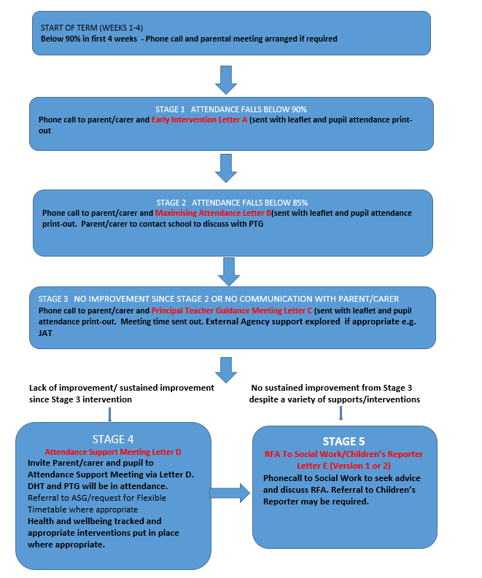

Appendix 1 Raising Awareness Letter

DATE

ATTENDANCE MATTERS

Dear Parent,

This is a raising awareness letter which we send out to all parents every year. Attendance at school is important for many reasons. These include: supporting our children to grow in confidence and self-esteem, to experience success in their learning and understand responsibility.

Our local authority attendance target is 95%. Low attendance can lead to social and emotional difficulties as well as impact progress in learning; however, we understand that there are times when your child cannot attend school, including if they are ill or attending medical appointments.

If you are experiencing difficulty getting your child into school, please contact the school office and ask for an appointment to speak with your child’s Guidance Teacher or Year Head who is happy to help.

Please see graphic below outlining the impact of days missed and late-coming.

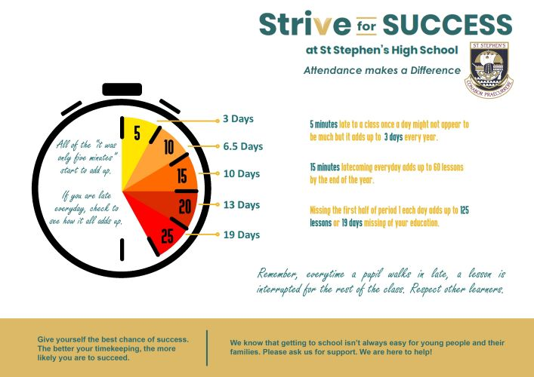

Yours sincerely,

Head Teacher

Appendix 2
Letter A – Early Intervention Letter

Date

To the Parent/ Guardian of

Dear

I am writing to you to notify you that your child’s attendance has fallen below 90%.

(Child’s name) current attendance percentage is (%).

As of (today’s date) they have missed (number of days) days at school.

(Child’s name) has been late in the morning/ late to class throughout the school day (no of times late) times.

St Stephen’s High School attaches great importance to high attendance and good timekeeping. Making sure all young people are included, engaged and involved in their education is fundamental to achievement and attainment in school and ultimately to their future. Regular attendance and positive timekeeping at school gives your child the best chance to develop good learning habits and a positive attitude to work.

I have enclosed CHILD’S NAME attendance printout and a link to the NHS Website NHS: Is my child too ill for school? The graphic below gives more detail on what attendance percentage means in terms of missed learning.

We understand that health issues do occur, and we ask that you report any illness to the school office or via parent portal. We are committed to working in partnership with parents/ carers and our young people to ensure that all pupils have the opportunity to reach their full potential.

We would greatly appreciate it if you would contact the school to discuss your child’s attendance so that we can best support your child.

Yours sincerely,

Principal Teacher of Guidance

Appendix 3 Letter B – Maximising Attendance Letter
Date

To the Parent/ Guardian of

Dear

I am writing to you as [Insert Child’s Name] attendance is giving cause for concern. It now stands at [insert percentage].

To date they have missed [X amount] days at school.

(CHILD’S NAME) has been late in the morning/ late to class throughout the school day (no of times late) times.
Poor attendance and timekeeping at school can have an adverse impact on achievement and attainment. Good attendance, therefore, prevents your child having gaps in their learning and gives them the chance to achieve their full potential.
If this pattern of poor and irregular attendance continues, the school will invite you to an attendance meeting to discuss ways in which we can work together to ensure CHILD’S NAME attendance improves. This is in line with the Scottish Government’s Policy on School Attendance as there is a legal obligation for children and young people to attend school.
I would be obliged, therefore, if you would telephone the school in the first instance to discuss the situation with me. If there are particular issues preventing good attendance, please bring them to my attention. We keen to work with you and support CHILD’S NAME to help ensure they achieve their potential in _________________________.

I look forward to hearing from you.

Yours sincerely

Principal Teacher of Guidance

Appendix 4 Letter C – Meeting with Principal Teacher of Guidance
Date

To the Parent/ Guardian of

Dear

I am writing to you as [Insert Child’s Name] attendance is giving cause for concern. It now stands at [insert percentage].

To date they have missed [X amount] days at school.

(CHILD’S NAME) has been late in the morning/ late to class throughout the school day (no of times late) times.
Poor attendance and timekeeping at school can have an adverse impact on achievement and attainment. Good attendance prevents your child having gaps in their learning and gives them the chance to achieve their full potential.
We keen to work with you and support CHILD’S NAME to help ensure they achieve their potential. I would like to invite you to a maximising attendance meeting to support your child.

Time

Date

If the date or time suggested above does not suit, please do not hesitate to contact me to reschedule.

Yours sincerely

Principal Teacher of Guidance

Appendix 5 Letter C(i) – Meeting with Principal Teacher of Guidance – Agreed Actions
Date

To the Parent/ Guardian of

Dear

ATTENDANCE MATTERS: Stage 3a Attendance Meeting Agreed Actions

Thank you for attending a meeting and helping us plan to improve (insert child’s forename) attendance.

Following this meeting, to support your child attending school, we agreed to do the following:
- Action 1:
- Action 2:

We will continue to work with you to improve (insert child’s forename) attendance, however, If there is no improvement after six weeks, then the next step will be a multi-agency meeting to support (insert child’s forename) towards improved attendance.

Your support in encouraging and promoting attendance at school is appreciated. If there is ever anything you wish to discuss regarding attendance, please do not hesitate to get in touch.

Yours sincerely

Principal Teacher of Guidance

Appendix 6 Letter D – Attendance Support Meeting
Date
Dear
I am writing to you as [Insert Child’s Name] attendance continues to be a serious concern and there has been no significant improvement since your meeting with your child’s Pupil Support teacher on (INSERT DATE).

Your child’s attendance now stands at [insert percentage]. To date they have missed [X amount] days at school.

(CHILD’S NAME) has been late in the morning/ late to class throughout the school day (no of times late) times.

As attendance has not improved since our previous letters and discussions, and in accordance with the Inverclyde Council Attendance Policy, you are invited to attend an Attendance Support Meeting. This will involve the Depute Head Teacher and Principal Teacher of Pupil Support. At this meeting we will discuss the continued reasons for poor attendance and agree targets and interventions to support improvement.

I take this opportunity to remind you that under the Education Scotland Act 1980, you have a parental obligation to ensure your child attends school regularly and to satisfy the Education Authority that there is a reasonable excuse for any absence.

We are committed to supporting you and your child to help remove barriers which are preventing them achieving their potential. Failing to attend this meeting will prevent us working together to ensure CHILD’S NAME is fully supported.

Non-engagement may result in us seeking further advice from multi-agency partners in order to explore how best to support your child.

Details of the meeting are as follows:

Date of Attendance Support Meeting:
Time:

Please arrive at the school office at least 5 minutes before your allocated time. Please contact the school if you are unable to this meeting and reschedule a more convenient time.

We look forward to working with you.

Yours sincerely

Depute Head Teacher
Appendix 7 Letter E – Referral to Children’s Reporter (Version 1 & 2) VERSION 1

Attendance %
Missed learning days
No. of times late

Dear

My recent letter to you described my concerns about CHILD’S NAME attendance record and invited you to attend an Attendance Support Meeting.
As you did not attend this meeting and (CHILD’S NAME) ‘s attendance record has not improved then I must seek further support from external agencies to help ensure (CHILD’S NAME) is fully supported to engage in education.
I must now seek assistance from Social Work Services and refer to the Children’s Reporter if advised.

In due course, you may be contacted by the Children’s Reporter giving details of how they intend to proceed.

Yours sincerely

Principal Teacher of Guidance

Or VERSION 2

Appendix 7 Letter E – Referral to Children’s Reporter (Version 1 & 2) VERSION 2

Attendance %
Missed learning days
No. of times late

Dear
You and your child recently attended an Attendance Support Meeting, and a number of support interventions were agreed. There has been limited engagement in these interventions and attendance continues to be a serious concern. Therefore, I must now seek assistance from Social Work Services and refer to the Children’s Reporter if advised.

In due course, you may be contacted by the Children’s Reporter giving details of how they intend to proceed.

Yours sincerely

Principal Teacher of Guidance

