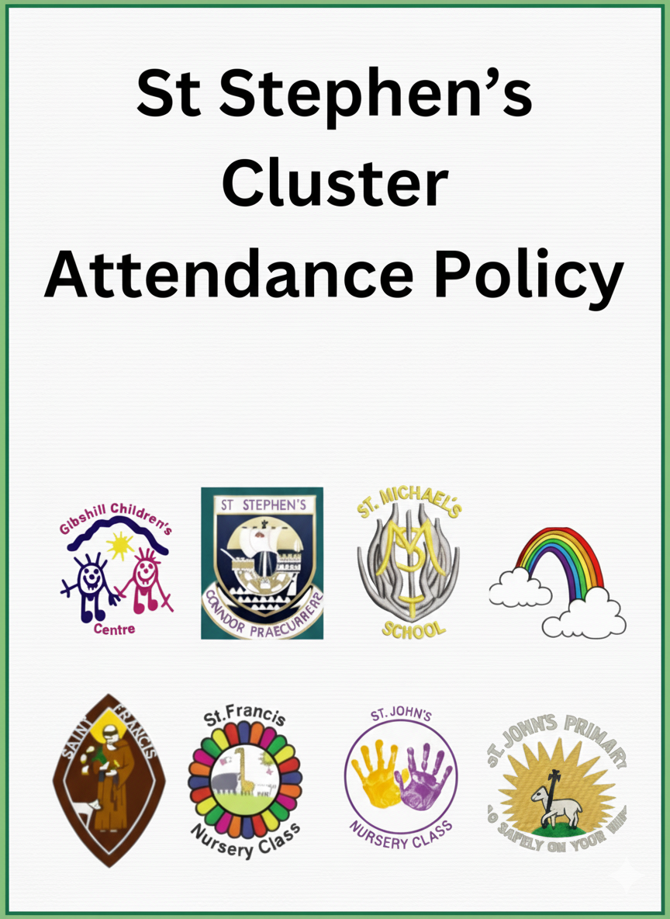
St Stephen’s Cluster
Attendance Policy
2025

Maximising Attendance and Minimising Absence Policy

Attendance is important because:
- it supports wellbeing, social connections, social competency, and social cohesion
- it gives us the opportunity to access and engage with learning (in and out of the classroom)
- it provides opportunities to develop skills and confidence, to contribute to and be part of a wider community, and to demonstrate that we can be responsible citizens now and, in the future,

Other benefits of attendance include things like providing us with a:
- a safe, calm, caring, learning environment
- a place to make and meet friends
- somewhere to develop and learn about ourselves, our emotions, and how we relate to, and respect, others

Every day of absence is a day of lost learning –> 1 day absent per fortnight = 1 year of lost learning by S3

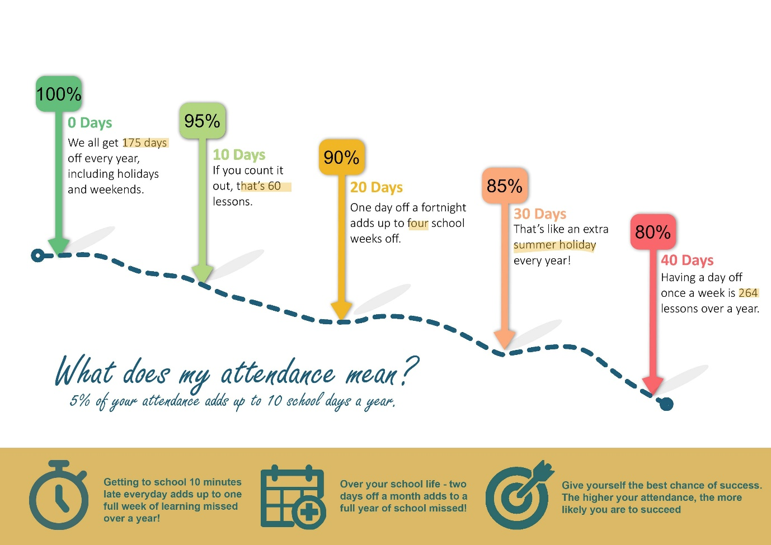

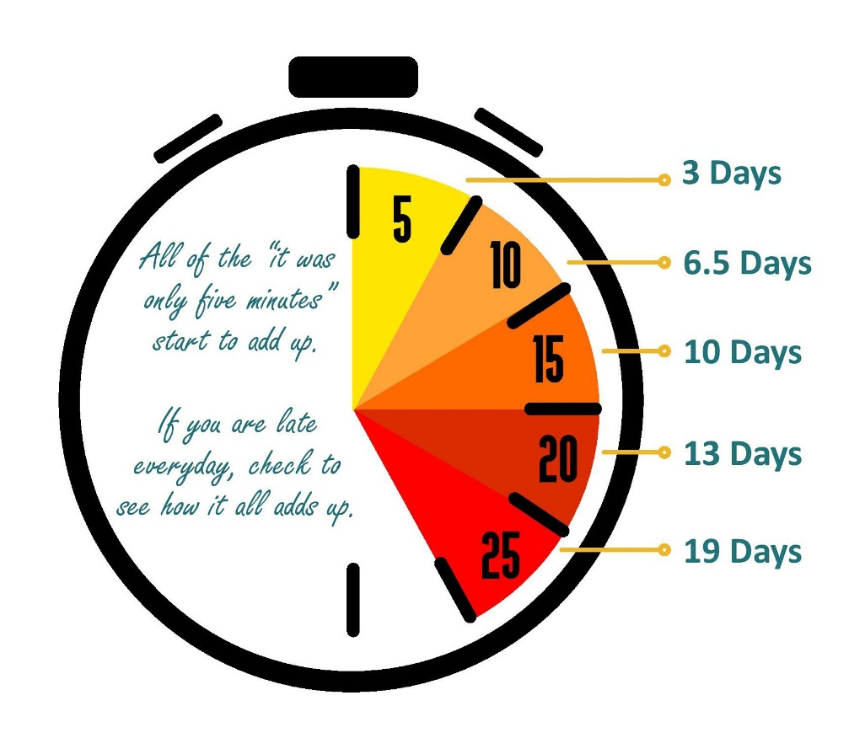

Rationale

This policy is underpinned by Inverclyde Attendance Policy (December 2024). Statistics and research have consistently demonstrated that children and young people’s progress, attainment and achievements can be negatively impacted by any absence. Evidence suggests that attendance that falls below 90% impacts negatively on progress, with the higher the absence, the greater the impact on attainment.

School attendance is a complex area of need, and involvement from other services/professionals can be helpful, appropriate and, at times, necessary. However, the aim of the current guidance is to support early and effective school attendance procedures and practice at a school level. The Scottish Government’s (2019a) Included, Engaged and Involved (Part 1) document states that attendance should not be considered in isolation and that work within schools, establishments and Local Authorities should be built upon a foundation of positive relationships, and an inclusive ethos and culture which promotes attendance.

Aims:
The aims of this policy are designed to reflect the overall aims of the Inverclyde Attendance Policy (October 2024). This attendance policy outlines our commitment to promoting regular attendance, punctuality, and engagement for all pupils. As a school, we aim to work in partnership with parents, carers and partners to ensure that all pupils attend school regularly and punctually, with support available when needed.

We aim:

- To provide guidance on procedures that support attendance and reduce absence in St Stephen’s Cluster.
- To outline the processes, we follow to maximise attendance in St Stephen’s Cluster
- To provide supporting guidance that can be implemented with greater flexibility, based on our unique contexts.
- To encourage full attendance and punctuality among all.
- To foster a positive culture where every child feels valued and supported.
- To work collaboratively with parents, carers, and external agencies to address and overcome any barriers to attendance.
- To ensure that all absences are accurately recorded and addressed in a timely manner.

Attendance is everyone’s responsibility – what’s your role?
Learners should as appropriate:
- take personal responsibility for attending as often as possible
- try not to be late
- engage in all aspects of the life of the school including learning and other social activities
- contribute to the daily life of the school and encourage peers to attend

Parents and carers should:
- ensure their child understands the importance of education and attendance
- support their child to attend as often as possible
- notify the school as soon as possible when their child is unexpectedly absent,by phone, Parents Portal, text or email.
- work with staff to minimise absence and reduce any barriers to attendance
- book medical appointments outside school hours where possible and give advance notice if an absence is unavoidable
- keep the school up to date with telephone numbers and emergency contacts
- Ensure that where one child does require to be absent, siblings still attend
- Consult NHS guidance where unsure: NHS: Is my child too ill for school?

Staff should (appropriate to their context):
- proactively develop respectful and supportive relationships that support a positive ethos and culture
- regularly promote good attendance through lessons, assemblies, informal and formal conversations, and events
- make learning interesting and relevant and support learner engagement using a range of strategies
- keep regular and accurate records of attendance for every learner
- share concerns about a learner's engagement, attendance or wellbeing, at the earliest stage
- respond sensitively to learners and parent/carers when exploring attendance concerns

Senior Leaders should:
- prioritise attendance and punctuality
- promote attendance through policies, procedures, training, meetings and communications
- aim to improve overall attendance and reduce lateness through supportive interventions
- follow-up on all absences and identify and investigate patterns of absence
- ensure consistency in practice that supports attendance and engagement

Partners will:
- Work with learners, parents/carers and staff to maximise learner participation in education

We promote attendance in our establishments by:
- building relationships and prioritising wellbeing and care
- being inclusive and rights respecting
- involving learners in all aspects of learning and the life of the establishment including improvement planning and policy making
- having a curriculum which is relevant, engaging, and meets the needs of all our learners
- using a range of pedagogical approaches that cater for different learning styles
- all adults promoting attendance as well as having specific adults to help learners and families who may need a little bit of extra support
- treating parents and carers as partners in supporting attendance

When absence becomes a concern then the school will begin an assessment process, in consultation with learners and parents or carers, to explore the reasons behind the absence and to offer supportive interventions if appropriate. To contact parent/carers we may use text, email, phone call or letter.
When absence becomes a concern, we support learners and their families in the following ways:
Support for attendance may include preventative strategies within the everyday classroom
and school environment, alongside more targeted approaches planned with learners and families. Strategies may include: mentoring, check-ins with a trusted adult, safe spaces or short-term withdrawal for targeted work.

Where more support is required, schools may work with partners such as Educational Psychology, health professionals, community services to create a tailored package of support.

In some cases, highly individualised programmes may be put in place to support attendance.

For more information or help:
Talk to your child’s key contact or Head of Establishment.

Flow Chart for Maximising Attendance & Letter Templates
Flowchart supporting improving attendance
The following flowchart is designed to maximise attendance and support absence. At all stages the children and families context should be considered alongside any identified actions.
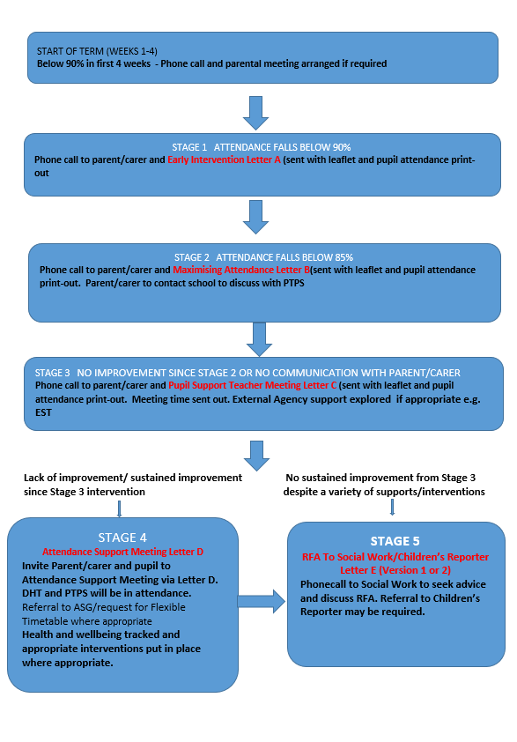

Sample letters are provided below to support the process:

A referral to SCRA re non-school attendance should only be considered when all of the above criteria to refer to RFA has been exhausted, and SW have been consulted so that no referrals are being submitted to SCRA for a child that has not been flagged to SW.
A referral to SCRA should only be considered where there are clear indicators that the family are not engaging on a voluntary basis or where the reason for a child’s sustained absence is due to environmental/parental factors e.g. not due to a child’s diagnosis or mental health issue.
Appendix 1: Decision Making Tree for Unexplained Absence

If a parent has not advised the school that the pupil will be absent, then it must be assumed that the parents are unaware of the absence and that the child is missing or truanting. If the school has been unable to establish contact with the parents, action must be taken to satisfy the school and the education authority that the child or young person is safe and well.
