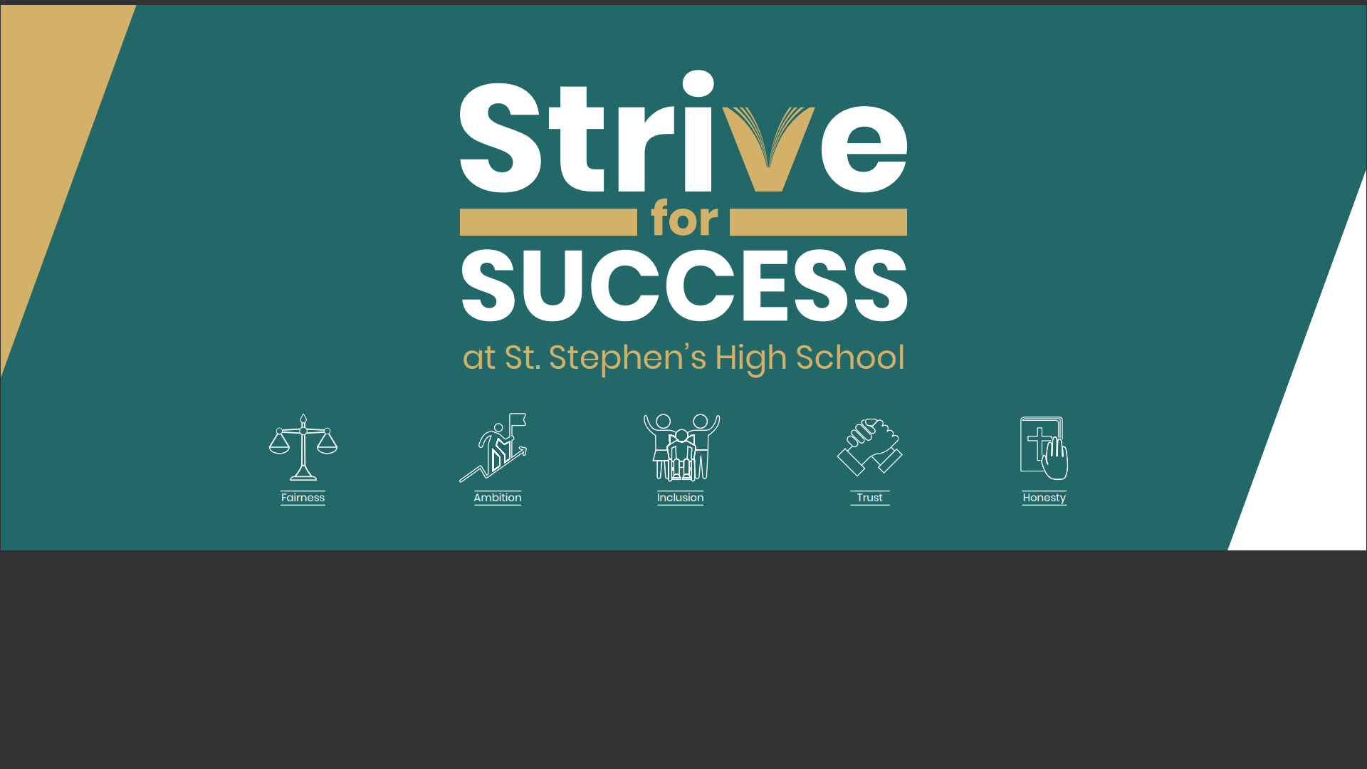



**School Handbook**

**2024-2025**

|  |
| --- |
|  |

Contents

Page

Contents 1

Introduction by Head Teacher 2

Authority Strategic Statement 3

Equality 4

Child Protection in Inverclyde 4

Complaints 4

Vision Aims and Values 5

St Stephen’s Prepared for Success 6

A Charter for Catholic Schools in Scotland 7

Introduction and General Information 8

Senior Leadership Team 9

List of Staff 10

The School Day 11

Transfer / Enrolment 11

School Holiday Arrangements 12

Information in Emergencies 13

Associated Primary Schools 13

Primary / Secondary Liaison 14

Curriculum for Excellence 15

S1 – S3 (The Broad General Education) 15

Transition from the Broad General Education to the Senior Phase 16

Transitions 17

Additional Support Needs 18

Educational Psychology Services 21

Equal Opportunities and Social Justice 22

Pastoral Care 23

Reporting to Parents 24

Home Learning 25

Supported Study 25

Religious Education 26

The School Chaplain 29

Religious Education and Observance 29

Extra-Curricular Activities 30

Other Achievements 30

Positive Relationships, Positive Behaviour 31

Attendance at School 33

Education Maintenance Allowance 34

Clothing and Uniform 36

Communication with Parents 39

School Meals 41

Data Protection Act 1998 42

Transport 42

Medical and Health Care 44

Parental Engagement 46

St Stephen’s Parent Council 48

Useful Addresses 50

Local Councillors 50

Appendices 51

Introduction from the Head Teacher

Dear Parents/Carers,

Welcome to St Stephen’s. Our school handbook contains important information that we hope will be helpful for you as your child makes their transition from their present school to St Stephen’s. We hope this will give you an insight into our school, our aims and our achievements.

First and foremost, we are a Catholic community of faith and learning which places our Gospel values at the heart of everything we do.  In St Stephen’s High School our vision is to strive for success and in order to achieve this we aim to provide high quality learning experiences in a loving, ambitious, inclusive and nurturing environment.  We value our Catholic faith and we live out our core values of Fairness, Ambition, Inclusion, Trust and Honesty on a daily basis and they underpin everything we do.

We are incredibly ambitious for our young people and very proud of their many achievements both academically and in sport, music, the arts and citizenship. We place great value on the positive relationships between our staff and pupils and we believe that our partnership working is key to supporting our young people and families. We believe that by working together with our parents, partners, and parishes, we can encourage our young people to flourish; to use their God given talents to achieve their potential and give back to others; and to become the very best version of themselves.

We invite you to work with us and the whole school community to continually improve our school and support and celebrate the attainment and achievement of our young people. We hope that this will be the beginning of a partnership that will develop as your child journeys through St Stephen’s. Please do not hesitate to contact your child’s Guidance teacher, Year Head or me if you would like to talk about any of the information contained within this handbook.

Kindest Regards,

Jennifer McDonald

Head Teacher

Authority Strategic Statement

***Building Inverclyde through excellence, ambition and regeneration.***

**Goals and Values**

Our Core values are –

* Respect
* Honesty
* Tolerance

Our vision for the children and young people of Inverclyde is that they should be ambitious for themselves and be successful learners, confident individuals, responsible citizens and effect contributors.

To achieve our ambition of building Inverclyde through excellence, ambition and regeneration our children must be:

***Safe:***

protected from abuse, neglect and harm by others at home, school and in the community.

***Healthy:***

enjoy the highest attainable standards of physical and mental health, with access to healthy lifestyles.

***Achieving:***

have access to positive learning environments and opportunities to develop their skills, confidence and self-esteem to the fullest potential.

***Nurtured:***

educated within a supportive setting.

***Active:***

active with opportunities and encouragement to participate in place and recreation including sport.

***Respected and responsible:***

involved in decisions that affect them, have their voices heard and be encouraged to play and active and responsible role in their communities.

***Included:***

have access to high quality services when required and should be assisted to overcome the social, educational, physical, environmental and economic barriers that create inequality.

Equality

‘Inverclyde Education Service is committed to ensuring that no children or members of staff or service users receive less favourable treatment on any ground including age, gender reassignment, pregnancy and maternity, race, disability, sex, sexual orientation, marriage and civil partnership, religion or belief. We have a moral, social and legal obligation to mainstream and put equality at the heart of everything we do. We aim to promote a culture in which equality of opportunity exists for all. We are opposed to all forms of discrimination, direct or indirect, and aim to eliminate all discriminatory practices. We will ensure that, in our schools and other educational establishments, equality permeates the curriculum and underpins all our policies and practices in terms of access to education. We must ensure that all our children achieve their full potential to develop physically, emotionally and academically. Finally, we believe that equality and inclusion should be a given right, where everyone is valued and treated with respect.’

Child Protection in Inverclyde

Inverclyde Council Education Services has Child Protection Guidelines and Procedures which all schools and establishments are required to follow. Education Services work very closely with other agencies namely Strathclyde Police, Social Work Services, NHS Greater Glasgow and Clyde and the Children’s Reporter to support children. Common responsibilities of all staff are to protect children from abuse and exploitation, to respond appropriately when abuse is identified, and to ensure whenever possible that all children are able to exercise their right to be raised in a warm, stimulating and safe environment with the support of staff, their families and carers.

Complaints

Any comments or complaints should be addressed directly to the school office where they will be dealt with by a member of the school leadership team. If parents seek a further response then they should contact Education Services, Wallace Place, Greenock PA15 1JB

General Data Protection Regulations and Data Protection Act 2018

Information on children, parents and guardian is stored on a computer system and may be used for teaching, registration, assessment and other administrative duties. In processing personal information, Inverclyde Council must comply with the General Data Protection Regulation and Data Protection Act 2018.

For further information please refer to <https://www.inverclyde.gov.uk/site-basics/privacy> or click on the following: [Privacy page link](https://www.inverclyde.gov.uk/site-basics/privacy)



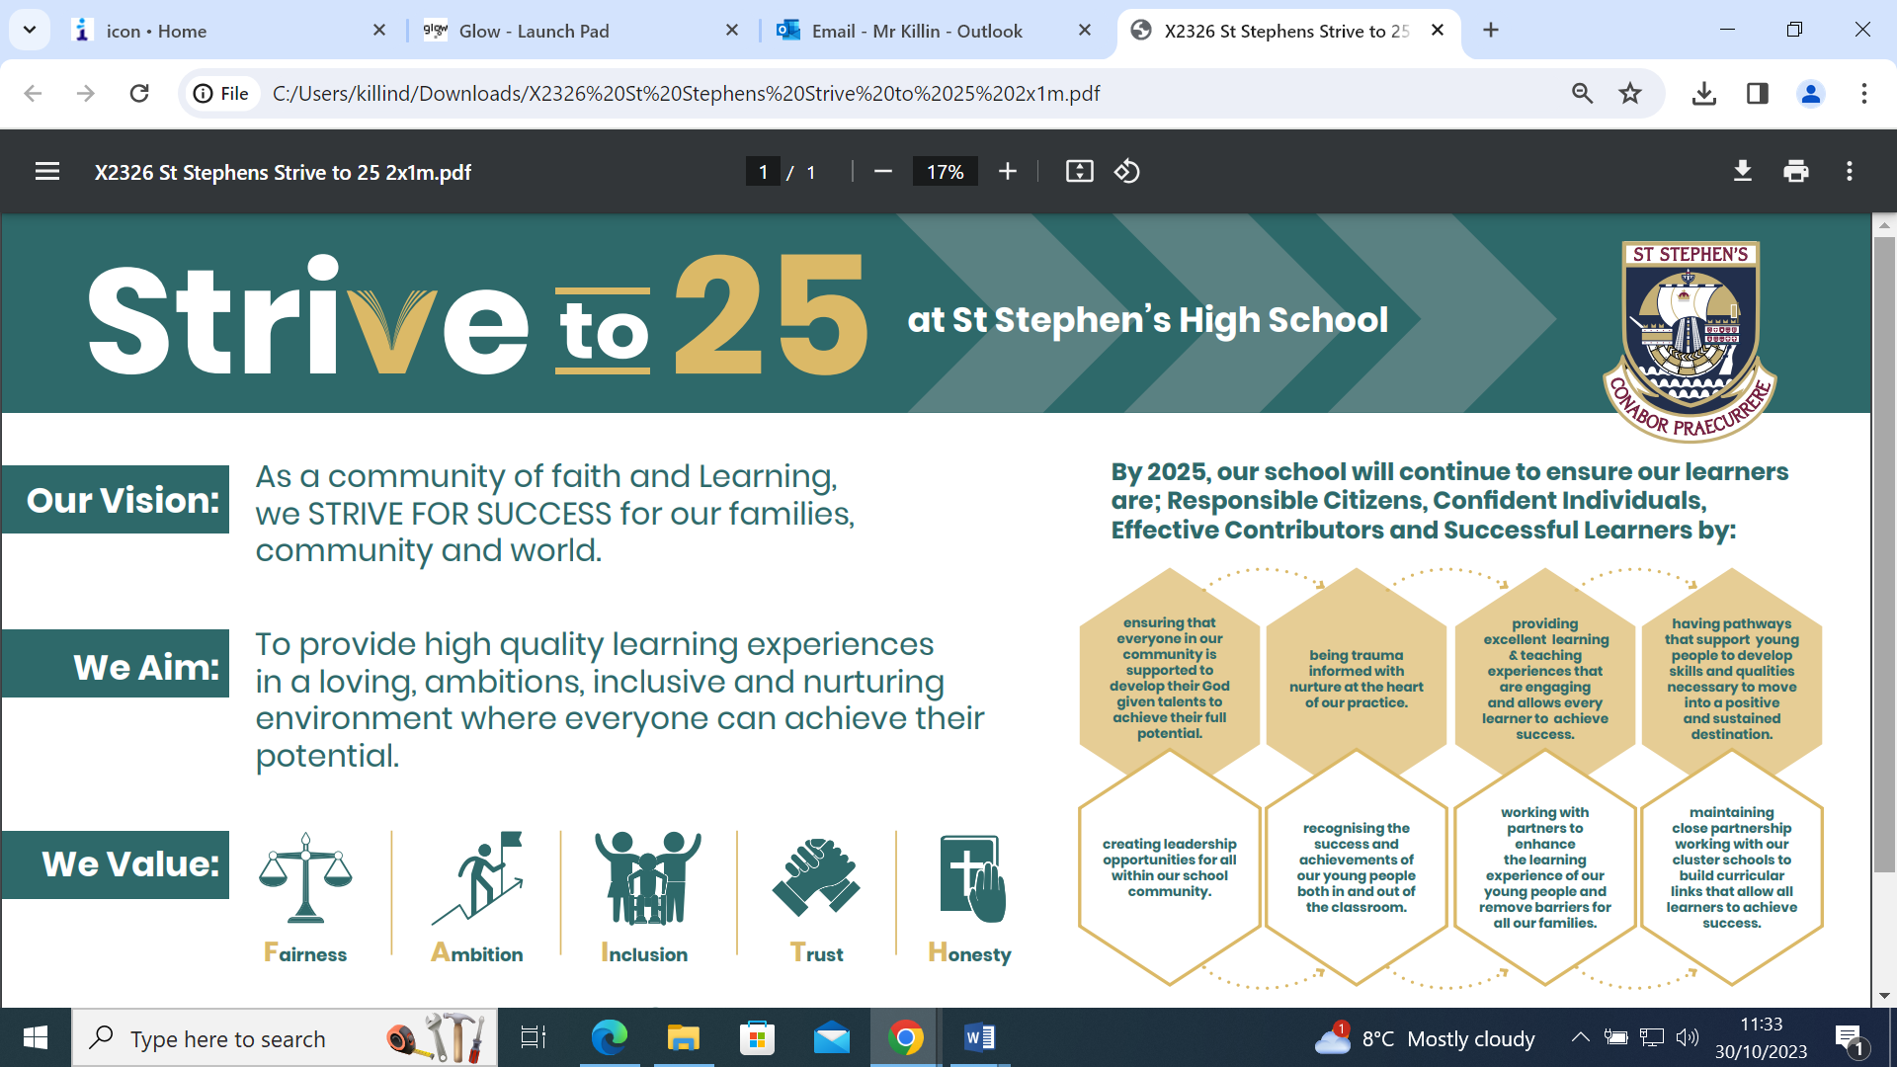

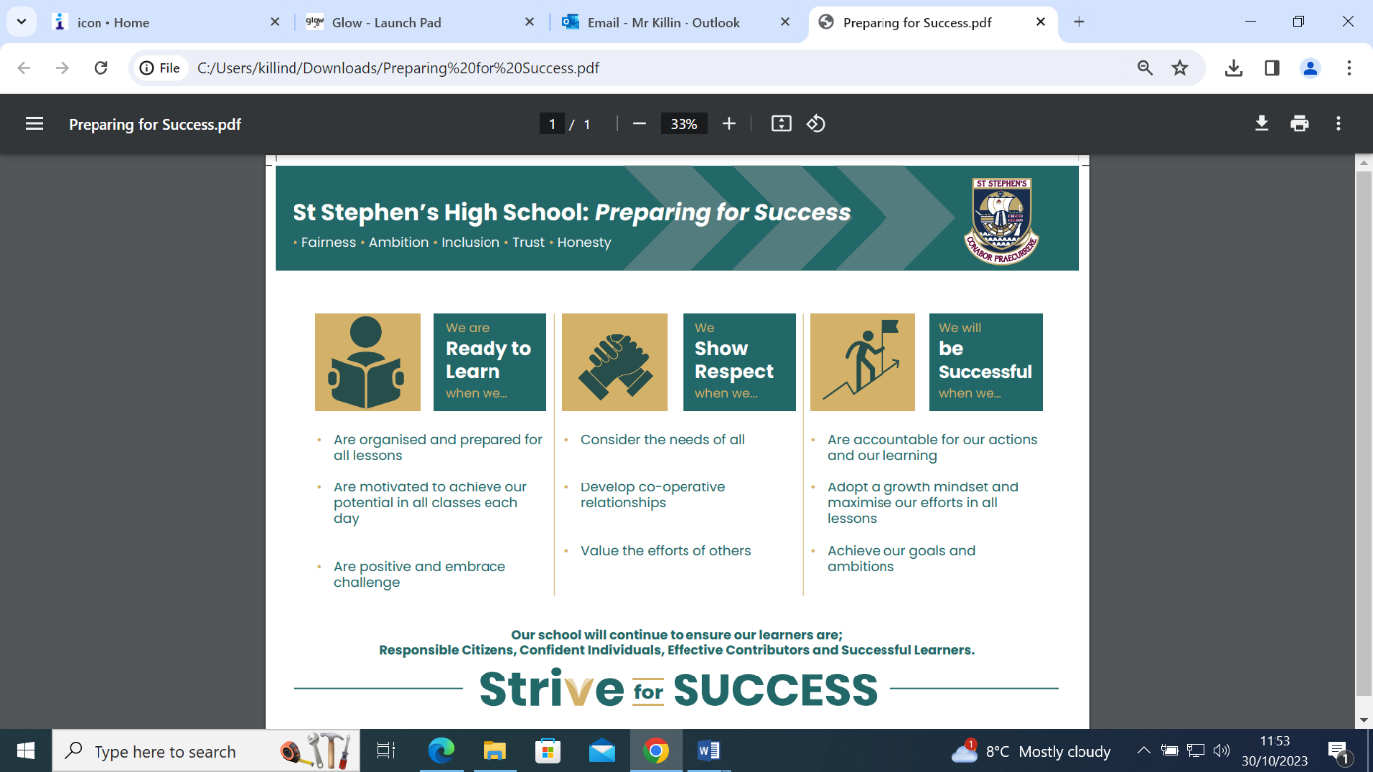A Charter for Catholic Schools in Scotland

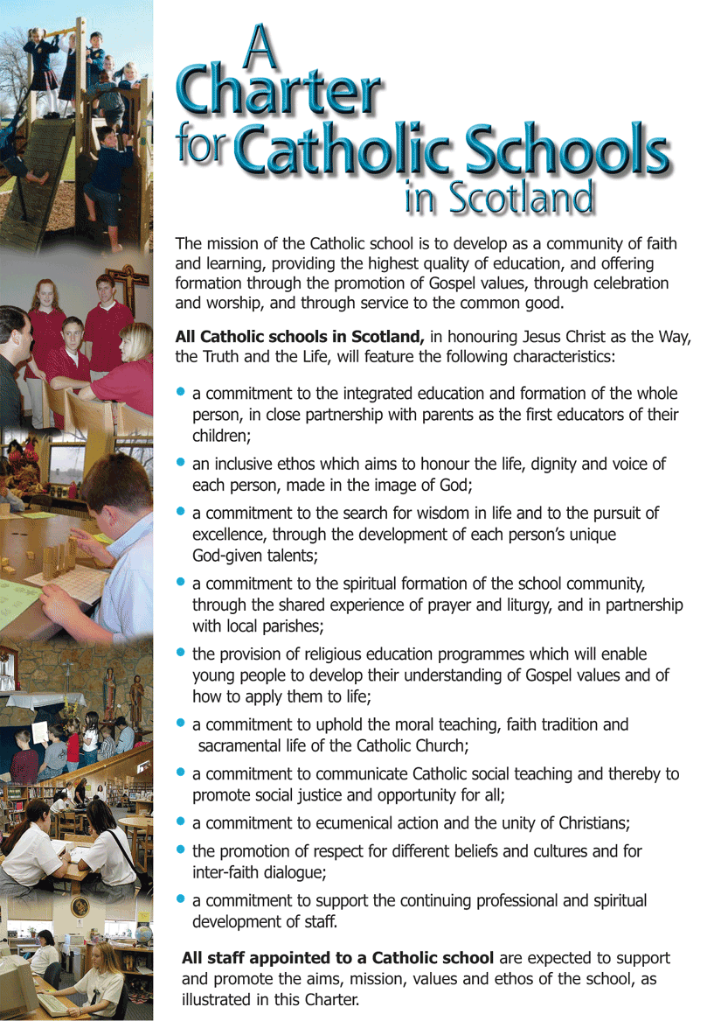

Introduction and General Information

St Stephen’s High School is a six year Catholic comprehensive secondarywhich provides an education for young people from the ages of 12 to 18 living in the areas of Port Glasgow and Kilmacolm.

St Stephen’s is committed to providing a high quality education within the context of a Catholic school. By recognising their uniqueness and dignity as human beings, we encourage our pupils to live their lives by Gospel values and by our shared school values. We show witness to our faith by praying together every day and by providing many opportunities for the spiritual development of staff and pupils. We are ably supported in this work by our school chaplain, Fr Jonathan Whitworth from St. Francis of Assisi Parish and Holy Family Parish.

**Address:** Kilmacolm Road

Port Glasgow

PA14 6PP

**Telephone:** 01475 715300

**Fax:**  01475 715301

**E-mail:** INStStephens@glow.sch.uk

**Website:** <http://st-stephens.inverclyde.sch.uk>

**Twitter**: @StStephensHS

**Head Teacher:** Jennifer McDonald



The current school roll is detailed below –

**S1** 93

**S2** 100

**S3** 92

**S4** 89

**S5** 94

**S6** 53

**Total** 521

Senior Leadership Team

The Senior Leadership Team (SLT) is composed of the Head Teacher and, currently, 3 Depute Head Teachers.



**Mr Carroll**

**Depute Head Teacher**

**Year Head S1 & S2**

3.1 Wellbeing, Equality & Inclusion,

Pupil Support, Transitions and Positive & Sustained Destinations and DYW, Attendance and ASN.

**Mrs McDonald**

**Head Teacher**

Responsibilities include:1.3 Leadership of Change, School Improvement and Pupil Equity Funding, Staffing and School Finances, Safeguarding and Child Protection, Attainment and Achievement.

**Miss McKinney**

**Depute Head Teacher Year Head S5 & S6**

2.3 Learning & Teaching

1.3 Self-evaluation for school improvement

Leadership of Learning & Parental Engagement



List of Staff – October 2024

**Mr Parsons**

**Acting Depute Head Teacher Year Head S3 & S4**

**Responsibilities include:**

Curriculum Development, Raising attainment & achievement, timetabling, all matters relating to S3 and S4.

**Mathematics**

Mr Dyer Principal Teacher

Mrs McIllaney

Mrs Coyle

Mr McAllister

Mrs Watt

**Physical Education**

Mrs McGinnity Principal TeacherT 0.8 FTE

Mrs Parsons Principal Teacher Guidance

Mr Maguire

Mr Forster Principal Teacher Targeted Support (acting)

**Religious Education**

Mr Girkins Principal Teacher

Mr McCole Principal Teacher Guidance

**Science**

Mrs Flynn Faculty Head (acting)

Physics

Mrs Fairlie Biology 0.4 FTE

Mrs McEwan Principal Teacher Guidance (acting) Biology

Dr Fleming Biology

Mr Cassidy Chemistry 0.8 FTE

Mr Sproul Chemistry

**Social Subject**

Miss McKenna Faculty Head

History

Miss McLean Geography

Mr Graham History

Miss Allardyce Modern Studies

**Technical**

Ms Morgan Technical & STEM Faculty Head

Mr Cox 0.6FTE

Miss Stevenson

**Learning Support**

Ms MacDonald Principal Teacher

Mrs Doyle

Mrs Fraser

Mrs Gatens

Mrs Gibson

Mr Gorman

Mrs McGurk

Ms Reilly

**Targeted Support**

Mr Forster Principal Teacher (acting)

**Technicians**

Mr Boyle Senior Technician

Miss McManus Science Technician

Mark Strachan Modern Apprentice

**Business Support officer**

Mrs Millar

**Finance Officer**

Mrs Boyle

**School Business Support Officer**

Miss McCabe

**School Office**

Mrs Dewar Office Manager

Mrs Doherty

Miss Robertson

Mrs Eardley

**Library**

Mrs O’Connor

**Janitors**

Mr Campbell Head Janitor

Mr Maloney

Mr Gibson

**Senior Management**

Mrs McDonald Head Teacher

Miss McKinney Depute Head Teacher

Mr Carroll Depute Head Teacher

Mr Parsons Depute Head Teacher (acting)

**Guidance**

Mrs Corr

Mrs Parsons

Mr McCole

Mrs McEwan (acting)

**Creative Arts**

**Music**

Ms Lamont Faculty Head

Mr O’Neill

**Art**

Mrs McLaren

Mr Forsyth

Miss Hilton Newly Qualified Teacher

**Home Economics**

Ms Rice

Miss Connor Newly Qualified Teacher

**ICT**

**Admin/Computing/Business Management**

Ms Kupsch Principal Teacher

Mr Gibson

Mr Hampson

**Languages and Literacy**

**English**

Mrs Stevenson Faculty Head

Mr Brewster

Mrs Delussey

Mrs Corr Principal Teacher Guidance

Mr Kilpatrick

**Modern Languages**

Miss Morrow

Ms Demelas 0.6 FTE

The School Day

The school day consists of 7 periods on a Monday and Tuesday and 6 periods Wednesday – Friday. Details are given below -

|  |  |
| --- | --- |
| **Registration** | **08:50 – 09:00** |
| **Period 1** | **09:00 – 09:50** |
| **Period 2** | **09:50 – 10:40** |
| **Interval** | **10:40 – 10:55** |
| **Period 3** | **10:55 – 11:45** |
| **Period 4** | **11:45 – 12:35** |
| **Lunch** | **12:35 – 13:15** |
| **Period 5** | **13:15 – 14:05** |
| **Period 6** | **14:05 – 14:55** |
| **Period 7** | **14:55 – 15:45** *(Monday & Tuesday only)* |

Transfer / Enrolment

In January/February pupils wishing to attend St Stephen’s in August of the same year are enrolled by the Head Teachers of the associated primary schools after due consultation with parents.

Placing Requests

If parents living out with our catchment area wish to make a placing request for their son or daughter to enrol in St. Stephen’s, they should contact Education Services, Wallace Place, Greenock PA15 1JB. The criteria for enrolment into St. Stephen’s are given in Inverclyde Council’s Policy on Placing Requests, which can be obtained from Education Services. Parents wishing to make arrangements to visit the school prior to a final decision on placing request application should, in the first instance, contact the school office.

School Holiday Arrangements

**LOCAL HOLIDAYS:** *Parents will be informed of dates by the school by letter and/or via*

*text message, Groupcall and Twitter.*

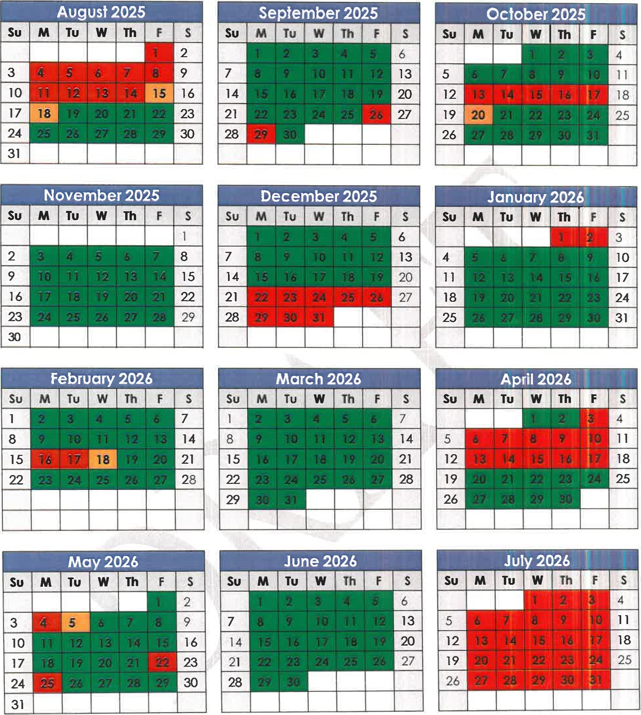

2025-26 Inverclyde Education

School holidays

Information in Emergencies

We make every effort to maintain a full educational service, but on some occasions circumstances arise which lead to disruption. Schools may be affected by, for example, severe weather, temporary interruption of transport, power failures or difficulties of fuel supply. In such cases we shall do all we can to let you know about the details of closure or reopening. We shall keep in touch by using letters, text messages, Twitter, Website, notices in local shops and community centres, announcements in local churches and announcements in the press and on local radio.

Associated Primary Schools

St Stephen’s enjoys an excellent relationship with its three associated primary schools. The close contact which has been established over the years helps to ease the transfer of pupils from primary to secondary. The associated primaries are –

**St Francis’ Primary School**

East Barmoss Avenue

Port Glasgow

PA14 6HX

Telephone: 01475 715725

***Head Teacher: Mrs L Kelly***

**St John’s Primary School**

Mary Street

Port Glasgow

PA14 5AL

Telephone: 01475 715728

***Head Teacher: Mr M Craig***

**St Michael’s Primary School**

Bridgend Avenue

Port Glasgow

PA14 5SU

Telephone: 01475 714690

***Head Teacher: Mrs C Wallace***

**Kilmacolm Primary School**

Churchill Road

Kilmacolm

PA13 4LH

Telephone: 01475 715812

***Head Teacher: Mrs S McCredie***

Primary / Secondary Liaison

Great importance is attached to maintaining good contacts with our associated primary schools. The partnership between us helps greatly to ensure a smooth transition in moving from primary to secondary school and builds on prior learning. Senior Management, Pupil Support and Guidance Teams work closely with our primary colleagues to make sure your child moves happily into St Stephen’s High School.

We have a very comprehensive liaison programme which includes:

* A nine week transition programme where P7 pupils follow a timetable here in St. Stephen’s on a Thursday afternoon
* All P7s participate in a STEM Transition event linked to the CREST Award.
* All P7s participate in a full day of PE activities in the spring
* Regular meetings between the senior staff of the primary schools and St Stephen’s
* Curricular meetings to ensure consistency in standards and in the transfer of information
* An open evening for the parents of pupils about to transfer to St Stephen’s. Any parent who has been offered a place for their child or who is seeking a place for their child can also contact the school office to make an appointment to visit the school if they wish
* Meetings between Guidance staff and P7 teachers to allow appropriate supports to be put in place
* Two parent information evenings during P7
* All P7 children spend two days in St Stephen’s in June following a normal timetable
* An enhanced transition programme during the summer holidays for pupils who require further support with the transition into St Stephen’s High School.

Curriculum for Excellence

The school has developed its curriculum in line with the Scottish Government’s Curriculum for Excellence initiative.

The aims of Curriculum for Excellence are that every child and young person should –

* know they are valued and will be supported to become a successful learner, an effective contributor, a confident individual and a responsible citizen.
* experience a traditionally broad Scottish curriculum that develops skills for learning, skills for life and skills for work, with a sustained focus on literacy and numeracy, that encourages an active, healthy and environmentally sustainable lifestyle and builds an appreciation of Scotland and its place in the world.

The Experience and Outcomes under Curriculum for Excellence and the significant Aspects of Learning are written and take account of progression to qualifications described under the Senior Phase.

Our aim is to ensure that the courses we offer pupils coming to us from P7 integrate with, and progress from, the courses that they have been following in primary school. The section under Primary / Secondary Liaison describes in more detail how this is done.

S1 – S3 (The Broad General Education)

Pupils in S1, S2 and S3 follow a broad, general education which provides the opportunity for all learners to overtake the experiences and outcomes up to Fourth Level. Although subject choices are not made during the first three years of secondary school, pupils are given the opportunity to specialise within curricular areas.

Religious Education, English, Mathematics, Social Subjects, Science, Modern Languages, ICT, Technology, Creative Arts, Home Economics, Physical Education and Personal and Social Education.

Transition from the Broad General Education to the Senior Phase

At the beginning of S4 pupils enter their Senior Phase of secondary education. The Senior Phase is the period when most young people engage with the national qualifications framework. During the Senior Phase, they are supported to extend and deepen their education as they build their portfolio of qualifications which recognises their learning, enabling them to continue to develop skills and offering pathways to the next stage – whether that is further or higher education, training or employment. During the Senior Phase young people are supported to choose courses and levels most appropriate to their prior attainment and career aspirations.

A common upper school schematic timetable operates across Inverclyde secondary schools. As a result, young people will continue to have a choice of up to five subjects for accreditation at SCQF Levels 3 to 7, (National 3, National 4, National 5, Higher and Advanced Higher) (Higher Grade).

No single school can normally offer its pupils the full range of different subjects and levels of courses that it would like. Schools therefore group themselves together, so that each pupil can take courses offered by other schools in the group. A group of schools operating in this way is called a consortium. Pupils taking courses in other schools are provided with free travel to and from the base school. St Stephen’s is closely linked with all other Inverclyde secondary schools. Additionally, students are able to follow some courses in West College Scotland.

**Scottish Qualifications Authority (SQA)**

The end of S4 is usually the first time that our pupils will be presented for SQA national examinations. The SQA is Scotland’s national body for qualifications. Our courses are packaged in a way which allows us to match very closely the national guidelines on courses for S4-6. This allows pupils to take a number of national courses as well as following school courses in Religious Education and Physical Education (S4) in the senior phase. The SQA website is [www.sqa.org.uk](http://www.sqa.org.uk).

Transitions

From S4 onwards all young people begin to pursue different options. Many of them will stay at school to study for further qualifications, others may choose a blend of school and college learning or work placement; some will plan to move on to university, college or a training programme or to get a job.

In St Stephen’s, regardless of which choice our young people take, they are supported in finding the best option for them. Extensive support from our pupil support team and partnership working with Skills Development Scotland, Careers Coaches, More Choices More Chances Team ensures that our young people receive the guidance required.

**Skills Development Scotland** brings together the knowledge and expertise of what were the Careers Service, Adult Guidance Networks, the Education Business Partnership and Lifelong Learning Partnerships. The services previously offered by these agencies have now been brought together in an integrated way.

In St Stephen’s, young people and their parents can contact the Careers Adviser through the school or by visiting their local Careers Centre. Sky McKnight is our Careers Adviser and is in the school Mondays, Tuesdays and Wednesdays. All pupils are given basic information about careers and interviews are organised for individual pupils. We also have Ellie Addison, our Developing Young Workforce Officer, who organises work placements and also supports our young people with gaining positive and sustained destinations.

Sky works in partnership with other relevant agencies such as Social Work, Health Service, More Choices, More Chances (MCMC), etc so that all pupils can be given the best possible advice about the opportunities open to them.

More information can be obtained from the Skills Development Scotland website - www.**skillsdevelopmentscotland**.co.uk/

The **More Choices, More Chances** team support the school in ensuring that those young people at risk of missing out on a positive destination when they leave school are fully supported in finding an appropriate placement.

Additional Support Needs (ASN)

All children and young people need support to help them learn. The main source of support in the school are the staff who, through their normal practice, are able to meet a diverse range of needs. With good quality teaching and learning and an appropriate curriculum most children and young people are able to benefit from education without the need for additional support.

The definition of additional support is a wide one and it is not possible to provide an exhaustive list of all possible forms of additional support.

Every teacher has a responsibility to support the learning of all pupils in their class. The type of support offered will vary according to the needs of pupils. This includes consideration given to children who have a disability, children with social, emotional and behavioural difficulties, children with learning difficulties of a specific or general nature, children who are exceptionally able, those who demonstrate underachievement relating to gender issues, children whose learning has been interrupted through absence or illness, bilingual children who have English as an additional language, traveling children and those children whose family circumstances impact on attendance and learning.

All pupils with an Additional Support Need are supported in completing an Individual Education Programme. Pupils with Additional Support Needs also have regular progress meetings also involving their parents/carers.

There will be many other examples besides these. Some additional support needs will be long term while others will be short term. The effect they have will vary from person to person. In all cases though, it is how these factors impact on the individual person’s learning that is important and this will determine the level of support required.

Additional supports can take the form of close monitoring by guidance staff, provision of an Individual Education Plan (IEP), cooperative teaching or individual tutorial support provided by Support for Learning staff. In addition, some pupils who require “Time out” from the curriculum can be accommodated for a short time in the ASN (Additional Support Needs) Base.

Other, more specialised services are accessed in consultation with the educational psychologist.

If a parent considers that his or her child has additional support needs and wishes to make enquiries on this they should contact Mrs MacDonald, Principal Teacher of Support for Learning.

Arrangements for free transport are made for pupils with recorded Additional Support Needs. Further information in relation to pupils support can be found at –

<http://www.scotland.gov.uk/Topics/People/Young-People/gettingitright>

Additional Support Needs (cont)

In addition to the information above, Inverclyde Council will provide:

1. the authority’s policy in relation to provision for additional support needs

A child or young person’s needs are identified at the earliest possible stage and can be met in a number of ways, for example by adaptations to the curriculum or learning environment, as well as input from the Support for Learning Teacher and, on occasion, support from visiting specialists. The appropriateness of the support is determined through a process of assessment, planning and monitoring, working jointly with parents and carers, and is regularly reviewed.

1. the arrangements made by the authority in making appropriate arrangement for keeping under consideration the additional support needs of each such child and young person and the particular additional support needs of the children and young persons so identified.

Learning outcomes for children and young people with additional support needs are set out in a plan and all educational establishments hold regular review meetings with parents and carers to determine needs and the most appropriate supports. Everyone’s views are equally important in order to consider what is currently working and how to determine next steps.

1. the other opportunities available under this Act for the identification of children and young persons who –
2. have additional support needs

Children and young people’s needs are identified in a number of ways, and the process of assessment is an on-going, shared process with partnerships with parents and carers at the forefront. On some occasions health service staff or other partner agencies make children known to Education Services. Other additional support needs may be notified to Education Services by parents themselves or identified by one of a range of staff working closely with the child.

1. require, or would require, a co-ordinated support plan

Some children and young people will have additional support needs arising from complex or multiple factors which require a high degree of co-ordination of support from both education and other agencies in order that their needs can be met. In these cases, the school will hold a meeting to decide whether the child or young person meets the criteria for a co-ordinated support plan.

The coordinated support plan is a statutory document which ensures regular monitoring and review for those children and young people who have one.

1. the role of parents, children and young persons in the arrangements referred to in paragraph (ii)

You have the right to ask the education authority to establish whether your child needs a coordinated support plan. Your child can make this request themselves, if they are aged 16 or over. You and your child, if they want to, will attend a meeting with staff at their school. Other professionals from different agencies who may be involved in providing support for your child will also attend. If your child does not want to attend meetings or feels unable to, their views must still be sought and considered.

1. the mediation services provided

Inverclyde’s mediation service can be accessed by contacting Michael Roach, Head of Education at the address below

1. the officer or officers of the authority from whom parents of children having additional support needs, and young persons having such needs, can obtain advice and further information about provision for such needs.

For further advice please telephone 01475 712850

Or write to;  Education Services

Wallace Place

GREENOCK

PA15 1JB

Advice, further information and support to parents of children and young people with ASN:

(a) Children in Scotland: Working for Children and Their Families, trading as “Enquire – the Scottish advice and information service for additional support for learning”, a charitable body registered in Scotland under registration number SC003527;

(b) Scottish Independent Advocacy Alliance, a charitable body registered in Scotland

(c) Scottish Child Law Centre, a charitable body registered in Scotland under registration number SCO12741.

Useful Links – [www.enquire.org.uk](http://www.enquire.org.uk)

[www.siaa.org.uk](http://www.siaa.org.uk)

[www.sclc.org.uk](http://www.sclc.org.uk)

Inverclyde Educational Psychology Service

Inverclyde Educational Psychology Service aims to improve the wellbeing and education of children and young people through the application of psychology in practice.

We do this by:

- providing training and coaching to educational staff with the goal of optimising the inclusion of all children and young people.

- using the latest research evidence in psychology to advise and consult with others.  This helps to assess and plan for children and young people with Additional Support Needs.

- working with others to seek solutions that build on the existing strengths of children and families.

- ensuring that children and young people’s views are heard and included in any planning.

There are many more roles of the Educational Psychologist, you may find these on our website https://www.inverclyde.gov.uk/education-and-learning/inverclyde-educational-psychology-service.

Equal Opportunities and Social Justice

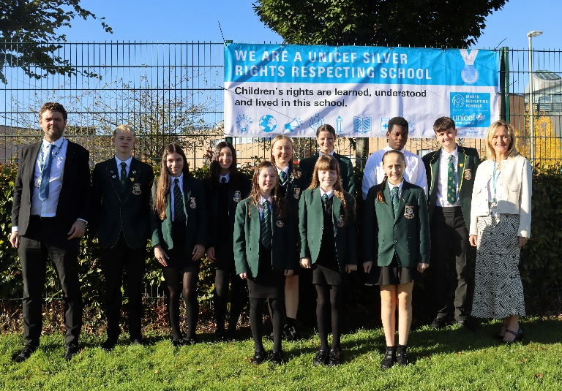As a Rights Respecting School we are determined to make sure that every pupil is supported throughout school, fairly and equally, regardless of circumstances. We call this social justice and it is about making sure that all pupils are given an equal chance to reach their potential. The St Stephen’s Charter is shown below and we are now striving towards Gold RRS accreditation.

In meeting the needs of all our pupils we will demonstrate no discrimination on the basis of race, gender, disability, sexual orientation or belief. This encompasses curricular, extra-curricular and classroom activities and is foremost in the attitudes which we develop in our pupils.

In light of recent legislation on Human Rights, Race Equality and Disability, the authority and its establishments are reviewing policy and practice on equal opportunities and social justice.

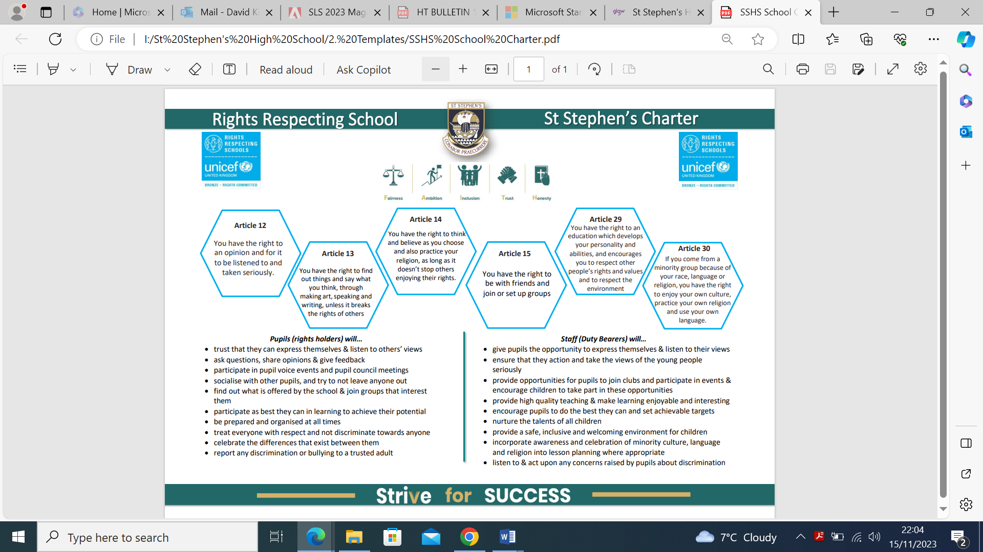

Pastoral Care

As part of the schools’ GIRFEC agenda, the aim of the Pupil Support Team is to provide a point of personal contact and support for pupils throughout his/her school career by monitoring his/her academic, personal, social and vocational development. Where necessary, the pupils’ educational environment is adapted to allow him/her maximum opportunity to fulfil his/her potential. The objectives of the staff are -

* to know the pupil
* to establish a link between home and school
* to provide staff of the school and partner agencies with a known point of referral
* to participate in the various transition programmes for pupils
* to advise pupils, in conjunction with subject departments and parents, which courses are best suited to their talents and career aspirations
* to establish a Careers programme in conjunction with Skills Development Scotland
* to counsel and support pupils when required
* to provide an atmosphere in which pupils may develop socially
* to advise on the UCAS process

The Pupil Support Team

The Pupil Support Team consists of –

Mrs M Corr (Principal Teacher Guidance – St Andrew)

Mr S McCole (Principal Teacher Guidance – St Bernadette)

Mrs Parsons (Principal Teacher Guidance – St Catherine)

Mrs McEwan (Acting Principal Teacher Guidance – St David)

Mrs A MacDonald (Principal Teacher Support for Learning)

Mr I Forster (Acting Principal Teacher of Targeted Support)

Guidance Teachers, along with subject teachers, provide important support for pupils at transition times. This will help to ensure that pupils are following the appropriate courses taking into account the pupil’s ability and career aspirations.

Our Pupil Support Team are happy to discuss any aspect of a child’s education with parents. Interviews can be arranged by contacting the school office.

Reporting to Parents

Our Calendar of Reports and Parents’ Meetings is as follows -

**Broad General Education (S1-3): Reports to parents**

* S1-3 Tracking: September
* S1 Full Report: May
* S2 Full Report: April
* S3 Full Report: December

**Broad General Education (S1-3): Parents Meetings**

* S1 Parent Meeting: October
* S2 Parent Meeting: January
* S3 Parent Meeting: March

**Senior Phase (S4-6): Reporting to Parents**

* S4-6: October
* S4: January
* S5-6: February

**Senior Phase (S4-6): Parents Meetings**

* S4 Parent Meeting: November
* S5/6 Parent Meeting: November

In addition to the reports issued, the parents of our First Year pupils will be invited to attend ‘Settling In’ Interviews in September with their Guidance Teacher to discuss how pupils have settled into the school.

Guidance Staff and departments are constantly monitoring pupil progress and when a concern is identified parents will be contacted if it is felt that this will be beneficial to the pupil.

Parents are always welcome to contact the school to obtain updates on their child’s progress. Initial contact should be made with the appropriate Guidance Teacher.

Home Learning

It is school policy that home learning is an integral part of a well-structured curriculum from S1 – S6. Together with parents the school wishes to develop in pupils a positive attitude towards study in school and at home.

Home learning tasks are set for all pupils at different stages for the following reasons:

* as a reinforcement for class lessons
* as an extension to class work when necessary
* as an opportunity to evaluate pupils’ progress
* as an opportunity to evaluate the success of a lesson
* as a means of motivating some pupils
* as an opportunity to communicate with parents

Valid home learning activities may include: writing, reading, research and investigation, problem solving, discussion with adults and revision of subject content. As pupils move through the school more encouragement and opportunity is given to develop regular, independent study. The amount of homework will vary according to various factors.

Parents play an important role in ensuring the benefits of home learning. Your cooperation in helping to monitor your child’s progress with home learning is highly valued by the teaching staff. Any parent who is concerned about any aspect of home learning is encouraged to contact the appropriate senior member of staff.

Supporting Pupils

The school currently runs sessions on study skills to support pupils in planning their personal study timetables and strategies for managing their time. We also access the support of external agencies to deliver workshops to our young people and their parents/carers.

Alongside this, there are opportunities for learners at all stages to access support with any work they find challenging. This includes:

* Lunchtime Clubs – run by our senior pupils to support pupils in the BGE with homework/ home learning tasks.
* Supported Study Sessions – for our Senior Phase pupils to help prepare for National Qualifications.
* Master Class Sessions – longer sessions run by departments focusing on specific aspects of their course in preparation for National Qualifications.
* Saturday Study Sessions – Short sessions delivered by staff to support pupils in preparing for national qualifications.
* Achieve - online study platform

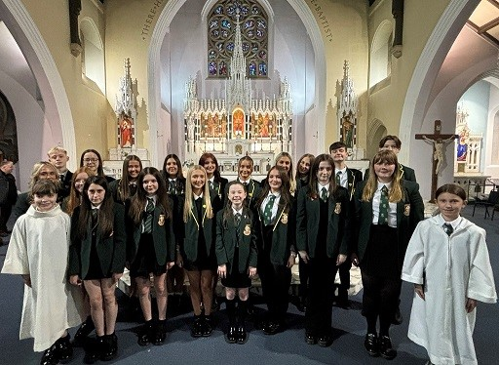The Catholic School

Having chosen to send your child to a Roman Catholic school, you will expect the school to support your child’s faith development and to offer opportunities and experiences which will encourage your child to take on responsibility for his/her own Catholic beliefs and practices. In St. Stephen’s this is done in a variety of ways:

***The R.E. Programme*** - The context of the R.E. programme has been built using the core learning of “This is our Faith” in S1-S3, and we are currently working to develop and implement the senior phase “This is our Faith” for S4-S6. It is designed to allow - and indeed encourage - all of our young people to develop their knowledge and experience of their faith, and to provide opportunities to express and reflect upon their own views and those of others. We also offer RMPS at Higher level. In addition, pupils are encouraged to become fully involved and engaged in a community where the values of our faith are central to how we work and learn.

Our RE Curriculum is framed on the “This Is Our Faith” documentation and this year, the new BGE Curriculum from the Diocese of Paisley are used as the basis of both our classroom teaching in religious education classes and also as the foundation of our development as a Catholic School.

***Liturgy*** - The school community engages in various forms of Liturgy to allow the school to celebrate its faith.

***Charity -*** Throughout the year our pupils are also encouraged to respond to the needs of others through charitable giving. A number of events will be organised and run by staff and pupils to collect money for a wide range of charities. Some of our fundraising events now sit proudly amongst the traditions of our school, such as the Pink Day, Christmas Toy Appeal and our foodbank collection. Other events will be organised to highlight particular charities, world events or liturgical seasons.

We choose our charities to reflect the work of various Catholic and Christian organisations who are able to work across the world with people of all faiths and none, and to reflect charities which may figure in the lives of our pupils and staff.

**Spiritual Development** - Through the work of the R.E. Department and of the school’s newly formed Chaplaincy Team, we ensure that our pupils are given the opportunity to take part in a range of services and prayer experiences appropriate to the Liturgical Calendar and to the age and stage of each pupil.

***Partnerships with the Community*** - Pupils are involved in Parish Liturgies; work with local charities in a practical way; assist local schools in the development of care and work in a partnership with our senior citizens.

***Morality*** - Our Religious and Social Education programmes present moral issues in accordance with the teaching of the Catholic Church, including new Catholic Education Commission guidelines on the teaching of relationships and moral education using the SCES “Called To Love” programme.

Above all the school believes it promotes the practice of Christianity in a practical and spiritual manner that benefits the community. We encourage our pupils to reflect upon rights and responsibilities for themselves and for others in the local, national and global community. Our commitment to Global Citizenship is evidenced not only through elements of the curriculum across all subjects, but also in the way in which pupils are encouraged to see themselves as active citizens and agents for change through programmes such as Project Partnership, charity and awareness raising, Pupil Leadership Council and our Junior & Senior St. Vincent de Paul groups.

Religious Observance in the Catholic School

The Education (Scotland) Act 1980 imposes a statutory duty on local authorities to provide “Religious Observance” in Scottish schools. This is defined in a national R.O. Review Group report published in 2004 as comprising*: “community acts which aim to promote the spiritual development of all members of the school’s community and express and celebrate the shared values of the school community”.*

In a letter of guidance issued by the Scottish Government in February 2011, it is acknowledged that Catholic schools take a distinctive approach to the provision of Religious Observance:

*Scottish Government Ministers welcome the tradition that, in Roman Catholic denominational schools, Catholic Liturgy will largely shape the nature and frequency of religious observance activities in the classroom and in the wider school community. So, at times, children and young people will be invited to participate in, and sometimes to lead, prayer and reflection in classrooms and at assemblies. At other times, to honour particular occasions or feasts, chaplains will lead school communities in the celebration of Mass and other forms of liturgical celebration.*

Catholic schools follow the customs and practices of the Church in order to nourish the spirituality and faith of pupils and staff. Our Catholic tradition is enriched by ancient rites, prayers and devotions which help young people to become aware of, and show reverence to, the sacred presence of the living God, Father, Son and Holy Spirit. Guided by this tradition, we celebrate various seasons and special feast days to honour God, Mary his Mother and the Saints.

Pupils are invited to pray with their teachers at times in classrooms and assemblies, as well as in liturgical services. Usually a classroom will display a Crucifix on the wall; in some classrooms and other areas of the school, a sacred space will feature a copy of the Bible and will be decorated with signs and symbols that reflect the changing seasons of the Church Calendar Year i.e., Advent, Christmas, Lent, Easter and Pentecost.

This regular practice of Prayer is complemented by religious services conducted, sometimes as part of an Assembly, to mark special occasions - e,g., the distribution of Ashes on Ash Wednesday, the seasons of Advent or Lent. To mark special Feast Days and Holy Days of Obligation, Holy Mass will be celebrated by the school chaplain, with the school community, in school buildings or in local parishes. Some pupils, at certain stages, may be able to participate in retreats and pilgrimages to places of special significance within the Catholic tradition.

While Religious Education is governed by separate Church guidance, it is complemented by Religious Observance practices and, together, these experiences help pupils to develop their understanding of the Catholic faith, to experience opportunities for spiritual growth and to commit to beliefs, values and actions in a positive response to God’s invitation to faith.

In terms of pupil participation in R.O. Scottish Government guidance makes it clear that it makes an important contribution to pupils' development and that it promotes the ethos of a school by bringing pupils together and creating a sense of community. However, it also makes clear that parents have the right to withdraw children from participation in religious observance and that this right should always be made known to parents and their wishes respected. The Scottish Government also recognises that:

*Where a parent chooses a denominational school for their child's education, they choose to opt in to the school's ethos and practice which is imbued with religious faith and religious observance. In denominational schools, it is therefore more difficult to extricate a pupil from all experiences which are influenced by the school's faith character.*

Parents from ethnic minority religious communities may request that their children be permitted to be absent from school in order to celebrate recognised religious events. Only written requests detailing the proposed arrangements will be considered. Appropriate requests will be granted on not more than three occasions in any one school session and the pupil noted as an authorised absentee in the register.

Religious Education Department

**STAFF**

* Mr J Girkins (Principal Teacher)
* Mr S McCole
* Fr Jonathan Whitworth (Chaplain)

**Our Parish Links**

The school has strong links with each of our associated parishes. These are –

* St Francis of Assisi, Port Glasgow
* Holy Family, Port Glasgow
* St John the Baptist, Port Glasgow

Priests of these parishes join with us to deliver the sacrament of Reconciliation. Mass takes place every Monday at lunchtime and on mornings during Advent and Lent, where students arrange and take part in the Liturgy.

Students also enjoy various activities including retreats, seminars, visits, specialist speakers, conferences, themed assemblies and fundraising Activities.

The School Chaplain

The school is very fortunate to be served by a very supportive chaplain:

**Fr Jonathan Whitworth**

The role of the chaplain is to support Religious Education within the school. This is done by visiting classes, supporting teachers and by being present around the school.

Mass is celebrated in the school at 12.40pm on a Monday. The Sacrament of Reconciliation can be available to the pupils at any time, however efforts are made during important times namely Advent and Lent of the Church’s year to ensure that opportunities are available to receive the Sacrament of Reconciliation at set times for each year group.

Extra-Curricular Activities

Over many years St Stephen’s has been fortunate in having a wide range of extra-curricular activities organised by dedicated staff who have been willing to give up their own time at lunch break, after school or at weekends.

Activities available to the pupils include –

**SPORTS**

A wide range of sporting activities are on offer – fitness, athletics, cross-country running, football, netball, rugby, badminton and basketball.

**MUSIC**

The music department provides opportunities for pupils to get involved in a range of activities. These include – choirs, brass ensemble, stage band, percussion ensemble, concert band. Our young people perform at the many school events during the year.

**GENERAL**

There are also a large number of other clubs that are open to pupils and we encourage our pupils to inform us if there is something we do not offer that we could offer, to let us know.

Other Achievements

**For further information please see Standards and Quality Report 2023 – 2024**

**https://blogs.glowscotland.org.uk/in/ststephenshs/policies/%20**

Nurturing Relationships for Success

The standard of behaviour of our pupils has always been high and is invariably commented upon favourably by visitors to the school. While there are several reasons for this, a major factor is the positive relationship between staff and pupils and the high expectations we have for all our young people. We nurture positive relationships between everyone in our school community to create a learning climate where everyone in our community feels valued, respected and supported to be their best. We celebrate this through our termly House Assemblies, our Merit System with messages sent home to parents informing them of their achievements and our ‘Over & Above’ Head Teacher Awards.

In St Stephen’s High School we ‘Strive for Success’ through building and promoting positive relationships between pupils, staff and all members of our school community. We achieve this by being:

**Ready:** Prepare, attend and be on time for all my classes.

**Respected:** Respect myself, others and the school in all that I do

**Responsible:** Take responsibility for my learning and my actions

**Resilient:** Try my best in all I do. Don’t give up and challenge myself to do better.

This is not to say that all pupils are always well behaved or that cases of indiscipline never occur – cases of dysregulated behaviour do occur and we try to deal with these effectively, promptly and positively. In St Stephen’s our Stages to Success clearly outlines the steps that are taken to support young people in maintaining positive behaviour within the school.

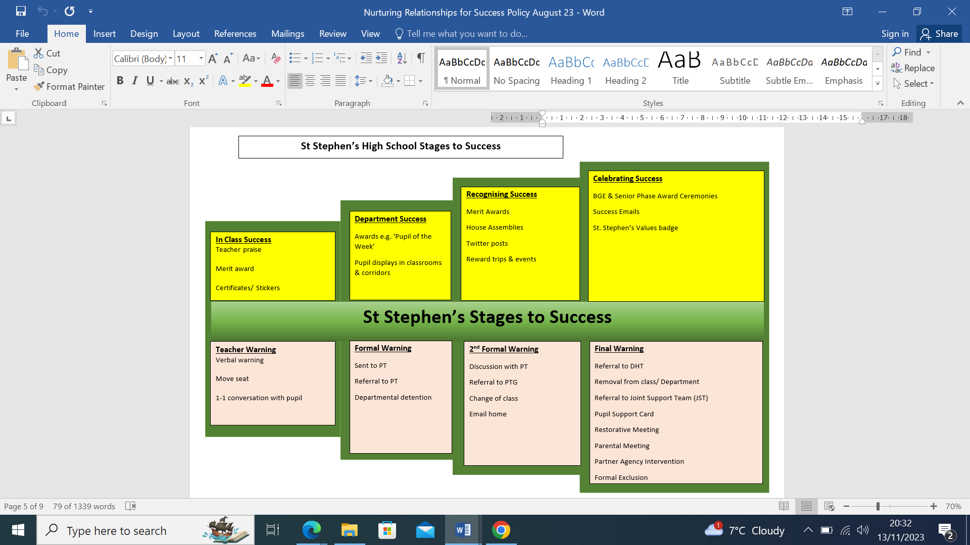

The school also operates a Recognising Achievement programme so that pupils whose behaviour is consistently positive are recognised in some way through assemblies and communication home to parents.

In order to ensure a safe, happy environment with the best conditions for learning all pupils our ‘Learning For Success’ posters are displayed around the school outlines our shared expectations. Frequent reference is made to this by class teachers and by guidance staff as well as senior staff at assemblies. Pupils are encouraged to accept responsibility for maintaining good order within the school community and treating all members of the community with respect.

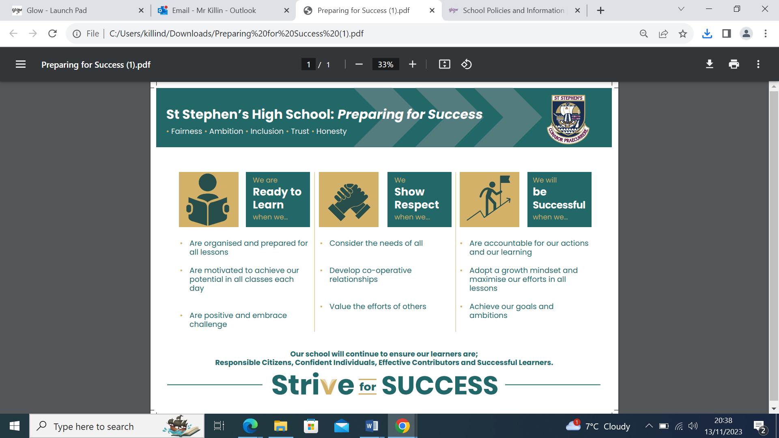

Parents also have a vital role to play working in partnership with the school in ensuring their children are aware that high standards of behaviour are also expected of them in the community, out with the school day.

Attendance at School

Parents should inform the school by telephone or via the Parent Portal on the first morning of an absence and provide a reason for the pupil’s absence. The school will contact the pupil’s family and thereafter other emergency contacts if no explanation is given for the pupil’s absence. This contact will be made before 10am on the first morning of an absence by text or telephone and early after the restart after lunch in the case of an afternoon absence.

Other agencies may be contact if no contact with the pupil’s family can be achieved and if there are continuing or emerging concerns about a pupil’s safety or wellbeing.

Parents should keep the school informed of any changes of address or telephone numbers, both their own and those of the emergency contacts.

Section 30 of the 1980 Education Act lays a duty on every parent of a child of ‘school age’ to ensure that their child attends school regularly. Attendance must be recorded at least twice a day, morning and afternoon. The school now records attendance on a period-by-period basis.

The Scottish Government has provided guidance on the management of attendance and absence in Scottish schools in its publication ‘Included, Engaged and Involved – Part 1: Attendance in Scottish Schools’. Every effort should be made to avoid family holidays during term time as this both disrupts the child’s education and reduces learning time. It has been clarified that family holidays should not be recorded as authorised absence, except in exceptional domestic circumstances, where a family needs time together to recover from distress, or where a parent’s employment is of a nature where school holiday leave cannot be accommodated (e.g. armed services or emergency services). It is for local authorities and school to judge when these circumstances apply and authorise absence accordingly.

The categorisation of most term-time holidays as unauthorised has been a contentious issue for some families, many of whom are concerned at the higher cost of holidays during school holiday periods. Our main focus is to encourage parents and pupils to recognise the value of learning and the pitfalls of disrupting learning for the pupil, the rest of the class and the teacher.

Clearly where an absence occurs with no explanation from the parent, the absence is unauthorised.

Schools investigate unexplained absence, and Education Services has the power to write to, interview or prosecute parents, or to refer pupils to the Children’s Reporter if necessary.

Absence rates are calculated as a percentage of the total number of possible attendances for all pupils of the school in the stage shown, each morning and afternoon of each school day being a separate possible attendance.

Education Maintenance Allowance

The Education Maintenance Allowance (EMA) is a grant provided by the government to encourage students to stay on at school beyond their statutory leaving date. It is available to S5 and S6 students if –

* they have completed Fourth Year at school
* they have reached the legal date at which they could have left school, and have opted to return
* they started a Fifth Year course of study in the school session following their statutory leaving date

The grant is a means-tested allowance, based on parental income, but paid directly to the student. The award is up to £30 a week. The payment of allowances, and the payment of the bonus, is dependent upon students maintaining 100% attendance, adhering to the school’s code of conduct and making good progress in their studies.

Clothing and Uniform

Giving that there is substantial parental and public approval of uniform, schools in Inverclyde are free to encourage the wearing of school uniform. In encouraging the wearing of uniform, account must be taken to prevent any direct or indirect discrimination on the grounds of race or gender. Any proposals will be subject of widespread consultation with parents and pupils. Against this background, it should be noted that it is the policy of the Education Lifelong Learning Committee not to insist on pupils wearing uniform or having specialist items of clothing as a prerequisite of their attending and engaging in all of the activities of the curriculum.

There are forms of dress which are unacceptable in school, such as items of clothing which:

* potentially encourage faction (such as football colours);
* could cause offence (such as anti-religious symbolism or political slogans);
* could cause health and safety difficulties, such as loose fitting clothing, dangling earrings or clothing made from flammable material, for example, shell suits in practical classes;
* could cause damage to flooring;
* carry advertising, particularly for alcohol or tobacco; and
* could be used to inflict damage on other pupils or be used by other to do so.

In addition jewellery such as dangling earrings and large rings could cause health and safety difficulties and are unacceptable to be worn in school.

Parents of children receiving one of the following benefits will normally be entitled to monetary grants for footwear and clothing for their children –

* Income Support (IS);
* Income-based Job Seekers Allowance (JSA);
* Employment and Support Allowance (Income Related) (ESA) ;
* Child Tax Credit, but not Working Tax Credit and where income is less than £16,105 (in 2019/20) as assessed by HMRC;
* Parent or Carer is in receipt of Working Tax Credit and/or Child Tax Credit with Annual Gross Earnings of no more than £11,288;
* Universal Credit, where your take home pay does not exceed £915, as shown on your monthly Universal Credit statement;
* An Asylum Seeker, receiving support under Part VI of the Immigration and Asylum Seekers Act 1999.

Pupils are eligible for a Clothing Grant in their own right if they are aged 16 – 18 and fall into any of the above categories.

Information and application forms for footwear and clothing grants may be obtained from schools and Customer Service Centre, Municipal Buildings, Clyde Square, Greenock PA15 1LY.

Parents are asked to assist in this area by ensuring that valuable items and unnecessarily expensive items of clothing are not brought to school. Parents should note that the authority does not carry insurance to cover the loss of such items and any claims submitted are likely to be met only where the authority can be shown to have been negligent.

More information around Education Maintainance Allowance and Clothing Grants can be accessed via the local authority website:

[www.inverclyde.gov.uk/education-and-learning/schools](http://www.inverclyde.gov.uk/education-and-learning/schools)

St Stephen’s School Uniform “Dress for Success”

Here at St Stephen’s High School, we place value on ensuring that all of our young people feel prepared to learn and have a sense of belonging to our community. A key feature of this is our school uniform.

There are a number of reasons for having a clearly defined uniform policy, in St Stephen’s High School, our Dress for Success policy:

* In a large school, for safety reasons, it is essential that all pupils are instantly recognisable as St Stephen’s High School pupils.
* We regard school as a ‘place of work’ for our young people and wearing school uniform creates the right climate and mindset required for learning.
* Wearing school uniform instils pride, a sense of belonging, a sense of purpose in class and projects an appropriate image to the local community and visitors to the school.
* Items of school uniform are significantly cheaper than branded items of clothing.
* School uniform removes the stigma attached to not wearing more expensive branded items and also reduces peer-pressure. I would like to thank you for your cooperation and support with this policy.

The recommended uniform is:

* black trousers / black skirt
* white shirt
* school tie
* black or green jumper / black or green cardigan (non branded)
* black shoes / all black trainers
* S1-5: Green blazer with school badge
* S6: Green blazer with Gold braiding and school badge.

The recommended PE kit is:

* Black PE T-Shirt
* black shorts / black leggings
* trainers

Please note that jewellery, watches, belts with metal buckles, etc may cause injury to the wearer or others taking part in PE and therefore must be removed. Jewellery as a result of body piercing causes a particular difficulty for a number of reasons. We would ask you to give careful consideration to the implications of body piercing and request that you first discuss this with the Head Teacher. Where a pupil is having body piercing we would encourage you to ensure that it is done in such a way that the jewellery can be removed and it is carried out during a school holiday period so that the healing process is complete and your child’s participation in PE is not at risk.







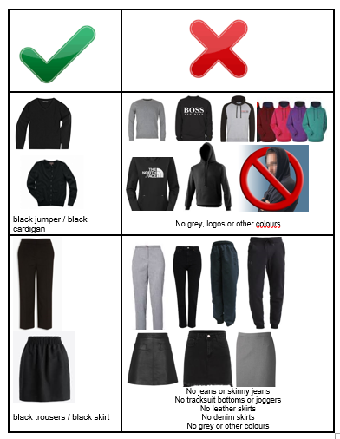

Communication with Home

Close partnership working with our parent body is essential in order to work together to support our young people to achieve the best whilst at school. Over the years, the school has established strong links with the home through our regular and transparent communication with home.

Although parents are always welcome to make an appointment to see their son/daughter’s Guidance Teacher there are certain times during the school year when contact with parents is most advantageous. At these times parents may be requested to attend the school for meetings or for interview at the following stages of their child’s school career –

* parents of Primary 7 pupils in associated primary schools
* key transition stages when pupils considering choice of subject
* S1/2/3 pupils after issue of progress reports
* Information Evenings regarding a range of school issues

There are a number of other structures in place for providing parents with information:-

**SWAY NEWSLETTER** – The school produces a Sway Rights Resecting Schools Newsletter monthly and a whole school newsletter termly which captures the wide range of learning and activities taking place across the school.

**TERMLY HEAD TEACHER UPDATES –** The Head Teacher communicates regularly with parents about events and issues which may be of interest to parents/carers about the school.

**TELEPHONE** - it is often extremely helpful for teachers to make immediate contact with the home – either to seek parent advice or to pass on information about matters affecting their child. It may also be helpful for parents who have busy work schedules to pass on information in this way. Often by talking on the telephone, regular liaison can be maintained between the home and the school.

It is important that the school has an emergency contact telephone number (along with a home number, where available) of a responsible adult (preferably a relative) who can take appropriate action if the parent cannot be contacted. Each child is supplied with a request form for this information at the beginning of each session.

**WEBSITE/TWITTER/GROUPCALL** – The school has a very active twitter feed which is updated regularly by the school and departments sharing the learning taking place as well as other activities relating to the life of the school. Parents can follow our twitter account @StStephensHS. The school has a website providing a wide range of information about the school. The website address is – https://blogs.glowscotland.org.uk/in/ststephenshs/.

**INTERVIEWS** - in many instances there is no substitute for arranged meetings between parents and teachers, especially when the matter is confidential or requires greater understanding by either party.

Initial contact should be made by making an appointment to see your son/daughter’s Guidance Teacher.

School Meals

There is a cafeteria system in operation for the serving of school meals. Hot meals, cooked on the premises by qualified staff, are available and a wide variety of snacks, sandwiches and filled rolls is also available. The provision of special diets e.g. for diabetics or those suffering from food allergies can also be arranged on receipt of a letter indicating the nature of the complaint. (As with all such information, these matters will be treated in strictest confidence). Snacks are also available at interval time in the morning.

Those who prefer to bring packed lunches will have accommodation set aside for them and they will be expected to keep such areas clean and tidy.

Children of parents in receipt of one of the following benefits are entitled to a free midday meal –

* Income Support (IS);
* Income-based Job Seekers Allowance (JSA);
* Employment and Support Allowance (Income Related) (ESA) ;

Child Tax Credit, but not Working Tax Credit and where income is less than £16,105 (in 2019/20) as assessed by HMRC;

* Parent or Carer is in receipt of Working Tax Credit and/or Child Tax Credit with Annual Gross Earnings of no more than £11,288;
* Universal Credit, where your take home pay does not exceed £915, as shown on your monthly Universal Credit statement;
* An Asylum Seeker, receiving support under Part VI of the Immigration and Asylum Seekers Act 1999.

Pupils are eligible for a free school meal in their own right if they are aged 16 – 18 and fall into any of the above categories.

Information and application forms for free school meals may be obtained from schools and Customer Service Centre, Municipal Buildings, Clyde Square, Greenock, PA15 1LY. You can also access this via the website:

<https://www.inverclyde.gov.uk/education-and-learning/schools/clothing-grant-and-free-school-meals-2023-2024>

General Data Protection Regulations and Data Protection Act 2018

Information on children, parents and guardian is stored on a computer system and may be used for teaching, registration, assessment and other administrative duties.  In processing personal information, Inverclyde Council must comply with the General Data Protection Regulation and Data Protection Act 2018. For further information please refer to <https://www.inverclyde.gov.uk/site-basics/privacy> or click on the following: [Privacy page link](https://www.inverclyde.gov.uk/site-basics/privacy)

Transport - Pick-up Points

Where free transport is provided it may be necessary for pupils to walk a certain distance to the vehicle pick-up point. Walking distance in total, including the distance from home to the pick-up point and from drop-off point to the school in any one direction, will not exceed the authority’s limits. It is the parents’ responsibility to ensure that their child arrives at the pick-up point in time. It is also the parents’ responsibility to ensure that the child behaves in a safe and acceptable manner while boarding, travelling in and alighting from the vehicle. Misbehaviour could result in your child losing the right to free transport.

Placing Requests

The education authority does not provide transport for those pupils in receipt of a placing request other than in exceptional circumstances.

In the case of under-age placing request if the child is offered a place in his/her catchment area school, transport will be provided in accordance with council policy stated above.

Medical and Health Care

MEDICAL EXAMINATION

The routine medical examination of children is undertaken at the ages of 10/11 years and 13/14 years by staff if the Inverclyde Health Board and parents may refer their child at other times to the Clinical Medical Officer for examination or advice.

BCG vaccinations are given in S2. Tetanus and polio vaccinations are given in S3 along with their routine medical examination.

Parents are given prior notice of these examinations and are welcome to attend.

ILLNESS DURING THE SCHOOL DAY

Please note that the school does not have the services of a qualified nurse although some teaching and auxiliary staff have been trained in first aid. It must be emphasised, therefore, that this service is for emergencies only and should you child show symptoms of illness or sustain cuts or bruises out with school he/she should be referred to his/her own doctor.

MEDICAL/EMERGENCY CONTACT FORM

Parents will be provided with a form on which they will be required to state any medical condition or physical disability affecting their child which might influence their education attainment. This also forewarns the school of medical provision or facilities which must be made available. Should parents wish to discuss health matters of a more confidential nature then it is recommended that an appointment be made with the appropriate Guidance Teacher or DHT.

EMERGENCY CONTACT

You will also be asked to provide the name, address and telephone number of at least one person who will be available immediately in case of an emergency (preferably a relation) since he/she may be asked to collect your child from school. If transport cannot be provided arrangements may be made to send the child home by taxi if there is someone at home to receive them.

If it is thought necessary to send the pupils to hospital the parent will be notified and asked to meet the child at the Casualty Department, Inverclyde Royal. Often the consent and signature of parent is required before further medical treatment can be carried out.

MEDICAL/DENTAL APPOINTMENTS

Permission to release pupils from school for medical or dental appointments will only be given when written notice from the parent/guardian is received. Notes should be presented to the Guidance Teacher on the morning of the appointment or at the Registration period of the preceding day of the appointment is early in the morning.

When a prolonged series of appointments is indicated parents are requested to contact the Guidance Teacher to ensure provision is made for missed schoolwork.

MEDICATION DURING SCHOOL HOURS

It is only on very rare occasions that children will require to take any form of medication during school hours. Most prescriptions allow for time adjustments so that parents can supervise the consumption/application of medicine at home.

In these cases where children need to take medicine in the school the parent must –

* advise the school of this;
* deposit the medication with the school via the child’s Guidance Teacher

Arrangements will then be made to ensure that the child is released from class to receive medication under supervision. On no account must any child be given any medicine to carry around the school or be allowed to regulate his/her own consumption or application of medicine at school.

Parental Engagement

In St Stephen’s we recognise that parents play an extremely important role in the education of their children. We believe that for the school to be successful we have to be committed to working in a genuine partnership with all parents.

This partnership is fostered in a number of ways –

* parents are involved regularly in stakeholder surveys about various aspects of the service provided by the school
* we provide parents with advice and support on how they can support their child’s education through our Family Learning Programme and Information Evenings
* we regularly update parents on all aspects of their child’s progress
* we have a very active Parent Council that meet regularly to discuss any aspect of school provision
* we keep parents regularly informed of what is going on in the school

Parents are encouraged to keep in close contact with the school to maintain and strengthen this partnership. A key aspect of this is shared through our Key Dates Calendar which we share with our parents.

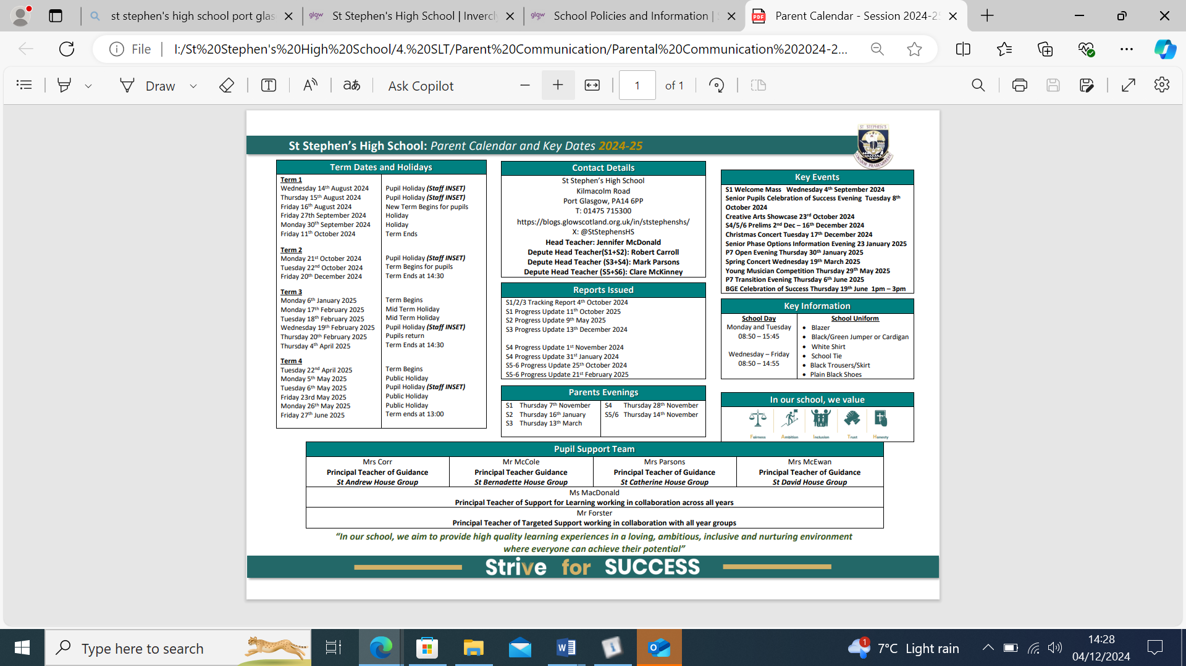

For further information please visit the school website:

<https://blogs.glowscotland.org.uk/in/ststephenshs/parental-engagement/parent-council-2/>

**PARENTZONE SCOTLAND**

[Parentzone Scotland](https://eu-west-1.protection.sophos.com/?d=gov.scot&u=aHR0cHM6Ly9lZHVjYXRpb24uZ292LnNjb3QvcGFyZW50em9uZQ==&i=NjIyOWM5ZWE3YzA2ZDIxZDM1MWE0YmEz&t=N1JJSzR3SFk3a0V6QlBOUjFCeHYzd2tXRFVKWVpVUjVhazZtTWZyR3V5UT0=&h=af1a4b6971814cc4ad734191f4ce631d&s=AVNPUEhUT0NFTkNSWVBUSVbneL_Jt0oZlomghPR_nN15K9Oy-_K53IQ1rAgw1UT0EsEE1vYNCNHynB7_pqJnoHw) is a unique website for parents and carers in Scotland, from early years to beyond school.  The website provides up-to-date information about learning in Scotland, and practical advice and ideas to support children’s learning at home in literacy, numeracy, health and wellbeing and science. Information is also available on Parentzone Scotland regarding additional support needs, how parents can get involved in their child’s school and education.

Parentzone Scotland also has details about schools, including performance data for school leavers from S4-S6 and links to the national, local authority and school level data on the achievement of Curriculum for Excellence levels.

**READ, WRITE, COUNT**

[Read, Write, Count](https://eu-west-1.protection.sophos.com/?d=scottishbooktrust.com&u=aHR0cHM6Ly93d3cuc2NvdHRpc2hib29rdHJ1c3QuY29tL3JlYWRpbmctYW5kLXN0b3JpZXMvcmVhZC13cml0ZS1jb3VudG9mZmVycw==&i=NjIyOWM5ZWE3YzA2ZDIxZDM1MWE0YmEz&t=ZDNQUStaRDEyUVQ0cUpNaFdYNkx6QklFVmxlVm83ZThnSmJIVi9ES2VMYz0=&h=af1a4b6971814cc4ad734191f4ce631d&s=AVNPUEhUT0NFTkNSWVBUSVbneL_Jt0oZlomghPR_nN15K9Oy-_K53IQ1rAgw1UT0EsEE1vYNCNHynB7_pqJnoHw) with the First Minister is a programme that aims to support parental engagement in literacy and numeracy. Gift bags are distributed annually to all Primary 2 and Primary 3 pupils in Scotland by Scottish Book Trust. The gift bags contain literacy and numeracy materials to support children’s learning, as well as advice and support to parents.

Studies show a direct link between a strong family learning environment and progress in reading, writing and counting. In addition to the activity booklet included in the bag Scottish Book Trust offers a range of hints, tips and advice to help parents engage in their child’s learning on the website.

**BOOKBUG**

[Bookbug](https://eu-west-1.protection.sophos.com/?d=scottishbooktrust.com&u=aHR0cHM6Ly93d3cuc2NvdHRpc2hib29rdHJ1c3QuY29tL2Jvb2tidWc=&i=NjIyOWM5ZWE3YzA2ZDIxZDM1MWE0YmEz&t=d3VtOGpkQnE3dVlGV0g4ZFhhNG90bU5STDlnVlBWZkllYlE1SjRHYkJoYz0=&h=af1a4b6971814cc4ad734191f4ce631d&s=AVNPUEhUT0NFTkNSWVBUSVbneL_Jt0oZlomghPR_nN15K9Oy-_K53IQ1rAgw1UT0EsEE1vYNCNHynB7_pqJnoHw) is Scotland’s universal early years book gifting programme and aims to inspire a love of stories, songs and rhymes from birth. Bookbug gives every child in Scotland four free bags of books as babies, toddlers, three and five year olds. The bags contain books and other resources for sharing songs and rhymes that are suited to their age. Gaelic Bookbug Bags are also available.

The **Bookbug Explorer Bag** is gifted to all 3 year olds at their childcare setting. It includes three lovely books, an activity book, pencils, and postcards to encourage mark making.

‘The Bookbug Primary 1 [Family Bag](https://eu-west-1.protection.sophos.com/?d=scottishbooktrust.com&u=aHR0cHM6Ly93d3cuc2NvdHRpc2hib29rdHJ1c3QuY29tL3JlYWRpbmctYW5kLXN0b3JpZXMvdGhlLWJvb2tidWctcHJpbWFyeS0xLWZhbWlseS1iYWc=&i=NjIyOWM5ZWE3YzA2ZDIxZDM1MWE0YmEz&t=aGtGeWJ5amNsTVZqZWUzenh1cktjY21EUTVoNHFNdVdaQ0JGR2FETXRPST0=&h=af1a4b6971814cc4ad734191f4ce631d&s=AVNPUEhUT0NFTkNSWVBUSVbneL_Jt0oZlomghPR_nN15K9Oy-_K53IQ1rAgw1UT0EsEE1vYNCNHynB7_pqJnoHw) encourages families to share books and activities to inspire a lifelong love of reading, writing and counting. These are gifted during Book Week Scotland in November every year!’

Check out the [website](https://eu-west-1.protection.sophos.com/?d=scottishbooktrust.com&u=aHR0cHM6Ly93d3cuc2NvdHRpc2hib29rdHJ1c3QuY29tL2Jvb2tidWc=&i=NjIyOWM5ZWE3YzA2ZDIxZDM1MWE0YmEz&t=d3VtOGpkQnE3dVlGV0g4ZFhhNG90bU5STDlnVlBWZkllYlE1SjRHYkJoYz0=&h=af1a4b6971814cc4ad734191f4ce631d&s=AVNPUEhUT0NFTkNSWVBUSVbneL_Jt0oZlomghPR_nN15K9Oy-_K53IQ1rAgw1UT0EsEE1vYNCNHynB7_pqJnoHw) for booklists, book sharing videos, activity ideas and much more.

Parent Forum and Parent Council

The Scottish Schools (Parental Involvement) Act 2006 led to the establishment of Parent Councils primary, secondary and special schools. The Act recognises the vital role that parents play in supporting their children’s learning. It places a duty on authorities to promote the involvement of parents in children’s education and the wider life of the school. It aims to help parents to be –

* Involved with their child’s education and learning
* Welcomed as an active participant in the life of the school
* Encouraged to express their views on school education generally

The Parent Council, as a statutory body, has the right to information and advice on matters which affect children’s education.

Parents who are involved on a regular basis in schools should undertake an enhanced disclosure through Disclosure Scotland.

All parents who have a child attending the school are automatically members of the Parent Forum for our school. Membership of the forum allows parents to have a say in the local arrangements to enable their collective view to be represented on matters such as the quality and standards of education at the school and other matters of interest to parents. These views can be represented, as appropriate, to the Head Teacher of the school, the Council and HMIe.

The Parent Council, as a statutory body, has the right to information and advice on matters which affect children’s education.

Meetings of the Parent Council are held approximately every 6 weeks and minutes of these meetings are available from the school and are posted on the school website. Agendas are also available via the school website prior to the meeting.

The Parent Council is open to any parent or carer of pupils in St Stephen’s. Parents/carers are regularly invited to join the Parent Council via the school newsletter.

Details of the St Stephen’s High School Parent Council are included on the next page.

Parents who are involved on a regular basis in schools should undertake an enhanced disclosure through Disclosure Scotland.

St Stephen’s Parent Council – membership

Chair Person: Cate McGeachy

Vice Chair: Elaine Murray

Treasurer: Elaine Proven

Secretary: Caroline Cassidy

**Staff Members:**

Mrs J McDonald

Miss C McKinney

Mr R Carroll

Mr M Parsons

You can contact the Parent Council on: [sshsparentcouncil@gmail.com](mailto:sshsparentcouncil@gmail.com)

You can also follow them on twitter: @sshsparents

Useful Addresses

**Head of Education**

Wallace Place  
Greenock

PA15 1JB 01475 712850

**Community Learning & Development**

Enterprise Centre

Port Glasgow Community Campus

PA14 6PP 01475 714250

**Skills Development Scotland**

112 West Blackhall Street

Greenock

PA151XR 01475 745903

Local Councillors

The elected representatives to Inverclyde Council who serve the catchment area of the school are –

Christopher Curley David Wilson

Public Examinations

Schools in consultation with pupil / parents normally decide on presentation for examinations. However, in the final analysis the school will accede to the wishes of parents.

**St Stephen’s Curricular Model**

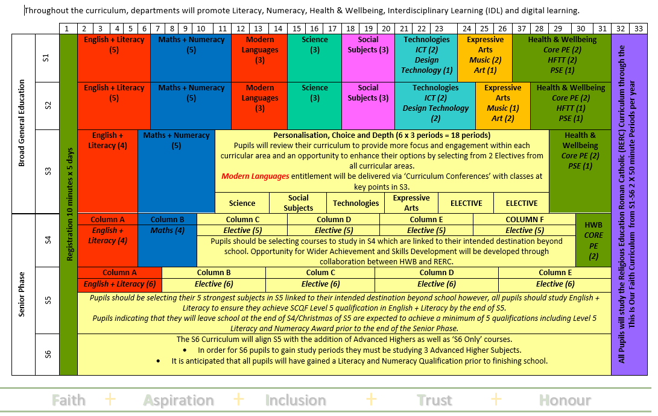

In S1-3, our pupils follow a Broad General Education and undertake planned learning activities linked to the Experience and Outcomes (Es and Os) up to and, for some, beyond fourth level.

As our learners progress through the curriculum, they will have the opportunity to undertake personalisation and choice exercises. These take place at the end of S2 into S3 and then from S3 into the S4, the start of the Senior Phase.

In S3 courses continue to be planned using Curriculum for Excellence experiences and outcomes. The courses are designed to support challenge for all pupils and to ensure transition into National Qualifications in fourth year.

In the Senior Phase, pupils have the opportunity to undertake learning in subjects linked to their chosen career pathways. These include a range of traditional National Qualification Subjects but also;

* Vocational courses at West College Scotland
* Foundation Apprenticeships
* Distance learning courses
* Open University courses (S6 only)
* Flexible Work Placements

**SCHOOL IMPROVEMENT**

**Standards and Quality Report**

A copy of St Stephen’s High School’s Standards and Quality Report is available on the school’s website.

<https://blogs.glowscotland.org.uk/in/ststephenshs/policies/>

**SQA Results**

Details of the SQA performance in the New Qualifications are available from the school on

request.

**Literacy, Numeracy and Health & Well Being**

Data for each of these areas will be made readily available and will be regularly updated on the school website.

**Planning for Improvement**

The following documents are available to view on the school’s website:

* School Improvement Plan

<https://blogs.glowscotland.org.uk/in/ststephenshs/policies/>

***

Although this information is correct at time of presenting, there could be changes affecting any of the matters dealt with in the document –

* before the commencement or during the course of the school year in question.
* in relation to subsequent years.