St Stephen’s High School

Digital and Online Learning

Student Guide to Using Teams

Section 1 – Logging in to Glow

Glow

Every pupil has a username to enable them to log into Glow. Your teacher will give you a copy of your email address, username and password. Any issues with your password please contact your teacher.

Accessing Glow – Glow can be accessed by typing in the following URL
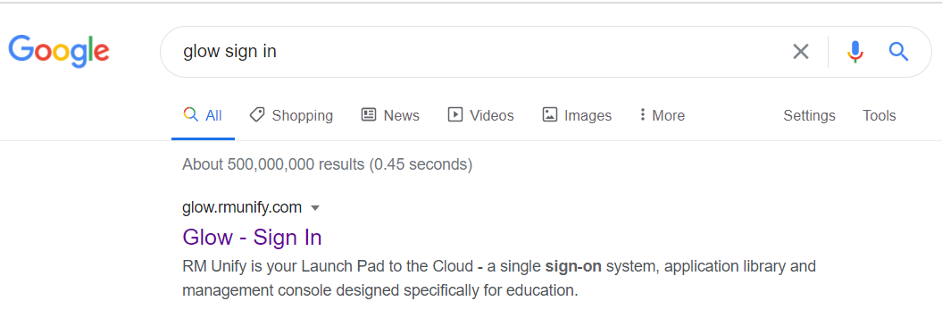
https://glow.rmunify.com/

All pupils have been issued with a username and password to log in
username@glow.sch.uk

Help with account and passwords
Contact the school if you have forgotten your password

Using the Launchpad

My Launch Pad

St Stephen’s High School Launch Pad
Inverclyde Council Launch Pad
Scotland Launch Pad

My Launch Pad

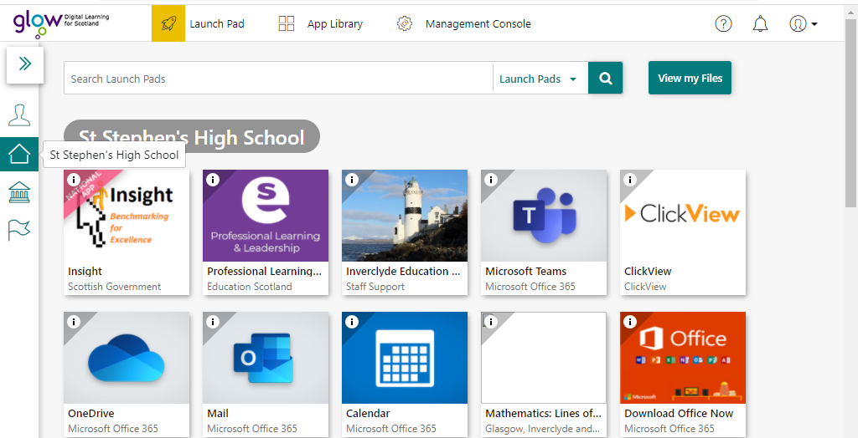
St Stephen’s High School Launch Pad

Section 2
Teams – Uploading an assignment
Teachers will set assignments for you to complete.
New assignment has been set for you (Activity will have a number next to it - see red circle).
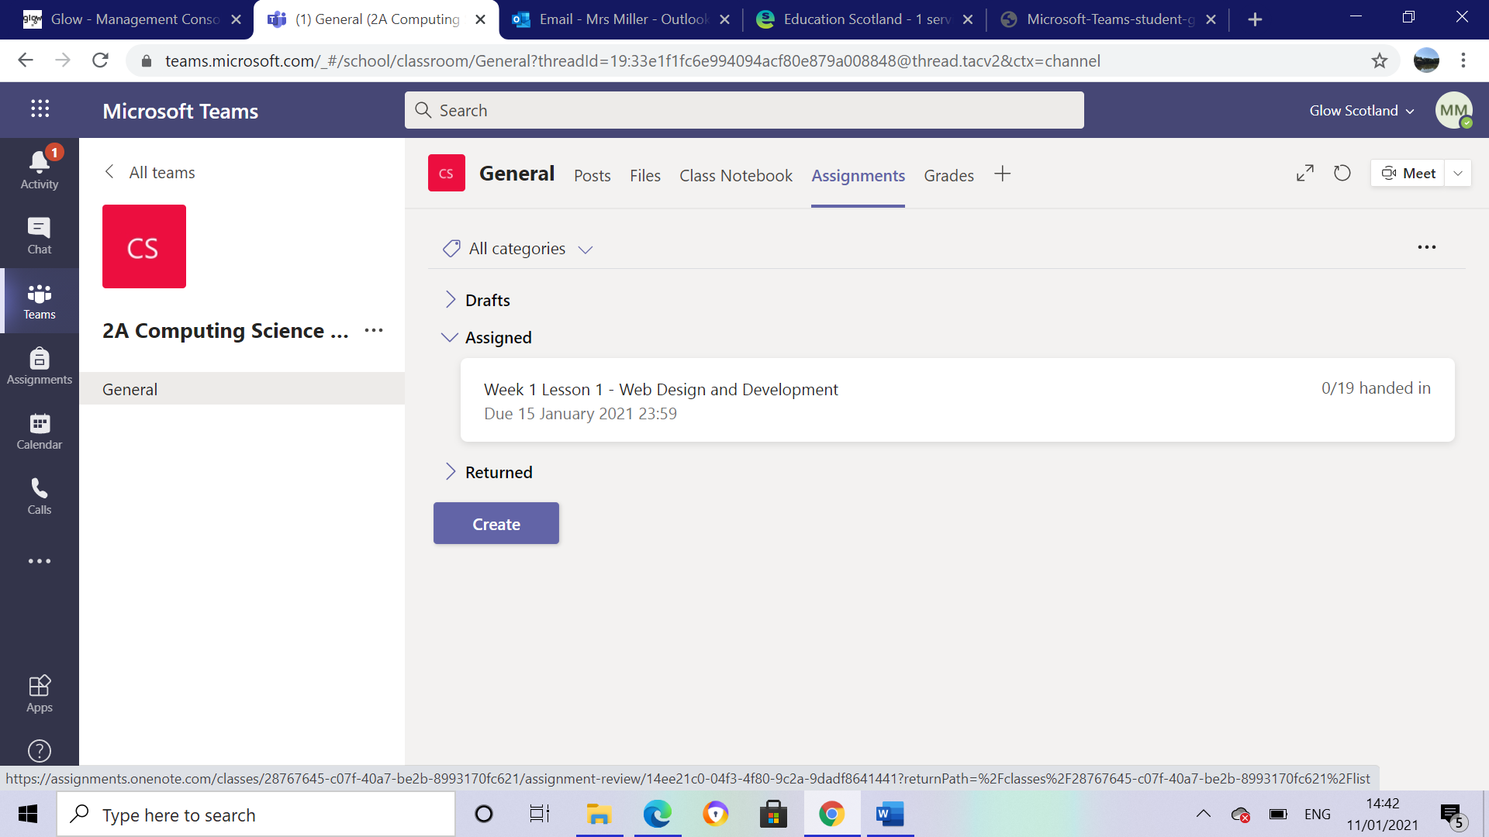
Assignment accessed by left-hand menu (circled in yellow)
Or … can be accessed by clicking Assignments link next to Class Notebook (circled in green).

Handing in your assignment on PC/Laptop
Click on three dots

Open in Teams – This saves automatically. Complete your work here and it will save

Download – This lets you download the document to your device and work on it.

If you have downloaded your file and want to upload it click “add work”

Select Upload from this device
Choose File to upload

Attach

Remember to click Hand in

Downloading Assignment Using a Phone
Click download icon

From here you can choose what you want to do with the document

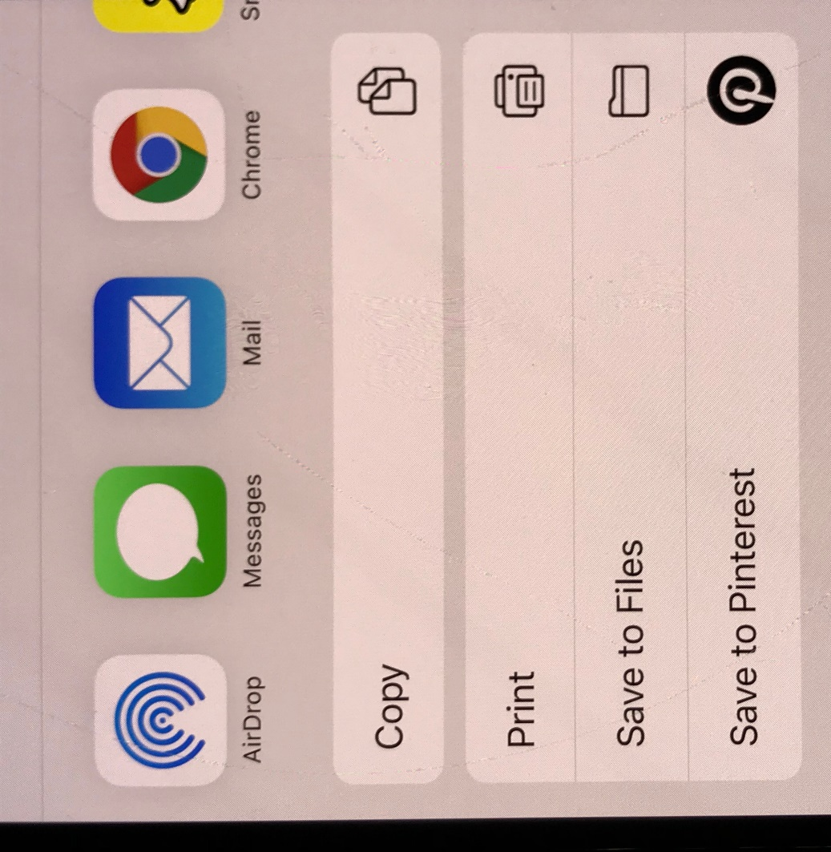

Handing in an assignment on a phone

Teacher Feedback

Watch YouTube clip for more help with Teams
https://www.youtube.com/watch?v=IRPVFyEKbvU&feature=emb_logo
Using Class NoteBook/Posts and Files

Microsoft Teams
When clicking on Teams all teams you are assigned to will appear on screen

Posts
This is a space where teachers and pupils can collaborate and discuss lessons. Please note if you post in this area it is visible to everyone who is in the team. If you wish to post work for only your teacher to view use your own Class Notebook.

Files
Under the files tab you will find work that has been uploaded by your teachers.

Accessing Files
Click Show Actions

Files can be opened or
downloaded to own device
from here

Class Notebook

Within your team click on Class Notebook

Class Notebook can be used to store a range of media including text, links, videos and images.

Each pupil has their own notebook which is organized into three parts:

- Student Notebooks — A private space shared between the teacher and each individual student. Teachers can access every student notebook, while students can only see their own.
- Content Library — A read-only space where teachers can share handouts with students.
- Collaboration Space — A space where everyone in your class can share, organize, and collaborate.

To access the personal notebook click on the show navigation icon

Once clicked you now have access to the Collaboration and Content Library and your own personal workspace

