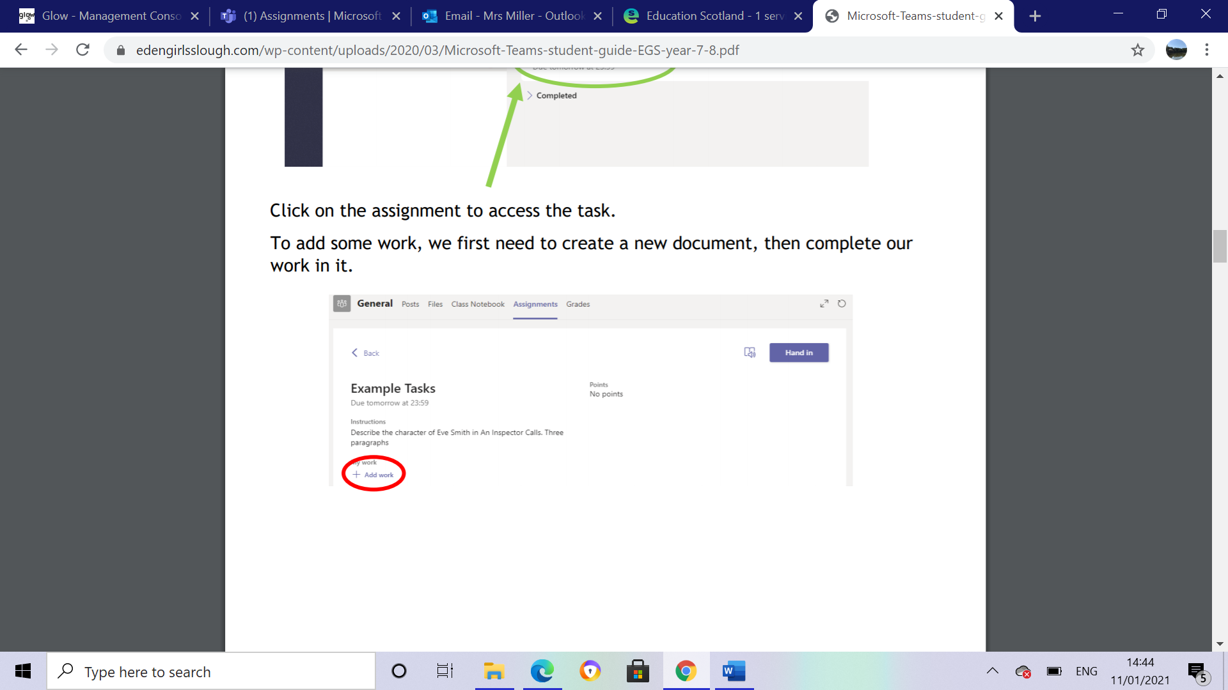**Handing in your assignment on PC/Laptop**

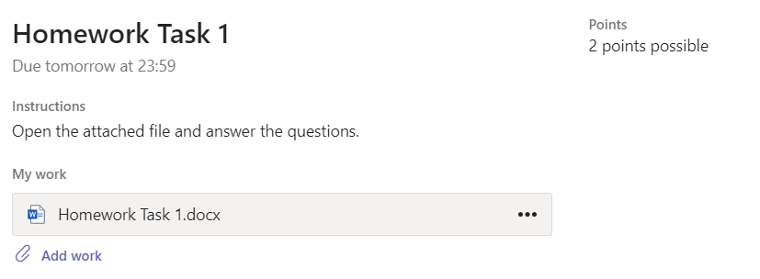

**Click on three dots**

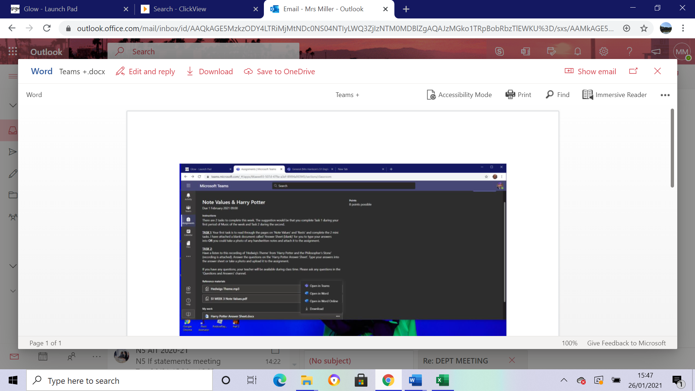

**Open in Teams** – This saves automatically. Complete your work here and it will save

**Download – This lets you download the document to your device and work on it.**

**If you have downloaded your file and want to upload it click “add work”**



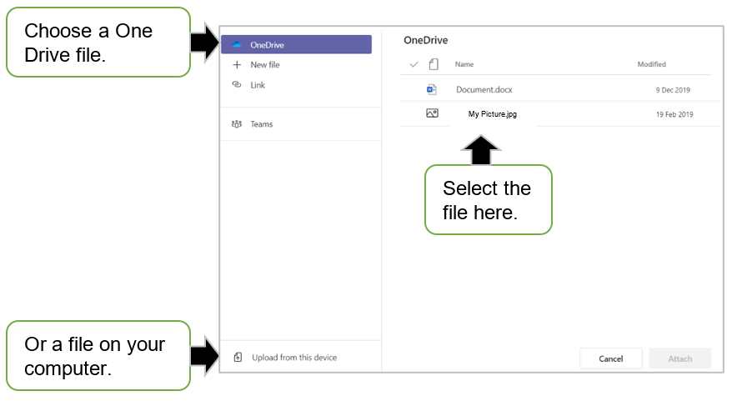

**Select Upload from this device**



**Choose File to upload**



**Attach**



**Remember to click Hand in**