St Stephen’s High School

Digital and Online Learning

Using Immersive Reader for pupils with Dyslexia or other reading difficulties

What is Immersive Reader?

Immersive reader is a tool that is free to use and can be opened within Office 365. It was created to help pupils with reading difficulties.

How to use it

Log in to Glow account and open the software you wish to use

MS Word Example
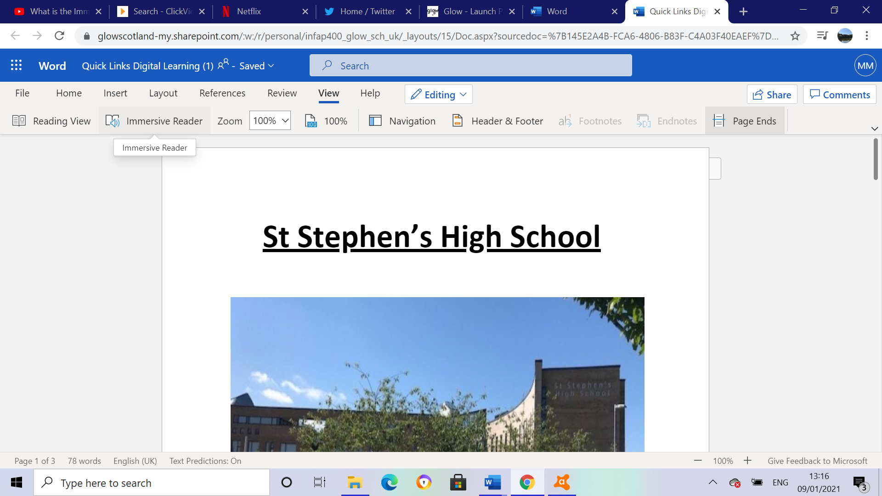

Immersive reader can read text to pupil either by selecting a specific word or by reading the whole document. Select Reading Preferences then either choose ‘By word’ or ‘Document’
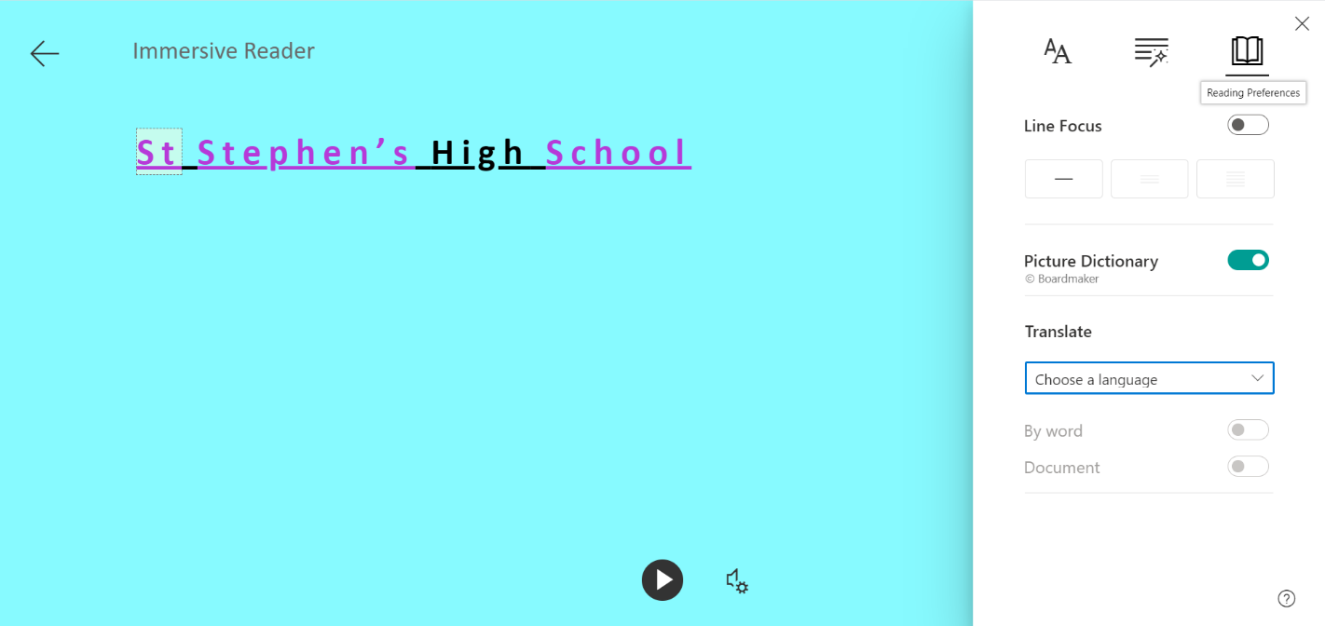
There is also an option to Translate text into another language

Grammar Options

Students can select Grammar Options. This can help with syllables of words.

Students can also select nouns, verbs, adverbs, and adjectives.

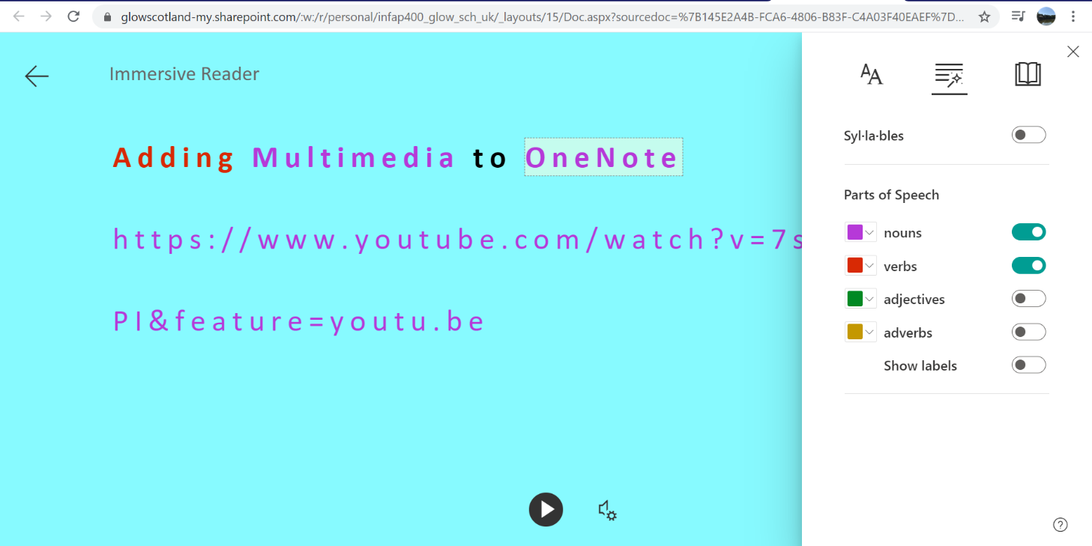
These are all colour coded and make it easy for the student to see within text which words are a noun for example.

Changing Voice

Voice speed and selection can be changed between female and male.

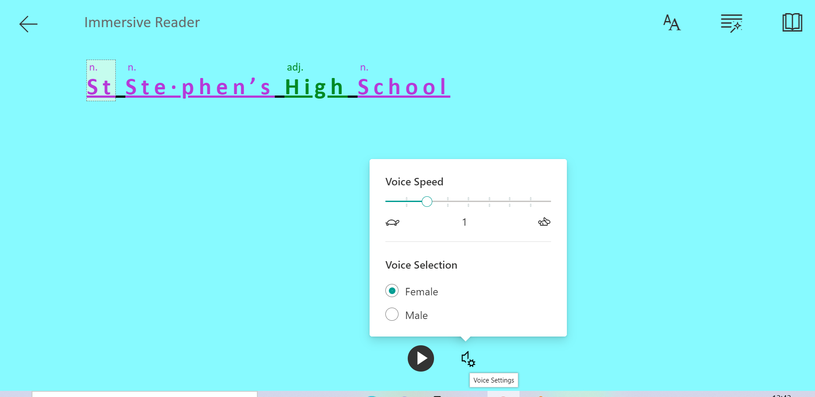

Accessibility

Students can personalise backgrounds, size of text or font style

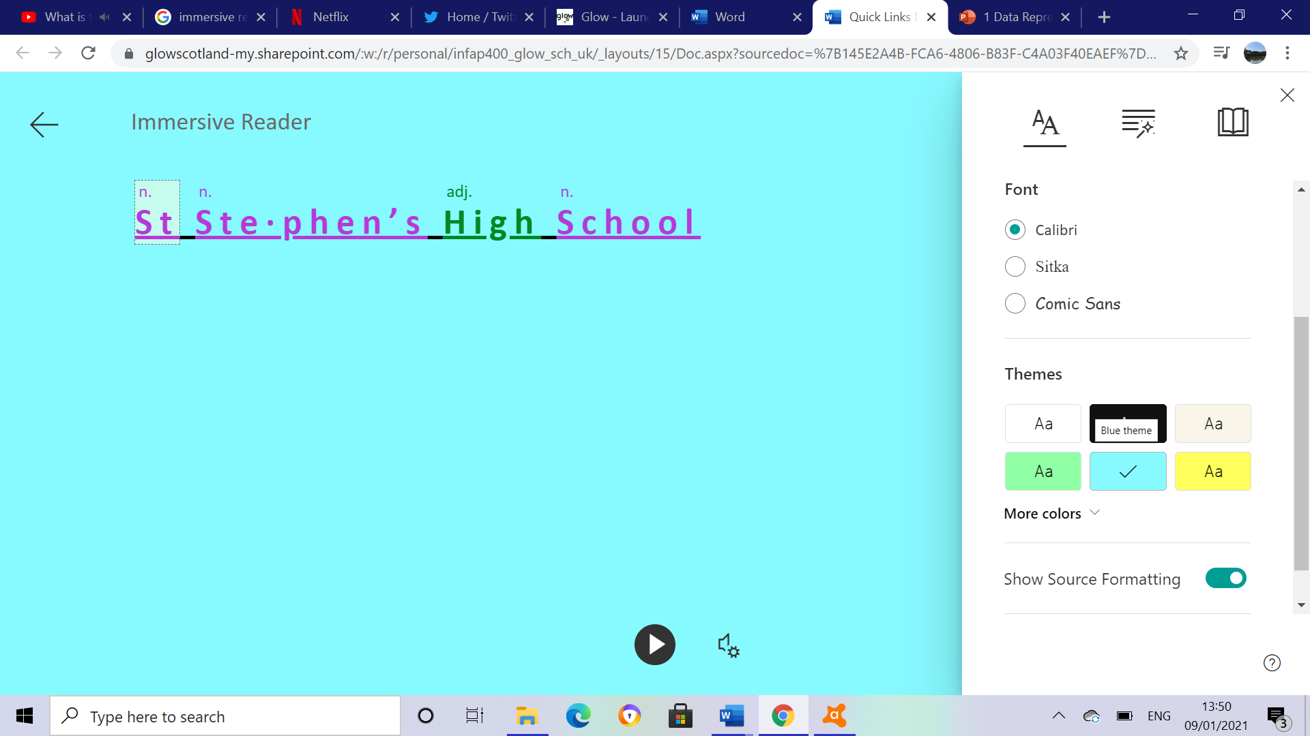

Immersive Reader in OneNote

Solving Equations in Maths

By clicking on the immersive reader button steps for completing the equation will be read out to the student
Immersive Reader Useful links

https://www.youtube.com/watch?v=wHJJCLV-DNg

https://www.callscotland.org.uk/blog/using-immersive-reader-with-teams/

