St Stephen’s High School

Digital and Online Learning

Using PowerPoint
Text to Speech

To hear PowerPoint read text, you will first need to add the Speak command to your Quick Access Toolbar:

- Select Customize Quick Access Toolbar above the ribbon and select More commands.
- Under Choose commands from, select All Commands.
- Select the Speak command, and then select Add > OK.
The Speak icon will appear on the Quick Access Toolbar.
- Select the text you want to hear and select Speak on the

Quick Access Toolbar
Click File/Options/Quick Access Toolbar

Under Choose Commands Select All Commands
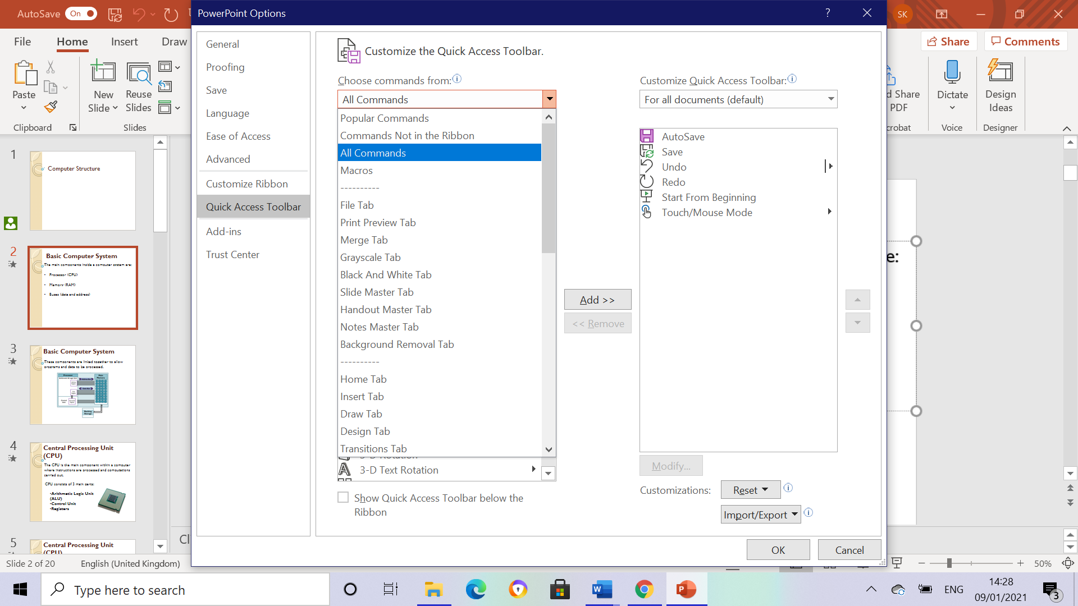

Select Speak
Click Add then OK

Speech option is now available on the toolbar

