St Stephen’s High School

Digital and Online Learning

Table of Contents
Glow 3
Logging in to Glow Glow email, username and password Using the Launchpad 4

Office 365 7
Accessing and downloading Office 365

Useful Apps for Learning 8
Apps for online learning

Class Notebook 12

OneDrive 16

Twitter 16
St Stephen’s High School Twitter Pages
Useful Twitter Pages for Digital Learning

Glow
Every pupil has a username to enable them to log into Glow. Your teacher will give you a copy of your email address, username and password. Any issues with your password please contact your teacher.

Accessing Glow – Glow can be accessed by typing in the following URL
https://glow.rmunify.com/

Logging in to Glow
All pupils have been issued with a username and password to log in
username@glow.sch.uk

Help with account and passwords
Advice and support for passwords and accounts can be found at:
https://glowconnect.org.uk/help-with-glow/glow-launchpad/accounts-and-passwords/

Using the Launchpad

My Launch Pad

St Stephen’s High School Launch Pad
Inverclyde Council Launch Pad
Scotland Launch Pad

My Launch Pad

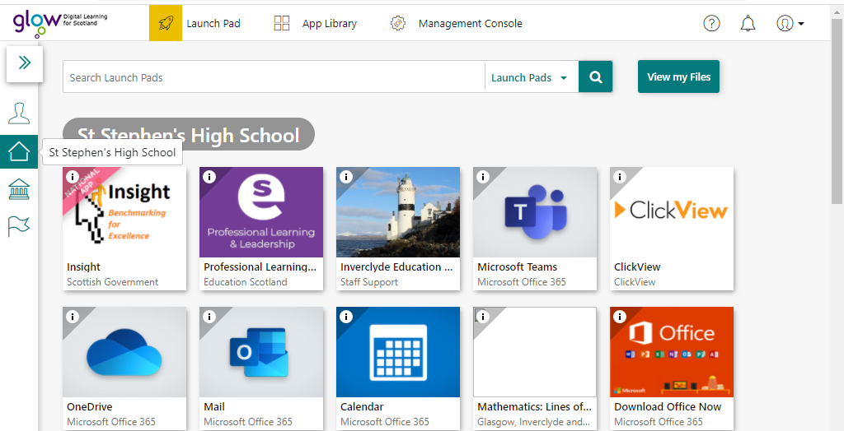
St Stephen’s High School Launch Pad

Help with Glow Account
Help with glow account can be found by clicking on the ? symbol

When the ? symbol is clicked the following page will display which contains useful links from RM Education YouTube channel to Digital Learning and Teaching in Scotland’s twitter page…….
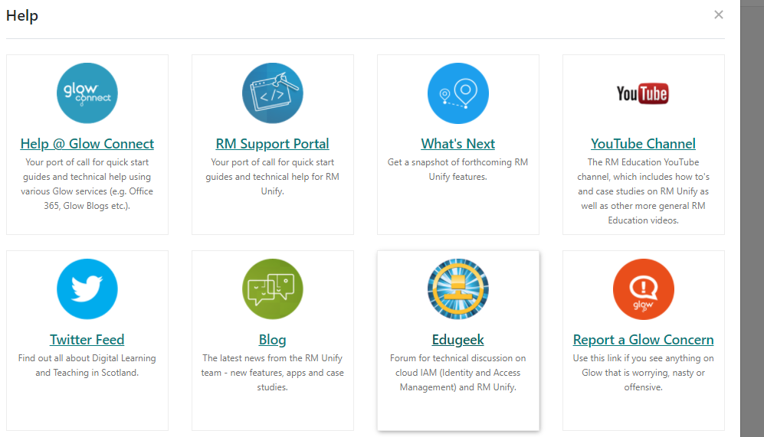
Follow Glow Digital Learning on Twitter for all the latest useful information (@GlowScot)

Using Microsoft Office 365
Office 365 is free to download onto your own device (PC, phones, tablets and Macs). This will give access to a range of Microsoft products (Word, Excel, PowerPoint, Access, OneNote).

Once logged in to Glow click on the Office Tile and follow online instructions.

If downloading to an iPad or iPhone the apps should be downloaded from the App Store first.

Click on the following link for further help setting up Office on a mobile device.

https://support.office.microsoft.com/en-us/article/set-up-office-apps-and-email-on-a-mobile-device-7dabb6cb-0046-40b6-81fe-767e0b1f014f?ui=en-US&rs=en-US&ad=US

Useful Apps for Learning
Microsoft Teams
Work will be set for pupils using Microsoft Teams. Teams is a virtual classroom where teachers and pupils can communicate through files, assignments and meetings in a central place.

It is recommended that you download the Teams app onto your device.

If using Teams in a Web Browser please use Google Chrome (not Internet Explorer as this is no longer being supported)

Microsoft Teams

Recent activity from your Teams will appear here (highlighted in red)
Used for Private Chat and Calling
Calendar will show any meetings you have been invited to
Teachers use this section to set assignments
Access to all Teams you are assigned to can be accessed here
Find an app

Microsoft Teams
When clicking on Teams all teams you are assigned to will appear on screen

Posts
This is a space where teachers and pupils can collaborate and discuss lessons. Please note if you post in this area it is visible to everyone who is in the team. If you wish to post work for only your teacher to view use your own Class Notebook.

Files
Under the files tab you will find work that has been uploaded by your teachers.

Accessing Files
Click Show Actions

Files can be opened or
downloaded to own device
from here

Class Notebook

Within your team click on Class Notebook

Class Notebook can be used to store a range of media including text, links, videos and images.

Each pupil has their own notebook which is organized into three parts:

- Student Notebooks — A private space shared between the teacher and each individual student. Teachers can access every student notebook, while students can only see their own.
- Content Library — A read-only space where teachers can share handouts with students.
- Collaboration Space — A space where everyone in your class can share, organize, and collaborate.

To access the personal notebook click on the show navigation icon

Once clicked you now have access to the Collaboration and Content Library and your own personal work space

Saving Class Notebook
For help saving a copy of your class Notebook click on the following link:
https://support.microsoft.com/en-us/office/save-a-copy-of-a-class-notebook-or-staff-notebook-44733e18-0ef1-4d4b-be51-fc2ac5bfe9ec

Scholar
Access to learning and revision materials for qualifications at National, Higher and Advanced Higher level courses can be accessed on Scholar.
Once logged on to Glow Scholar can be accessed via the app.

BBC Bitesize
BBC Bitesize is a useful online study resource for 3rd level through to Higher level (S1 to S6).
Study guides, tests and video clips can all be accessed online.
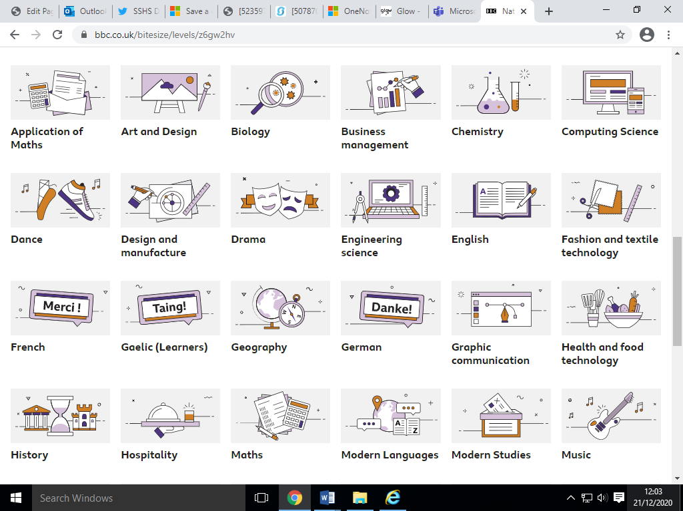
https://www.bbc.co.uk/bitesize/secondary

OneNote
OneNote is an application that allows you to take notes. It provides a central point for all of your notes. These notes can be organised into individual sections.
Notes can be shared with others. You can invite others to view and make changes your notebook, or you can create a link to a page of notes that you can paste in an email, blog, or web page.

Help and support for using sharing notes and other features of OneNote can be found by accessing the following links:
https://support.microsoft.com/en-us/office/onenote-online-help-7e497458-6bf3-4de3-a362-f83636f0d5b9

http://onenoteineducation.com/

OneDrive
OneDrive is your cloud storage within Glow. All files/work can be stored here. You can share work from it with your teacher or other pupils.

Office 365 documents you create can be saved here and you can upload files from your home device.

Twitter
See below a list of useful Twitter Accounts to help with your home learning.
@Ststephenshs – School Twitter
@sshs_Soc – Social Subjects
@SSHSICT – ICT Department
@sshs_maths – Maths Department
@DigitalSshs – Digital Learning at St Stephen’s High School
@GlowScot – National account for Glow
@OneNoteEDU – Official OneNote Education account
@EducationScot – Official Education Scotland account

