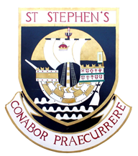

ST STEPHEN’S HIGH SCHOOL

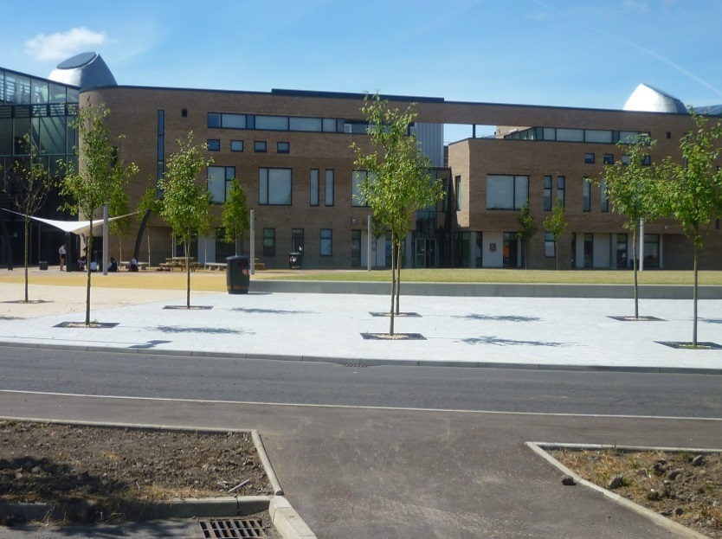

SCHOOL HANDBOOK 2020/21

Handbook Contents

Page

Introduction by Head Teacher 3 Introduction and General Information 4
Staffing 6

The School Day 7

School Vision and Values 8
Primary Secondary Liaison 10
School Policy 11 Curriculum for Excellence 12

Pastoral Support 13
Support for Pupils 15

Attendance 16 Parent Council 19

Child Protection 21
Homework 21
Assessment/National Examinations 22
Senior Phase Options 23
Additional Information 26

Introduction by Head Teacher

Dear Parents and Carers,

It gives me great pleasure to write this introduction as the Head Teacher of St Stephen’s High School. It is a privilege and source of great satisfaction to serve your children and the wider community. I am delighted that you are considering sending your child to St Stephen’s High School in Port Glasgow.

Here in St. Stephen’s we are committed to ensuring that the full potential of every young person is developed and we strive to make sure that they maximise their achievement and attainment. In addition, we seek to develop our young people into mature, health-conscious and active young people who are equipped with the necessary skills and knowledge to enable them to participate in further developing society.

As part of our efforts to fulfil these aims, we are committed to providing you with information and encouraging you to tell us what you think of our service. This handbook is about the first of these aims; providing you with information. We rely on you for the second aim. If you have any concerns please do not hesitate to contact either myself, the two Depute Head Teachers - Miss McKinney and Mr Carroll - or your child’s Guidance teacher. All of these people are ready to listen to you and to take account of what you say.

I am sure that your child will be happy in St Stephen’s and I look forward to seeing you at one of our forthcoming Parental events.

Kind regards

Mrs. Alison Fanning
Head Teacher

Introduction and General Information

Address: Kilmacolm Road

Port Glasgow
PA14 6PP

Telephone: 01475 715300 Fax: 01475 715301

E-mail: INStStephens@glow.sch.uk

Website: http://st-stephens.inverclyde.sch.uk

Twitter: @Ststephenshs

Head Teacher: Alison Fanning

Associated
Primary Schools: St Francis’ Primary School
East Barmoss Avenue
Port Glasgow

PA14 6HX

Telephone: 01475 715725

St John’s Primary School
Mary Street
Port Glasgow
PA14 5AL
Telephone: 01475 715728

St Michael’s Primary School
Bridgend Avenue
Port Glasgow
PA14 5SU
Telephone: 01475 714690

Kilmacolm Primary School
Churchill Road
Kilmacolm
PA13 4LH
Telephone: 01475 715812

At present our roll is 550:- 98 in S1, 120 in S2 96 in S3, 90 in S4, 81 in S5, 65 in S6

The number of pupils likely to come into S1 over the next three years is:

2019: 90 2020: 115 2021: 90

St Stephen’s High School is a six year Catholic comprehensive secondary which provides an education for young people from the ages of 12 to 18 living in the areas of Port Glasgow and Kilmacolm.

St Stephen’s is committed to providing a high quality education within the context of a Catholic school. ‘Catholic’ here is more than a reference to religious instruction: rather, it means that we work to convince pupils that as members of a Catholic school community they should live out the values of their religion, for example by praying together and by showing a Christian respect for others.

By recognising their uniqueness and dignity as human beings, we encourage our pupils to live their lives by Gospel values.

St Stephen’s High School has an important role to play in the local community. Pupils are encouraged to become involved in local and national charities and to be involved in community service. Our Twitter pages and regular newsletters provide information on some of the activities in which pupils have been involved.

Staffing

Senior Leadership Team
Head Teacher Mrs A Fanning
Depute Head Teachers Miss C McKinney
Mr R Carroll

Curriculum:
ART
J McDade (0.6)
L McLaren (0.6)
L Deeney NQT

BIOLOGY
G McGowan
Y Fleming

CHEMISTRY
J Cochrane (0.5)
C Templeton (0.5)

ENGLISH
G Stevenson PT

INFORMATION
TECHNOLOGY
M Harvey FH
K Gibson
L Kupsch PTG
S Miller (0.8)

MATHEMATICS
M Dyer PT
A Coyle
C Watt
M Parsons PTG

MODERN LANGUAGES

RELIGIOUS ED
J Girkins PT
S McCole

TECHNICAL
EDUCATION
C Macqueen PT
P Murray PTG
J Cox (0.5)

PUPIL SUPPORT
H Stewart PT
F Carlin PT DYW

J Johnston
M McCrory
G Hamilton
D Brewster
M Delussey
C McKinney DHT

D Cummings PT
N Sandford

MODERN STUDIES
I MacGillivray PT

A Curley PTG

NOTE

GEOGRAPHY
Vacancy

HISTORY
S McKenna FH
S Graham

HOME ECONOMICS
K Taylor PT
L Rice

PHYSICAL
EDUCATION
K McGinnity PT 0.8
I Forster PT 0.2
M Magee
H Cook
R Carroll DHT

PHYSICS
S Stevens Faculty PT
Physics and Biology
S McAlister

DHT DeputeHead Teacher
PT Principal Teacher
FH Faculty Head
PTG Principal Teacher
Of Guidance
NQT Newly Qualified
Teacher
FTE Full time equivalent

Currently staffed to 46.2 FTE

The School Day

The School day is as follows:
Registration: | 8.50 – 9.00
Period 1: | 9.00 – 9.50
Period 2: | 9.50 – 10.40
Interval: | 10.40 – 10.55
Period 3: | 10.55 – 11.45
Period 4: | 11.45 – 12.35
Lunch: | 12.35 – 1.15
Period 5: | 1.15 – 2.05
Period 6: | 2.05 – 2.55
Period 7: | 2.55 – 3.45 (Monday and Tuesday only)

Vision and Values

Vision

As a Roman Catholic faith community St Stephen’s seeks to provide conditions and experiences that will promote the spiritual, moral, physical, social and intellectual development of both staff and students. We strive to ensure that all of our young people have the opportunity to develop their God-given talents to their fullest potential. The ethos of our school reflects our core Christian values and our respect for the rights outlined in the United Nations Convention on the Rights of the Child (UNCRC). As a school community, we respect all of these rights but, in particular, the following articles as outlines in our school charter: Articles 12, 19, 23, 24, 29 and 31.

Values

Our daily interactions with everyone in our faith community are an opportunity to demonstrate that we live our lives true to the values and virtues demonstrated by Our Lord Jesus Christ. We respect the views and of every individual and their right to be treated with dignity at all times and act with compassion to those in our community who are vulnerable and in need of our support.

Aims

1. Curriculum

The school will offer a curriculum that will provide breadth, balance and choice for all in a planned, progressive and structured way allowing our students to progress and develop their God-given talents and to become confident, resilient individuals.

2. Attainment

The school will provide opportunities for the intellectual and personal development of all students, enabling them to become successful learners and achieve their full potential by building on their prior learning, their strengths and identified areas of personal
development.

3. Teaching and learning

The school seeks to provide the highest quality teaching that meets the needs of all learners and promotes effective learning by providing our teachers and support staff with opportunities for personal and professional development.

4. Support for pupils

The school will provide personal, curricular and vocational support for pupils through teaching, guidance and close links with parents and the community and provide opportunities for them to develop as responsible citizens and to contribute effectively their local community and the wider Scottish society.

5. Ethos

The school seeks to foster an effective partnership between home, school and parish, which promotes a Catholic ethos within the school and a positive image of the school within the community.

Primary Secondary Liaison

Great importance is attached to maintaining good contacts with our associated primary schools. The partnership between us helps greatly to ease the problems which some pupils may foresee in moving from primary to secondary school and builds on prior learning. Senior Management, Pupil Support and Guidance Teams work closely with our primary colleagues to make sure your child moves happily into St Stephen’s High School.

We have a very comprehensive liaison programme which includes:

- A nine week transition programme where P7 pupils follow a timetable here in St. Stephen’s on a Wednesday afternoon

- Regular meetings between the senior staff of the primary schools and St Stephen’s

- Curricular meetings to ensure consistency in standards and in the transfer of information

- Senior staff from St Stephen’s make themselves available to parents of pupils in P6 and P7 at primary school parents’ nights

- An open evening for the parents of pupils about to transfer to St Stephen’s. Any parent who has been offered a place for their child or who is seeking a place for their child can also contact the school office to make an appointment to visit the school if they wish

- Meetings between Guidance staff and P7 teachers to allow appropriate supports to be put in place

- Two parent information evenings during P7

- All P7 children spend two days in St Stephen’s in June following a normal timetable

- An enhanced transition programme during the summer holidays for pupils who might wish some further support with the transition into St. Stephen’s High School

School Policy Documents

School Documents
A copy of the following documents can be found on the school website:

- School Improvement Plan
- School Induction Booklet
- 3 year Overview of Priorities
- Attending School Matters
- Anti-bullying Policy
- Pupil Equity Fund
- School Complaints Procedure
- Equlity and Inclusion Policy

Standards and Quality Report
A copy of the School Standards and Quality Report can be found on the school website.

SQA Results
School SQA results in National Qualifications are available on request from the school on request.

Curriculum for Excellence

Broad General Education (S1 – S3)
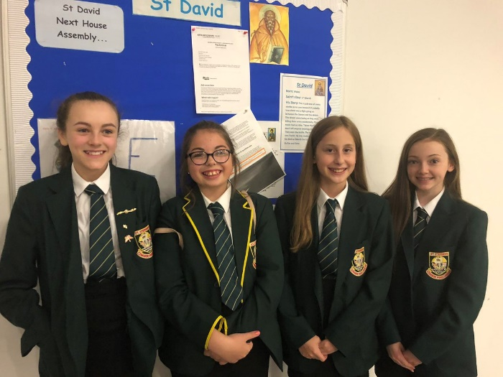
In the early stages of secondary education the curriculum provides a broad, general education designed to meet the needs of all young people. In first year pupils will follow a common course with appropriate balance of time allocated to each curriculum area and subjects within curriculum areas. At an appropriate time during S3, pupils may be given the opportunity to study a fewer number of subjects in greater depth. Formal subject choice should take place by the end of third year.

Within St.Stephen’s, in the first two years pupils are mainly taught in mixed ability classes. In English and Mathematics they are taught in ability groups for some of the time. Classes are formed so that there is a complete range of ability in each class and steps are taken to ensure that each child has at least one primary school friend in his or her class.

In S1-S3 pupils are taught in the following curricular areas:

Religious Education, English, Mathematics, Social Subjects, Science, Modern Languages, ICT, Technology, Creative Arts, Home Economics, Physical Education and Personal and Social Education.

The Senior Phase (S4-S6)

The Senior Phase is the period when most young people engage with the national qualifications framework. During the senior phase, they are supported to extend and deepen their education as they build their portfolio of qualifications which recognises their learning, enabling them to continue to develop skills and offering pathways to the next stage – whether that is further or higher education, training or employment. During the Senior Phase young people are supported to choose courses and levels most appropriate to their prior attainment and career aspirations.
A common upper school schematic timetable will operate across Inverclyde secondary schools. As a result, young people will continue to have a choice of up to five subjects for accreditation at National 6 (Higher Grade). St. Stephen’s provides clear pathways and routes of progression through the levels to National 6 (Higher) and beyond.

Scottish Qualifications Authority (SQA)

The end of S4 is usually the first time that our pupils will be presented for SQA national examinations. The SQA is Scotland’s national body for qualifications. Our courses are packaged in a way which allows us to match very closely the national guidelines on courses for S4-6. This allows pupils to take a number of national courses as well as following school courses in religious education and physical education in the senior phase. The SQA website is www.sqa.org.uk.

Pastoral Support

It is the responsibility of every teacher to help our pupils reach their full potential socially as well as academically. Many of our staff are willing to assist and encourage their pupils in ways which go beyond simply teaching them a subject. Staff at all levels support pupils on educational matters, careers, further and higher education, their conduct and personal matters. Such a caring attitude among teachers does much for the welfare of pupils and is totally consistent with our role as a caring Catholic Community.

In a sense all teachers have a “guidance” role. There are, however, four promoted guidance staff who have special responsibilities for given groups of children. They are responsible to the Head Teacher for ensuring that the services which the school has to offer are made available to all pupils and their parents.

Their duties include the following:

- to help new pupils settle into the school;
- to check the progress, attendance, timekeeping and conduct of pupils and to keep parents informed of these;
- to guide pupils in their choice of subjects from third year onwards;
- to provide pupils with advice on careers and on courses for further and higher education;
- to work closely with the school’s Home Link Worker in dealing with pupils whose attendance is unsatisfactory;
- to arrange a programme of visits, films and lectures which help prepare our pupils for adult life;
- Guidance staff are often the first members of staff to be in contact with parents, school medical service, psychological services and the careers office. They also prepare reports on pupils for a variety of agencies including employers. Staff see guidance staff as the natural people to give and receive a whole variety of information about the pupils in their house groups.

For this reason parents will also wish to speak to guidance staff. The office staff will normally try to arrange interviews with guidance staff for parents when problems arise. Other staff are often also involved but normally a problem concerning any pupil is best first discussed with the appropriate member of the guidance staff.

Pastoral Team

The Principal Teachers of Guidance are:

Mrs A Curley St Andrew’s House
Ms L Kupsch St Bernadette’s House
Mr M Parsons St Catherine’s House
Mr P Murray St David’s House

A child will remain in the same guidance group throughout their school career. This is intended to allow staff, pupils and families to develop a close working relationship. Every effort will also be made to ensure that brothers and sisters will be placed in the same house group

Support for Pupils

There is a variety of supports available for pupils who experience some difficulties with certain aspects of learning, health and wellbeing.

The Principal Teacher of Support for Learning (Mr Stewart) is responsible for managing the selection of suitable materials and programmes for pupils who experience difficulties. The PT coordinates support for pupils who have specific learning difficulties or additional support needs. Intensive small group or individual support may also be timetabled in response to their individual needs and exam concessions may also be put in place.

The Hub is another area where pupils can be supported in both their learning and in their health and wellbeing. This is overseen by Mr McGarvey, who coordinates the work of a range of teaching and non-teaching staff. The types of support which can be offered by Hub staff include:

- Individual and group interventions
- Support, advice and information on physical and mental wellbeing
- Parental engagement and support – J Boyland is our Home Link Worker
- Partnership working – Jac Kinnimont from CLD is our school Youth Support Officer and Emma Stevenson is OUR Barnardo’s Family Support Worker
- Flexible Pathways which include work placements – normally overseen by Mr Carlin who is PT with responsibility for Developing the Young Workforce

Please feel free to contact any of the above named members of staff for advice, information or support.

Inclusion and Equality

‘Inverclyde Education Service is committed to ensuring that no children or members of staff or service users receive less favourable treatment on any ground including gender, race, disability, age, sexual orientation, religion or belief. We have a moral, social and legal obligation to put equality at the heart of everything we do.

St Stephen’s High School asks that the school community respects the individuality of each person. We are determined to make sure that every pupil is supported throughout school, fairly and equitably, regardless of circumstances. We are committed to social justice in order to ensure sure that all pupils are given an equal chance to reach their potential.

- There are numerous opportunities to become involved in fund raising activities with money going to SCIAF and other charities.

- End of year activities are available ranging from trips to Alton Towers and visits to various local leisure attractions.

- Support for Learning provide a lunchtime class to catch up on homework.

Attendance

Parents should inform the school by telephone on the first morning of an absence and provide a reason for the pupil’s absence. The school will contact the pupil’s family and thereafter other emergency contacts if no explanation is given for the pupil’s absence. This contact will be made before 10.00 a.m. on the first morning of an absence and early after the restart after lunch in the case of an afternoon absence.

Other agencies may be contacted if no contact with the pupil’s family can be achieved and if there are continuing or emerging concerns about a pupil’s safety or wellbeing.

On return to school parents should provide a note explaining the reasons for absence.
Parents should keep the school informed of any changes of address or telephone numbers, both their own and those of the emergency contacts.

Section 30 of the 1980 Education Act lays a duty on every parent of a child of “school age” to ensure that their child attends school regularly. Attendance must be recorded twice a day, morning and afternoon.

The Scottish Government has provided guidance on the management of attendance and absence in Scottish schools in its publication Included, Engaged and Involved – part1: Attendance in Scottish Schools. Every effort should be made to avoid family holidays during term time as this both disrupts the child’s education and reduces learning time. It has been clarified that family holidays should not be recorded as authorised absence, except in exceptional domestic circumstances, where a family needs time together to recover from distress, or where a parent’s employment is of a nature where school-holiday leave cannot be accommodated (e.g. armed services or emergency services). It is for local authorities and schools to judge when these circumstances apply and authorise absence, accordingly.

The categorisation of most term-time holidays as unauthorised absence has been a contentious issue for some families, many of whom are concerned at the higher cost of holidays during school holiday periods. The Scottish Government has no control over the pricing decisions of holiday companies or flight operators. Our main focus is to encourage parents and pupils to recognise the value of learning and the pitfalls of disrupting learning for the pupil, the rest of the class and the teacher. Clearly where an absence occurs with no explanation from the parent, the absence is unauthorised.

Schools investigate unexplained absence and Education Services has the power to write to, interview or prosecute parents, or to refer pupils to the Children’s Reporter, if necessary.

Young people of school age may be unable to attend school for a wide range of reasons including illness, accidents or long term medical conditions. In general there will be an automatic referral by the school for education outwith school after 15 days of continuous or 20 working days of intermittent absence, within a single session, for verifiable medical reasons.

Parents from ethnic minority religious communities may request that their children be permitted to be absent from school in order to celebrate recognised religious events. Only written requests detailing the proposed arrangements will be considered. Appropriate requests will be granted on not more than three occasions in any one school session and the pupil noted as an authorised absentee in the register.

Cooperation from Parents in Attendance Matters
The help of parents in the following matters is very much appreciated:
- Please try to inform the school if you know that your child is likely to be absent for some time.

- Give your child a note, stating the reason for absence, on his / her return to school.

- Cooperate with the school when staff are investigating unexplained absences or truancy. Such cooperation makes life more pleasant for everyone and is likely to prevent pupils getting into trouble through truancy.

- Pupils are registered for school during registration at the start of the day. This attendance is entered into the computerised attendance record. Pupils who arrive after the attendance has been recorded must report to the office and enter their names in the late book. This allows the attendance record to be updated. The school operates an automated telephone call system whereby parents are contacted on a child’s first day of absence if no information has been received from parents. Parents can opt out of this system if they wish.

- Absence rates are calculated as a percentage of the total number of possible attendances for all pupils of the school in the stage shown, each morning and afternoon of each school day being a separate possible attendance.

Where figures or percentages based on a number of pupils under any particular heading is between 1 and 4 no information is given and **** is inserted in place of the figures.
Adults attending day school classes are not subject to the attendance regulations outlined above.

The authority’s and Scotland’s figures include all education authority and grant-aided secondary schools, but exclude all special schools.

Our Parent Council

Scottish Schools (Parental Involvement) Act 2006 led to the establishment of Parent Councils in primary, secondary and special schools. The Act recognises the vital role that parents play in supporting their children’s learning. It places a duty on authorities to promote the involvement of parents in children’s education and the wider life of the school. It aims to help parents be:-

- Involved with their child’s education and learning
- Welcomed as an active participant in the life of the school
- Encouraged to express their views on school education generally

The Parent Council, as a statutory body, has the right to information and advice on matters which affect children’s education.

Parents who are involved on a regular basis in schools should undertake an enhanced disclosure through Disclosure Scotland.

St Stephen’s has established a Parent Council and the Parent Council meets at 7 pm on the third Tuesday of the month in the school. Meetings are open to the public. Dates will also be posted on the school’s website.

Elections take place in line with agreed constitution. Parents are invited to AGM voting if needed.

The Parent Forum can access minutes of the meetings and the constitution by contacting the school office. They will also be posted on the school website.

Members of the Parent Council

Chairperson: Mrs L Dickson
Parents: S Glancy
P Weir
M Sweeney
D McIlkenny
K Hanley
C Osborne
D Buirds
D McNaught
S Jamieson

Church Representative: Mrs A Deighan

Parental Involvement

We, in St Stephen’s, are committed to the view that education is a partnership between parents, pupils and teachers. For that reason we wish to encourage parental involvement in all aspects of the life of the school. Parents who are worried about their child’s progress, attendance, conduct or welfare should not hesitate to ask for an appointment to see their child’s guidance teacher or year group head.

Before visiting the school, parents should try to make an appointment. This will ensure that the meeting can be arranged for a time when the teacher does not have a timetabled class or another appointment.

Meetings

Parents’ meetings are arranged for every year group so that parents have the opportunity to discuss pupils’ progress with teachers. The school has reviewed the format of these evenings in order to make them as effective as possible for parents and staff. The pattern of parents meetings is included in the Appendix “Key Dates for Parents” towards the end of this brochure.

From time to time open meetings are held to provide information to pupils on particular aspects of school life. Parents of new first year pupils have a meeting in December and May in the year prior to their children starting in St Stephen’s. In addition, if any parent has been offered a place in the school for their child, or is wishing to seek a place for their child, they can contact the school office to make an appointment with the senior management team or guidance staff to discuss any aspects of the placement they are unsure of. Parents can also make an appointment to visit the school if they so wish.

All parents’ meetings are publicised by letters which are sent to pupils’ homes and by notices in the local churches.

Parents of pupils who are enrolling in the school other than at the start of first year will usually be seen by a senior member of staff who will be able to answer any questions about the school.

Child Protection in Inverclyde

Inverclyde Council Education Services has Child Protection Guidelines and Procedures which all schools and establishments are required to follow. Education Services works very closely with other agencies, namely Strathclyde Police, Social Work Services, NHS Greater Glasgow and Clyde and the Children’s Reporter to support children.

Common responsibilities of all staff are to protect children from abuse and exploitation, to respond appropriately when abuse is identified, and to ensure whenever possible that all children are able to exercise their right to be raised in a warm, stimulating and safe environment with the support of staff, their families and carers.

Homework

Given the importance of homework, it is essential that teachers, pupils and parents are clear about the school’s homework policy. The policy adopts a whole school approach to homework and outlines a set of principles and guidelines by which all departments in the school can offer homework to their pupils.

It is school policy for teachers to set work or study which pupils should undertake at home. Exercises may be set which reinforce what has been taught in class. On other occasions pupils will be asked to read, to revise notes, to research materials in books, newspapers and magazines or to watch a television programme. Some departments now allocate homework tasks to be completed over a period of a week or more. This should help pupils in planning their work.

The amount of homework which is given should be manageable. In S1 and S2 about four to six hours per week would be regarded as the maximum. In S3 and S4 between six and nine hours per week maximum and in S5 and S6 three hours per higher is the general amount of time spent on homework per week. For many courses in the upper school homework and study are essential if the student is to progress.

Assessment

All courses offered in St Stephen’s are assessed. The methods used will depend on the nature of the course and the age of the pupils involved. For those courses which prepare candidates for the SQA Examinations the type of assessment used will often be decided by the examination procedures. For young pupils, and other courses, there are often end of term or end of topic assessments. Some of these will assess skills rather than knowledge especially in practical subjects.

The results of tests and assessments are often used by subject teachers to determine which course materials a pupil should go on to next or to identify if extra help or learning support might be needed.

Records of tests and assessments are kept by subject departments and the results of these tests are made available to parents. Reports are prepared for parents twice each session in year one and halfway through years two, three, four, five and six. In these reports teachers also comment on pupils’ effort, attitude, attendance and punctuality in subject classes

The parents of a pupil who has a record of special educational need may choose whether national tests should be taken or not.

The present pattern of dates for reports and parents’ nights is included as Appendix “Key Dates for Parents” at the end of this brochure.

Parents who have concerns about their child’s progress at other times in the year should get in touch with the appropriate member of the guidance team.

National Examinations

The school’s policy is that all students are encouraged to complete all the courses which they undertake and take the relevant examination at an appropriate level.

Schools in consultation with pupils / parents normally decide on presentation for examinations.

Fourth year pupils are taking the new National courses and when they complete all course work and sit the examinations where applicable, pupils will have a certificate which shows what they have achieved.

In fifth and sixth years students are given advice about which courses they should take and a suitable curriculum is planned. Again all students are entered for the appropriate examinations.

Subjects currently being undertaken by our fifth and sixth year pupils are:-

Advanced Highers in English, Maths, Chemistry, Physics, Biology, History, Music, Modern Studies and Spanish

Highers in English, Maths, French, Spanish, Geography, History, Modern Studies, Administration, Biology, Human Biology, Chemistry, Physics, Fashion & Textile, Graphic Communication, PE, Business Management, Design & Manufacture, Art & Design, Computing, Drama and Music

National courses in English, Maths, Mathematical Life Skills, French, Spanish, Geography, History, Modern Studies, Computing, Hospitality Practical Cookery, Music, Administration, Biology, Chemistry, Physics, PE, Design & Manufacture, Practical Woodworking, Business Management, Art & Design, Hospitality Cake Craft, Fashion & Textile and Graphic Communication

As well as the above courses some of our pupils also opt to take a college course(s)

Our aim is to have each student leave St Stephen’s with national certification which match their achievements. This will ensure that they can take maximum benefit from further and higher education or from training opportunities.
SQA website is www.sqa.org.uk

Senior Phase Options

Detailed information for each subject within the school can be found on the school website.

Additional Information

School Transport

The Council has a policy of providing free transport. Parents who consider they are eligible should obtain an application form from the school or education office. These forms should be completed and returned before the end of February for those pupils beginning school in August to enable the appropriate arrangements to be made.

Applications may be submitted at any time throughout the year but may be subject to delay whilst arrangements are made.

The appropriate officer has discretion in special circumstances to grant permission for pupils to travel in transport provided by the authority, where spare places are available.

Pick-Up Points:
Where free transport is provided it may be necessary for pupils to walk a certain distance to the vehicle pick-up point. Walking distance in total including the distance from home to the pick-up point and from the drop-off point to the school in any one direction will not exceed the authority’s limits (see above paragraph.)

It is the parents’ responsibility to ensure their child arrives at the pick-up point in time. It is also the parent’s responsibility to ensure the child behaves in a safe and acceptable manner while boarding, travelling in and alighting from the vehicle. Misbehaviour could result in a child losing the right to free transport.

Transport is povided for children from Kilmacolm and some areas in lower Port Glasgow. Certain areas of Greenock used to be within the school’s catchment area before the area was rezoned. The pupils who live in Greenock, and who were in receipt of free school transport to St Stephen’s from the old catchment area, will still qualify for free school transport whilst they remain in St Stephen’s High School. Any new pupils from Greenock, who reside within the old catchment area and who wish to attend St Stephen’s High School, will not qualify for free school transport to St Stephen’s as a right. The catchment school for those pupils is now Notre Dame.

Complaints

When a parent has a complaint or some concern which they wish to discuss at a time other than at a parents’ evening they should not hesitate to contact the school. In the first instance you should contact your child’s Pastoral Care teacher or a member of the Senior Management Team. This can be done by telephone, letter, e-mail or by making an appointment and calling at the school.

Free Shool Meals/Clothing Grants

Further information about Clothing grants and Free School Meals can be found on the following website:

https://www.inverclyde.gov.uk/education-and-learning/schools/clothing-grant-and-free-school-meals

ParentPay

Information on how to access ParentPay can be found on the following website:

https://www.parentpay.com/

