Homework

Name: Class

Look at the map below. Choose a country that was part of the Roman Empire.
Your task is to now find 5 facts about the impact the Romans had on your chosen county. This could include what the Roman name was for the country, when they conquered this country, how long they spent there and important battles or even Roman remains!

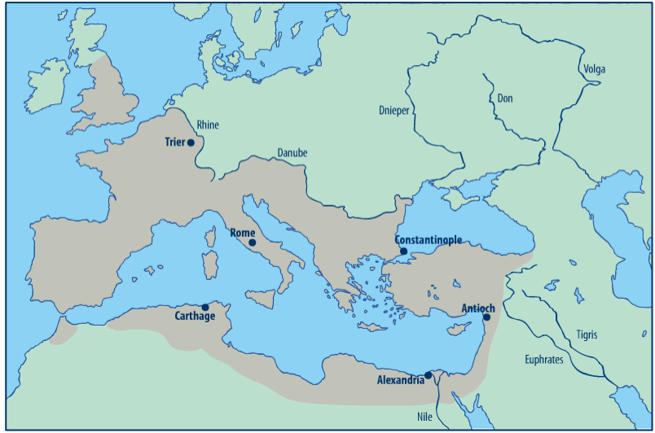
Turkey
6
Spain
France
England
Scotland
----------------------------------------------------------------------------------------------------------------------------------------------------------------------------------------------------------------------------------------------------------------------------------------------------------------------------------------------------------------------------------------------------------------------------------------------------------------------------------------------------------------------------------------------------------------------------------------------------------------------------------------------------------------------------------------------------------------------------------------------------------------------------------------------------------------------------------------------------------------------------------------------------------------------------------------------------------------------------------------------------------------------------------------------------------------------------------------------------------------------------------------------------------------------------------------------------------------------------------------------------------------------------------------------------------------------------------------------------------------------------------------------------------------------------------------------------------------------------------------------------------------------------------------------------------------------------------------------------------------------------------------------------------------------------------------------------------------------------------------------------------------------------------------------------------------------------------------------------------------------------------------------------------------------------------------------------------------------------------------------------------------------------------------------------------------------------------------------------------------------------------------------------------------------------------------------------------------------------------------------------------

