ST STEPHEN’S HIGH SCHOOL HISTORY DEPARTMENT

S3
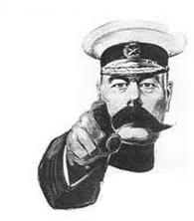
HOMEWORK BOOKLET
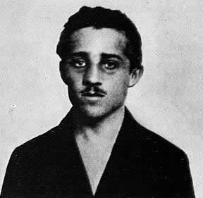
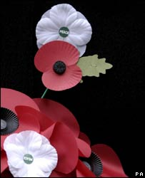
Name:_________________________________________________________
Class:___________________________________________________________
Homework 1 – Answer on the Sheet

Source A: Kaiser Wilhelm II, in an interview with the British paper the Telegraph, 1908
My heart is set upon peace, and it is one of my dearest wishes to live on the best of terms with England. But, you will say, what of the German navy? Against whom but England are my squadrons being prepared? My answer is clear. Germany is a young and growing empire. We must have a powerful fleet to protect our trade.

- Evaluate the usefulness of Source A as evidence of the rivalry between Britain and Germany before WWI.
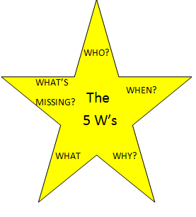
Who wrote it? ______________________________________________________
..making it useful because _____________________________________________

When was it written? _____________
..making it useful because ________________________________________________________________

Why was it written? ____________________________________________________________________
..making it useful because________________________________________________________________

What does it tell us? _____________________________________________________________________
..making it useful because_________________________________________________________________

What important information is missing? _____________________________________________________________________________________________________________________________________________________________________________
Homework 2: Newspaper Article First Draft
Using the evidence that you have collected in class, write a newspaper article on the assassination of Archduke Franz Ferdinand.
Remember:
- It should have two sections: (i) The details of the assassination, and (ii) What does this mean for Europe?
- You will be redrafting your reports using a Microsoft Publisher template in the library or computer suite

Headline: __________________________________________________________________
Section 1: The Assassination
___________________________________________________________________________________________________________________________________________________________________________________________________________________________________________________________________________________________________________________________________________________________________________________________________________________________________________________
___________________________________________________________________________________________________________________________________________________________________________________________________________________________________________________________________________________________________________________________________________________________________________________________________________________________________________________
___________________________________________________________________________________________________________________________________________________________________________________________________________________________________________________________________________________________________________________________________________________________________________________________________________________________________________________
___________________________________________________________________________________________________________________________________________________________________________________________________________________________________________________________________________________________________________________________________________________________________________________________________________________________________________________
___________________________________________________________________________________________________________________________________________________________________________________________________________________________________________________________________________________________________________________________________________________________________________________________________________________________________________________
______________________________________________________________________________________________________________________________________________________________________________________________________________________________________________________________________________________________________________________________________________________________________________________________________________________________________________________________________________________________________________________________________________________________________________________________________________________________________________________________________________________________________________________________________________________________________________________________________________________________________________________________________________________________________
Section 2: What now for Europe?
___________________________________________________________________________________________________________________________________________________________________________________________________________________________________________________________________________________________________________________________________________________________________________________________________________________________________________________
___________________________________________________________________________________________________________________________________________________________________________________________________________________________________________________________________________________________________________________________________________________________________________________________________________________________________________________
___________________________________________________________________________________________________________________________________________________________________________________________________________________________________________________________________________________________________________________________________________________________________________________________________________________________________________________

Homework 3: New Technology
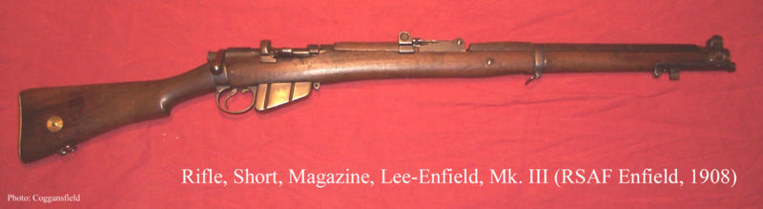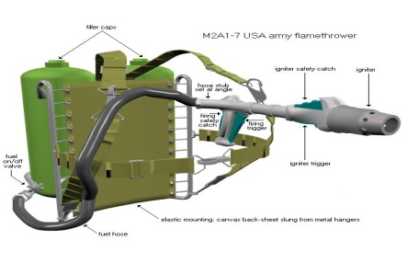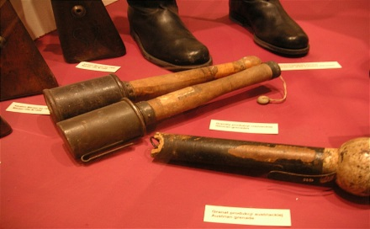
Enfield Rifle Flamethrower Hand – grenades
*Standard issue rifle * Not very effective: difficult * Useful as they can be
(all British soldiers had one) to operate and could only be thrown from a trench or by
* German Mauser was better safely fired from a trench a charging soldier

- If you were a soldier on the front line, which weapon would you prefer to be armed with: an Enfield rifle, a flamethrower or hand-grenades? Explain your answer, and explain why you rejected the other weapons.
______________________________________________________________________________________________________________________________________________________________________________
_____________________________________________________________________________________________________________________________________________________________________________________________________________________________________________________________________
SOURCE B is by a British army doctor. He describes the effects of mustard gas in 1917.

SOURCE B
When the shells exploded they released clouds of bright yellow gas. Some of the men did not get their gasmasks on quickly enough. They were horribly injured. The worst cases coughed up blood and gasped for air as they struggled to breathe. We could do nothing for them and most died.

Complete the spider diagram below to explain why mustard gas was such a terrible weapon. You should find at least one reason in SOURCE B and give at least one reason that is not mentioned in the source.
2

Why mustard gas was such a terrible weapon.
________________________________________
________________________________________

________________________________________

Homework 4: The Treaty of Versailles

Germany’s army was limited to 100,000 men, and she was allowed no air force and only a very small navy
Article 231 of the treaty was the War Guilt clause, which said that Germany was fully responsible for the war
Germany lost land to France, Belgium and Poland, as well as all of her overseas territory.
Germany had to pay France and Belgium money and resources worth £6.6 billion to pay for the damage caused by war.

- Organise the information above under the correct heading:
- Put the information in your own words.

Blame: _____________________________________________________________________________________________________________________________________________________________________________________________________________________________________________________________________
Reparations _____________________________________________________________________________________________________________________________________________________________________________________________________________________________________________________________________
Armaments _____________________________________________________________________________________________________________________________________________________________________________________________________________________________________________________________________
Territory: _____________________________________________________________________________________________________________________________________________________________________________________________________________________________________________________________________

