National History: The Atlantic Slave Trade Homework 1

Source A — from the logs of two ships involved in the Triangular Trade in the 1750s.
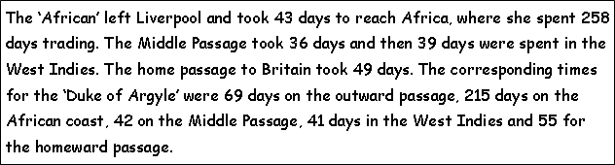
Task
1. Use Source A to construct a table to show the time spent on each part of the voyage.
Put in a total for the time each ship took on the Triangular Trade.

Journey Stage | ‘The African’ (no of Days) | ‘The Duke of Argyll’ (no of Days)
Outward
Trading in Africa
Middle Passage
Trading in the Caribbean
Homeward
Total

2. Study the table you have just drawn, and answer these questions in sentences.
(a) What was the normal length of a voyage on the Triangular Trade?
________________________________________________________________
(b) Which part of the voyage took the longest time?
_______________________________________________________________
(c) What makes Source A useful as evidence about the Triangular Trade?
__________________________________________________________________________________________________________________________________________________________________________________________________________________________________________________________________________________________________________________________________________________________________________________________________________________________________________________________________

