
Standards and Quality Report 2025-2026
We review our progress with the improvements we planned for 2025-2026. This helps us to plan for further improvement in 2026-2027.
How did we do? Attendance.
Attendance remained at the same level as last year.
Our attendance is higher than schools like us in Inverclyde, and higher than the average for all Inverclyde Primary Schools.
Instances of late-coming decreased for children who live in SIMD 1&2, and for those who are FME.

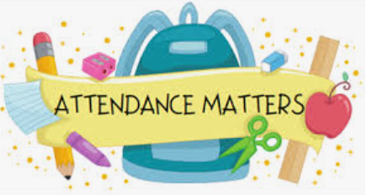

How did we do? Attainment.
Almost all children were On Track in Listening & Talking.
Most children were On Track in Reading and Numeracy.
The majority of children were On Track in Writing.
For our children who were Behind Expectation in Literacy & Numeracy, more made a year’s progress.
More children are Beyond Expectation in all areas of Literacy and in Numeracy.



How did we do? Health & Wellbeing.
Our children chose high scores when they completed the survey we use to tell us how our children are feeling about school.
More children gave higher scores than last year, with less children giving lower scores.
This tells us that our children feel safe, healthy, included and valued here at St Patrick’s.

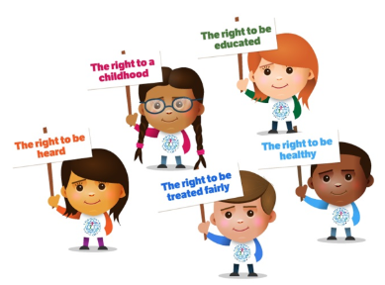

How did we do? Achievement.
Our children still really love sharing their achievements at our Magical Moments during our Assemblies.
Staff and Visitors responded well to reporting when children Showcase our School Values.
Our classes made great progress with their Action Plans to contribute to School Improvement.
We achieved The Promise Award.


You can read about our successes and achievements more fully in our full Standards and Quality Report for 2025-2026 on the St Patrick’s School Website.
School Improvement Plan 2026-2027

Our Improvement Plan shows what we will work on to improve our school. Having talked to and listened to pupils, staff and our parents/carers, our priorities are:
Priority 1: Learning, Teaching and Assessment
- Continue to focus on learning, teaching and assessment to improve attainment in Reading, Writing and Numeracy.

- Introduce Class Sways to better inform and include parents/carers in children’s learning.

Priority 2: Pull to School
- Continue to refresh our curriculum to make school as engaging as possible.

- Review Pupil Leadership and Participation across the school so children are contributing to wider school and community.
- Develop children’s understanding and use of language around
skills for life learning and work.

Priority 3: Health & Wellbeing

- Review procedures and practices in line with new Supporting Children with Health Care Needs Policy.
- Celebrate our diversity better, and create a St Patrick’s
Equalities Policy.
- Continue to help children regulate and manage emotions using
various resources to support children’s understanding.

These are our main priorities and areas of focus for this year.
The full version of the School Improvement Plan 2026-2027 is on the St Patrick’s School website.
We want our parents/carers to be involved in their children’s learning.
We hope to see as many of you as possible in our school over this year.
You can keep up to date by reading our regular Newsletters. These are emailed to you.
We will also be launching new Class Sways for every class. Details will be emailed in October 2026.

