

St Patrick’s Primary School
Standards and Quality 2025-2026
Context of the School
St Patrick’s Primary is a denominational primary school (Roman Catholic), which serves the centre of Greenock, providing education for pupils from P1 to P7. Our building opened in November 2016 and is a bright, stimulating environment for children to learn. Features make the most of natural light and the stunning views over the River Clyde. We have 12 classrooms, a PE hall, a library area, a dining area, 3 playground areas and daily access to the adjacent 3G football pitch owned by Inverclyde Leisure.
In 2025-26 we had 306 pupils over 11 classes, 3 of which were composite. Our school roll increased and continued to fluctuate throughout the year, as new children arrived and some left. 18 new pupils enrolled in our school, and 4 pupils left our school, between August 25 and May 26. Just over a fifth (21%) of our pupils did not begin their Primary education with us in Primary 1. 56% of our pupils lived in areas defined as SIMD 1&2 (Scottish Index of Multiple Deprivation). 34% of our pupils were Free Meal Entitled. 34% of our pupils had an additional support for learning need. 7% of our pupils had English as an Additional Language (EAL). 14% of our children were new to Curriculum for Excellence. 24% of our children have a minority ethnicity. 11% of our children are assessed or declared disabled. 3% of our children are refugees or seeking asylum. Our overall attendance was 94%: the same figure as last year.
15.1 teachers were allocated to the school but using the Pupil Equity Fund, teaching allocation increased to 16.1. The Senior Leadership Team comprised the Head Teacher, one Depute Head Teacher and a Principal Teacher. 13 Pupil Support Assistants (8 of whom were part-time, totalling 9.49 allocation), 2 Clerical Assistants and a Janitor also supported the school.
Our Vision
In St Patrick’s we strive to provide a secure, happy, caring school in which children are nurtured and enabled to achieve their full potential through effective learning and teaching experiences of the highest quality.
Our Motto
Our motto, inspired by our Patron Saint, St Patrick; Christ be beside me in all I say, all I do and all I am.
Our Values
Members of St Patrick’s Primary School community have Kindness at the heart of all we do, and are guided by the 3 Rs; Respect, Rights and Responsibility; and the 2 As; we are Ambitious to Achieve.
Our Aims
- To foster an open, welcoming and caring school in which all children are safe, healthy, achieving, nurtured, active, respected, responsible and included.
- To nurture successful learners by providing all pupils with the best opportunities to achieve their full potential and prepare them for a life of learning.
- To inspire responsible citizens who develop positive attitudes to serve the common good, promote social justice and opportunity for all.
- To form confident individuals with a self-belief and passion for using their God given talents to pursue excellence for themselves and others.
- To encourage effective contributors with enterprising attitudes, resilience and independent skills capable of positively impacting the communities in which they live.
- To develop as a community of faith, promoting Gospel values and respecting the dignity of all God’s children.

School Priority 1: Learning, Teaching and Assessment
Improvements in attainment, particularly in literacy and numeracy
Closing the attainment gap between the most and least disadvantaged children and young people
National Improvement Framework Outcomes  1. Empowered and accountable education system supporting lifelong learning.  3. Inclusive curriculum and assessment for a sustainable future.  4. High achievement and reduced attainment gap for all learners.  5. Skilled teachers and leaders delivering excellent, inclusive education. | How Good is Our School? 4 QIs  1.1 Self-evaluation for self-improvement  2.3 Learning, teaching and assessment  3.1 Ensuring wellbeing, equality and inclusion  3.2 Raising attainment and achievement | UNCRC  Article 28: (Right to education):  Article 29 (Goals of education): | Developing in Faith  Serving the common good  Developing as a community of faith and learning
Outcomes:
- By June 2026, attainment in Literacy and Numeracy across the school will have increased: by 2% in Listening & Talking to 94%; by 5% in Reading to 84%; by 6% in Writing to 78%; and by 4% in Numeracy to 82%.
- By June 2026, most children (75%-90%) who are Behind Expectation in Literacy and Numeracy, will make a year’s progress for a year’s teaching.
- By June 2026, attainment in Literacy and Numeracy for pupils who live in SIMD 1&2 will have increased by: 2% in Listening & Talking to 90%; by 4% in Reading to 77%; by 2% in Writing to 67%; and by 3% in Numeracy to 76%.
- By June 2026, attainment in Literacy and Numeracy for pupils who are FME will have increased by: 1% in Listening & Talking to 89%; by 1% in Reading to 69%; by 3% in Writing to 62%; and by 2% in Numeracy to 62%.

PEF used to support closing the gap:
- Teacher (1.0) to release PT and DHT to model and coach high quality-first learning and teaching in Reading, Writing and Numeracy, with a particular focus on Writing. To release teachers to visit other establishments to observe high quality learning, teaching and assessment, with a particular focus on Writing. £64,446.29.
- Resources to enhance learning, teaching and assessment in literacy and numeracy – replenish existing resources and buy new subscriptions. £7,188.67.

Progress and impact of outcomes for learners:
- Almost all children are On Track in Listening & Talking (92%). Most children were On Track in Reading (76%). This was a decrease of 3% on last year, and short of our target. The majority of our children were On Track in Writing (68%). This was a decrease of 4% on last year, and short of our target. Most children were On Track in Numeracy (76%). This was a decrease of 2% on last year, and short of our target.
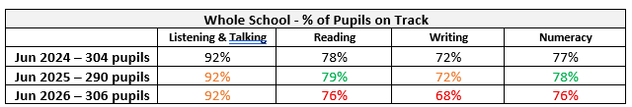

- Of the children who were Behind Expectation in Literacy and Numeracy, around two-thirds made a year’s progress in 25-26. 68% made a year’s progress in Listening & Talking; 59% in Reading; 62% in Writing; and 66% in Numeracy.
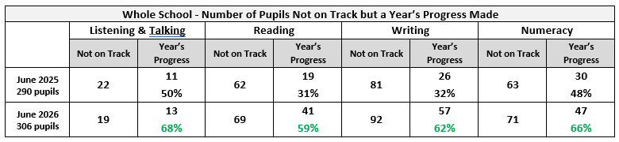

- Attainment of pupils who live in SIMD 1&2 has increased in Listening & Talking to 89% (+1%). It has decreased in Literacy by 2-3%; 70% in Reading (a decrease of 3%), and 63% in Writing (a decrease of 2%). In Numeracy, the attainment of pupils who live in SIMD 1&2 has decreased by 2% to 71%.
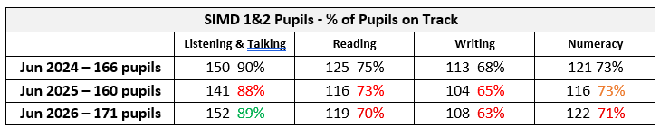

- Attainment of pupils who are FME has decreased in all areas, and by more than peers in Reading and Writing. In Listening & Talking 86% were On Track (a decrease of 2%). In Reading 63% were On Track (a decrease of 5%). In Writing 50% were On Track (a decrease of 9%). In Numeracy 59% were On Track (a decrease of 1%).
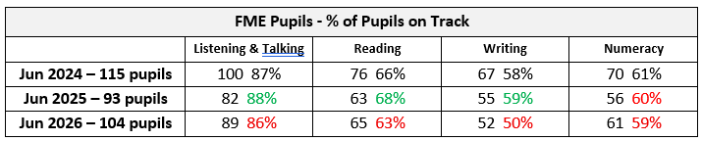

- Attainment compared to Family Group Average is lower in all areas: by 1% in Listening & Talking; by 7% in Reading, by 10% in Writing and by 8% in Numeracy.
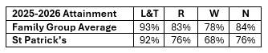

Overall, attainment has declined this year, apart from in Listening & Talking, where it has remained the same. Overall, learning and teaching observations and learning walk rounds continue to show practice ranging from good to very good, yet this is not translating to improved attainment. The number of children behind expectation who are making a year’s progress has increased. The number of children beyond expectation has increased. However, the nationally expected levels of attainment have fallen, and attainment is now further behind our Family Group. There has been an increased focus on assessment information. Going forward, consideration should be given to how these assessments contribute to Teachers’ Professional Judgements of achievement of a level.
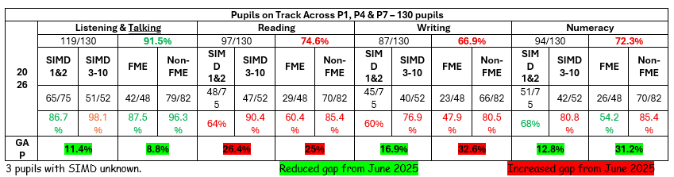
Next steps
- Engage in Education Scotland’s National Improving Writing Programme (Cohort 2) to improve practice in learning, teaching and assessment of writing.
- Engage in Reflective Reading training to improve practice in learning, teaching and assessment of reading comprehension.
- Improve quality-first learning and teaching in Reading and Writing.
- Review additional support provision to ensure appropriate targeting in Reading and Writing.
- Be more responsive to adapting support throughout the year.
- Enhance moderation to improve practice in learning, teaching and assessment ie differentiation and assessment of achievement of a level.
- Develop Dialogic Teaching practice further to improve children’s language of learning and metacognitive skills to raise expectations and attainment.
- QAMSO to lead self-evaluation in practice of moderation for teaching staff.
- Learning Walks as a standing item at Teaching Staff Meetings. Everyone to contribute to quadrant: What we saw, What we heard, What we’d like to see more of, What we’d like to hear more of.

School Priority 2: Pull to School
Placing the human rights and needs of every child and young person at the centre of education
Improvements in attainment, particularly in literacy and numeracy
Closing the attainment gap between the most and least disadvantaged children and young people
Improvement in skills and sustained, positive school-leaver destinations for all young people
National Improvement Framework Outcomes  1. Empowered and accountable education system supporting lifelong learning.  2. Strong partnerships between schools, services, families, and communities.  3. Inclusive curriculum and assessment for a sustainable future.  4. High achievement and reduced attainment gap for all learners.  5. Skilled teachers and leaders delivering excellent, inclusive education.  6. Positive relationships, behaviour, and attendance in a respectful culture.  7. Digital technology enhancing learning and tackling digital inequality. | How Good is Our School? 4 QIs  1.2 Leadership of learning  1.3 Leadership of change  2.2 Curriculum  2.3 Learning, teaching and assessment  3.1 Ensuring wellbeing, equality and inclusion  3.2 Raising attainment and achievement  3.3 Increasing creativity and employability | UNCRC  Article 12 (Respect for the views of the child):  Article 13 (Freedom of expression):  Article 28: (Right to education):  Article 29 (Goals of education):  Article 31 (Leisure, play and culture): | Developing in Faith  Promoting Gospel values  Serving the common good
Outcomes:
- By June 2026, overall whole school attendance will increase to 94.6% at least.
- By June 2026, attendance rate for children living in SIMD 1&2 will increase to 94%.
- By June 2026, there will be a 5% increase in >90% attendance for children who are FME.
- By June 2026, there will be a reduction of 5% in the number of pupils with >5 instances of late-coming across the school.
- By June 2026, there will be a reduction of 6% in the number of pupils with >5 instances of late-coming who live in SIMD 1&2.
- By June 2026, there will be a reduction of 6% in the number of pupils with >5 instances of late-coming who are FME.

PEF used to support closing the gap:
- Teacher (1.0) to release PT and DHT to engage with children and families in bespoke ways to encourage attendance and punctuality. £64,446.29.
- Enhance learning experiences with workshops and trips – cost of the school day. £3,143.17.

Progress and impact of outcomes for learners:
- Whole school attendance remained at 94%. 0.6 lower than target.
- Attendance rate for children living in SIMD 1&2 was 93%. This is a decrease of 0.1% on last year. This is less of a decrease than for children living in SIMD 3-10. It is, however, 1% short of the 94% target set.
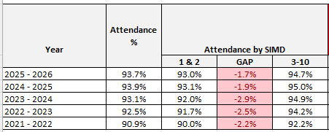

- There has been a 5% increase in >90% attendance for children who are FME. Target achieved.
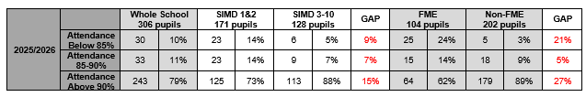
- There has been an increase of 7% in the number of pupils with >5 instances of late-coming across the school. Target not achieved.
- There has been a reduction of 3% in the number of pupils with >5 instances of late-coming who live in SIMD 1&2. Target of 6% not achieved, but a reduction, nevertheless.
- There has been a reduction of 1% in the number of pupils with >5 instances of late-coming who are FME. Target of 6% not achieved, but a reduction, nevertheless.
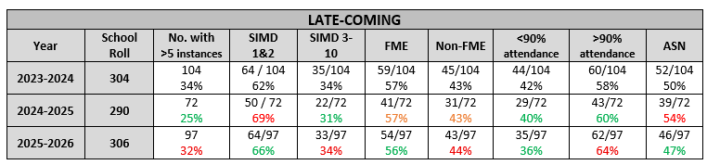

Overall, attendance has decreased by 0.2%. The gap between SIMD 1&2 and 3-10 has narrowed but attendance of SIMD 3-10 pupils has decreased by 0.3%, rather than improvements for SIMD 1&2. Attendance continues to be above the Family Group average (0.6% higher as of 19th June 26). Attendance continues to be above Inverclyde Primary Schools’ average (0.8% higher).
Next steps
- Improve “Pull to School” offer
  - enhanced curriculum offer – Digital Music project
  - improved pupil contribution and participation in the life of the school through leadership development – review areas of responsibility for new classes.
  - outdoor education – Explorers Awards – class leadership responsibility.
  - Enhance partnership with 32nd Scouts
- Ask Pupil Council to lead an Improve Attendance and Reduce Late-coming Fact, Story, Action project.
- Continue with robust attendance management procedures and use of SLT to provide bespoke adaptations as necessary to gain improvements.
- Adapt start of year attendance management procedures to highlight and target 25-26 low attendance from the beginning of 26-27.
- Parental Engagement – mini-inductions to support better understanding of school ethos and policies - SLT before Visit the Class sessions in September.
- Improve communication of learning and achievements to parents/carers.

School Priority 3: Health & Wellbeing
Placing the human rights and needs of every child and young person at the centre of education
Improvement in children and young people's health and wellbeing
National Improvement Framework Outcomes  1. Empowered and accountable education system supporting lifelong learning.  2. Strong partnerships between schools, services, families, and communities.  3. Inclusive curriculum and assessment for a sustainable future.  4. High achievement and reduced attainment gap for all learners.  5. Skilled teachers and leaders delivering excellent, inclusive education.  6. Positive relationships, behaviour, and attendance in a respectful culture.  7. Digital technology enhancing learning and tackling digital inequality. | How Good is Our School? 4 QIs  1.2 Leadership of learning  2.2 Curriculum  3.1 Ensuring wellbeing, equality and inclusion  3.2 Raising attainment and achievement  3.3 Increasing creativity and employability | UNCRC  Article 6 (Survival and development):  Article 12 (Respect for the views of the child):  Article 28: (Right to education):  Article 29 (Goals of education):  Article 42 (Knowledge of rights): | Developing in Faith  Honouring Jesus Christ as the Way, the Truth and the Life  Developing as a community of faith and learning  Serving the common good
Outcomes:
- By December 2025, Glasgow Motivation & Wellbeing Profile will show an increase of at least 4% to 84% in scores of 8-10 for Affiliation, Agency, Autonomy and Healthy & Safe, and a reduction of at least 2% to 3% in scores of 1-3.
- By May 2026, each of the P4-P7 classes, and specific Pupil Voice groups, will have evaluated their impact positively on school improvement, using bespoke Action Plans, Learner Participation Arena or Wee HGIOurS? theme.

PEF used to support closing the gap:
Enhance learning experiences with workshops and pupil visits - £3,143.17.

Progress and impact of outcomes for learners:
- Sustained high and increased results from the Glasgow Motivation & Wellbeing Profile show that our children continue to feel nurtured, included, safe and respected. More children scored 8-10 and 4-7, with less scoring 1-3, compared with last year.

- All classes from P4-P7 created Action Plans for their area of leadership. Progress was made within each Action Plan in all classes. Missio Bronze Award achieved. Sport Scotland submission to renew Gold Award completed and awaiting feedback. Reading Schools Award – silver submission feedback that some additional details required for re-submission in September.
Next steps
- Continue to use GM&WP to monitor children’s wellbeing across the school.
- Continue to use GM&WP to monitor individual children’s needs and respond appropriately.
- Review Learner Participation areas of responsibility to enhance class leadership and pupil contribution – use 25-26 Action Plans as catalyst.
- Simplify Vision and Aims – review with children.
- Recently reviewed Supporting Children with Healthcare Needs Policy to be used to audit and improve practice and procedures.

Additional PEF Spend
Closing the attainment gap between the most and least disadvantaged children and young people
NIF Driver  Closing the attainment gap between the most and least disadvantaged children and young people | HGIOS QIs  2.3 Learning, teaching and assessment  3.1 Ensuring wellbeing, equality and inclusion  3.2 Raising attainment and achievement | UNCRC  Article 28: (Right to education):  Article 29 (Goals of education): | Developing in Faith  Serving the common good  Developing as a community of faith and learning
Spend:
- £2,310 spent on additional teaching staff to preserve the original use of the planned spend on the 1.0 Teacher.

Progress and impact of outcomes for learners:
- Almost all teaching staff visited a neighbouring school to observe Dialogic Teaching and other practice worth observing (school received 4 gradings of excellent by HMIE).
- Better continuity for 3 classes impacted by teacher absence.
Next Steps:
Planned spend for next year’s PEF to include:
- Additional teaching staff to ensure continued coaching, modelling and targeted support.
- Resources to support learning, teaching and assessment in literacy and numeracy, but also across the curriculum to ensure pull to school and equitable access to materials.

Data
Key Strengths of the School:

- There continue to be no exclusions in St Patrick’s. Staff are committed to practising nurturing, inclusive, trauma-informed and responsive approaches.
- Attendance is higher than the Inverclyde average and Family Group average.
- Improvement in the number of children who are Behind Expectation but are making a year’s progress within 25-26.
- An increased number of pupils attaining Beyond Expectation across Literacy and Numeracy.
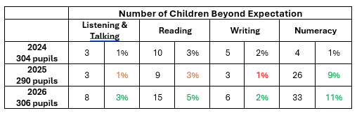

- Our long-term data shows that children feel safe in our school. They feel they belong, that they are connected and that they contribute. This data remains high each year. This data is reflected in individual check-ins for TAC Meetings.

Key Priorities for the School:
- Raise attainment in Reading, Writing and Numeracy, with a particular focus on Reading and Writing.
- Address the barriers to learning that prevent attainment in Reading, Writing and Numeracy.
- Continue to strive to close the poverty related attainment gap.
- Increase number of children who make more than a year’s progress if they are behind expectation.
- Increase number of children who attain beyond expectation.

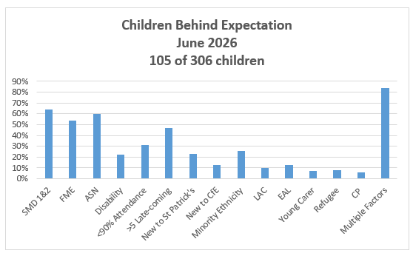

National Improvement Framework Quality Indicators
1.3 Leadership of change
Very Good
Key Strengths of the School:
- There is a very strong sense of community in St Patrick’s Primary, where all staff care deeply about the children in their care.
- The high-quality work promoting a shared approach to developing positive relationships translates the vision, values and aims into reality. Interactions are underpinned by these shared values.
- The senior leadership team provide clear strategic direction with clear expectations, communicating highly effectively with staff.
- There are effective processes in place to monitor and evaluate the impact of changes on outcomes for learners.
- High quality professional and collegiate working is evident across the school with the majority of staff leading improvement priorities.
- The school improvement planning cycle enables Career Long Professional Learning (CLPL) opportunities to align with whole school improvement priorities.
Key Priorities for the School:
- Further enhance opportunities for all members of the school community to contribute to the quality assurance process systematically eg Learning Walks, Focus Groups…
- Continue to empower staff to lead improvement priorities, particularly around the refreshed curriculum (content, pedagogy and assessment).
- More rigour to further develop the monitoring of progress of School Improvement priorities within existing Quality Assurance approaches.

2.3 Learning, teaching and assessment
Good
Key Strengths of the School:
- The welcoming, nurturing and supportive ethos, permeated by gospel values, is evidenced by a calm learning environment with happy and respectful children.
- A clear vision alongside expectations of high-quality teaching and learning. Children can verbalise that they are ‘ambitious to achieve’ and know what this means.
- Robust and effective tracking systems which identify where children are in their learning journey, which are used to identify and plan appropriate personalised support.
- A good range of opportunities for pupils to contribute to the wider life of the school.
- The effective deployment and skills of Pupil Support Assistants which ensures identified children receive appropriate support.
- Assessment evidence is valid and reliable.
- For children facing additional challenges, assessment is modified to match learning needs and promote progress.
- Improvements identified by teaching staff in all aspects of the Learning, Teaching & Assessment cycle during self-evaluation activities. Observable in lessons.
Key Priorities for the School:
- Develop a wider range of appropriate evidence which demonstrates greater breadth, challenge and application. This will be included in Cluster Moderation and school-level moderation.
- Further enhance dialogic teaching to ensure learners are equipped to be fully involved in the learning process, including target-setting and evaluating their progress.
- Fully embed The St Patrick’s Way in learning, teaching and assessment across whole school, including new staff.
- Continue to reflect as a staff team on various pedagogical approaches to offer more challenge to learners.
- Improved implementation of planning for the Four Contexts for Learning.
- Improve parental knowledge and understanding of learning and achievement.

3.1 Ensuring wellbeing, equity and inclusion
Very Good
Key Strengths of the School:
- The culture and ethos of the school is built upon positive, nurturing relationships. Children are able to articulate that they feel safe, valued and respected.
- The responsive approaches by Senior Leaders (SLT) ensure that children’s needs are met effectively. Robust systems for tracking attainment and monitoring wellbeing are in place.
- Collaboration with partners has created provision which meets the diverse range of children’s needs.
- Partners feel connected and welcome in St Patrick’s; they have a very positive impact on children’s lives.
- Pupil Voice is valued and has been incorporated into the planning of a range of learning experiences. Children are able to articulate the child centred approach evident within the school and acknowledge the range of supports in place and the difference they make.
- We are committed to Keeping the Promise for our care experienced children.
- DHT and HT attended Signs of Safety and Healing Training, and implement practices.
- Promoting Positive Relationships Policy – in use and document shared.
- School Child Protection Policy completed – in use and document shared.
- School Anti-bullying Policy – in use and document shared.
Key Priorities for the School:
- Embed Trauma Responsive practice across the school.
- Ensure greater diversity within curriculum. Staff will be supported by Equalities Co-ordinator.
- Continue to strengthen children’s confidence and ability to challenge all aspects of discrimination and intolerance.
- Fully implement Supporting Children with Healthcare Needs Policy.
- Create Equalities Policy.
- Further celebrate the diversity within our school community.

3.2 Raising attainment and achievement
Good
Key Strengths of the School:
- Attainment levels in literacy and numeracy are a central feature of the school’s priorities for improvement and a clear, robust and achievable plan is in place to raise attainment.
- SLT and staff regularly collaborate, using a robust process, to ensure a shared knowledge and understanding of every child’s learning journey across literacy, numeracy and health & wellbeing.
- Inclusion and support mechanisms are clearly in place to provide all children with the equitable opportunities for success academically, socially and emotionally.
- Effective systems are in place to record success and achievement in the wider life of the school and community and SLT ensure that all children are given the opportunity to experience this.
- An effective plan is in place to ensure PEF provides equity of opportunity for the most deprived and the poverty related attainment gap is narrowed.
Key Priorities for the School:
- Implement plans to increase levels of attainment in literacy and numeracy.
- Engage in Reflective Reading training to improve reading comprehension.
- Engage with Education Scotland Improving Writing Project (Cohort 2).
- For children who are behind expectation in learning, move to “Fact, Story, Action” model to improve experiences and outcomes.

Other quality indictors evaluated from 3 year plan
1.1 Self-evaluation for self-improvement
1.2 Leadership of learning
2.1 Safeguarding and child protection
2.2 Curriculum
2.4 Personalised support
3.3 Increasing creativity and employability
Key Strengths of the School:
- The pride in and commitment of all stakeholders to the values and ethos of the school. These are deeply understood and lived by all staff promoted by the clear leadership of the Senior Leadership Team.
- The happy, well-mannered children who are confident in talking about their learning both within the classroom and throughout the school in leadership roles.
- The leadership capacity of the school, which has ensured that recent changes to roles have not had a detrimental effect on the overall capacity to improve and reflect the highly effective teamwork and commitment of the whole staff team.
- The inclusive ethos of the school, including the actions being taken to ensure that the curriculum and pedagogy being employed are representative and reflective of all.
- The rigour of Additional Support Needs procedures which prioritises achieving positive outcomes for all through a broad range of creative approaches to address barriers to learning.
- Cluster moderation focus on anti-racism and equalities in developing progressive planning for learning using novels.
Key Priorities for the School:
- Continue to further develop the strong capacity of distributed leadership at all levels to drive forward the priorities in the school improvement plan.
- Further develop a fuller curriculum offer to all pupils.
- In line with the curriculum development work planned, utilise staff commitment and expertise to lead the development of more creative approaches to learning and teaching thus ensuring that pupils lead more of their own learning.
- Use Curriculum Rationale Review results to launch improved Curriculum Rationale.
- Continue to adapt offers based on participation levels of children impacted by poverty.

Key Achievements of the School
We are proud of the achievements of our pupils and school community throughout 2025-26, including:
- We achieved The Promise Award by completing staff training and committing to the 5 Foundations of The Promise ie Voice, Family, Care, People and Scaffolding.
- A hugely successful Kids in Sports Day in partnership with Learn to Lead Tennis with Miss-Hits and E.ON. Our P5s were: trained by Judy Murray OBE in an Active Tennis workshop; engaged in a STEM & Sustainability challenge; trained in Sports First Aid; and explored Media Presenting Skills.
- Our P7 girls, as part of the Learn to Lead Tennis with Miss-Hits, successfully coached our younger girls in active tennis sessions at lunch time. They enjoyed a celebration together when sessions were complete, reflecting on all they had achieved as leaders and participants.
- Improved pupil leadership opportunities within the school at every stage.
- Strong partnership working with our School Chaplain, Fr Gerry, and St Patrick’s Parish, as well as our Diocesan Team:
  - We pulled together as a family to support our children, and staff, when one of our PSAs died quite unexpectedly. Fr Gerry led us in a Prayer Service to celebrate her life, remember her and to pray for the repose of her soul.
  - Day of Pilgrimage
    - The whole school attended a Day of Pilgrimage in Paisley to celebrate the end of the Year of Hope. We visited Paisley Abbey and processed to St Mirin’s Cathedral.
  - Our Missio Group visited a nearby residence for the elderly to engage in real-life community outreach.
  - Opportunities for our children to engage in reflection, penance and reconciliation during Advent and Lent.
  - Our P5-P7 pupils led the school community in Advent Reflections and Lenten Reflections each Friday of Advent and Lent.
  - Our P7 pupils led us in the Rosary at assemblies in May.
  - P4 developed their singing, working with the Diocesan Choral Director. Choir ongoing for P5-P6 children. They even sang at the Parish Sunday Mass for the Feast of Copus Christi.
  - Our Choir visited nearby residences for the elderly to spread some Christmas cheer.
- Charitable contributions raised by children:
  - Our P7 pupils organised and hosted a Fun Day for the whole school, raising £258.46 for the Bishop’s Fund as part of their preparation for Confirmation.
  - P4 Mini Vinnies hosted a Coffee Morning in the Church Hall after Mass and raised £505.58 for SVdP.
- Our strong partnership with Active Schools meant continued high levels of participation in activities and sports for all our children, including those impacted by poverty:
  - 92% of school roll participated in lunch or afterschool sport & physical activity. That’s an increase of 4% on last year.
  - 53% of that number are children who live in areas defined as SIMD 1&2 (a 1% increase on last year).
  - All ages and stages had opportunity of either lunch-time or after-school club
- Further enhancement of the music curriculum from Inverclyde Music Services:
  - Our school choir and vocal instruction groups, as well as our strings and brass groups contributed to the NDHS Cluster Concert and the Inverclyde Festival.
  - Lots of parents/carers gave us suggestions of different genres of music and we had a daily Listening Party in each class to develop our appreciation of music.
- Transition and Induction arrangements encouraged smooth preparations for our infants and upper school pupils
  - Partnership working with 11 Early Years’ Establishments to ensure smooth transitions for our 33 new P1s.
  - Partnership working with NDHS and St Columba’s High School to ensure smooth transitions for our 48 P7s.
  - Buddying programme was successfully implemented. Feedback from new parents/carers was positive.
- Celebration of wider achievements continues to motivate children:
  - Magical Moments – increased parental and pupil interest. Celebrated feature of weekly assemblies.
  - Showcase Our Values – celebrated feature of weekly assemblies.
- Successful Partnership working
  - Wellpark Children’s Centre continues to be an excellent partner as we improve practice and opportunities for our infants and senior children.
  - Barnardo’s Family Support targeted group work eg Girls Empowering Minds and Seasons for Growth
  - Educational Psychologist supported school priorities of Trauma-informed Practice, Personalised Support approaches and Buddying Recruitment process.
  - 32nd Scout Group supported our transport needs to a variety of events as well as collaborating with us to enhance our community events.
  - A new partnership for us this year was with The Anchor, who delivered the Beyond the Pitch programme to 8 of our P7 boys. This has led to further plans for next year too.

