

St Patrick’s Primary School
Standards and Quality 2024-2025
Context of the School
St Patrick’s Primary is a denominational primary school (Roman Catholic), which serves the centre of Greenock, providing education for pupils from P1 to P7. Our building opened in November 2016 and is a bright, stimulating environment for children to learn. Features make the most of natural light and the stunning views over the River Clyde. We have 12 classrooms, a PE hall, a library area, a dining area, 3 playground areas and daily access to the adjacent 3G football pitch owned by Inverclyde Leisure.
In 2024-25 we had 290 pupils over 11 classes, 3 of which were composite. Continuing the trend from previous years, our school roll stayed high but continued to fluctuate throughout the year, as new children arrived and some left. 27 new pupils enrolled in our school, and 19 pupils left our school, between August 24 and May 25. A fifth (20%) of our pupils did not begin their Primary education with us in Primary 1. 55% of our pupils lived in areas defined as SIMD 1&2 (Scottish Index of Multiple Deprivation). 32% of our pupils were Free Meal Entitled. 33% of our pupils had an additional support for learning need. 5% of our pupils had English as an Additional Language (EAL). 16% of our children were new to Curriculum for Excellence. 21% of our children have a minority ethnicity. Our overall attendance was 94%: an increase of 0.4% on last year, and higher than the Inverclyde average and in line with the Family Group average.
15.1 teachers were allocated to the school but using the Pupil Equity Fund, teaching allocation became 16.1. The Senior Leadership Team comprised the Head Teacher, one Depute Head Teacher (0.6 + Acting 0.4) and a Principal Teacher (0.6 + Acting 0.4). 13 Pupil Support Assistants (8 of whom were part-time), 2 Clerical Assistants and a Janitor also supported the school.
Our Vision
In St Patrick’s we strive to provide a secure, happy, caring school in which children are nurtured and enabled to achieve their full potential through effective learning and teaching experiences of the highest quality.
Our Motto
Our motto, inspired by our Patron Saint, St Patrick; Christ be beside me in all I say, all I do and all I am.
Our Values
Members of St Patrick’s Primary School community have Kindness at the heart of all we do, and are guided by the 3 Rs; Respect, Rights and Responsibility; and the 2 As; we are Ambitious to Achieve.
Our Aims
- To foster an open, welcoming and caring school in which all children are safe, healthy, achieving, nurtured, active, respected, responsible and included.
- To nurture successful learners by providing all pupils with the best opportunities to achieve their full potential and prepare them for a life of learning.
- To inspire responsible citizens who develop positive attitudes to serve the common good, promote social justice and opportunity for all.
- To form confident individuals with a self-belief and passion for using their God given talents to pursue excellence for themselves and others.
- To encourage effective contributors with enterprising attitudes, resilience and independent skills capable of positively impacting the communities in which they live.
- To develop as a community of faith, promoting Gospel values and respecting the dignity of all God’s children.

School Priority 1: Learning, Teaching and Assessment
Improvements in attainment, particularly in literacy and numeracy
Closing the attainment gap between the most and least disadvantaged children and young people
NIF Driver  Teacher professionalism  Assessment of children's progress  Parental engagement  School Improvement | HGIOS QIs  1.1 Self-evaluation for self-improvement  2.3 Learning, teaching and assessment  3.1 Ensuring wellbeing, equality and inclusion  3.2 Raising attainment and achievement | UNCRC  Article 28: (Right to education):  Article 29 (Goals of education): | Developing in Faith  Serving the common good  Developing as a community of faith and learning
Outcomes:
- By June 2025, attainment in Literacy and Numeracy across the school will have increased: by 2% in Reading to 80%; by 4% in Writing to 76%, and; by 4% in Numeracy to 81%.
- By June 2025, most children (75%-90%) who are Behind Expectation in Literacy and Numeracy, will make a year’s progress for a year’s teaching.
- By June 2025, attainment in Literacy and Numeracy for pupils who live in SIMD 1&2 will have increased: by 2% in Reading to 77%; by 8% in Writing to 76%, and; by 3% in Numeracy to 76%.
- By June 2025, attainment in Literacy and Numeracy for pupils who are FME will have increased: by 2% in Reading to 68%; by 4% in Writing to 62%, and; by 4% in Numeracy to 65%.

PEF used to support closing the gap:
- Teacher (1.0) to release PTs to model and coach high quality-first learning and teaching in Reading, Writing and Numeracy, and to release staff to visit other establishments to observe high quality learning and teaching - £59,830.60
- Resources to enhance learning and teaching in literacy and numeracy - £6,437.54

Progress and impact of outcomes for learners:
- Most children were On Track in Reading (79%). This was an increase of 1% on last year, but 1% short of our 80% target. The majority of our children were On Track in Writing (72%). This was the same figure as last year, and 4% short of our 76% target. Most children were On Track in Numeracy (78%). This was an increase of 1% on last year, but 3% short of our 81% target. Although targets were not achieved, attainment increased or remained stable. This is reassuring given the change we experienced in school roll; 9% of our roll are children who are new to us in 24-25, and 7% of our school roll left us in 24-25. The use of PEF to fund teaching staff meant that most teachers were able to visit another school to observe effective practice in improving reading and writing. The use of PEF to fund teaching staff also meant that the PT was able to coach and model effective practice in numeracy, and establish the use of Learning Sprints with all teachers working with P2-P7.
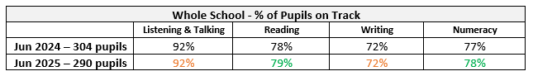

- Of the children who were Behind Expectation in Literacy and Numeracy, around a third, or more, made a year’s progress in 24-25. 50% made a year’s progress in Listening & Talking; 31% in Reading; 32% in Writing; and 48% in Numeracy. The use of PEF to fund teaching staff meant that planned interventions were implemented. PEF also funded appropriate resources for teachers to use to more effectively support children.
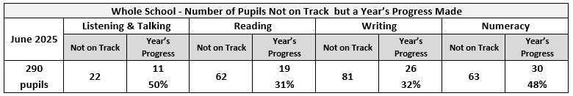

- Attainment of pupils who live in SIMD 1&2 has remained stable in Numeracy (73%), but has decreased in Literacy; 73% in Reading (a decrease of 2%), and 65% in Writing (a decrease of 3%). It is reassuring that attainment has remained stable, given the change we experience in school roll. However, almost half (49%) of children who live in SIMD 1&2 have issues with attendance and/or late-coming. This means that planned interventions can be missed, as well as core learning.
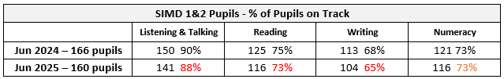

- Attainment of pupils who are FME has increased in all areas of Literacy. In Reading 68% were On Track (an increase of 2%). In Writing 59% were On Track (an increase of 1%). The target set was achieved in Reading but missed by 3% in Writing. In Numeracy the 4% target was missed by 3% as 60% of children who are FME achieved On Track. Almost two-thirds (63%) of children who are FME have issues with attendance and/or late-coming. This means that planned interventions can be missed, as well as core learning.
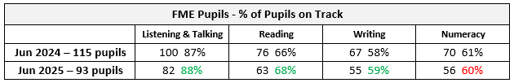

Next steps
- Enhance learning, teaching and assessment to ensure quality-first provision, with a particular focus on Writing.
- Target appropriately to increase attainment in Reading, Writing and Numeracy, for children who are behind national expectation.
- Improve attendance and decrease late-coming to ensure children have full entitlement to education realised.
- Continue to engage with partners to support parents/carers to improve attendance and decrease late-coming eg Whole Family Wellbeing Hub, Barnardo’s and Social Work Services.
- Review additional support provision to ensure appropriate targeting.

School Priority 2: Pull to School
Placing the human rights and needs of every child and young person at the centre of education
Improvements in attainment, particularly in literacy and numeracy
Closing the attainment gap between the most and least disadvantaged children and young people
Improvement in skills and sustained, positive school-leaver destinations for all young people
NIF Driver  Teacher professionalism  Assessment of children's progress  School Improvement | HGIOS QIs  1.2 Leadership of learning  1.3 Leadership of change  2.2 Curriculum  2.3 Learning, teaching and assessment  3.1 Ensuring wellbeing, equality and inclusion  3.3 Increasing creativity and employability | UNCRC  Article 12 (Respect for the views of the child):  Article 13 (Freedom of expression):  Article 28: (Right to education):  Article 29 (Goals of education): | Developing in Faith  Promoting Gospel values  Serving the common good
Outcomes:
- By June 2025, overall whole school attendance will increase to 94% at least.
- By June 2025, attendance rate for children living in SIMD 1&2 will increase to 94%.
- By June 2025, there will be a 6% increase in >90% attendance for children who are FME.
- By June 2025, there will be a reduction of 10% in the number of pupils with >5 instances of late-coming across the school.
- By June 2025, there will be a reduction of 6% in the number of pupils with >5 instances of late-coming who live in SIMD 1&2.
- By June 2025, there will be a reduction of 6% in the number of pupils with >5 instances of late-coming who are FME.

PEF used to support closing the gap:
- Extend / Enhance pupils’ experiences through trips and workshops - £2,933

Progress and impact of outcomes for learners:
- Whole school attendance increased to 94%; an increase of 0.4% on last year. Outcome achieved.
- Attendance rate for children living in SIMD 1&2 was 93%. This is an increase of 1.1% on last year. This is a greater increase than for children living in SIMD 3-10 (1% of a positive difference). It is, however, 1% short of the 94% target set. The use of PEF to fund teaching staff, allowed SLT availability to support parents/carers around improving attendance.
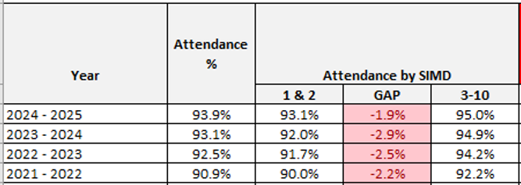

- 57% of children who are FME have >90% attendance. This is an improvement on last year’s figures of 5%, 1% short of the 6% increase planned for. The use of PEF to fund teaching staff, allowed SLT availability to support parents/carers around improving attendance.
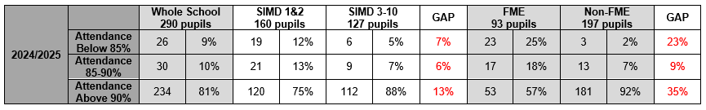

- There has been a reduction of 9% in the number of pupils with >5 instances of late-coming across the school. This is 1% short of the 10% target set.
- There has been an increase of 7% to 69% in the number of pupils with >5 instances of late-coming who live in SIMD 1&2. Outcome not achieved.
- The number of pupils with >5 instances of late-coming who are FME has stayed the same. Outcome not achieved.
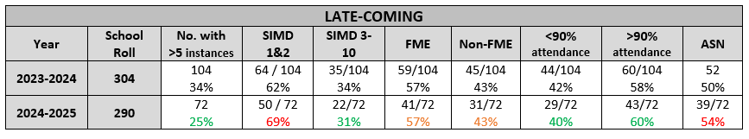

Overall, attendance has improved. It has also improved for children living in SIMD 1&2. Instances of late-coming have decreased overall too. Children living in SIMD 1&2 have improved attendance from last year (a 5% decrease in <90% attendance, and a 5% increase in >90% for SIMD 1&2). Children who are FME also have improved attendance from last year (a 5% decrease in <90% attendance, and a 5% increase in >90% for FME). The gap between SIMD 1&2 and SIMD 3-10 in attendance has remained the same but there’s a 6% reduction in the gap between FME and non-FME of <90% attendance, and a 2% reduction in the gap for >90% attendance. The use of the PEF teacher to allow SLT time to work with parents/carers around decreasing late-coming and improving attendance, has had a positive impact.
Next steps
- Focus staffing, resources and PEF budget on making the everyday, school day more of a pull eg curriculum offer, after-school clubs, lunch-time clubs.
- Consult children about how to improve attendance and reduce late-coming.
- Develop Fact, Story, Action model.
- Continue with robust attendance management procedures and use of SLT to provide bespoke adaptations as necessary to sustain improvements.

School Priority 3: Health & Wellbeing
Placing the human rights and needs of every child and young person at the centre of education
Improvement in children and young people's health and wellbeing
NIF Driver  Teacher professionalism  Assessment of children's progress  School Improvement  Parental engagement | HGIOS QIs  2.2 Curriculum  3.2 Raising attainment and achievement  3.1 Ensuring wellbeing, equality and inclusion | UNCRC  Article 28: (Right to education):  Article 29 (Goals of education):  Article 6 (Survival and development):  Article 42 (Knowledge of rights): | Developing in Faith  Developing as a community of faith and learning  Serving the common good
Outcomes:
- By December 2024, Glasgow Motivation & Wellbeing Profile will show an increase in Affiliation, Agency, Autonomy and Healthy & Safe scores 8-10 from last session.
- By May 2025, each class will have evaluated their impact on school improvement using their Action Plans, Learner Participation Arena or Wee HGIOurS? theme (Action Plans to be created).

PEF used to support closing the gap:
N/A

Progress and impact of outcomes for learners:
- Sustained high results from the Glasgow Motivation & Wellbeing Profile show that our children continue to feel nurtured, included, safe and respected. More children scored 8-10 and 4-7, with less scoring 1-3, compared with last year.
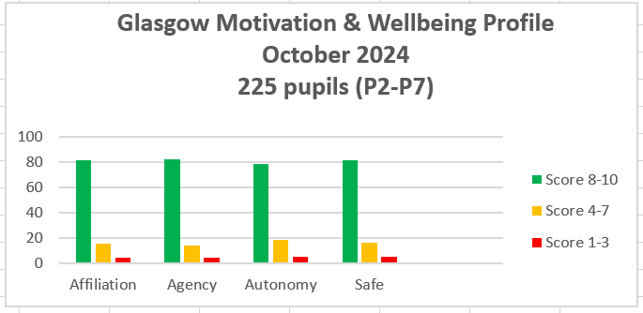

- All classes from P4-P7 created Action Plans for their area of leadership. Progress was made within each Action Plan in all classes, with P4 overcoming all of their Action Plan points. Staff absence in some classes impacted the progress of implementing the Action Plans.
Next steps
- Continue to use GM&WP to monitor children’s wellbeing across the school.
- Continue to use GM&WP to monitor individual children’s needs and respond appropriately.
- Continue to promote Learner Participation through class leadership of aspects of school improvement, including P1-P3 – “Little People, Big Voices”.
- Review, refresh and simplify Vision and Aims.
- Ensure Trauma-Responsive Practices are embedded across the school.
- Add question to TAC Meetings as matter of routine to establish views on whether a child could be defined as a Young Carer.

Additional PEF Spend
Closing the attainment gap between the most and least disadvantaged children and young people
NIF Driver  Closing the attainment gap between the most and least disadvantaged children and young people | HGIOS QIs  2.3 Learning, teaching and assessment  3.1 Ensuring wellbeing, equality and inclusion  3.2 Raising attainment and achievement | UNCRC  Article 28: (Right to education):  Article 29 (Goals of education): | Developing in Faith  Serving the common good  Developing as a community of faith and learning
Spend:
- £15,620 spent on additional teaching staff to preserve the original use of the planned spend on the 1.0 Teacher.
- £6,437.54 spent on additional resources to support learning in literacy, numeracy, play, and across the curriculum.

Progress and impact of outcomes for learners:
- 9 teachers were able to visit other establishments to observe effective practice, including visits to:
- Gavinburn Primary School to observe effective practice in the use of Accelerated Reader to improve learning, teaching and assessment in Reading.
- St Ninian’s Primary School to observe effective practice in Writing.
- Wellpark Nursery to observe effective practice in Early Years planning and observation in play.
- Better continuity for 5 classes impacted by significant teacher absence.
- Children had access to resources to target necessary interventions including:
- Development in phonics, including decodable readers.
- Online subscription to Education City to allow teachers to target support in class and at home.
- Access to non-fiction resources to support IDL in class.
- Games and equipment to enhance play in playground.
- Resources to encourage active engagement in learning within classroom.
Next Steps:
Planned spend for next year’s PEF to include:
- Additional teaching staff to ensure continued coaching, modelling and targeted support.
- Resources to support learning, teaching and assessment in literacy and numeracy, but also across the curriculum to ensure pull to school and equitable access to materials.

Data
Key Strengths of the School:

- Attendance is improving overall, for children living in SIMD 1&2 and for those living in SIMD 3-10. The gap in attendance between children living in the most and least deprived areas has narrowed.
- There continue to be no exclusions in St Patrick’s. Staff are committed to practising inclusive approaches.
- Attendance is higher than the national average.
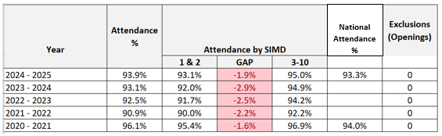

- Attainment across the whole school has been maintained in Listening & Talking and Writing, and improved by 1% in Reading and Numeracy.
- The attainment gap between FME and non-FME has reduced by 2% in Listening & Talking, and by 3% in Reading and Writing on last year’s figures.
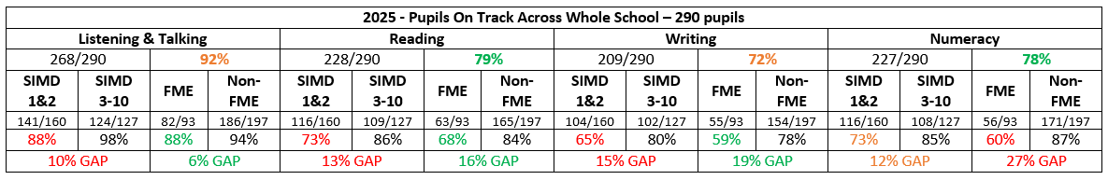

- Achievement of a Level combined at P1, P4 and P7 in the targeted areas of Reading, Writing and Numeracy, has also improved on last year. An increase of 5.1% in Reading, 3.9% in Writing and 1% in Numeracy.
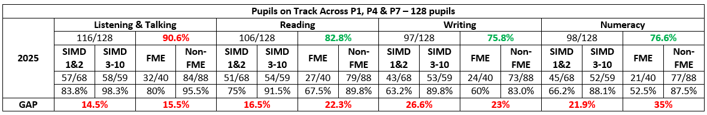
- The number of children who are Beyond Expectation has been maintained in Listening & Talking and Reading. It has increased by 8% in Numeracy.
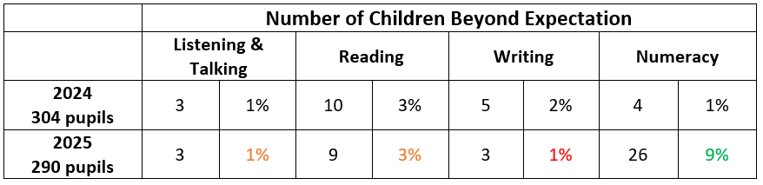

- In P2 and P3, 99% of pupils surveyed said that Learning Sprints helped them get better at Numeracy.
- In P4-P7, 72% of pupils surveyed saw an increase in their confidence with Numeracy because of the Learning Sprints. 86% said Learning Sprints helped them improve in Numeracy.
- In P4-P7, 63% of pupils surveyed saw an increase in their confidence with Reading because of Accelerated Reader. 91% said Accelerated Reader helped them improve in Reading.

- Our long-term data shows that children feel safe in our school. They feel they belong, that they are connected and that they contribute. This data remains high each year. This data is reflected in individual check-ins for TAC Meetings.
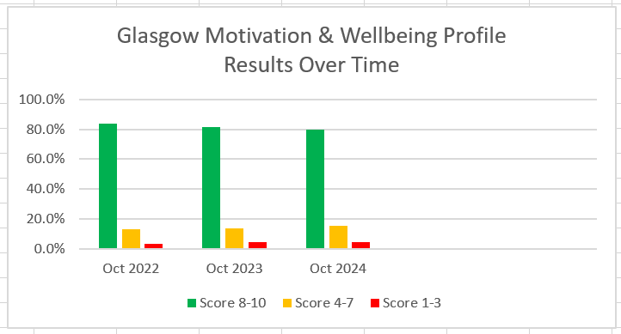

Key Priorities for the School:
- Raise attainment in Reading, Writing and Numeracy, with a particular focus on Writing.
- Address the barriers to learning that prevent attainment in Reading, Writing and Numeracy.
- Continue to strive to close the poverty related attainment gap.
- Further develop the use of Learning Sprints and Accelerated Reader to improve children’s confidence and assessment capabilities in numeracy and reading.
- Increase number of children who make more than a year’s progress if they are behind expectation.
- Increase number of children who attain beyond expectation.

National Improvement Framework Quality Indicators
1.3 Leadership of change
Very Good
Key Strengths of the School:
- There is a very strong sense of community in St Patrick’s Primary, where all staff care deeply about the children in their care.
- The high-quality work promoting a shared approach to developing positive relationships translates the vision, values and aims into reality. Every interaction is underpinned by these shared values.
- The senior leadership team provide very clear strategic direction with very clear expectations, communicating highly effectively with staff. The impact of this very strong leadership is recognised across the cluster, local authority and diocese.
- There are highly effective processes in place to monitor and evaluate the impact of changes on outcomes for learners.
- High quality professional and collegiate working is evident across the school with the majority of staff leading improvement priorities.
- The school improvement planning cycle enables Career Long Professional Learning (CLPL) opportunities to align with whole school improvement priorities.
Key Priorities for the School:
- Further enhance opportunities for all members of the school community to contribute to the quality assurance process systematically.
- Continue to empower staff to lead improvement priorities, particularly around the refreshed curriculum (content, pedagogy and assessment).
- More rigour to further develop the monitoring of progress of School Improvement priorities within existing Quality Assurance approaches.

2.3 Learning, teaching and assessment
Good
Key Strengths of the School:
- The welcoming, nurturing and supportive ethos, permeated by gospel values, is evidenced by a calm learning environment with happy and engaged children.
- A clear vision alongside expectations of high-quality teaching and learning. Children can verbalise that they are ‘ambitious to achieve’ and know what this means.
- Robust and effective tracking systems which identify where children are in their learning journey, which are used to identify and plan appropriate personalised support.
- A good range of opportunities for pupils to contribute to the wider life of the school.
- The highly effective deployment and skills of Pupil Support Assistants which ensures identified children receive appropriate support.
- Assessment evidence is valid and reliable. Assessments are recorded and shared between all staff. Pupils have greater understanding of their achievements and next steps.
- For children facing additional challenges, assessment is modified to match learning needs and promote progress.
- Improvements identified by teaching staff in all aspects of the Learning, Teaching & Assessment cycle during self-evaluation activities. Observable in lessons.
Key Priorities for the School:
- Develop a wider range of appropriate evidence which demonstrates greater breadth, challenge and application. This will be included in Cluster Moderation.
- Revisit dialogic teaching to ensure learners are equipped to be fully involved in the learning process, including target-setting and evaluating their progress.
- Work with newly-agreed model for high quality learning, teaching and assessment to finalise “The St Patrick’s Lesson”.
- Continue to reflect as a staff team on various pedagogical approaches to offer more challenge to learners.
- Improved implementation of planning for the Four Contexts for Learning.
- Launch and promote the “Did You Know…?” series for parents/carers.

3.1 Ensuring wellbeing, equity and inclusion
Very Good
Key Strengths of the School:
- The culture and ethos of the school is built upon positive, nurturing relationships. Children are able to articulate that they feel safe, valued and respected.
- The responsive approaches by Senior Leaders (SLT) ensure that children’s needs are met effectively. Robust systems for tracking attainment and monitoring wellbeing are in place.
- Highly effective collaboration with partners has created provision which meets the diverse range of children’s needs.
- Partners feel connected and welcome in St Patrick’s; they have a very positive impact on children’s lives.
- Whole Family Wellbeing Hub pilot project has had a positive impact on identified families.
- Pupil Voice is valued and has been incorporated into the planning of a range of learning experiences. Children are able to articulate the child centred approach evident within the school and acknowledge the range of supports in place and the difference they make.
Key Priorities for the School:
- Embed Trauma Responsive practice across the school.
- Ensure greater diversity within curriculum. Staff will be supported by Equalities Co-ordinator.
- Continue to strengthen children’s confidence and ability to challenge all aspects of discrimination and intolerance.
- Continue to develop children’s understanding and awareness of wellbeing indicators as an integral feature of school life.
- Launch and promote the “Did You Know…?” series for parents/carers.

3.2 Raising attainment and achievement
Good
Key Strengths of the School:
- Attainment levels in literacy and numeracy are a central feature of the school’s priorities for improvement and a clear, robust and achievable plan is in place to raise attainment.
- Accurate teacher judgements, together with benchmarking and an appropriate range of assessments, are leading to improvements in attainment in literacy and numeracy.
- SLT and staff regularly collaborate, using a robust process, to ensure a shared knowledge and understanding of every child’s learning journey across literacy, numeracy and health & wellbeing.
- Inclusion and support mechanisms are clearly in place to provide all children with the equitable opportunities for success academically, socially and emotionally.
- Effective systems are in place to record success and achievement in the wider life of the school and community and SLT ensure that all children are given the opportunity to experience this.
- An effective plan is in place to ensure PEF provides equity of opportunity for the most deprived and the poverty related attainment gap is narrowed.
Key Priorities for the School:
- Implement plans to increase levels of attainment in literacy and numeracy.
- Further develop the robust tracking system, to ensure continuous progress and attainment for all learners across the totality of the curriculum.
- For children who are behind expectation in learning, move to “Fact, Story, Action” model to improve experiences and outcomes.
- Launch and promote the “Did You Know…?” series for parents/carers.

Other quality indictors evaluated from 3 year plan
1.1 Self-evaluation for self-improvement
1.2 Leadership of learning
2.1 Safeguarding and child protection
2.2 Curriculum
2.4 Personalised support
3.3 Increasing creativity and employability
Key Strengths of the School:
- The pride in and commitment of all stakeholders to the values and ethos of the school. These are deeply understood and lived by all staff promoted by the clear leadership of the Senior Leadership Team.
- The happy, well-mannered and motivated children who are confident in talking about their learning both within the classroom and throughout the school in leadership roles.
- The leadership capacity of the school, which has ensured that recent changes to roles have not had a detrimental effect on the overall capacity to improve and reflect the highly effective teamwork and commitment of the whole staff team.
- The inclusive ethos of the school, including the actions being taken to ensure that the curriculum and pedagogy being employed are representative and reflective of all.
- The rigour of Additional Support Needs procedures which maximises positive outcomes for all through a broad range of creative approaches to address barriers to learning.
- Children and staff benefited from partnership with Learning Through Landscapes to improve outdoor learning experiences and skills development. Training from Kilmacolm Primary School staff motivated staff to explore the benefits of outdoor learning.
- STEM Lead liaised with Primary Science/STEM Development Officer to improve staff awareness of STEM. STEM Lead timetabled to work with classes throughout the school to develop progression in STEM.
Key Priorities for the School:
- Continue to further develop the strong capacity of distributed leadership at all levels to drive forward the priorities in the school improvement plan.
- Further develop a fuller curriculum offer to all pupils, including the commitments already made to developing building racial literacy and anti-racist education.
- In line with the curriculum development work planned, utilise staff commitment and expertise to lead the development of even more creative approaches to learning and teaching thus ensuring that pupils lead more of their own learning with a particular focus on creativity and challenge.
- Use Curriculum Rationale Review results to launch improved Curriculum Rationale.
- Monitor participation levels of children impacted by poverty.

Key Achievements of the School
We are proud of the achievements of our pupils and school community throughout 2024-25, including:
- Papal Nuncio Visit
  - We were very honoured to have been chosen by Bishop John Keenan (Bishop of Paisley Diocese) to welcome the Papal Nuncio to our school to demonstrate the partnership that exists between school, parish Diocese and Authority. Our children greeted His Excellency, Archbishop Miguel Maury Buendía, Apostolic Nuncio to Great Britain, to our school and engaged him in a prayer service which the children led. The Papal Nuncio was very impressed by the partnership working to contribute to the spiritual formation of our children in St Patrick’s.
- Improved pupil leadership opportunities within the school
  - MISSIO – Five Star award completed and application complete.
  - Young Leaders of Learning – Outdoor Learning Charter established and launched with children and families.
  - Pupil Council – consulted with all stakeholders to lead review of the Curriculum Rationale.
  - Junior Road Safety Officers – improved communication with families and encouraged walking to school.
  - P7 – Anti-bullying Charter, Assembly and Launch, as well as visiting classes to teach children about anti-bullying.
- Strong partnership working with our School Chaplain, Fr Gerry, and St Patrick’s Parish, as well as our Diocesan Team:
  - Extensive opportunities to engage in Mass in Church throughout the year, including a special Mass to mark the start of the Jubilee Year of Hope.
  - Our Missio Group visited a nearby residence for the elderly to engage in real-life community outreach.
  - Opportunities for our children to engage in penance and reconciliation during Advent and Lent.
  - Our P5-P7 pupils led the school community in Advent Reflections and Lenten Reflections each Friday of Advent and Lent.
  - P4 developed their singing working with the Diocesan Choral Director and Choir ongoing for P5-P6 children.
  - Our Choir visited nearby residences for the elderly to spread some Christmas cheer.
- Charitable contributions raised by children:
  - Our P7 pupils organised and hosted a Fun Day for the whole school, raising £248 for the Bishop’s Fund as part of their preparation for Confirmation.
  - P4 Mini Vinnies hosted a Coffee Morning in the Church Hall after Mass and raised £645 for SVdP.
- Our strong partnership with Active Schools meant continued high levels of participation in activities and sports for all our children, including those impacted by poverty:
  - 88% of school roll participated in lunch or afterschool sport & physical activity.
  - 52% of that number are children who live in areas defined as SIMD 1&2.
  - All ages and stages had opportunity of either lunch-time or afterschool club
- Further enhancement of the music curriculum from Inverclyde Music Services:
  - P5 engaged in a series of workshops developing their digital musical skills. A grant to extend this to a whole year has been applied for 2025-26.
  - P5 attended drumming workshops thanks to Youth Music Initiative
  - Our school choir and vocal instruction groups, as well as our strings and brass groups contributed to the NDHS Cluster Concert and the Inverclyde Festival.
- Transition and Induction arrangements encouraged smooth preparations for our infants and upper school pupils
  - Partnership working with 10 Early Years’ Establishments to ensure smooth transitions for our 46 new P1s.
  - Partnership working with NDHS, St Columba’s High School and Clydeview Academy to ensure smooth transitions for our 39 P7s.
  - Buddying programme was successfully implemented. Feedback from new parents was positive.
- Improved celebration of wider achievements:
  - Magical Moments – increased parental and pupil interest. Celebrated feature of weekly assemblies.
  - Showcase Our Values – celebrated feature of weekly assemblies.
- Successful Partnership working
  - Wellpark Children’s Centre continues to be an excellent partner as we improve practice and opportunities for our infants and senior children.
  - Barnardo’s Family Support targeted group work eg Girls Empowering Minds and Seasons for Growth
  - Educational Psychologist supported school priorities of Trauma-informed Practice, Personalised Support approaches and Buddying Recruitment process.
  - 32nd Scout Group supported our transport needs to a variety of events as well as collaborating with us to enhance our community events.
  - Whole Family Wellbeing Hub – selected families benefited from inclusion in the WFWH. Support included filial therapy.

