St Patrick’s Primary



Standards & Quality Report
2024-2025
and
School Improvement Plan
2025-2026

Family Edition
September 2025

Vision, Values and Aims of St Patrick’s Primary School

Our Vision
In St Patrick’s we strive to provide a secure, happy, caring school in which children are nurtured and enabled to achieve their full potential through effective learning and teaching experiences of the highest quality.
Our Motto
Our motto is inspired by our Patron Saint, St Patrick; Christ be beside me in all I say, all I do and all I am.
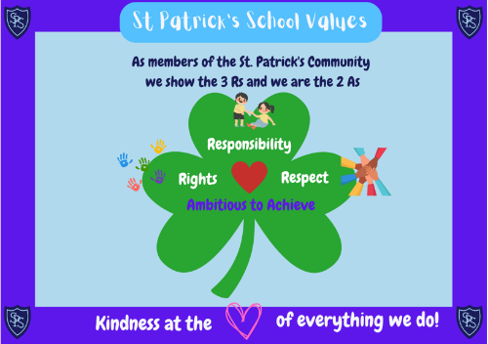
Our Values
Members of St Patrick’s Primary School community have Kindness at the heart of all we do, and are guided by the 3 Rs; Respect, Rights and Responsibility and the 2 As; we are Ambitious to Achieve.

Our Aims
• To foster an open, welcoming and caring school in which all children feel safe, healthy, achieving, nurtured, active, respected, responsible and included.
• To nurture successful learners by providing all pupils with the best opportunities to achieve their full potential and prepare them for a life of learning.
• To inspire responsible citizens who develop positive attitudes to serve the common good and promote social justice and opportunity for all.
• To form confident individuals with a self-belief and passion for using their God given talents to pursue excellence for themselves and others.
• To encourage effective contributors with enterprising attitudes, resilience and independent skills capable of positively impacting on the communities in which they live.
• To develop as a community of faith, promoting Gospel values and respecting the dignity of all God’s children.
Standards and Quality Report 2024-2025
We review our progress with the improvements we planned for 2024-2025. This helps us to plan for further improvement in 2025-2026.

How did we do? Attendance.
Attendance improved, overall. We increased attendance by 0.4% from 23-24.
This is a higher rate than schools similar to us in Inverclyde and higher than the average for all Inverclyde Primary Schools.
Instances of late-coming decreased overall too.
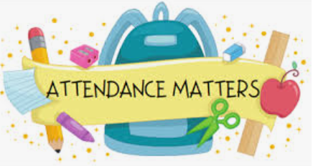

How did we do? Attainment.
Overall, our attainment improved or stayed the same as last year. This is reassuring because we had lots of new children to our school and lots of children who left our school.
We maintained the number of children who were Beyond Expectation in Listening & Talking and in Reading, and increased by 8% in Numeracy.


How did we do? Health & Wellbeing.
Our children gave high scores when they completed the survey we use to tell us how our children are feeling about school.
More children gave higher scores than last year, with less giving lower scores.
This tells us that our children feel safe, healthy, included and valued here at St Patrick’s.
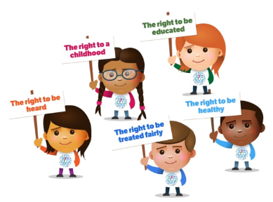

How did we do? Achievement.
Our children really love sharing their achievements at our Magical Moments during our Assemblies.
Parents/Carers have responded really well by emailing us to share their children’s achievements from outside of school.
We started Showcasing our School Values at Assemblies too, and this is going well.


We had many more successes and key achievements. You can read about them in our full Standards and Quality Report for 2024-2025 on the St Patrick’s School Website.
School Improvement Plan 2025-2026
Our Improvement Plan shows what we will work on to improve our school. Having talked to and listened to pupils, staff and our parents/carers, our priorities are:
Priority 1: Learning, Teaching and Assessment
- Continue to focus on learning, teaching and assessment to improve attainment in Reading, Writing and Numeracy.

- Introduce WOW Work Wednesdays and Feedback Fridays so children can tell the Senior Leadership Team all about their learning.

Priority 2: Pull to School
- Continue to refresh our curriculum to make school as engaging as possible.

- Continue to improve Pupil Leadership and Participation across the school so pupils are fully contributing to the life of the school.
- Simplify our Vision and Aims.

Priority 3: Health & Wellbeing
- Launch St Patrick’s Anti-bullying Charter with Parents/Carers.

- All staff to continue with Trauma Informed Practice training.
- Gain Keeping the Promise Award.
- Continue to help children regulate and manage emotions.

These are our main priorities and areas of focus for this year.
The full version of the School Improvement Plan 2025-2026 is on the St Patrick’s School website.

We want our parents/carers to be involved in their children’s learning. We hope to see as many of you as possible in our school over this year. You can keep up-to-date by reading our regular Newsletters that are emailed to you, and by following us on Twitter: @StPatricksPS15

