**St Patrick’s Primary School**



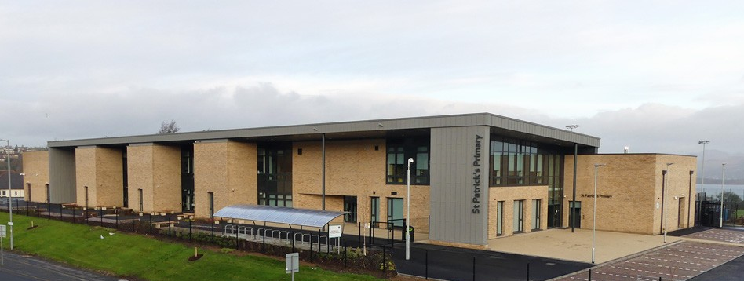

**Handbook**

**Session 2025 / 2026**

WELCOME FROM THE HEAD TEACHER 4

AUTHORITY STRATEGIC STATEMENT 5

ST PATRICK’S VISION, VALUES AND AIMS 6

SCHOOL INFORMATION 7

STAFF 8

SCHOOL CALENDAR 9

THE SCHOOL, THE COMMUNITY AND FAMILY ENGAGEMENT 10

SCHOOL CLUSTER 11

ENROLMENT OF PUPILS TO PRIMARY 1 11

TRANSFER FROM PRIMARY SCHOOL TO SECONDARY SCHOOL 12

SCHOOL IMPROVEMENT AND ACHIEVEMENT 12

CURRICULUM FOR EXCELLENCE 13

EXTRA-CURRICULAR ACTIVITIES 19

ASSESSMENT AND PROGRESS 19

REPORTING TO PARENTS 20

HOMEWORK 20

SUPPORT FOR PUPILS 21

PASTORAL CARE 22

SUPERVISION OF PLAYGROUNDS 23

PROMOTING POSITIVE RELATIONSHIPS AND BEHAVIOUR 23

BASIC SECURITY PRACTICES 23

CLOTHING & UNIFORM 25

MEDICAL AND HEALTH CARE 26

ATTENDANCE AT SCHOOL 26

PARENT FORUM AND PARENT COUNCIL 28

MEALS 29

TRANSPORT 29

INFORMATION IN EMERGENCIES 30

CHILD PROTECTION 30

INCLUSION AND EQUALITY 30

EQUALITIES 31

USEFUL ADDRESSES AND CONTACTS 31

LOCAL COUNCILLORS 32

INVERCLYDE COMPLAINT PROCEDURE 33

GENERAL DATA PROTECTION REGULATION AND DATA PROTECTION ACT 2018 33

**St Patrick’s Primary School**

Broomhill Street

Greenock

PA15 4HL

Telephone: 01475 715696

Email address: office@st-patricks.inverclyde.sch.uk

Website: <https://blogs.glowscotland.org.uk/in/stpatricksprimary/>

X: @StPatricksPS15

Head Teacher: Mrs K Doherty

Depute Head Teacher: Mrs G Ogilby



WELCOME FROM THE HEAD TEACHER

December 2024

Dear Parents and Carers,

Welcome to the St Patrick’s Primary School Handbook. At St Patrick’s Primary we offer you and your child(ren) a warm welcome to the school. Whether you are an existing member of the St Patrick’s community or a prospective parent I hope you find this Handbook informative.

St Patrick’s has a proud tradition as a school very much at the heart of the parish and community and we strive to maintain and develop the finest aspects of this tradition. Our school takes great pride in the warm and welcoming atmosphere, which staff, pupils and parents have worked hard to achieve. We consider ourselves to be an open school; we encourage our parents to be involved in the life of the school and visit us for various events throughout the year. We also encourage parents to contact us directly with any suggestions or concerns.

In St Patrick’s we strive to ensure that, from Primary 1 to Primary 7, our pupils have the best opportunities possible enabling them to fulfil their potential.  We value our strong partnerships with our families and look forward to working with you to continue your child’s learning so we can provide the best experiences, enabling our children to achieve the best possible outcomes.

We strive to keep you up-to-date using email, X and a regular newsletter but should you require further information, or wish to discuss any matter, please contact the school office.

Yours sincerely,

K Doherty

Mrs Kirsteen Doherty

Head Teacher

AUTHORITY STRATEGIC STATEMENT

Building Inverclyde through excellence, ambition and regeneration.

**Goals and Values**

Our Core values are: **Respect**, **Honesty** and **Tolerance**.

Our vision for the children and young people of Inverclyde is that they should be ambitious for themselves and be **successful learners**, **confident individuals**, **responsible citizens** and **effective contributors**.

To achieve our ambition of building Inverclyde through excellence, ambition and regeneration our children must be:

**Safe**: protected from abuse, neglect and harm by others at home, school and in the community.

**Healthy**: enjoy the highest attainable standards of physical and mental health, with access to healthy lifestyles.

**Achieving**: have access to positive learning environments and opportunities to develop their skills, confidence and self-esteem to the fullest potential.

**Nurtured**: educated within a supportive setting.

**Active**: active with opportunities and encouragement to participate in play and recreation including sport.

**Respected** and **responsible**: involved in decisions that affect them, have their voices heard and be encouraged to play an active and responsible role in their communities.

**Included**: have access to high quality services when required and should be assisted to overcome the social, educational, physical, environmental and economic barriers that create inequality.

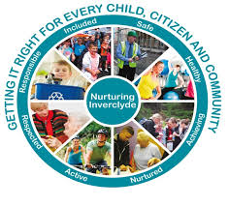

ST PATRICK’S VISION, VALUES AND AIMS

**Our Vision**

In St Patrick’s we strive to provide a secure, happy, caring school in which children are nurtured and enabled to achieve their r full potential through effective learning and teaching experiences of the highest quality. Our motto is inspired by our Patron Saint, St Patrick; ***Christ be beside me in all I say, all I do and all I am.***

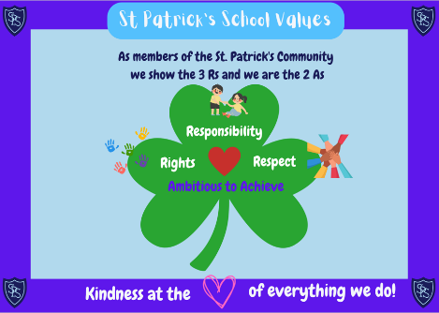

**Our Values**

Members of St Patrick’s Primary School community have **Kindness** at the heart of all we do, and are guided by the 3 **R**s; **Respect**, **Rights** and **Responsibility**; and the 2 **A**s; we are **Ambitious to Achieve**.

**Our Aims**

To foster an open, welcoming and caring school in which all children feel safe, healthy, achieving, nurtured, active, respected, responsible and included.

To nurture successful learners by providing all pupils with the best opportunities to achieve their full potential and prepare them for a life of learning.

To inspire responsible citizens who develop positive attitudes to serve the common good, promote social justice and opportunity for all.

To form confident individuals with a self-belief and passion for using their God given talents to pursue excellence for themselves and others.

To encourage effective contributors with enterprising attitudes, resilience and independent skills capable of positively impacting on the communities in which they live.

To develop as a community of faith, promoting Gospel values and respecting the dignity of all God’s children.

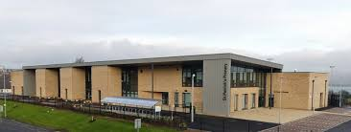SCHOOL INFORMATION

St Patrick’s Primary School

Broomhill Street

Greenock

PA15 4HL

**Tel**: 01475 715696

**Website**: <https://blogs.glowscotland.org.uk/in/stpatricksprimary/>

**X**: @StPatricksPS15

**Email**: office@st-patricks.inverclyde.sch.uk

**Present Roll**: 291

**Capacity**: 341

**Working Capacity**: Working capacity of school may vary dependent upon the number of pupils at each stage and the way in which the classes are organised.

Saint Patrick’s Primary is a denominational (Roman Catholic) primary school which serves the centre of Greenock and offers education for pupils from P1 to P7. The school is a modern building which opened in November 2016. It is a bright, stimulating environment for children to learn and was designed to make the most of the natural light and stunning views over the River Clyde. Accommodation includes 12 classrooms, a PE hall, a library area, a dining area, 3 playground areas and daily access to the adjacent 3G football pitch owned by Inverclyde Leisure.

**School Hours**

**09:00 School Opens** 10:30 – 10:45 Interval

**15:00 School Closes** 12:15 – 13:00 Lunch

**Punctuality**

We expect all pupils to be on time. We suggest pupils arrive in the playground between 8:45am and before 9:00am ready for school to begin at 9:00am.

**Attendance**

Good attendance is important for children’s progress in learning and we follow Inverclyde Council’s Policy on maximising attendance. Our target is for no child to fall below 95% attendance rate in any year (that is no more than 9 days in a full school year).

**Breakfast Club**

Breakfast Club is available Tuesday – Thursday from 8.00 – 8.45am at a cost of £1 per pupil, per day. Pupils who are eligible for a clothing grant can attend for free.

STAFF

**Head Teacher** Mrs K Doherty

**Depute Head Teacher** Mrs G Ogilby (part-time)

**Principal Teacher** Mrs M O’Neill (and Acting Depute Head Teacher – part-time)

**Acting Principal Teacher** Mrs C Docherty (part-time)

**Office Staff** Mrs L O’Neill

Mrs L Davidson

**Janitor** Mr A Harkness

**Teaching Staff** P1A Mrs A Sinclair

P1B Mrs A Elder / Miss S Clark

P2 Miss C Forbes

P2/3 Miss L Sinclair

P3 Mrs Reynolds

P4 Mrs L Campbell

P4/5 Mr J McGachy / Miss S Clark

P5 Mrs R Dooley / Miss S Clark

P6 Mr M McGregor

P6/7 Mr K Ferrie / Mrs P McGeehan

P7 Mrs L Harvey

Support for Learning Mrs C Molloy-Smith

**Pupil Support Assistants** Mrs J McClement

Mr K O’Brien

Mrs P Rowles

Mrs A Taylor

Mrs J Glasheen

Miss M McGeachy

Mrs K Maguire

Mrs T Orr

Mrs C McFeeters

Mrs K Quinn

Mrs A McLaren

Mrs C McMahon

Mrs A Porter

**Catering Manager** Mr R Mealey

**School Chaplain** Monsignor Gerry Gallagher

**Educational Psychologist** Ms K McPherson

**Active Schools Co-ordinator** Mr G Forbes

**Music Instructors** Mr A Digger (Brass)

Mrs L McColl (Violin)

Miss J Howie (Singing)

Mrs R Anderson (Cello)

Mr A McPherson (Chanter)

SCHOOL CALENDAR 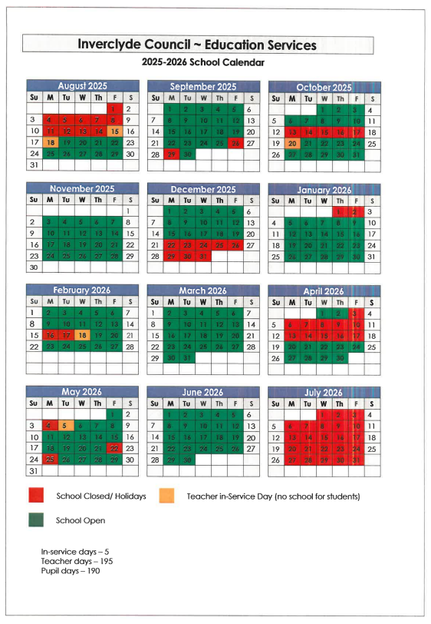

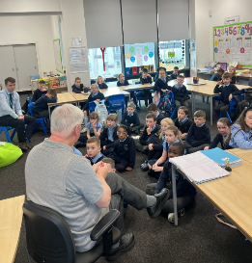THE SCHOOL, THE COMMUNITY AND FAMILY ENGAGEMENT

**Parish**

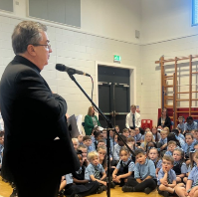We enjoy excellent relationships within the school and as part of the local community. The school, as an integral part of St Patrick’s Parish, is very much involved with the life of the parish. Monsignor Gerry Gallagher, the Parish Priest of St Patrick’s Church who is also our school chaplain supports the school very well. He is a member of our Missions Group and works with the boys and girls to improve the religious life of the school. The SVdP Society and the parish community, as a whole, are also very supportive of our school’s work. On the first Sunday of every month, the children from the school lead the Liturgy of the Word during Mass in Church for the Parish. A number of children within the school actively trained as Altar Servers and support the celebration of every weekend Mass, as well as school Masses. We visit St Patrick’s Church throughout the year and join with the parish community for various Sacraments and celebrations throughout the year.

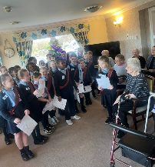

Children also participate in fund raising for a number of charities, which has included; Missio Scotland, SCIAF, the Live With Hope Centre in Kenya, Mary’s Meals, Macmillan Cancer Support and locally supported St Patrick’s SVdP Foodbank and Ardgowan Hospice.

**Local Community**

We are lucky to enjoy very good relationships and partnerships with a number of local community groups who help us to enhance the experiences we provide in St Patrick’s throughout the year. Thanks to our community partners, 32nd Scout Group, we have enhanced the experiences of our senior pupils through working in partnership with Scouts Leaders to create bespoke workshops to encourage our children to develop their skills.

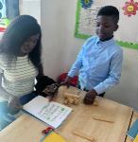**Family Engagement**

Family engagement is so important to our school and our families and children really benefit. Throughout the year, we have opportunities for our parents/carers to visit the school to share in our children’s learning. We also have workshops throughout they year too. We regularly send out surveys to capture the views of our parents/carers to help us to improve our school. There are 2 Pupil Progress Meetings in the school year (usually October and March) for parents/carers to meet with their child’s teacher to discuss progress and next steps. We send out regular Newsletters and families can send us their views by clickin on a Form link. Our Parent Drop-in Café normally runs in the canteen from 2pm-3pm on a Friday afternoon. Our Parent Council meet on a Monday night from 7pm around 6 times per year. We look forward to welcoming you to fully engage in the life of the school.

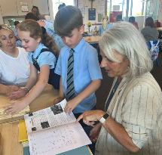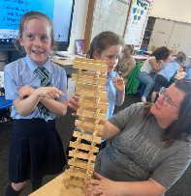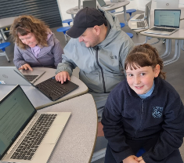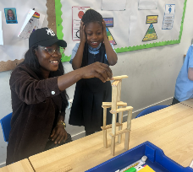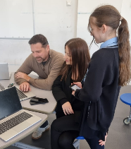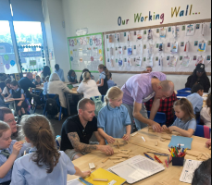

SCHOOL CLUSTER

While its own Head Teacher and Senior Staff manage each school in Inverclyde, we are also part of a cluster of schools and establishments that work together to continually improve and develop. Our cluster involves our neighbouring Primary Schools, the associated Secondary School and Early Years Establishments.

Our Cluster consists of:

* Blairmore Nursery
* Glenbrae Pre-5 Centre
* Hillend Children’s Centre
* Wellpark Children’s Centre
* All Saints Primary School
* St Mary’s Primary School
* Notre Dame High School

We also work very closely with many other establishments, particularly Whinhill Nursery and Whinhill Primary School. Children transfer to us from various other nurseries in Inverclyde and our transition programme extends to them too.

ENROLMENT OF PUPILS TO PRIMARY 1

The registration process for new Primary 1 pupils is undertaken by completing an online application form which can be found on the Inverclyde Council website at <http://www.inverclyde.gov.uk/p1-registration>.

Children who reach the age of five years between 1 March 2025 and 28 February 2026 (this will be children who are born between the 1 March 2020 - 28 February 2021) are due to start primary 1 at the beginning of the new school term in August 2025.

Parents/Carers should complete the P1 online registration process between Monday 6 – Friday 10 January 2025 regardless if they are considering a deferred year to school for their child.  Parents/Carers can choose between denominational or non-denominational schools or Gaelic Medium Education. Gaelic Medium Education is available at Whinhill Primary School for all pupils residing in Inverclyde**.** Please choose Whinhill (Gaelic) School from the online drop down menu when registering.

It’s vitally important that parents follow the online registration process to register their child for a Primary 1 place in an Inverclyde school.

A deferred entry application is also available to parents considering deferring their child’s entry to Primary 1 in August 2025.

No documents will be required at this stage; however, we may have to contact you, should we require further information.

Parents will be notified by 30 April 2025 confirming their child’s place in school and information regarding induction days will follow from the school after this date.

Parents who do not have internet access to apply online, are asked to contact their child’s current Early Years Establishment for assistance.

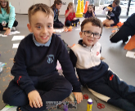

Our transition programme from early years to Primary 1 ensures that the change from nursery to primary school is as smooth as possible and supports continued learning and progress.

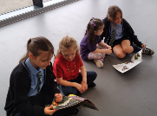During the summer term, we invite the new P1 entrants and their parents to visit the school on a number of occasions. This allows the children to get to know each other, as well as the school staff, and to become familiar with the Primary School environment. At this time, we give parents more information about St Patrick’s and about Primary 1 in particular. We also have our P6 Buddies visit our new entrants during the session before August entry.

TRANSFER FROM PRIMARY SCHOOL TO SECONDARY SCHOOL

Pupils are normally transferred between the ages of 11 ½ and 12 ½, so that they will have the opportunity to complete at least 4 years of secondary education. Parents will be informed of the arrangements no later than December of the year preceding the date of transfer at the start of the new season.

The secondary school associated with St Patrick’s is:

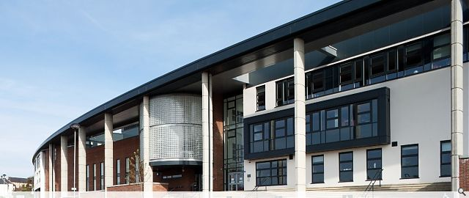Notre Dame High School

Dunlop Street

Greenock

PA16 9BJ

Tel: 01475 715150

The strong links we have with Notre Dame High School ensure that the change of school is as smooth as possible and supports continued learning and progress. There are a number of opportunities for our Primary 7 pupils to become familiar with the staff and building during their Primary 7 year.

SCHOOL IMPROVEMENT AND ACHIEVEMENT

Information about the main achievements and successes of the school over the past year can be found in our Standards and Quality Report 2023-2024, which can be accessed from our school website, and details our successes and achievements. Our School Improvement Plan for session 2024-2025 can also be accessed from our school website, and details our priorities for planning for improvement.

Through our consistent approaches to self-evaluation for continued improvement there is an ethos of shared commitment to collaborative working in St Patrick’s. All staff are highly committed to school improvement and the raising of standards to ensure equity and excellence for our learners. This commitment and focus means that throughout the school almost all of our children have achieved the expected CfE levels for their year group in Listening and Talking (92%); while most of our children have achieved the expected CfE levels in Reading (78%), in Writing (72%) and in Numeracy (77%).

Our parents/carers and pupils are fully involved in the evaluation of how well we are doing as a school and how we can continue to improve. They are often asked to contribute their views at various times; during meetings, at family events and by survey. The Parent Council is a great asset to the school in terms of consultation, often acting as an initial sounding board for ideas and improvement planning. We have been working hard to enhance the contributions of our pupils to improving the school. We have developed various Pupil Voice Groups who contribute to the improvements planned for the school. We value partnership working and the views of all our school community to help us continue to improve as a school serving our community.

CURRICULUM FOR EXCELLENCE

The curriculum framework for all Scottish educational establishments 3-18 is called Curriculum for Excellence. It is designed to provide the breadth and depth of education to develop flexible and adaptable young people with the knowledge and skills they will need to thrive now and in the future. It aims to support young people in achieving and attaining the best they possibly can to become successful learners, confident individuals, responsible citizens and effective contributors.

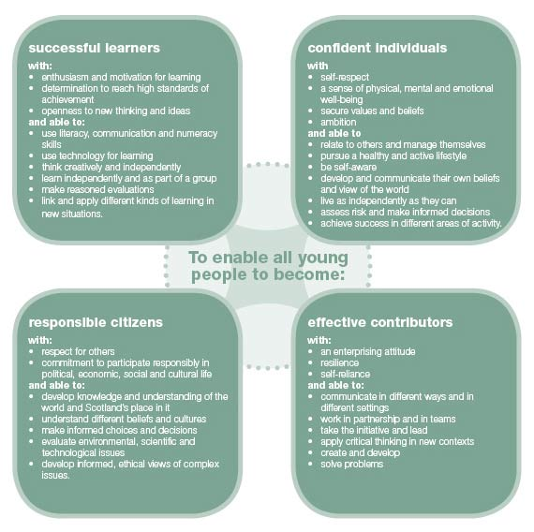

During the broad general education, children and young people should:

* achieve the highest possible levels of literacy, numeracy and cognitive skills.
* develop skills for learning, skills for life and skills for work.
* develop knowledge and understanding of society, the world and Scotland's place in it.
* experience challenge and success so that they can develop well-informed views and the four capacities.

The experiences and outcomes under Curriculum for Excellence are written at five levels, with progression to qualifications described under the senior phase.

* **Early Level** – the pre-school years and P1, or later for some
* **First Level** – to the end of P4, but earlier for some
* **Second Level** – to the end of P7, but earlier for some
* **Third and Fourth** – S1 to S3, but earlier for some
* **Senior phase** – S4 – S6 and college or other means of study

In St Patrick’s learning is organised to encourage progression from one stage of learning to another. Teachers begin from where the child is and build upon his/her existing knowledge and skills. Active learning is very important. Children work in a variety of ways; at times in groups, and at other times, individually. When pupils change classes, teachers liaise with one another to ensure children progress from year to year.

The following sections outline the eight main curriculum areas, through which learning and teaching are planned to meet the principles for curriculum design: **challenge** and **enjoyment**, **breadth**, **progression**, **depth**, **personalisation** and **choice**, **coherence** and **relevance**.

**The curriculum areas:**

* Literacy and English
* Numeracy and Mathematics
* Health and Wellbeing
* Expressive Arts
* [Sciences](http://www.ltscotland.org.uk/curriculumforexcellence/publications/Buildingthecurriculum1/religiousandmoraleducation/intro.asp)
* Social Studies
* Technologies
* [Religious](http://www.ltscotland.org.uk/curriculumforexcellence/publications/Buildingthecurriculum1/technologies/intro.asp) and Moral Education (Religious Education in Roman Catholic Schools)

**Languages**

**Literacy and English**

*“Literacy is fundamental to all areas of learning, as it unlocks access to the wider curriculum. Being literate increases opportunities for the individual in all aspects of life, lays the foundations for lifelong learning and work, contributes strongly to the development of all four capacities of Curriculum for Excellence.” CfE – Principles and Practice.*

There are two main aspects of the languages area of the curriculum. The first aspect covers experiences and outcomes in the language a young person needs to engage fully in their learning and in society - whether that is English, Gaelic or, for young people who need additional support, the means of communication which enables them to communicate most effectively. The second aspect covers experiences and outcomes in a modern language. In St Patrick’s, Spanish is taught throughout the school. Spanish words and phrases are used throughout the curriculum at all stages, and children learn through listening and talking, games and songs.

Language is at the core of thinking. We develop our ideas, communicate and reflect through language. Language and the development of literacy skills help young people achieve their potential and become active members of society who can contribute through their ideas and work. In St Patrick’s, we foster a love of reading. Literature opens up new horizons, and a love of reading can be an important starting point for lifelong learning. We have a range of books available to children in class and in the school library. Talking and listening for thinking is developed across all stages in the school and is used in every curricular area. The teaching of writing takes place within the area of language but also in many other curricular areas.

**Numeracy and Mathematics**

*“Mathematics is important in our everyday life, allowing us to make sense of the world around us and to manage our lives. Using mathematics enables us to model real-life situations and make connections and informed predictions. It equips us with the skills we need to interpret and analyse information, simplify and solve problems, assess risk and make informed decisions.” CfE – Principles and Practice.*

Pupils progress through activities designed to equip children with skills required for life, learning and work. At all stages, we aim to make learning in numeracy and maths as active possible and linked to real-life, practical situations.

Mathematics includes specific aspects of numeracy which are developed both in mathematics and through activities in other areas of the curriculum. Learning in numeracy and mathematics involves a variety of topics organised under 3 main headings;

* Number and number processes
* Multiples, factors and primes
* Powers and roots
* Fractions, decimal fractions and percentages
* Money
* Time
* Measurement
* Mathematics – its impact on the world, past, present and future
* Patterns and relationships
* Expressions and equations
* Shape, position and movement
* Properties of 2D shapes and 3D objects
* Angle, symmetry and transformation
* Information handling
* Data and analysis
* Ideas of chance and uncertainty

**Health & Wellbeing**

Health and wellbeing includes experiences and outcomes for personal and social development, understanding of health, physical education and physical activity, and food health.

In Physical Education a balanced programme in Gymnastics, Games Skills and Active Health is provided. At various times in the year the children’s physical education is enhanced by visiting coaches in a number of areas, for example; football, cricket, rugby, tennis, hockey and basketball, supported by our close working with Active Schools. Parents should note that health and safety requirements state that jewellery of any kind must not be worn where pupils are undertaking games or physical activities. This includes jewellery worn as a result of body piercing. We would ask that parents discourage pupils from having body piercing during term time to ensure full participation in physical education.

Children and young people need to experience what it feels like to develop, enjoy and live a healthy lifestyle. A healthy lifestyle supports physical, social and emotional wellbeing, and underpins successful learning. Learning in health and wellbeing ensures that children and young people develop the knowledge and understanding, skills, capabilities and attributes which they need for mental, emotional, social and physical wellbeing now and in the future.

**Expressive Arts**

The expressive arts include experiences and outcomes in art and design, drama, dance and music. Through the expressive arts, children and young people have rich opportunities to be creative and imaginative and to experience inspiration and enjoyment.

The music programme for the school is based upon the ABC music resource. In addition to this, Primary 4 children can try out for string instruction (violin or cello), and in Primary 6 for brass instrument instruction. All P5 pupils have input from Youth Music Initiative. Also in P6 and P7 pupils have the opportunity to be trained for voice by Miss Howie as a continuation of the P5 training.

Art and design includes drawing, painting and using a variety of materials, media and techniques to investigate visually and record.

Within drama, children are encouraged to participate in improvisation, role-play, characterisation, simulation and creative movement. We also provide opportunities for children to perform in front of an audience eg our Christmas concerts, Grandparents’ Day and the Inverclyde Music Festival.

Children experience a range of dance styles, including Scottish Country Dance.

**Sciences**

Science includes experiences and outcomes in biological, chemical, physical and environmental contexts. In St Patrick’s we aim to stimulate, nurture and sustain the curiosity, wonder and questioning of children. Children are encouraged to develop their natural sense of wonder and curiosity and to be active and eager learners who endeavour to make sense of the world. They develop ideas through play, investigation, first-hand experience and discussion. Children are encouraged to ask searching questions based on their everyday observations and experiences of living things, the environment, materials, and objects and devices they interact with.

**Social Studies**

Social studies include experiences and outcomes in historical, geographical, social, political, economic and business contexts. It is important for children and young people to understand the place where they live and the heritage of their family and community. Through social studies, children and young people develop their understanding of the world by learning about other people and their values, in different times, places and circumstances, and how their environment has been shaped. They learn about human achievements and to make sense of changes in society, conflicts and environmental issues. With greater understanding comes the opportunity to influence events by exercising informed and responsible citizen-ship. This area of the curriculum is supported by educational visits to linked experiences. Teachers use Social Studies topics to build inter-disciplinary links across subjects and to make learning more relevant and coherent, and in exploring Children’s Rights.

**Technologies**

This curriculum area includes creative, practical and work-related experiences and outcomes in craft, design, engineering, graphics, food, textile, and information technologies. To participate fully in modern life, children and young people need to be skilled and knowledgeable users of technologies and be ready to embrace further developments in the future. The technologies consider how knowledge can be applied for practical purposes. They provide exciting opportunities to develop children’s creativity and the enterprising attitudes which Scotland needs, not least to compete in a global economy. Technologies are developing at an unprecedented rate. Such dramatic change brings risks as well as benefits, and children and young people need to be able to assess the impact of technologies so that they can take action in an informed way.

**Religious and Moral Education**

As a denominational school, St Patrick’s reflects the faith perspective of the Roman Catholic Church. Religious and moral education takes place within the context of the Catholic faith community. Religious education in Catholic schools is designed to nurture faith and assist children and young people to be able to make an informed response to God in faith. ‘This is Our Faith’ is used to plan for specific learning in RE but beyond explicit learning our ethos is defined by our daily religious practices.

‘God’s Loving Plan’, the Catholic sex education programme, is implemented from Primary 1 to Primary 7. Sex and Relationship education is an integral part of our health education programme. It focuses on the physical, emotional, moral and spiritual development of all children. Parents/Carers are fully informed of the content and purpose of sex and relationship education in schools and have the opportunity to discuss this with school staff. On an occasion where a parent wishes to exercise the right to withdraw his/her child from sex and relationship education they should discuss their concerns with school staff (as per Inverclyde Council’s policy “Sexual Health and Relationship Education”).

Our children are currently learning about ways in which they can be Stewards of God’s creation – to love God, look after each other and protect our world – through Pope Francis’ Encyclical, Laudato Si’ Care of Our Common Home.

In conjunction with our school chaplain, Monsignor Gerry Gallagher, arrangements are made for children to attend Church for Mass on holy days of obligation and special feasts. Children also plan for and participate in Class Mass. Children are prepared to fully participate in the Liturgy. Parents /Carers are the prime educators of our children and therefore we like to involve parents/carers as much as possible in the children’s Religious Education. Hence, we invite you to join us when we have Mass or during the preparation for the Sacraments of Reconciliation, Holy Eucharist and Confirmation. In Lent and Advent we also come together as a school community to reflect on the season on a Friday morning before school begins. All members of our school community are welcome to attend and participate with us

Parents from other religious communities may request that their children be permitted to be absent from school in order to celebrate recognised religious events. Only written requests detailing the proposed arrangements will be considered. Appropriate requests will be granted on not more than three occasions in any one school session and the pupil noted as an authorised absentee in the register. The right of parents to withdraw their child from corporate acts of worship and religious instruction exists in law.

**Read, Write, Count**

[Read, Write, Count](https://eu-west-1.protection.sophos.com/?d=scottishbooktrust.com&u=aHR0cHM6Ly93d3cuc2NvdHRpc2hib29rdHJ1c3QuY29tL3JlYWRpbmctYW5kLXN0b3JpZXMvcmVhZC13cml0ZS1jb3VudG9mZmVycw==&i=NjIyOWM5ZWE3YzA2ZDIxZDM1MWE0YmEz&t=ZDNQUStaRDEyUVQ0cUpNaFdYNkx6QklFVmxlVm83ZThnSmJIVi9ES2VMYz0=&h=af1a4b6971814cc4ad734191f4ce631d&s=AVNPUEhUT0NFTkNSWVBUSVbneL_Jt0oZlomghPR_nN15K9Oy-_K53IQ1rAgw1UT0EsEE1vYNCNHynB7_pqJnoHw) with the First Minister is a programme that aims to support parental engagement in literacy and numeracy. Gift bags are distributed annually to all Primary 2 and Primary 3 pupils in Scotland by Scottish Book Trust. The gift bags contain literacy and numeracy materials to support children’s learning, as well as advice and support to parents/carers.

Studies show a direct link between a strong family learning environment and progress in reading, writing and counting. In addition to the activity booklet included in the bag Scottish Book Trust offers a range of hints, tips and advice to help parents engage in their child’s learning on the website.

**Bookbug**

[Bookbug](https://eu-west-1.protection.sophos.com/?d=scottishbooktrust.com&u=aHR0cHM6Ly93d3cuc2NvdHRpc2hib29rdHJ1c3QuY29tL2Jvb2tidWc=&i=NjIyOWM5ZWE3YzA2ZDIxZDM1MWE0YmEz&t=d3VtOGpkQnE3dVlGV0g4ZFhhNG90bU5STDlnVlBWZkllYlE1SjRHYkJoYz0=&h=af1a4b6971814cc4ad734191f4ce631d&s=AVNPUEhUT0NFTkNSWVBUSVbneL_Jt0oZlomghPR_nN15K9Oy-_K53IQ1rAgw1UT0EsEE1vYNCNHynB7_pqJnoHw) is Scotland’s universal early years book gifting programme and aims to inspire a love of stories, songs and rhymes from birth. Bookbug gives every child in Scotland four free bags of books as babies, toddlers, three and five year olds. The bags contain books and other resources for sharing songs and rhymes that are suited to their age.  Gaelic Bookbug Bags are also available.

The **Bookbug Explorer Bag** is gifted to all 3 year olds at their childcare setting. It includes three lovely books, an activity book, pencils, and postcards to encourage mark making.

‘The Bookbug Primary 1 [Family Bag](https://eu-west-1.protection.sophos.com/?d=scottishbooktrust.com&u=aHR0cHM6Ly93d3cuc2NvdHRpc2hib29rdHJ1c3QuY29tL3JlYWRpbmctYW5kLXN0b3JpZXMvdGhlLWJvb2tidWctcHJpbWFyeS0xLWZhbWlseS1iYWc=&i=NjIyOWM5ZWE3YzA2ZDIxZDM1MWE0YmEz&t=aGtGeWJ5amNsTVZqZWUzenh1cktjY21EUTVoNHFNdVdaQ0JGR2FETXRPST0=&h=af1a4b6971814cc4ad734191f4ce631d&s=AVNPUEhUT0NFTkNSWVBUSVbneL_Jt0oZlomghPR_nN15K9Oy-_K53IQ1rAgw1UT0EsEE1vYNCNHynB7_pqJnoHw) encourages families to share books and activities to inspire a lifelong love of reading, writing and counting. These are gifted during Book Week Scotland in November every year!’

Check out the [website](https://eu-west-1.protection.sophos.com/?d=scottishbooktrust.com&u=aHR0cHM6Ly93d3cuc2NvdHRpc2hib29rdHJ1c3QuY29tL2Jvb2tidWc=&i=NjIyOWM5ZWE3YzA2ZDIxZDM1MWE0YmEz&t=d3VtOGpkQnE3dVlGV0g4ZFhhNG90bU5STDlnVlBWZkllYlE1SjRHYkJoYz0=&h=af1a4b6971814cc4ad734191f4ce631d&s=AVNPUEhUT0NFTkNSWVBUSVbneL_Jt0oZlomghPR_nN15K9Oy-_K53IQ1rAgw1UT0EsEE1vYNCNHynB7_pqJnoHw) for booklists, book sharing videos, activity ideas and much more.

EXTRA-CURRICULAR ACTIVITIES

Throughout the year we provide a variety of extra-curricular activities supported by our partners in Active Schools and NDHS. These include; football, netball and athletics. The School Athletics Team participates well in all local competitions. Active Schools also run multi-skills classes during lunch times for our infant classes.

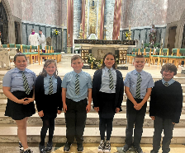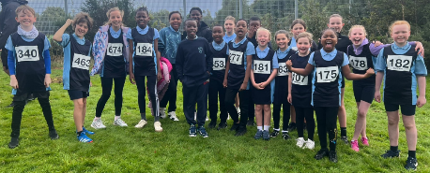

ASSESSMENT AND PROGRESS

Teachers carry out continuous assessment in all subjects. Teachers use their professional judgement to assess pupils on a daily basis to help plan for next steps in learning and teaching. Pupils are fully involved in setting targets for themselves. Most assessment takes place formatively where teachers involve pupils in thinking about their own learning and progress. Teachers are constantly monitoring and assessing the progress of pupils through:

* Observations
* Oral tasks and feedback
* Written tasks and feedback
* Practical activities
* Standardised tests

A variety of other diagnostic tools are used to identify and support any challenges that may arise for some children at times in their education. Our aim is for all pupils to make appropriate progress.

Pupils in P1, P4 and P7 are also assessed using a computer-based programme called NSA (National Standardised Assessments). These assessments are completed online for reading, writing and numeracy as part of everyday learning and teaching. NSAs provide another piece of information to help support teachers’ professional judgement about how well children are progressing. They also help us to track our pupils’ progress from P1 through to P7. Data from across Scotland on achievement of the Curriculum for Excellence levels is reported to the Scottish Government annually. More details of this can be found on the Parentzone website; <https://education.gov.scot/parentzone/>.

REPORTING TO PARENTS/CARERS

Written reports are usually issued to parents at the end of the school year. Reports are also given orally twice each year to parents/carers during Pupil Progress Meetings (ordinarily in October and March). Children also showcase their learning at various times throughout the year during which parents/carers are welcomed into school. Parents/Carers of children with an additional support need also have review meetings at appropriate times throughout the year. Parents/carers should contact the school if they wish any information on their child’s learning at any other point in the school year.

HOMEWORK

Homework is given to reinforce and enhance aspects of learning in a variety of subjects. At St Patrick’s we believe homework is valuable for creating and maintaining a successful partnership between home and school and so we encourage parents/carers to participate in homework activities with children. It is expected that pupils will be given homework for Monday to Thursday. The suggested time spent on homework activities depends on the age of your child. Homework should take no more than 20 minutes per night in the P1-P3 classes, and no more than half an hour in the P4-P7 classes. Homework will not usually be given for over the weekend. Each Class Teacher will make sure that children and parents/carers understand the homework activities given.

SUPPORT FOR PUPILS

All children and young people need support to help them learn. The main sources of support in schools are the staff who, through their daily practice, are able to meet a diverse range of needs. With good quality teaching and learning and an appropriate curriculum, most children and young people are able to benefit appropriately from education without the need for additional support. Some children require additional support at different stages through school. The definition of additional support is a wide one and it is not possible to provide an exhaustive list of all possible forms of additional support, but could include:

* children who have a disability
* children with social, emotional and behavioural needs
* children with learning needs of a specific or general nature
* children who require challenge
* those who demonstrate underachievement relating to gender issues
* children whose learning has been interrupted through absence or illness
* children who have English as an additional language
* children from travelling families
* children whose family circumstances impact on attendance and learning.

St Patrick’s has an Additional Support Needs Co-ordinator whom parents would speak to if you think that your child requires additional support in school. Mrs O’Neill, our PT and Acting DHT, is our ASN Co-ordinator. Please contact Mrs O’Neill if you wish to discuss your child’s additional support need.

As with all local authority schools in Scotland, St Patrick’s operates under the terms of the Additional Support for Learning Act (2009) and its accompanying Code of Practice. These procedures have been strengthened through the Children and Young People Act (2014). Therefore, a child or young person’s needs are identified at the earliest possible stage and can be met in a number of ways, for example by adaptations to the curriculum or learning environment, as well as input from the Support for Learning Teachers and, on occasion, support from visiting specialists. The appropriateness of the support is determined through a process of assessment, planning and monitoring, working jointly with children, parents and teachers and is reviewed regularly.

Learning outcomes for children and young people with additional support needs are set out in a plan and all educational establishments hold regular review meetings with parents/carers to determine needs and the most appropriate supports. Everyone’s views are equally important in order to consider what is currently working and how to determine next steps.

Children’s needs are identified in a number of ways, and the process of assessment is an ongoing, shared process with partnerships with parents/carers at the forefront. On some occasions health service staff or other partner agencies make children known to Education Services. Other additional support needs may be notified to Education Services by parents/carers themselves or identified by one of a range of staff working closely with the child.

Some children and young people will have additional support needs arising from complex or multiple factors which require a high degree of co-ordination of support from both education and other agencies in order that their needs can be met. In these cases, the school will hold a meeting to decide whether the child meets the criteria for a co-ordinated support plan.

The coordinated support plan is a statutory document which ensures regular monitoring and review for those children and young people who have one.

You have the right to ask the education authority to establish whether your child needs a coordinated support plan. Your child can make this request themselves, if they are aged 16 or over. You and your child, if they want to, will attend a meeting with staff at their school. Other professionals from different agencies who may be involved in providing support for your child will also attend. If your child does not want to attend meetings or feels unable to, their views must still be sought and considered.

**PARENTZONE SCOTLAND**

[Parentzone Scotland](https://eu-west-1.protection.sophos.com/?d=gov.scot&u=aHR0cHM6Ly9lZHVjYXRpb24uZ292LnNjb3QvcGFyZW50em9uZQ==&i=NjIyOWM5ZWE3YzA2ZDIxZDM1MWE0YmEz&t=N1JJSzR3SFk3a0V6QlBOUjFCeHYzd2tXRFVKWVpVUjVhazZtTWZyR3V5UT0=&h=af1a4b6971814cc4ad734191f4ce631d&s=AVNPUEhUT0NFTkNSWVBUSVbneL_Jt0oZlomghPR_nN15K9Oy-_K53IQ1rAgw1UT0EsEE1vYNCNHynB7_pqJnoHw) is a unique website for parents/carers in Scotland, from early years to beyond school.  The website provides up-to-date information about learning in Scotland, and practical advice and ideas to support children’s learning at home in literacy, numeracy, health and wellbeing and science. Information is also available on Parentzone Scotland regarding additional support needs, how parents/carers can get involved in their child’s school and education.

Parentzone Scotland also has details about schools, including performance data for school leavers from S4-S6 and links to the national, local authority and school level data on the achievement of Curriculum for Excellence levels.

Inverclyde’s mediation service can be accessed by contacting Michael Roach, Head of Education, at the address below.

For further advice please telephone 01475 712850.

Or write to:

Education Services

Wallace Place

GREENOCK, PA15 1JB

These websites may also prove useful to parent/carers of children with an additional support need:

[www.enquire.org.uk](http://www.enquire.org.uk)

[www.siaa.org.uk](http://www.siaa.org.uk)

[www.sclc.org.uk/](http://www.sclc.org.uk/)

PASTORAL CARE

The school has a strong tradition of pastoral care for pupils and for their families. The ethos of the school is such that caring is a natural element in our daily interaction with our pupils. All our staff members make time to get to know pupils and their families.

We work closely with our associated nurseries and secondary school to support our children in the transition period from nursery to primary, and from primary to secondary. Our Psychologist, Ms McPherson works well with our staff and parents to help us support our pupils. There are also other agencies who work with our school from time to time to help pupils and parents/carers, for example, Social Work Services, Barnardo’s and Action for Children.

SUPERVISION OF PLAYGROUNDS

The safety of our pupils is our priority. An adult presence is provided in playgrounds at break times in terms of the Schools (Safety and Supervision of Pupils) (Scotland) Regulations, 1990. The Janitor and Support Staff carry out these duties to help keep children safe and to deal with any injuries that may occur while children are playing. The playground is supervised from 8:45am every morning and during all intervals and lunch breaks.

PROMOTING POSITIVE RELATIONSHIPS AND BEHAVIOUR

We strive at all times to promote positive relationships and behaviour across the school. This is highlighted in and promoted through our School Values. Respectful standards of behaviour are necessary for a pleasant and safe environment for our children to get the best from their education. We, therefore, expect our children to strive for the standards of behaviour that are necessary to promote this pleasant and safe environment. In encouraging our children to *show respect for themselves for others and for property*, we are promoting positive relationships and positive behaviour. School rules are made in the interest of, and for the well-being and safety of all of our children. We rely on our parents/carers to support us in this endeavour so please encourage your child to respect our values and adhere to our rules. Strong partnership working between home and school is essential to allow our children to continue to learn in the positive environment that St Patrick’s enjoys.

Our school uses ‘restorative approaches’ to handle any issues of conflict where children are encouraged to take responsibility for their actions and support one another in moving forward with respect. We aim to seek solutions to any conflicts which may arise. Our school follows Inverclyde’s Positive Relationship Policy. Instances of inappropriate or challenging behaviour are dealt with in line with Inverclyde policy and parents/carers are kept fully informed.

BASIC SECURITY PRACTICES

In the interest of security, the following practices have been adopted:

* After pressing the security buzzer for reception all visitors should use the main entrance only and must report to the school office on arrival. Other school entrances are for pupil use only.
* All visitors are required to sign the Visitors’ Book – both in and out – and are accompanied around the building unless they hold a valid PVG.

CLOTHING & UNIFORM

In St Patrick’s there is substantial parental support for school uniform. Parents/Carers have been very clear that they wish the wearing of school uniform to be encouraged. Given that there is substantial parental and public approval of uniform, schools in Inverclyde are free to encourage the wearing of school uniform. In encouraging the wearing of uniform, account is taken of any proposals to prevent any direct or indirect discrimination on the grounds of race or gender. Any proposals will be the subject of widespread consultation with the parents/carers and pupils. Against this background it should be noted that it is the policy of the Education & Lifelong Learning Committee not to insist on pupils wearing uniform or having specialist items of clothing as a prerequisite of their attending and engaging in all of the activities of the curriculum.

There are forms of dress which are unacceptable in school, such as items of clothing which:

* potentially, encourage faction (such as football colours);
* could cause offence (such as anti-religious symbolism or political slogans);
* could cause health and safety difficulties, such as loose fitting clothing, dangling earrings or clothing made from flammable material for example shell suits in practical classes;
* could cause damage to flooring;
* carry advertising, particularly for alcohol or tobacco;
* could be used to inflict damage on other pupils or be used by others to do so.

The Council is concerned at the level of claims being received regarding the loss of pupils’ clothing and/or personal belongings. Parents/Carers are asked to assist in this area by ensuring that valuable items and unnecessarily expensive items of clothing are not brought to school. Parents/Carers should note that the Authority does not carry insurance to cover the loss of such items and any claims submitted are likely to be met only where the Authority can be shown to have been negligent.

Parents/Carers should note that the activities the children may become involved in may be restricted because health and safety requirements state that jewellery of any kind must not be worn where children are undertaking physical activities. This includes jewellery worn as a result of body piercing.

Since August 2023 all children in P1-P7 automatically qualify for free school meals.

However, if you wish to be considered for the clothing grant, or your child is or will be in S1 – S6, you must submit an application form. You may qualify for a clothing grant if one of the following statements applies to your family circumstances:

* You are currently in receipt of:
* Income Support (IS);
* Income Based Job Seekers Allowance (JSA);
* Any income related element of Employment and Support Allowance (ESA);
* Child Tax Credit, but not Working Tax Credit, and your income is less than £19,995 (in 2024/2025) as assessed by HMRC;
* Working Tax Credit and/or Child Tax Credit and have an income of no more than £15,051 (in 2024/2025) as assessed by HMRC;
* Universal Credit, where your take home pay does not exceed £1,199,

or

* You are seeking asylum and receiving support under part VI of the Immigration and Asylum Act 1999;

or

* You look after a child/children as part of a formal Kinship Care agreement, registered by Social Work Services.

Approval of requests for such grants made by parents in different circumstances is at the discretion of the Corporate Director of Education and Social Care. Information and application forms may be obtained from schools and from Education Services, 105 Dalrymple Street, Greenock, PA15 1HU.

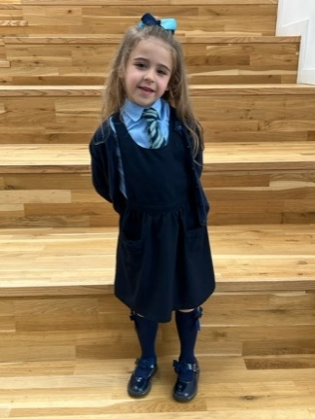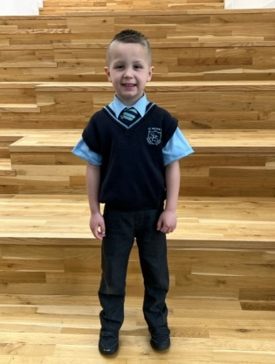

A list of uniform for your reference is shown below:

Light blue Shirt/Blouse or Polo Shirt

Grey Trousers or Navy Blue Skirt/Pinafore

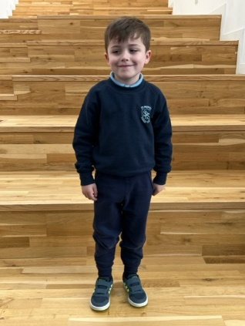School tie

Navy Blue Pullover/Jumper/Sweatshirt/Cardigan

**PE**

T-Shirt or school polo shirt

Dark shorts / dark tracksuit trousers / dark leggings

Sandshoes / Trainers

During PE lessons children are not allowed to wear jewellery of any description, this is to ensure the health and safety of all children. Children should not wear false nails either for reasons of health and safety. Since Covid our children have come to school wearing their PE kit on PE days

We do not support the buying and wearing of Leavers’ Hoodies in P7, however we have agreed with our P7 parents that P7 pupils may wear a “Class of…” hoody, eg “Class of 2025”. This is not compulsory and parents/carers should not feel obliged to purchase this item of clothing.

MEDICAL AND HEALTH CARE

Routine medical checks take place throughout the child’s life in school by the School Health Service.

Minor accidents are attended to in the school, but in more serious cases, parents/carers or emergency contacts are informed, so that the child may be taken to hospital. If no one can be contacted, the child will be transported immediately to Inverclyde Royal Hospital by a member of staff.

If a child becomes ill and cannot remain in school, parents/carers or emergency contacts will be telephoned to come and take the child home. Therefore, it is essential to keep the school informed of any changes to the emergency contact telephone number or your home or work telephone number so that contact can be made as quickly as possible.

If there are any medical requirements for a child, parents/carers should inform the school in writing. Parents/Carers of children requiring medication during school hours are welcome to come into the school office to administer the medication. If parents/carers would like a member of staff to administer medication, they must bring prescribed medication in to the school office and complete the appropriate consent form.

**Allergies/Peanut Free Zone**

As some pupils can be allergic to peanuts and peanut products and could suffer an anaphylactic reaction if exposed to them, we ask that children do not bring peanuts or peanut products to school.

**Child Absent from School through Ill Health**

Children may be unable to attend school for a wide range of reasons including illness, accidents or long-term medical conditions. In general there will be an automatic referral by the school for education out with school after 15 days of continuous or 20 working days of intermittent absence, within a reasonable timeframe.

ATTENDANCE AT SCHOOL

Parents/Carers must inform the school of any absence before 9.15am each day. If no contact is made, the school office will contact the pupil’s family and, thereafter, other emergency contacts beginning at 9.30am on the first morning of an absence and early after the restart after lunch in the case of an afternoon absence. Other agencies may be contacted if no contact with the pupil’s family can be achieved and if there are continuing or emerging concerns about a pupil’s safety or wellbeing. If the school is not provided with a reason for absence, the absence will be recorded as “unauthorised”. It is essential for the safety of our children that parents/carers keep the school informed about every absence. It is also essential that parents/carers keep the school informed of any changes of address or telephone numbers, both their own and those of the emergency contacts.

Section 30 of the 1980 Education Act lays a duty on every parent/carer of a child of ‘school age’ to ensure that their child attends school regularly. Attendance must be recorded twice a day, morning and afternoon. Regulation 7 of The Education (School and Placing Information) (Scotland) Amendment etc Regulations 1993 requires each child’s absence from school to be recorded in the St Patrick’s Primary school register as either *authorised*: ie approved by the authority or *unauthorised*: ie unexplained by the parent (truancy) or temporarily excluded from school. The Scottish Government has provided guidance on the management of attendance and absence in Scottish schools in its publication *Included, Engaged and Involved - Part 2: Attendance in Scottish Schools*.

Every effort should be made to avoid family holidays during term time, as this both disrupts the child’s education and reduces learning time. It has been clarified that family holidays should not be recorded as authorised absence, except in exceptional domestic circumstances, where a family needs time together to recover from distress, or where a parent's/carer’s employment is of a nature where school holiday leave cannot be accommodated (eg armed services or emergency services). It is for local authorities to judge when these circumstances apply and authorise absence, accordingly. The categorisation of most term-time holidays as unauthorised absence has been a contentious issue for some families, many of whom are concerned at the higher cost of holidays during school holiday periods. The Scottish Government has no control over the pricing decisions of holiday companies or flight operators. Our main focus is to encourage parents/carers and pupils to recognise the value of learning and the pitfalls of disrupting learning for the pupil, the rest of the class and the teacher. Clearly, where an absence occurs with no explanation from the parent/carer the absence is unauthorised. Schools investigate unexplained absence, and Education Services has the power to write to, interview or prosecute parent/carers, or to refer pupils to the Children’s Reporter, if necessary.

**Absence Rates**

Absence rates are calculated as a percentage of the total number of possible attendances for all pupils in the school, each morning and afternoon of each school day being a separate possible attendance.

**Attendance Matters at St Patrick’s**

You will find a copy of our Attendance Matters information leaflet on our school website [St Patrick's Primary, Greenock | Inverclyde site (glowscotland.org.uk)](https://blogs.glowscotland.org.uk/in/stpatricksprimary/)

Our target is to have every child’s attendance at 95% or above. Attendance is monitored closely on a regular basis. If a child’s attendance falls below 90% then parents/carers are informed. If there is no improvement then parents/carers are invited to a meeting in school to discuss how to improve attendance. If attendance continues to fall then the school seeks support from other agencies, such as, school health, social work and the Children’s Reporter.

PARENT FORUM AND PARENT COUNCIL

Scottish Schools (Parental Involvement) Act 2006 led to the establishment of Parent Councils in primary, secondary and special schools. The Act recognises the vital role that parents/carers play in supporting their children’s learning. It places a duty on authorities to promote the involvement of parents/carers in children’s education and the wider life of the school. It aims to help parents/carers to be:

* Involved with their child’s education and learning
* Welcomed as an active participant in the life of the school
* Encouraged to express their views on school education generally

When there is a vacancy in the Parent Council the Chair Person will write to all parents who are eligible for election to ask for a volunteer. If there are more volunteers than vacancies on the Council an election will be called. Each candidate will be asked to provide a statement which will be sent out to all parents/carers and an election will be held at a specified date and time. The parents/carers will be informed of the result.

The Parent Council, as a statutory body, has the right to information and advice on matters which affect children’s education.

Parents/Carers who are involved on a regular basis in schools should undertake an enhanced disclosure through Disclosure Scotland.

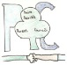**St Patrick’s Parent Council**

St Patrick’s has an active Parent Council which has an excellent relationship with the school. There is a very successful PTA sub-group of the Council that holds various fundraising events throughout the year to support the work of the school.

Meetings are held regularly in the school on a Monday night at 7pm, and dates are given in the ‘Dates for Your Diary’ section of the newsletters, via X and via the Parent Council Facebook page.

Events are made known by Groupcall, emails, X and the Parent Council Facebook Group. New members are always welcome – the school office can be contacted for more information.

**Committee Members are:**

Mrs L Meek

Chairperson

Mrs J McLachlan and Mrs L Wilson

Treasurers

Mrs J Thomson and Ms Y Scott

Secretaries

Mrs G Ogilby

Co-opted staff member

MEALS

School meals are provided on a cafeteria basis. In Inverclyde, all children in P1-7 are entitled to a free school meal. Hot meals, snacks, sandwiches, fruit, drinks etc are available daily. Our Catering Manager, can also cater for children who require a special diet, so please inform the school if this is necessary. The school dinner menu can be viewed on the Inverclyde Council website;

<https://www.inverclyde.gov.uk/education-and-learning/schools/school-lunch/school-lunches-in-primary-school>

Children can bring a packed lunch to eat while sitting in the dining hall if they prefer. There are adults present, in a supervisory capacity, in the school dining hall for children’s safety.

There is, in Inverclyde, an Education Services Health Policy and using this we have succeeded in making our school a “Health Promoting School”. This was achieved through improved health awareness in the curriculum, greater opportunities for physical activity – as shown by our after-school activities, healthier school meals and by giving out fruit as a snack.

Parents/Carers of children receiving one of the benefits as outlined on page 25 will normally be entitled to monetary grants for free school meals. Information and application forms for free school meals may be obtained from schools and Education Services, Wallace Place, Greenock, PA15 1JB.

TRANSPORT

The Council currently has a policy of providing free transport to all primary pupils who live more than one mile from their local school by the recognised shortest walking route. This policy is more generous than the law requires. This means that the provision of transport could be reviewed at any time. Parents/Carers who consider they are eligible should obtain an application form from the school or Education Services at Wallace Place, Greenock, PA15 1JB. These forms should be completed and returned before the end of February for those pupils beginning school in August to enable the appropriate arrangements to be made.

Applications may be submitted at any time throughout the year but may be subject to delay whilst arrangements are made. The appropriate officer has discretion in special circumstances to grant permission for pupils to travel in transport provided by the authority, where spare places are available and no additional costs are incurred.

**Pick up Points**

Where free transport is provided it may be necessary for pupils to walk a certain distance to the vehicle pick-up point. Walking distance in total including the distance from home to the pick-up point and from the drop-off point to the school in any one direction will not exceed the authority’s limits (see above paragraph). It is the parent’s/carer’s responsibility to ensure that their child arrives at the pick-up point in time. It is also the parent’s/carer’s responsibility to ensure the child behaves in a safe and acceptable manner while boarding, travelling in and alighting from the vehicle. Misbehaviour could result in a child losing the right to free transport.

**Placing Requests**

Education Services does not provide transport for those pupils in receipt of a placing request other than in exceptional circumstances. In the case of under-age placing requests if the child is offered a place in his/her catchment area school, transport will be provided in accordance with Council policy stated above.

INFORMATION IN EMERGENCIES

We make every effort to maintain a full educational service, but on some occasions, circumstances arise which lead to disruption. Schools may be affected by, for example, severe weather, temporary interruption of transport, power failures or difficulties of fuel supply. In such cases we will do all we can to let you know about the details of closure or re-opening.

We shall keep you in touch by using email, Inverclyde Council Website, Social Media and announcements in the press and on local radio.

<https://www.inverclyde.gov.uk/>

CHILD PROTECTION

Inverclyde Council Education Services has Child Protection Guidelines and Procedures which all schools are required to follow. Education Services work very closely with other agencies namely Police Scotland, Health & Social Care Partnership (HSCP), NHS Greater Glasgow and Clyde and the Children’s Reporter to support children. Common responsibilities of all staff are to protect children from abuse and exploitation, to respond appropriately when abuse is identified, and to ensure whenever possible that all children are able to exercise their right to be raised in a warm, stimulating and safe environment, supported by their families or carers.

In St Patrick’s, all staff have a responsibility to safeguard and protect our children. Safety is our first priority in our responsibility of Getting It Right For Every Child. Staff with any concerns about a child’s safety or welfare report directly to Mrs Doherty, Mrs Ogilby, Mrs O’Neill or Mrs Docherty; who each undertake the role of Child Protection Officers.

INCLUSION AND EQUALITY

Inverclyde Council Education Service aims to:

* Offer education of the highest quality to all young people within a developing culture of inclusion;
* Endorse the principles of inclusion, entitlement and equality of opportunity in the development of best practice;
* Value the diversity of interests, qualities and abilities of every learner;
* Believe that every child and young person is entitled to educational opportunities which enable the achievement of success and further development of the individual’s learning potential within the least restrictive environment;
* Affirm the right of all young people to have access to the highest quality of educational provision which is appropriate to learning needs, is supportive of the young person and is delivered in partnership with young people, parents and the wider community.

In meeting the needs of all of our pupils we will demonstrate no discrimination on the basis of race, gender, disability, sexual orientation, religion or belief. This encompasses curricular, extra-curricular and classroom activities and is foremost in the attitudes which we develop in our pupils.

EQUALITIES

Inverclyde Education Service is committed to ensuring that no children or members of staff or service users receive less favorable treatment on any ground including age, gender reassignment, pregnancy and maternity, race, disability, sex, sexual orientation, marriage and civil partnership, religion or belief. We have a moral, social and legal obligation to mainstream and put equality at the heart of everything we do. We aim to promote a culture in which equality of opportunity exists for all. We are opposed to all forms of discrimination, direct or indirect, and aim to eliminate all discriminatory practices. We will ensure that, in our schools and other educational establishments, equality permeates the curriculum and underpins all our policies and practices in terms of access to education.  We must ensure that all our children achieve their full potential to develop physically, emotionally and academically. Finally, we believe that equality and inclusion should be a given right, where everyone is valued and treated with respect.

USEFUL ADDRESSES AND CONTACTS

**CORPORATE DIRECTOR OF EDUCATION, COMMUNITIES & ORGANISATIONAL DEVELOPMENT**

Ms Ruth Binks

Municipal Buildings

Clyde Square

GREENOCK

PA15 1LX

**Phone:**  01475 712761

**LOCAL AUTHORITY EDUCATION OFFICE**

Inverclyde Council

Wallace Place

GREENOCK

PA15 1JB

**Phone:** 01475 712850

**Head of Education**:

Mr Michael Roach

Education HQ

Wallace Place

Greenock

PA15 1JB

01475717171

**SKILLS DEVELOPMENT SCOTLAND**

112 West Blackhall Street,

GREENOCK

**Phone:** 01475553710

**Head of Inclusive Education, Culture & Corporate Policy:**

MrTony McEwan

Education HQ

Wallace Place

Greenock

PA15 1JB

01475717171

**CONVENER EDUCATION & COMMUNITIES COMMITTEE**

Councillor Jim Clocherty

Education Services Committee

Municipal Buildings

GREENOCK

**Phone:** 01475 712727

**COMMUNITY LEARNING & DEVELOPMENT**

James Watt Building

105 Dalrymple Street

Greenock

PA15 1HU

**Phone:** 01475 715450

**BOOKING OFFICE**

Gamble Halls

Shore Street

Gourock

**Phone:** 01475 213131

(Community Groups wishing to hire school facilities should contact above address)

LOCAL COUNCILLORS

**Ward 3**

Mr Colin Jackson

Mr Michael McCormick

Ms Pam Armstrong

**Ward 4**

Ms Francesca Brennan

Mr Graeme Brooks

Mr Jim Clocherty

Mrs Elizabeth Robertson

**Ward 7**

Mr John Crowther,

Mr Tommy McVey

Ms Natasha McGuire

**Phone:** 01475 712727

INVERCLYDE COMPLAINT PROCEDURE

Inverclyde Council is committed to providing high quality customer services. **We value complaints and use information from them to help us improve our services.**  If something goes wrong, or you are dissatisfied with our services, please tell us. Details can be found using the link below;

[How to make a complaint - Inverclyde Council](https://www.inverclyde.gov.uk/council-and-government/complaint)

GENERAL DATA PROTECTION REGULATION AND DATA PROTECTION ACT 2018

Information on children, parents and guardian is stored on a computer system and may be used for teaching, registration, assessment and other administrative duties. In processing personal information, Inverclyde Council must comply with the General Data Protection Regulation and Data Protection Act 2018.

For further information please refer to <https://www.inverclyde.gov.uk/site-basics/privacy> or click on the following: [Privacy page link](https://www.inverclyde.gov.uk/site-basics/privacy)

A range of authority policies relating to education can be found on the Inverclyde Council website;

<https://www.inverclyde.gov.uk/education-and-learning/schools>

**Although the information contained in this Handbook is correct at time of writing (December 2024), there could be changes affecting any of the matters dealt with in the document;**

1. before the commencement or during the course of the school year in question
2. in relation to subsequent school years