**St Patrick’s Primary**

Standards & Quality Report

2023-2024

and

School Improvement Plan

2024-2025

**Family Edition**

**October 2024**

**Vision, Values and Aims of St Patrick’s Primary School**

**Our Vision**

In St Patrick’s we strive to provide a secure, happy, caring school in which children are nurtured and enabled to achieve their full potential through effective learning and teaching experiences of the highest quality.

**Our Motto**

Our motto is inspired by our Patron Saint, St Patrick; ***Christ be beside me in all I say, all I do and all I am*.**

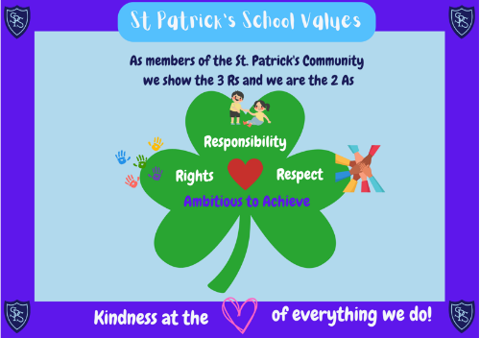

**Our Values**

Members of St Patrick’s Primary School community have **Kindness** at the heart of all we do, and are guided by the **3 R**s; **Respect, Rights** and **Responsibility** and the **2 A**s; we are **Ambitious** to **Achieve**.

**Our Aims**

• To foster an open, welcoming and caring school in which all children feel safe, healthy, achieving, nurtured, active, respected, responsible and included.

• To nurture successful learners by providing all pupils with the best opportunities to achieve their full potential and prepare them for a life of learning.

• To inspire responsible citizens who develop positive attitudes to serve the common good and promote social justice and opportunity for all.

• To form confident individuals with a self-belief and passion for using their God given talents to pursue excellence for themselves and others.

• To encourage effective contributors with enterprising attitudes, resilience and independent skills capable of positively impacting on the communities in which they live.

• To develop as a community of faith, promoting Gospel values and respecting the dignity of all God’s children.

**Standards and Quality Report 2023-2024**

*We review our progress with the improvements we planned for 2023-2024. This helps us to plan for further improvement in 2024-2025.*

**How did we do? Attainment.**

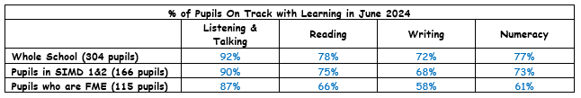Overall, our attainment stayed stable from last year. This is reassuring as we had 38 new children and 71% of new pupils were new to the Scottish Curriculum.

**How did we do? Attendance.**

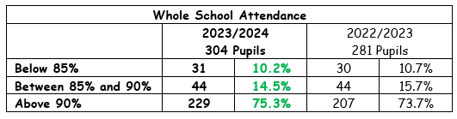Our attendance rate for 23-24 was 93.1% - an increase of 0.6% from last year. That is 0.4% higher than similar schools to us in Inverclyde and 0.2% higher than the Inverclyde average for all Primary Schools. Pupils who are not attaining national expectations tend to have higher absence rate and higher late-coming.

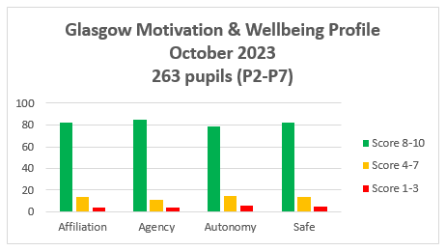**How did we do? Health & Wellbeing of our Pupils.**

We continued to have high scores when P2-P7s completed the *Glasgow Health & Wellbeing Survey*. The graph shows that most of our pupils chose the highest scores and so feel healthy, safe, included and valued here in St Patrick’s.

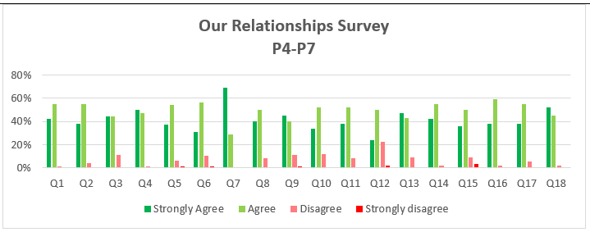Our Pupil Council organised surveys for our pupils to find out how good our relationships are. P1-P3 completed a Hands-up Survey and P4-P7 complete a Form online. Pupil Council analysed the data and were pleased to report that relationships are a key strength in St Patrick’s.

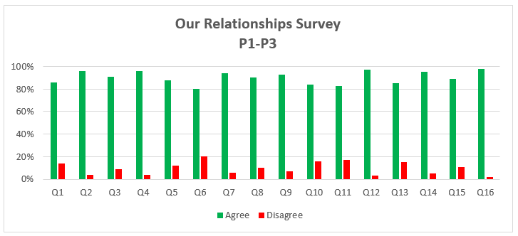

We had many more successes and key achievements. You can read about them in our full *Standards and Quality Report for 2023-2024* on the [St Patrick’s School Website](https://blogs.glowscotland.org.uk/in/stpatricksprimary/).

**School Improvement Plan 2024-2025**

*Our Improvement Plan shows what we will work on to improve our school. Having talked to and listened to pupils, staff and our parents/carers, C:\Users\Angela\AppData\Local\Microsoft\Windows\Temporary Internet Files\Content.IE5\WBMZU3R7\MC900089034[1].wmf our priorities are:*

**School Priority 1: Learning, Teaching and Assessment**

* *Teaching Sprints* approach to assess impact of change.
* “Magical Moments” celebrated at Assemblies.
* Improve attainment in reading – phonics, fluency, comprehension and reading for pleasure.
* Keep working as a staff with our Cluster schools to keep improving learning, teaching and assessment. Staff to attend Power Up Your Pedagogy as a Cluster.
* Improve attainment in writing – use Inverclyde’s Framework for sentence building and planning for writing.
* Pupil Feedback – Feedback Fridays and WOW Work Wednesdays.

**School Priority 2: Pull to School**

* Review Curriculum Rationale – what we teach and what children learn.
* Improve Pupil Leadership:
  + P1-P3 – Little People, Big Voices!
  + P4 – Mini Vinnies
  + P4/5 – Sports Group
  + P5 – Rights Respecting Promoters
* P6 – Laudato Si / and Eco friendly
* P6/7 – Anti-Racism
* P7 – Equalities
* Better Yearly Overviews for learning about Global Citizenship, Cultural Diversity, Building Racial Literacy and Emotional Literacy.
* Improve Outdoor Learning – staff to engage with Learning Through Landscapes training.

**School Priority 3: Health & Wellbeing**

* Continue to build positive relationships – Pupil Council to act on last session’s survey responses.
* Launch St Patrick’s Anti-bullying Charter.
* All staff to continue Trauma Informed Practice training.
* Whole Family Wellbeing Pilot with Educational Psychology.

*These are our main priorities and areas of focus for this year.*

*The full version of the School Improvement Plan 2024-2025 is on the* [*St Patrick’s School website*](https://blogs.glowscotland.org.uk/in/stpatricksprimary/)*.*

We want our parents/carers to be involved in their children’s learning. We hope to see as many of you as possible in our school over this year.You can keep up-to-date by reading our regular Newsletters that are emailed to you, and by following us on Twitter: [**@StPatricksPS15**](https://twitter.com/stpatricksps15)