St Patrick’s Primary School
Standards and Quality 2022/23
Context of the School
St Patrick’s Primary is a denominational primary school (Roman Catholic), which serves the centre of Greenock, providing education for pupils from P1 to P7. The building was newly built and opened in November 2016. It is a bright, stimulating environment for children to learn. Features make the most of natural light and the stunning views over the River Clyde. Accommodation includes 12 classrooms, a PE hall, a library area, a dining area, 3 playground areas and daily access to the adjacent 3G football pitch owned by Inverclyde Leisure.
Our Vision
In St Patrick’s we strive to provide a secure, happy, caring school in which children are nurtured and enabled to achieve their full potential through effective learning and teaching experiences of the highest quality.
Our Motto
Our motto is inspired by our Patron Saint, St Patrick; Christ be beside me in all I say, all I do and all I am.
Our Values
Members of St Patrick’s Primary School community have Kindness at the heart of all we do, and are guided by the 3 Rs; Respect, Rights and Responsibility; and the 2 As; we are Ambitious to Achieve.
Our Aims
- To foster an open, welcoming and caring school in which all children are safe, healthy, achieving, nurtured, active, respected, responsible and included.
- To nurture successful learners by providing all pupils with the best opportunities to achieve their full potential and prepare them for a life of learning.
- To inspire responsible citizens who develop positive attitudes to serve the common good, promote social justice and opportunity for all.
- To form confident individuals with a self-belief and passion for using their God given talents to pursue excellence for themselves and others.
- To encourage effective contributors with enterprising attitudes, resilience and independent skills capable of positively impacting the communities in which they live.
- To develop as a community of faith, promoting Gospel values and respecting the dignity of all God’s children.

We currently have 281 pupils over 10 classes, four of which are composite. 59% of our pupils live in areas defined as SIMD 1&2. 41% of our pupils are in receipt of Free School Meals.

13.8 teachers were allocated to the school, but using the Pupil Equity Fund, as well as support from the Scottish Attainment Challenge and Scottish Government funding, teaching allocation became 16.9. The Senior Leadership Team consists of the Head Teacher, one Depute Head Teacher and an Acting Principal Teacher. The school was also supported by 12 Pupil Support Assistants (6 of whom were part-time), 2 Clerical Assistants and the Janitor.
School Priority 1
NIF Priority  Improvements in attainment, particularly in literacy and numeracy  NIF Driver  Assessment of children's progress  Teacher professionalism | HGIOS QIs  2.3 Learning, teaching and assessment  3.2 Raising attainment and achievement  UNCRC  Article 28: (Right to education):  Article 29 (Goals of education):  Developing in Faith  Developing as a community of faith and learning
Outcomes:
- By June 2023 almost all learners will be On Track in Listening & Talking (95%), and most learners in Reading (87%), in Writing (86%) and in Numeracy (86%).
- By Term 4, learning observations will show almost all learners (91-99%) will experience high quality, differentiated learning in Reading.
- By end of May 2023, children’s attainment in Reading will be based on more robust assessment procedures.
- By May 2023 all P1 pupils will have had increased opportunities to engage in child-initiated play compared with baseline.
- By May 2023 all P2 pupils will have had increased opportunities to engage in play compared with baseline.
- By June 2023, whole school attendance rate will increase to 94.6% (3-year average from pre-covid years, 2017-2019).

PEF used to support closing the gap:
- Teacher (0.2) to support developmentally appropriate play for P1 and P2 - £12,000
- Teacher (1.1) to release Acting PT and additional staffing to support teachers across P2-P7 with high quality learning and teaching - £66,000

Progress and impact of outcomes for learners:
- Almost all learners were On Track in Listening & Talking (91%); most learners were On Track in Reading (79%) and Numeracy (80%); and the majority of learners were On Track in Writing (73%). This falls below the targets set last session. Targets were based on pre-covid averages and were too optimistic. Despite not meeting the targets set, the majority of learners who were Behind Expectation in August 2022, made a year’s progress; 65% in Listening & Talking, 64% in Reading, 57% in Writing and 62% in Numeracy. Interventions were not able to be implemented as planned this session, for a variety of reasons. However, next year, there will be protected space around implementation of support provision and intervention delivery.
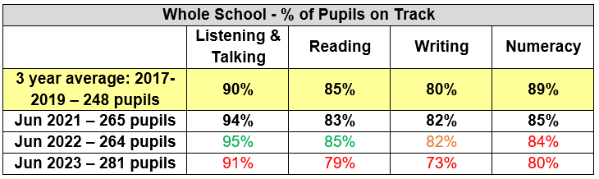

- Reading materials and approaches are improved quality and have led to a more differentiated experience for most learners.
- Assessment procedures in Reading are more robust with almost all NSA results matching TPJs during interrogation at Progress Meetings in May.
- P1 engage in child-initiated play throughout the day with adult-led learning for explicitly taught skills.
- P2 now have child-initiated play opportunities daily.
- Whole school attendance rate is 92.6%. Although, a 2% shortfall on the target set, this is an increase of 1.6% from previous year. Target set last year was based on pre-covid averages and was too optimistic.
Next Steps:
- Effective learning, teaching and assessment to ensure a year’s progress for a year’s worth of teaching in Literacy and Numeracy.
- Develop a culture of reading within the school and focus on effective learning and teaching to promote fluency and comprehension.
- Engage school community in more systematic self-evaluation for continuous improvement through quality assurance process.

School Priority 2
NIF Priority  Closing the attainment gap between the most and least disadvantaged children and young people  NIF Driver  Assessment of children's progress  Teacher professionalism  Parental engagement | HGIOS QIs  2.3 Learning, teaching and assessment  3.2 Raising attainment and achievement  UNCRC  Article 28: (Right to education):  Article 29 (Goals of education):  Developing in Faith  Developing as a community of faith and learning
Outcomes:

By June 2023, attendance rate for children living in SIMD 1&2 will increase to 93.5% (3-year average from pre-covid years, 2017-2019).
- By June 2023, the gap between SIMD 1&2 and SIMD 3-10 in achieving above 90% will decrease to 8% maximum (in line with previous year’s gap).
- No child will have below 85% attendance rate by June 2023.
- By June 2023, for children living in SIMD 1&2, attainment in Listening & Talking will be maintained at 94%, and increase to 85% in Reading (increase of 2% on June 22), 81% in Writing (increase of 4% on June 22) and 84% in Numeracy (increase of 3% on June 22).
- By June 2023, for children who are in receipt of FSM, attainment in Listening & Talking will be maintained at 91%, and increased to 80% in Reading (increase of 4% on June 22), 73% in Writing (increase of 3% on June 22) and increased to 81% in Numeracy (increase of 5% on June 22).
- Almost all children (91-99%) who are behind expectation will make a year’s progress for a year’s teaching by the end of June 2023.
- By March 2023, identified parents will show an increase in confidence as a result of participation in specific CLD-run parent interventions.
- By June 2023, almost all parents (91-99%) will have engaged in at least 1 class-specific/curricular parental involvement activity within school.
- By June 2023, almost all parents of P1 and P2 pupils will have an increased understanding of Play Pedagogy compared to their baseline.

PEF used to support closing the gap:
- Teacher (1.1) to release Acting PT and additional staffing to support teachers across P2-P7 with high quality targeted interventions - £66,000
- Resources to support parental engagement - £160.41

Progress and impact of outcomes for learners:
1 – 3: Although targets set for improved attendance were not realised, St Patrick’s continued to have better attendance rate than our Family Group in Inverclyde. Our overall attendance for session 2022-23 is 92.6%, compared with Family Group average of 91.9%. Children living in SIMD 1&2 had increased attendance of 1.7% from previous year to 91.7%. The gap between SIMD 1&2 and SIMD 3-10 in achieving above 90% attendance was reduced by 11.8% to 14.6%. There was a significant increase in attendance of over 90% for children living in SIMD 1&2 to 68.1%, an increase of 33.9% on the year before. 30 pupils had attendance below 85%, a reduction of 3.2%. 7 children were referred to the Children’s Reporter on the grounds of attendance.
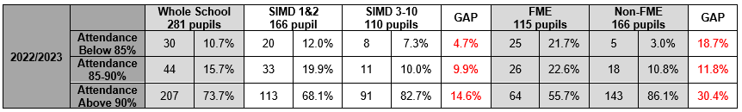

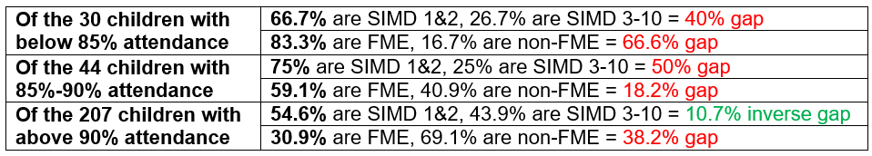

4 – 6: For children living in SIMD 1&2, almost all learners were On Track in Listening & Talking (92%); most learners were On Track in Reading (77%) and Numeracy (77%); and the majority of learners were On Track in Writing (68%).
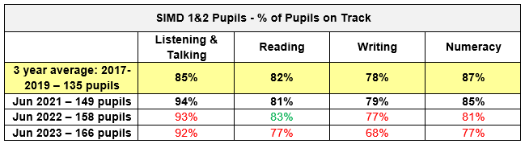

For children who were FME, most learners were On Track in Listening & Talking (87%); and the majority of learners were On Track in Reading (67%), in Writing (56%) and in Numeracy (69%).
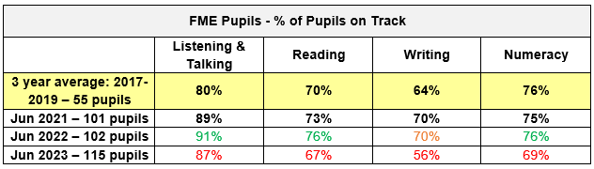

These attainment figures fall below the targets we set last session. Targets were based on pre-covid averages and were too optimistic. Additionally, interventions were not able to be implemented as planned this session, for a variety of reasons. In recognition of this, we targeted support towards children who are most at risk of being impacted by poverty. As a result, the majority of children living in SIMD 1&2 or who are FME made a year’s progress for a year’s worth of teaching. This shows that, despite the limitations to the implementation of our interventions and targeted support, our priority was to focus support most to children who could be disadvantaged by poverty.

Of the children who are Behind Expectation in June 23, but made a year’s progress, the majority or most of them were living in SIMD 1&2 (74%-77%) or were FME (62%-71%).
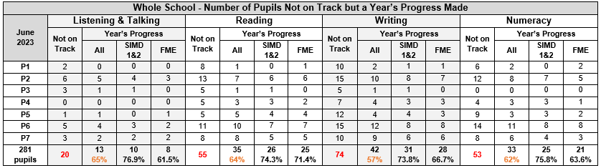

7. There were limitations on provision this session. Family Reading Club impacted 3 families and 6 children. We received good feedback from parents with regards to supporting their children’s reading. Parent Drop-in Café, Chatty Crafty Group and Broth and a Blether had regular participation with families reporting positive experiences.
8. A good to very good turnout of parents (ranging from 60%-80%) was evident at the various workshops on offer this year. In-class events were better attended than generic, curricular events.
9. All of the parents who attended the Play Pedagogy learning events held by P1 and P1/2 classes, noted an increase in their understanding of learning through Play Pedagogy.
Next Steps:
- Improve attendance.
- Enhance personalised support including targeted support and interventions.
- Enhance parental engagement.

School Priority 3
NIF Priority  Improvement in children and young people's health and wellbeing  NIF Driver  School Improvement  Teacher professionalism | HGIOS QIs  2.1 Safeguarding and child protection  2.2 Curriculum  2.3 Learning, teaching and assessment  3.1 Ensuring wellbeing, equality and inclusion  UNCRC  Article 2 (Non-discrimination):  Article 4 (Protection of rights):  Article 29 (Goals of education):  Article 42 (Knowledge of rights):  Developing in Faith  Honouring Jesus Christ as the Way, the Truth and the Life  Developing as a community of faith and learning  Promoting Gospel values  Serving the common good
Outcomes:
- By December 2022, upper school pupils will have improved skills, knowledge and confidence to cope with challenges and adversity.
- By December 2022, upper school pupils will have increased confidence, resilience, compassion and empathy for others.
- By April 2023, pupils across the school will have an increased awareness and understanding of equality and inclusion, compared with baseline data.
- By June 2023, pupils across the school will have an increased awareness, knowledge and understanding of cyber resilience and internet safety compared with baseline data.

PEF used to support closing the gap:
- Participatory Budgeting = £2,000 (2.5% approx.) to enhance reading materials.
  - supplement resources to support Equality and Inclusion – reading materials to be more diverse

Progress and impact of outcomes for learners:
1 & 2: Individual pupils in the P6 and P7 year groups engaged in regular/daily check-ins with SLT and identified PSAs to promote strategy-use to minimise undesirable responses. Targeted learners were involved in less conflict. Staffing issues impacted PSAs ability to coach and model in playground/pitch setting.
3. Pupils in P6 and P7 year groups engaged in workshops centred on protected characteristics. Almost all pupils had increased awareness and understanding compared with pre-intervention. Instances of language centred around protected characteristics used to “banter” or “roast” peers has persisted. There is a greater range of materials to support diversity, equality and inclusion.
4. Staffing change resulted in this outcome not being fulfilled. A new member of staff with skills and experience has been identified for next session.
Next Steps:
- Continue to focus on promoting positive relationships.
- Focus on meeting the social and emotional needs of our children.
- Develop systems to improve pupil engagement and authentic pupil voice.

School Priority 4
NIF Priority  Improvement in skills and sustained, positive school-leaver destinations for all young people  NIF Driver  School Improvement | HGIOS QIs  2.2 Curriculum  2.3 Learning, teaching and assessment  3.3 Increasing creativity and employability  UNCRC  Article 29 (Goals of education):  Article 42 (Knowledge of rights):  Developing in Faith  Honouring Jesus Christ as the Way, the Truth and the Life  Developing as a community of faith and learning  Promoting Gospel values  Serving the common good
Outcomes:
- By October 2023, almost all children across all stages will be able to articulate, appropriate to their stage, what it means in St Patrick’s to be a Laudato Si’ school.
- By June 2023, almost all children across all stages will be able to articulate, appropriate to their stage, their pledge to be Stewards of God’s creation – to love God by looking after each other and protecting our world.
- By June 2023, learning through Laudato Si’ will be progressive in line with draft IDL planner.

Progress and impact of outcomes for learners:
1 – 3: Changes to staffing meant our Laudato Si’ journey did not progress to intended outcomes. A member of staff has been identified to lead curricular change with regards to linking Laudato Si’, Children’s Rights and Global Goals for next session.
Next Steps:
- Build racial literacy.
- Engage in West Partnership’s collaborative action research: Primary Curriculum – The Refreshed Narrative – How Do We Do It?
- Pilot new Social Studies planners to promote contexts for learning, IDL and promote pupil engagement.

School Priority 5
NIF Priority  Placing the human rights and needs of every child and young person at the centre of education  NIF Driver  School leadership  School Improvement | HGIOS QIs  1.1 Self-evaluation for self-improvement  1.2 Leadership of learning  1.3 Leadership of change  3.1 Ensuring wellbeing, equality and inclusion  UNCRC  Article 12 (Respect for the views of the child):  Article 29 (Goals of education):  Developing in Faith  Developing as a community of faith and learning  Serving the common good
Outcomes:
- Increased pupil engagement with school improvement process for P7 pupils leading the Plan, Do, Reflect and Share cycle.
- Increased opportunities for pupils across the school to have their voices heard and recorded to impact improvements in the school through process of data gathering.

Progress and impact of outcomes for learners:
1 & 2: Pupil Council representatives engaged in discussions with SLT to use HGIOurS? Theme 1 – Our Relationships to create a baseline of views around the features of highly effective practice. Senior Pupil Council reps have turned these features into questions, appropriate to the age and stage of pupils across the school to gather baseline data in August.
Next Steps:
- Launch child-friendly St Patrick’s Positive Relationships Policy.
- Continue to use HGIOurS? With pupil leadership group. Theme 2: Our Learning and Teaching.
- Engage in Young Leaders of Learning programme.

Additional PEF Spend – Cost of the School day
NIF Priority  Closing the attainment gap between the most and least disadvantaged children and young people | HGIOS QIs  2.4 Personalised support  3.1 Ensuring wellbeing, equality and inclusion  UNCRC  Article 31 (Leisure, play and culture):  Developing in Faith  Serving the common good
Spend: £3,206.96
Progress and impact of outcomes for learners:
- Families supported with the cost of the P7 residential trip to Millport so that all pupils had equitable offer of experience.
- Families supported with the cost of educational visit (all classes across the school) to mitigate the increase in cost of living to ensure that all pupils had equitable access to trip to enhance learning.
Next Steps:
- Continue to minimise the cost of the school day.

Data
Key Strengths of the School:

- Continued high results from Glasgow Motivation & Wellbeing Profile show that our children feel nurtured, included, safe and respected.
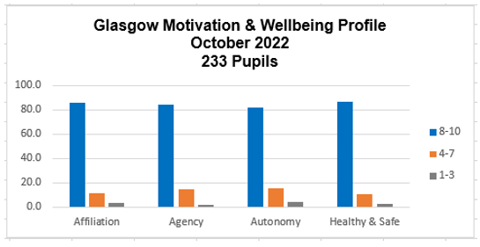

- Across the school, there is a high level of effort and behaviour. 96% of children across the school were awarded a grade 1 or 2 from a 4-point scale for effort. 93% of pupils were awarded a grade 1 or 2 from a 4-point scale for behaviour.
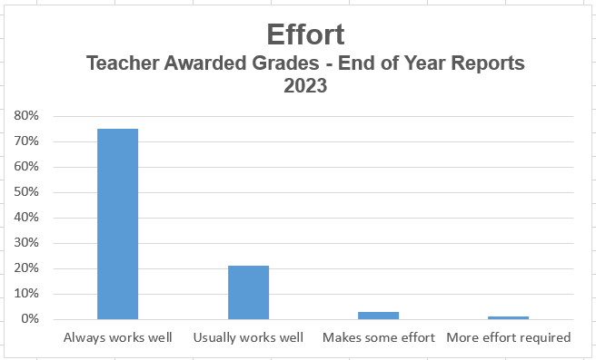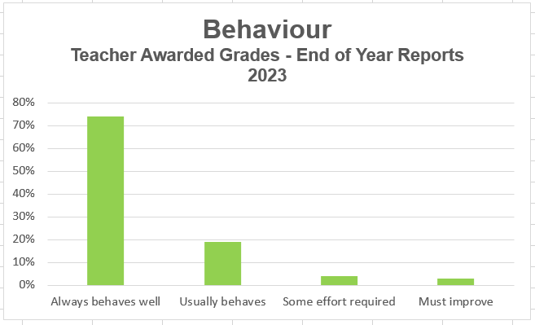

Key Priorities for the School:

- Raise attainment for all.
- Reduce poverty-related attainment gap.
- Increase pupil engagement and promote pupil leadership.
- Refresh curriculum.

National Improvement Framework Quality Indicators
1.3 Leadership of change Good
Key Strengths of the School:
- The vision of the school puts children at the centre. It is focused on the children’s needs and improving their opportunities and outcomes.
- Staff have a clear understanding of the context of the school and are committed to ensuring the highest possible standards and success for all learners. Their daily work is underpinned by the established school values.
- Senior leaders protect time for professional dialogue and collegiate learning.
- We have effective strategies in place to monitor and evaluate the impact of changes on outcomes for learners and the work of our school.
- Senior leaders inspire and motivate staff to work in a culture of curiosity and reflection through collegiality and collaboration.

Key Priorities for the School:
- Self-evaluation for continuous improvement. All members of the school community will contribute to quality assurance process more systematically to ensure high quality.
- Staff, pupils and partners will engage regularly in critical and creative thinking to reflect on and develop practice taking account of self-evaluation and vision for continuous improvement.
- As a result, children will have developed increased capacity to respond and adapt to change.

2.3 Learning, teaching and assessment Good
Key Strengths of the School:
- The learning environment is built on positive, nurturing and appropriately challenging relationships which lead to high-quality learning outcomes.
- Our practice and approaches are evidence-based.
- Termly planning is proportionate and manageable and clearly identifies what is to be learned and assessed.
- Inverclyde Pathways are used in the learning, teaching and assessment cycle to ensure progression.
- Tracking and monitoring processes are well-understood and used effectively to understand pupils’ progress and needs, in planning appropriate learning.
- All teachers have well-developed understanding of data and engage in analysis with SLT to plan for next steps.

Key Priorities for the School:
- Learners will receive high-quality feedback and have an accurate understanding of their progress in learning and what they need to do to improve.
- Learners will be able to give effective feedback to peers on their learning and suggest ways in which they can improve.
- Processes for assessment and reporting are manageable and very effective in informing planned improvements in learning and teaching.
- Learners’ achievements in and out of school will be recorded and recognised.
- Learners will play a more active role in the school and wider community and regularly take on leadership roles, including leading learning.

3.1 Ensuring wellbeing, equality and inclusion Very Good
Key Strengths of the School:
- The whole learning community has a shared understanding of wellbeing and children’s rights.
- All staff promote a climate where children and young people feel safe and secure.
- All staff and partners model behaviour which promotes and supports the wellbeing of all.
- All staff and partners are sensitive and responsive to the wellbeing of each individual child and colleague.
- Staff and partners have created an environment where children and young people feel listened to and are secure in their ability to discuss personal and sensitive aspects of their lives because they feel cared about.
- Children and young people are knowledgeable about equalities and inclusion. Most children feel able to challenge discrimination, xenophobia and intolerance when they come across it.
- Children have more opportunities for outdoor learning and learning outdoors.

Key Priorities for the School:
- The curriculum will provide children with well-planned and progressive opportunities to explore diversity and multi-faith issues, and to challenge racism and religious intolerance.
- Better use of playground and resources to encourage child-initiated play during intervals and lunch times.
- Children will better know, understand and use the wellbeing indicators as an integral feature of school life.

3.2 Raising attainment and achievement/Securing children’s progress Good
Key Strengths of the School:
- Attainment levels in literacy and numeracy are a central feature of the school’s priorities for improvement and raising attainment for all.
- Attainment is monitored frequently. Interventions and supports are adapted in response to the needs of the children.
- Established robust tracking of attainment over time in Literacy, Numeracy and Health & Wellbeing at all stages.
- Teacher judgements are based on assessment of achievement of pathways and benchmarking.
- Exclusion rates are low and inclusion is important to all staff.
Key Priorities for the School:
- Almost all children will attain appropriate levels and the data will demonstrate our current learners are making very good progress.
- Children will be fully engaged in their learning and participate in decision-making about their learning pathways.
- The school will empower children more to have a say in the quality of their learning experiences and how to improve.
- Attendance levels will be high and improving.
- There will be evidence that children are applying and increasing their achievements through active participation in their local community.

Other quality indictors evaluated from 3 year plan:
1.1 Self-evaluation for self-improvement
2.2 Curriculum
Key Strengths of the School:
- Across the year, there is focused attention on monitoring and evaluating learning and teaching and children’s achievements, and to taking improvements forward.
- Staff work effectively as a team. There is a strong ethos of sharing practice, and of peer support and challenge.
- Forward planning is sufficiently detailed and has a clear purpose.
- Professional learning activities for all staff are clearly linked to the results of self-evaluation and identified areas for improvement
- All staff understand the need to be outward and forward-looking in their evaluation and improvement activities.
- Teachers use a range of different assessments to measure children’s progress in Literacy and Numeracy.
- Parents have regular opportunities to support improvement by participating in a range of formal and informal activities.
- All staff are ambitious and expect high levels of attainment and achievement for all learners.
- Time is protected for professional learning and collegiate working to develop the curriculum.
- School leaders provide a clear direction through a manageable long-term plan for the ongoing development of the curriculum.
- There is a clear focus on developing skills of literacy and numeracy.

- Key Priorities for the School:
- Self-evaluation will be integral to how we work within our community and be an ongoing feature of school life for all staff, pupils, parents and partners to engage in.
- Children will take more of a lead role in aspects of school improvement.
- Staff will work more effectively with colleagues in-school and across the Cluster to moderate effective learning, teaching and assessment.
- Children will confidently engage in reviewing their own learning and the work of the school.
- All stakeholders will be able to talk about how the unique features of the school community inform the design of the curriculum.
- Planning for progression in learning will focus on the four contexts and show how knowledge, understanding and skills are built over time.
- Outdoor learning will be a more progressive curriculum-led experience for all learners.

Key Achievements of the School
We are proud of the achievements of our pupils and school community:

- Our strong partnership with our school chaplain, Fr Gerry, and St Patrick’s Parish:
  - Mission Group
    - Pupil voice group who worked together to liaise with Fr Gerry to create a school prayer and share with school and parish.
    - Example of good practice highlighting the importance of school, parish and home partnerships – article will appear in August edition of the Diocese of Paisley’s Centred on Christ.
  - Our upper school pupils lead the Liturgy of the Word at 11am Mass on the first Sunday of every month in the Church
  - Our pupils returned to leading the school in-person Advent Reflections and Lenten Reflections
  - Linked with SVDP to understand and support St Patrick’s Parish Foodbank
- Our children were able to continue their charitable work throughout the year:
  - In Lent the SCIAF Wee Box appeal raised £274.64.
  - Contributed to Compassionate Inverclyde Christmas card appeal.
- Strong partnership with Active Schools to provide lunch time clubs and after-school activities to encourage children to participate in activities and sports:
  - 80% of school roll
  - 58% of participants living in SIMD 1&2.
  - Engaging with NDHS Sports Leaders alongside Active Schools to develop skills and provide enhanced opportunities for our children to have wider sports and physical activity experiences.
  - Further opportunities for Cluster and neighbouring schools’ friendly football games and tournaments.
- Continued enhancement of the music curriculum from Inverclyde Music Services:
  - P5 have been attending drumming workshops thanks to Youth Music Initiative
  - Our school choir and vocal instruction contributed to the NDHS Cluster Concert, the Inverclyde Festival and the Inverclyde Concerts.
  - String and brass instruction continues with our students performing at NDHS Cluster Concert.
- Our Transition and Induction arrangements encouraged smooth preparations for our infants and upper school pupils:
  - Partnership working with our Cluster pre-establishments and 10 others.
  - Partnership working with NDHS.
  - Buddying programme fully operational and great feedback from new parents.
- Parental Engagement
  - Strong partnership with our Parent Council to enhance the experiences of our pupils and to contribute to school improvement.
  - Broth and a Blether. As a result of our strong partnership working with CLD Support Worker to secure funding from Communities and the Voluntary Sector, Inverclyde’s Warm Hand of Friendship initiative, our Parent Council established a very successful drop-in service for our families and friends on a Friday afternoon. Parents provided access to peer support, access to warm, winter clothes and school uniform, as well as access to hot soup, bread, beverages, biscuits, and the possibility to take away fresh veg soup packs, with accompanying recipes. There was also frozen soup in containers to be heated at home and signposting to further support in the community. Inverclyde Life
- Opportunities to increase play across the school continued:
  - Introduction of Play Pedagogy in Primary 2
  - Loose Parts Play for outdoor learning across the school
- Successful Partnership Working
  - Morton in the Community supported football coaching
  - Barnardo’s Family Support and Seasons for Growth
  - Community Learning Development – Chatty Crafty Parents Group, Family Reading Club in partnerships with Libraries Services – P1 – P3.
  - Educational Psychologist supported school priorities of Play Pedagogy, Positive Relationships and Buddying Recruitment process
  - 32nd Scout Group supported our transport needs to events as well as collaborating with us to enhance our outdoor education curriculum for senior pupils. P6 and P7 attended a half day at the Scouts Hall to engage in lots of different activities to enhance skills for learning, life and work.

