**St Patrick’s Primary**

Standards & Quality Report

2022-2023

and

School Improvement Plan

2023-2024

**Family Edition**

**September 2023**

**Vision, Values and Aims of St Patrick’s Primary School**

**Our Vision**

In St Patrick’s we strive to provide a secure, happy, caring school in which children are nurtured and enabled to achieve their full potential through effective learning and teaching experiences of the highest quality.

**Our Motto**

Our motto is inspired by our Patron Saint, St Patrick; ***Christ be beside me in all I say, all I do and all I am*.**

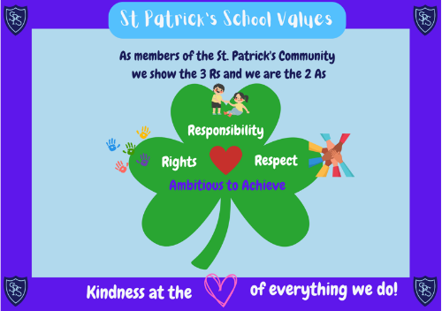

**Our Values**

Members of St Patrick’s Primary School community have **Kindness** at the heart of all we do, and are guided by the **3 R**s; **Respect, Rights** and **Responsibility** and the **2 A**s; we are **Ambitious** to **Achieve**.

**Our Aims**

• To foster an open, welcoming and caring school in which all children feel safe, healthy, achieving, nurtured, active, respected, responsible and included.

• To nurture successful learners by providing all pupils with the best opportunities to achieve their full potential and prepare them for a life of learning.

• To inspire responsible citizens who develop positive attitudes to serve the common good and promote social justice and opportunity for all.

• To form confident individuals with a self-belief and passion for using their God given talents to pursue excellence for themselves and others.

• To encourage effective contributors with enterprising attitudes, resilience and independent skills capable of positively impacting on the communities in which they live.

• To develop as a community of faith, promoting Gospel values and respecting the dignity of all God’s children.

**Standards and Quality Report 2022-2023**

*We review our progress with the improvements we planned for 2022-2023. This helps us to plan for further improvement in 2023-2024.*

**How did we do? Attainment.**

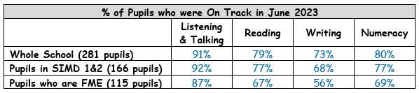Overall, our attainment dipped from last year as you can see from the table. However, thanks to our interventions to support children’s learning, the majority of our learners made a year’s progress in 22-23.

**How did we do? Attendance.**

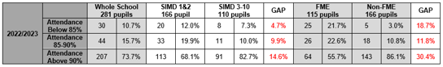Our attendance rate for 22-23 was 92.6%. That is higher than similar schools to us in Inverclyde. Children living in SIMD 1&2 (areas of high deprivation) had better attendance in 22-23 by 1.7%. We reduced the number of children with attendance below 85% by 3.2%. We had to get help from the Children’s Reporter this year for a number of children on the grounds of poor attendance.

**How did we do? Health & Wellbeing of our Pupils.**

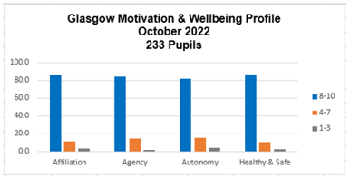Our P2-P7s completed the *Glasgow Health & Wellbeing Survey*. The graph shows that most of our pupils chose the highest scores and so feel healthy, safe, included and valued here in St Patrick’s. We will continue to monitor our children’s health and wellbeing and make any adjustments we can to support our pupils.

**How did we do? Parental Engagement.**

We were very well supported by our Parent Council, Shari our CLD worker, Library Services and our parents as a whole group.

* Family Reading Club for our infants
* Parent Drop-in Café
* Chatty Crafty Group
* Broth and a Blether
* Good turnout to our parental workshops (between 60% and 80%)

We had many more successes and key achievements. You can read about them in our full *Standards and Quality Report for 2021-2022*; found on our school website:

[St Patrick's Primary, Greenock | Inverclyde site (glowscotland.org.uk)](https://blogs.glowscotland.org.uk/in/stpatricksprimary/)

**School Improvement Plan 2023-2024**

*Our Improvement Plan shows what we will work on to improve our school. Having talked to and listened to pupils, staff and parents, C:\Users\Angela\AppData\Local\Microsoft\Windows\Temporary Internet Files\Content.IE5\WBMZU3R7\MC900089034[1].wmf our priorities are:*

**School Priority 1: Learning, Teaching and Assessment**

* New Forward Planning documents for teachers to plan children’s learning
* Review our assessment strategies so that children are more able to assess their own learning and make good decisions to move their learning forward
* Think about how we celebrate achievement and attainment in classes and as a school
* Encourage reading through a refreshed library and reading opportunities
* Keep working as a staff with our Cluster schools to keep improving learning, teaching and assessment



**School Priority 2: Personalised Support**

* Improve attendance, particularly for children with barriers to learning
* Develop personal learning plans further for children who are behind expectation
* Parental workshops to support children’s learning in positive relationships, school values, anti-bullying, literacy and numeracy



**School Priority 3: Health & Wellbeing**

* Support positive relationships between pupils
* Launch our Positive Relationships Policy with our families
* Create St Patrick’s Anti-bullying Charter
* All staff to take part in Trauma Informed Practice training
* Strengthen our Pupil Voice Groups, including Young Leaders of Learning

**School Priority 4: Refreshed Curriculum**

* Building Racial Literacy – develop our children’s understanding of racism and their confidence to challenge racism and promote racial equality
* Help children to make links in their learning to encourage greater understanding of skills and how to apply them in other subject areas and areas of interest
* Further develop Play Pedagogy

*These are our main priorities and areas of focus for this year.*

*The full version of the School Improvement Plan 2023-2024 can be found on the St Patrick’s School website:* [St Patrick's Primary, Greenock | Inverclyde site (glowscotland.org.uk)](https://blogs.glowscotland.org.uk/in/stpatricksprimary/)

We want our parents/carers to be involved in their children’s learning. We hope to see as many of you as possible in our school over this year.You can keep up-to-date by reading our regular Newsletters that are emailed to you, and by following us on Twitter: [**@StPatricksPS15**](https://twitter.com/stpatricksps15)