**ST NINIAN’S PRIMARY SCHOOL**

**GOUROCK**

**Respect Resilience**

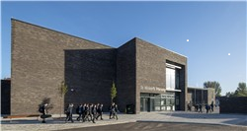

Kindness Inclusion



"Teach with Love and Learn with Pride"

SCHOOL HANDBOOK

SESSION 2024 - 2025

Inverclyde Council

**CONTENTS**

**ESSENTIAL INFORMATION**

Welcome 3

School Aims 4

Authority Strategic Statement 5

School Information 6

School Term Dates 9

Enrolment 10

Spiritual, Social, Moral and Cultural Values 10

Transfer from Primary School to Secondary 11

Behaviour 12

Wet Weather Arrangements 12

Playground Supervision 12

Attendance at School 13

GDPR 14

Clothing and Uniform 14

Physical Education 15

School Meals 16

Transport 17

Placing Requests 17

Road Safety 17

Medical and Health Care 18

Child Protection 18

Inclusion and Equality 18

Information in Emergencies 19

Complaints Procedure 19

**THE CURRICULUM**

Languages and Literacy 20

Modern Languages 22

Mathematics and Numeracy 22

Technologies 22

Social Studies 23

Expressive Arts 23

Health & Wellbeing 24

Religious Education 24

Assessment and Reporting 25

Additional Support Needs 25

Homework 27

Extra-curricular Activities 27

**HOME, SCHOOL AND COMMUNITY**

Partnership with Parents 28

Parent Partnership 28

Community Links 29

Sport Facilities 29

Relevant Addresses 29

Local Councillors 30

**WELCOME TO ST NINIAN'S PRIMARY**

If this is your first association with St Ninian’s, I extend a warm welcome to you as parents and look forward to a successful partnership over the coming years. If you already have a child here,

I am pleased to renew the links between us.

It is important that mutual understanding and trust are the basis of the shared responsibility which parents and teachers have in the education of children. Confidence in a school comes from knowing and understanding what is happening within it. I hope that your knowledge of school education in St Ninian’s will be increased through contact and discussion with members of staff and that you will take advantage of opportunities for consultation.

Siobhan Currie

Head Teacher

**SCHOOL AIMS**

All authorities are required by law to issue a copy of the school handbook incorporating current policies and practices of both the Council and the school to certain parents in December each year for their use as appropriate.

**Vision**

In the warm, supportive faith community of St Ninian’s Primary School we *‘teach with love and learn with pride’,* challenging our children to be the very best they can be by developing and applying skills for learning, life and work in Inverclyde and beyond enabling them to serve The Common Good.

**Values**

The school community models our values of Respect, Resilience, Inclusion and Kindness

**Aims**

* We aim to foster the Catholic character of the school through promotion of the Gospel values.
* To provide the highest quality learning activities which enhance every child’s potential
* Encourage personal excellence and strive to maintain the highest possible levels of achievement and attainment
* Provide a happy, secure, welcoming environment where partnership working enhance children’s learning experiences and promote wellbeing and respect
* Value and empower all members of our school community
* Foster high quality leadership at all levels

**Curriculum Rationale**

In St Ninian’s Primary, we have high expectations of success for all. Everyone in our school community is valued and work together in partnership.

Our Curriculum is inclusive. It is a stimulus for personal achievement and is designed to give our pupils a broad experience of the world encouraging them to commit to social justice. Pupils are encouraged to be confident in their own abilities, to challenge themselves in their learning and collaborate with others. They have opportunities to lead learning through discussion and questions of what and how they want to learn. Staff knowledge and understanding of the curriculum and a collegiate approach to developing experiences and outcomes in our school context underpins development.

We provide a rich environment for learning using ICT effectively, making full use of the outdoors and offering a variety of active and engaging approaches to learning and teaching.

We have a continuous focus on Literacy, Numeracy and Health & Wellbeing ensuring well planned progressive opportunities to develop, reinforce and extend learning in these areas.

We track and monitor our pupils’ progress in these areas three times a year. We formally report to parents four times a year recognising their importance as partners in their child’s learning.

Through our challenging, motivating and creative curriculum, our children have the opportunity to participate in a wide range of musical tuition enabling them to develop a range of skills and provide opportunity to extend their wider achievement.

**AUTHORITY STRATEGIC STATEMENT**

Building Inverclyde through excellence, ambition and regeneration.

Goals and Values

Our Core values are: Respect, Honesty and Tolerance.

Our vision for the children and young people of Inverclyde is that they should be ambitious for themselves and be successful learners, confident individuals, responsible citizens and effective contributors.

To achieve our ambition of building Inverclyde through excellence, ambition and regeneration our children must be:

Safe: protected from abuse, neglect and harm by others at home, school and in the community.

Healthy: enjoy the highest attainable standards of physical and mental health, with access to healthy lifestyles.

Achieving: have access to positive learning environments and opportunities to develop their skills, confidence and self-esteem to the fullest potential.

Active: active with opportunities and encouragement to participate in play and recreation including sport.

Respected and responsible: involved in decisions that affect them, have their voices heard and be encouraged to play an active and responsible role in their communities.

Included: have access to high quality services when required and should be assisted to overcome the social, educational, physical, environmental and economic barriers that create inequality.

Nurtured: educated within a supportive setting.

**SCHOOL INFORMATION**

St Ninian’s Primary School, Kirn Drive, Gourock, PA19 1SQ

Telephone Number: 01475 715853

E-mail: [instninians@glowscotland.onmicrosoft.com](mailto:instninians@glowscotland.onmicrosoft.com)

Web Site: <http://st-ninians.inverclyde.sch.uk/>

Twitter: @saintninians

St Ninian’s is a Roman Catholic co-educational establishment which offers comprehensive educational provision for Primary 1 to Primary 7 stages. It serves the Gourock, Inverkip and Wemyss Bay areas.

While the agreed planning capacity roll is 495 pupils, the current capacity roll is 399. Parents should note that the working capacity of the school may vary dependent upon the number of pupils at each stage and the way in which the classes are organised. The maximum number of places available in a class at Primary 1 is 25 and at Primaries 2 and 3 is 30 per class. At all other stages 33 children can be accommodated. Where the need arises to form composite classes, the school will follow authority guidelines.

The present school roll is 311, detailed below:

**STAGE PUPILS**

P1 43

P2 52

P3 50

P4 44

P5 40

P6 37

P7 45

Accommodation is on two floors linked by a central staircase. External access can be gained at both levels. There are 14 classrooms, a Music Room, a Library/Cyberzone, a gymnasium/assembly hall and a dining area. The school is fitted with a secure door entry system and each external door is alarmed. A visual fire alarm system has been fitted in all public areas for the benefit of pupils with hearing difficulties. There is a sports field adjacent to the school playground. The school accommodation is used in the evenings by several groups including guides and brownies.

Any individual or organisation wishing use of school premises should contact the Area Officer, at the address given on page 28.

**Promoted Staff and Remits**

**Head Teacher - Mrs Siobhan Currie**

Overall responsibility for the running of the school

Management Issues School Budget

Pastoral Care Staff Development

Parental Communications Staff Support

Class Organisation Pupil Support

Resourcing School Policies

Curriculum Support

**Depute Head Teacher - Mrs Claire Coggins**

Pastoral Care/Curriculum Support

Deputising for Head Teacher

Supporting colleagues, probationary teachers and students

Numeracy and Maths

Religious Education

Additional Support for Learning

**Principal Teacher - Mrs Janine Munro**

Support to Colleagues

Health and Wellbeing

Active Schools Co-ordinator

**Class Teachers -**

Primary 1A Mrs C Hunter

Primary 1B Miss Y Tait

Primary 2A Miss O Black

Primary 2B Mrs L Clark

Primary 3A Miss N Droy

Primary 3B Miss R Oliver

Primary 4A Miss J Skelton

Primary 4/5 Mrs C Kavanagh

Primary 5 Ms K Farmer

Primary 6 Mrs J Erskine

Primary 7/6 Mrs A Coyle

Primary 7 Mrs C Clarke

RCCT Teachers Mrs R Camburn

Mrs S Robertson

Mrs E Watson

**Visiting Teachers**

Mr D Hutchison Brass

Ms R Anderson Cello

Ms G Grant Violin

Mr J Sutton Saxaphone

Mrs Beck Singing and Choir

**Support Staff**

Mrs Y O’Donnel Senior Clerical Assistant

Mrs L Deegan Clerical Assistant (P/T)

Ms S Clarke Clerical Assistant (P/T)

Mrs A M McKinnon Pupil Support Assistant

Mrs P Steven Pupil Support Assistant

Mrs A McAulay Pupil Support Assistant

Mrs C McEwen Pupil Support Assistant

Mrs S Lang Pupil Support Assistant

Mrs M McClintock Pupil Support Assistant

Mr G Murray Janitor

Mrs S Coyle Cook in Charge

**School Hours**

9.00am - 12.15pm (Morning interval 10.30am – 10.45am)

12.15pm - 1.00pm Lunch

1.00pm - 3.00pm

Our Breakfast Club is available on Tuesday and Wednesday mornings from 8 am.

**SCHOOL TERM DATES: SESSION 2023 – 2024**

First Term Inservice Wednesday 14 August/Thursday 15 August 2024

Pupils Return Friday 16 August 2024

Local Holiday Friday 27 September/Monday 30 September 2024

October Week Close Friday 11 October 2024

Inservice Monday 21 October 2024

Pupils Return Tuesday 22 October 2024

Christmas Close Friday 20 December 2024

Second Term Re-open Monday 6 January 2025

February Weekend Close Friday 14 February 2025

Mid Term Monday/Tuesday 17/18 February 2025

Inservice Wednesday 19 February 2025

Pupils Return Thursday 20 February 2025

Close Thursday 4 April 2025

Third Term Spring Break Monday 7 April to Monday 21 April 2025 Pupils Return Tuesday 22April 2025

May Day Monday 5 May 2025

Inservice Tuesday 6 May 2025

Pupils Return Wednesday 7 May 2025

Close Thursday 22 May 2025

Local Holiday Friday/Monday 23/26 May 2025 Pupils Return Tuesday 28 May 2024

Close for Summer Friday 27 June 2025

**ENROLMENT**

Each year the registration dates for new entrants are placed in the local press during the month of January. Notices will also be posted in local nurseries, St Ninian’s Church, Gourock and St Joseph’s and St Patrick’s Church in Wemyss Bay. Parents are now invited to register their child for school online - see Notice below.

j0346645

Parents and children are invited to visit the school during the months of May/June. During these visits Mrs Currie, Head Teacher will provide parents with general information about their children’s first year in school. There is also an opportunity to ask questions and meet other parents. The visit is helpful for children in that they meet with their teachers, other children and spend some time in what will be their Primary 1 classrooms.

To enrol children, other than those entering Primary 1, all that is required is a telephone call to arrange a suitable time to visit the school.

**IMPORTANT NOTICE**

**REGISTRATION INFORMATION FOR CHILDREN STARTING PRIMARY 1 IN AUGUST 2024**

Children who reach the age of five years between 1 March 2024 and 28 February 2025 are due to start Primary 1 at the beginning of the new school term in August 2024.

There are no denominational primary schools within the areas of Quarriers Village, Kilmacolm, Inverkip and Wemyss Bay. Parents often choose to send their children to the local non-denominational primary school because of the travelling distance to their nearest denominational primary school. In such circumstances, the following admission arrangements will apply:

Only those children who have a certificate of baptism into the Roman Catholic faith when registering for Primary 1 will have the choice at Primary 7 to seek admission to the denominational school assigned to their address.

Gaelic Medium Primary Education is available at Whinhill Primary School for all pupils residing in Inverclyde.

Once parents have completed the Primary 1 registration, they will have the choice to complete a placing request application to a school other than the catchment primary. A deferred entry application is also available to parents considering deferring their child’s entry to Primary 1 in August 2024.

No documents will be required at this stage; however, we may have to contact you, should we require further information.

Parents will be notified by 30 April 2024 confirming their child’s place in school and information regarding induction days will follow from the school after this date.

Parents who do not have internet access to apply online, are asked to contact their child’s current Early Years Establishment for assistance.

**SPIRITUAL, SOCIAL, MORAL AND CULTURAL VALUES**

Parents from ethnic minority religious communities may request that their children be permitted to be absent from school in order to celebrate recognised religious events. Only written requests detailing the proposed arrangements will be considered. Appropriate requests will be granted on not more than three occasions in any one school session and the pupil noted as an authorised absentee in the register.

In St Ninian’s we use God’s Loving Plan which helps guide teachers on how children can be helped to develop healthy and respectful attitudes to their bodies and to all aspects of God’s gift of Life. It takes a sensitive and gradual approach to teaching children about some of the most personal and intimate features of life. It helps children to understand their bodies, including their sexual capacities and to be at ease with themselves as their bodies grow. It shows how Love can be at the heart of all aspects of their lives physical, emotional, social, intellectual, and spiritual. It teaches them how to love themselves, to love others and to Love God.

We foster a strong partnership working with the parishes of St Ninian's in Gourock and St Joseph & St Patrick's, Wemyss Bay. Father Gerry McNelis is our School Chaplain. Both he and Father Desmond Berry regularly visit the school to support us to uphold the moral teaching, faith tradition and sacramental life of the Catholic church.

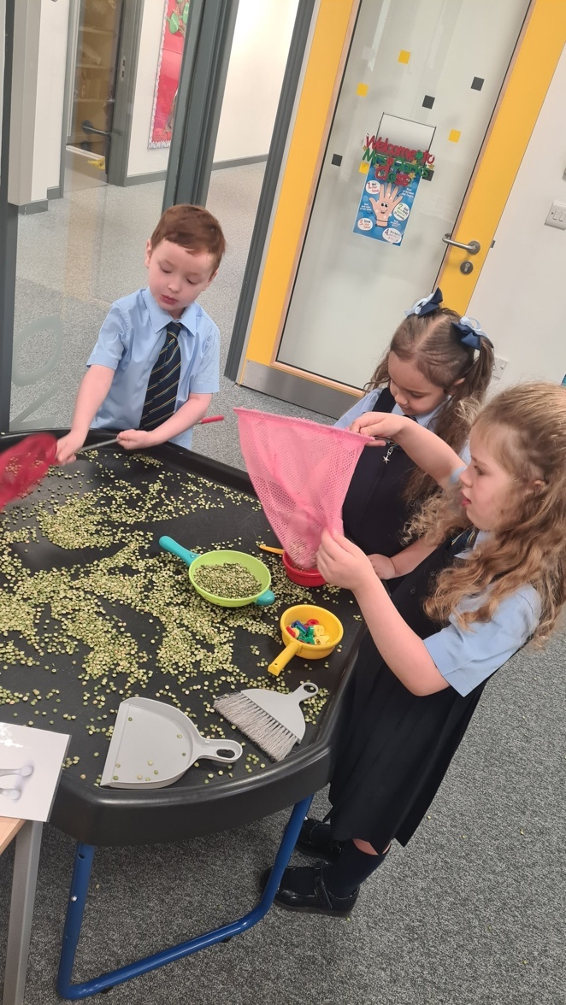

**TRANSFER FROM PRIMARY SCHOOL TO SECONDARY**

Pupils are normally transferred between the ages of 11½ and 12½ years, so that they will have the opportunity to complete at least 4 years of secondary education. Parents will be informed of the arrangements no later than December of the year preceding the date of transfer at the start of the new session.

The associated secondary school for children in St Ninian’s Primary is:

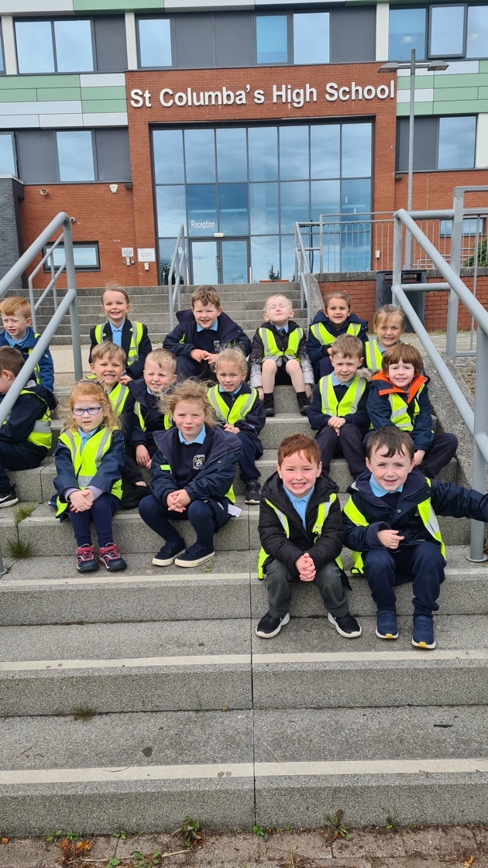

St Columba’s High School

Fletcher Avenue

GOUROCK PA19 1TP

Tel: 01475 715250

Fostering very strong links with St Columba’s, we collaborate in a number of ways. Members of its staff, from a range of departments, visit the school regularly to work with our senior pupils on a team teaching basis. We participate in joint events such as the Catholic Education Week and the Primary 7 Induction Programme.

We participate in a number of cluster events with St Columba’s High, St Andrew’s and St Joseph’s Primary School. Staff have opportunities to engage in professional dialogue, working together to enhance experiences and to ensure standards across the cluster. We have benefitted from Sports Leaders from St Columba’s High working with our pupils in P.E. We accommodate several pupils from St Columba’s High for their S4 work experience programme. In addition, those senior pupils of St Columba’s, wishing to study Primary Teaching at University, are placed here and visit this school weekly to work in classes with our teachers and children.

This partnership has enormous benefits for all and smooths the transition from primary to secondary education for our P7 pupils. In June, parents and staff from St Columba's are invited to a "Transition Tea" where children showcase their learning throughout the curriculum, demonstrating they are leaders of their own learning. Pupil learning profiles are made available for staff and parents.

If parents wish their child to transfer to this school they must live within the catchment area otherwise a placing request must be submitted.

**BETTER RELATIONSHIPS, BETTER LEARNING, BETTER BEHAVIOUR**

As a Rights Respecting School, it is important that we nurture positive relationships between staff, pupils and parents. Relationships lie at the heart of the learning process and are fundamental to improving outcomes for all our children.

Our aim is to get it right for every child and therefore we encourage a positive ethos ensuring children are Safe, Healthy, Achieving, Active, Nurtured, Responsible, Respected, Included and Valued.

In St Ninian’s Primary, we use Restorative Approaches to promote positive relationships and provide an opportunity to repair any harm or upset when difficulties have occurred. This moves away from blame and punishment and moves the focus to reasons, cause, responsibilities and feelings.

Our School Charter sets the following expectations to ensure better relations:

Respect our friend’s rights to play and to learn

Remain safe within the school grounds

Look after our school

Be kind and caring to all members of our school community

In St Ninian’s we adhere to Inverclyde Council’s Anti-Bullying Policy. The school is fully committed to promoting equal opportunities and this is provided through an appropriate curriculum.

**WET WEATHER INTERVALS**

On wet days children are permitted to stay indoors at intervals and lunchtime.

During wet weather intervals, children are encouraged to play quietly within the classroom. Reasonable standards of behaviour are expected and are necessary for their own and others’ safety. Children can bring in colouring books, books or card games to play during wet plays. We have a network of P7 school monitors who support our pupil support assistants in supervising classes.

With regard to wet mornings, the teachers’ day begins at 9.00am and although there may be supervision, this cannot always be guaranteed.

**SUPERVISION OF PLAYGROUNDS**

An adult presence is provided in playgrounds at break times in terms of the Schools (Safety and Supervision of Pupils) (Scotland) Regulations 1990.

This duty is an official part of the janitor’s remit. Additional supervision is provided by Classroom Assistants and ASN Auxiliaries who wear high visibility vests at all times. All pupils are expected and encouraged to be responsible for their own behaviour and are frequently reminded of school rules and acceptable playground conduct.

**CHILDREN ABSENT FROM SCHOOL THROUGH ILL HEALTH**

Young people of school age may be unable to attend school for a wide range of reasons including illness, accidents or long term medical conditions. In general, there will be an automatic referral by the school for education outwith School after 15 days of continuous or 20 working days of intermittent absence, within a single session, for verifiable medical reasons.

**ATTENDANCE AT SCHOOL**

Parents should inform the school by telephone or through the Parent Portal on the first morning of an absence and provide a reason for the pupil’s absence. The school will contact the pupil’s family and thereafter other emergency contacts if no explanation is given for the pupil’s absence. This contact will be made before 10am on the first morning of an absence and early after the restart after lunch in the case of an afternoon absence.

Other agencies may be contacted if no contact with the pupil’s family can be achieved and if there are continuing or emerging concerns about a pupil’s safety or wellbeing.

Parents should keep the school informed of any changes of address or telephone numbers, both their own and those of the emergency contacts.

Section 30 of the 1980 Education Act lays a duty on every parent of a child of ‘school age’ to ensure that their child attends school regularly. Attendance must be recorded twice a day, morning and afternoon.

Regulation 7 of The Education (School and Placing Information) (Scotland) Amendment, etc Regulations 1993 requires each child’s absence from school to be recorded in the school register as authorised: ie. approved by the authority and unauthorised: i.e. unexplained by the parent (truancy) or temporarily excluded from school.

The Scottish Government has provided guidance on the management of attendance and absence in Scottish schools in its publication Included, Engaged and Involved - Part 1: Attendance in Scottish Schools. Every effort should be made to avoid family holidays during term time as this both disrupts the child’s education and reduces learning time. **It has been clarified that family holidays should not be recorded as authorised absence, except in exceptional domestic circumstances, where a family needs time together to recover from distress, or where a parent's employment is of a nature where school-holiday leave cannot be accommodated (eg. armed services or emergency services). It is for local authorities and schools to judge when these circumstances apply and authorise absence, accordingly.**

The categorisation of most term-time holidays as unauthorised absence has been a contentious issue for some families, many of whom are concerned at the higher cost of holidays during school holiday periods. The Scottish Government has no control over the pricing decisions of holiday companies or flight operators. Our main focus is to encourage parents and pupils to recognise the value of learning and the pitfalls of disrupting learning for the pupil, the rest of the class and the teacher.

Clearly where an absence occurs with no explanation from the parent, the absence is unauthorised.

Schools investigate unexplained absence, and Education Services has the power to write to, interview or prosecute parents, or to refer pupils to the Children’s Reporter, if necessary.

Every six weeks we check the attendance of each child. If your child’s attendance falls below 90% you will be notified through a letter from the school.

**GDPR (General Data Protection Regulations and Data Protection Act 2018)**

Information on children, parents and guardian is stored on a computer system and may be used for teaching, registration, assessment and other administrative duties. In processing personal information, Inverclyde Council must comply with the General Data Protection Regulation and Data Protection Act 2018.

For further information, please refer to https://www.inverclyde.gov.uk/site-basics/privacy.

**CLOTHING AND UNIFORM**

Given that there is substantial parental and public approval of uniform, schools in Inverclyde are free to encourage the wearing of school uniform. In encouraging the wearing of uniform account is taken in any proposals to prevent any direct or indirect discrimination on the grounds of race or gender. Any proposals will be the subject of widespread consultation with the parents and pupils. Against this background, it should be noted that it is the policy of the Education & Lifelong Learning Committee not to insist on pupils wearing uniform or having specialist items of clothing as a prerequisite of their attending and engaging in all of the activities of the curriculum.

Most of our pupils do wear school uniform and the items are listed below:

BOYS GIRLS

Navy blue blazer/fleece Navy blue blazer/fleece

School sweatshirt School sweatshirt Blue shirt Blue blouse

Navy blue/grey trousers Navy blue skirt, navy blue/grey trousers

School polo shirt School polo shirt

School tie School tie

Socks in school colours Socks in school colours

Black shoes Black shoes

School summer dress

The supplier for school dress is Smith’s West Blackhall Street, Greenock.

There are forms of dress which are unacceptable in school, such as items of clothing which:

* Potentially, encourage faction (such as football colours)
* Could cause offence (such as anti-religious symbolism or political slogans)
* Could cause health and safety difficulties such as loose fitting clothing, dangling earrings or clothing made from flammable material for example shell suits in practical classes
* Could cause damage to flooring
* Carry advertising, particularly for alcohol or tobacco
* Could be used to inflict damage on other pupils or be used to do so

The Council is concerned at the level of claims being received regarding the loss of children's clothing and/or personal belongings. Parents are asked to assist in this area by ensuring that valuable items and unnecessarily expensive items of clothing are not brought to the establishment. Parents should note that the authority does not carry insurance to cover the loss of such items and any claims submitted are likely to be met only where the authority can be shown to have been negligent.

Parents should note that the activities the children may become involved in may be restricted because of Health and Safety requirements state that jewellery of any kind must not be worn where children are undertaking physical activities. This includes jewellery worn as a result of body piercing.

**PHYSICAL EDUCATION**

The Scottish Government legislation states that pupils are entitled to 2 hours quality PE a week.

For physical education we would recommend: navy blue shorts, school polo shirt and sandshoes/trainers.

It is requested that all items of clothing are clearly marked with the owner’s name. A bag marked with the child’s name is required to hold indoor shoes and physical education kit.

**Health and Safety in Physical Education: A Code of Practice:**

The above named code recommends the following:

* Pupils should wear clothing and footwear suitable for the activity
* Children will not be permitted to take part in PE wearing jewellery
* Belts with metal buckles which may cause injury to the wearer shall be removed before the activities.
* Gum should not be chewed.
* The school should be informed of medical information concerning pupils as it is relevant to activities undertaken by them.

**Outdoor PE**

Our outdoor physical education facility is a wonderful asset to our school. Each class is timetabled for an outdoor PE session on our MUGA. Children should dress suitable for the weather, this should include: Navy jogging/tracksuit bottoms, lightweight rain jacket, eg. Pac-a-mac and suitable outdoor footwear.

**SCHOOL MEALS**

All pupils in Primary 1 to 5 will be entitled to a free school meal.

To make a new application for clothing grant/free school meals, your child/children must attend a school managed by Inverclyde Council. In addition, you should be in receipt of one of the qualifying benefits:

* Income Support (IS)
* Income-based Job Seeker's Allowance (JSA)
* Income related Employment and Support Allowance (ESA)
* Child Tax Credit, but not Working Tax Credit, and has an income of less than £16,105 in 2020/2021 (as assessed by the Inland Revenue)
* Parent is in receipt of Working Tax Credit and/or Child Tax Credit with annual gross earnings of no more than £11,665
* Universal Credit - where your take home pay does not exceed £951, as shown on your most recent monthly Universal Credit statement
* An asylum seeker, receiving support under Part VI of the Immigration and Asylum Seekers Act 1999

OR

* You look after a child/children as part of a FORMAL Kinship Care agreement, registered by Social Work Services.

The Council's preferred method of submission of clothing grant/free school meals application is by email to the Customer Service Centre (customerservice@inverclyde.gov.uk).

Refer to Inverclyde Council website or contact Education Services on 01475 712893 where you will be provided with advice on the application process.

The school meals service operates a cafeteria system, with parents being informed in advance of menu details. We are use a cashless system known as “ParentPay” where school meals are prepaid. If your child has any special dietary needs, please make these known to the school as soon as possible so that arrangements may be made by catering staff.

Space is provided in the dining hall for children who bring packed lunches. Given the fact that we have a number of children who are allergic to peanuts, parents’ co-operation in providing a nut-free environment in the school is greatly appreciated. No glass flasks, bottles or cans are allowed in the dining room. If your child carries a packed lunch, please ensure that school books are well protected.

**TRANSPORT**

**General**

It is parents’ responsibility to ensure their children arrive at school and return home from school in a safe and responsible manner. The Council has a policy of providing free transport to all primary pupils who live more than one mile from their local school by the recognised shortest walking route. This policy is more generous than the law requires. This means that the provision of transport could be reviewed at any time. Parents who consider they are eligible should obtain an application form from the school or Customer Service Centre, Inverclyde Council, Clyde Square, Greenock PA15 1LY. These forms should be completed and returned before the end of February for those pupils beginning school in August to enable the appropriate arrangements to be made.

Applications may be submitted at any time throughout the year but may be subject to delay whilst arrangements are made. The appropriate officer has discretion in special circumstances to grant permission for pupils to travel in transport provided by the authority, where spare places are available and no additional costs are incurred.

**Pick Up Points**

Where free transport is provided it may be necessary for pupils to walk a certain distance to the vehicle pick-up point. Walking distance in total including the distance from home to the pick-up point and from the drop-off point to the school in any one direction will not exceed the authority’s limits (see above paragraph). It is the parent’s responsibility to ensure that their child arrives at the pick-up point in time. It is also the parent’s responsibility to ensure the child behaves in a safe and acceptable manner while boarding, travelling in and alighting from the vehicle. Misbehaviour could result in a child losing the right to free transport.

**PLACING REQUESTS**

Education Services does not provide transport for those pupils in receipt of a placing request other than in exceptional circumstances. In the case of under-age placing requests if the child is offered a place in his/her catchment area school, transport will be provided in accordance with Council policy stated above.

**ROAD SAFETY**

Throughout the school year children are reminded about road safety. Parents are asked to assist by refraining from parking in Staffa Street between Kirn Drive and Kingsway.

j0297579**Parking in the staff car park cannot be permitted**. Such action may result in a child being seriously injured. We have a new car parking facility in Drumshantie Road, using this facility eases congestion and enables children to use the school crossing patrol to safely cross the road.

Parents who drive their children to school are requested to drop them off on Kirn Drive

or on Staffa Street at its junction with Kingsway. Please do not park on the Keep Clear

signs, this enables our children to cross the road safely.

**MEDICAL AND HEALTH CARE**

Throughout children’s years in primary school, dental hygiene checks are made and, if dental care is considered necessary, parents will be notified.

If a child takes ill in school and gives cause for concern, the parents will be notified immediately. If the parent is not available, the emergency contact will be telephoned so please ensure that the school has that number. Should an accident happen, parents will be contacted immediately and all necessary action taken to ensure the child’s wellbeing.

If your child has a hearing or sight impairment or a particular medical requirement, for example, daily drug administration or any allergies, please inform the school on enrolment. Special forms require to be completed by parents before any medication can be administered in school.

**CHILD PROTECTION IN INVERCLYDE**

Inverclyde Council Education Services has Child Protection Guidelines and Procedures which all schools are required to follow. Education Services work very closely with other agencies namely Strathclyde Police, Social Work Services, NHS Greater Glasgow and Clyde and the Children’s Reporter to support children. Common responsibilities of all staff are to protect children from abuse and exploitation, to respond appropriately when abuse is identified, and to ensure whenever possible that all children are able to exercise their right to be raised in a warm, stimulating and safe environment with the support of staff, their families and carers.

**INCLUSION AND EQUALITY**

Inverclyde Education Service is committed to ensuring that no children or members of staff or service users receive less favourable treatment on any ground including gender, race, disability, age, sexual orientation, religion or belief. We have a moral, social and legal obligation to mainstream and put equality at the heart of everything we do. We aim to promote a culture in which equality of opportunity exists for all. We are opposed to all forms of discrimination, direct or indirect, and aim to eliminate all discriminatory practices. We will ensure that, in our schools and other educational establishments, equality permeates the curriculum and underpins all our policies and practices in terms of access to education.  We must ensure that all our children achieve their full potential to develop physically, emotionally and academically. Finally, we believe that equality and inclusion should be a given right, where everyone is valued and treated with respect.

**Inverclyde Council Education Service aims to:**

- Offer education of the highest quality to all young people within a developing culture of inclusion

- Endorse the principles of inclusion, entitlement and equality of opportunity in the development of best practice

- Value the diversity of interests, qualities and abilities of every learner

- Believe that every child and young person is entitled to educational opportunities which enable the achievement of success and further development of the individual’s learning potential within the least restrictive environment

- Affirm the right of all young people to have access to the highest quality of educational provision which is appropriate to learning needs, is supportive of the young person and is delivered in partnership with young people, parents and the wider community

In meeting the needs of all of our pupils we will demonstrate no discrimination on the basis of race, gender, disability, sexual orientation, religion or belief. This encompasses curricular, extra curricular and classroom activities and is foremost in the attitudes which we develop in our pupils.

**INFORMATION IN EMERGENCIES**

We make every effort to maintain a full educational service, but on some occasions circumstances arise which lead to disruption. Schools may be affected by, for example, severe weather, and temporary interruption of transport, power failures or difficulties of fuel supply. In such cases we shall do all we can to let you know about the details of closure or re-opening. We shall keep you in touch by using letters, notices in local shops and community centres, announcements in local churches and announcements in the press and on local radio.

Please check for updates on Inverclyde Council website, school Twitter site and announcements on local radio.

**COMPLAINTS PROCEDURE**

Inverclyde Council has reviewed their policy and procedures regarding complaints in relation to schools. Stage One of the complaint handling procedure will now be handled directly by schools.

If parents feel their complaint has not been resolved to their satisfaction, a complaint can be escalated to Education HQ at Stage Two of the complaint handling procedure.

As a result of this, all complaints sent in to Education HQ that have not been through Stage One at school level, will be referred back to the responsible school.

In the first instance, we would hope to resolve any complaint - this includes more informal concerns that can be raised by contacting the school. Information about the complaint handling procedure is available at:

<https://www.inverclyde.gov.uk/council-and-government/complaint>

**THE CURRICULUM**

The aims of Curriculum for Excellence are that every child and young person should:

* Know they are valued and will be supported to become a successful learner, an effective contributor, a confident individual and a responsible citizen.
* Experience a traditionally broad Scottish curriculum that develops skills for learning, skills for life and skills for work, with a sustained focus on literacy and numeracy that encourages an active, healthy and environmentally sustainable lifestyle and builds an appreciation of Scotland and its place in the world.

The experiences and outcomes under Curriculum for Excellence are written at five levels, with progression to qualifications described under the senior phase:

Early Level: the preschool years and P1 or later for some

First Level: to the end of P4, but earlier or later for some

Second Level: to the end of P7, but earlier or later for some

Third and Fourth: S1 to S3, but earlier for some

Senior Phase S4-S6 and college or other means of study.

The curriculum can be divided into the following main areas:

**Languages and Literacy Mathematics and Numeracy**

**Technologies Environmental Studies**

**Expressive Arts Religious Education**

**Health and Wellbeing Social Studies**

**Sciences**

Planning for improvement in these areas of the curriculum is detailed within the School’s Improvement Plan which can be found on the school website at

<http://st-ninians.inverclyde.sch.uk/> where you can also access our Standard & Quality Report.

**LANGUAGES AND LITERACY**

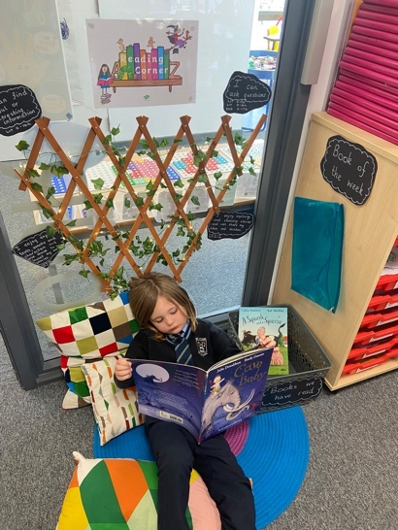

Language is at the heart of children’s learning; it is central to their intellectual, emotional and social development. We aim to provide children with structured and stimulating opportunities to use language in ways appropriate to their needs and to the world in which they live.

High priority is placed upon developing in the children the ability to use English language appropriately and concisely through listening attentively, talking fluently, reading with understanding, and writing with style and accuracy.

Children are introduced to Reading through a systematic Synthetic Phonics Programme. From Primary 3, while children continue to develop fluency with the school reading programme, emphasis is given to a wide range of higher order reading skills in a structured way.

Through discussion of the texts read, children learn to form and offer opinions and extend their vocabulary. They are encouraged to respond to different types of text and develop a deeper understanding of what they are reading.

The school has a reference library and each class has its own fiction library. Reading for research and enjoyment is encouraged at all times and parents are asked to foster this at home.

Recent curricular guidance provides a framework for the teaching of writing at all stages in the school. At every stage, meaningful opportunities for writing are linked with curriculum content.

**Read, Write, Count**

The Read, Write, Count programme aims to support parental engagement in literacy and numeracy. Gift bags are distributed annually to all P2 and P3 pupils in Scotland by the Scottish Book Trust. The gift bags contain essential literacy and numeracy materials to support children's learning, as well as advice and support to parents.

Studies show a direct link between a strong family learning environment and progress in reading, writing and counting. In addition to the parent guide included in the gift bags, the Parent Club website ( [https://parentclub.scot/ )](https://parentclub.scot/%20)%20) offers a range of hints, tips and advice to help parents engage in their child's learning.

**First Minister's Reading Challenge**

The First Minister's Reading Challenge is an inclusive, exciting programme for all children - fostering a love of reading for pleasure. Research shows that reading for pleasure is crucially important for children's development.

The Challenge is open to all local authority and independent primary and secondary schools across Scotland, as well as libraries and community groups. You can find out more information on the Challenge and also how schools can register to take part here: <https://www.readingchallenge.scot/>

A reading app called Bookzilla, aimed at S1-S3 pupils, helps them find and recommend books and to set themselves reading challenges.

**Parentzone Scotland**

Parentzone Scotland is a one-stop shop website for information and advice on education and learning in Scotland. The website continues to be updated and improved and can be accessed using [https://education.gov.scot/parentzone](https://education.gov.scot/parentzone%20%20)  Why not check out the website for ideas on how you can support your child's learning.

j0157763**MODERN LANGUAGES**

Pupils will be taught French from Primary 1 with an additional language (Spanish) taught from Primary 5.

**MATHEMATICS AND NUMERACY**

This area of the curriculum involves the children in number work, measurement, shape, data handling and problem solving.

Heinemann Mathematics is the programme used to introduce children to increasingly complex mathematical ideas. Alongside this programme, teachers give strong emphasis to mental calculation. The children are actively involved in their learning and are given practical material and equipment to help their understanding.

In addition to the above, mathematical activities arising from their work in other areas of the curriculum help to communicate to the children the idea that mathematics, like English language, is relevant to everyday living. Children are given opportunities to apply and practise their skills in realistic and problem solving situations.

**TECHNOLOGIES**

The technologies curriculum area includes craft, design, engineering, graphics, food, textile and information technologies. These areas of study offer a rich context for the development of all of the four capacities and for developing the life skills that are recognised as being important for success in the world of work. They also offer an excellent platform for a range of technology-related careers.

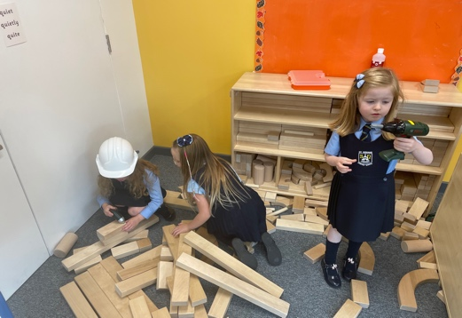The technologies curriculum area offers challenging activities which involve research, problem solving, exploration of new and unfamiliar concepts, skills and materials, and the rewarding learning which often results from creating products which have real applications. It also provides a basis for progression in cognitive skills. Children and young people can develop their creativity and entrepreneurial skills and be encouraged to become innovative and critical designers of the future. These attributes are essential if our children and young people are to play a major part in the global economy and embrace technological developments in the 21st century.

**SOCIAL STUDIES**

Through social studies, children and young people develop their understanding of the world by learning about other people and their values, in different times, places and circumstances, and how their environment has been shaped. As they mature, children’s experiences can be broadened using Scottish, British, European and wider contexts for learning. Children and young people learn about human achievements and how to make sense of changes in society, conflicts and environmental issues. With greater understanding comes the opportunity to influence events by exercising informed and responsible citizenship.

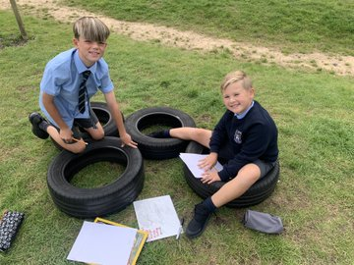Although the content of the curriculum is important, these aspirations can only be achieved through high quality learning and teaching. The social studies experiences and outcomes are designed to stimulate the interest and motivation of children and young people, and to support staff in planning challenging, engaging and enjoyable learning and teaching activities. They will allow flexibility and choice for both practitioners and learners which can sustain interest and enthusiasm.

**EXPRESSIVE ARTS**: Art, Drama, Music and Dance

Learning in, through and about the expressive arts helps children and young people recognise and appreciate their own and others’ creative and artistic abilities. The expressive arts foster imagination and creativity, and provide opportunities for children and young people to develop a wide range of technical, presentational and performance skills, to think creatively and be proactive and enterprising within meaningful and relevant contexts.

By engaging in and reflecting on experiences within the expressive arts, children can recognise and represent their feelings and emotions and those of others. The expressive arts play a central

role in shaping our sense of personal, social and cultural identity.

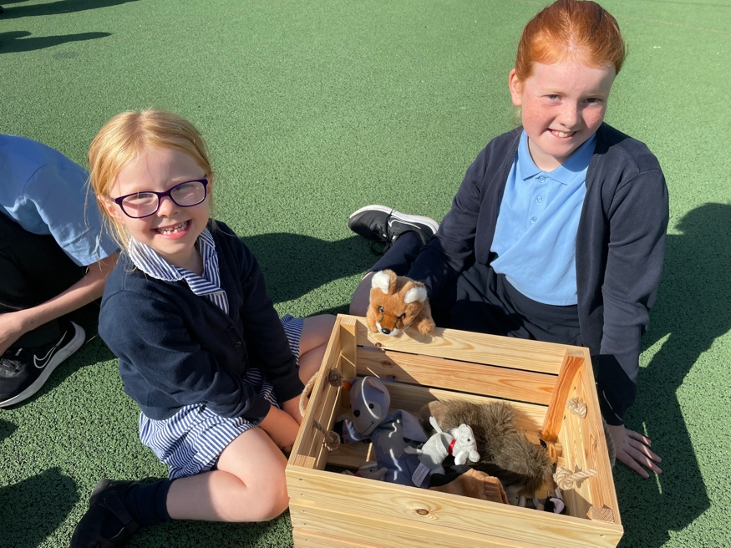

**HEALTH AND WELLBEING**

*Curriculum for Excellence* has an important role to play in promoting the health and wellbeing of children and of all of those in the educational communities to which they belong.

The experiences and outcomes within this area of the curriculum are in keeping with the United Nations Convention of the Rights of the Child, which sets out the right for all children to have access to appropriate health services and to have their health and wellbeing promoted.

The main purpose of health and wellbeing is to develop the knowledge and understanding, skills, capabilities and attributes necessary for

children’s mental, emotional, social and physical wellbeing now and in the future.

**RELIGIOUS EDUCATION**

Religious education in Catholic schools takes place in partnership with home and parish. It is an integral part of the Catholic school, which is itself a community of faith. It is designed to assist children to make an informed and mature response to God in faith and to nurture that faith.

In addition to developing their understanding of the Catholic faith, children will also learn respect for, and understanding of other Christian traditions. They will also come to an appreciation of significant aspects of major world religions, recognising and respecting the sincere search for truth which takes place in other faiths.

This is Our Faith is used throughout the school. This is the programme prescribed for all Catholic primary schools in the diocese of Paisley.

In Primary 4, children are prepared for Sacraments of Reconciliation, and the reception of First Eucharist. In Primary 7, children complete their initiation when they receive the Sacrament of Confirmation.

The school works in partnership with parents and the parish community of St Ninian’s. Throughout the year, parents are invited to meetings, prayer services and masses, all of which enhance the religious education programme. On Holydays of Obligation, Mass is celebrated in the school.

The Scottish Government also recognise that: *Where a parent chooses a denominational school for their child's education, they choose to opt in to the school's ethos and practice which is imbued with religious faith and religious observance. In denominational schools, it is therefore more difficult to extricate a pupil from all experiences which are influenced by the school's faith character.*

Parents who wish to do so are asked to discuss with the Head Teacher.

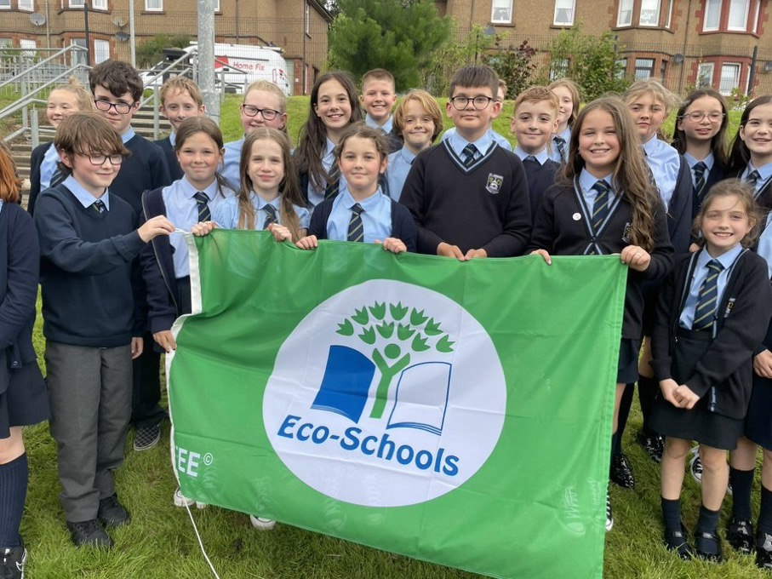

**ASSESSMENT AND REPORTING**

j0233964Assessment is an integral part of learning and teaching. It helps provide a picture of the learner’s progress and achievements, and identifies the next steps in learning.

Assessment includes supporting learning, learner engagement and ensuring appropriate support.

**Tracking learners’ progress**

Information on learners’ progress is gathered through planned assessments and this information is recorded. This allows teachers to have a clear picture of how learners are progressing. It will also allow teachers to identify next steps in learning and inform reporting on progress and achievement.

**Reporting**

Written reports are sent out to parents in Terms 2 and 4 with oral reports at Parents' Evenings in Terms 1 and 3.

**ADDITIONAL SUPPORT NEEDS**

Every teacher has a responsibility to support the learning of all pupils in their class. The type of support offered will vary according to the needs of pupils. This includes consideration given to children who have a disability, children with social, emotional and behavioural difficulties, children with learning difficulties of a specific or general nature, children who are exceptionally able, those who demonstrate underachievement relating to gender issues, children whose learning has been interrupted through absence or illness, bilingual children who have English as an additional language, travelling children and those whose family circumstances impact on attendance and learning.

If a parent considers that his or her child has additional support needs and wishes to make enquiries about this they should contact the head teacher.

A child or young person’s needs are identified at the earliest possible stage and can be met in a number of ways, for example by adaptations to the curriculum or learning environment, as well as input from the Support for Learning Teacher and on occasion support from visiting specialists.

The appropriateness of the support is determined through a process of assessment, planning and monitoring, working jointly with parents and carers, and is regularly reviewed.

Learning outcomes for children and young people with additional support needs are set out in a plan and all educational establishments hold regular review meetings with parents and carers to determine needs and the most appropriate supports. Everyone’s views are equally important in order to consider what is currently working and how to determine next steps.

Children and young person’s needs are identified in a number of ways, and the process of assessment is an ongoing, shared process with partnerships with parents and carers at the forefront. On some occasions, health service staff or other partner agencies make children known to Education Services. Other additional support needs may be notified to Education Services by parents themselves or identified by one of a range of staff working closely with the child.

Some children and young people will have additional support needs arising from complex or multiple factors which require a high degree of co-ordination of support from both education and other agencies in order that their needs can be met. In these cases, the school will hold a meeting to decide whether the child or young person meets the criteria for a co-ordinated support plan.

The coordinated support plan is a statutory document which ensures regular monitoring and review for those children and young people who have one.

You have the right to ask the education authority to establish whether your child needs a coordinated support plan. Your child can make this request themselves, if they are aged 16 or over. You and your child, if they want to, will attend a meeting with staff at their school.

Other professionals from different agencies who may be involved in providing support for your child will also attend. If your child does not want to attend meetings or feels unable to, their views must still be sought and considered.

Inverclyde’s mediation service can be accessed by contacting Tony McEwan, Head of Culture, Communities and Educational Resources at the address below.

The officer of officers of the authority from whom parents of children having additional support needs, and young persons having such needs, can obtain advice and further information about provision for such needs.

For further advice please telephone 01475 712850 or write to:

Education Services

Wallace Place

GREENOCK PA15 1JB

Organisations offering further information and support to parents of children and

young people with ASN are identified under The Additional Support for Learning (Sources

Of Information (Scotland) Amendment Order 2011 as:

a) Children in Scotland: Working for Children and their Families, trading as "Enquire - the Scottish advice and information service for additional support for learning", a charitable body registered in Scotland under registration number SC003527 - www.enquire.org.uk

b) Scottish Independent Advocacy Alliance, a charitable body registered in Scotland under registration number SC033576 - www.siaa.org.uk

c) Scottish Child Law Centre, a charitable body registered in Scotland under registration number SC012741 - [www.scic.org.uk](http://www.scic.org.uk)

**HOMEWORK**

Covid restrictions have changed our policy for Homework. All home learning tasks will be emailed to parents. Homework is given in order to:

* establish good habits of home study and self-discipline;
* allow children to reinforce what they have learned in school;
* allow children to prepare for future work in school;
* provide information for parents;
* give parents the opportunity to become involved in and support their child’s learning.

The homework programme for children in Primaries 4 to 7 incorporates literacy, numeracy and health and wellbeing. The maximum time allocation for Primaries 4 to 7 is approximately thirty minutes per evening. Homework at weekends is not a feature of our policy.

Parents are asked to foster in their children an enjoyment of reading. This can be done by spending ten or fifteen minutes, perhaps three or four times per week, reading to their child or getting their child to read to them. Parents or interested adults who can make this commitment will be doing a great deal to enhance children’s learning.

**EXTRA CURRICULAR ACTIVITIES**

Children are encouraged to participate in a range of activities during lunchtime and/or the end of the school day. Included in the school programme are the following activities:

Netball

Athletics

Scottish Country Dancing

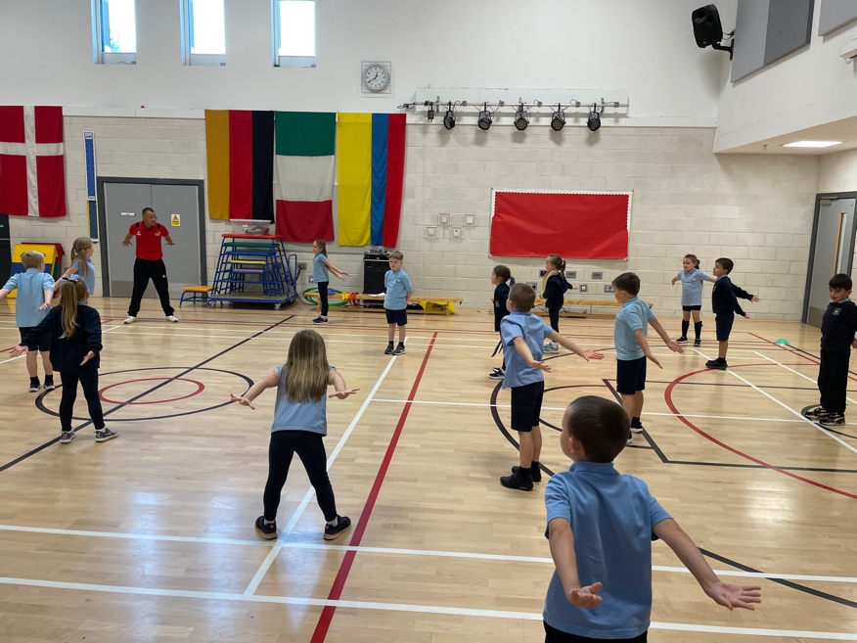

**HOME, SCHOOL AND COMMUNITY**

**PARTNERSHIP WITH PARENTS**

Children’s success in learning depends upon close partnership working between home and school.

Parents are kept informed of school activities and events by newsletters which are emailed monthly. This has proved to be the most effective and economical method of communication. These newsletters, together with a range of school documents such as the improvement plan and standards and quality report, are posted on the school website. Text messaging is used to keep parents informed of, for example, adverse weather conditions which will affect the opening hours of the school. Parents can also keep up to date with regular updates on the School App for phones and on the school's Twitter page.

In October and March, parents are given the opportunity to discuss their children’s progress with class teachers and to view children’s work. In December and June, written reports are sent to parents. Parents are most welcome to visit the school at other times to discuss any aspect of their child’s progress or well-being. All that is required is a telephone call to arrange a suitable time.

When a parent contacts the school with a concern or complaint, every effort is made to address the issue without delay. Any action to be taken is discussed fully and the parents encouraged to put their views as to how they would like school staff to resolve the concern or complaint.

Parents are involved in a variety of activities. They accompany children and teachers on educational visits, visit classes to share knowledge and expertise with the children, and generally assist with on-going school activities. There are regular opportunities for parents to share their views and make suggestions as to how the school can improve.

**PARENT PARTNERSHIP**

Scottish Schools (Parental Involvement) Act 2006 led to the establishment of Parent Councils in primary, secondary and special schools. The Act recognises the vital role that parents play in supporting their children’s learning. It places a duty on authorities to promote the involvement of parents in children’s education and the wider life of the school. It aims to help parents to be:

* involved with their child’s education and learning
* welcomed as an active participant in the life of the school
* encouraged to express their views on school education generally

Details of Parent Partnership members are as follows:

Chairperson – Mrs Colette Jones

PTA – Parent Partnership Fundraising Sub Committee – Mrs Karen McBride

The school has a Parent Partnership which meets regularly throughout the school year and serves by promoting a sense of partnership between the parents and staff for the benefit of the children who attend St Ninian’s. The programme of events, together with the names and telephone numbers of office bearers, is sent out to parents at the beginning of each school year.

**COMMUNITY LINKS**

As children grow, they become more aware that they are part of a wider community. Links with the local community are fostered through the learning and teaching programmes for environmental studies. The local area is used as a first-hand resource for learning and members of the community are invited to visit classrooms to share their knowledge and expertise with the children.

The school fosters a sense of community spirit by encouraging many activities which are community linked, for example, inter-school netball, football, swimming and sports activities, and awareness of the needs of local and national charities.

Local Community Groups provide presentations on a wide range of issues for children at each stage.

**SPORTS FACILITIES**

The school has a MUGA (Multi Use Games Area). This is used for outdoor PE facilities as well as for the "Daily Mile" which classes participate in.

**RELEVANT ADDRESSES**

Ruth Binks

Corporate Director of Education, Communities & Organisational Development

Inverclyde Council

Municipal Buildings

Clyde Square

Greenock PA15 1LX Tel: 01475 712850

Booking Office

Waterfront Leisure Centre

8 Custom House Way

Greenock PA15 1XR Tel: 01475 213131

**LOCAL COUNCILLORS**

The elected members of Inverclyde Council who represent the catchment area of the school are:

Ronald Ahlfeld

Chris McEleny

Lynne Quinn

Convenor of Education and Communities Committee - Councillor Jim Clocherty

Although this information is correct at time of presenting, there could be changes affecting any of the matters dealt with in the document –

1. before the commencement or during the course of the school year in question.
2. in relation to subsequent years.