ST MICHAEL’S PRIMARY SCHOOL

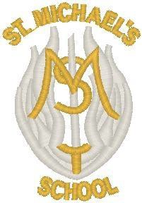

HANDBOOK

Updated December 2023

CONTENTS
 | Page
AUTHORITY STRATEGIC STATEMENT | 3
INTRODUCTION BY HEAD TEACHER | 4
SCHOOL AIMS AND VALUES | 5
SCHOOL INFORMATION | 6
INFORMATION IN EMERGENCIES | 8
CHILD PROTECTION IN INVERCLYDE | 8
STAFF | 9
THE SCHOOL DAY | 11
THE SCHOOL YEAR | 13
ADDRESSES | 14
ENROLMENT | 15
TRANSFER FROM PRIMARY TO SECONDARY SCHOOL | 16
POSITIVE RELATIONSHIPS POLICY | 17
THE CURRICULUM | 18
ASSESSMENT/REPORTING | 24
SCHOOL IMPROVEMENTS AND ACHIEVEMENTS | 24
HOMEWORK | 25
EXTRA CURRICULAR ACTIVITIES | 26
ADDITIONAL SUPPORT NEEDS | 27
EQUALITIES | 28
CLOTHING AND UNIFORM | 29
MEALS | 31
TRANSPORT | 34
MEDICAL AND HEALTH CARE | 35
HOME AND SCHOOL LINKS | 36
COMMUNITY LINKS | 40
PUPIL VOICE GROUPS | 41
TRANSFERRING EDUCATIONAL DATA ABOUT PUPILS | 43
GENERAL DATA PROTECTION REGULATIONS | 43
AND DATA POTECTION ACT 2018

AUTHORITY STRATEGIC STATEMENT

BUILDING INVERCLYDE THROUGH EXCELLENCE, AMBITION AND REGENERATION

Goals and Values

The core values of Inverclyde Council are: Respect, Honesty and Tolerance

Our vision for the children and young people of Inverclyde is that they should be ambitious for themselves and be successful learners, confident individuals, responsible citizens and effective contributors

To achieve our ambition of building Inverclyde through excellence, ambition and regeneration our children must be:

- Safe – protected from abuse, neglect and harm by others at home, school and in the community

- Healthy – enjoy the highest attainable standards of physical and mental health, with access to healthy lifestyles

- Achieving – have access to positive learning environments and opportunities to develop their skills, confidence and self-esteem to the fullest potential

- Active – active with opportunities and encouragement to participate in play and recreation including sport

- Respected and Responsible – involved in decisions that affect them, have their voices heard and be encouraged to play an active and responsible role in their communities

- Included – have access to high quality services when required and should be assisted to overcome the social, educational, physical, environmental and economic barriers that create inequality

- Nurtured – educated within a supportive setting

Inverclyde Council

St Michael’s Primary School

St Michael’s Primary School Bridgend Avenue
Port Glasgow PA14 5SU

Telephone: 01475 714690
Email: INStMichaels@glowscotland.onmicrosoft.com Website: http://st-michaels.inverclyde.sch.uk/
X (Twitter): @SMPG1964

Dear Parents and Carers,

As the Head Teacher of St Michael’s Primary School and Chair of our Parents’ Group, we would like to welcome you and your child to the school.

We pride ourselves on the excellent partnership we have between the home, the parish and our school. We work in partnership on a whole range of things, for example, school improvement projects, school policies and decision making about use of our Pupil Equity Fund. We also work in partnership to raise funds for our school; two of the highlights being our Winter Wonderland at Christmas and our Family BBQ in the summer. It has been an absolute to be able to return to these in-person events.

Our school handbook contains a wealth of information which we hope you find useful. We welcome visits from prospective parents and families at any time. Appointments can be arranged by contacting our school office.

Throughout each term we share lots of information with parents via email and also through our school X (Twitter) account.

Please do not hesitate to contact us if you require any further information. We look forward to working with you and your family in the years ahead.

Colette Wallace Susan McElwee
Head Teacher Chair of St Michael’s Parents’ Group

OUR SCHOOL VISION, AIMS AND VALUES

Our Vision

Following consultation with pupils, parents and staff, we created a vision statement for our school which reflects all our aspirations.

At St Michael’s Primary School, as a community of faith and learning, we aspire:

Through a nurturing approach and high quality learning and teaching, to provide our pupils with the knowledge, skills and attributes they need for learning, life and work; to develop each
person’s unique, God-given talents, ensuring that every child exceeds what they believe their potential to be.

Our Aims

It is the aim of everyone in St Michael’s to ensure that:

- There is a welcoming atmosphere fostering a commitment to a sense of identity and pride in the school
- A strong partnership with parents exists and that we strive to keep parents fully informed and involved in their child’s education
- Every child’s needs are met – intellectual, physical, spiritual, social and emotional, through teaching and learning experiences of the highest standard
- All staff are committed to their ongoing professional development and there is a strong commitment to teamwork amongst staff
- As a Catholic school, Gospel Values permeate throughout all of school life and spiritual formation develops in partnership with the home and parish
- Respect for each other, co-operation, self-discipline and positive attitudes are encouraged
- We reach out to develop links with our local community and other agencies and establishments

Our Values

The school community has identified the following values which reflect the important principles on which we base all our decisions:

  - Respect
  - Honesty
  - Ambition
  - Compassion
  - Learning

SCHOOL INFORMATION
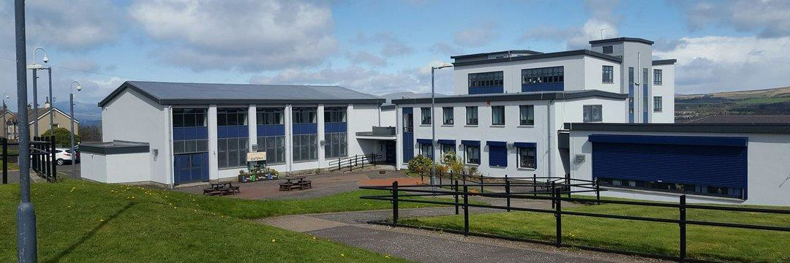

SCHOOL NAME St Michael’s Primary School

ADDRESS Bridgend Avenue
Port Glasgow PA14 5SU

TELEPHONE Telephone: 01475 714690

E-MAIL ADDRESS INStMichaels@glowscotland.onmicrosoft.com

SCHOOL WEBSITE https://blogs.glowscotland.org.uk/in/stmichaelsprimary/

SCHOOL X (TWITTER) ACCOUNT @SMPG1964 PRESENT ROLL 151
AGREED CAPACITY 429

Parents should note that the working capacity of the school might vary dependent upon the number of pupils at each stage and the way in which the classes are organised.

In session 2022-23 our classes are:

CLASS NUMBER OF PUPILS
Primary 1 20
Primary 2 20
Primary 3 14
Primary 4 21
Primary 5 29
Primary 6 27
Primary 7 20
ACCOMMODATION

Our refurbished building includes:

13 Classrooms which includes our Rainbow Room ICT suite
Library/Family Hub called The Arc Meeting Room
Staff Workroom and Common Room Office accommodation
Separate Gym Hall, Assembly Hall and Dining Room Medical Room
Classrooms have provision for a Soundfield/voice enhancing system Wi-Fi throughout the school
All classes have an interactive whiteboard Ramp access and lift to all levels of the building
Security features include CCTV and electronic shutters The school is equipped with a sprinkler system
School grounds are landscaped to provide adequate playing facilities for pupils, picnic benches and staff/visitor car parking
A MUGA (multi use games area) STATUS
Roman Catholic – co-educational COMMUNITY/FACILITIES
Rainbows, Brownies and Guides meet in the school on Mondays.

Further particulars on school letting may be had from:

Waterfront Leisure Complex Greenock

Email: bookingoffice@inverclydeleisure.com
Telephone: 01475 717171

PARENTS’ GROUP – FORMERLY KNOWN AS THE PARENT COUNCIL

Our elected Council members are:

Susan McElwee Chair
Claire McMenamin Vice Chair
Marie Stewart Treasurer
Joanne Thomson Social Media/PR
Laura and Darrin Ballingall Secretaries
Fr Dan Fitzpatrick Church Representative

The Parent’s Group can be contacted via email saint.michaels.pc@gmail.com or via private message on Facebook https://www.facebook.com/StMichaelPC or Direct Message on X (Twitter) https://twitter.com/St_Michaels_pc
Our associated pre-5 establishments are:

- Newark Nursery School
- Rainbow Family Centre
- Gibshill Children’s Centre

Registration takes place in January each year. This is a formal process which is now completed online. (See Page 15 for details of Enrolment for school).

An induction programme is planned throughout the year with the main emphasis in May/June.

INFORMATION IN EMERGENCIES

We make every effort to maintain a full educational service but on some occasions, circumstances arise which lead to disruption. Schools may be affected by, for example, severe weather, temporary interruption of transport, power failures or difficulties of fuel supply. In such cases, we shall do all we can to let you know about the details of re-locating pupils to Newark Primary, closure or re-opening. Information will be shared with you via a range of media: email, text messaging, letters, Twitter and Inverclyde Council’s website.

CHILD PROTECTION IN INVERCLYDE

Inverclyde Council Education Services has Child Protection Guidelines and Procedures which all schools and establishments are required to follow. Education Services work very closely with other agencies namely Strathclyde Police, Social Work Services, NHS Greater Glasgow and Clyde and the Children’s Reporter to support children. Common responsibilities of all staff are to protect children from abuse and exploitation, to respond appropriately when abuse is identified, and to ensure whenever possible that all children are able to exercise their right to be raised in a warm, stimulating and safe environment with the support of staff, their families and carers.

SCHOOL STAFF
in session 2023/24

OUR SCHOOL CHAPLAIN – Father Dan Fitzpatrick, Parish Priest of Holy Family Church

TEACHING STAFF

TEACHING STAFF
Mrs Colette Wallace | Head Teacher
Mrs Janet Russell | Depute Head Teacher
Mrs Maria Moses | Primary 1
Mrs Natasha Deacon and Mrs Michelle Harkins | Primary 2
Mrs Erin Deegan | Primary 3
Miss Danielle Kearns | Primary 4
Mrs Isabel McColl | Primary 5
Mrs Stacey Felgate | Primary 6
Mrs Claire McEnaney and Mrs Lesley Gillan | Primary 7
Miss Christine Donnelly | Support for Learning Teacher
Miss Christine Donnelly | Nurture Teacher
Miss Rachael McDaid | Targeted Interventions Teacher/RCCT teacher
Mrs Lesley Gillan | Targeted Interventions Teacher/RCCT teacher
Mrs Katie Williamson | Targeted Interventions Teacher

SUPPORT STAFF

Mrs Sharon Calder | PSA (Pupil Support Assistant)
Mrs Fiona Griffin | PSA
Miss Karen Henry | PSA
Mrs Karen Kearns | PSA
Mrs Mary McGachy | PSA
Mrs Claire McLaughlin | PSA
Mrs Julie Masterson | PSA
Mrs Mellisa McIntyre | PSA
Miss Agnes O’Donnell | PSA

OFFICE STAFF

Ms Lynn Paul | Senior Admin Assistant
Mrs Alice Buchanan | Admin Assistant
Mrs Sharon Penniston | Admin Assistant and Attendance Support  (Funded through Pupil Equity Fund)

VISITING MUSIC INSTRUCTORS

Ms Amanda Currie | YMI Tutor
Mrs Victoria Douglas | Woodwind Tutor
Mr Andrew Fodden | Brass Tutor
Ms Elysia Wilson | Vocal Coach

VISITING TEACHERS FUNDED BY SCOTTISH ATTAINMENT CHALLENGE
Mrs Sharon Tucker – Literacy and Numeracy

BARNARDO’S FAMILY SUPPORT WORKER FUNDED BY THE SCOTTISG ATTAINMENT CHALLENGE
Claire Conway

KITCHEN STAFF

Catering Manager – Mrs Teresa O’Donoghue

Catering Assistants
Mrs Charlene Blair
Mrs Lauren McElwee
Mrs Christine McConnell
Mrs Gail MacKay
Mrs Maureen Campbell
Miss Ashleigh Beaton

CLEANING STAFF

Margaret Hair – Head of Cleaning Staff
Sonia Blaikie
Cath Ellis

JANITOR – TBC

SCHOOL HOURS

Open | 9.05
Interval | 10.35 - 10.50
Lunch | 12.30 – 1.15
Close | 3.05

Punctuality
Our expectation is that pupils will be at school on time but we are aware that that there may be exceptional circumstances that lead to a child being late. Being late can cause anxiety for pupils as lessons have already started. If we have concerns regarding your child’s timekeeping we will contact you to try to resolve any problems that may prevent you getting your child to school on time.

Attendance
There is a direct link between good school attendance and attainment. If your child is going to be absent, we ask that you contact the school, by email, Parents Portal or telephone, giving the reason for the absence. This should be done daily except where a parent can state clearly on the first day of absence the numbers of days their child will be absent. On return to school, parents should provide their child with a letter for their class teacher confirming the reason for absence.
We follow Inverclyde Council’s policy, “Attending School Matters,” when monitoring and supporting pupil attendance. Details of this can be found on our website at https://blogs.glowscotland.org.uk/in/public/stmichaelsprimary/uploads/sites/6737/2022/10/04093038/Attending-School-Matters-Leaflet.pdf
If your child has a medical or dental appointment please inform our school office so that your child’s attendance is marked appropriately.

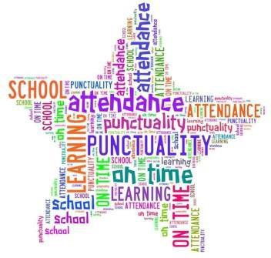

Arrival at school
On arrival at school, pupils should make their way to their playground via the infant door facing Bridgend Avenue. Please note that playgrounds are unsupervised until 8.50am each morning. In the interest of safety we ask that parents and carers do not enter the school grounds.
Staff are present in the playground at break times and lunchtimes in accordance with the Schools (Safety and Supervision of Pupils) (Scotland) Regulations 1990.

Outdoor Clothing
We encourage our pupils to play outdoors as much as possible. Only when we feel that there is a safety risk being outdoors eg high winds, will we ask that the children play indoors. Therefore we ask that children are dressed appropriately for the weather. Please ensure your child has a warm coat, hat and gloves for cold days. A lighter weight coat is appropriate for finer weather. There are times when we get sunny spells of weather. We ask that you apply sun cream to your child and provide them with a sun hat or cap.

Inclement Weather
When our weather is particularly wet, snowy or icy, children will be admitted to school at 8.50am. We ask that pupils do not arrive before this time as we are unable to bring them indoors any earlier due to availability of staff to supervise.

Home Lunches
If your child is going home for lunch, we ask that you notify the school. Your child will need to sign in and sign out at the main office.

Healthy Snacks
We encourage children bringing a snack from home to include only one item and one drink. Due to children have serious allergies within our school, we ask that you support the school by sending snacks and packed lunches which are free from: nuts, peas, lentils, chickpeas, sesame and ginger. In class pupils are encouraged to drink water. We ask that a water bottle is brought in to school from home for use with our water coolers. These should be taken home to be washed daily and returned to school the next day. Following national guidelines, diluted juice and flavoured water are not permitted in class.

Car Parking
There are no car parking or drop off facilities for parents and carers within the school grounds. We ask that all parents and carers respect this in order to ensure everyone’s safety. Accessible parking bays are for children who are “Blue Badge” holders. There are park and stride facilities at Newark Care Home and North Road which we encourage everyone to use.
Together with Newark Primary and Newark Nursery School we ask that everyone is a “Child Friendly Driver.”

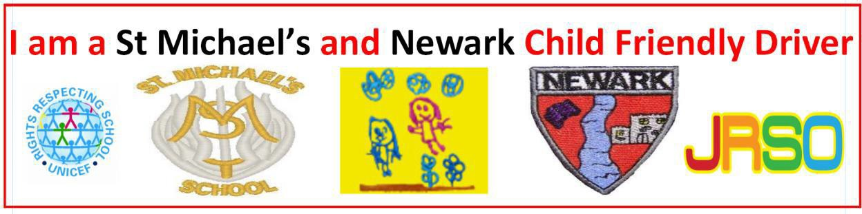

THE SCHOOL YEAR 2024-25

ADDRESSES

The following are helpful addresses/telephone numbers:

Education Services
Wallace Place
Greenock PA15 1JB | Telephone: | 01475 712892
Councillor Jim Clocherty (Education Convener) Inverclyde Council  Municipal Buildings Greenock | Telephone: | 01475 717171
LOCAL COUNCILLORS:  Kirsty Law/Drew McKenzie/R Moran  Inverclyde Council  Municipal Buildings Greenock | Telephone: | 01475 712020
School Health  Port Glasgow Health Centre Bay Street  Greenock | Telephone: | 01475 495264

Claire Conway
Family Support Worker (Barnardo’s)
9 Terrace Road
Greenock  Holy Family Presbytery Parkhill Avenue | Telephone: | 07725625941/01475 728493
Port Glasgow | Telephone: | 01475 705585
St Francis Presbytery Auchenbothie Road Port Glasgow | Telephone: | 01475 700700
St John’s Presbytery Shore Street  Port Glasgow | Telephone: | 01475 741339

ENROLMENT

Inverclyde Council has changed the way in which children register for primary school. This process will now be undertaken by completing an online application form which can be found on the Inverclyde Council website at https://www.inverclyde.gov.uk/education-and-learning/schools/registering-for-primary-school/school-session-2024-2025

It’s vitally important that parents follow the online registration process to register their child for a Primary 1 place in an Inverclyde school.

Children who reach the age of five years between 1 March 2024 and 28 February 2025 are due to start Primary 1 at the beginning of the new school term in August 2024. Parents are asked to register their child in their chosen denominational or non-denominational catchment primary school, from Monday 8th January until Friday 12th January.

Once parents have completed the Primary 1 registration, they will have the choice to complete a placing request application to a school other than the catchment primary Inverclyde Council Online Forms (This includes Primary 1 Gaelic Medium education at Whinhill Primary School).
No documents will be required at this stage; however, we may have to contact you, should we require further information. Parents will be notified by 30 April 2024 confirming their child’s place in school.
Parent who do not have internet access to apply online are asked to contact their child’s current Early Years establishment for assistance.
DEFER ENTRY
A deferred entry application is also available to parents considering deferring their child’s entry to Primary 1 in August 2024. Defer entry applications for the school term starting August 2024 are open until 1 February 2024. To make an application you should have registered your child for Primary 1 between 8 – 12 January https://www.inverclyde.gov.uk/education-and-learning/schools/registering-for-primary-school/deferred-school-entry
Parents will be advised of the outcome of their application no later than 30 April.

PLACING REQUEST
The Education Authority does not provide transport for those pupils in receipt of a placing request other than in exceptional circumstances. In the case of under age placing requests, if the child is offered a place in his/her catchment area school, transport will be provided in accordance with Council policy.

ARRANGEMENTS FOR PUPILS WITH ADDITIONAL SUPPORT NEEDS
Inverclyde Council has a policy on inclusion and equality which incorporates the assumption that all children will routinely be educated within their own community. Transitional arrangements for children with additional support needs, moving from nursery to primary or primary to secondary, are discussed at a child’s review meeting. Any child or young person with additional support needs who requires more specialist support will be discussed at Inverclyde’s Additional Support Needs Monitoring Forum. The Forum will make recommendations related to resources, support and necessary specialist placements.
PRE-SCHOOL PROGRAMME
This scheme is ongoing throughout the year. Children, parents and carers will have opportunities to join with our school community during the session.
Parents will receive a letter advising of the dates/times of these sessions.

The opportunity is always available for all prospective parents to visit and be shown round the school before any final decision is made.
TRANSFER FROM PRIMARY TO SECONDARY SCHOOL

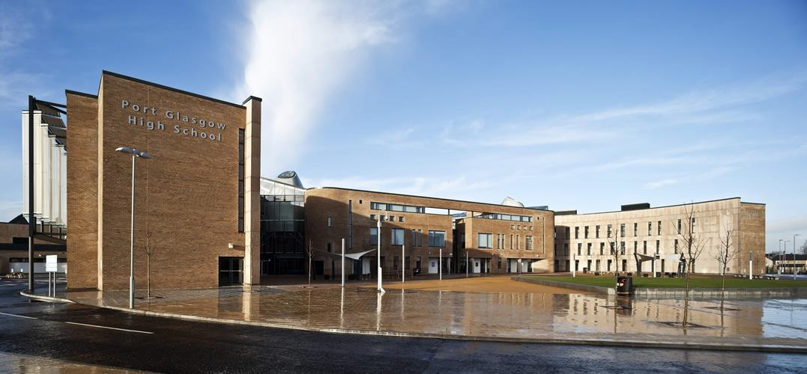

Pupils normally transfer to secondary school between the ages of 11½ and 12½ so that they will have the opportunity to complete at least four years of secondary education. Parents will be informed of the arrangements no later than December of year preceding the date of transfer at the start of the new session.

Pupils living within the catchment area normally transfer to St Stephen’s High School, Port Glasgow Community Campus, Kilmacolm Road, Port Glasgow – telephone 01475 715300.

During the session, Primary 7 participate in various aspects of the curriculum at St Stephen’s and St Stephen’s school staff also visit the children at St Michael’s during the year.

Mr Robert Carroll, DHT of St Stephen’s, has responsibility for primary/ secondary liaison. He attends our twice yearly Parents’ Evenings for an informal chat or to discuss any concerns.
The parents of children who require an enhanced transition programme will be invited to attend planning meetings with St Michael’s and St Stephen’s staff.

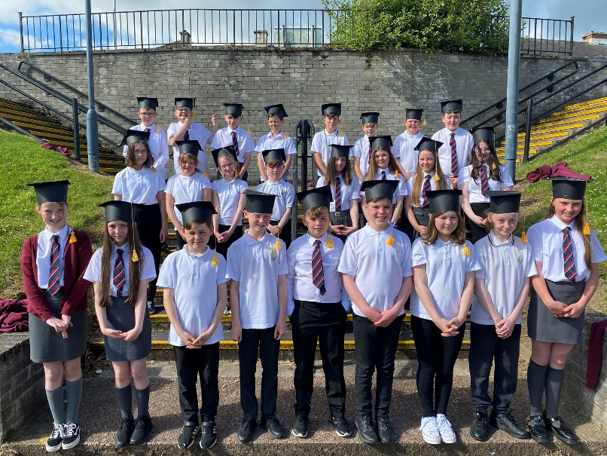

POSITIVE RELATIONSHIPS POLICY

Our policy is based on mutual respect for one another. This positive caring aspect is emphasised in order that all children feel safe and secure and are able to progress and develop in their work and play activities. The co-operation of all parents is essential in this regard.

As a Rights Respecting School, each class has developed a classroom charter which demonstrates the rights every child has as part of their Right to an Education (article 28 of UNCRC). We also have a charter for our playground.

These are enforced in all areas of our school.

Our rights and values permeate all areas of school life.

We encourage and recognise good behaviour by use of praise, stickers, certificates, weekly Values Ambassadors awards and Beautiful Attitudes awards.

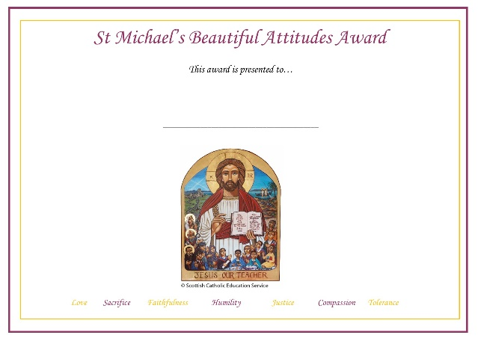

We use restorative practice to resolve issues of conflict in our school. This methodology seeks to explore what happened and how those involved felt about the situation. We then look at a solution and ways of repairing the hurt caused and preventing a similar situation happening again.

It should be stressed that good standards of behaviour are displayed by the vast majority of children in the school who reach the ultimate aim of self discipline. Some pupils do however need additional support in forming good relationships with their peers and staff. It is only through close partnership working between home and school that success can be achieved.

CURRICULUM FOR EXCELLENCE

The curriculum framework for all Scottish educational establishments 3 - 18, called Curriculum for Excellence, aims to offer better educational outcomes for all young people and provide more choices and more chances for those young people who need them.

The aims of Curriculum for Excellence are that every child and young person should:

  - Know they are valued and will be supported to become a successful learner, an effective contributor, a confident individual and a responsible citizen;

  - Experience a traditionally broad Scottish curriculum that develops skills for learning, skills for life and skills for work, with a sustained focus on literacy and numeracy that encourages an active, healthy and environmentally sustainable lifestyle and builds an appreciation of Scotland and its place in the world.

The experiences and outcomes under Curriculum for Excellence are written at five levels, with progression to qualifications described under the senior phase.

Early Level - the pre-school years and P1 or later for some First level - to the end of P4, but earlier for some
Second level - to the end of P7, but earlier for some Third and Fourth - S1 to S3, but earlier for some
Senior phase - S4-S6 and college or other means of study

All pupils should experience a balanced curriculum in their seven years in primary school. The curriculum should also offer challenge and enjoyment, breadth, progression, depth, personalisation and choice, coherence and relevance.
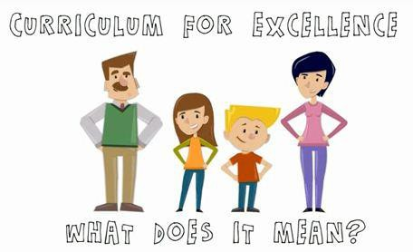

Further information can be found by visiting:

https://education.gov.scot/parentzone

OUR CURRICULUM

Our Rationale

As an Attainment Challenge school, the Key Drivers of Improvement, identified by the Scottish Government, inform and guide our practice as we endeavour to provide equity and excellence for all learners. We use this framework to plan for school improvement and this is evidenced through our Strategic Improvement Plan. We work in partnership with parents and families, our Parish, our local community, the local authority Attainment Challenge team and external partners to create a learning environment and ethos which will inspire and motivate learners, as we seek to develop a community of learners who can confidently take their place in society. In order to achieve this, we must provide our learners with experiences which are relevant and will develop their knowledge, skills and attributes, fostering curiosity and a love of learning.

Our parents have high expectations for their children and trust that their children are receiving the best possible learning experiences. They are proud of the school, many of them being former pupils themselves. They aspire that their children will be well prepared to make the transition to secondary school. By working in effective partnership we can achieve this aspiration, raising attainment within our school.

Learning and Teaching

Under the direction and with the support of the Senior Management Team, our staff engage in curriculum development sessions, collegiate practice, peer observation and ongoing professional learning, which leads to continuous development of high quality learning and teaching. This is at the heart of our curriculum. As a Rights Respecting School, clear links with Articles from the UNCRC are evident in our teaching and learning.

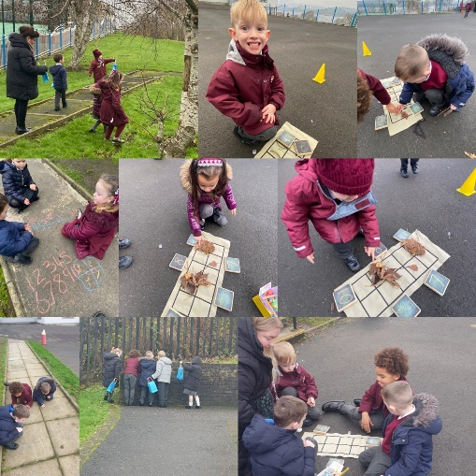
St Michael’s Primary School takes a child-centred approach to planning pupils’ learning experiences and assessment is an integral part of this process. The use of the wellbeing indicators in developing a holistic understanding of our learners is an essential part of our practice. Learning experiences are planned carefully using the
Experiences and Outcomes of Curriculum for Excellence and based on the seven principles of curriculum design. Taking account of the learning needs of their pupils, our staff employ a range of teaching strategies. Children will be encouraged to learn independently as well as co-operatively. They will carry out solo tasks, paired and trio based activities, participate in small group and large team based events. Learning will take place both within and outwith the classroom. Activities will always be purposeful; providing new learning experiences or opportunities to demonstrate knowledge and understanding by applying skills in new or unfamiliar contexts. They have opportunities to lead their learning within their classes and also through a range of well-planned activities outwith their class setting.

Our learning and teaching takes place within four different contexts:

Curriculum areas and subjects

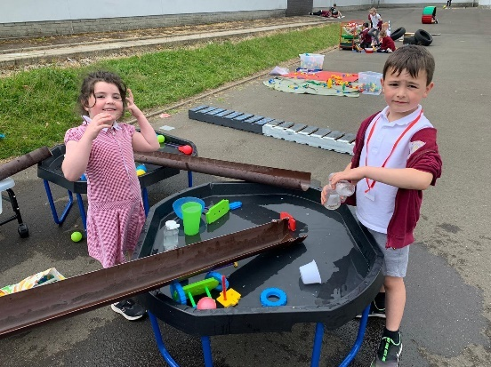
Our staff ensure that all pupils in St Michael’s Primary experience a Broad General Education as outlined in Curriculum for Excellence, “progressing through the Levels, as far as this is consistent with their learning needs and prior achievements.” (Education Scotland).
This is their entitlement. This means that pupils will learn: Languages (English and French), Numeracy and Mathematics, Religious Education in Catholic Schools, Health and Wellbeing, Social Studies, Science, Technologies and Expressive Arts.

By applying the principles of GIRFEC, staff ensure that all pupils experience an appropriate curriculum, enabling them to be successful in their learning journey. It is our duty to ensure that our pupils’ learning experiences develop their capacities for life.

Learning through play happens regularly at the early stages of our school. Play helps children to understand the world and things that happen in their life. When playing, children are able to make connections with their experiences, practice skills and discover new challenges. Play also develops an interest in and motivation for learning that children will have their whole lives. Play will cover a balance between 3 different types of learning:
- activities led by staff
- resources or activities planned by staff but left for children to explore independently
- activities led by the children
Staff will use observations of your child – their interests, strengths & areas for development - to plan for their setting's learning environment. This will include the learning space & resources as well as the experiences & interactions as above.

As our approaches to learning through play develop, we will extend this approach to other stages of the school.

Interdisciplinary Learning

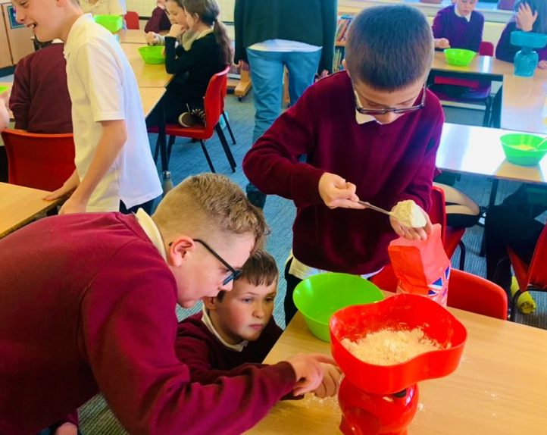
Our staff plan interdisciplinary learning (IDL) experiences for their pupils, enabling them to encounter and explore relevant links between different subjects. It also provides pupils with opportunities to apply skills that they have learned in new and unfamiliar contexts, providing staff with opportunities to assess the depth of children’s understanding. In line with Building the Curriculum 3, our staff achieve this through a range of approaches, for example, through one-off projects or longer courses of study and providing opportunities for
mixed stage learning which is interest based. IDL projects greatly inspire and motivate learners and provide opportunities for pupils to showcase their learning to their parents and families.
These celebrations of learning give further opportunities for our pupils to develop their skills and receive very positive feedback from families. Mixed stage learning has been highly successful within our infant department and will be extended to other areas of the school.

Ethos and life of the school
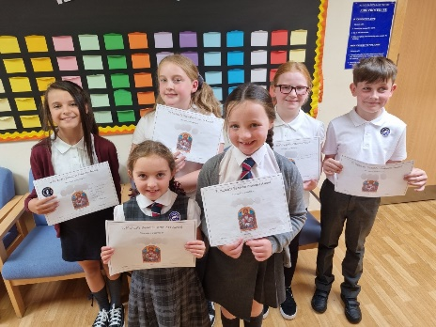
As a community of faith we have “an inclusive ethos which aims to honour the life, dignity and voice of each person, made in the image of God.” (Charter for Catholic Schools in Scotland). By our actions we promote the Gospel values of
love, sacrifice, faithfulness, humility, justice, compassion and tolerance. As a nurturing school, the application of the principles of nurture in our daily practice firmly supports the creation of an inclusive ethos and the promotion of the Gospel values. Positive relationships are at the heart of our school.

Our staff ensure that pupils are provided with opportunities to contribute to the school and its wider community, and actively encourage them to do so. As a Rights Respecting School, the voice of each person is valued and each person has the opportunity to contribute to decision making processes which lead to school improvement. One of the ways in which we achieve this is by ensuring pupils can have their say through our Pupil Voice Groups. These groups have clear mission statements which reflect the focus of the group, its impact for its individual members and for the whole school. Our pupils are also regularly consulted through Learning Conversations and pupil audits.

Pupils are provided with leadership opportunities within classes and throughout the school, developing positive attributes and skills required to be responsible citizens. They share their talents with others.

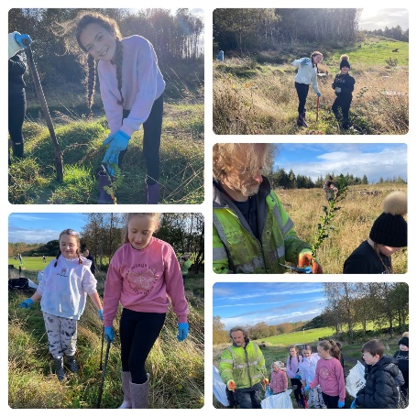
Opportunities for personal achievement

Planning for pupils’ learning ensures that there opportunities for pupils to experience personal achievement.

In St Michael’s Primary our staff are dedicated to providing pupils with a range of opportunities for personal achievement outwith their daytime classroom experience. This is evident through the vast range of after school and lunchtime clubs that are available. Opportunities are planned so that pupils of all age groups are having these experiences.

Our school works in close partnership with Brnardo’s, CLD, Active
Schools, Inverclyde Music Service, Library Services and Clyde Muirshiel Rangers Service to further extend the opportunities available to our pupils.

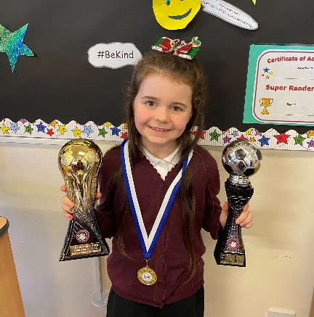

We celebrate the achievements of our pupils through assemblies, newsletters, Twitter, our website and the local press. As we continue to celebrate pupils’ achievements we are seeking ways for parents and carers to share their children’s achievements from outwith school.

SPIRITUAL, SOCIAL, MORAL AND CULTURAL VALUES – RELIGIOUS AND MORAL EDUCATION

The Education (Scotland) Act 1980 imposes a statutory duty on local authorities to provide
“Religious Observance” in Scottish schools. This is defined in a national R.O. Review Group report published in 2004 as comprising: "community acts which aim to promote the spiritual development of all members of the school's community and express and celebrate the shared values of the school community".

In a letter of guidance issued by the Scottish Government in February 2011, it is acknowledged that Catholic schools take a distinctive approach to the provision of Religious Observance:
Scottish Government Ministers welcome the tradition that, in Roman Catholic denominational schools, Catholic Liturgy will largely shape the nature and frequency of religious observance activities in the classroom and in the wider school community. So, at times, children and young people will be invited to participate in, and sometimes to lead, prayer and reflection in classrooms and at assemblies. At other times, to honour particular occasions or feasts, chaplains will lead school communities in the celebration of Mass and other forms of liturgical celebration.¹
Catholic schools follow the customs and practices of the Church in order to nourish the spirituality and faith of pupils and staff. Our Catholic tradition is enriched by ancient rites, prayers and devotions which help young people to become aware of, and show reverence to, the sacred presence of the living God, Father, Son and Holy Spirit. Guided by this tradition, we celebrate various seasons and special feast days to honour God, Mary his Mother and the Saints.

Pupils are invited to pray with their teachers at times in classrooms and assemblies, as well as in liturgical services. Usually a classroom will display a Crucifix on the wall; in some classrooms and other areas of the school, a sacred space will feature a copy of the Bible and will be decorated with signs and symbols that reflect the changing seasons of the Church Calendar Year i.e., Advent, Christmas, Lent, Easter and Pentecost.

This regular practice of Prayer is complemented by religious services conducted, sometimes as part of an Assembly, to mark special occasions, eg, the distribution of Ashes on Ash Wednesday, the seasons of Advent or Lent. To mark special Feast Days and Holy Days of Obligation, Holy Mass will be celebrated by the school chaplain, with the school community, in school buildings or in local parishes. Some pupils, at certain stages, may be able to participate in retreats and pilgrimages to places of special significance within the Catholic tradition.

While Religious Education is governed by separate Church guidance, it is complemented by Religious Observance practices and, together, these experiences help pupils to develop their understanding of the Catholic faith, to experience opportunities for spiritual growth and to commit to beliefs, values and actions in a positive response to God’s invitation to faith.

In terms of pupil participation in R.O. Scottish Government guidance makes it clear that it makes an important contribution to pupils' development and that it promotes the ethos of a school by bringing pupils together and creating a sense of community. However, it also makes clear that parents have the right to withdraw children from participation in religious observance and that this right should always be made known to parents and their wishes respected. The Scottish Government also recognises that:
Where a parent chooses a denominational school for their child's education, they choose to opt in to the school's ethos and practice which is imbued with religious faith and religious

1 Curriculum For Excellence - Provision of Religious Observance in Schools, Scottish Government, 17 February 2011

observance. In denominational schools, it is therefore more difficult to extricate a pupil from all experiences which are influenced by the school's faith character.

The Catholic Church has designed a new programme, “God’s Loving Plan”, which will be used to deliver our sex education programme. Sex and relationship education is an integral part of a

school’s health education and RE programme. It focuses on the physical, emotional, moral and spiritual development of all children. Teachers are central to the delivery of sex education from Primary 1-7 and work in partnership with parents/carers and appropriate health professionals.

Parents/Carers are fully informed and consulted on the content and purpose of sex and relationship education in schools, and have the opportunity to raise concerns with school staff. On an occasion where a parent/carer wishes to exercise the right to withdraw his/her child from sex and relationship education or any aspect of religious education, they should discuss this with school staff (as per Inverclyde’s policy “Sexual Health and Relationship Education”) and alternative arrangements will be made.

Parents from ethnic minority religious communities may request that their children be permitted to be absent from school in order to celebrate recognised religious events. Only written requests detailing the proposed arrangements will be considered. Appropriate requests will be granted on not more than three occasions in any one school session and the pupil noted as an authorised absentee in the register.

In St Michael’s School we have very strong links between the school, home and parish.
Father Laurent, as our school chaplain, leads us in worship and regularly visits our school. We work closely together to support all learners in their faith journey.

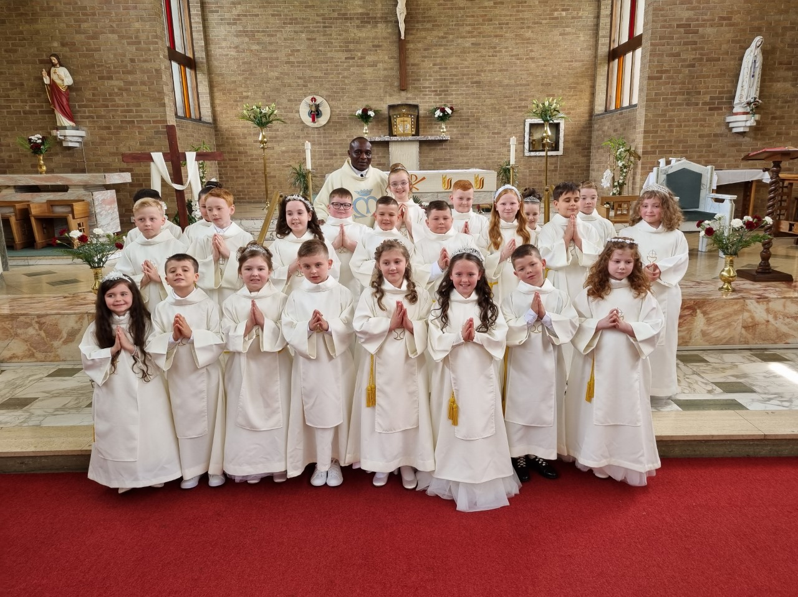

ASSESSMENT/REPORTING

Assessment is the term used to describe the process of evaluating a child’s progress. We continue to develop formative assessment at St Michael’s. This is assessment which directly affects the learning and teaching that takes place. To this end we are involving our pupils in sharing what is to be learned. We are involving pupils in self and peer evaluation and we are concentrating on meaningful feedback for our pupils.

Assessment is an important part of learning and teaching.

Class and group tests are part of our summative assessment programme. This type of assessment comes at the end of a piece of work. Our assessment procedures fulfil three purposes

- To diagnose areas of difficulty
- To provide reliable information on pupil progress
- To provide the basis for communicating to parents areas of strength and concern Assessment will include
- Scottish National Standardised Assessments at P1, P4 and P7
- Class based assessments on spelling, reading, writing and maths.

Parents will be informed of their child’s progress during each school session in a number of ways:

- At our twice yearly Parents’ Evenings
- Written reports
- Class newsletters
- By attending our PATPAL sessions
- Parents may at any time make an appointment if they would like to discuss a child’s progress either with the class teacher, the Depute Head Teacher or the Head Teacher
- Telephone calls

SCHOOL IMPROVEMENTS AND ACHIEVEMENTS

Further information about school improvement and achievements can be found on the school website http://st-michaels.inverclyde.sch.uk and also shared via X (Twitter) @SMPG1964.
Our Standards and Quality Report for session 2022-23 can be accessed on the “Welcome” page of our website https://blogs.glowscotland.org.uk/in/stmichaelsprimary/. Our Strategic Improvement Plan for session 2023/24 can also be accessed on the same page. Our most recent HMIe Report can be accessed at
https://education.gov.scot/education-scotland/inspection-reports/reports-page/?id=4682 Full information about our levels of attendance and attainment can be accessed at
https://scotland.shinyapps.io/sg-primary_school_information_dashboard/

HOMEWORK

Home learning activities are an essential part of every pupil’s school programme. In accordance with a Curriculum for Excellence, it encourages pupils to become Successful Learners, Effective Contributors, Responsible Citizens and Confident Individuals. Its purpose is to:

- Actively promote parental involvement
- Enable parents and carers to share the range of learning experiences and methods used in the classroom
- Set tasks to challenge individual learning experiences
- Provide additional practice across a wide range of curricular areas
- Consolidate and reinforce new learning
- Initiate dialogue involving child, carer and teacher
- Promote pupil self evaluation
- Promote lifelong learning

Our school policy was formed following consultation with pupils, parents and staff but is now under further review.

Primary 1 to 3, work should not exceed 20 minutes and from Primary 4 to 7, should not exceed 30 minutes.

At times, family learning activities are provided in relation to a class topic. These should be given no more than twice per year. The school will provide a starter pack of resources for such tasks.

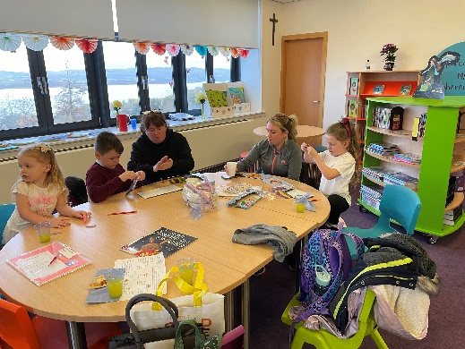

Family Learning clubs are provided at various times throughout the school year and are led by school staff and Barnardo’s Family Support Workers.

EXTRA CURRICULAR ACTIVITIES

Our children benefit from numerous opportunities to be active and further develop their fitness levels.

We recently received a Gold Award from sportscotland in recognition of our commitment to promoting and providing our young people with a vast range of opportunities to be involved in sport.

The school is regularly involved in sporting events such as athletics, football, netball and rugby. Pupils in Primary 6 are given the opportunity to take part in a programme of cycling proficiency and are encouraged to take the subsequent written and practical tests leading to the award of a cycling proficiency certificate and badge.

We have an annual festival of sport involving all pupils. This is designed and led by our senior pupils in partnership with their teachers and our Active Schools co-ordinator, Brad Cathie.

We regularly carry out an audit of pupil interests so that we provide extra curricular activities which are of interest to everyone over the course of the school year. Most recently we have had requests for a pop music club, magic club and dance club. We always do our very best to deliver what the children are looking for.

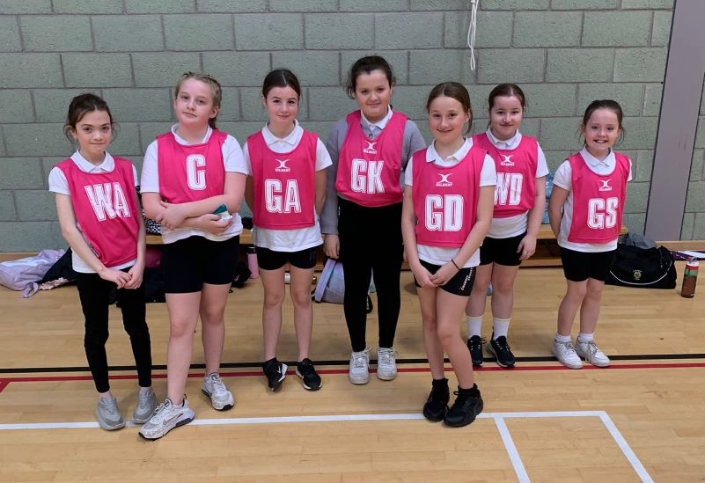

ADDITIONAL SUPPORT NEEDS

“Getting It Right For every Child” (GIRFEC) is at the heart of all that we do. GIRFEC is the national approach in Scotland to improving outcomes and supporting the wellbeing of our children and young people by offering the right help at the right time from the right people. It supports them and their parents to work in partnership with the services that can help them.

In our school, parents of children experiencing any difficulties will be informed at the earliest opportunity. Additional support will then be put in place which may include individual programmes of study, alternative resources, additional input from class teacher, classroom assistant, learning assistant, ASN auxiliary, our nurture teacher, our Support for Learning teacher or Attainment Challenge outreach teachers. We also have access to a Family Support Worker, Marie Linning, who can support children both at home and school. Referrals to this service can be made directly by parents or via the school.

If appropriate, or where a difficulty continues, Support for Learning staff will carry out further assessments and provide additional advice and support. Should a concern persist, the Educational Psychologist may become involved.

Wellbeing Assessments are drawn up in consultation with pupils, parents and staff for children requiring individualised support. A Wellbeing Assessment looks at the strengths and challenges a child encounters by focussing on eight wellbeing indicators: Safe, Healthy, Achieving, Nurture, Active, Respected, Responsible and Included. These wellbeing indicators are often referred to as SHANARRI.

In conjunction with other agencies, we aim to provide emotional, physical and educational support for all pupils in an environment within which they feel secure and happy and are enabled to develop to their full potential.

We actively encourage parents to contact Mrs Wallace, Head Teacher, if they have any concerns about any aspect of their child’s wellbeing.

Our refurbished school has a ramp and lift ensuring access to all levels for all our pupils, staff and visitors.

In addition to the information above, the following is specified by the Education (Additional Support for Learning) (Scotland) Act 2009:

A child or young person’s needs are identified at the earliest possible stage and can be met in a number of ways, for example, by adaptations to the curriculum or learning environment, as well as input from the Support for Learning teacher and on occasion support from visiting specialists. The appropriateness of the support is determined through a process of assessment, planning and monitoring, working jointly with parents and carers, and is regularly reviewed.

Learning outcomes for children and young people with additional support needs are set out in a plan and all educational establishments hold regular review meetings with parents and carers to determine needs and the most appropriate supports. Everyone’s views are equally important in order to consider what is currently working and how to determine next steps.

Children and young person’s needs are identified in a number of ways, and the process of assessment is an ongoing, shared process with partnerships with parents and carers at the forefront. On some occasions health service staff or other partner agencies make children known to Education Services. Other additional support needs may be notified to Education

Services by parents themselves or identified by one of a range of staff working closely with the child.

Some children and young people will have additional support needs arising from complex or multiple factors which require a high degree of co-ordination of support from both education and other agencies in order that their needs can be met. In these cases, the school will hold a meeting to decide whether the child or young person meets the criteria for a co-ordinated support plan. The co-ordinated support plan is a statutory document which ensures regular monitoring and review for those children and young people who have one.

You have the right to ask the education authority to establish whether your child needs a co- ordinated support plan. Your child can make this request themselves if they are aged 16 or over. You and your child, if they want to, will attend a meeting with staff at their school. Other professionals from different agencies who may be involved in providing support for your child will also attend. If your child does not want to attend meetings or feels unable to, their views must still be sought and considered.

Inverclyde’s mediation service can be accessed by contacting Michael Roach, Head of Education, at the address below.
For further advice, please telephone 01475 712850 or write to: Education Services
Wallace Place
Greenock PA15 1JB

Parents may find the following websites useful:

www.enquire.org.uk

www.siaa.org.uk

www.sclc.org.uk

EQUALITIES

Inverclyde Education Service is committed to ensuring that no children or members of staff or service users receive less favourable treatment on any ground including age, gender reassignment, pregnancy and maternity, race, disability, sex, sexual orientation, marriage and civil partnership, religion or belief. We have a moral, social and legal obligation to mainstream and put equality at the heart of everything we do. We aim to promote a culture in which equality of opportunity exists for all. We are opposed to all forms of discrimination, direct or indirect, and aim to eliminate all discriminatory practices. We will ensure that, in our schools and other educational establishments, equality permeates the curriculum and underpins all our policies and practices in terms of access to education. We must ensure that all our children achieve their full potential to develop physically, emotionally and academically.

Finally, we believe that equality and inclusion should be a given right, where everyone is valued and treated with respect.

CLOTHING AND UNIFORM

Given that there is substantial parental and public approval of uniform, schools in Inverclyde are free to encourage the wearing of school uniform. In encouraging the wearing of uniform, account is taken in any proposals to prevent any direct or indirect discrimination on the grounds of race or gender. Any proposals will be the subject of widespread consultation with the parents and pupils. Against this background, it should be noted that it is the policy of the Education & Lifelong Learning Committee not to insist on pupils wearing uniform or having specialist items of clothing as a pre-requisite of their attending and engaging in all of the activities of the curriculum. Parents may therefore provide their children with the following items of uniform:

Following extensive consultation during session 2014/15, it was agreed that our uniform would be streamlined from August 2016, giving a clearer sense of identity for St Michael’s. Our school uniform is now as follows:

Grey: skirt, pinafore or trousers White: blouse, shirt or polo shirt
Maroon: blazer, cardigan, sweater, tank top or sweatshirt St Michael’s tie

- Please note: we do not have tartan pinafores or skirts as part of our uniform. Also, we do not have stripes on the collars of our polo shirts or round the neckline of our knitwear. This has been introduced by individual companies and is not at the request of the school. Hoodies with the school logo are also not part of our uniform and have been introduced by individual companies.

It is not necessary for children to have the school logo on their polo shirt, sweatshirt, jumper or cardigan. All we ask is that families respect the colours of our school uniform and do not introduce colours that do not form part of it.

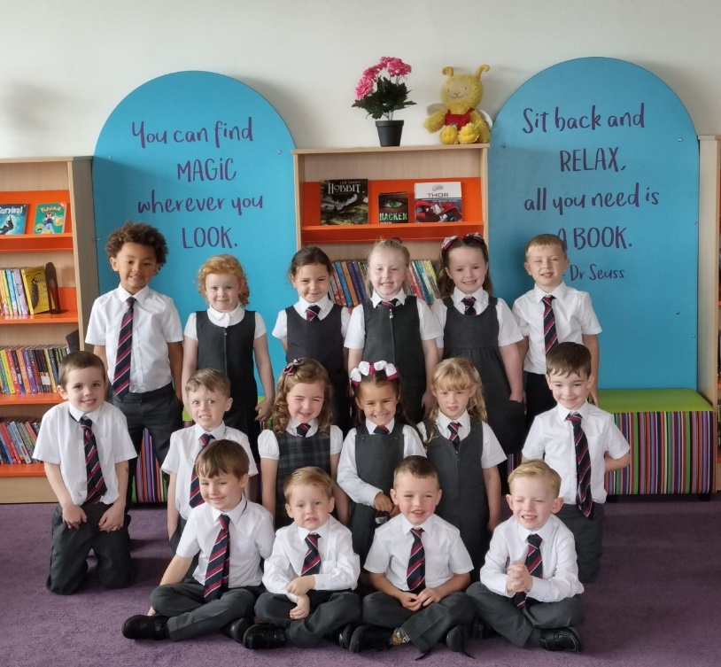

For PE lessons we ask that children wear a white t shirt or polo shirt with dark coloured shorts. Black sandshoes are ideal for PE.

There are forms of dress which are unacceptable in school such as items of clothing which:

  - Potentially, encourage faction (such as football colours)
  - Could cause offence (such as anti-religious symbolism or political slogans)
  - Could cause health and safety difficulties such as loose fitting clothing, dangling earrings or clothing made from flammable material for example shell suits in practical classes
  - Could cause damage to flooring
  - Carry advertising, particularly for alcohol or tobacco and
  - Could be used to inflict damage on other pupils or be used to do so

In addition, jewellery such as dangling earrings and large rings, could cause health and safety difficulties and are unacceptable to be worn in school. The council is concerned at the level of claims being received regarding the loss of children’s’ clothing and/or personal belongings.
Parents are asked to assist in this area by ensuring that valuable items and unnecessarily expensive items of clothing are not brought to the establishment. Parents should note that the authority does not carry insurance to cover the loss of such items and any claims submitted are likely to be met only where the authority can be shown to have been negligent.
We request that all items of clothing, schoolbags and packed lunch boxes, are labelled clearly with your child’s name.

Parents of children receiving one of the following benefits will normally be entitled to monetary grants for footwear and clothing for their children:

- Income Support (IS);
- Income Based Job Seekers Allowance (JSA);
- Income Related Employment and Support Allowance (ESA);
- Child Tax Credit, but not Working Tax Credit, and your income is less than £18,725 (in 2023/2024) as assessed by HMRC;
- Working Tax Credit and/or Child Tax Credit and have an income of no more than £13,671 as assessed by HMRC or
- Universal Credit, where your take home pay does not exceed £1,111, as shown on your most recent monthly Universal Credit Statement.
or
- you are seeking asylum and receiving support under part VI of the Immigration and Asylum Act 1999;
or
- you look after a child/children as part of a formal Kinship Care agreement, registered by Social Work Services.

Applications are mad online at https://inverclyde-online.victoriaforms.com/Viewer-VicForms.asp?user=anon&Form=Inverclyde%20Application%20for%20Clothing%20Grant%20and%20Free%20School%20Meals%2023%20-%2024.wdf

Approval of requests for such grants made by parents in different circumstances is at the discretion of the Corporate Director of Education, Communities & Organisational Development. Information and application forms may be obtained from schools and from Education Services, Wallace Place, Greenock PA15 1JB.

Parents should note that the activities the children may become involved in may be restricted because health and safety requirements state that jewellery of any kind must not be worn where children are undertaking physical activities. This includes jewellery worn as a result of body piercing.

MEALS
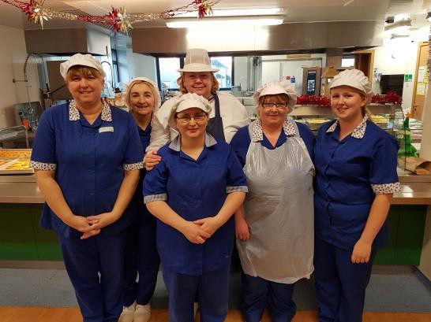

All children in primary schools in Inverclyde, regardless of family financial status, are now entitled to a free school meal every day.

Pupils selecting a main meal may have 5 items, eg. Dish of the day, vegetable/salad, potato/starchy, drink and soup or dessert. A snack option consists of 4 items, eg. Sandwich/roll, salad/fruit, soup or dessert and drink. A copy of the menu is issued annually and can also be viewed on our school website, Twitter account or Inverclyde Council website. If a special diet, eg. Diabetic, gluten free, is required, this can be arranged. Children who bring packed lunches are also accommodated in our dining room. Picnic benches are available for use outside when weather permits.

Each morning, the children will order in class what they would like for lunch that day. They are issued with a coloured band which lets the canteen staff know which option the child has selected and gives them their preferred choice accordingly.

(Sample of school lunch menu)

TRANSPORT

The Council currently has a policy of providing free transport to all primary pupils who live more than one mile from their local school by the recognised shortest walking route. This policy is more generous than the law requires. This means that the provision of transport could be reviewed at any time. Parents who consider they are eligible should obtain an application form from the school or Education Offices at Wallace Place, Greenock PA15 1JB. These forms should be completed and returned before the end of February for those pupils beginning school in August to enable the appropriate arrangements to be made.

Applications may be submitted at any time throughout the year but may be subject to delay whilst arrangements are made. The appropriate officer has discretion in special circumstances to grant permission for pupils to travel in transport provided by the authority where spare places are available and no additional costs are incurred.

PICK-UP POINTS

Where free transport is provided, it may be necessary for pupils to walk a certain distance to the vehicle pick-up point. Walking distance in total including the distance from home to the pick-up point and from the drop-off point to the school in any one direction will not exceed the authority’s limits (see above paragraph). It is the parent’s responsibility to ensure that their child arrives at the pick-up point in time. It is also the parent’s responsibility to ensure the child behaves in a safe and acceptable manner whilst boarding, travelling in and alighting from the vehicle. Misbehaviour could result in a child losing the right to free transport.
If you wish to change travel arrangements for your child ie they are not travelling by bus, it is essential that parents and carers notify our office staff.

PLACING REQUESTS

Education Services does not provide transport for those pupils in receipt of a placing request other than in exceptional circumstances. In the case of under-age placing requests, if the child is offered a place in his/her catchment area school, transport will be provided in accordance with Council policy stated above.

MEDICAL AND HEALTH CARE

Parents are asked to inform the school of any medical condition their child may have and of any special requirements as a result.

Should a child require to take medication during the school days, parents are requested to call at the school office to discuss this with a member of staff and sign a consent form. We cannot give any medication without a consent form.

In the event of a child taking ill or having an accident, the parent or other relative, is contacted and asked to come and collect the child. If the parent cannot come, arrangements can be made to take the child home or in the case of a serious accident, to the hospital. It is important that families keep us informed of any changes in contact details. Eg. New telephone numbers, for this reason. A report of accidents is made to the Director of Education and the Safety Officer.

ROUTINE MEDICAL SCREENING

PRIMARY 1

  - Height and weight, vision, health questionnaire to parents
  - Refer to audiomatrician or speech therapy if concerns
  - Dental screening PRIMARY 7
  - Height and weight, vision, health questionnaire to parents, colour vision
  - Dental screening SCHOOL HEALTH
Your school nurse is there for you and your child to get the best out of their time at school. Today, school nurses take on a wide role by:
  - Checking for health problems
  - Offering immunisations
  - Providing health education
  - Advising teachers and families
  - Supporting individual children whatever their needs
The school nursing team can be contacted at the address below: School Health Department
Port Glasgow Health Centre Port Glasgow PA14 5EW Telephone: 01475 506026

HOME AND SCHOOL LINKS

PARENT FORUM AND PARENT’ GROUP (PARENT COUNCIL)

Scottish Schools (Parental Involvement) Act 2006 led to the establishment of Parent Councils in primary, secondary and special schools. The Act recognises the vital role that parents play in
supporting their children’s learning. It places a duty on authorities to promote the involvement of parents in children’s education and the wider life of the school. It aims to help parents to be:

  - Involved with their child’s education and learning
  - Welcomed as an active participant in the life of the school
  - Encouraged to express their views on school education generally

All parents who have a child attending the school are automatically members of the Parent Forum for our school. Membership of the forum allows parents to have a say in the local arrangements to enable their collective view to be represented on matters such as the quality and standards of education at the school and other matters of interest to parents. These views can be represented, as appropriate, to the Head Teacher of the school, the Council and HMIe.

The Parent Council, as a statutory body, has the right to information and advice on matters which affect children’s education.

The Head Teacher and the local councillor may attend all meetings of the School Council and have the right to speak, although not being members of the Council, have no right to vote.

All parents may attend meetings of the School Council and may contribute to the discussion on any topic. However, should a vote be necessary on any occasion, only elected Council members may vote.

SOCIAL COMMITTEE

There is a very active Social Committee, a sub group of the Parents Group. Regular meetings are held in the school throughout the year. All parents/carers are welcome to attend – details of these meetings will be published in the newsletters.

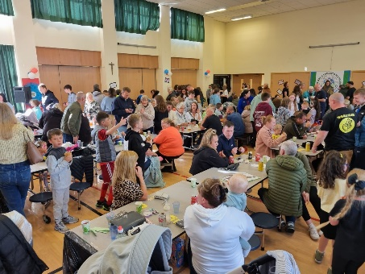
Various fundraising and social events are organised throughout the year. These
Include: a Hallowe’en Disco, a Spring Disco, Winter Wonderland, Primary 7 Leavers’ Dance and family BBQ.

PATPAL SESSIONS – PUPILS AS TEACHERS PARENTS AS LEARNERS
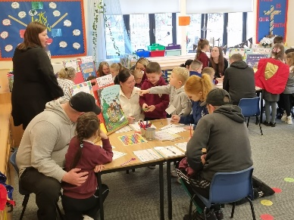

These sessions are held at least once per session. The children become teachers and guide their parents through what and how they have been learning at school. These have had very positive feedback from parents as they have found that they have a better understanding of how they can help their child to learn at home. Some classes choose to have stay and play sessions or celebrations of learning for families rather than two PATPAL sessions.

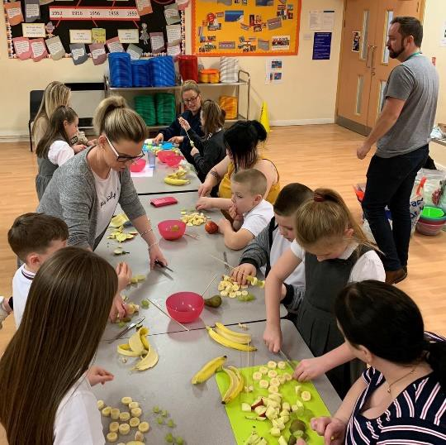
PARENT AND CHILD HOMEWORK SESSIONS
These are run at various times of the school year and led by school staff and our Barnardo’s family support worker.

PARENTS’ EVENINGS

Formal appointments with the class teacher are arranged twice a year to enable parents to discuss their child’s progress and view school work.
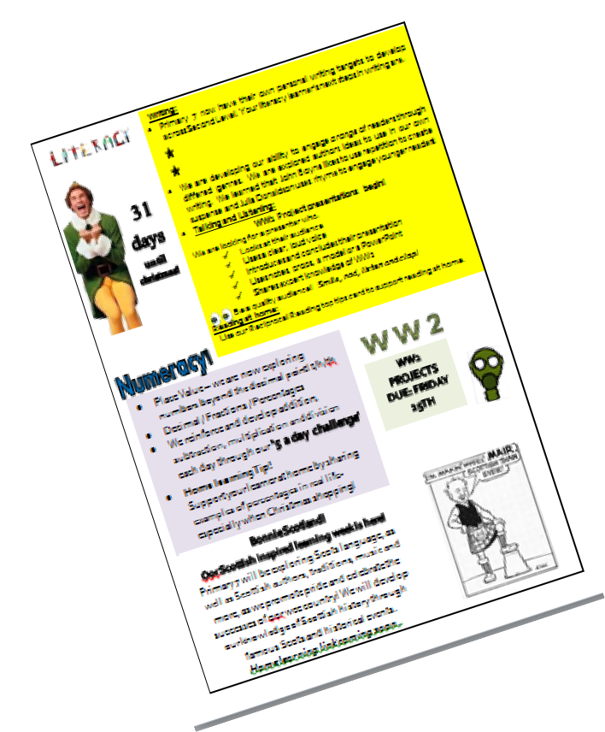
If you have a concern about your child, parents are encouraged to contact the school at any time to discuss these – please do not wait until the next Parents’ Evening.

CLASS NEWSLETTERS

These are produced three times per year and will keep you up to date with the learning that has been taking place in your child’s class.

SCHOOL NEWSLETTERS

School newsletters are published once a fortnight, giving information about the life and work of the school.

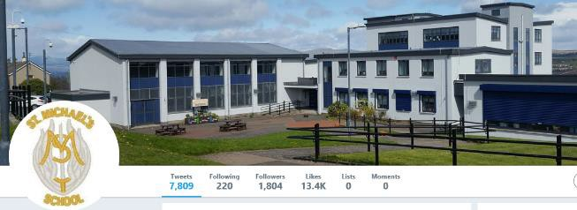
X (TWITTER)
The school actively uses X (Twitter)to share what has been happening and future events @SMPG1964. All classes have their own X (Twitter) accounts, sharing additional information with parents and carers.

PARENTAL FEEDBACK

We actively encourage your comments about the life and work of our school. This helps us to evaluate and refine our work as required.

FAMILY SUPPORT

Through funding from the Scottish Attainment Challenge, we have access to a Family Support Worker, Claire Conway. Our Family Support Workers are able to support children and families, both at home and in school.

Parents are always welcome to make an appointment to meet with the Head Teacher or Depute Head Teacher to discuss any worries or concerns. Should parents wish to make a complaint to Education Services this should be done via the following link https://www.inverclyde.gov.uk/council- and-government/complaint or by calling 01475 717171.

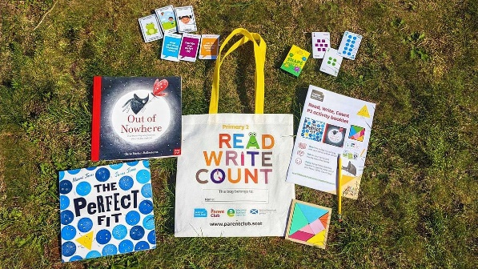
READ, WRITE, COUNT

Read, Write, Count with the First Minister is a programme that aims to support parental engagement in literacy and numeracy. Gift bags are distributed annually to all Primary 2 and Primary 3 pupils in Scotland by Scottish Book Trust. The gift bags contain literacy and numeracy materials to support children’s learning, as well as advice and support to parents.

Studies show a direct link between a strong family learning environment and progress in reading, writing and counting. In addition to the activity booklet included in the bag Scottish Book Trust offers a range of hints, tips and advice to help parents engage in their child’s learning on the website.

FIRST MINISTER’S READING CHALLENGE AND READING SCHOOLS

The First Minister’s Reading Challenge and Reading Schools programmes provides a range of options and support on how to build a love of reading and/or develop a reading culture in your setting. These programmes are brought to you by Scottish Book Trust. Both programmes are flexible to your setting and open to every stage of your reading journey. They have been proven to improve attainment in children and provide professional development opportunities. Whatever stage you are on your reading journey these programmes can support you to get to the next level.

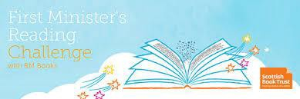

BOOKBUG

Bookbug is Scotland’s universal early years book gifting programme and aims to inspire a love of stories, songs and rhymes from birth. Bookbug gives every child in Scotland four free bags of books as babies, toddlers, three and five year olds. The bags contain books and other resources for sharing songs and rhymes that are suited to their age. Gaelic Bookbug Bags are also available.

The Bookbug Explorer Bag is gifted to all 3 year olds at their childcare setting. It includes three lovely books, an activity book, pencils, and postcards to encourage mark making.

‘The Bookbug Primary 1 Family Bag encourages families to share books and activities to inspire a lifelong love of reading, writing and counting. These are gifted during Book Week Scotland in November every year!’

Check out the website for booklists, book sharing videos, activity ideas and much more.

COMMUNITY LINKS

The school actively participates in the life of our parishes – Holy Family, St Francis and St John’s.

Father Dan is our school chaplain. Mass is celebrated on Feast days and each month at 11am in our school hall. There will be times when we attend Mass in Holy Family Church. Families and members of the parish community are invited to attend.

As our school is part of the Scottish Attainment Challenge, we have extended links with Barnardo’s and Library Services.

Our school works closely with the other schools in our cluster (St Francis, St John’s and St Stephen’s) and with our neighbouring school Newark Primary, to develop curricular areas.

We visit our neighbouring care home during the year to meet and entertain the residents there.

The school participates in local events and competitions such as the Port Glasgow Flower Show and the Greenock Festival.

We support the work of Compassionate Inverclyde on an annual basis and our senior learners lead a series of lessons for our younger children based on the Hi 5 Health and Wellbeing programme.

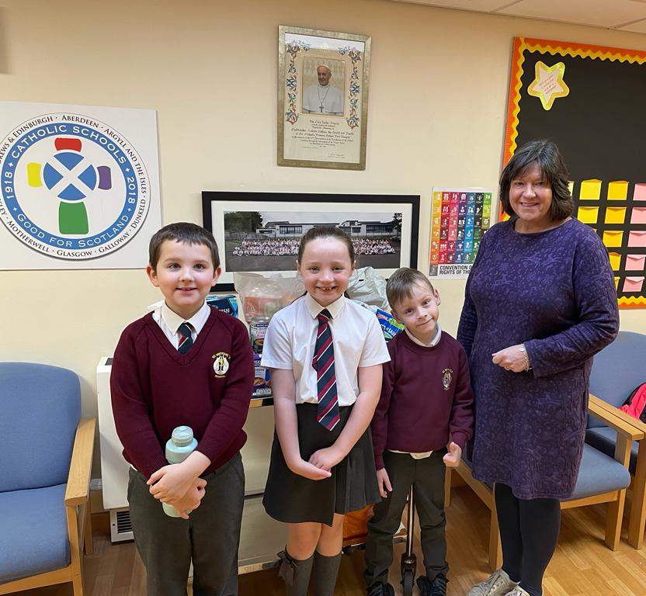
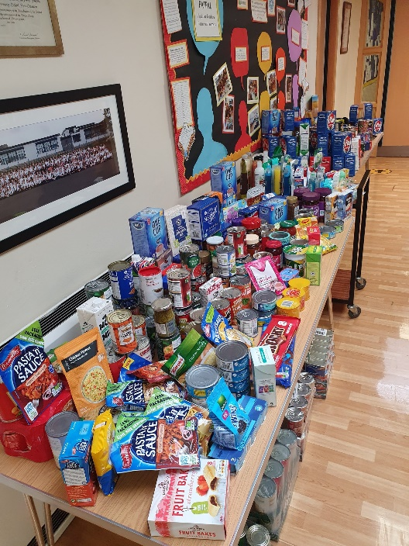

PUPIL VOICE GROUPS

Through their Pupil Voice Groups, pupils from P4 - P7 have an active role in leading school developments and improvements. All groups will reflect on the Rights that are appropriate to their discussions.

RRS Steering Group
- to ensure that Children’s Rights are at the centre of our daily practice
- to support our wider community in developing an understanding of Children's RIghts
- to raise awareness of Children’s Rights by having a clear focus at assembly and in class every week in class
- to lead whole school initiatives in raising awareness of the Rights of others beyond our own community
- to ensure our policies and practice have Children's Rights embedded within them
Fairtrade Group
- to raise awareness of Fairtrade and its impact, making a difference to the lives of others
- to maintain Fairtrade status within our school • to plan and lead events related to Fairtrade Fortnight
- to develop awareness of Scotland’s place in the wider world
- to look for real life contexts for global citizenship • to form partnerships with others to lead whole school projects
Junior Road Safety Officers
- to take the lead in improving road safety in and around our school
- to work with other schools on Road Safety issues
- to share the benefits of healthy routes to school eg walking bus
Learner Council
- to raise awareness of developments which are ongoing within the school
- to help the school’s self-evaluation process by using “How Good Is OUR School?” and “Developing in Faith” by looking at what is working well and what could be improved upon
- to use a range of methods for gathering view points and evidence and work in partnership with the Parents Group
- to reflect on the Gospel values; how do we show these in our daily practice in school? eg do we show awareness of the needs of others and what it means to have compassion?
- work in partnership with neighbouring and cluster schools, developing mutual understanding and respect for one another
- to work with the local parish and other churches to develop ecumenism
Reading Ambassadors
- to promote and develop a love of reading in the school
- to allow learners to interact independently from adult led discussion to make recommendations around books
- to encourage use of The Arc and our local library
- to arrange and support book buddy activities across the school
Laudato Si' Group
- to choose two quotes from Laudato Si’ to focus on for the year
- to lead whole school assemblies and projects that develop everyone’s understanding of our promise to care for our common home
- to plan activities and events for our classes, school and local community that support our Laudato Si’ mission
Digital Leaders
- to be responsible for ensuring pupils in all classes recognise ways to keep safe when online
- to work together to help educate their peers about online dangers, types of cyberbullying and ways to tackle unkind behaviour when using social media
- to share their knowledge with others and promote the use of all things digital throughout the school

TRANSFERRING EDUCATIONAL DATA ABOUT PUPILS

Data on each pupil is collected by schools, Inverclyde Council and the Scottish Government Education department. Data is held securely and no information on individual pupils can or would be published. The data collected and transferred covers areas such as date of birth, Scottish Candidate Number (SCN), post code, registration for free school meals, whether a pupil is looked after by his/her local authority, is looked after at home or has additional support needs including disability and English as an Additional Language (EAL), and attendance, absence and exclusions from school. Pupil names and addressed are not passed to the Scottish Government Education department. Post code is the only part of your address that is transferred and these are grouped to identify “localities” rather than specific addresses. Dates of birth are passed on as “month and year” only, to ensure that individuals are never identified.

General Data Protection Regulations and Data Protection Act 2018

Information on children, parents and guardian is stored on a computer system and may be used for teaching, registration, assessment and other administrative duties. In processing personal information, Inverclyde Council must comply with the General Data Protection Regulation and Data Protection Act 2018.

For further information please refer to https://www.inverclyde.gov.uk/site-basics/privacy or click on the following: Privacy page link

Although this information is correct at time of presenting, there could be changes affecting any of the matters dealt with in the document –

- before the commencement or during the course of the school year in question.

- in relation to subsequent years.

