Education – Improvement Planning Document – 2024-25

Establishment Name: St. Mary’s Primary School

CONTENTS

1. Establishment Vision, Values and Aims
2. Curriculum Rationale
3. 3 Year overview of priorities – based on the National Improvement Framework
4. Action Plan for session 2024-25 including PEF planning

|  |  |  |  |
| --- | --- | --- | --- |
| Head of Establishment | Mark Deegan | Date | June 24 |

|  |  |  |  |
| --- | --- | --- | --- |
| Quality Improvement Officer | Alison McLellan | Date | June 24 |

Our Vision, Values and Aims

In St. Mary’s Primary School, we aim to develop the faith, knowledge and skills of all learners to prepare them to have a happy, successful and prosperous life in the 21st century.

As a Catholic Primary School, a strong emphasis is placed on developing our Christian faith and promoting the Gospel values. Through your help, and with continued support from our parish, we aim to develop a genuine love of God and an understanding of social justice in our children’s lives.

**Agreed Core Values**

* Happiness
* Respect
* Kindness
* Ambition

All members of our school community are valued equally, as is their right to be themselves and to excel in different ways. Regardless of sex, race or creed, everyone is offered the same opportunities to participate in the life of the school.

**Aims**

In order to equip the children to achieve their full potential, we aim to:

* Provide a happy, safe and welcoming environment where each member of our school community feels valued and respected.
* Provide the highest quality learning experiences which support and enhance each child’s potential for success and life-long learning.
* Develop as a community of faith, through the promotion of Christian values, celebration and worship, and service to others.

**Our Shared Vision**

In St. Mary’s Primary School, we aim to develop the faith, knowledge and skills of all learners to prepare them to have a happy, successful and prosperous life in the 21st century.

As a Catholic Primary School, a strong emphasis is placed on developing our Christian faith and promoting the Gospel values. Through your help, and with continued support from our parish, we aim to develop a genuine love of God and an understanding of social justice in our children’s lives.

******Our Shared Values**

**Happiness Respect**

To support everyone in showing respect for ourselves, peers and our whole school community.

To create an environment where our whole school community experiences happiness.



**Kindness Ambition**

To always aim for the very top by giving everything we do our best.

To promote kindness to all in our words and actions and to treat others like Jesus taught us.

**St. Mary’s Primary School**

**Curriculum Rationale 2024-2027**

In St. Mary’s Primary School, we value Happiness, Respect, Kindness and Ambition. We have worked with pupils, staff, parents and partners to ensure our curriculum reflects our uniqueness and is designed to build the skills our pupils need in life, learning and work in an ever changing world. We recognise that the curriculum is wider than the experiences and outcomes and that all stakeholders support our curriculum. We have encouraged the contribution of all stakeholders to develop a curriculum rationale which is designed to meet the needs of the pupils in our context.

**What makes us unique?**

There are several things which make us unique to any other school. We asked pupils, staff, parents and partners over a three week period in February 2024 for their views on this. The following four key things were easily identifiable from the views of all stakeholders:

*Our strong values*

Our school community all played a part in developing values which match the context, needs and wishes of everyone: Happiness, Kindness, Respect and Ambition. You can see our pupils living our values any time you enter the school. We have shown how important they are to us by displaying them in every class, greeting visitors with them in the playground, having them visible in our hall and discussing them at every opportunity.

*The opportunities we offer*

In St. Mary’s Primary School it is recognised that we provide many opportunities to be part of a group, try new activities, go on trips or have new experience. Pupils have the opportunity to take on roles within Houses, taking leadership opportunities as House Captains and Vice Captains, attending the theatre for a musical and for a panto, attending football matches, getting outdoors and on trips regularly, trying new things on residentials and so much more. The work in the Inverclyde Music Festival to develop and showcase the talents of our pupils has been highly commended by all and identified as a strength people wish to see continue moving forward.

*Our staff and pupils*

Our whole community recognised the warmth and love the staff show our pupils and the hard work they put in to ensure every child achieves success. We aim to ensure every child feels safe, happy and cared for and this is reflected in the positive relationships between staff and pupils. Our caring and nurturing ethos is visible for all parents, partners and visitors who enter our school.

The kindness, respect and manners our pupils display has also been identified as making us unique. The dedication to living the values in our school is clear and our pupils are excellent ambassadors for our school when they are out in public.

*Our high standards*

We pride ourselves in having high standards in all that we do in St. Mary’s Primary. Our community recognises this in terms of behaviour, achievement, and conduct. They are also proud of the uniqueness and high standards we hold for uniform. Our green shirts make us easily identifiable and we aim to leave a lasting memory after participation in events by showcasing our high standards when we wear them.

When thinking about what makes us unique, we must take into consideration that 28% of our pupils reside in SIMD 1 and 2. We have welcomed 40 New Scots to our school in the last two years increasing our population to 15.7% of pupils joining us from other countries. Our school community has always been very open, friendly and welcoming when new pupils join us and show respect to everyone regardless of any differences.

Ensuring we take forward the driver of Diversity and continue to provide equity for our pupils must be taken into consideration during the development of our curriculum and School Improvement Planning over the next three years.

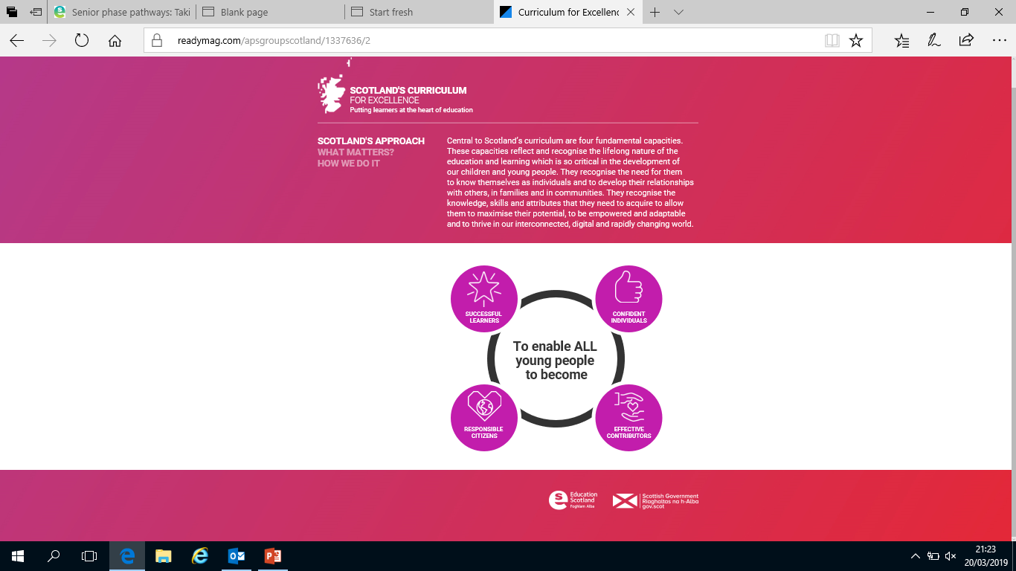**What skills are important to us?**

We want to develop skills that allow all our learners to develop as successful learners, confident individuals, effective contributors and responsible citizens and we will have this at the heart of all curriculum decisions.

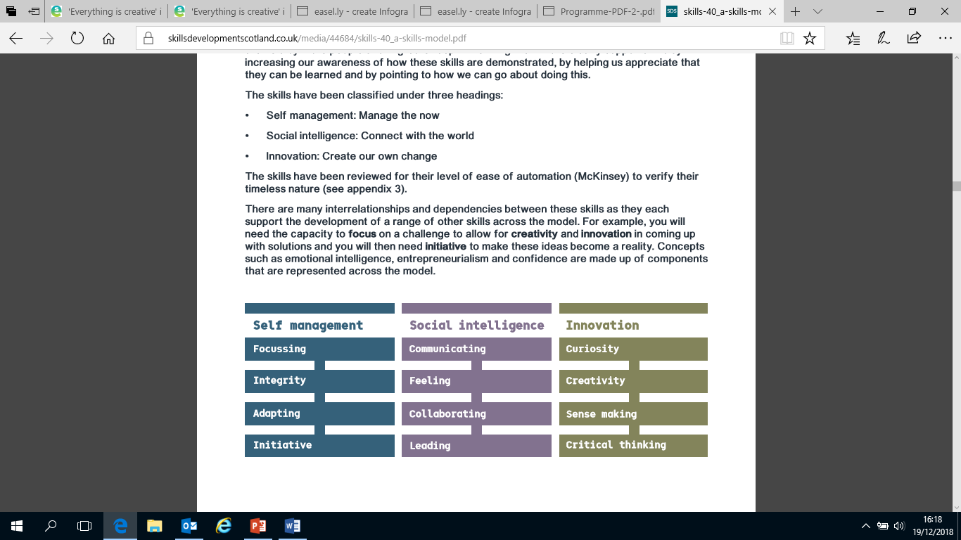

We also want to develop meta skills but in particular we will focus on 5 key skills which staff have identified as being most important and needed for our pupils; Collaborating, Creativity, Critical Thinking, Adapting and Initiative.

Article 29

Children’s education should help them fully develop their personalities, talents and abilities.

Article 28

Every child has the right to an education.

Article 3

When adults make decisions, they should think about how their decisions affect children.

**What comes next?**

* Collegiate sessions for 2024-2025 will focus on the design of our curriculum, the bundling of Es and Os and creating overviews of what we cover through the ‘Hidden Curriculum’.
* We will review our approach to IDL and the 7 design principles.
* Enlist the support of parents, partners and the community to enhance our curriculum and support the development of skills.
* Review our rationale at the end of 2026-2027.

3 Year Overview of Establishment Priorities

The improvement priorities for our establishment are noted on the following page. They have been expressed in the context of the National Improvement Framework

Our Improvement Priorities extend in a rolling programme over three years. Each priority has been coded accordingly:

Session 2024-2025

Session 2025-2026

Session 2026-2027

Overview of rolling three year plan

|  |  |  |  |
| --- | --- | --- | --- |
| **National Priorities** | Session 2023-2024 | Session 2024-2025 | Session 2025-2026 |
| Improvements in attainment, particularly in literacy and numeracy | Play Pedagogy  Reading for Pleasure  Assessment, Tracking and Monitoring and Targeted Support  Writing (Maintenance) | Play Pedagogy  Reading and Writing- targeted and beyonds | Play Pedagogy  Numeracy |
| Closing the attainment gap between the most and least disadvantaged children | Assessment, Tracking and Monitoring and Targeted Support  Reading for Pleasure  Writing (Maintenance) | Reading and Writing- targeted and beyonds | Numeracy |
| Improvement in children and young people's health and wellbeing | Transitions  Curriculum Rationale  Outdoor learning | Development of Meta Skills and DYW  Outdoor learning | Development of Meta Skills and DYW  Outdoor learning |
| Improvement in employability skills and sustained positive school leaver destinations for all young people | Digital Literacy (Maintenance+)  Curriculum Rationale | Development of Meta Skills and DYW | Development of Meta Skills and DYW |
| Placing the human rights and needs of every child and young person at the centre of education | Equalities  Trauma Informed Practice and Meeting Needs  Rights Respecting School (Gold) | Equalities  Trauma Informed Practice  Pupil Leadership Development | Equalities  Trauma Informed Practice  Pupil Leadership Development |

*Stakeholder’s views*

**How were stakeholders views collected?**

|  |
| --- |
| Staff collegiate sessions  Parent Group meetings  House captain meetings  Houses  Forms  Partners meetings |

**How was PEF spend consulted on?**

|  |
| --- |
| PEF Questionnaire  Collegiate sessions with staff  Parent group meetings  House meetings |

Plan: Session 2024-2025

|  |  |  |
| --- | --- | --- |
| **Priority 1: Developing Meta Skills and Developing the Young Workforce/ Play Pedagogy**  Improvement in children and young people's health and wellbeing  Improvement in skills and sustained, positive school-leaver destinations for all young people  Improvements in attainment, particularly in literacy and numeracy | | |
| **NIF Driver**  School leadership  Teacher professionalism  Parental engagement | **HGIOS/ELC QIs**  3.1 Ensuring wellbeing, equality and inclusion  3.3 Increasing creativity and employability  2.2 Curriculum | **UNCRC**  Article 28: (Right to education):  Article 31 (Leisure, play and culture):  **Developing in Faith**  Developing as a community of faith and learning |

|  |
| --- |
| **Rationale for change based self-evaluation including data and stakeholder views** |
| In session 2023-2024, we developed a Curriculum Rationale in consultation with all stakeholders in order to; identify the needs of pupils in our context, the drivers for our curriculum, the job opportunities of the future, the uniqueness of our setting and the skills our pupils will require in life, learning and work. We now want to develop our curriculum this session in order to develop a range of meta skills (with a particular focus on Critical Thinking, Collaborating, Adapting, Curiosity and Initiative) through experiential learning and improve the understanding of learners of skills for life, learning and work.  Last session, we developed our play further in primary 1 with an increase in outdoor learning and a better balance between play and teacher-led learning which led to an increase of attainment from entry levels at primary 1 of 30% in reading and writing. This was also commented positively on during a school review in April/May. We want to progress this model in primary 2. |
| **Expected outcomes for learners**  **Who? By how much? By when? What?** | |
| * By June 25, identified pupils potentially impacted by measures of poverty in P5-7 will have an increased understanding of how the skills they are learning in school can be applied in life, learning and work. * By June 25, all pupils will achieve all identified practical skill awards to be determined through collegiate working. * Throughout the year, identified group of potentially disengaged learners will see improved engagement in school through skill based learning activities. * Continued improved engagement in primary 2 through play based pedagogy and outdoor learning will result in all children continuing to progress at the national standard or beyond expectations by June 25. | |
| **Measure of Impact: What we will see and where?**  How will we measure this? What does “better” look like? How will we recognise better when we see it? | |
| * Observations by SLT will evidence skills as a key feature in lessons and an increase in children discussing these. * World of work celebration to evidence work on skills across the year with knowledge of the children on display. * Skills awards to be displayed in classes and all children to have the opportunity to achieve all awards. * Leuven scale to be used to track engagement of targeted group of learners at identified points in the year to measure improvement. | |
| ​**If PEF spend is supporting – how much and what?** | |
| N/A | |

| **Tasks to achieve priority** | **Timescale** | **RAG** | **Those involved/responsible – including partners** | **Resources and staff development** |
| --- | --- | --- | --- | --- |
| Lottery grant submitted for Skills Hub to be built on the school grounds and ongoing liaising with council with regards to building warrants and planning if granted | By August 24 |  | M. Deegan  G. Murray  E. Montgomery | Lottery Grant submission  Building Warrant forms  Relevant info from Polycrub |
| In-service to revise curriculum rationale and identified skills for the school in order to begin planning for skill development across lessons. | August 24 |  | All staff | Curriculum Rationale Document  SDS Resources |
| If Lottery Grant and planning approved, Skills Hub to be built. | August- Oct 24 |  | M. Deegan  G. Murray  E. Montgomery | Lottery Grant submission  Building Warrant forms  Relevant info from Polycrub |
| Collegiate sessions to plan for 6 Practical Skill Awards and progression of skills across stages. | August – Oct 24 |  | All teaching staff | Skills awards  Skills progression framework from Kilmalcolm  SDS Resources |
| Staff to keep records of skills being taught throughout the year and evidence of work. | All year |  | All teaching staff |  |
| World of Work week to take place with a showcase for work across the year at the end of the week for parents. | May 24 |  | All staff  All pupils  Parents | SDS Resources  Skills awards  Ongoing work  Display boards |
| Opportunities for joint planning from Primary 1 into Primary 2. | Ongoing |  | P1 and 2 teachers | Inverclyde play strategy.  Realising the Ambition  Relevant Play literature |
| Continuation of progress made in outdoor learning by accessing the local community on a weekly basis at P1 and P2. Begin to develop planning overviews for this. | Ongoing |  | P1 and 2 teachers |  |
| Development of “St. Mary’s Play is the Way” Policy. | By Dec 24 |  | P1 and 2 teachers | Inverclyde play strategy.  Realising the Ambition  Relevant Play literature |

|  |  |  |
| --- | --- | --- |
| **Priority 2: Upskilling in Reading and Writing and Targeted Support**  Closing the attainment gap between the most and least disadvantaged children and young people  Improvements in attainment, particularly in literacy and numeracy | | |
| **NIF Driver**  School leadership  Assessment of children's progress  Performance information | **HGIOS/ELC QIs**  1.3 Leadership of change  2.3 Learning, teaching and assessment  3.2 Raising attainment and achievement | **UNCRC**  Article 28: (Right to education):  Article 29 (Goals of education):  **Developing in Faith**  Developing as a community of faith and learning |

|  |
| --- |
| **Rationale for change based self-evaluation including data and stakeholder views** |
| Within our school, we have an inverse gap in all curricular areas between learners who reside in simd 1-2 and simd 3-10. However, our gap is evident when looking at learners who are Beyond Expectations, with the largest gaps being 16.6% in Reading and 13.2% in Writing. We recognise from discussions with secondary colleagues that those who are Beyond Expectations when leaving primary are more likely to achieve Higher Qualifications. While we raised the number of children residing in simd 1-2 to Beyond Expectations in all areas in 2023-2024, we aim to target more children to move Beyond Expectations in Reading and Writing.  In session 2023-2024, a small test of change was carried out by our NQT which demonstrated that Outdoor Experiential Learning had an impact on the engagement, quality and quantity of writing for a targeted group of reluctant writers impacted by poverty. We know that reading and writing can be impacted by a lack of prior knowledge and understanding from poverty of experience. We will develop planning and approaches in reading and writing, led by our PEF DHT in a coaching and modelling/lead of attainment role, which will improve prior knowledge, vocabulary and experience leading to an increase in the quality of work produced and raised attainment, particularly for those impacted by poverty.  While a group of our primary 7 learners are working on their own pathway in numeracy, we recognise the need to increase the pace of learning for them in order to narrow the gap between the level they are working and the national expectation level of on track. Improved handover information alongside targeted interventions will improve chances of achieving qualifications at National 4/5 level in high school. |
| **Expected outcomes for learners**  **Who? By how much? By when? What?** | |
| By June 25, the number of pupils who are Beyond Expectations in Reading and Writing and residing in simd 1-2 will increase by 9.4%  By June 25, targeted pupils in primary 3 who are behind expectations in reading and writing will move to on track leading to 94.2% achieving expected levels.  By June 25, targeted pupils in primary 4 who are behind expectations in writing will move to on track leading to 91.9% achieving expected levels.  By June 25, targeted pupils in primary 6 who are behind expectations in writing will move to on track leading to 100% achieving expected levels.  At the very least, all pupils who are currently on track and impacted by poverty will continue to progress as on track.  By June 25, targeted group of learners in Primary 7 will make more than a year of progress in numeracy. | |
| **Measure of Impact: What we will see and where?**  How will we measure this? What does “better” look like? How will we recognise better when we see it? | |
| * Attainment data will demonstrate increases identified across the year. * Tracking and monitoring meetings will evidence targeting of individual and groups. * DHT will evidence impact of improved pedagogy from coaching and modelling. * Collegiate sessions will evidence progression in approaches. * Jotters will demonstrate progress. | |
| ​**If PEF spend is supporting – how much and what?** | |
| DHT Upgrade £6497  0.8 PEF Teacher- £52, 034  Total: £58, 531 | |

| **Tasks to achieve priority** | **Timescale** | **RAG** | **Those involved/responsible – including partners** | **Resources and staff development** |
| --- | --- | --- | --- | --- |
| Reading and writing training across the year with a focus on relevancy, prior knowledge, experiential opportunities and an increase in vocabulary knowledge. | All year |  | All teaching staff  N. Macdonald Lead | Genre features booklets  Writing planners  Training powerpoints |
| Review of current novels used in the school and links to social subjects/equalities/rights to be made. | By Oct 24 |  | All teaching staff  N. Macdonald Lead | Novels overviews  Frameworks shared by colleagues in other establishments |
| Delivery of team teaching/coaching and modelling in writing. | Ongoing |  | N. Macdonald  All teaching staff | Writing planners  Genre Features booklets |
| Whole staff engagement with writing framework training. | By November 24 |  | SEF Lead  Pedagogy Leads | Inverclyde Writing Framework |
| Targeted groups for interventions/additionality to be identified, support timetabled and staff delivering briefed. | By end August 24 |  | N. Macdonald  J. Blincow  Additional teaching staff | Data dashboard  Intervention pathways/resources |
| Monthly check-ins to analyse progress of intervention/support and termly review of pupils receiving additionality. | Ongoing |  | SLT  Additional teaching staff | Data dashboard  Tracking information |

|  |  |  |
| --- | --- | --- |
| **Priority 3: Trauma Informed Practice**  Improvement in children and young people's health and wellbeing  Placing the human rights and needs of every child and young person at the centre of education | | |
| **NIF Driver**  School leadership  Teacher professionalism | **HGIOS/ELC QIs**  3.1 Ensuring wellbeing, equality and inclusion  2.1 Safeguarding and child protection  2.7 Partnerships | **UNCRC**  Article 3 (Best interests of the child):  Article 28: (Right to education):  **Developing in Faith**  Developing as a community of faith and learning  Serving the common good |

|  |
| --- |
| **Rationale for change based self-evaluation including data and stakeholder views** |
| As an authority, Trauma Informed Practice has been identified as a priority in order to support children in Inverclyde who may be dealing with long term adverse effects from traumatic experiences which can impact their mental, physical, emotional and spiritual wellbeing. Last session, we started the first part of our journey as a staff to becoming trauma informed by engaging in a series of online training. Our next stage will be to work with Educational Psychology to continue to develop our understanding as a whole staff in order to support all pupils to feel safe, happy and settled in school, even when we cannot see the difficulties they may be facing. |
| **Expected outcomes for learners**  **Who? By how much? By when? What?** | |
| By May 25, most children will again indicate they are listened to, involved in decision making which affects them and are treated fairly in our school. | |
| **Measure of Impact: What we will see and where?**  How will we measure this? What does “better” look like? How will we recognise better when we see it? | |
| * Through questionnaires, we will gain pupil feedback on the support they receive in school in which most pupils will recognise that they are listened to, involved in decision making and treated fairly. * Tracking materials will show support for those pupils who indicate lower scores on wellbeing webs and improvements over time. * SLT observations will demonstrate that trauma informed practices are becoming embedded. | |
| ​**If PEF spend is supporting – how much and what?** | |
| N/A | |

| **Tasks to achieve priority** | **Timescale** | **RAG** | **Those involved/responsible – including partners** | **Resources and staff development** |
| --- | --- | --- | --- | --- |
| All staff to participate in the next level of Trauma Informed Practice training led by Educational Psychology. | Ongoing |  | All staff  Karen McPherson | Educational Psychology Training |
| New staff to participate in online training completed by staff in session 2023-2024. | By Dec 24 |  | New staff joining August 24 | NES Level 1 Trauma Training  Level 2 Emodules |
| Wellbeing webs to be used to check in on wellbeing of all learners termly and interventions applied when required. | Termly |  | All pupils  All teachers  SLT | Wellbeing webs  Shanarri presentation |
| Questionnaire distributed to all pupils to assess feeling of involvement and their voice being heard. | May 25 |  | All pupils | Yearly form |

|  |  |  |
| --- | --- | --- |
| **Priority 4: Pupil Leadership / Equalities**  Improvement in skills and sustained, positive school-leaver destinations for all young people  Placing the human rights and needs of every child and young person at the centre of education | | |
| **NIF Driver**  School leadership  Teacher professionalism  School Improvement | **HGIOS/ELC QIs**  3.1 Ensuring wellbeing, equality and inclusion  1.5 Management of resources to promote equity  2.2 Curriculum | **UNCRC**  Article 2 (Non-discrimination):  Article 12 (Respect for the views of the child):  **Developing in Faith**  Developing as a community of faith and learning  Promoting Gospel values |

|  |
| --- |
| **Rationale for change based self-evaluation including data and stakeholder views** |
| Session 2023-2024 saw the evolution of pupil voice and pupils leadership through the creation of the St. Mary’s Houses: Edinburgh Castle House, Stirling Castle House, Culzean Castle House and Inveraray Castle House. We appointed our first ever House Captains and Vice Captains in January 24 who led Pupil Voice opportunities through regular House meetings and meetings with the SLT. While this has been a very successful start, we will continue to develop our House System to ensure it impacts meaningful change and provides opportunities to build a sense of community and ownership within each House.  As well as continuing our Rights Respecting Schools group, we started three new pupil voice groups to alongside our Houses with representatives from each house to be part of each group: Equalities Group, Young Leaders of Learning and Eco Group. These groups will now need to develop strategic action plans and meet regularly to make change happen within our school.  Inverclyde have identified Equalities/Racial Literacy as a priority for all schools to address. The demographic of St Mary’s continued to become more diverse during the session 2023-2024. 17% of our pupils can be identified as New Scots. While we are inclusive and continue to celebrate diversity, we recognise we must continue to develop our curriculum and provide opportunities across the school year to ensure we incorporate diversity, celebrate different cultures and improve outcomes for all. Our RRS group has identified that, linked to our work on equalities, a next step for us as a school is to develop our knowledge and understanding of the Global Goals. |
| **Expected outcomes for learners**  **Who? By how much? By when? What?** | |
| * By June 25, pupil participation in decision making will be evidenced through changes made by pupil leadership groups. * By June 25, almost all children will be able to demonstrate their knowledge of the range of cultures in our school community and an understanding of the Global Goals. * By June 25, our Equalities Group will evidence the increased presence of diversity in our literature. | |
| **Measure of Impact: What we will see and where?**  How will we measure this? What does “better” look like? How will we recognise better when we see it? | |
| * Strategic plans for pupils leadership groups will evidence outcomes, steps and evaluate progress. * Pupil voice groups will discuss improvements. * Feedback in questionnaires. * Discussions at assemblies will evidence knowledge of global goals. * Pupils will be able to discuss global goals in HGIOURS sessions. * Literature will show more diversity and be linked in overviews. | |

| **Tasks to achieve priority** | **Timescale** | **RAG** | **Those involved/responsible – including partners** | **Resources and staff development** |
| --- | --- | --- | --- | --- |
| House Captain and Vice Captain campaigns and elections to take place. | By mid Sep 24 |  | All staff and p6-7 pupils |  |
| Staff to choose strategic pupil leadership groups to be involved in. | August 24 |  | All teaching staff | Leadership groups |
| Refresh of strategic planning for pupil leadership groups. | August-Sep 24 |  | All teaching staff | Pupil leadership plans |
| Groups to meet once per month during assembly. | Ongoing |  | All teaching staff  Leadership groups | Pupil leadership plans |
| Equalities group to lead an assembly about anti-racism | Nov 24 |  | Mrs Combe  Equalities group | Assembly slides |
| Equalities group to work with Mrs Mac auditing current reading materials across the school. | Aug-Dec 24 |  | Mrs Combe  Mrs Macdonald  Equalities | Novels overviews |
| New novels materials to be purchased and links to social subjects and rights to be made. | Jan-May 24 |  | Mrs Macdonald  Equalities Group | Novels overviews |

|  |  |  |  |  |
| --- | --- | --- | --- | --- |
| **St. Mary’s Primary School Maintenance Agenda** | | | | |
| **National Priorities** | **Previous Target** | **Next Steps** | **Staff Involved/ Responsible** | **Additional PEF Spend** |
| Improvements in attainment, particularly in literacy and numeracy  Closing the attainment gap between the most and least disadvantaged children and young people | Accelerated Reader | Training for new staff on use of Accelerated Reader.  Continue to embed use of Accelerated Reader to improve opportunities and engagement with reading for pleasure | All P4-7 teaching staff | N/A |
| Improvement in skills and sustained, positive school-leaver destinations for all young people  Improvements in attainment, particularly in literacy and numeracy | Embed Digital Across Learning | Digital Champion to continue in Reduced Class Contact Teacher role with remit to teach IT skills discretely and further develop Pathways which can be taken forward by all staff.  Target group impacted by poverty to engage with additional IT opportunities through an extra-curricular to provide equity through further opportunities to develop skills.  Continue to enhance opportunities by engaging with partners including parents and the college who can offer opportunities not readily available in school in technology. | D. McGlashan- Digital Champion  All staff  Parents/College Partners | N/A |
| Placing the human rights and needs of every child and young person at the centre of education | Rights Respecting Schools | Continue with action plans developed by RRS group after we receive feedback from our Gold accreditation.  All classes to engage with the global goals and present an assembly on a chosen Global Goal.  Continue to engage parents in RRS work through parents’ evenings. | C. Donnelly (Lead)  All staff  All pupils  All parents  Partners | N/A |
| Closing the attainment gap between the most and least disadvantaged children and young people | Quality Assurance | Review of processes currently in place.  Visit to Inverkip to discuss quality assurance processes.  Continue to review assessment processes.  Creation of new/updated trackers for those targeted using PEF.  Ongoing evaluation of processes | J. Blincow (Lead)  All staff  All pupils  All parents  Partners | N/A |
| Improvement in children and young people's health and wellbeing | Partnership working | Continue to engage with Ardgowan Primary for opportunities to improve transition experiences.  Plan for opportunities for partnership events across the year with Ardgowan Primary to build positive relationships in the community. | M. Deegan  E. Picken  Staff across both schools  Nursery partners |  |