

St. Mary’s Primary School Handbook
2024-2025
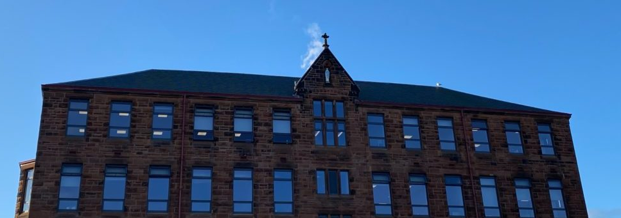
All authorities are required by law to issue a copy of the school handbook incorporating current policies and practices of both the council and the school to certain parents in December of each year for their use as appropriate.

CONTENTS

ST. MARY’S PRIMARY SCHOOL 3
AUTHORITY STRATEGIC STATEMENT 4
ST. MARY’S VISION, VALUES AND AIMS 5
SCHOOL INFORMATION 6
SCHOOL STAFF 7
SENIOR MANAGEMENT REMITS 8
OUR ACHIEVEMENTS AND PRIORITIES FOR IMPROVEMENT 10
THE SCHOOL YEAR 2023-2024 12
USEFUL ADDRESSES AND TELEPHONE NUMBERS 13
SCHOOL CLUSTERS / ENROLMENT 14
TRANSFER FROM PRIMARY TO SECONDARY SCHOOL 15
CURRICULUM FOR EXCELLENCE 16
LITERACY 19
MATHEMATICS 22
SOCIAL STUDIES 24
SCIENCES 24
TECHNOLOGIES 26
HEALTH AND WELLBEING 27
EXPRESSIVE ARTS 28
RELIGIOUS EDUCATION 31
ADDITIONAL SUPPORT NEEDS 34
ASSESSMENT 36
HOME-SCHOOL LINKS 37
SCHOOL – COMMUNITY LINKS 39
POSITIVE BEHAVIOUR 39
INCLUSION AND EQUALITY 40
EQUALITIES 41
ATTENDANCE 41
EXTRA CURRICULAR ACTIVITIES 43
MEDICAL AND HEALTH CARE 43
ALLERGIES/PEANUT FREE ZONE 44
TRANSPORT 44
SUPERVISION IN PLAYGROUNDS 45
SAFETY FACTORS 45
INFORMATION IN EMERGENCIES 45
CHILD PROTECTION 46
SCHOOL MEALS 46
FREE MEALS & CLOTHING GRANT 47
UNIFORM 48
PLACING REQUESTS 49
PARENT FORUM AND PARENT PARTNERSHIP 49
READ, WRITE, COUNT 51
PARENTZONE 51
DATA PROTECTION ACT 1998 52

ST. MARY’S PRIMARY SCHOOL
St Mary’s Primary School

Headteacher: Mr Mark Deegan
4 Kelly Street
GREENOCK
PA16 8NF

Telephone: 01475 715694

Email address: - INStMarys@glowscotland.onmicrosoft.com
Website address: https://blogs.glowscotland.org.uk/in/stmarysps
Twitter: @StMarysPS14

Dear Parent/Carer

I would like to extend a very warm welcome to you and your child.

This handbook is designed to give you an insight into our school, our curriculum and expectations. I hope you find it helpful and interesting.

In St Mary’s Primary, we aim to provide a happy and stimulating learning environment that encourages ambition in all our pupils, and fosters respect and tolerance for others. We place a high value on effort and we have high expectations of all our pupils.

As a Catholic Primary School, a strong emphasis is placed on developing our Christian faith and positive values. Through your help, and with continued support from our parish, we aim to develop a genuine love of God and an understanding of social justice in our children’s lives.

In order to achieve these aims, we welcome and value your support. Throughout the year, many activities will be organised in order to further promote good communication and positive relationships between home and school. We hope that you will feel welcome and able to support these events.

Should you require further information or wish to discuss any matter, please do not hesitate to contact me.

Yours faithfully

Mr M Deegan
Headteacher

AUTHORITY STRATEGIC STATEMENT

Building Inverclyde through excellence, ambition and regeneration.

Goals and Values

Our Core values are: Happiness, Respect, Kindness and Ambition

Our vision for the children and young people of Inverclyde is that they should be ambitious for themselves and be successful learners, confident individuals, responsible citizens and effective contributors.

To achieve our ambition of building Inverclyde through excellence, ambition and regeneration our children must be:

Safe: protected from abuse, neglect and harm by others at home, school and in the community.

Healthy: enjoy the highest attainable standards of physical and mental health, with access to healthy lifestyles.

Achieving: have access to positive learning environments and opportunities to develop their skills, confidence and self-esteem to the fullest potential.

Active: active with opportunities and encouragement to participate in play and recreation including sport.

Respected and responsible: involved in decisions that affect them, have their voices heard and be encouraged to play an active and responsible role in their communities.

Included: have access to high quality services when required and should be assisted to overcome the social, educational, physical, environmental and economic barriers that create inequality.

Nurtured: educated within a supportive environment.


Our Shared Vision
In St. Mary’s Primary School, we aim to develop the faith, knowledge and skills of all learners to prepare them to have a happy, successful and prosperous life in the 21st century.
As a Catholic Primary School, a strong emphasis is placed on developing our Christian faith and promoting the Gospel values. Through your help, and with continued support from our parish, we aim to develop a genuine love of God and an understanding of social justice in our children’s lives.


Our Shared Values

Happiness Respect
To create an environment where our whole school community experiences happiness.
To support everyone in showing respect for ourselves, peers and our whole school community.

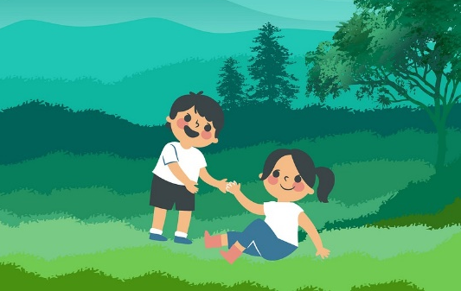


Kindness Ambition
To promote kindness to all in our words and actions and to treat others like Jesus taught us.
To always aim for the very top by giving everything we do our best.

All members of our school community are valued equally, as is their right to be themselves and to excel in different ways.

Regardless of sex, race or creed, everyone is offered the same opportunities to participate in the life of the school.

Aims

In order to equip the children to achieve their full potential, we aim to:

- Provide a happy, safe and welcoming environment where each member of our school community feels valued and respected.

- Provide the highest quality learning experiences which support and enhance each child’s potential for success and life-long learning.

- Develop as a community of faith, through the promotion of Christian values, celebration and worship, and service to others.

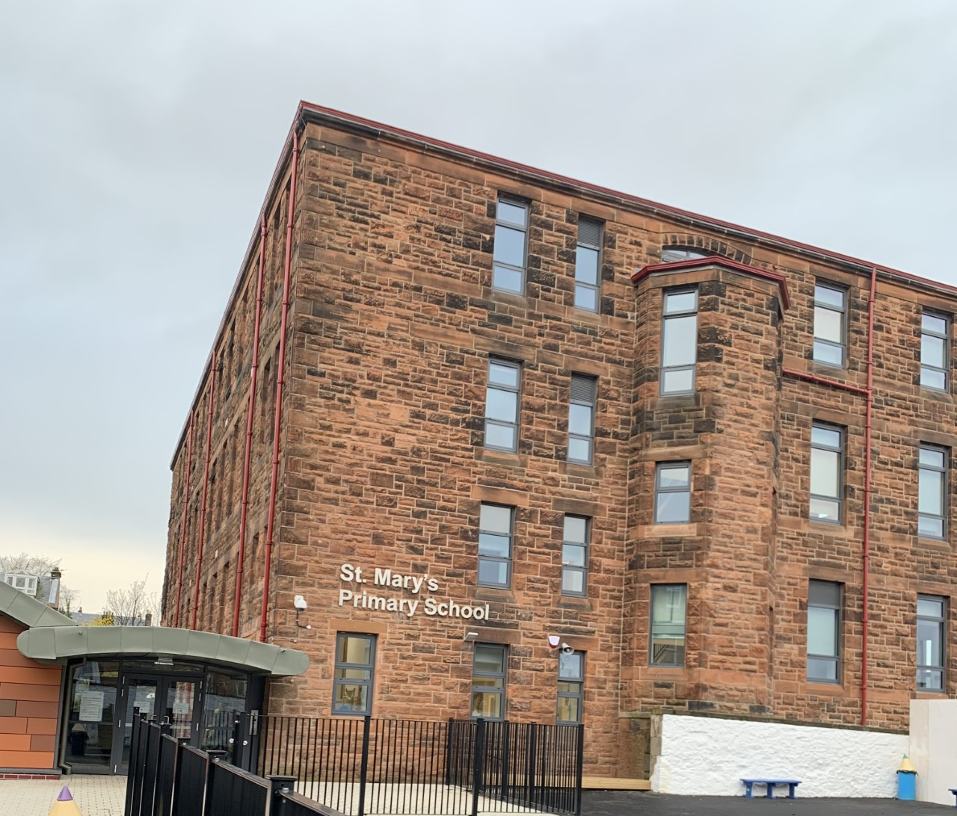
SCHOOL INFORMATION

St. Mary’s Primary School
4 Kelly Street
Greenock
PA16 8NF
Tel.01475 715694

e-mail: INStMarys@glowscotland.onmicrosoft.com

Present Roll: 244
P1 | P2 | P3 | P4 | P5 | P6 | P7 | TOTAL
32 | 36 | 33 | 27 | 45 | 32 | 39 | 244
Capacity: 388

St. Mary’s is a Roman Catholic co-education school. The school has recently undergone a multi-million pound refurbishment to create an excellent learning environment with facilities fit for education in the 21st century.

Parents should note that the working capacity of the school may vary depending upon the number of pupils at each stage and the way in which the classes are organised.

The school is available for community use. Applications for School lets may be made to:

Booking Office, Waterfront Leisure Centre,
8 Custom House Way
GREENOCK
PA15 1EW
Tel No: 213131
Email: bookingoffice@inverclydeleisure.com

Punctuality

We strive to achieve a high standard of punctuality and expect all pupils to be on time.

School Hours

9.00am School opens
10.30 – 10.45am Interval
12.15 – 1.00pm Lunch
3.00pm School closes

Primary 1 pupils start and finish early on their first day and commence full day attendance from Friday 16th August 2024.

SCHOOL STAFF

Headteacher Mr. Mark Deegan

Depute Headteacher Mrs. Jacqueline Blincow

Acting Depute Headteacher Mrs. Nicole Macdonald

Class Teachers Mrs. Carol Donnelly – P1
Mrs. Audrey Grant– P2/1
Miss Gillian Haggerty – P2
Mrs Jennifer McColgan and Mrs Nicole Macdonald – P3
Mr. Grant Macdonald – P4/3
Miss Laura Pettigrew and Miss Sophie Montgomery– P5/4
Mrs Erin O’Neill and Mrs Alison Miller (Friday)- P5
Miss Ciara Sloan- P6
Mrs. Pauline Smith – P7A
Mrs. Jenna Boyd – P7B

Additional teachers* Mrs. Claire Molloy-Smith
Mrs Rachel Cunningham
Mrs. Dominque McGlashan

*Covering Reduced Class Contact and Support for Learning

Janitor Mr. Paul Fulton

Clerical Assistants Mrs. Lynsey Nelson
Ms. Jillian Pollock

Pupil Support Assistants Mrs. Angela Young
Mrs. Margaret Wilson
Ms. Irene Sorrell
Mr. Henry Bunce
Mrs. Kay Boyle
Mrs. Nathalie Zukowski
Mrs. Pauline Stewart
Mrs. Joan Sorrie
Mrs. Margaret Hendry

SENIOR MANAGEMENT REMITS

Head Teacher: Mark Deegan
TASK | DESCRIPTION
- To lead and manage the school effectively to deliver high quality education to all pupils and which promotes high attainment and high achievement for all pupils.
- To foster Catholic values and promote respect for other faiths and cultures.
- To provide teaching support
- To be responsible for curriculum development
- To be responsible for learning and teaching at all levels- focus for monitoring Second Level
- To act as CPD co-ordinator for all school staff.
- To liaise regularly with Education HQ.
- To be responsible for the care and welfare of pupils and staff.
- To create a positive ethos within the school
- To co-ordinate behavioural support needs provision within the school
- To monitor and evaluate the quality of educational provision within the school
- To manage and support school staff and deliver the continuing professional development and professional review to all stages.
- To work in partnership with parents, school staff, Parish, all other members of the school community and other professionals and external agencies
- To ensure that full communication with parents and other stakeholders takes place
- To be responsible for the management of the school’s DMR budget and other financial dealings
- To manage the health and safety of all members of the school community within and outwith the school premises
- To ensure that the school’s accommodation is fit for purpose and maintained to the requisite standards

Depute Head Teacher: Jacqueline Blincow
TASK | DESCRIPTION
- To teach as required
- To foster Catholic values and promote respect for other faiths and cultures
- To support the Head Teacher in carrying out his duties
- To work in partnership with the Head Teacher to lead curriculum development
- To be responsible for learning and teaching at Early-First Level.
- To deputise for the Head Teacher in his absence
- To monitor and evaluate the quality of education provision within the school
- To coordinate GIRFEC Pathways within the school and support staff in the processes.
- To coordinate learning support provision within the school.
- To support the Head Teacher in behaviour management in respect of pupils.
- To work collaboratively with P1 class teacher and associated Nursery establishments to support and co-ordinate programme of transition from nursery to P1.
- To work collaboratively with P7 teacher to co-ordinate programme of transition from P7 to St. Columba’s High School or other designated High School.
- To support the Headteacher with Quality Improvement Planning
- To co-ordinate school efforts to further develop Partnership with Parents.
- To mentor probationer teachers and to offer support and guidance to student teachers on placement.
- To lead Pupil Voice opportunities.
- To take overall responsibility for the organisation of baseline tests, SNSA for P1, 4& 7 and the recording of test results.
- Coordinate religious celebrations, in particular School Masses

Acting Depute Head Teacher: Nicole Macdonald
TASK | DESCRIPTION
- To teach as required
- To foster Catholic values and promote respect for other faiths and cultures
- To support the Head Teacher in carrying out his duties
- To work in partnership with the Head Teacher to lead curriculum development
- To be responsible for learning and teaching at First Level.
- To deputise for the Head Teacher in his absence
- To monitor and evaluate the quality of education provision within the school
- To coordinate target data gathering, target setting and tracking of achievement within the school and support staff in the processes.
- To support the Head Teacher in behaviour management in respect of pupils.
- To support the Headteacher with Quality Improvement Planning
- To co-ordinate school efforts to further develop Partnership with Parents.
- To lead self-evaluation using HGIOS and HGIOURR with all stakeholders which leads to improvement.
- To coordinate, support and develop approaches to reading across the school.

If, at any time, you have concerns and would like to speak to your child’s class teacher or a member of the management team, please contact the school office. If no one is available to speak to you immediately, we will get back to you as soon as possible.

SCHOOL POLICIES

Information about school policies can be obtained by contacting the school office.


THE SCHOOL YEAR 2024 – 2025
August 2024
- Wednesday, 14 August 2024 (Return date for Teachers & In-service day)
- Thursday, 15 August 2024 (In-service day)
- Friday, 16 August 2024 (Return date for pupils)
September 2024
- Schools close at 3.00 pm on Thursday, 26 September 2024
- Friday, 27 September 2024 & Monday, 30 September 2024 (September weekend)
- Schools return on Tuesday, 1 October 2024
October 2024
- Schools close at 3.00 pm on Friday, 11 October 2024
- Monday, 14 October 2024 to Friday, 18 October 2024 (October week)
- Monday, 21 October 2024 (Return date for Teachers & In-service day)
- Tuesday, 22 October 2024 (Return date for pupils)
December 2024
- Schools close at 2.30 pm on Friday, 20 December 2024
- Monday, 23 December 2024 to Friday, 3 January 2025 (Christmas & New Year)
January 2025
- Schools return on Monday, 6 January 2025
February 2025
- Schools close at 3.00 pm on Friday, 14 February 2025
- Monday, 17 February 2025 & Tuesday, 18 February 2025 (Mid-term break)
- Wednesday, 19 February 2025 (Return date for Teachers & In-service day)
- Thursday, 20 February 2025 (Return date for pupils)
April 2025
- Schools close at 2.30 pm on Friday, 4 April 2025
- Monday, 7 April 2025 to Monday, 21 April 2025 (Spring Break)
(Good Friday – 18 April 2025 & Easter Monday – 21 April 2025)
- Schools return on Tuesday, 22 April 2025
May 2025
- Schools close at 3.00 pm on Friday, 2 May 2025
- Monday, 5 May 2025 (May Day)
- Tuesday, 6 May 2025 (Return date for Teachers & In-service day)
- Wednesday, 7 May 2025 (Return date for pupils)
- Schools close at 3.00 pm on Thursday, 22 May 2025
- Friday, 23 May 2025 & Monday, 26 May 2025 (May weekend)
- Schools return on Tuesday, 27 May 2025
June 2025
- Schools close at 1.00 pm on Friday, 27 June 2025

USEFUL ADDRESSES AND TELEPHONE NUMBERS

Director of Education Head of Education
Ruth Binks Michael Roach
Municipal Buildings Municipal Buildings
Clyde Square Clyde Square
GREENOCK GREENOCK
PA15 1LY PA15 1LY
Telephone No: 712850 Telephone No: 712850

Tony McEwan
Head of Inclusive Education
Culture & Corporate Policy Provost Dew McKenzie
Inverclyde Council Inverclyde Council
Municipal Buildings Municipal Buildings
Clyde Square Clyde Square
GREENOCK GREENOCK
PA15 1LY PA15 1LY
Telephone No. 712727 Telephone No. 712727

Councillor Elizabeth Robertson Councillor Graeme Brooks
Inverclyde Council Inverclyde Council
Municipal Buildings Municipal Buildings
Clyde Square Clyde Square
GREENOCK GREENOCK
PA15 1LY PA15 1LY
Telephone No. 712727 Telephone No. 712727

Convenor of Education Ronnie Cowan MP for Inverclyde
& Communities Committee 20 Crawfurd Street
Jim Clocherty GREENOCK
Inverclyde Council PA15 1LJ
Municipal Buildings Telephone No. 721 877
Clyde Square
GREENOCK Councillor Francesca Brennan
PA15 1LY Inverclyde Council Municipal Buildings
Telephone No. 712727 Clyde Square
GREENOCK
Community Learning & Development (CLD) PA15 1LY
32 Nicolson Street
Stuart McMillian MSP for Greenock
& Inverclyde
26 Grey Place
GREENOCK
PA15 1YF
Telephone No. 720930
GREENOCK
PA16 3DE

Telephone No. 715450

SCHOOL CLUSTERS

While each school in Inverclyde is managed by its own Head Teacher and Senior Staff, this school is part of a cluster of schools working together to secure improvements and developments in agreed areas of priority. This cluster of schools involves neighbouring Primary Schools, the associated Secondary Schools and Early Years establishments.

Our cluster consists of:

- Blairmore Nursery
- Glenbrae Pre-5 Centre
- Wellpark Children’s Centre
- St. Patrick’s Primary School
- All Saints Primary School
- Notre Dame High School

We also work very closely with many other establishments, particularly Glenpark Early Learning Centre and Ardgowan Primary as part of a ‘mini cluster’ in our local area.

ENROLMENT

Annual registration for infant beginners takes place each January and this now takes place online at: https://www.inverclyde.gov.uk/education-and-learning/schools/registering-for-primary-school

Parents are most welcome to visit the school prior to enrolment. It is our intention to hold an open evening in Autumn 2023 prior to enrolment opening to allow parents to visit the school and hear a bit about the fabulous work which goes on in St. Mary’s.

The attention of parents is drawn to the provision made through recent legislation for parental choice in selection of school.

Parents should enrol their child in the first instance at the Primary School for which they are zoned. If a placing request to another school is being considered then additional forms must be completed. The necessary information and forms are to be found in the Inverclyde Council leaflet “Sending your child to school”.

Parents are requested to supply a copy of Birth and Baptismal Certificates as part of enrolment. Parents are also asked to produce appropriate documentation as confirmation of address, such as a copy of a current Council Tax bill, a lease agreement, a lawyer’s letter to show house purchase has been successful and a recent utilities bill.

Pupils transfer to St. Mary’s from a number of local nurseries, including our local Glenpark Early Learning Centre. Effective liaison between St. Mary’s and these nurseries ensures that the change from nursery to primary school does not impede the progress of any pupil.

During the spring and summer terms, we invite the new P1 entrants and their parents to visit the school on a number of separate occasions. This allows the children to get to know each other, as well as the school staff, and to become familiar with their new environment. At this time, parents are given more information about the school in general, and P1 in particular.

TRANSFER FROM PRIMARY TO SECONDARY SCHOOL

Pupils are normally transferred between the ages of 11½ and 12½ years, so that they will have the opportunity to complete at least 4 years of secondary education. Parents will be informed of the arrangements no later than December of the year preceding the date of transfer at the start of the new session.

Pupils are normally transferred to:

Notre Dame High School
Dunlop Street
Greenock
PA16 9BJ
Telephone no. 715150

The strong liaison between St. Mary’s and Notre Dame High School ensures that the change of school does not adversely affect the progress of any pupil.
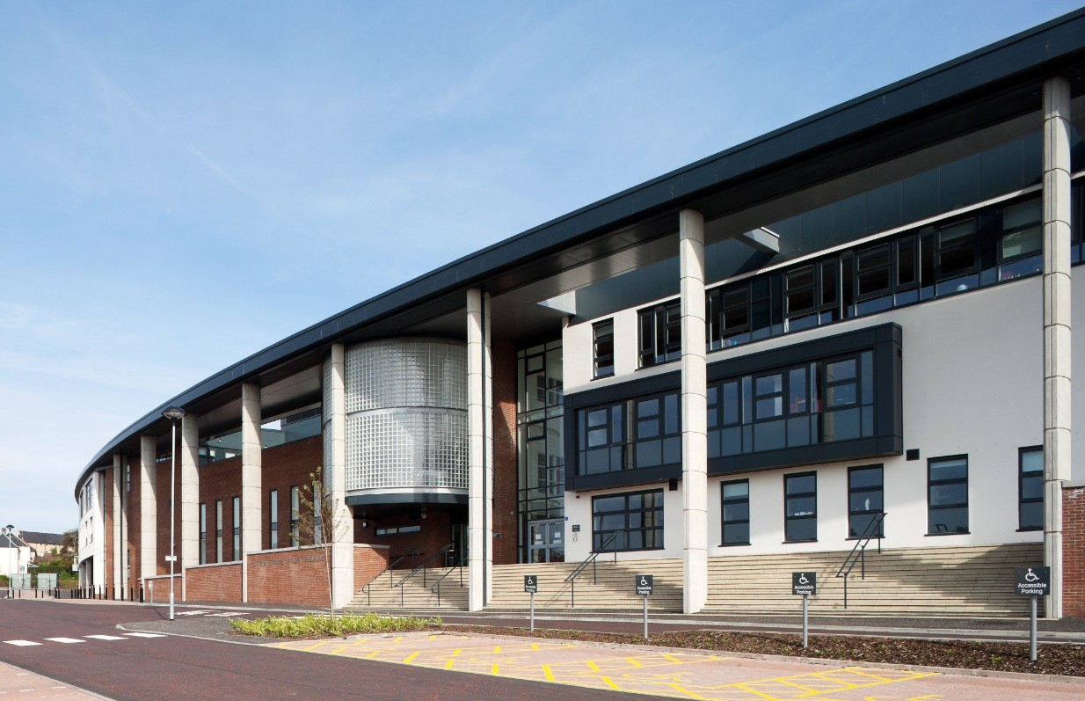

CURRICULUM FOR EXCELLENCE

Our curriculum, which is based on the national guidelines of A Curriculum for Excellence, aims to help the children to develop as confident individuals, responsible citizens, effective contributors and successful learners.

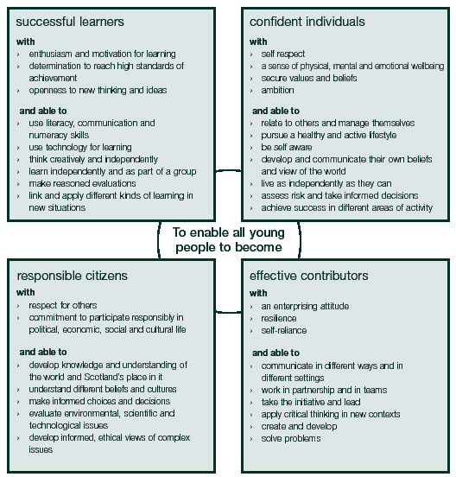
Every child and young person should experience a Broad Scottish Curriculum that develops skills for learning, skills for life and skills for work, with a sustained focus on literacy and numeracy that encourages an active, healthy and environmentally sustainable lifestyle and builds an appreciation of Scotland and its place in the world. Further information about this can be found at:
http://www.educationscotland.gov.uk/thecurriculum/whatiscurriculumforexcellence/index.asp

The experiences and outcomes under Curriculum for Excellence are written at five levels, with progression to qualifications described under the senior phase.

- Early Level – the pre-school years and P1, or later for some
- First Level – to the end of P4, but earlier for some
- Second Level – to the end of P7, but earlier for some
- Third and Fourth – S1 to S3, but earlier for some
- Senior phase – S4 – S6 and college or other means of study

Teaching at St Mary’s is organised to encourage a natural progression from one stage of learning to another. Teachers begin their work from where the child is and build upon his/her existing knowledge. When pupils change classes, there is time given for teachers to liaise with one another. Similarly, we have good links with the secondary schools and we help the staff there in every way to ensure a smooth change from primary to secondary school through pupil and staff visits.

We also have valuable links with our associated nursery schools and visits to these are made during the session preceding August entry.

Children work in groups, sometimes with their friends, sometimes with other classmates or with children of similar ability. Active learning is very important and children are encouraged to take increasing responsibility for their learning as they move through the school.

We are also very aware of the value of play as part of children’s learning, and our Primary One and Two classes have been developing Play Pedagogy alongside other effective teaching and learning approaches.

Learning through play supports the aims of Curriculum for Excellence by helping children to become:

Successful learners - through the use of imagination and creativity, tackling new experiences and learning from them, and developing important skills including literacy and numeracy through exploring and investigating while following their own interests.

Responsible Citizens - through encountering different ways of seeing the world, learning to share and give and take, learning to respect themselves and others, and taking part in making decisions.

Confident Individuals - through succeeding in their activities, having the sense of +satisfaction of a task accomplished, learning about bouncing back from setbacks, dealing safely with risks.

Effective Contributors - through playing together in leading or supporting roles, tacking problems, extending communication skills, taking part in sustained talking and thinking, and respecting the opinions of others.

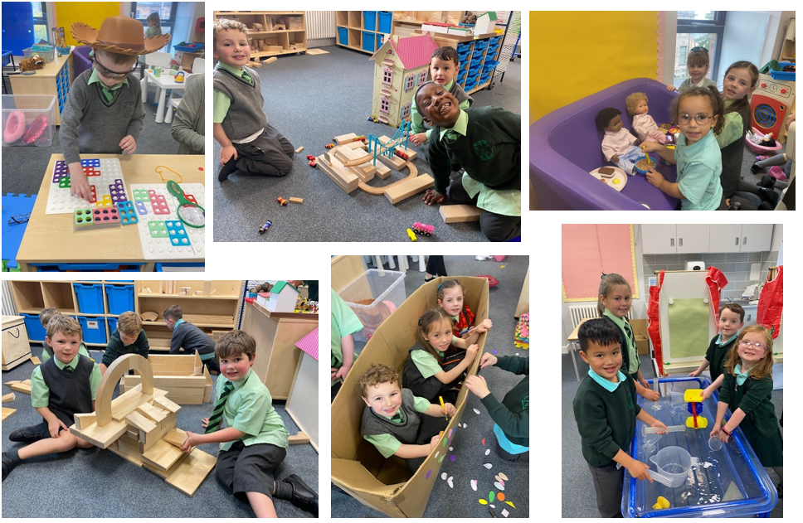

The following sections outline the eight main curriculum areas for which learning and teaching will be planned to meet the principles for curriculum design: challenge and enjoyment, breadth, progression, depth, personalisation and choice, coherence and relevance.

Literacy

There are two main aspects of the literacy area of the curriculum. The first covers experiences and outcomes in the language a young person needs in order to engage fully with their learning and in society; whether that is English or Gaelic. The second covers experiences and outcomes in a Modern language. At St Mary’s, Spanish is taught throughout the school.

Language is at the core of thinking. We develop our ideas, communicate and reflect through language. The acquisition of language and the development of literacy skills help young people achieve their potential and become active members of society who can contribute through their ideas and work.

In St Mary’s, we foster a love of reading and an appreciation of poetry and literature. Through our literacy programme, we also offer our pupils opportunities to use new technologies to communicate and share ideas. We develop leadership in reading by having Reading Reps from each class developing plans for reading across the school.

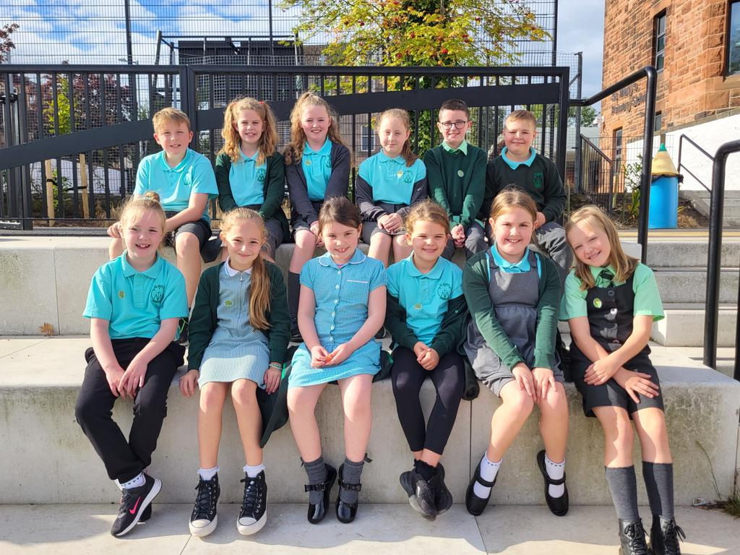

St. Mary’s Reading Reps

Scotland has a rich diversity of language, including Scots Language. The growing number of immigrants to Scotland bring a rich cultural diversity and enables our pupils to experience different cultures and become global citizens.

Learning through the Literacy area of the curriculum enables young people to:

- develop the high level of skills in listening, talking, reading and writing which are essential for learning, work and life
- develop their ability to communicate their thoughts and feelings and respond to those of other people
- use different media effectively for learning and communication
- develop their understanding through questioning and critical thinking
- enhance their enjoyment and their understanding of their own and different cultures through literature and other forms of language
- develop competence in other languages so that they can understand and communicate.

In St. Mary’s, we endeavour to make sure that each child is successful when first learning to read and, to do this, we make the early reading work at Primary 1 as thorough as possible, with each child progressing at his own rate. Our core reading scheme is Oxford Reading Tree (P1 – P3) and Kingscourt/Big Cat Readers/Novels in
P3 - 7. Non-fiction texts are also used throughout the school, particularly in relation to class topics. We ensure all classes visit the Greenock Central Library across the school year and promote reading for pleasure.
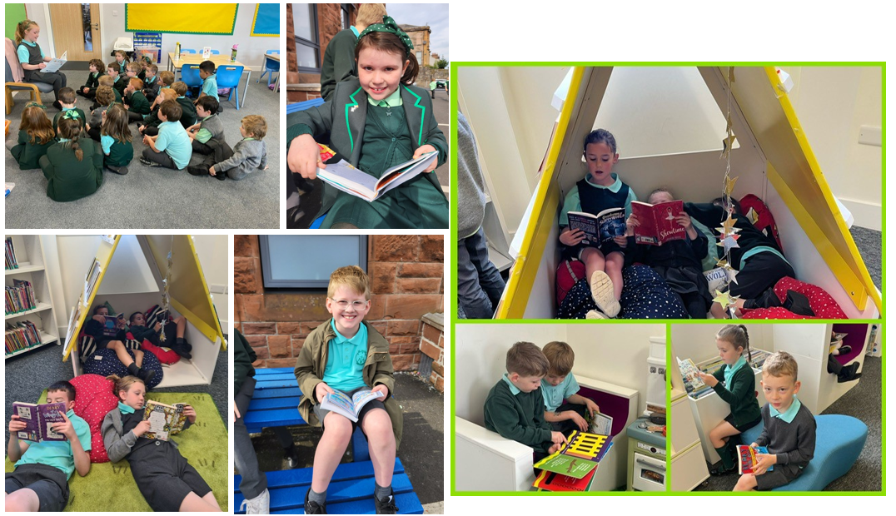

Active Literacy is our Phonics and Spelling programme, and Talking and listening is developed across the curriculum.

A variety of additional resources are used to develop language skills. Teachers assess reading continuously and keep careful records of progress though phonic skills and reading schemes.

In writing, we build on the early skill of drawing and scribing first sentences to developing punctuation, vocabulary, writing in paragraphs with more detail and writing for different purposes. We encourage children to develop a legible, fast, joined script, style of handwriting. We use a wide range of resources to develop writing skills and focus on developing writing across a range of genre.

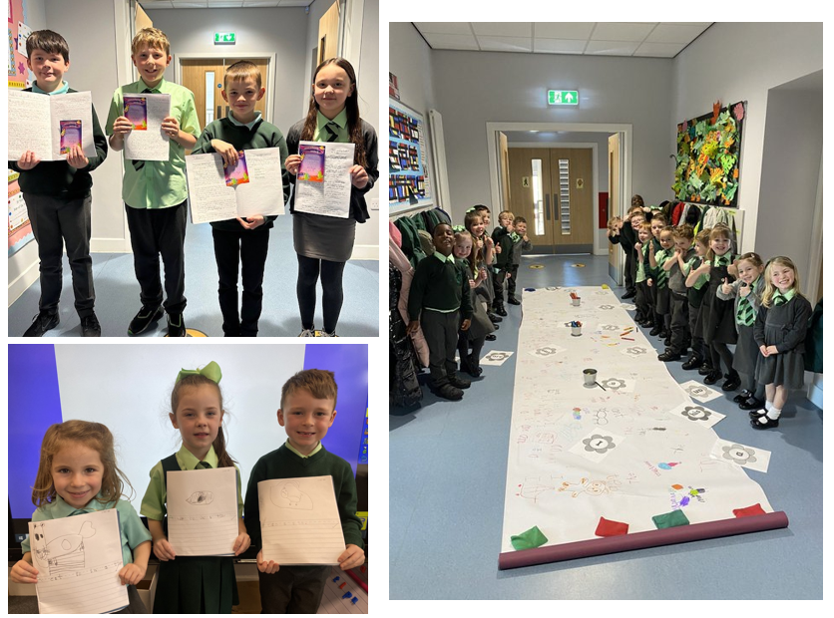

MATHEMATICS

Mathematics includes specific aspects of numeracy which will be developed both in mathematics and through activities in other areas of the curriculum.
“Mathematics is important in our everyday life, allowing us to make sense of the world around us and to manage our lives. Using mathematics enables us to model real life situations and make connections and informed predictions. It equips us with the skills we need to interpret and analyse information, simplify and solve problems, assess risk and make informed decisions. “ CfE – Principles and Practice.
Learning through mathematics enables young people to:

- develop numeracy skills which allow them to participate fully in society
- develop a secure understanding of the concepts, principles and processes of mathematics and apply these in different situations, including the world of work
- establish firm foundations for further specialist learning, including for those who will be the mathematicians of the future.

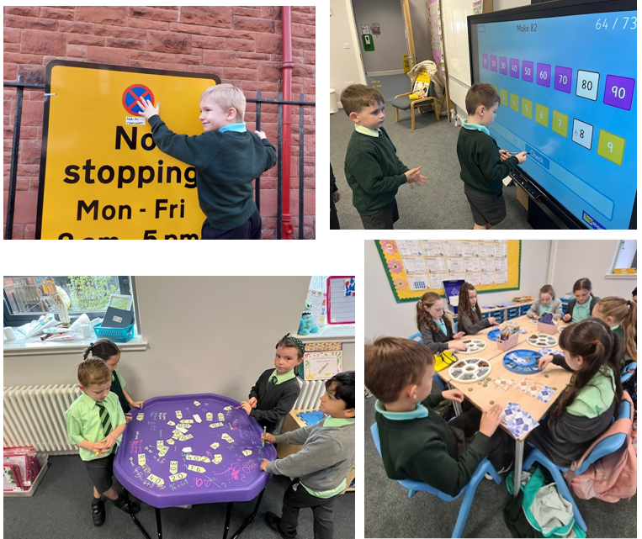

Pupils progress through activities involving number, graphs, money, measure, shape, time, problem solving and information handling. At all stages, we aim to make Maths as active as possible and link the maths we are teaching to real life practical situations.

The modern learning and teaching methods we employ rely far less on textbooks and traditional worksheets. A variety of additional resources, including interactive whiteboard materials, are used to enrich learning. Interactive Mental Maths is given emphasis throughout the school to encourage quick recall of number facts.

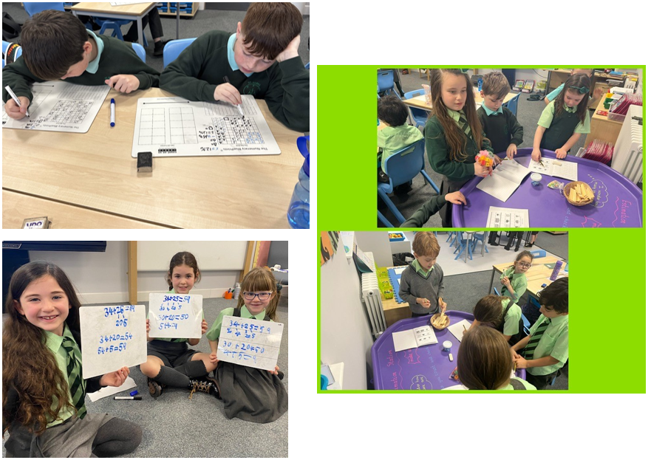

SOCIAL STUDIES

Social Studies include experiences and outcomes in history, geography, social, political, economic and business contexts.
It is important for young people to understand the place where they live and the heritage of their family and community. Through Social Studies, children and young people develop their understanding of the world by learning about other people and their values, in different times, places and circumstances. They also develop their understanding of their environment and of how it has been shaped.
As they mature, children and young people’s experiences will be broadened using Scottish, British, European and wider contexts for learning, while maintaining a focus on the historical, social, geographic, economic and political changes that have shaped Scotland. Children and young people learn about human achievements and about how to make sense of changes in society, conflicts and environmental issues. With greater understanding comes the opportunity and ability to influence events by exercising informed and responsible citizenship.
As they participate in experiences and outcomes in Social Studies, children and young people will:
- develop their understanding of the history, heritage and culture of Scotland, and an appreciation of their local and national heritage within the world
- broaden their understanding of the world by learning about human activities and achievements in the past and present by exploring and evaluating different types of sources and evidence
- learn how to locate, explore and link periods, people and events in time and place
- develop their understanding of their own values, beliefs and cultures and those of others
- develop an understanding of the principles of democracy and citizenship through experience of critical and independent thinking
- establish firm foundations for lifelong learning and for further specialised study and careers.
All of these are taught through topic work e.g. Mary Queen of Scots, Clyde Coastal Towns, Children’s Rights. Teachers use Social Studies topics to build inter-disciplinary links across subjects and to make learning more relevant and coherent.

SCIENCES

Sciences include experiences and outcomes in biological, chemical, physical and environmental contexts.

Through Science at St Mary’s, we endeavour to stimulate, nurture and sustain the curiosity and wonder of our pupils.

Children and young people participating in the experiences and outcomes in the sciences will:

- interact with their environment by observing, exploring, investigating and recording
- develop skills of scientific inquiry and investigation using practical techniques
- demonstrate a secure knowledge and understanding of the big ideas and concepts of the sciences
- recognise the role of creativity and inventiveness in the development of the sciences
- recognise the impact the sciences make on their lives, the lives of others, the environment and on society
- develop an understanding of the Earth’s resources and the need for responsible use of them
- express opinions and make decisions on social, moral, ethical, economic and environmental issues based upon sound understanding
- develop as scientifically literate citizens with a lifelong interest in the sciences
- establish the foundation for more advanced learning and, for some, future careers in the sciences and the technologies.

At St Mary’s, we follow an agreed cluster programme of study for Science. We are looking at how closely this matches the outcomes for a Curriculum for Excellence and adapting our programme accordingly. We also work with West College Scotland across the year to support our work in science.

The Science outcomes are divided into Planet Earth, Forces, Electricity and Waves, Biological Systems, Materials, and Topical Sciences. Links with other areas of the curriculum will be further developed as part of the inter-disciplinary learning.

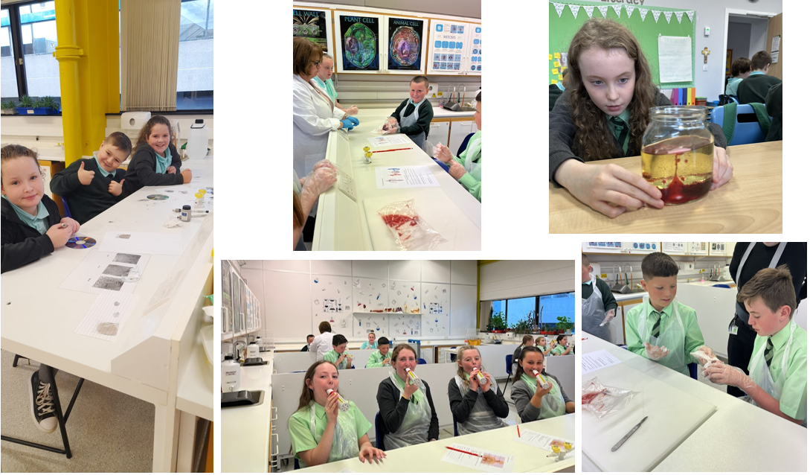

TECHNOLOGIES
This curricular area includes creative, practical and work related experiences and outcomes in Digital Literacy, Food & Textile Technology, Technological Developments in Social Society and Business, Craft, Design, Engineering & Graphics and Computing Science.
To participate fully in modern life, children and young people need to be skilled and knowledgeable users of technologies and be ready to embrace further developments in the future. The technologies consider how knowledge can be applied for practical purposes. They provide exciting opportunities to develop children’s creativity and enterprising attitudes.
Learning in Technologies enables children and young people to be informed, skilled, thoughtful, adaptable and enterprising citizens, and to:

- develop understanding of the role and impact of technologies in changing and influencing societies
- contribute to building a better world by taking responsible ethical actions to improve their lives, the lives of others and the environment
- gain the skills and confidence to embrace and use technologies now and in the future, at home, at work and in the wider community
- become informed consumers and producers who have an appreciation of the merits and impacts of products and services
- be capable of making reasoned choices relating to the environment, to sustainable development and to ethical, economic and cultural issues
- broaden their understanding of the role that information and communications technology (ICT) has in Scotland and in the global community
- broaden their understanding of the applications and concepts behind technological thinking, including the nature of engineering and the links between the technologies and the sciences
- experience work-related learning, establish firm foundations for lifelong learning and, for some, for specialised study and a diverse range of careers.
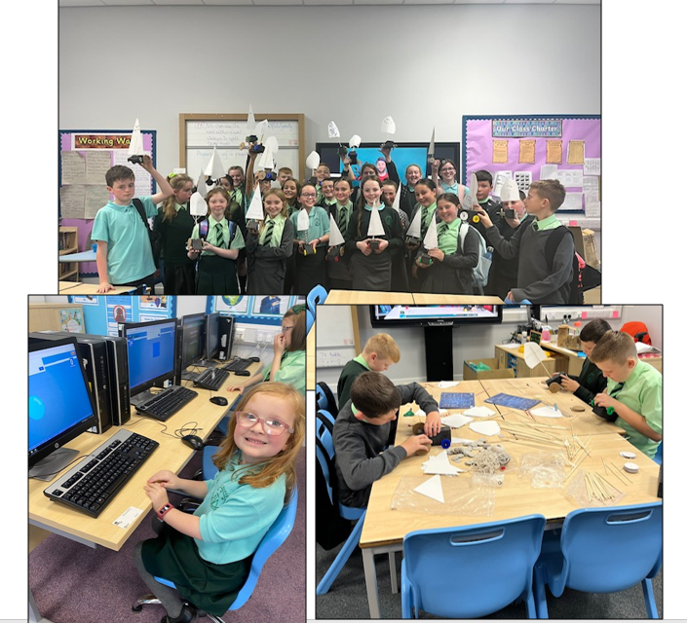

HEALTH AND WELLBEING EDUCATION

Health and Wellbeing includes experiences and outcomes for personal and social development, understanding of health, nutrition, physical education and physical activity, and contributions from home economics.

Children and young people need to experience what it feels like to develop, enjoy and live a healthy lifestyle. A healthy lifestyle supports physical, social and emotional wellbeing, and underpins successful learning.

Learning in health and wellbeing ensures that children and young people develop the knowledge and understanding, skills, capabilities and attributes which they need for mental, emotional, social and physical wellbeing now and in the future.

Learning through health and wellbeing enables children and young people to:

- make informed decisions in order to improve their mental, emotional, social and physical wellbeing
- experience challenge and enjoyment
- experience positive aspects of healthy living and activity for themselves
- apply their mental, emotional, social and physical skills to pursue a healthy lifestyle
- make a successful move to the next stage of education or work
- establish a pattern of health and wellbeing which will be sustained into adult life, and which will help to promote the health and wellbeing of the next generation of Scottish children.

It also enables some to perform at high levels in sport or prepare for careers within the health and leisure industries.

At St Mary’s, our Health and Wellbeing lessons are delivered under the following headings:

- Mental, emotional, social and physical wellbeing
- Physical education, physical activity and sport
- Food and health
- Substance misuse
- Relationships, sexual health and parenthood

In 2009, the school received accreditation as a Health Promoting School.

Physical Education (PE)

Children take part in a range of physical activity, including Gymnastics, Active Health, Games Skills and Dance.

Additional blocks of sports training are provided through support from our Active Schools Co-ordinator.

Parents should note that pupil activities may be restricted because health and safety requirements state that jewellery of any kind must not be worn where pupils are undertaking games or physical activities. This includes jewellery worn as a result of body piercing. We would ask that parents discourage pupils from having body piercing during term time.

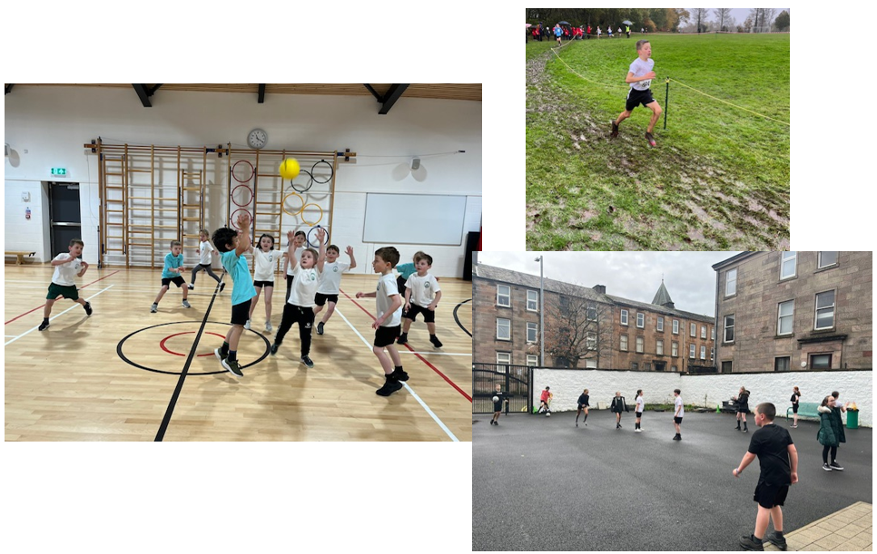

EXPRESSIVE ARTS

The Expressive Arts programme include experiences and outcomes in Art and Design, Drama, Dance and Music.

Through Expressive Arts, children and young people can have rich opportunities to be creative and imaginative and to experience inspiration and enjoyment.

Learning through Expressive Arts enables children and young people to:

- be creative and express themselves in different ways
- experience enjoyment and contribute to other people’s enjoyment through creative and expressive performance and presentation
- develop important skills, both those specific to the expressive arts and those which are transferable
- develop an appreciation of aesthetic and cultural values, identities and ideas
- for some pupils, prepare for advanced learning and future careers, by building foundations for excellence in the expressive arts.

In Expressive Arts, the majority of the activities will be practical, involving creating and presenting, and will allow children to make choices to broaden their experience. It provides the opportunity to express ideas, thoughts and feelings working, both alone and with others.

Evaluating and appreciating will be used to enhance enjoyment and understanding. Expressive Arts offers many opportunities for interdisciplinary learning. In all areas of this curricular area, full use will be made of visiting groups and specialists to enhance learning experiences. The school presents an annual Christmas Show which is very well received by the wider community.

Art and Design

The Art programme includes drawing, painting and using a variety of materials, media and techniques to investigate visually and record. Printing and collage work allows children to investigate, design and create using a range of materials, media and techniques.
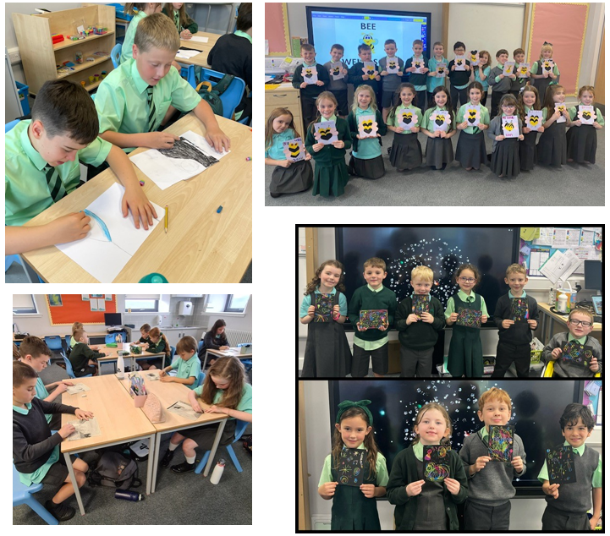

Music

Work in this area allows children to explore sound, using both voice and instruments. The children are given the opportunity to create, present and listen to music and also to reflect and respond.

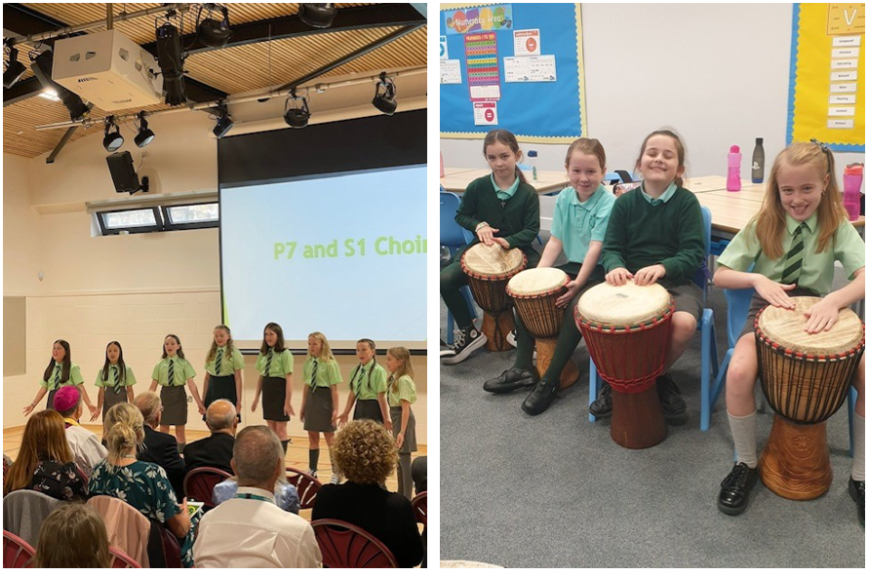

Drama

Children are encouraged to participate in improvisation, role play, characterisation, simulation and creative movement. We also provide opportunities for children to perform in front of an audience e.g. our Christmas concerts.
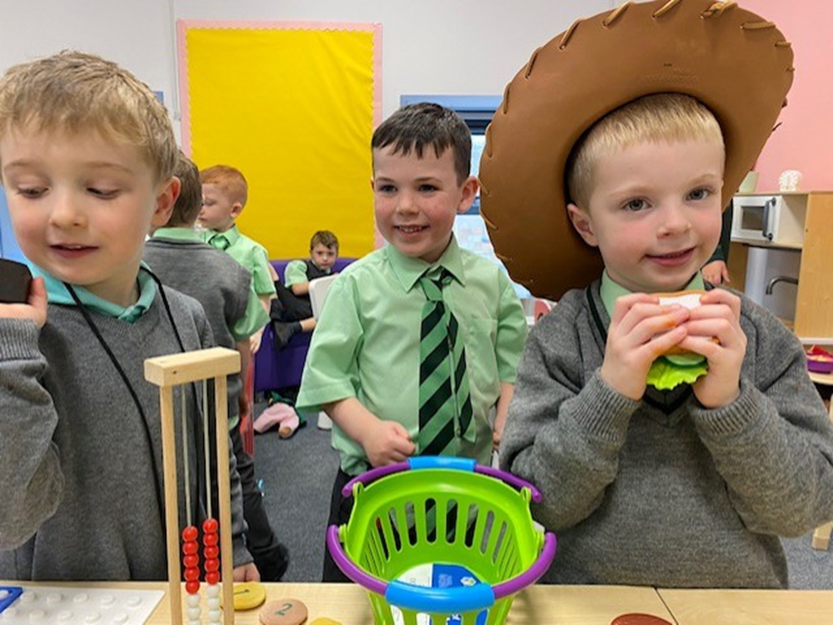

Dance

Children will experience a range of dance styles, including Scottish Country Dance and dance from other cultures.
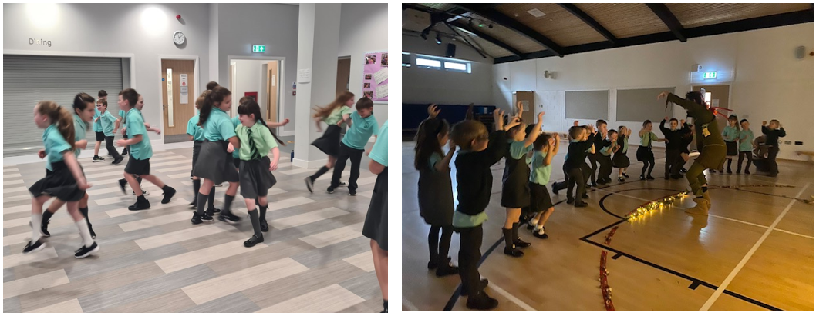

RELIGIOUS EDUCATION

Religious Education includes learning about Christianity and other world religions, and supports the development of beliefs and values. In Roman Catholic Schools, religious and moral education is taught from a Catholic perspective using guidance from Curriculum for Excellence but also supplementary guidance from “This is Our Faith” from the Scottish Catholic Education Service. The curriculum in a denominational school will reflect its particular faith perspective. In Roman Catholic schools, it will build on the openness of Catholic schools to other young people regardless of denominations and faiths.

Learning through religious education enables children and young people to:
- develop their knowledge and deepen their understanding of the Catholic faith
- investigate and understand the relevance of the Catholic faith to questions about truth and the meaning of life
- highlight, develop and foster the values, attitudes and practices which are compatible with a positive response to the invitation to faith
- develop the skills of reflection, discernment, critical thinking, and deciding how to act in accordance with an informed conscience when making moral decisions
- nurture the prayer life of the individual and of the school community
- understand and appreciate significant aspects of other Christian traditions and major world religions
- make a positive difference to themselves and the world by putting their beliefs and values into action.
Teachers will remain faithful to the mission of promoting an understanding of the Catholic faith and they will also teach respect for persons of different religious convictions. Religious education in the Catholic school considers the significance of faith from the perspective of the life of the person and of the faith community.
In addition to developing their understanding of the Catholic faith, children and young people will also learn respect for, and understanding of, other Christian traditions. They will come to an appreciation of significant aspects of major world religions, recognising and respecting the sincere search for truth which takes place in other faiths. Where appropriate, they will learn similarly about stances for living which are independent of religious belief.
In St Mary’s, we seek to fulfill our role in the total welfare of your child, body – mind – spirit. Thus, the Christian faith permeates the whole ethos of curriculum and school community. In holding to this view, we reflect the wishes of the Scottish Roman Catholic Hierarchy and Laity.

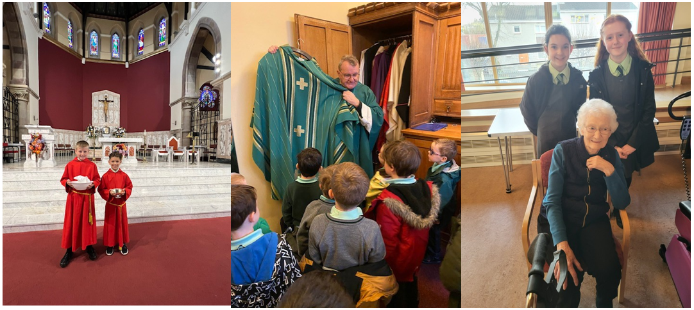

Special religious services for children are held at Christmas, Easter and the beginning and end of the academic year, as well as various other times throughout the year. In particular, staff and pupils attend Mass in St. Mary’s church on the first Friday of each month and on Holidays of Obligation, and parents are always welcome to join us for these celebrations. Details of these services are printed in the school’s Religious Events Calendar issued each year.

Children in P4 and P7 are prepared for the Sacraments of First Reconciliation, First Eucharist and Confirmation. Our school chaplain, Father Tom, also ensures children have the opportunity to receive the sacrament of Reconciliation in school at specific times of the year.

Our P6 and 7 pupils take part in the Pope Francis Faith Award, as part of their preparation for Confirmation. In addition to gaining the PFFA award, the children can also work towards a parish commendation by volunteering at their local church. We also have children in the school taking part in ‘Mini Vinnies’ in working with The Little Sisters of the Poor during the year and supporting our local nursing homes at Christmas.
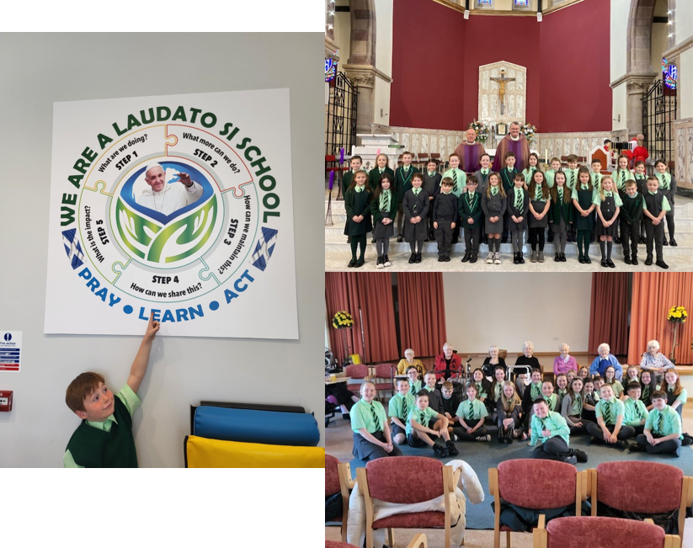

Parents enrolling their sons and daughters in denominational schools may be expected to follow the programmes of worship and religious education in these schools. However, they retain the right to withdraw their children from religious observance (as per Inverclyde’s Equalities Advice Note).

Parents from other religious communities may request that their children be permitted to be absent from school in order to celebrate recognised religious events. Only written requests detailing the proposed arrangements will be considered. Appropriate requests will be granted on not more than three occasions in any one school session and the pupil noted as an authorised absentee in the register.

Sex and Relationship education is an integral part of a school’s health education programme. It focuses on the physical, emotional, moral and spiritual development of all children. In delivering this programme, we follow God’s Loving Plan from P1-7, which provides teachers in Catholic primary schools with updated guidance on teaching about loving relationships in the context of Religious Education and Health Education.

Parents/carers will be fully informed and consulted on the content and purpose of sex and relationship education in schools, and have the opportunity to raise concerns with school staff. On an occasion where a parent/carer wishes to exercise the right to withdraw his/her child from sex and relationship education, they should discuss their concerns and alternative arrangements with school staff (as per Inverclyde Council’s policy “Sexual Health and Relationship Education”).

ADDITIONAL SUPPORT NEEDS

All children and young people need support to help them learn. The main sources of support in early years and in schools are the staff who, through their normal practice, are able to meet a diverse range of needs. With good quality teaching and learning and an appropriate curriculum, most children and young people are able to benefit appropriately from education without the need for additional support.

The definition of additional support is a wide one and it is not possible to provide an exhaustive list of all possible forms of additional support but could include consideration given to:

- children who have a disability
- children with social, emotional and behavioural difficulties
- children with learning difficulties of a specific or general nature
- children who are exceptionally able
- those who demonstrate underachievement relating to gender issues
- children whose learning has been interrupted through absence or illness
- bilingual children who have English as an additional language
- travelling children
- children whose family circumstances impact on attendance and learning.

Each school has a Learning Support Co-ordinator – this is the person you would speak to if you think that your child requires additional support in school. At present, our Learning Support Co-ordinator is Mrs. Jacqueline Blincow. As part of her role, she organises:

- timetables for Learning Support teachers
- review meetings for pupils with additional support needs
- materials to support learning
- support from external agencies

In keeping with the requirements of the Education (Additional Support for Learning (Scotland) Act 2009, a child or young person’s needs are identified at the earliest possible stage and can be met in a number of ways, for example by adaptations to the curriculum or learning environment, as well as input from the Support for Learning Teacher and, on occasion, support from visiting specialists. The appropriateness of the support is determined through a process of assessment, planning and monitoring, and working jointly with parents and carers, and is regularly reviewed.

Learning outcomes for children and young people with additional support needs are set out in a plan and all educational establishments hold regular review meetings with parents and carers to determine needs and the most appropriate supports. Everyone’s views are equally important in order to consider what is currently working and how to determine next steps.

Children and young person’s needs are identified in a number of ways, and the process of assessment is an ongoing, shared process with partnerships with parents and carers at the forefront. On some occasions, health service staff or other partner agencies make children known to Education Services. Other additional support needs may be notified to Education Services by parents themselves or identified by one of a range of staff working closely with the child.

Some children and young people will have additional support needs arising from complex or multiple factors which require a high degree of co-ordination of support from both education and other agencies in order that their needs can be met. In these cases, the school will hold a meeting to decide whether the child or young person meets the criteria for a coordinated support plan. The coordinated support plan is a statutory document which ensures regular monitoring and review for those children and young people who have one.

You have the right to ask the education authority to establish whether your child needs a coordinated support plan. Your child can make this request themselves, if they are aged 16 or over. You and your child, if they want to, will attend a meeting with staff at their school. Other professionals from different agencies who may be involved in providing support for your child will also attend. If your child does not want to attend meetings or feels unable to, their views must still be sought and considered.

Inverclyde’s mediation service can be accessed by contacting Tony McEwan, Head of Inclusive Education, Culture and Corporate Policy at the address below

For further advice please telephone 01475 712850
Or write to:
Education Services
Wallace Place
GREENOCK PA15 1JB
In addition, advice can be sought from the following websites:
www.enquire.org.uk
www.siaa.org.uk
www.sclc.org.uk

ASSESSMENT

Effective learning and teaching can only take place within a framework of clear aims, careful planning, motivation and appropriate assessment and evaluation.

If a child’s needs are to be met effectively, then regular and reliable information about their attainment and abilities is necessary. We continually use assessment information to:

- monitor where each child is in the learning process
- place the child in an appropriate working group/class
- identify pupils with additional support needs
- compare the attainment of a particular year group
- ensure pupils are working at appropriate levels of difficulty
- provide appropriate challenge

Teachers use both formative and summative assessments to ensure pace and challenge for all pupils, including Scottish National Standardised Assessments, which are carried out in P1, P4 and P7. These help to inform teachers’ judgements about children’s progress and their next steps in learning.

Formative Assessment

Formative assessment involves both the teacher and the pupil in dialogue about learning and how to improve the learning which takes place. It involves:

- sharing learning outcomes and success criteria
- quality feedback from both teachers and other pupils
- ongoing review and reflection of progress being made

Research has shown that this type of assessment activity not only raises attainment but also raises pupil self–esteem and motivation.

Reporting to Parents

We keep careful records of each child’s progress, especially in Maths and Literacy. Parents’ Evenings are normally held in November and May, which give parents an opportunity to discuss their child’s progress with the teacher. Short, written reports are also provided three times a year.

In keeping with the principles of Curriculum for Excellence, reporting should be a three-way process with the child, parent and teacher. Weekly Learning Logs and Termly Targets are sent home to help the children become more reflective about their learning. These are also used as a means of sharing regular information with parents.

We also provide many occasions for you to see your child “in action”, either through invitations to the class or as part of wider school events. Attending these events will provide excellent opportunities for you to talk to your child about what he/she is learning in school.

HOME – SCHOOL LINKS

Parents are always welcome to make an appointment to discuss their child’s progress. Please try to give a brief outline of your concerns when you make an appointment, so that the teacher can deal with your enquiry more effectively. Class teachers are also usually available at 3pm once they have dismissed their classes. If you need to pass information on to the teacher at the beginning of the day, please give your child a note or contact the office staff.

At St Mary’s, we recognise that parents are the first educators of their child. We also recognise the importance of working in close partnership with parents. This is done in several ways, from the informal meetings with parents in the playground to the more structured Parents’ Evenings. There are many mutual benefits which can stem from a close working relationship between parents and staff, so we are anxious to encourage parental involvement activities, especially those activities which involve engagement in pupil learning.

Parents are involved in a variety of fundraising ventures throughout the year and we are always delighted to have parent helpers to support the work of the school e.g. helping at the Book Fair or accompanying pupils on school outings.

Parental Workshops

Where appropriate, we try to provide workshops on curricular methods and new resources or initiatives. Please try to attend these if you can.

Information

We strive to keep you up to date with school news and events through:

- newsletters
- texts
- letters and reminders
- local press e.g. Greenock Telegraph
- telephone calls
- school website
- twitter
- emails

Home Learning

Home learning activities are an essential part of every pupil’s school programme.

The purpose of home learning is to:

- promote parental involvement
- provide parents/carers with opportunities to share learning experiences with their children
- provide additional practice across a wide range of curricular areas
- consolidate and reinforce learning
- promote pupils’ self-esteem and motivation
- engage pupils in evaluating their own work
- set challenging tasks to encourage independent research

School Policy on Home Learning

Parents are asked to be supportive in fostering responsible attitudes in their children when home learning tasks are assigned.

In the case of a child who has missed work through prolonged absence, parents may request additional homework to be set by the class teacher for a short period. We would ask you to be guided as to its content and necessity by the class teacher.

We would also hope that our pupils will, of their own accord, wish to follow up some of the activities in which they have been involved at school.

This policy was updated in 2021 collaboration with teachers, pupils and parents. Time given to home learning takes into consideration the child’s age, aptitude and health, but should never be excessive. It is also important that children have time at home to relax and play, as well as take part in particular hobbies and clubs.

Wet Weather Procedures

In severe weather, three bells will be rung at 8.45 am and children may enter by the middle doors and proceed to the school hall (Adults may not go to the school playground for security reasons). Non-teaching staff will bring pupils indoors.

Children at St Mary’s also enjoy indoor intervals and lunchtimes in bad weather. Pupils are supervised by members of the Senior Management Team and non-teaching staff. During the lunch break, once children have eaten, they will go to the classroom where our Pupil Support Assistants will supervise them. Monitors from P7 will work in pairs in P1 – P6 classes to help with supervision. The headteacher or the depute headteacher will always be available during intervals and lunch breaks to deal with any problems which might arise.
It is our aim to make indoor breaks the exception rather than the norm when it is raining and only stay in when it is heavy rain as there are so many benefits to children being outdoors as much as possible. Please dress appropriately for all weathers.

SCHOOL/COMMUNITY LINKS

The school, as part of the local community, tries to play a meaningful part in local events such as competitions, Parish and Ecumenical Services and visits to homes for the elderly.

Our pupils are encouraged to explore and know their local community and to care for it responsibly.

We are happy to acknowledge at this point the superb co-operation of local industry and commerce in our ventures.

POSITIVE BEHAVIOUR

Good behaviour is essential for effective learning to take place. Within St Mary’s Primary School, we have a safe, welcoming and nurturing environment which creates the right atmosphere for learning and building positive raltionships.

Each classroom provides a safe environment for quality learning and teaching, allowing every pupil a sense of security, promoting high self-esteem and recognition of individual achievement.

Class teachers use a variety of approaches to manage behaviour, however, we make sure we involve our parents as partners to work together if any challenges arise. Parental support is vital in maintaining a high standard of behaviour and engagement in class.

Good behaviour is rewarded in a variety of ways throughout the school.

Rights and Responsibilities

We work in a values based culture where rights are respected and responsibilities accepted. We have achieved the first level as a Rights Respecting School.

From Primary 1 through to Primary 7, pupils learn about children’s rights as stated in the summary of The United Nations Convention on the Rights of the Child (UNCRC) and consequently realise their responsibility to respect the rights of others. Positive behaviour is reinforced through the language of rights and pupil responsibility to be a rights ‘giver’.

Everyone has the right to:

- feel safe and secure
- be respected
- be heard
- be educated without disruption
- be treated fairly
- learn in a healthy, clean environment

Everyone has the responsibility to:

- help ensure that others feel safe and secure
- respect friends, staff, visitors and parents
- be a good listener
- allow others to learn without disruption
- treat others the way they like to be treated
- make healthy choices and look after the environment

The Authority’s guidance on steps leading to the exclusion of a child is available from the Headteacher.

INCLUSION AND EQUALITY

Inverclyde Council Education Service aims to:

- offer education of the highest quality to all young people within a developing culture of inclusion
- endorse the principles of inclusion, entitlement and equality of opportunity in the development of best practice
- value the diversity of interests, qualities and abilities of every learner
- believe that every child and young person is entitled to educational opportunities which enable the achievement of success and further development of the individual’s learning potential within the least restrictive environment
- affirm the right of all young people to have access to the highest quality of educational provision which is appropriate to learning needs, is supportive of the young person and is delivered in partnership with young people, parents and the wider community

In meeting the needs of all of our pupils, we will demonstrate no discrimination on the basis of race, gender, disability, sexual orientation, religion or belief. This encompasses curricular, extra-curricular and classroom activities and is foremost in the attitudes which we develop in our pupils.

EQUALITIES

The Equality Statement for Inverclyde Schools

‘Inverclyde Education Service is committed to ensuring that no children or members of staff or service users receive less favourable treatment on any ground including gender, race, disability, age, sexual orientation, religion or belief. We have a moral, social and legal obligation to mainstream and put equality at the heart of everything we do. We aim to promote a culture in which equality of opportunity exists for all. We are opposed to all forms of discrimination, direct or indirect, and aim to eliminate all discriminatory practices. We will ensure that, in our schools and other educational establishments, equality permeates the curriculum and underpins all our policies and practices in terms of access to education. We must ensure that all our children achieve their full potential to develop physically, emotionally and academically. Finally, we believe that equality and inclusion should be a given right, where everyone is valued and treated with respect.’

ATTENDANCE

Absence rates are calculated as a percentage of the total number of possible attendances for all pupils of the school in the stage shown, each morning and afternoon of each school day being a separate possible attendance.

Where figures or percentages based on a number of pupils under any particular heading is between 1 and 4 no information is given and *** is inserted in place of the figures.

Adults attending day school classes are excluded.

The authority’s and Scotland’s figures include all education authority and grant-aided primary schools, but exclude all special schools.

Children Absent from School through Ill-health

Young people of school age may be unable to attend school for a wide range of reasons including illness, accidents or long term medical conditions.

Attendance at School

Parents should inform the school by telephone each day of an absence and provide a reason for the pupil’s absence. The school will contact the pupil’s family and, thereafter, other emergency contacts, if no explanation is given for the pupil’s absence. This contact will be made before 9.30 am on the first morning of an absence and early after the restart after lunch in the case of an afternoon absence. Other agencies may be contacted if no contact with the pupil’s family can be achieved and/or if there are continuing or emerging concerns about a pupil’s safety or wellbeing. On return to school, parents should provide a note explaining the reasons for absence.

Parents should keep the school informed of any changes of address or telephone numbers, both their own and those of the emergency contacts.

Section 30 of the 1980 Education Act lays a duty on every parent of a child of ‘school age’ to ensure that their child attends school regularly. Attendance must be recorded twice a day, morning and afternoon.

Regulation 7 of The Education (School and Placing Information) (Scotland) Amendment etc Regulations 1993 requires each child’s absence from school to be recorded in the school register as authorised: i.e. approved by the authority and unauthorised: i.e. unexplained by the parent (truancy) or temporarily excluded from school.

The Scottish Government has provided guidance on the management of attendance and absence in Scottish schools in its publication Included, Engaged and Involved - part 1: Attendance in Scottish Schools. Every effort should be made to avoid family holidays during term time, as this both disrupts the child’s education and reduces learning time. It has been clarified that family holidays should not be recorded as authorised absence, except in exceptional domestic circumstances, where a family needs time together to recover from distress, or where a parent's employment is of a nature where school holiday leave cannot be accommodated (e.g. armed services or emergency services). It is for local authorities and schools to judge when these circumstances apply and authorise absence, accordingly.

The categorisation of most term-time holidays as unauthorised absence has been a contentious issue for some families, many of whom are concerned at the higher cost of holidays during school holiday periods. The Scottish Government has no control over the pricing decisions of holiday companies or flight operators. Our main focus is to encourage parents and pupils to recognise the value of learning and the pitfalls of disrupting learning for the pupil, the rest of the class and the teacher.

Clearly, where an absence occurs with no explanation from the parent, the absence is unauthorised.

Schools investigate unexplained absence, and Education Services has the power to write to, interview or prosecute parents, or to refer pupils to the Children’s Reporter, if necessary.

EXTRA CURRICULAR ACTIVITIES

Throughout the year, there are opportunities for pupils to participate in a range of activities and events outside of school. Our parents regularly help to supervise pupils on educational and social outings, and we warmly welcome such participation.

Depending on resources available, there may be opportunities for children to attend after school clubs. Parents will be notified if this is the case.

Parents should note that the activities the pupils may become involved in may be restricted because health and safety requirements state that jewellery of any kind must not be worn where pupils are undertaking games or physical activities. This includes jewellery worn as a result of body piercing. Physical activities include activities undertaken within physical education (P.E.) classes.

MEDICAL AND HEALTH CARE

Provision is made by the Schools’ Medical Service for checks on pupils’ general health, vision, hearing, hygiene, dental health etc.

Parents of new entrants are invited to attend the first medical examination.

Pupil illness or accident

In the event of a pupil taking ill or having an accident, every effort is made to contact the parent immediately. If no one can be contacted, the child is kept in the school foyer until he/she can be collected.

Parents are asked to list an emergency contact. It is essential to keep the school informed of any change in the emergency contact telephone number or your home or work telephone number.

However, in the event of any emergency, which should be dealt with without delay, the child will be transported immediately to the Inverclyde Hospital by a member of staff accompanied by the school’s first aider. If there are any medical requirements for a child, parents should inform the school in writing.

Medication

Parents of children requiring medication during school hours are welcome to come into the school office to administer the medication. If parents would like a member of staff to administer medication, they must hand the medication in to the school office and complete the appropriate consent form.

ALLERGIES/PEANUT FREE ZONE

As some of our pupils are allergic to peanuts and peanut products and could suffer an anaphylactic reaction if exposed to them, we ask that children do not bring peanut/peanut products to school.

TRANSPORT

The Council has a policy of providing free transport to all primary pupils who live more than one mile from their local school by the recognised, shortest walking route. This policy is more generous than the law requires. This means that the provision of transport could be reviewed at any time. Parents who consider they are eligible should obtain an application form from the school or Inverclyde Council, Customer Service Centre, Municipal Buildings, Clyde Square, GREENOCK, PA15 1LY. These forms should be completed and returned before the end of February for those pupils beginning school in August to enable the appropriate arrangements to be made.

Applications may be submitted at any time throughout the year but may be subject to delay whilst arrangements are made. The appropriate officer has discretion in special circumstances to grant permission for pupils to travel in transport provided by the authority, where spare places are available and no additional costs are incurred.

Pick Up Points

Where free transport is provided, it may be necessary for pupils to walk a certain distance to the vehicle pick-up point. Walking distance in total, including the distance from home to the pick-up point and from the drop-off point to the school in any one direction, will not exceed the authority’s limits (see above paragraph). It is the parent’s responsibility to ensure that their child arrives at the pick-up point on time. It is also the parent’s responsibility to ensure the child behaves in a safe and acceptable manner while boarding, travelling in and alighting from the vehicle. Misbehaviour could result in a child losing the right to free transport.

SUPERVISION IN PLAYGROUNDS

An adult presence is provided in playgrounds at break times in terms of the Schools (Safety and Supervision of Pupils) (Scotland) Regulations, 1990. Our Pupil Support Assistants are available in our playgrounds during lunchtime and interval time.

SAFETY FACTORS

- School commences at 9.00 a.m. Transport arrangements and working parents do influence the early arrival of some children. However, children should arrive in school no earlier than 8.45 a.m.
- Parents are requested to leave children at the school gate in the morning and collect them from the gate at the end of the day (P1-3 parents are permitted in the playground at pickup from Kelly Street entrance). Please stand away from the gate in order to allow children to exit the school safely from the school playground. Where possible, you should stand at the same spot every day so that your child knows exactly where to look for you when he/she comes out of school.
- In the interests of safety, parents are requested not to park in front of the school on the yellow lines.
- In order to avoid congestion, parents are requested not to come into the school entrance corridor or to the hall when children are assembling.
- Primary 1-3 children must be collected by a responsible adult at the end of the school day.
- No child will be allowed to leave during school hours (e.g. dental, hospital, doctor appointments) unless collected by a responsible adult. Please send in a letter if someone else is picking your child up for an appointment during school hours.
- The pupils’ entrances are secured during the day. Any parent requiring access to the school should use the main entrance on Kelly Street and report to the school office.

INFORMATION IN EMERGENCIES

We make every effort to maintain a full educational service but, on some occasions, circumstances arise which lead to disruption. Schools may be affected by, for example, severe weather, a temporary interruption of transport, power failures or difficulties with fuel supply. In such cases, we shall do all we can to let you know about the details of closure or re-opening. We shall keep in touch by using emails, texts, letters, notices in local shops and community centres, announcements in local churches, in the press and on local radio.

In the case of evacuation of the school building, our assembly point is the large playground facing on to West Stewart Street.

CHILD PROTECTION IN INVERCLYDE

Inverclyde Council Education Services has Child Protection Guidelines and Procedures which all schools and establishments are required to follow. Education Services work very closely with other agencies namely Police Scotland, Social Work Services, NHS Greater Glasgow and Clyde and the Children’s Reporter to support children. Common responsibilities of all staff are to protect children from abuse and exploitation, to respond appropriately when abuse is identified, and to ensure whenever possible that all children are able to exercise their right to be raised in a warm, stimulating and safe environment with the support of staff, their families and carers.

SCHOOL MEALS

Hot meals and packed lunches prepared in our school kitchen are available daily. Payment being made through Parentpay. There is a standard price - presently £2.25 - for either a hot meal or packed lunch. P1-5 children are now entitled to a free school meal each day.

Special diets may be available on medical grounds.

Arrangements are also made for those children who bring a packed lunch.

At St Mary’s, we are committed to being a Health Promoting School through raising health awareness, providing greater opportunities for physical activity and offering healthy school meals.

FREE MEALS AND CLOTHING GRANT
To make a new application for clothing grant and free school meals, your child/children must attend a school managed by Inverclyde Council. In addition, you should be in receipt of one of the qualifying benefits:
- Income Support (IS)
- Income Based Job Seekers Allowance (JSA)
- Income related Employment and Support Allowance (ESA)
- Child Tax Credit, but not Working Tax Credit and have an income of less than £17,005 in 2022/2023 as assessed by HMRC
- Parent is in receipt of Working Tax Credit and/or Child Tax Credit with annual gross earnings of no more than £12,417
- Universal Credit, where your take home pay does not exceed £1,007, as shown on your most recent monthly Universal Credit statement
- An asylum seeker, receiving support under Part VI of the Immigration and Asylum Seekers Act 1999
Or
- You look after a child/children as part of a FORMAL Kinship Care agreement, registered by Social Work Services.
If this is the first time you have applied and are unsure how to proceed, please call Education Services on 01475 712893, where a member of the team can provide advice on the application process.
All children in P1-5 are automatically entitled to receive a free school meal. However, if you wish to apply for a clothing grant, an application form will still need to be completed and the appropriate household income evidence submitted.

If a child is over the school leaving age, the application for clothing grant and free school meals will be processed when it is confirmed that the child has returned to school.

Approval of requests for such grants made by parents in different circumstances is at the discretion of the Corporate Director, Education and Social Care. Information and application forms may be obtained from schools and from Customer Service Centre, Municipal Buildings, Clyde Square, Greenock, PA15 1LY.

UNIFORM

Given that there is substantial parental and public approval of uniform, schools in Inverclyde are free to encourage the wearing of school uniform. In encouraging the wearing of uniform, account is taken in any proposals to prevent any direct or indirect discrimination on the grounds of race or gender. Any proposals will be the subject of widespread consultation with the parents and pupils. Against this background, it should be noted that it is the policy of the Education & Lifelong Learning Committee not to insist on pupils wearing uniform or having specialist items of clothing as a prerequisite of their attending and engaging in all of the activities of the curriculum.

There are forms of dress which are unacceptable in school, such as items of clothing which:

    - potentially encourage faction (such as football colours)
    - could cause offence (such as anti-religious symbolism or political slogans)
    - could cause health and safety difficulties, such as loose fitting clothing, dangling earrings or clothing made from flammable material, for example, shell suits in practical classes
    - could cause damage to flooring
    - carry advertising, particularly for alcohol or tobacco and
    - could be used to inflict damage on other pupils or be used to do so

The council is concerned at the level of claims being received regarding the loss of children’s clothing and/or personal belongings. Parents are asked to assist in this area by ensuring that valuable items and unnecessarily expensive items of clothing are not brought to the establishment. Parents should note that the authority does not carry insurance to cover the loss of such items and any claims submitted are likely to be met only where the authority can be shown to have been negligent.

Parents should note that the activities the children may become involved in may be restricted because health and safety requirements state that jewellery of any kind must not be worn where children are undertaking physical activities. This includes jewellery worn as a result of body piercing.

Although it is not the policy of the education committee to insist on pupils having school uniform or specialised clothing, where possible, however, children are encouraged to wear our attractive uniform.

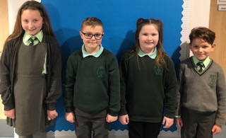

- Green blazer with school badge or green padded waterproof jacket
- Green shirt and school tie
- Grey pullover or grey cardigan
- Green sweatshirt with school badge
- Green polo shirt with school badge (particularly useful for PE days)
- Grey trousers and grey pinafore or skirt
- Black shoes for boys.

Sensible, black, flat-heeled shoes for all girls are advised. The stairs in our building could present a hazard for fashion heeled shoes.

The school PE kit consists of a white round neck t-shirt with or without school badge, black shorts and black sandshoes.

PLACING REQUESTS

Education Services does not provide transport for those pupils in receipt of a placing request other than in exceptional circumstances. In the case of under-age placing requests if the child is offered a place in his/her catchment area school, transport will be provided in accordance with council policy as stated above.

PARENT FORUM AND PARENT PARTNERSHIP

Scottish Schools (Parental Involvement) Act 2006 led to the establishment of Parent Councils in primary, secondary and special schools. The Act recognises the vital role that parents play in supporting their children’s learning. It places a duty on authorities to promote the involvement of parents in children’s education and the wider life of the school. It aims to help parents to be:

- involved with their child’s education and learning
- welcomed as an active participant in the life of the school
- encouraged to express their views on school education generally

Information must be provided on whether or not a Parent Council has been established and the reason(s) given for the non-establishment or dis-establishment of a board.

Information should be given about the members of the council. Details of where/how the Parent Forum can access minutes of meetings and constitution should be given.

In St Mary’s, we have a very active and supportive Parent Partnership. Some of the ways in which pupils have benefitted from their services include:

- gifts for each pupil receiving First Holy Communion and Confirmation, a shoe bag for each of our new entrants and a gift for each child moving on to secondary school

- treats for Hallowe’en and Christmas parties.

- Picnic benches to create an outdoor classroom

- New sports kits for football and athletics events

As you can imagine, shopping for so many children costs a lot of money. Without parents’ help, their fundraising would not be possible. They are always looking for new volunteers to help – please consider coming along to meetings.

At present, our Parent Partnership committee members are:

- Chairperson – Mr Kevin Ferrie
- Vice Chairperson - Miss Jennifer Sheridan
- Treasurer – Mrs Veronica Pollard
- Vice Treasurer – Mrs Sarah O’Brien
- Secretary/Minute Taker – Mrs Nathalie Dvorak & Mrs Geraldine Henry

Parish Representative – Mrs Evelyn Fitzharris

Staff Representatives - Mrs Jacqueline Blincow and Mrs Nicole Macdonald

When a vacancy occurs in the Parent partnership, nominations are invited from the Parent Forum. These nominations are considered at a Parent Forum Meeting and, if need be, a vote is taken.

The Parent Partnership, as a statutory body, has the right to information and advice on matters which affect children’s education.

Parents who are involved on a regular basis in schools should undertake a PVG check through Disclosure Scotland.

PARENTZONE SCOTLAND

Parentzone Scotland is a unique website for parents and carers in Scotland, from early years to beyond school. The website provides up-to-date information about learning in Scotland, and practical advice and ideas to support children’s learning at home in literacy, numeracy, health and wellbeing and science. Information is also available on Parentzone Scotland regarding additional support needs, how parents can get involved in their child’s school and education.

Parentzone Scotland also has details about schools, including performance data for school leavers from S4-S6 and links to the national, local authority and school level data on the achievement of Curriculum for Excellence levels.

READ, WRITE, COUNT

Read, Write, Count with the First Minister is a programme that aims to support parental engagement in literacy and numeracy. Gift bags are distributed annually to all Primary 2 and Primary 3 pupils in Scotland by Scottish Book Trust. The gift bags contain literacy and numeracy materials to support children’s learning, as well as advice and support to parents.

Studies show a direct link between a strong family learning environment and progress in reading, writing and counting. In addition to the activity booklet included in the bag Scottish Book Trust offers a range of hints, tips and advice to help parents engage in their child’s learning on the website.

BOOKBUG

Bookbug is Scotland’s universal early years book gifting programme and aims to inspire a love of stories, songs and rhymes from birth. Bookbug gives every child in Scotland four free bags of books as babies, toddlers, three and five year olds. The bags contain books and other resources for sharing songs and rhymes that are suited to their age. Gaelic Bookbug Bags are also available.

The Bookbug Explorer Bag is gifted to all 3 year olds at their childcare setting. It includes three lovely books, an activity book, pencils, and postcards to encourage mark making.

‘The Bookbug Primary 1 Family Bag encourages families to share books and activities to inspire a lifelong love of reading, writing and counting. These are gifted during Book Week Scotland in November every year!’

Check out the website for booklists, book sharing videos, activity ideas and much more.

General Data Protection Regulations and Data Protection Act 2018

General Data Protection Regulations and Data Protection Act 2018

Information on children, parents and guardian is stored on a computer system and may be used for teaching, registration, assessment and other administrative duties. In processing personal information, Inverclyde Council must comply with the General Data Protection Regulation and Data Protection Act 2018.

For further information please refer to https://www.inverclyde.gov.uk/site-basics/privacy or click on the following: Privacy page link

Transferring Educational Data about Pupils
The Scottish Government and its partners collect and use information about pupils through the Pupil Census to help to improve education across Scotland. This note explains why we need this information, how we use it and what we do to protect the information that you have supplied to us.
Why do we need your data?
In order to make the best decisions about how to improve our education service, Scottish Government, education authorities and other partners such as the SQA and Skills Development Scotland need accurate, up-to-date data about our pupils. We are keen to help all our pupils do well in all aspects of school life and achieve better examination results. Accurate and up-to-date data allows us to:
o plan and deliver better policies for the benefit of all pupils
o plan and deliver better policies for the benefit of specific groups of pupils
o better understand some of the factors which influence pupil attainment and
achievement
o share good practice
o target resources better
o enhance the quality of research to improve the lives of young people in Scotland
Data policy
Information about pupils’ education is collected through our statistical surveys in partnership between the Scottish Government and Local Authorities through the ScotXed Programme which aims to help schools and Local Authorities by supporting efficient collection, processing and dissemination of statistical information. The Scottish Government then provides analysis of the data to support research, planning, management and monitoring of education services as well as to produce National Statistics publications.
Education data within Scottish Government is managed effectively by secure systems and is exploited as a valuable corporate resource, subject to confidentiality restraints. As part of its data policy, Scottish Government will not publish or make publicly available any information that allows individual pupils to be identified, nor will data be used by Scottish Government to take any actions in respect of individuals. Data is held securely and no information on individual pupils can or would be made publicly available by Scottish Government.
The individual data collected by Scottish Government through the Pupil Census is used for statistical and research purposes only.
Your data protection rights
The collection, transfer, processing and sharing of ScotXed data is done in accordance with the Data Protection Act (1998). We also comply with the National Statistics Code of Practice requirements and other legislation related to safeguarding the confidentiality of data. The Data Protection Act gives you the right to know how we will use your data. This note can give only a brief description of how we use data. Fuller details of each individual ScotXed survey, including the purpose of each and the published data, can be found on the ScotXed website (www.scotxed.net).
Scottish Government works with a range of partners including Education Scotland, Skills Development Scotland and the SQA. On occasion, in order to help meet our aim of improving the life of young people in Scotland, we may make individual data available to partners such as the National Records of Scotland to carry out research relating to the national population census and also academic institutions and organisations to carry out additional research and statistical analysis to meet their own official responsibilities. Any sharing of data will be done under the strict control of Scottish Government, and will be consistent with our data policy. This will ensure that no individual level data will be made public as a result of the data sharing and that these data will not be used to take any actions in respect of an individual. Decisions on the sharing of data will be taken in consultation with relevant colleagues and individuals within and outwith Scottish Government. At all times pupils’ rights under the Data Protection Act and other relevant legislation will be ensured.
Concerns
If you have any concerns about the ScotXed data collections you can email the Head of Schools Analysis, Mick Wilson, at mick.wilson@scotland.gsi.gov.uk or write to The ScotXed Support Office, Area 2D, Victoria Quay, Leith, EH6 6QQ. Alternative versions of this page are available, on request from the ScotXed Support Office, in other languages, audio tape, Braille and large print.

Although this information is correct at time of presenting, there could be changes affecting any of the matters dealt with in the document –

- before the commencement or during the course of the school year in question.

- in relation to subsequent years.

