St. Mary’s Primary School

Standards and Quality 2022/23
Context of the Establishment:

Our Establishment
St. Mary’s Primary is a denominational school which serves the west end of Greenock and also part of the central area of the town. We currently have 259 pupils over 10 classes, three of which are composite. Our SIMD 1&2 and FME levels are both 24%.

The staffing level allocated to the school this year has been 14.9 teachers (13.5 core and 1.4 PEF/recovery). The senior leadership team is made up of the Headteacher, one Depute Headteacher and an Acting Headteacher upgraded through PEF(Substantive post as Principal Teacher). The school is also supported by eight pupil support assistants, three clerical assistants (one full time and two part-time) and the school janitor.

Our school is a well-established local landmark, which was opened in 1909 as a secondary school and refurbished in 1975 to create a primary school. The building has recently undergone an extensive modernisation and we now have a very modern, well-equipped building which is fit for education in the 21st century. All classes have use of our computer suite for learning core IT skills, access to a laptop caddy for IT across the curriculum and each class has an interactive smartboard. There is also a large dining hall and a separate hall for PE and assemblies. Outside, we have a multi-use games area (MUGA) and a play area with climbing frames and balance beams.

Vision and Values
In St. Mary’s Primary School, we aim to develop the faith, knowledge and skills of all learners to prepare them to have a happy, successful and prosperous life in the 21st century.
As a Catholic Primary School, a strong emphasis is placed on developing our Christian faith and promoting the Gospel values. Through the support of our families, and with continued support from our parish, we aim to develop a genuine love of God and an understanding of social justice in our children’s lives.

Agreed Core Values
- Happiness
- Respect
- Kindness
- Ambition

All members of our school community are valued equally, as is their right to be themselves and to excel in different ways. Regardless of sex, race or creed, everyone is offered the same opportunities to participate in the life of the school.

Aims
In order to equip the children to achieve their full potential, we aim to:
- Provide a happy, safe and welcoming environment where each member of our school community feels valued and respected.
- Provide the highest quality learning experiences which support and enhance each child’s potential for success and life-long learning.
- Develop as a community of faith, through the promotion of Christian values, celebration and worship, and service to others.

Establishment priority 1:
NIF Priority  Improvements in attainment, particularly in literacy and numeracy  -  NIF Driver  Teacher professionalism  Parental engagement  Assessment of children's progress | HGIOS/ELC QIs  1.2 Leadership of learning  2.5 Family learning  3.2 Raising attainment and achievement  UNCRC  Article 3 (Best interests of the child):  Article 28: (Right to education):  Developing in Faith  Developing as a community of faith and learning
Play Pedagogy and Writing
Outcomes:
- By June 2023, all pupils in P2 will be increasing their readiness to learn through play pedagogy, both indoors and outdoors.
- By June 2023, 55% of our pupils will be above expectation on SEEMIS for Writing through consistent approaches to teaching the subject.
- By June 2023, 30% of our FME pupils will be above expectation on SEEMIS for Writing through consistent approaches to teaching the subject.
- By June 2023, 35% of our SIMD 1&2 pupils will be above expectation on SEEMIS for Writing through consistent approaches to teaching the subject.

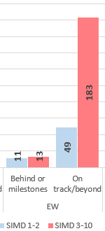
Progress and impact of outcomes for learners:

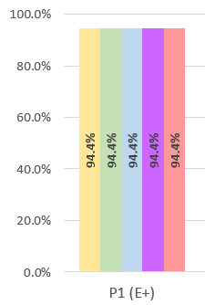
Fig 1
Fig 2

- Due to resourcing, staff changes and limited progress in the previous academic year with play in primary 1, the focus for this session has been on developing, improving and increasing play based learning opportunities in primary 1 and primary 2/1 with aspects which started last session continuing into primary 2. A play room has been developed for use by P1 and P2 pupils this year for free play and the primary 1 classroom has been re-developed into zones for play based learning through all aspects of the curriculum. Pupils are enjoying easier access to play activities and staff knowledge and confidence has improved as the year has progressed. Almost all children have achieved expected levels in Primary 1 (94.4%) as can be seen in Fig.1.
- The approach to teaching, learning and assessment in writing has been overhauled this year with writing taught through a range of genre and assessed holistically across a term as opposed to a “cold piece” assessment. Staff and pupils have given positive feedback to this approach with breadth and depth of learning clearer and more confident and accurate judgements of achievement identified. While targets for this year were unrealistic, we have achieved a very positive attainment picture in writing with consistent, effective practice evident across the school. Almost all of our pupils are on track in writing (91%) as seen in Fig.2 with 28.8% of pupils across the school above expectations. We would expect new processes will have positive longer term impact as learners work on new genre features approach and core targets for writing across a level rather than in a single year when this process is introduced and more pupils will confidently move beyond expectations.
Next steps:
- Continue to develop play in primary 1 and into primary 2 to ensure consistency of experience across early into first level.
- Develop play outdoors through clpl activities and investment in high quality resources.
- Continue to embed developments in writing and support staff in meeting learners’ needs who are below expectations.

Establishment priority 2:
NIF Priority  Closing the attainment gap between the most and least disadvantaged children and young people  NIF Driver  Teacher professionalism  Assessment of children's progress  Performance information | HGIOS/ELC QIs  3.2 Raising attainment and achievement  3.2 Securing Children's Progress  UNCRC  Article 3 (Best interests of the child):  Article 28: (Right to education):  Developing in Faith  Serving the common good  Promoting Gospel values
Attendance and Targeted Support
Outcome:
- By June 2023, most children receiving free school meals and/or living in SIMD1&2 areas will achieve at least 85% attendance.
- By June 2023, all pupils impacted by absence will recover loss of learning to achieve their intended targets for Literacy and Numeracy.
- Almost all pupils will attain expected levels by June 2023 as outlined in the school stretch aims which feed into the local authority stretch aims.

PEF used to support closing the gap:
Acting DHT – August 2022 until the end of March 2023 = £5,400
Teachers (1FTE) - £69,000
Total Cost: £74,300

Progress and impact of outcomes for learners:

Attendance
Attendance was closely monitored this year using the Inverclyde attendance policy and keeping in regular contact with families whose attendance dropped or stayed below targeted levels. Following the policy, attendance letters were sent along with the ‘Attendance Matters’ information leaflet in Oct 22 for any family below 90%. This was followed up with letters to these families in January either indicating an improvement, levels staying the same or decline with further support offered if necessary. This was again repeated in March/April. Regular contact was kept with families who struggled to maintain a high level of attendance as the year progressed and support/advice offered.
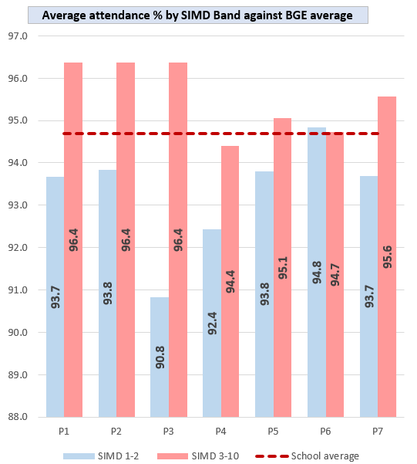
These actions resulted in:
Fig 3

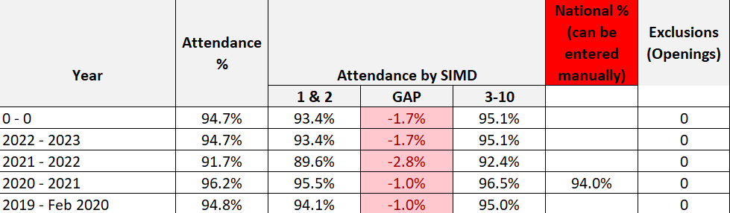
Fig 4

- The attendance for the school has finished just 94.7% which was just below the aim of 95% at the beginning of the session and among the highest in the authority. It was also an increase of almost 2.5% from session 2021-2022. All of those under 90% throughout the year have received letters highlighting lower attendance than expected and progress has been tracked.
- We have met attendance targets for those on FSM with 85% of those on FSM over 85% attendance for the year and 92% of SIMD 1-2 pupils achieving over 95% attendance. As can be seen in Fig.3, there is a gap in each stage for attendance for simd1-2 vs 3-10 which we will aim to close in the next session. The picture overall is clearly improving as per Fig.4 which shows an increase of almost 4% for pupils residing in simd1-2 and 2.7% for simd 3-10. While we do have still a gap, we have managed to close this it 1.1% while also raising the attendance overall.
- Almost all pupils who have been impacted by absence in their attainment have recovered.

Attainment
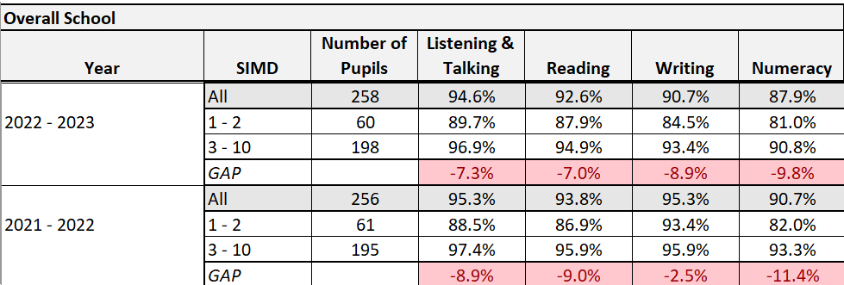
Fig 5

Rigorous tracking and monitoring procedures took place across the session with targeted support allocated through recovery, additional staffing and management at termly meetings with staff. Staff were fluent in discussing needs, targeted pupils (including simd levels and asn) and supports in place. Pupils identified for stretch aims were discussed regularly as well as long term stretch aims identified by the school.

Additionality allocated and timetabled was significantly impacted by long term absence in more than one stage and across support teachers across this school session leading to targeted support being heavily disrupted, a lack of consistency in support taking place and last minute changes to plans. Our PEF DHT spent 2.5 days in class from October until June due to absence coupled with a negative impact on learners in this class in the previous session from absence to ensure their progression and deliver consistency for them and families. It would be difficult to assess the increased targeted support as being positively impactful due to these unfortunate and unavoidable reasons.

The targets for our school changed constantly in the last session as every cohort experienced significant changes with new pupils joining from October through to June. We had 22 New Scots joining our school throughout the year in total.

This resulted in:
- As evidenced in Fig. 5, almost all pupils achieved expected levels in Listening and Talking, Reading and Writing with most achieving in Numeracy. The gap was narrower at the end of the session in Listening and Talking, Reading and Numeracy however attainment overall was slightly down in each area from 2021-2022. A large cohort of 50 Primary 7 pupils left the school in June 22 who were all on track in every area which did impact figures this session.
- Almost all pupils identified in the school stretch aims have achieved expected levels, some who were behind and some who were previously marked as on track but assessments showed large gaps.
Next steps:
- Acting DHT to take forward responsibilities for tracking systems, including attendance and attainment, and implement systems to track growth/declines to target groups/individuals.
- Continue to develop assessment procedures to ensure consistency across all stages and track progress accurately.
- Continue to apply authority and school attendance procedures to maintain an average attendance of 95%

Establishment priority 3:
NIF Priority  Improvement in children and young people's health and wellbeing  -  NIF Driver  School Improvement  Teacher professionalism  Performance information | HGIOS/ELC QIs  3.2 Raising attainment and achievement  3.2 Securing Children's Progress  UNCRC  Article 3 (Best interests of the child):  Article 28: (Right to education):  Developing in Fath  Serving the common good  Developing as a community of faith and learning  Promoting Gospel values
Vision and Values Refresh and Laudato Si
Outcome:
- By June 2023, all stakeholders will have a shared understanding of the vision, values and aims of the school in order to ensure that our pupils continue to be fully supported and their needs are met.

- By June 2023, pupils will have further improved their understanding about what they can do to follow the message of Pope Francis (Laudato Si) to love God, look after each other and protect the world.
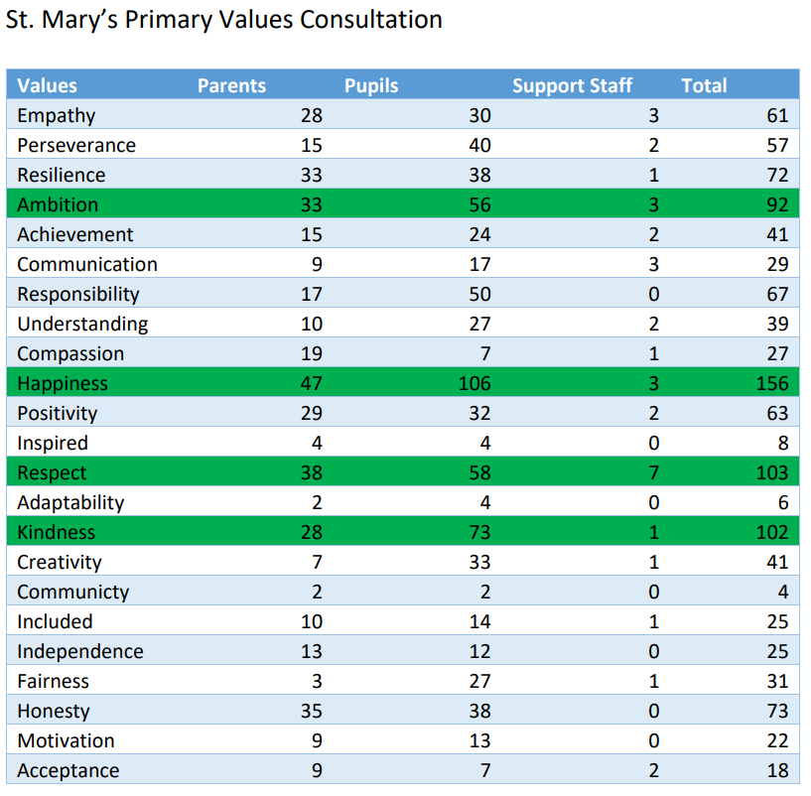
Fig 6

Progress and impact of outcomes for learners:
- All stakeholders were consulted in a refresh of our school vision, values and aims which led to the creation of a new statement including the values of: Happiness, Respect, Kindness and Ambition. This has been implemented since Easter and pupils talk regularly about our values and what they mean to them with this being a central focus of assemblies. Fig.6 demonstrates the wide consultation which took place with pupils, parents and support staff after teaching staff created a list of values which would be important for our pupils as they grow in society today.
- While Laudato Si has been discussed with pupils at assembly and Faith overarches everything we do, the themes of Laudato Si have not been developed and it will move onto next session as a focus.
Next steps:
- Create a curriculum rationale in collaboration with all stakeholders which reflects the context, vision and values of our school and prepares children for life in the 21st century.
- Continue to develop aspects of Laudato Si across our school with a focus on a key theme in order to meaningfully progress.

Establishment priority 4:
NIF Priority  Improvement in skills and sustained, positive school-leaver destinations for all young people  -  NIF Driver  Assessment of children's progress  Teacher professionalism | HGIOS/ELC QIs  3.2 Raising attainment and achievement  3.2 Securing Children's Progress  3.3 Increasing creativity and employability  UNCRC  Article 3 (Best interests of the child):  Article 28: (Right to education):  Developing in Fath  Serving the common good  Developing as a community of faith and learning  Promoting Gospel values
Digital Technology
Outcome:
- By June 2023, pupils will have enhanced learning experiences through the opportunity to use a wider range of digital/technology equipment.

PEF used to support closing the gap
Additional Laptops and Caddy - £13,000

Progress and impact of outcomes for learners:
Embedding digital technology across the curriculum to enhance learning experiences proved to be a challenge in the first half of the session. The majority of IT available for regular access was through the IT Suite, with many devices unreliable and availability limited due to timetabling. Laptops in the school mainly supported individuals and small groups.
The decision was made in December to increase capacity by purchasing 14 laptops (with 6 in school taking to a total of 20) and a caddy for transporting between classes with the use of PEF. These arrived at Easter after a delay in the preparation of them and have been used successfully in the final term to improve the use of IT across the curriculum in most classes. Pupils have responded positively to the increased opportunities and parents have recognised the positive impact on questionnaires. We also bought an Ipad to provide opportunities for recording and film making. Due to the late arrival, we are yet to see an impact of this investment but would plan for it to impact in the next school session.
Next steps:
- Continue to create more opportunities for embedding IT across the curriculum.
- Further enhance IT provision in the school to ensure skills are developed and access increases, particularly for those impacted by poverty.
- Continue to develop staff skills and confidence in utilising IT to enhance all areas of the curriculum.

Establishment priority 5:
NIF Priority  Placing the human rights and needs of every child and young person at the centre of education  -  NIF Driver  School Improvement  Assessment of children's progress | HGIOS/ELC QIs  1.2 Leadership of learning  3.2 Raising attainment and achievement  UNCRC  Article 3 (Best interests of the child):  Article 12 (Respect for the views of the child):  Article 28: (Right to education):  Developing in Fath  Developing as a community of faith and learning  Promoting Gospel values
Pupil Voice
Outcome:
- By June 2023, pupil voice and choice will be increased within the school and curriculum, leading to children having more autonomy over their learning and decisions which affect them.

Progress and impact of outcomes for learners:
In this session pupils have continued to have a say in whole school decision making through pupil council, eco group and rights respecting group. The pupil council met regularly with Mrs Blincow to discuss developments across the school and facilitated meetings within class to consult the rest of the pupil body. Pupil voice was taken into consideration through the development of PEF planning and school improvement planning as a result of this work and through questionnaires.

Pupils were involved in GIRFEC planning and reviews throughout this year to have a say on decision making which impacted them. This resulted in pupil voice being integral to children’s planning and in line with Children’s Rights.

The Rights Respecting group met weekly with Mrs Donnelly after school across the final two terms. They presented several whole school assemblies on Rights and ensured rights were at the forefront across the school. They gathered the evidence which saw us submit evidence which will achieve our Silver Rights Respecting award at the beginning of the next session.

While groups had impact this year, we have identified that we want to involve even more children in decision making and being part of pupil-led initiatives. We have also identified that more opportunities for pupils to take on leadership roles would be a key next step.
Next steps:
- Develop leadership opportunities for pupils which enhances pupil decision making across the school.
- Create opportunities for pupils to engage regularly with self-evaluation using ‘How good is OUR school?’ through participation in Young Leaders of Learning.
- Begin work towards Gold Rights Respecting.

Additional PEF Spend
NIF Priority  Closing the attainment gap between the most and least disadvantaged children and young people | HGIOS QIs  3.2 Securing Children's Progress  3.1 Ensuring wellbeing, equality and inclusion  UNCRC  Article 31 (Leisure, play and culture):  Article 28: (Right to education):
Spend:
Cost of the school day: £900
Removing the barriers of the high cost of an extra-curricular event was identified and agreed as buses were paid and long payment options agreed for a trip to the theatre in Edinburgh for a musical.

Progress and impact of outcomes for learners:
Almost all pupils in Primary 6 and 7 attended the theatre with those who didn’t joining the class late or choosing not to for other reasons. Identified pupils reported through discussions as having an increase in confidence, stronger friendships and positive memories created as a result of the experience.

All parents were issued a survey around PED spend and of those completed (52 parents):
- 65.4% feel PEF spend on more excursions for less cost for parents has a high impact and they wish to see more spent on it.
- 30.8% feel PEF spend on more excursions for less cost for parents has a medium impact and they are happy for it to continue.
- 3.8% feel PEF spend on more excursions for less cost for parents has a low impact and they wish to see it reduced.
- 0 want to stop the spend in this area.

Next Steps:
- Continue to consult all stakeholders on PEF spend which increases experiences without increasing the cost of the school day. Look to target this through school fund in the next session.

Data
Key Strengths

- 90%+ attainment at all stages except P3 (88.9%) in Talking and Listening.
- 81.9% in P2, 85.2% in P3 and 90%+ attainment at all other stages in reading.
- 81.9% in P2, 85.2% in P3, 88% in P7 and 90%+ attainment at all other stages in writing.
- Almost all pupils in P1 and P4 and most (all above 80%) in all other classes attaining expected levels in numeracy.
- Attendance figures just below 95% and among highest in the authority overall.
- Most pupils residing in SIMD1-2 are on track across the school.

Key Priorities

- Target group of primary 2 pupils in the next session as targets for stretch aims in literacy and numeracy.
- Embed new Literacy Policy to ensure consistency in progression across the school.
- Continue to embed approach to writing and challenge high attaining pupils.
- Evaluate approaches to numeracy across the school.

National Improvement Framework Quality Indicators
1.3 Leadership of change Very Good
Key Strengths
Theme 1: Developing a shared vision, values and aims relevant to the school and its community.
- All stakeholders played a part in creating a new vision, aims and values for our school in the final term in 22-23.

Theme 2: Strategic planning for continuous improvement.
- Conditions are in place where staff are supported to make changes and take on leadership opportunities.
- School improvement planning takes the voice of all staff in order to plan manageable and effective change.

Theme 3: Implementing improvement and change.
- Staff responsibilities in implementing change clearly marked in improvement planning.
- Strategies in place to monitor the impact of change including effecting quality assurance, self evaluation, tracking and monitoring and reporting procedures.

Key Priorities
Theme 1: Developing a shared vision, values and aims relevant to the school and its community.
- Continue to embed the vision, aims and values through all aspects of the school day.
- Collegiate sessions to develop and understanding of our curriculum through the 4 contexts for learning.

Theme 2: Strategic planning for continuous improvement.
- Schedule time for pupil, parent and partner self-evaluation activities which lead to meaningful input in improvement planning.

Theme 3: Implementing improvement and change.
- Support our NQT in practitioner enquiry this year and share with all staff.
- Continue to promote leadership CLPL with all staff.
- Develop our curriculum rationale including the voice of all stakeholders.

2.3 Learning, teaching and assessment Very Good
Key Strengths
Theme 1: Learning and engagement
- There are positive, nurturing relationships at all levels across the school.
- The school expects to receive silver RRS award at assessment and is already well on the way to gold.
- Observations have shown highly engaged pupils who are actively engaged in learning in most classes.
- Community engagement is strong with Mini Vinnies, partners in local homes, compassionate Inverclyde work, partnerships with the church, work with the WSC and engagement with the museum.
- Increased opportunities for pupils to express views regarding their wellbeing.

Theme 2: Quality of teaching
- Through class visits, SMT have identified that communication is clear in classrooms and most staff are skilled in their questioning techniques and in developing independent learners.
- Feedback has been developed to inform and support progress with work in the previous session to identify the most effective forms of feedback.
- Staff development opportunities are planned based on research and evidence informed practice which will lead to improved outcomes.

Theme 3: Effective use of assessment
- Staff in most classes have assessment procedures which allow learners to demonstrate their knowledge and understanding, skills, attributes and capabilities in different contexts.
- We have developed effective assessment procedures in writing which support TPJ and allow staff and pupils to identify next steps.
- Consistent approaches to AIFL have been developed and agreed across the school which is working to develop assessment capable learners.

Theme 4: Planning, tracking and monitoring
- We have effective planning procedures in place which staff are aware of and work within for short, medium and long term planning.
- We effectively plan for those impacted by poverty or other facing additional challenges.
- Effective interventions are in place across the school to support those facing challenges.
- Children are developing self and peer assessment to improve learning.

Key Priorities
Theme 1: Learning and engagement
- Develop IT skills through digital champion explicitly teaching in RCCT sessions and staff collegiate time to focus on how to make effective use of IT across learning.
- Young leaders of learning to be developed this session.
- House system to be developed.
- Celebrate achievements at assembly and encourage regular sharing of success outside.
- Engage in classes with explicit discussion about skills being developed for life, learning in work.

Theme 2: Quality of teaching
- Plan for collegiate work on outdoor learning.

Theme 3: Effective use of assessment
- PEF DHT allocated to the role of leading tracking, monitoring and assessment and will develop robust systems to support learning, teaching and assessment in literacy and numeracy.
- Build in time for staff to work across levels to build a clear picture of progression through quality moderation activities.
- Develop a new approach to reporting, ensuring the voice of all stakeholders is heard.

Theme 4: Planning, tracking and monitoring
- Develop a pathway for interventions for staff to have a clear overview of supports which can be available.
- Introduce Young Leaders of Learning.
- Create time for pupils to evaluate learning and develop next steps at key points.

3.1 Ensuring wellbeing, equity and inclusion Very Good
Key Strengths
Theme 1: Wellbeing
- Wellbeing surveys are carried twice per year to allow pupils to express how they feel in relation to all wellbeing indicators.
- Strong relationships across the school with shared values at the heart of it.
- Children are involved in decision making which affects them, particularly through GIRFEC processes.
- Children’s rights is a focus during assembly, with classes presenting a Rights focus, and a steering group create plans for the school which have led to the Silver award submission

Theme 2: Fulfilment of statutory duties
- All staff have yearly updates on statutory duties and aware of their role in ensuring improved outcomes for all.

Theme 3: Inclusion and equality
- Pupils are treated with dignity and respect regardless of personal characteristics and circumstances.
- We have effective strategies in place to ensure equity and staff can discuss pupils who require and receive additional support.

Key Priorities
Theme 1: Wellbeing
- Share information about how we support the wellbeing of all pupils with parents.
- Create a staff and partner questionnaire to measure how supported and valued they feel.
- Focus on wellbeing indicators in assembly and through pupils evaluating their own wellbeing.

Theme 3: Inclusion and equality
- Questionnaire for staff and partners will identify that they feel treated with fairness and respect.
- Develop the use of outdoors in the next session and train staff and pupils in the use of loose parts.

3.2 Raising attainment and achievement/Securing children’s progress Very Good
Key Strengths
Theme 1: Attainment in literacy and numeracy
- We have evidence of raising and attainment and tracking individuals who require intervention to remain or move to on track.

Theme 2: Attainment over time
- The school has consistently maintained high attainment in all areas and focuses on ensuring the best outcome for all learners.
- We aim to improve prior levels and challenge pupils to move beyond expectations.

Theme 3: Overall quality of learners’ achievement
- Pupils take opportunities to take part in a range of activities and events in the wider community and display confidence and responsibility at all times.
- We provide a wide range of opportunities for pupils to achieve success and experience new things which build personal skills and attributes.
- Pupils are encouraged to build on skills and talents they have had the opportunity to develop through school.
- Our attendance is amongst the highest in the authority, has improved consistently in the last 3 years and we are closing the gap between simd1-2 and 3-10.

Theme 4: Equality for all learners
- We identify children who may be impacted by measures of poverty or circumstance and increase opportunities for them to achieve success and try new things.

Key Priorities
Theme 1: Attainment in literacy and numeracy
- Continue to target support for pupils to raise attainment and ensure almost all are on track.

Theme 2: Attainment over time
- PEF DHT to develop robust assessment processes and tracking systems which will increase teacher confidence in making evidence informed judgements.

Theme 3: Overall quality of learners’ achievement
- Celebrate achievements regularly through assembly and wider school.

Theme 4: Equality for all learners
- Target interventions for those impacted by poverty and continue to increase opportunities for them.

Other quality indictors evaluated from 3 year plan:
2.2 Curriculum
Key Strengths

2.2 Curriculum
- Improvement in educational visits linked to learning in classes this year in local area and further afield.
- Staff knowledge of needs of pupils to provide targeted support is clear and led by ASN Coordinator and discussed through tracking meetings.
- The Catholic ethos of the school is evident and links with the local Parish are strong.
- Pathways in literacy and numeracy allows clear progression across stages and range of resources allows autonomy for teachers in how to approach lessons.
- Approach to writing provides consistency across the school and clear breadth, depth and challenge across all genre.

Key Priorities

2.2 Curriculum
- Develop whole school rationale including the voice of all stakeholders
- Gather contacts to build links with partnerships in the wider community
- Develop learning for sustainability further linked with Laudato Si
- Further develop pupil voice within the school – development of a house system

Key Achievements of the Establishment

- Meet the teacher event at the beginning of the year very well attended.
- Official school opening took place in September.
- Great efforts by all who attended Cross Country events with the P5 girls team securing overall Silver medals.
- Athletics team finished second in Inverclyde at the first heat.
- Almost all parents attended both Parents’ Evenings with positive feedback about the structure of it.
- P7 hosted two very successful coffee mornings raising £640 for McMillan Cancer Charity and £800 split between Mary’s Meals, Ardgowan Hospice and Missio.
- A successful year for our boys football team and girls football teams. Our boys won every game at their cluster tournament and competed very well at the Inverclyde Festival winning most games. Our girls’ football team competed against local schools and performed well at the Inverclyde Festival in May at Notre Dame, winning their section.
- We had representatives at the Highland Games, Relay event, Rugby Festival and Boccia festival. We achieved Gold in two sets of events at the Relays and were overall winners at the Rugby Festival (winning every game).
- Four fantastic, sold out shows at Christmas showcasing the singing, dancing and acting talents of all.
- Several of our pupils showcased their talents at cluster events such as the Notre Dame Cluster Music Concert and took the opportunity to perform in the Notre Dame Joseph and the Amazing Technicoloured Dreamcoat Musical.
- Five wonderful visits with our Christmas choir to local care homes and to EE to spread Christmas cheer.
- Catholic Education Week helped to focus our minds on the theme of Communion, Participation and Mission and started so well with an extremely busy P7 Prayer Breakfast.
- A lovely Advent Service led by Primary 4 to finish the term with the parish and family members.
- The whole school enjoyed 2 visits to the Waterfront Cinema and at least 3 trips across the year.
- Every class has visited the local library at least twice this session.
- Wonderful experiences and memories made at our two residential trips- P6 in Largs and P7 in Dalguise.
- Primary 6 and 7 pupils had a wonderful night at the theatre to see Charlie and the Chocolate Factory The Musical.
- Primary 4 celebrated the Sacraments of Reconciliation and First Holy Communion. Primary 7 celebrated the Sacrament of Confirmation. Both class displayed reverence and maturity as they celebrated.
- Primary 7 developed skills in radio and television as they worked with the BBC for ‘The Lab- Then and Now’ project which is now live online.
- We had a successful Sports Day in June which was very well attended by parents.
- Leavers’ Mass and Assembly was very well attended and received by parents.

