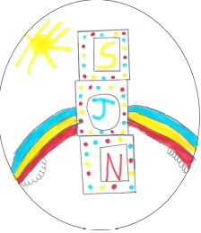
Duty of Candour Report – Daycare of Children Service
St Joseph’s Nursery – Nil Report

All health and social care services in Scotland have a duty of candour. This is a legal requirement which means that when things go wrong and mistakes happen, the people affected understand what has happened, receive an apology, and that organisations learn how to improve for the future.

An important part of this duty is that we provide an annual report about the duty of candour in our services. This short report describes how our care service has operated the duty of candour during the time between 1 April 2025 and 31 March 2026. We hope you find this report useful.
- How many incidents happened to which the duty of candour applies?

In the last year, there have been no incidents to which the duty of candour applied.

- Information about our policies and procedures

Where something has happened that triggers the duty of candour, our staff report this to the nursery manager who has responsibility for ensuring that the duty of candour procedure is followed. The manager records the incident and reports as necessary to the Care Inspectorate. When an incident has happened, the manager and staff set up a learning review. This allows everyone involved to review what happened and identify changes for the future.

All new staff learn about the duty of candour at their induction. We know that serious mistakes can be distressing for staff as well as people who use care and their families. We have access to occupational health support in place for our staff if they have been affected by a duty of candour incident.

Where parents or children are affected by the duty of candour, we have arrangements in place to provide support as necessary.

