
St. Joseph’s Primary & Nursery Class
Standards and Quality 2025-26

Context of the Establishment

Our Establishment
St Joseph’s Primary School is a denominational school and is situated in the Southwest of Greenock. The current roll is 117 pupils across 7 classes from P1-P7. The school’s Senior Management Team consists of 1 FTE Head Teacher and 1 FTE Depute Head. There are 5 full time teachers and 4 part time teachers, one of whom is 0.8 NQT. We have used PEF funding to employ an additional teacher specifically to provide additional support and input. The school is supported by nine Pupil Support Assistants, two clerical staff members split over 37 hours, a janitor, and the school chaplain Father Maurice Callaghan.
The % of pupils in the school living in SIMD 1 and 2 is 76% with a PEF allocation to the school of approximately £89,000. 44% of pupils are identified with Additional Support Needs, a further 5.4% with English as an Additional Language and 5.3% of pupils are Care Experienced.
The current roll in our nursery class is 48 in the 3-5 room and 10 in the 2-3 room with room to accommodate more within specific patterns. There is one nursery Depute, one Senior Early Years Education and Childcare Officer (SEYECO), full six full-time EYECOs, two part-time EYECOs, two Early Years Support Assistants and one clerical staff member. The % of pupils in the nursery living in SIMD 1 and 2 is approximately 62%.
Vision
Inspira ad Aspirandum

Inspire to Aspire
At St. Joseph’s we want to inspire all our stakeholders to aspire to become better in all that we do. In our learning, in our Faith, in our everyday lives we can grow and develop our skills, knowledge and understanding to be God’s special gift to the world.

Our Aims
We aim to:
- work in partnership with parents and community to enable all children to develop their capacities as successful learners, confident individuals, responsible citizens and effective contributors to society.
- provide the highest quality learning activities and educational programmes suited to individual needs and attributes.
- maintain the highest possible levels of attainment and achievement.
- encourage all pupils to aim high and reach their full potential.
- provide a happy, secure, welcoming environment which promotes well-being and respect.
- develop leadership at all levels – in staff and in pupils.

Establishment priority 1

NIF Priority  Improvements in attainment, particularly in literacy and numeracy  Choose an item  NIF Driver  School Improvement  Assessment of children's progress | HGIOS  2.3 Learning, teaching and assessment  3.2 Raising attainment and achievement  QIF ELC QIs  Choose an item.  2.1 Children Experience High Quality Spaces  3.3 Learning, Teaching and Assessment  Choose an item.  UNCRC  Article 28: (Right to education):  Choose an item.
Outcome:

Literacy & Numeracy
- By June 2026 at least 85% of school will be on track across all curricular measures
- By June 2026 almost all pupils not recorded as having personal milestones will have made 1 year’s improvement in at least one area of literacy and in numeracy.
- By June 2026 all staff will be able to evidence engagement with Inverclyde PASE blog, Inverclyde Literacy Framework and Inverclyde Numeracy Strategy and evidence impact of engagement in their classroom practice.
Play
- By June 2026 most of the learning in P1 & P2 will be delivered through a planned, progressive, full immersive play pedagogy.
- By June 2026 play pedagogy will have begun to be established as a significant learning vehicle in the P3 curriculum.
- By June 2026 an updated Play Pedagogy Policy will be developed and in full implementation.
Outdoor Learning
- By June 2026 the St. Joseph’s Outdoor Learning Framework will be revised and updated and every pupil at every stage will have experienced regular outdoor learning opportunities.
Environments
- By October 2025 every member of Early Years staff will have received training on developing and adapting a variety of learning environments to promote maximum learning opportunities for pupils.
- By December 2025 every member of Early Years staff will have visited at least one other Early Years Establishment in the LA in order to identify good practice in creating good learning environments and shared this at collegiate time with colleagues.
- By June 2026 every member of Early Years staff will have demonstrated in planning and evaluation how they have utilised their training to improve the learning environments in the nursery setting.
- On an ongoing basis throughout the year children’s level of engagement with environments will increase as measured using the Leuven Scale.
Target Setting & Assessment
- On an ongoing basis all staff will continue to embed the use of Inverclyde’s Early Years Tracking tool.
- By December 2025, staff will review the effectiveness of “Together Time” in support of children’s engagement in target setting and will adopt, adapt or abandon.
- By June 2026 all staff will have supported pupils to engage in self-assessment and self-evaluation through play experiences relating to targets.
- By June 2026 SLT and peer observations, floor books and learning journals will produce evidence of high quality staff observations and how these inform planning and target setting for children.
New Improvement Framework
By June 2026 all staff will have participated in collegiate training around the New Improvement Framework and will be evidenced by updated self-evaluation procedures.
PEF used to support closing the gap:
- Purchase of Literacy & Numeracy Resources - £3500
- Purchase of Play materials & replacement of broken/worn resources for P1 & P2- £5000
- Inspection & Upkeep of existing playground infrastructure - £1000
- Purchase of resources for Playground & Outdoor learning - £3000

Progress and impact of outcomes for learners:
- By June 2026 at least 85% of school will be on track across all curricular measures

The table below demonstrates that this target was not met. In fact, it evidences that attainment across the school was lower in all curricular areas

P2 – Attainment levels maintained
P3 – 4 pupils who were on track with support were unable to maintain learning progress
P4 – 1 pupil moved to behind expectation in writing but continues to make progress at a slower pace
P5 – Attainment levels maintained
P6 – Attainment Levels maintained
P7 – 1 pupil moved to behind expectation in numeracy
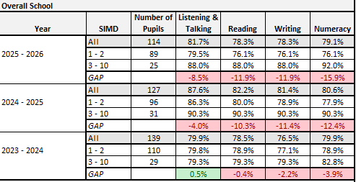

Targets 2-5 have all been achieved and can be evidenced through planning and PRD documentation.
Target 6 – Updated Play pedagogy policy has been written and consulted upon.
Target 7 – Outdoor learning opportunities have been provided and can be evidenced in planning documentation.

Targets 8-11 have all been overtaken. Our environments were praised in our recent Authority Peer Review stating, ”a strong and consistent focus on high quality environments and interactions underpins all aspects of the setting’s work.” (St. Joseph’s Peer Review)
Throughout all quality indicators explored, the environment is noted as an area of strength.

Target Setting & Assessment
Targets 12 – 15 have all been overtaken.
Target 12 – All staff have engaged with tracking tool. “Staff make very effective use of a range of documentation provided by Inverclyde Council to record, track and monitor children’s progress across the 3-5 tracker. This helps staff demonstrate the progress children are making over time and identify where individuals may need support or challenge in their learning.” (St. Joseph’s Peer Review)
Target 13 – “Together Time” has been thoroughly reviewed and the evidence points to an increase in attainment for N5 pupils in every measure. Utilisation of “Together Time” has also provided additional opportunities for staff to identify those pupils who would benefit from additional support and/or challenge.
Target 14 & 15 have been met with some success but will continue to be reviewed as points for further development were identified in the peer review. “Staff use floorbooks to involve children in planning and documenting learning. They are keen to continue to develop further how they use floorbooks, for example ensuring children play an active role in planning their own learning.”
All staff have engaged in collegiate training around the new Improvement Framework and have made use of it in self-evaluation processes.
Next steps
- Targets to be far more specific and measurable in order to ensure appropriate progression for every pupil.
- Single Paragraph Outline to be adopted by all teachers in all classes.
- Pace and challenge in lessons, particularly literacy & numeracy, to be reviewed and improved with support of Visible Learning materials.
- Review of Learning & Teaching Policy and “The St. Joseph’s Way” to ensure a more strategic, school wide approach to ensuring the consistency of high-quality learning and teaching.
- Continue to develop data literacy in order to inform and empower rigour in assessment and identifying next steps for staff and pupils.
- Strengthen outdoor learning to support literacy & numeracy
- Review planning systems to better meet individual children’s needs.
- Develop staff language of learning to improve observations and capture children’s learning more clearly.
- Use floorbooks more effectively to capture children’s voice and enhance their involvement in planning.
- Enhance tracking processes to support better identification of progress, support and challenge.
- Enhance tracking to support planning for greater breadth, depth and challenge.
13. We will format “Together Time” into ability grouping rather than Key Worker grouping in order to focus more tightly on supporting attainment and support/challenge in relation to key measures around literacy and numeracy.

Establishment priority 2

NIF Priority  Improvement in skills and sustained, positive school-leaver destinations for all young people  Choose an item  NIF Driver  Performance information  Choose an item. | HGIOS/ELC QIs  3.3 Increasing creativity and employability  Choose an item.  QIF ELC QIs  Choose an item.  Choose an item.  Choose an item.  4.3 Children's Progress  UNCRC  Article 29 (Goals of education):  Choose an item.
Outcome:
- By June 2026 almost all pupils will have further developed their ability to exemplify how meta-skills impact their learning in school and beyond.
- By June 2026 almost all pupils in 3-5 room will have delivered a presentation to school pupils on what they have learned about meta-skills and how they use them in the nursery.
- By June 2026 all pupils will have participated in developing a presentation for parents on what meta-skills are and how they are utilised in school and in life-long learning.
- By June 2026 almost all pupils in Primaries 6 & 7 will achieve accreditation with the Dynamic Youth Award.
- By June 2026 a plan will be created to deliver Dynamic Youth Award or similar accreditation across 1st and 2nd level.
- By June 2026 a plan will be created in partnership with St. Columba’s High School and cluster partners to utilise Dynamic Youth Award or similar accreditation into our transition programme.

PEF used to support closing the gap:
- Registration with Dynamic Youth Award – Approx. £350 for P6 & P7
- Resources to support delivery of Meta-Skills learning and conferences - £1000
- Barnardo’s Family Support worker – Co-ordination of DYA and support in leading across school – Approx 1/3 of workload equates to £10,400

Progress and impact of outcomes for learners:
Targets 1,2 & 3. Progress has been made in taking forward learning about meta-skills but it has not been consistent across all levels or explicitly tracked in order to measure impact effectively. This is commented upon in our recent Peer Review, “There has been a focus on Tree of Knowledge, Meta Skills and Digital Technology to support attainment across the school. Meta Skills are displayed across classrooms and in communal areas throughout the school. Young people could identify meta-skills and there was evidence of jotter work containing references to Meta Skills.” (St. Joseph’s Peer Review 2026).
Targets 4 & 5 – These targets have been overtaken and further work will be carried out over the next academic year.
Target 6 – This plan was explored at cluster level. However, it was agreed that, with the curriculum improvement cycle ongoing and a variety of meta-skills development approaches already being undertaken in some establishments, other priorities took precedence.

Next steps
- School to develop an effective tracking tool to better measure impact of meta-skills development.
- Make more explicit the links between meta-skills, Developing The Young Workforce and the revised school vision of inspiring all our young people to aspire to success and achievement.
- Further embed The Dynamic Youth Award in P6 & P7and extend to P5. Use this approach to explicitly support pupils to take even more responsibility for devising projects which benefit and have a positive impact upon the school community.
- Use Dynamic Youth Award and meta-skills to develop community partnership opportunities and encourage parental engagement.

Establishment priority 3

NIF Priority  Improvement in children and young people's health and wellbeing  Placing the human rights and needs of every child and young person at the centre of education  NIF Driver  Parental engagement  Performance information | HGIOS  3.1 Ensuring wellbeing, equality and inclusion  1.5 Management of resources to promote equity  QIF ELC QIs  Choose an item.  Choose an item.  Choose an item.  4.2 Wellbeing, Inclusion and Equality  UNCRC  Article 29 (Goals of education):  Choose an item.
Outcome:
- By May 26, almost children will again indicate they are listened to, involved in decision making which affects them and are treated fairly in our school.

- By June 26, our attendance rate will increase by 1.1% to 92.5% and the gap between SIMD 1-2 and SIMD 3-10 will narrow to 2.0%

- By May 26, almost all pupils will recognise the Respect Me definition of bullying and will indicate that either they have not experience bullying or that it has been dealt with appropriately.

- The only outcome above which does not include our nursery class is the attendance one, as attendance is not compulsory in Early Years. However, DHT and Senior will monitor nursery attendance and report to HT on weekly basis.

- By June 26, our Barnardo’s Family Support Worker will have run at least one GEM group programme for identified girls in P6 & P7

- By June 26, our Barnardo’s Family Support Worker will have run at least one Seasons for Growth group for identified pupils.

PEF used to support closing the gap:
- Barnardo’s Family Support Worker – Approximately 1/3 of time will be allocated to supporting attendance. Equates to £10,400
- Barnardo’s FSW – Approximately 1/3 of time will be allocated to supporting social and emotional H&W of pupils and families – Equates to £10,400
- Clerical Support in recording & reporting attendance – 14 hours per week - £9000
- Resources to Support attendance – Printing and publication costs – Approx £1000
- Resources to support Equalities, including Anti-Bullying - £3,648

Progress and impact of outcomes for learners:
- Our recent Peer Review highlighted numerous areas of strength where our young people’s voices are heard and included in having a positive impact upon various facets of school life. Below are a few examples.
“Young people are given the opportunity to have a say in what extra-curricular opportunities they receive at St Joseph’s Primary. They reported that they had the opportunity to join a number of extra-curricular clubs and, if they so wished, create a club with the support of staff where there was not an opportunity to engage in an area of their choice. Most children are able to identify leadership opportunities and their role within the school in leading pupil voice groups.“
“Most children report they feel valued, respected and included. This is reflected in their positive relationships and behaviour, contributing to a welcoming, calm and nurturing ethos across the school. The children demonstrate kindness and respect in their daily interactions, both in classrooms as well as during less structured times.”
“Almost all children said they felt they had someone in the school they could speak to if they were upset or worried about something. The strong relationships between staff and children is clear through their daily interactions.”
- Attendance rates did increase but only by 0.1% to 91.6%. The attendance gap between SIMD 1&2 and 3-10 also decreased from 3.3% to 3.0%. As a result of the input from our Barnardo’s FSW and the revised approaches for managing attendance there was a marked decrease in the number of unauthorised absences recorded.
- All stakeholders were consulted in the creation of an updated establishment anti-bullying policy and charter which reflected Inverclyde’s revised policy and Respect Me’s updated definition of bullying. Almost all stakeholders indicated in questionnaire responses that they had not experienced bullying and those that did felt it had been addressed effectively.
- While attendance is not compulsory at Nursery, there are many clear evidentiary links between good attendance at nursery and academic progress throughout the entire school career. Across the last academic year St. Joseph’s Nursery Class had the lowest attendance of all Council Early Years establishments at 86.1%
- Barnardo’s FSW ran a Gem Group programme for P6 girls as all P7 girls had already completed it. A Connect group programme was run for P7 boys.
- Seasons for Growth was not carried out as there was no appropriate groups. Individual bereavement work was carried out such as, “Muddles, Puddles and Sunshine” and “The Invisible String.” A number of pupils also benefitted from undertaking LIAM (Let’s Introduce Anxiety Management) with our FSW.
Next steps
- Embed understanding of new anti-bullying policy among all stakeholders.
- Update PPR Policy in consultation with all stakeholders
- Create and implement Equalities policy in consultation with all stakeholders.
- Work with pupils and families with attendance between 80-90% to support improved attendance at school.
- Create a working partnership with the school and Barnardo’s FSW to inform parents of the importance of consistent attendance in early years and the positive impact this can have on the learner’s journey during their academic career. Encourage and support families to improve nursery attendance.
- Review support for learning procedures and adapt to ensure appropriate information is shared with all stakeholders to ensure maximum impact and benefit to individual learners across nursery and school.
- Review all process where pupils receive individual support to ensure goals and strategies are effectively communicated to and implemented by all stakeholders

Establishment priority 4

NIF Priority  Placing the human rights and needs of every child and young person at the centre of education  Choose an item  NIF Driver  School Improvement  Choose an item. | HGIOS  1.2 Leadership of learning  Choose an item.  QIF ELC QIs  Choose an item.  Choose an item.  Choose an item.  Choose an item.  UNCRC  Article 14 (Freedom of thought, conscience and religion):  Choose an item.
Outcome:
- All staff and pupils will re-engage with “The Charter for Catholic Schools Scotland”
- Staff will be given the opportunity to evaluate the characteristic of Developing as A Community of Faith and Learning, with a specific focus on their own spiritual and professional development.
- Pupils will have more opportunities to develop their faith life by participating in a greater variety of faith-based activities through more developed Chaplaincy partnerships

Progress and impact of outcomes for learners:
All outcomes were overtaken.
Next steps
- The theme for next year in our Developing In Faith journey will be Promoting Gospel Values.
- We will continue to develop our prayer space in the school in partnership with our local parish.
- We will continue to develop our charity work, taking our lead from our pupil voice Charity Group.

Additional PEF Spend

NIF Priority  Closing the attainment gap between the most and least disadvantaged children and young people | HGIOS QIs  3.1 Ensuring wellbeing, equality and inclusion  3.2 Securing Children's Progress  UNCRC  Article 29 (Goals of education):  Choose an item. Article 31 (Leisure, play and culture):
Spend:
- Increase cultural capital by giving pupils experiences outwith school – Cost of coaches and tickets - £3534.00
- P7 & P6 Residential Trips & Transport - £5159.00
- Upgrade Old I-pads and sync set-up with new i-pads - £2250.00
- Subscriptions & Additional Classroom materials - £2959.00

Progress and impact of outcomes for learners:
The evidence of progress and impact for learners from the above spend is anecdotal and relates to feedback given verbally to teachers or observations made by staff during learning activities. The pupil learning activities outwith school resulted in increased engagement in learning and in children having experiences for the first time. An example of this would be the P6 pupils who attended a trip to a restaurant where they observed and participated in food preparation in the kitchen, saw many of the process involved in running a restaurant, learned about the cultural significance of food, (in this case Japanese cuisine) and enjoyed the experience of eating a meal in a restaurant setting.
Pupils who participated in the residential experiences were found to have developed improved team building and participation skills, enhanced confidence in problem solving and a more resilient attitude towards facing challenges. The children were able to make links to the experiences they had and the subsequent development of specific meta-skills.
All pupils in the school made positive use of I-pads at various time to enhance and support their learner experience. This was commented upon positively in our recent Peer Review.
“Staff use digital approaches effectively to support learning in most classes. Children confidently discuss the role of ICT and digital approaches within their learning.” St. joseph’s Peer Review 2026.

Next Steps:
- Develop a school-wide system to measure and record specific impact and progression of pupils in relation to PEF Spend.

Data

Cohort
 |  |  |  |  |  |  | Cohort % difference - Current & Previous Year
Year | SIMD | Number of Pupils | Listening & Talking | Reading | Writing | Numeracy | Listening & Talking | Reading | Writing | Numeracy
 | All | 15 | 93.3% | 86.7% | 86.7% | 80.0% | 0.0% | 0.0% | 0.0% | -6.7%
2025 - 2026 (Primary 7) | 1 - 2 | 10 | 88.9% | 77.8% | 77.8% | 66.7% | 0.0% | 0.0% | 0.0% | -11.1%
 | 3 - 10 | 5 | 100.0% | 100.0% | 100.0% | 100.0% | 0.0% | 0.0% | 0.0% | 0.0%
 | All | 15 | 93.3% | 86.7% | 86.7% | 86.7%
2024 - 2025 (Primary 6) | 1 - 2 | 10 | 88.9% | 77.8% | 77.8% | 77.8%
 | 3 - 10 | 5 | 100.0% | 100.0% | 100.0% | 100.0%
 |  |  |  |  |  |  | Cohort % difference - Current & Previous Year
Year | SIMD | Number of Pupils | Listening & Talking | Reading | Writing | Numeracy | Listening & Talking | Reading | Writing | Numeracy
 | All | 14 | 85.7% | 85.7% | 85.7% | 85.7% | 0.0% | 0.0% | 0.0% | 0.0%
2025 - 2026 (Primary 6) | 1 - 2 | 9 | 88.9% | 88.9% | 88.9% | 77.8% | 0.0% | 0.0% | 0.0% | 0.0%
 | 3 - 10 | 5 | 80.0% | 80.0% | 80.0% | 100.0% | 0.0% | 0.0% | 0.0% | 0.0%
 | All | 14 | 85.7% | 85.7% | 85.7% | 85.7%
2024 - 2025 (Primary 5) | 1 - 2 | 9 | 88.9% | 88.9% | 88.9% | 77.8%
 | 3 - 10 | 5 | 80.0% | 80.0% | 80.0% | 100.0%
 |  |  |  |  |  |  | Cohort % difference - Current & Previous Year
Year | SIMD | Number of Pupils | Listening & Talking | Reading | Writing | Numeracy | Listening & Talking | Reading | Writing | Numeracy
 | All | 19 | 90.0% | 85.0% | 85.0% | 90.0% | -0.5% | -0.7% | -0.7% | 4.3%
2025 - 2026 (Primary 5) | 1 - 2 | 15 | 93.3% | 93.3% | 93.3% | 100.0% | -0.4% | -0.4% | -0.4% | 6.3%
 | 3 - 10 | 4 | 75.0% | 75.0% | 75.0% | 75.0% | 0.0% | 0.0% | 0.0% | 0.0%
 | All | 20 | 90.5% | 85.7% | 85.7% | 85.7%
2024 - 2025 (Primary 4) | 1 - 2 | 16 | 93.8% | 93.8% | 93.8% | 93.8%
 | 3 - 10 | 4 | 75.0% | 75.0% | 75.0% | 75.0%
 |  |  |  |  |  |  | Cohort % difference - Current & Previous Year
Year | SIMD | Number of Pupils | Listening & Talking | Reading | Writing | Numeracy | Listening & Talking | Reading | Writing | Numeracy
 | All | 15 | 66.7% | 66.7% | 66.7% | 66.7% | -19.0% | -4.8% | -4.8% | -4.8%
2025 - 2026 (Primary 4) | 1 - 2 | 11 | 63.6% | 63.6% | 63.6% | 63.6% | -26.4% | -6.4% | -6.4% | -6.4%
 | 3 - 10 | 4 | 75.0% | 75.0% | 75.0% | 75.0% | 0.0% | 0.0% | 0.0% | 0.0%
 | All | 14 | 85.7% | 71.4% | 71.4% | 71.4%
2024 - 2025 (Primary 3) | 1 - 2 | 10 | 90.0% | 70.0% | 70.0% | 70.0%
 | 3 - 10 | 4 | 75.0% | 75.0% | 75.0% | 75.0%
 |  |  |  |  |  |  | Cohort % difference - Current & Previous Year
Year | SIMD | Number of Pupils | Listening & Talking | Reading | Writing | Numeracy | Listening & Talking | Reading | Writing | Numeracy
 | All | 27 | 70.4% | 66.7% | 66.7% | 63.0% | -6.3% | -6.7% | -6.7% | -17.0%
2025 - 2026 (Primary 3) | 1 - 2 | 25 | 68.0% | 64.0% | 64.0% | 60.0% | -6.1% | -6.4% | -6.4% | -17.8%
 | 3 - 10 | 0 | 100.0% | 100.0% | 100.0% | 100.0% | 0.0% | 0.0% | 0.0% | 0.0%
 | All | 30 | 76.7% | 73.3% | 73.3% | 80.0%
2024 - 2025 (Primary 2) | 1 - 2 | 27 | 74.1% | 70.4% | 70.4% | 77.8%
 | 3 - 10 | 3 | 100.0% | 100.0% | 100.0% | 100.0%
 |  |  |  |  |  |  | Cohort % difference - Current & Previous Year
Year | SIMD | Number of Pupils | Listening & Talking | Reading | Writing | Numeracy | Listening & Talking | Reading | Writing | Numeracy
 | All | 7 | 85.7% | 85.7% | 85.7% | 85.7% | -1.8% | -1.8% | -1.8% | 10.7%
2025 - 2026 (Primary 2) | 1 - 2 | 6 | 83.3% | 83.3% | 83.3% | 83.3% | -2.4% | -2.4% | -2.4% | 11.9%
 | 3 - 10 | 1 | 100.0% | 100.0% | 100.0% | 100.0% | 0.0% | 0.0% | 0.0% | 0.0%
 | All | 8 | 87.5% | 87.5% | 87.5% | 75.0%
2024 - 2025 (Primary 1) | 1 - 2 | 7 | 85.7% | 85.7% | 85.7% | 71.4%
 | 3 - 10 | 1 | 100.0% | 100.0% | 100.0% | 100.0%

The table above demonstrates a very consistent level of attainment year on year for most classes. The exceptions are P3 & P4 and these dips in attainment are related to specific barriers to learning which are identified and being addressed.

Attendance, Absence & Exclusions
Year | Attendance % | Attendance by SIMD |  |  | National % (can be entered manually) | Exclusions (Openings)
 | Attendance % | 1 & 2 | GAP | 3-10
2025 - 2026 | 91.6% | 90.9% | -3.1% | 93.9% |  | 0
2024 - 2025 | 91.5% | 90.7% | -3.3% | 94.0% |  | 0
2023 - 2024 | 90.3% | 89.3% | -5.0% | 94.3% |  | 0
2022 - 2023 | 91.2% | 90.7% | -2.1% | 92.8% |  | 0
2021 - 2022 | 90.7% | 90.2% | -2.0% | 92.2% |  | 0

While we did not attain our attendance target of 92.5%, the above table demonstrates that we continue to improve our attendance and have the best attendance of the last five years. We have also continued to improve upon the attendance gap between SIMD 1-2 and SIMD 3-10.

Year | Attendance by Stage
Year | P1 | P2 | P3 | P4 | P5 | P6 | P7
2025 - 2026 | 93.0% | 93.5% | 92.2% | 93.0% | 88.1% | 87.5% | 94.4%
2024 - 2025 | 94.4% | 91.4% | 92.6% | 89.5% | 88.9% | 93.4% | 91.9%
2023 - 2024 | 91.1% | 92.9% | 87.0% | 90.4% | 89.6% | 91.9% | 89.0%
2022 - 2023 | 92.5% | 89.0% | 91.0% | 93.8% | 91.3% | 88.0% | 93.5%
2021 - 2022 | 89.1% | 94.0% | 94.0% | 91.7% | 88.7% | 92.0% | 88.0%

The attendance by stage table demonstrates very clearly a need to focus attendance support towards P7 and P6 next year.

Quality Indicators
1.3 Leadership of Change  Good | 1.3 Leadership of Continuous Improvement (ELC QIF)  Good
Key Strengths:
School/ELC Nursery class/
• The strong Catholic ethos which underpins the life and work of the school, promoting a nurturing environment where almost all stakeholders feel valued, respected and supported. Relationships are central to the school community.
• The school values are well embedded and consistently reinforced through assemblies and class practice. A collaborative approach to developing the values of Friendship, Honesty, Kindness and Respect has supported a shared understanding, with almost all pupils able to articulate and demonstrate these in their daily interactions.
• The Senior Leadership Team maintain a visible and approachable presence, including daily engagement with families. Almost all feedback from staff and parents indicates that the school is well led and that this visibility supports positive relationships and communication.
• Staff are committed to the school and its improvement journey, engaging in collegiate processes, with emerging opportunities to contribute to aspects of school improvement.
• Leadership opportunities are in place through curricular responsibilities and committee groups, involving staff and pupils in aspects of school improvement, including groups such as Mini Vinnies, Playground Pals, STEM and Diversity and Rights.
- The nursery class have a vision, values and aims that are underpinned by improved outcomes for all learners.
- The reflective leadership of the DHT of the nursery class, which promotes a culture of professional trust, high-quality environments and ambition to make continuous improvement.
- The DHT of the nursery class and staff demonstrate a shared understanding of pedagogy and engage in meaningful professional learning which enhances practice and outcomes for children.
- The DHT of the nursery class and staff work very well with partners to further develop their approaches to meeting the needs of children and families.

Key Priorities:
School/ELC Nursery class
• Develop a clear, concise and shared vision, understood and articulated by all stakeholders.
• Review and refresh the curriculum rationale, ensuring alignment with the vision and current context of the school.
• Strengthen strategic alignment across the School Improvement Plan, Quality Assurance and self evaluation processes to ensure a coherent and focused approach to school improvement.
• Develop robust approaches to triangulating evidence, with a clear focus on measuring impact and demonstrating improved outcomes for learners.
• Continue to build leadership capacity across all staff, increasing ownership of change beyond the Senior Leadership Team.
• Establish a stronger culture of professional enquiry, supporting staff to evaluate the impact of their work and contribute to evidence-informed improvement.
- Senior leaders should work intrinsically together to further develop systematic and coherent approaches to self-evaluation, planning and monitoring to ensure sustained and evidence-based improvement over time.
- Strengthen processes to measure and evidence the impact of professional learning on practice and children’s outcomes. ·
- Enhance approaches to gathering, analysing and using a wider range of evidence to inform future improvement priorities and strategic planning.

2.3 Learning, teaching and assessment  Good | 3.3 Learning, teaching and assessment (ELC QIF)  Good
Key Strengths:
School/ELC Nursery class/
- The commitment of the Headteacher and the wider team has successfully created a warm, nurturing Catholic ethos which is evident across the school. Strong relationships, calm learning environments, and shared values support children to feel safe, respected and ready to learn.
- Most lessons are motivating, well matched to learner needs, and promote high levels of engagement. Learners show enthusiasm, resilience and willingness to take risks in their learning.
- Teachers use a range of assessments to track progress. Self and peer‑assessment are embedded and written and verbal feedback clearly supports improvement. Teachers value assessment information and use it to plan next steps.
- Teachers and PSAs work collaboratively to meet individual needs. Enhanced registers guide the support required and PSAs provide discreet, high‑quality assistance that positively impacts learning, emotional regulation and class engagement.
- The ethos of the nursery class is a real strength, underpinned by the very strong relationships the staff have with their families.
- The environments are welcoming, bright and homely to promote a sense of belonging. The staff have worked extremely hard on this area of development and very proud of the impact it has had on the children’s wellbeing and engagement.
- The warm and nurturing interactions between all staff and all children. All relationships are nurturing, trusting and based on mutual respect between staff, children and families.
- Almost all parents are engaging in learning journals and voiced very positive views on how well staff share information about their child’s learning, progress and next steps.
Key Priorities:
School/ELC Nursery class/
- To further strengthen the quality of learning, teaching and assessment, ensure pacing better matches the learner needs and explore challenge within lessons
- Further develop a more strategic school wide approach to ensuring the consistency of high-quality learning and teaching.
- Continue to strategically develop pupil voice groups across the school demonstrating the impact of actions.
- Further develop staff ownership of data and strategic processes to raise attainment.
- There is effective and innovative use of outdoor spaces to enhance experiences, and to raise attainment in numeracy and literacy. Revisit planning blocks to ensure all staff are engaged and motivated to deliver learning, teaching and assessment outdoors.
- Planning systems and processes should be revisited to ensure robust and bespoke plans for induvial children to meet their needs.
- High-quality, open-ended questioning should be revisited to allow for differentiation, challenge and depth of learning.
- Ensure staff use rich language when writing up observations on learning journals, to ensure they reflect what knowledge, skills and understanding the children are ‘learning.’

3.1 Ensuring wellbeing, equity and inclusion  Good | 4.2 Wellbeing, inclusion and equity (ELC QIF)  Good
Key Strengths:
School/ELC Nursery class/
- There is a very strong positive ethos across the whole establishment
- Positive relationships and visibility of SLT have been central in fostering a sense of belonging, resulting in a calm environment.
- Strong partnerships with other agencies, including the PEF funded Family Support Worker to support families.
- Strong relationships with parents where children and parents are supported in their wellbeing.
- Termly GIRFEC meetings to identify needs and update interventions.
- There are clear transition timelines in place resulting in positive experiences from Early Years to Primary and then Primary to Secondary.
- The setting demonstrates a warm, nurturing ethos, where the SLT and practitioners build respectful and trusting relationships with children. The calm, welcoming environment helps children to feel safe and valued. While positive interactions ensure they feel listened to and respected.
- Practitioners place children’s wellbeing at the centre of their practice by responding sensitively to children’s needs and supporting their engagement and participation.
- Staff work collaboratively with parents and partner agencies to support children’s needs. This supports a shared understanding of children’s wellbeing and contributes to inclusive practice. Practitioners are beginning to consider how to reduce barriers to learning, supporting experiences that are more equitable for children.
- Most children are supported to express their views and make choices within their play and daily experiences, helping them to feel included and respected as individuals within the setting.

Key Priorities:
School/ELC Nursery class/
- Continue to support all stakeholders, including non-teaching staff, so that they are increasingly confident and consistent in implementing the actions identified for each child following an educational review.
- Staff should now look outwards in order to challenge their own thinking in terms of ensuring wellbeing, equality and inclusion.
- Further develop a consistent approach to tracking children’s wellbeing, inclusion and progress, ensuring information is used effectively to support early identification of need, monitor impact and inform next steps.
- Develop staff understanding and application of inclusive and equitable practice, ensuring children with barriers to their learning are fully included, clearly identified and needs are met.
- Develop personalised, targeted support strategies and interventions, ensuring all children receive appropriate support to meet their individual needs and promote equitable outcomes.
- Continue to develop a shared and consistent approach across the setting by sharing effective practice, ensuring all staff implement agreed strategies to support children’s wellbeing, inclusion and participation. This will support greater consistency and improve experiences for all children.

3.2 Raising attainment and achievement/Securing children’s progress  Good | 4.3 Children’s progress (ELC QIF)  Good
Key Strengths:
School/ELC Nursery class/

- Attainment data shows that most children in the primary establishment are making good progress in their learning with the majority of learners on track in literacy and numeracy.
- Young people have opportunities to develop leadership skills through participation in school leadership groups
- Practitioners use effective interactions to support and extend children’s learning during play. Children are encouraged to think and explore their ideas. As a result, children are making progress in their thinking, curiosity and problem solving.
- The environment is well organised, nurturing and welcoming, supporting children to feel safe and develop a strong sense of belonging. This supports children’s learning, with children observed to be engaged and confident in their play.
- In some areas of the nursery, floor books and learning journals are used effectively to capture children’s experiences and support their progress in learning.

Key Priorities:
School/ELC Nursery class/

- The school should further develop its approaches to tracking wider achievement to ensure this information is used effectively to plan and support young people in developing meta skills.
- Continue to focus on gaps in learning identified through attainment data to inform appropriate interventions, with these interventions reviewed regularly to evaluate their impact.
- As per the School Improvement Plan, refocus on Literacy and Numeracy approaches and interventions
- Embed a systematic and robust approach to data analysis gathering to ensure information is effectively interpreted and used to monitor progress, supporting all children to achieve sustained and measurable progress in their learning.
- Strengthen individualised support planning to ensure every child with a barrier to learning has clearly identified support strategies that are consistently implemented by all staff. This consistent and inclusive approach will better support children’s engagement and participation, leading to improved progress and outcomes that are more positive over time.
- Develop approaches to tracking children’s progress to ensure observations more clearly identify those exceeding expected milestones. This will support more effective, responsive planning and ensure appropriate levels of challenge are consistently provided to extend children’s learning.

Key Achievements of the Establishment

- Primary 1 enjoyed fantastic outdoor learning activities with our Pre-5 pupils at the Coves Reservoir.
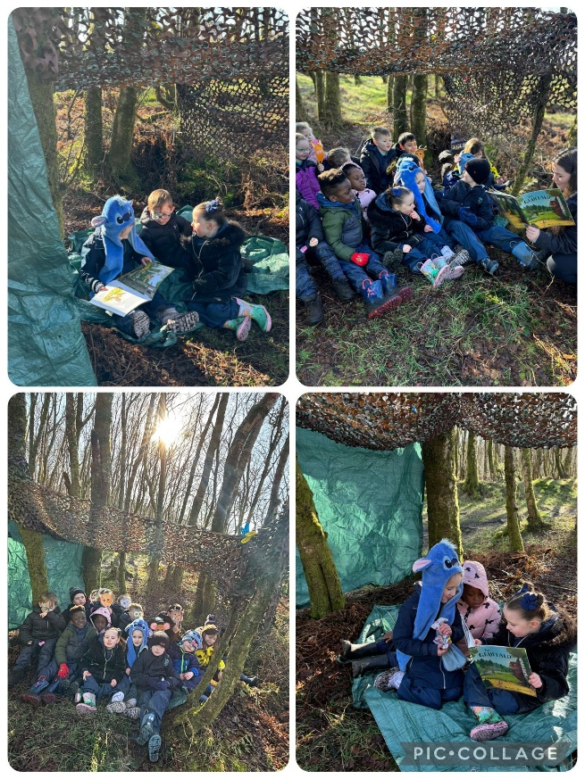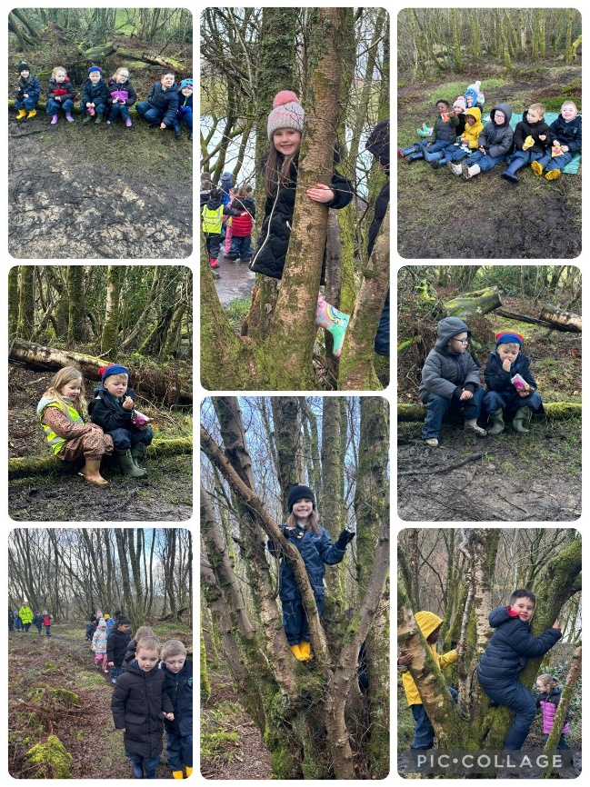
- Primary 2/3 enjoyed numerous visits to our local South West Library as we continue to encourage all our pupils to love reading for pleasure.
- Primary 3 visited the Sea Life Centre in furtherance of their learning about pollution, conservation and creatures who live in the sea.
- Primary 4 celebrated the Sacraments of Reconciliation and the Eucharist.
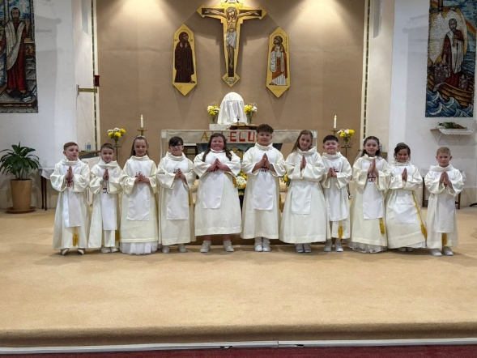
- Primary 5 participated in a brilliant mapping project in partnership with Glasgow University.
- Primary 6 enjoyed an overnight residential at the National Sports Centre in Largs.
- Primary 7 shared a fantastic 4 night/5 day residential experience at PGL Dalguise with St. Catherine’s Primary, Edinburgh.
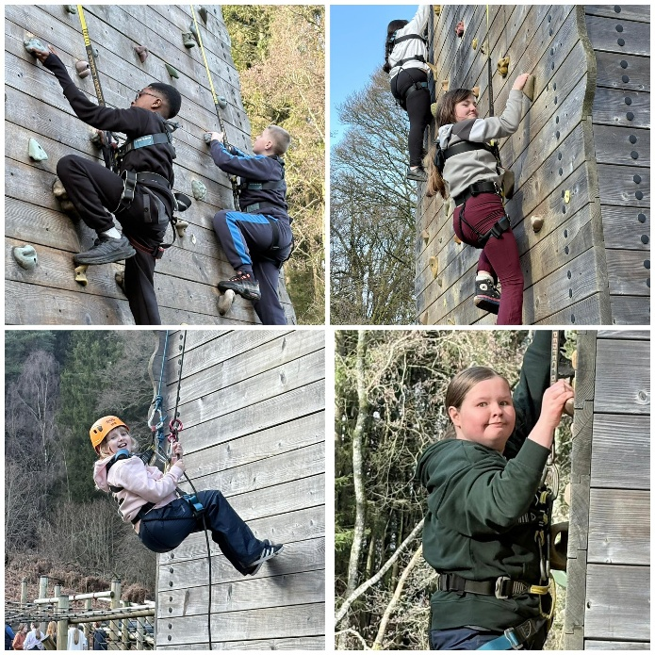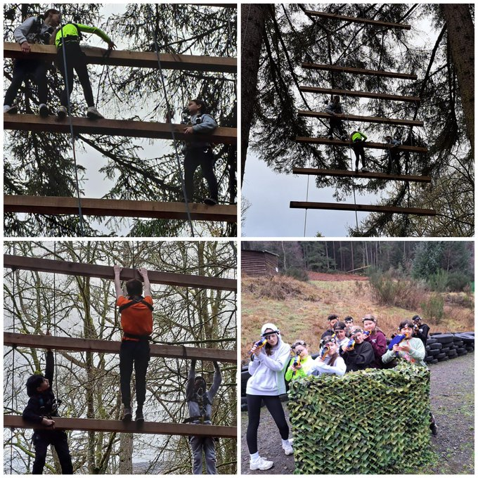
- We continued to develop our Pupil Voice experience and shared this with all our stakeholders through the use of Sways.
- All our pupils experienced enhanced STEM opportunities through a variety of fantastic partnerships with Thermo Fisher Scientific, Glasgow Science Centre, Wind for Kids, Inverclyde Skywatchers and DXC.
- Our choir performed at various local community centres helping residents get into the Christmas Spirit.
- One of our Primary 5 pupils was selected as a winning entry to a national Christmas Card design competition and his design will feature on MISSIO Christmas cards in December 2026.

