ST JOSEPH’S
PRIMARY SCHOOL
&
NURSERY CLASS



HANDBOOK
2025-2026

AUTHORITY STRATEGIC STATEMENT

Building Inverclyde through Excellence, Ambition and Regeneration.

Goals and Values

Our core values are: RESPECT, HONESTY and TOLERANCE

Our vision for the children and young people of Inverclyde is that they should be ambitious for themselves and be successful learners, confident individuals, responsible citizens and effective contributors.

To achieve our ambition of building Inverclyde through excellence, ambition and regeneration our children must be:

Safe: protected from abuse, neglect and harm by others at home school and in the community

Healthy: enjoy the highest attainable standards of physical and mental health with access to healthy lifestyles.

Achieving: have access to positive learning environments and opportunities to develop their skills, confidence and self esteem to the fullest potential.

Nurtured: educated within a supportive setting

Active: active with opportunities and encouragement to participate in play and recreation including sport

Respected and responsible: involved in decisions that affect them, have their voices heard and be encouraged to play an active and responsible role in their communities

Included: have access to high quality services when required and should be assisted to overcome the social, educational, physical, environmental and economic barriers that create inequality.

Inverclyde Council

CONTENTS
2 Authority Strategic Statement

5 Head Teacher’s message

6 Visions, values & aims/School Information

7 What Makes St. Joseph’s Special? (By the pupils)

9 School Information/Community Facilities

11 School Staff

12 Nursery Staff/ Nursery Information

17 School Year.

19 Enrolment

20 Placing Requests

21 Curriculum/Health & Wellbeing

23 Literacy

25 Numeracy & Mathematics

28 Play Pedagogy

30 Sciences

31 Social Studies/Expressive Arts/Technologies/Meta-Skills

33 Curriculum for Excellence

34 Religious Instruction

36 Spiritual, Social, Moral & Cultural Values

38 Assessment/ Support for Pupils

41 Inclusion and Equality

42 Homework/Home & School Links

44 School Improvement

45 Child Protection/School & Community

46 Extra Curricular Activities

50 Discipline/Playground Supervision/Medical & Health Care/Emergency Contact

51 Medication/Allergies/Appointments/Clothing & Uniform

55 School Meals

56 Attendance

57 Transferring Education Data about pupils/ Data Protection

58 Information in Emergencies/Transport

59 Placing Requests/Parent Forum & Parent Council

60 Transfer to Secondary School

61 Useful Addresses /Glossary of Terms

St. Joseph’s Primary School & Nursery Class
Wren Road
Greenock, PA16 7NH.
School Telephone 01475 715719
Nursery Telephone 01475 715736

E Mail office@st-josephs.inverclyde.sch.uk
Website: http://st-josephs.inverclyde.sch.uk/
X (formerly Twitter): @st_josephps

Dear Parents,

A warm welcome to St. Joseph’s Primary School and Nursery Class. This handbook provides you with information about the school which I hope you will find helpful.

St. Joseph’s aims to be a fun, safe place for children to experience learning opportunities of the highest standards. Working in close partnership with parents and the many other agencies which support us in the community, we aim to continue to set high standards which will encourage our children to be all they can be.

You have a hugely important role to play in making sure St. Joseph’s becomes the centre of excellence we want it to be. Your views, ideas and support will mould and shape the school. In this handbook you will find some of the ways you can be fully included in the life of the school.

We also now include information about our Pre-5 offer in the form of our Nursery Class which provides a fantastic learning service for 2-5 year olds.

If at any time there is anything you wish to discuss about your child’s education, please do not hesitate to get in touch with me. You will always be welcome and we look forward to you and your family becoming involved with us at St. Joseph’s.

Yours sincerely,

Mr Alan Graham
Head Teacher

VISIONS AND VALUES AND AIMS

Visions and Values
St. Joseph’s Primary aspires to develop as a community of faith and learning, through the faith, tradition and sacramental life of the Catholic Church. We believe that all children have the right to be safe, healthy, achieving, nurtured, active, respected, responsible and included. We value all members of the school community and believe that the Christian values of the Gospel should permeate the life of the school.
All stakeholders were consulted and adopted the key values of Friendship, Respect, Honesty and Kindness.

Aims
We aim to:
- work in partnership with parents and community to enable all children to develop their capacities as successful learners, confident individuals, responsible citizens and effective contributors to society.
- provide the highest quality learning activities and educational programmes suited to individual needs and attributes.
- maintain the highest possible levels of attainment and achievement.
- encourage all pupils to aim high and reach their full potential.
- provide a happy, secure, welcoming environment which promotes well-being and respect.
- develop leadership at all levels – in staff and in pupils.
- value and develop our staff

WHAT MAKES ST. JOSEPH’S SPECIAL?
We asked our boys and girls this question and have included some of their answers in this handbook.

"When everyone plays together we show respect." (Primary 1 Class)

"Our teachers help us to be the best we can be.” (Primary 1 Class)

“Everyone is kind and I like when we pray to God together.” (Waslat, P3)

“Learning is fun for everyone.” (Macie, P4)

“St. Joseph’s is special because we make it special.” (Killian, P4)

“St. Joseph’s is special because, in this school, there is people with kind hearts.” (Hailie, P4)

“I think St Joseph's is special because they have nice staff who teach us new things, help us when we need it, and look after us.” (James, P5)

“Our school is special because we have houses and we all work together.”(Kielan, P6)

"Everyone here is kind. Adults always look out for you." (Rocco, P6)

"The people in this school make it special. The pupils are respectful and look out for each other." (Christopher, P6)

"The canteen ladies and the staff are really nice, then the children are kind to each other." (Wadeea, P6)

"The big playground is special, it is where children and PSAs have fun together." (Aiden, P6)

“I like how positive the people are. When I am feeling down, I have good friends to help” (Poppy, P7)

“I think St. Joseph’s is special because everyone is kind to each other and respects everyone’s rights.” (Aaliyah, P7)

At our recent Parents’ Evening, our parents said:


SCHOOL INFORMATION

The school was built in 1953 and refurbished in 2005/6. Our accommodation is comprised of seven classrooms, a Nurture Room, a library/meeting room, a large gym hall with stage, a kitchen and a dining hall. The school is designed for disabled access.

The school website can be found at: https://blogs.glowscotland.org.uk/in/stjosephsprimary/

SCHOOL ROLL
At present there are 117 children although the school can accommodate more. Parents should note that the working capacity of the school may vary dependent upon the number of pupils at each stage and the way in which the classes are organised.

P1 – 17 P5 – 20
P2/3 – 14 P6 – 14
P3 – 21 P7 – 16
P4 – 15

Current Teaching Staff: 10.5

NURSERY ROLL
At present there are 39 pupils in our 3-5 room and 11 in our 2-3 room, but we have capacity for more.

Current Staff : 15 (Including 3 EYSAs)

St. Joseph’s is a denominational school which caters for boys and girls.
We share our buildings with Bluebird Family Centre (Tel: 715722). Bluebird Centre takes children from 0-5 years of age.

SCHOOL HOURS
Morning 9.00 a.m. - 10.30a.m.
Interval 10.30 a.m. - 10.45 a.m.
Lunch 12.15 p.m. - 1.00 p.m.
Afternoon 1.15 p.m. - 3.00 p.m.

Pupils are allowed into the school at 8.45 a.m. in bad weather.

NURSERY HOURS

All of our pupils are full time placements, 5 days a week and the nursery class offers a term-time provision for 2-5 year olds.

The core daily hours are 8:45 a.m. – 2:45 p.m.

COMMUNITY FACILITIES
Community facilities are available within the school and details of letting procedures are available from:

Inverclyde Leisure
Waterfront Leisure Complex
Customhouse Way
Greenock PA15 1EW

Tel: 01475 791675

SCHOOL STAFF

Mr A. Graham Head Teacher

Mrs C. Combe Depute Head Teacher

Miss N. Thomson Primary 1 Teacher

Mrs C. Cameron Primary 2/3 Teacher

Miss K. McVey Primary 3 Teacher

Ms K. Christie Primary 4 Teacher

Miss S. MacPherson Primary 5 Teacher (NQT)

Miss J. Skelton Primary 6 Teacher
Mr C. Mullan Primary 7 Teacher
Miss. E. McAteer SfL Teacher

Mrs L. McLaughlin RCCT
Miss. M. McKay Senior Clerical Assistant
Mrs. A. Brady Senior Clerical Assistant
Mr Paul Donnelly Janitor
Mrs L. McGunnigle Pupil Support Assistant
Ms M. Orr Pupil Support Assistant
Mrs M Gavigan Pupil Support Assistant
Mrs L McKenzie Pupil Support Assistant
Mrs L. Stevens Pupil Support Assistant
Ms. L. Cunningham Pupil Support Assistant
Miss C. Findlater Pupil Support Assistant
Mrs M Wilson Pupil Support Assistant
Ms N Provan Pupil Support Assistant
Miss N McClure Pupil Support Assistant

School Chaplain: Father Maurice Callaghan

NURSERY STAFF

Mrs F. Laiolo Depute Head

Miss E. Love Senior EYECO

Miss N. Rodgers Clerical

Mrs A. Killeen EYECO

Mrs. J. Stewart EYECO

Mrs L. Gallacher EYECO

Miss M. Gorman EYECO

Miss E. Sutherland EYECO

Mrs C. McGarrity EYECO

Mrs C. McIntyre EYECO

Mrs J. McCann EYECO

Ms. M. Dougan EYSA

Miss L. Gill EYSA

Mr. S. McQuillian EYSA

St. Joseph’s Nursery Class

St Joseph’s Nursery Class offers provision to children aged from 2-5 year old’s in a safe, nurturing and welcoming environment. We provide learning opportunities through stimulating play experiences. Our core hours are from 8:45am until 2:45pm.

The Nursery is open Monday to Friday during school term time and takes the same holidays as St Joseph’s Primary School.

Our Learning

Our Explorer Room (2-3) provides fun stimulating experiences in line with Realising the Ambition encouraging the children to develop their confidence, creativity and curiosity skills.
Our Adventurer Room (3-5) follows Curriculum for Excellence early level, providing a variety of activities across literacy, numeracy, health and wellbeing, technologies, social subjects, expressive arts, sciences, religious and moral education. Within the playroom children can explore our Discovery and Social Zones. Children also have daily opportunities for outdoor play. Staff support children to record their learning within floorbooks across our three zones which allow the children to express their interests and take the lead in their own learning. Each child has their own online Learning Journal that parents can log onto to find out what their child has been learning about at nursery.

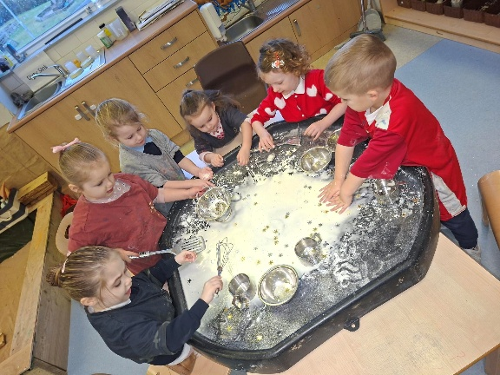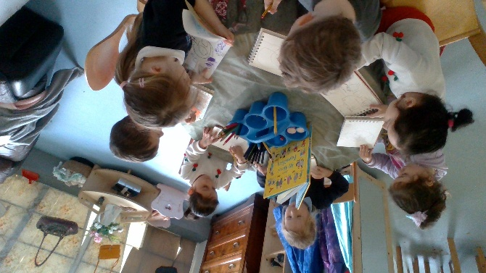
Community Links

Our children go on local outings to Coves Reservoir, “Rezzy Ramblers”, where they can investigate aspects within the forest, learn about boundaries and keeping themselves safe. Children enjoy attending our local library to pick a variety of stories for the nursery to enhance their learning. Going to the surrounding parks is an adventure where children can develop their gross motor skills. On some occasions the children go on a trip to the shops which develops their understanding of money and what this is used for.
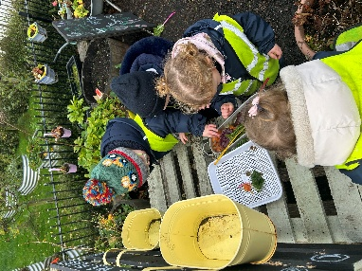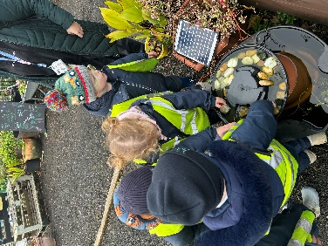

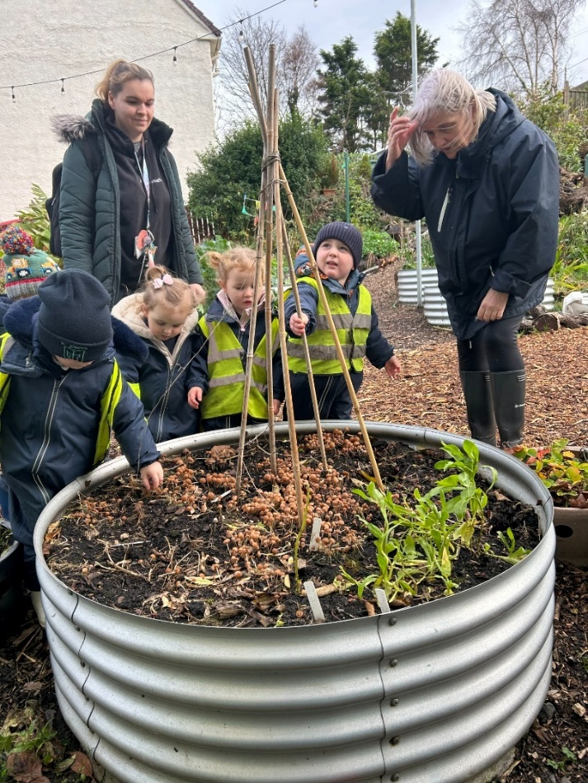
Home Links

We have an open door policy where parents/carers can speak to any of the staff team regarding their child or any important information. Monthly newsletters are regularly sent home detailing nursery events and our learning. We also share messages on our learning journals. We encourage parents/carers to support us with fundraising and special events. We offer stay and play sessions where parents/carers can join their child’s learning experiences both indoors and out. Children take part in lending library where they choose their own story and take this home to share with their parents/carers. We welcome any suggestions and parental feedback.

Clothing

A polo shirt and sweatshirt were designed by pupils in the school and are available from Smiths in Greenock. This is not compulsory, however it is advised that the children should not wear “good clothes” to nursery. The children are involved in many types of activities from baking, to painting, to the many outdoor activities, and although they are provided with some waterproof clothing, accidents do happen. Please can you ensure your child’s clothes and footwear are clearly marked with their name. Can you please ensure children have a full set of spare clothes including socks that are kept in the nursery at all times?

Snacks & Lunch

St Joseph’s Nursery Class is a health promoting establishment with a healthy eating policy based on the guidelines contained in Food Matters and Setting the Table.

The children are provided with a healthy snack such as fruit, vegetables, toast and milk.

We will provide you with a lunch menu in the induction pack which you and your child can talk about before choosing an option.
We encourage children to be independent at snack and lunch times
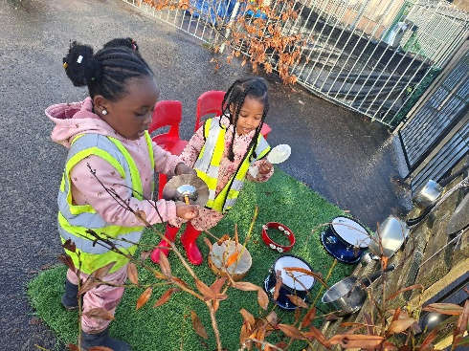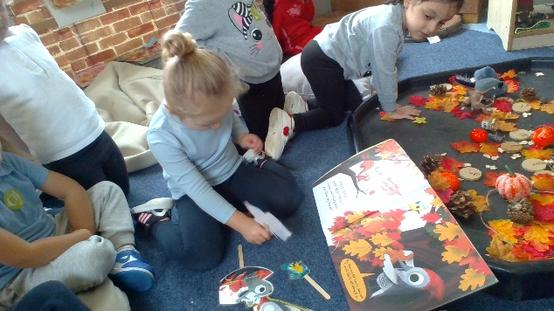

Attendance

Regular attendance at nursery and spending time in a stimulating environment encourages your child to be secure and confident. It is important and encouraged that absences are kept to a minimum as education is a continuous process. We ask that parents contact the Nursery before 10.00am if their child will be absent from the nursery.

Collecting Children

If an alternative arrangement for collection is to be made, the staff in the nursery must be informed in advance and password given for safe collection.

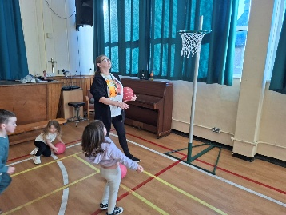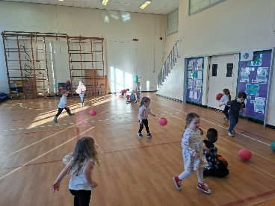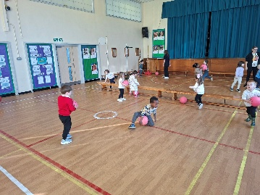

Transition

The key to effective transition is effective communication between the early year’s establishment, school and parents. The transition process is on-going with strong links between our own nursery and P1 and with other nurseries in our community.
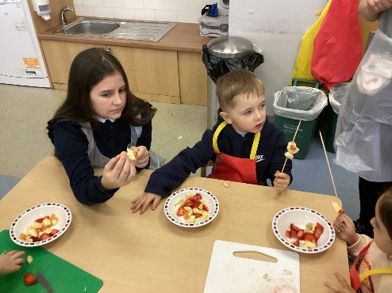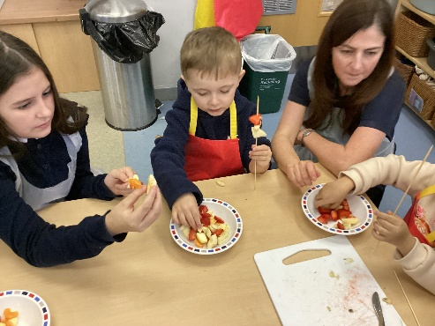

Care Inspectorate

Care Inspectorate is the Scottish Commission for Regulation of Care. This organisation inspects the service provided for the children who attend the nursery on a regular basis. Inspections can be planned or unannounced and are carried out by Inspectorate Officers. During the inspection the Officers speaks with the Head Teacher, staff, children and parents. They also look at the range of policies, procedures and records. Our most recent Care Inspection can be found on the school website.

Care Inspectorate
Central West Region
4th Floor
No1 Smithhills Street
Paisley
PA1 1EB

Tel: 01418436840

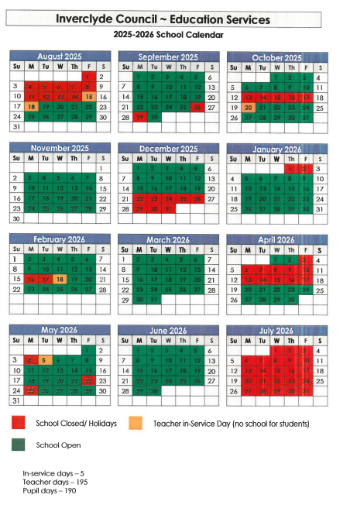

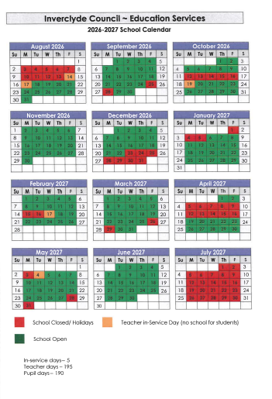

In order to minimise disruption to your child’s education and assist the school in
meeting its attendance targets set by the Scottish Executive Education Department, please make every effort not to take children on holiday during term time.

ENROLMENT
Registration and Enrolment of new entrants takes place between 5th & 9th January 2026 and is now carried out on-line. The following link will take you to the page.
P1 Registration, Defer Entry & Placing Request information for term 2026/27 - Inverclyde Council
Information about enrolment is available from the school or nursery/playgroup and is also advertised in the Greenock Telegraph. Legislation gives parents freedom of choice of school for their children. However, ALL CHILDREN MUST BE REGISTERED IN THE SCHOOL SERVING THEIR AREA. Children moving into the area during the school year should be registered.
SCHOOL CATCHMENT AREA
Auchneagh Avenue Kenmore Place
Auchneagh Crescent Kestrel Crescent
Auchneagh Farm Lane Kestrel Place
Auchneagh Farm Road Kilbrannan Drive
Auchneagh Road Killin Place
Baine Street Larkfield Road (nos. 12-40 only)
Bow Road Lawers Place
Brae View Linnet Road
Brambling Road Lyle Road (nos. 56-78 only)
Buchanan Street MacBeth Road
Cairngorm Court Mallard Crescent
Canmore Crescent Mallard Lane
Cawdor Crescent Maple Road
Cawdor Place Mary Street
Curlew Crescent Mavis Road Merlin Avenue
Curlew Lane Merlin Lane
Davey Street Munro Street
Dee Street Murray Street
Delfie Drive Ness Road
Don Street Nevis Court
Falcon Crescent Nicol Drive
Falcon Lane Nicol Street
Fancy Farm Place Old Inverkip Road (over 140 & 147)
Fancy Farm Road Osprey Road
Fearnan Place Partridge Road
Fergus Drive Paton Street
Fergus Place Pennyfern Drive
Fergus Road Pennyfern Road
Finch Road Pentland Court
Florence Street Plover Lane
Forth Street Rankin Street
Gael Street Raven Road
Gateside Avenue Redpoll Place
Gateside Gardens Robin Road
Gateside Grove Rook Road
Glamis Drive Rose Street
Glamis Place Rowan Street
Glencoe Court Sandpiper Lane
Graham Street Siskin Close
Grampian Court Skye Street
Grieve Crescent Smithston Cottages
Grieve Road Tasker Street
Harrier Way Tay Street
Heron Road Tweed Street
Inverkip Road (1-12, even nos 70-202 odds from 163)
Iona Street Walker Street
Jura Street Wheatear Close
Kenmore Drive Wren Road
There is an ongoing review of streets and house number.

PLACING REQUESTS
Education Services does not provide transport for those pupils in receipt of a placing request other than in exceptional circumstances. In the case of under-age placing requests if the child is offered a place in his/her catchment area school, transport will be provided in accordance with Council policy stated above.

CURRICULUM
In. St. Joseph’s we aim to provide a wide and varied curriculum – i.e. a broad and balanced variety of subjects, balancing traditional and new technology. Learning and teaching cover a wide range of styles and methods – if you visit your child’s classroom you may find him or her working with a group of other children, or on an individual task, practising problem-solving skills in mathematics or technology or doing research.

Every year we produce a Strategic Improvement Plan for our school to enable us to prioritise our needs for each school year along with a Standards and Quality Report to evaluate the success of school developments. Both documents are available to parents and on our school website.

HEALTH AND WELLBEING
A healthy lifestyle is promoted from Nursery to Primary 7. We are committed to providing more opportunities for outdoor learning and making our playgrounds safe, fun places to develop social skills and have fun. “Playground Pals” encourage pupils to play active games at break times. A variety of games equipment is provided in our playgrounds.
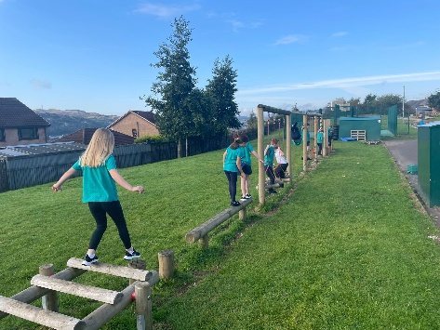
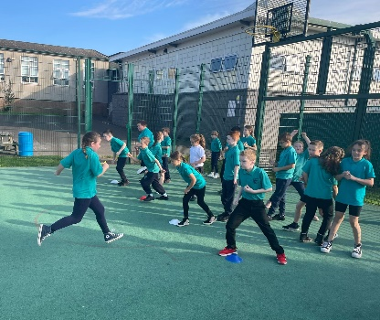
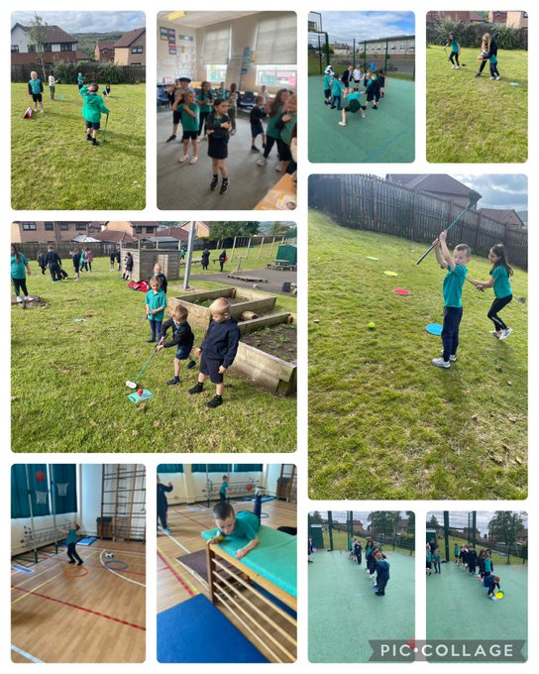

We are an active school – all children experience at least two hours of physical education (P.E.) every week. There are after-school activities for different classes. The whole school follows a Health & Wellbeing programme called Paths, which promotes social and emotional wellbeing.
We are developing a Whole School Nurturing Approach utilising the key principles of Nurture in every area of the school experience.

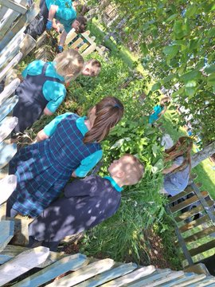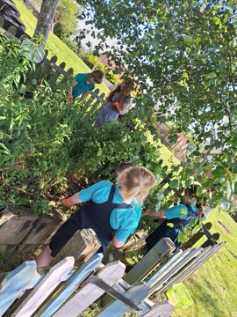
We try to take advantage of our fantastic grounds by learning outside when possible.

LITERACY
Literacy skills are fundamental to children’s learning. Listening and talking, reading and writing are delivered through structured programmes and are developed throughout our literacy rich curriculum. Listening and talking skills are developed, using a Dialogic approach. A Dialogic approach is good quality listening and talking. We use this approach to allow children the opportunity to learn how to articulate themselves, to explore differences of opinion, to give arguments and support their ideas and to explore concepts and develop within a community of enquiry. This builds life-long skills and prepares our children and young people for life and work beyond education.
The development of reading skills begins in St Joseph’s nursery through Phonological Awareness activities and vocabulary development programmes using the Word Aware approach. Within St Joseph’s, we are supported by colleagues from the Attainment Challenge to use the North Lanarkshire Literacy programmes to deliver phonics and spelling. In addition, we use PrimEd spelling in the upper stages. The North Lanarkshire programme provides a structured and systematic approach to teaching phonics which children use to read and write. Currently, we use The Big Cat reading scheme and a variety of novels throughout the school to develop higher order thinking skills through discussion, questioning and debating the content and different styles of stories, texts and information. We seek to develop a love of reading and have achieved a Reading Schools Gold Accreditation.
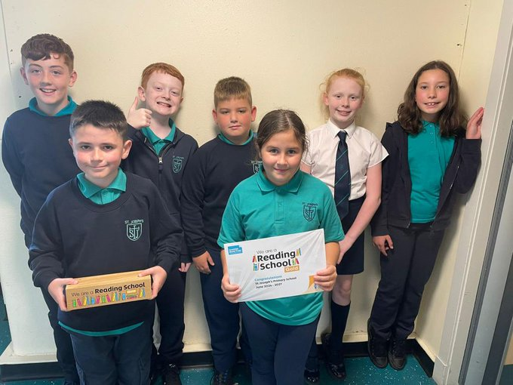
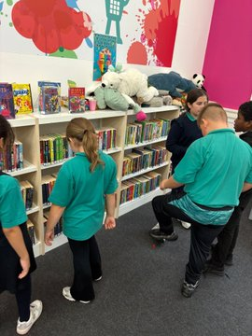
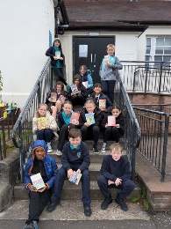
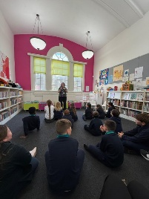
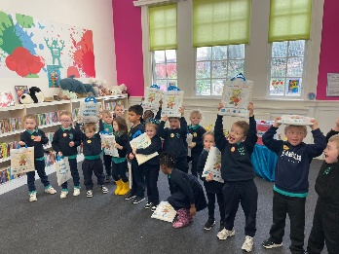
We work closely with partners at Inverclyde Libraries to promote reading for pleasure.

Please give your child(ren) every encouragement to read at home and discuss the books they are reading. In addition to class libraries, we have an engaging and attractive school library where the children regularly visit and borrow books.
We teach the children to communicate clearly through their written work so that it will be read and understood by others. We use the PenPals Handwriting scheme throughout the school and encourage the children to take pride in the presentation of their work as well as having high standards of spelling, punctuation and grammar. We teach a range of genres to our children to prepare them for lifelong learning and work. We celebrate the hard work and efforts of the children through star writers' certificates in class and at assemblies and display their writing in classrooms and corridors.
Bookbug

Bookbug is Scotland's universal early years book gifting programme which supports families to read, sing, and play with their little ones from birth to give them the best start in life. Starting school is an exciting and challenging time for your child and your support at home makes a real difference to their learning. Look out for your Bookbug Primary 1 Family Bag, a free bag of books and activities your child will receive at school in November from Bookbug, to help support their reading, writing and counting skills. You will find films of the books being read aloud and more information about the P1 Bag here.

Read Write Count

Read Write Count with the First Minister is a National gifting programme, aiming to build parents' confidence and encourage families to include easy and fun reading, writing and counting activities in their everyday lives. Every Primary 2 and Primary 3 child in Scotland will receive a free bag with books, educational games and writing materials to be gifted during Book Week Scotland, in November. Resources for schools and extra activities for families to use at home can be found here

NUMERACY/MATHEMATICS
Numeracy is a fundamental life skill which permeates all areas of learning. Being numerate involves developing, fluency, reasoning, confidence and competence in using numbers to solve problems, interpret and analyse information and make informed decisions in everyday life.
The Curriculum for Excellence Numeracy & Mathematics experiences and outcomes are organised into these 3 main areas and sub divisions:
Number, Money & Measure
· Estimating and Rounding
· Number and number processes
· Fractions, decimal fractions and percentages
· Money
· Time
· Measurement
· Mathematics – its impact on the world past, present and future
· Patterns and relationships
· Expressions and equations
Information Handling
· Data and analysis
· Ideas of chance and uncertainty
Shape, position and movement
· Properties of 2D and 3D shapes
· Angle, symmetry and transformation
Active learning, planned purposeful play, outdoor learning and loose parts play are used to allow learners to experience numeracy and maths in a fun and interactive way. These approaches enable learners to develop those necessary numeracy skills for life and work. All learners are encouraged to explain their thinking, reason, develop problem solving skills, as well as developing the ability to work independently and as part of a team.
In Scotland our aim is to: • Transform public attitudes to maths. • Improving confidence and fluency in maths for children, young people, parents and all those who deliver maths education to raise attainment and achievement across learning. • Promote the value of maths as an essential skill for every career. (Making Maths Count 2016)
Concrete- Pictorial- Abstract
A CPA (Concrete- Pictorial- Abstract) approach is used at all levels. This involves concrete materials, pictures (to show the quantity) and abstract numbers being used to develop a deeper understanding of numeracy & maths.
SEAL
As part of our work in the Attainment Challenge, pupils in P1-4 are working through a numeracy pathway called SEAL (Stages of Early Arithmetic Learning). This process will provide breadth and depth of learning and foster a greater understanding of numeracy which will allow skills to be applied in new and unfamiliar contexts.
Ten Frames and finger patterns to show understanding of number and for addition
Daily oral mathematics and Number Talks is a feature of every classroom from
P1- P7. We use our new ‘Numeracy Blueprint’ boards for mental maths, number talks and to help pupils understand new maths concepts such as fraction, decimals and percentages.
The above approaches and resources enable pupils to:
· develop a deeper understanding of Maths concepts
· make connections and come up with their own strategies
· work towards using more meaningful and efficient strategies
· justify their reasoning and think about whether answers make sense
· strengthen mental maths skills.
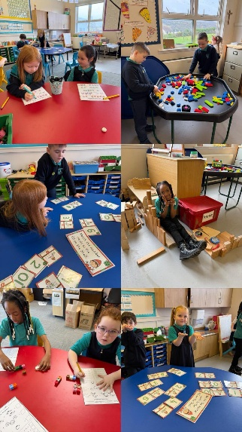
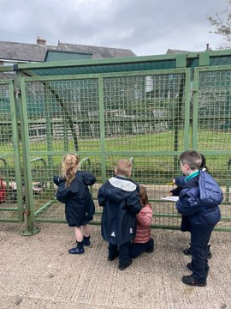
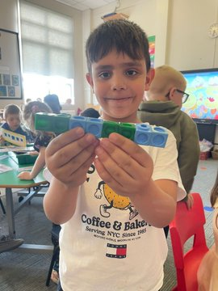
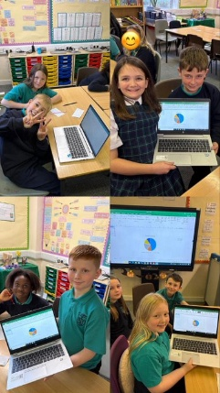

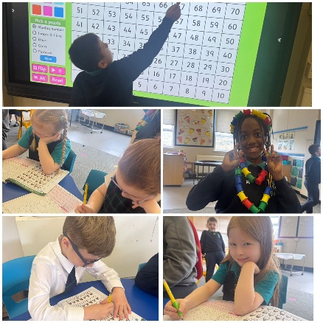

PLAY PEDAGOGY

“Playing and learning are like the two wings of a butterfly – one cannot exist without the other.” (Carla Rinaldi, President of Reggio Children)

Research has shown that play experiences are not merely fun but plays a crucial role in learning and in preparing children for challenges in childhood and beyond.

We have embedded Play Pedagogy into our Primary 1 & 2 curriculum based upon the research and advice of many agencies including, Education Scotland and Scottish Government. This was found to be an Area of Good Practice in our recent Peer Review and we will share that good practice over the coming year with our colleagues across the authority.

When we say “play” this means many different experiences, some structured, some free and imaginative, some teacher-led and every variety in-between.

This does not mean that the experiences are haphazard. A great deal of planning goes into the creation of opportunities for children to learn in a great variety of ways.

We have adapted our classroom and playground environment significantly to ensure our children have the best possible opportunities to learn through play.

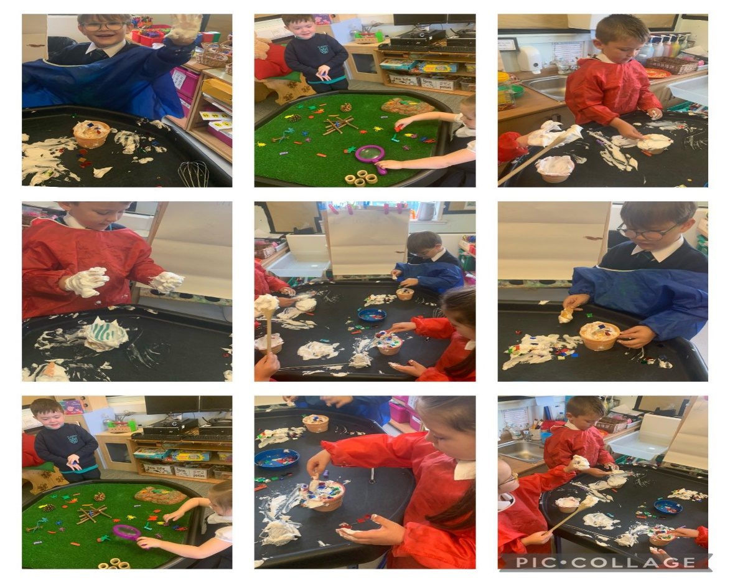
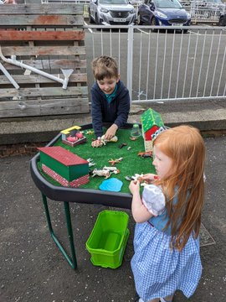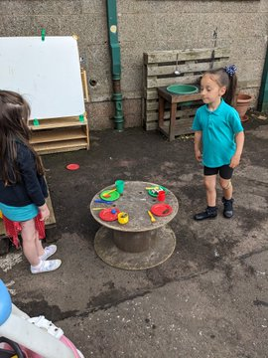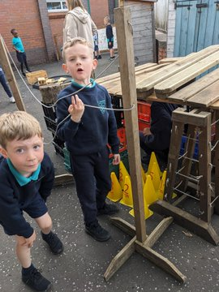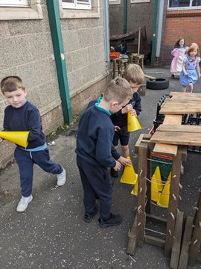

Learning Through Play

SCIENCES
Science is an important part of our heritage and its applications are part of our everyday lives at work, at leisure or in the home. Through science children develop their interest in, and understanding of, the living, material and physical world. They can take part in a wide range of tasks to help them to develop important skills and understanding of science.

St. Joseph’s follows a structured programme of science developed by Inverclyde Education Services. Science is also integrated within other curricular areas where appropriate, e.g. social studies.

Development of STEM (Science, Technology, Engineering and Maths) has been a key aim in our Improvement Plan and Mrs McLaughlin is our co-ordinator for this area. She has worked with staff and pupils to develop a whole school approach to this very important curricular area and provides Science & Stem learning during reduced Class contact time. We are working with our Early Years partners to develop STEM through outdoor education and will continue to support the development of this across the whole cluster.

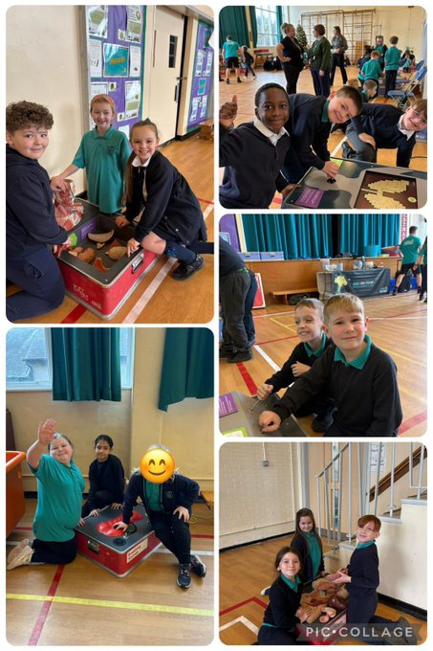
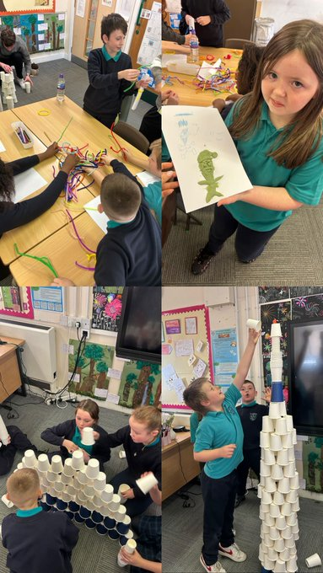

Glasgow Science Centre DXC in P5

SOCIAL STUDIES
In Social Studies pupils look at societies at different times (history) and in different places (geography). This will, for example, involve them in studying important people and events in the past, investigating transport and communication networks at home and further afield; and in looking at the ways our communities are run.
Visits to places of educational interest are arranged whenever possible to allow the children the opportunity of seeing things at first hand. The experiences are designed to encourage links with other areas of the curriculum so that learners have deeper, more enjoyable and more active experiences.

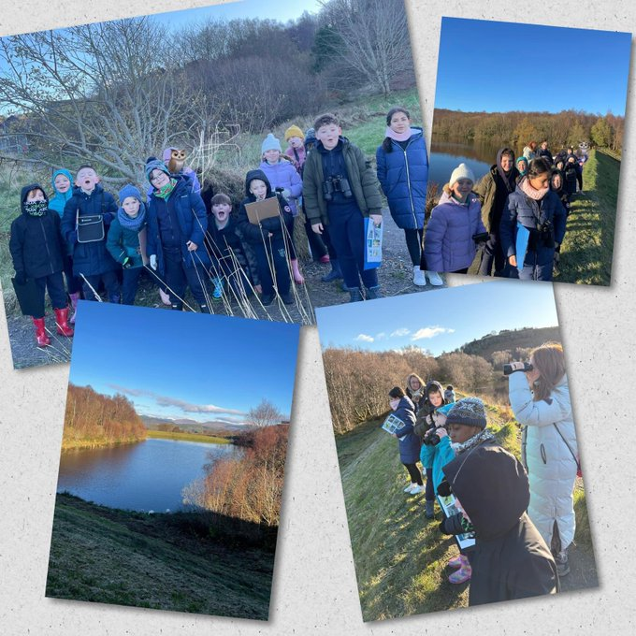

Primary 4 Birdwatching in support of their novel study.

EXPRESSIVE ARTS
Drama, dance, music and visual arts are included in the expressive arts. In St. Joseph’s we aim to encourage children’s talents, skills and enjoyment of the arts. Suitable programmes are in place from Primary 1 to Primary 7. This area of the curriculum is crucial in the development of pupils’ confidence and social skills. It allows many pupils to experience and enjoy success. The importance of creativity in the employees of the future is a very important message for our children.

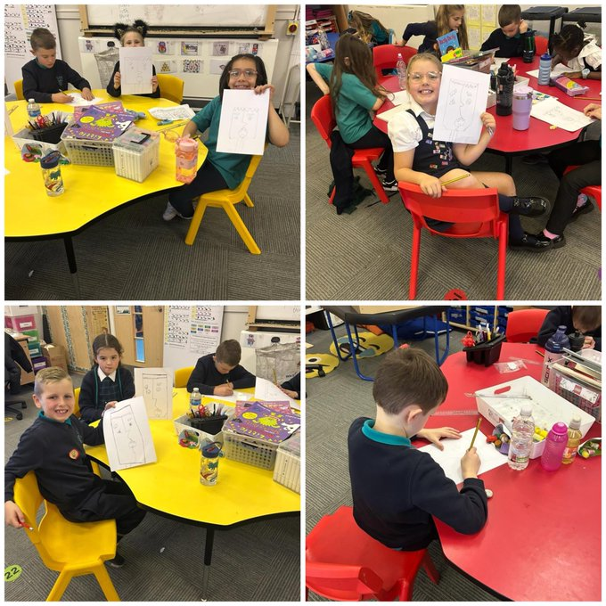

Primary 3 exploring the artwork of Pablo Picasso

TECHNOLOGIES
Technology is not simply the use of computers or gadgets. It is about thinking creatively and solving problems. It is about using resources in new and inventive ways. It involves skills in mathematics, science and engineering. As mentioned previously we are working very hard to further develop learning opportunities in this curricular area. A structured technology programme is also in place and all staff and pupils can access GLOW, Scotland’s online education community.

META-SKILLS
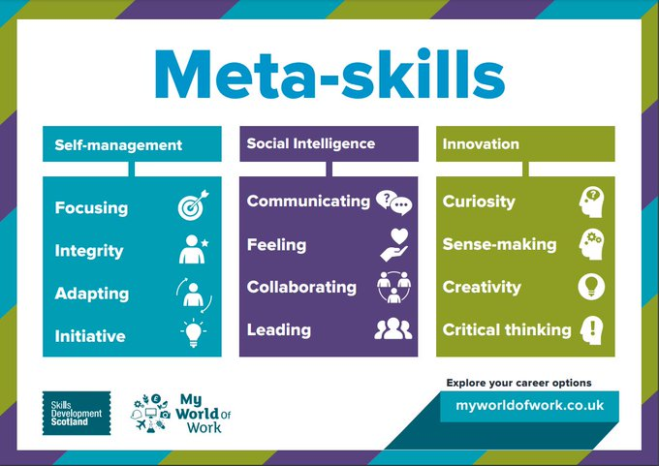
In response to our findings when we reviewed our Curriculum Rationale, we are developing our learning about Meta-Skills from nursery through to P7. This work will continue to be a focus in our school improvement plan for the next few years.

Meta-skills are higher-order skills that create adaptive learners and promote success in whatever context the future brings. From birth, children use their meta-skills as they test and explore the world around them, and it is these meta-skills that act as a key to unlock the development of other transferable and technical skills.

CURRICULUM FOR EXCELLENCE
A curriculum framework for all Scottish educational establishments 3 – 18, called Curriculum for Excellence, offers better educational outcomes for all young people and provides more choices and more chances for those young people who need them.

The aims of Curriculum for Excellence are that every child and young person should:
- Know they are valued and will be supported to become a successful learner, an effective contributor, a confident individual and a responsible citizen;
- Experience a traditionally broad Scottish curriculum that develops skills for learning, skills for life and skills for work, with a sustained focus on literacy and numeracy that encourages an active, healthy and environmentally sustainable lifestyle and builds an appreciation of Scotland and its place in the world.

The experiences and outcomes under Curriculum for Excellence are written at five levels with progression to qualifications described under the senior phase.

Early Level – the pre school years and P1 or later for some.

First Level – to the end of P4, but earlier for some.

Second Level – to the end of P7, but earlier for some.

Third and Fourth – S1 to S3, but earlier for some.

Senior phase – S4 to S6 and college or other means of study.

All pupils should experience a balanced curriculum in their seven years in primary school.
The curriculum should also offer challenge and enjoyment, breadth, progression, depth, personalisation and choice, coherence and relevance.

RELIGIOUS INSTRUCTION
Since we are a Catholic school, our aim is to help the children to become aware of God’s presence in their lives. In accordance with your wishes, our children are taught the doctrine, prayers and practices of the Roman Catholic Church.

You are encouraged to participate in our school Masses from P1 – P7. At Primary 4, children are prepared to receive the Sacraments of Reconciliation and Holy Eucharist and at Primary 7 children are prepared to receive the Sacrament of Confirmation. Our P6 pupils are given the opportunity to undertake The Pope Francis Faith Award which is part of the early preparation for Confirmation.

With your cooperation, we encourage the children to become practising members of the church. There are many opportunities in school to worship God and share our Faith – in classroom prayers, assemblies and School Masses. Opportunities are provided for children to receive the Sacrament of Penance in school. Father Maurice Callaghan, our school chaplain, plays an active part in the life of the school.

Should any parent wish to withdraw their child from this religious programme, they should contact the Head Teacher and, if necessary, special arrangements can be made.

The Religious Education programmes, This is Our Faith and God’s Loving Plan, are approved by the Bishops of Scotland and are structured to ensure a sense of unity and coherence from P1-P7. In these programmes pupils are helped to explore and gain insights into beliefs and practices of people of other faiths.
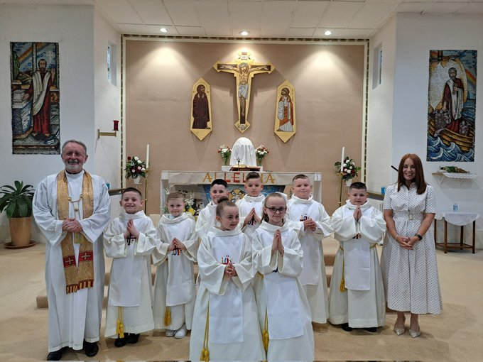
Primary 4 First Holy Communion
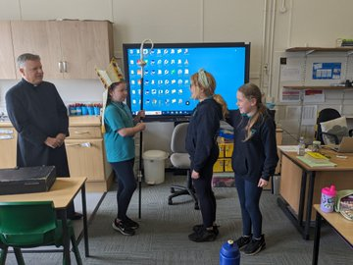
Bishop John preparing the Confirmandi

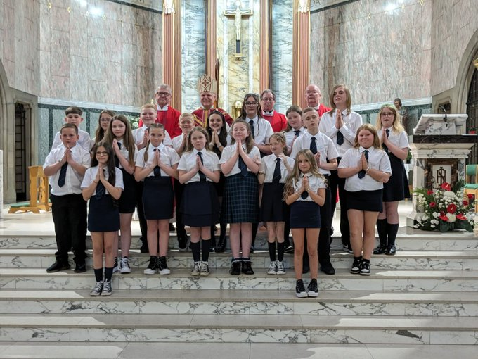
P7 Confirmation
SPIRITUAL, SOCIAL, MORAL AND CULTURAL VALUES
Parents from ethnic minority religious communities may request that their children be permitted to be absent from school in order to celebrate recognised religious events. Only written requests detailing the proposed arrangements will be considered. Appropriate requests will be granted on not more than three occasions in any one school session and the pupil noted as an authorised absentee in the register.

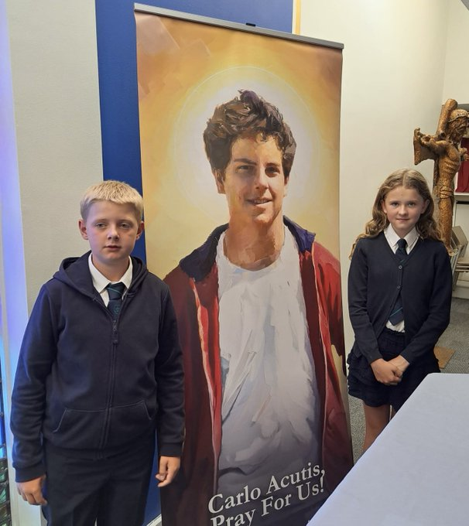
Celebrating the relics of St. Carlo Acutis


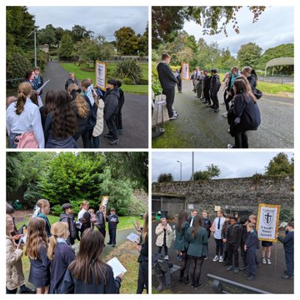
Primary 7s as Pilgrims in The Park

Sex and Relationship Education
Sex and Relationship education is an integral part of a school’s health education
programme and is delivered in accordance with the teachings of the Catholic Church through a programme called “God’s Loving Plan.” It focuses on the physical, emotional, moral and spiritual development of all children. Teachers are central to the delivery of sex education from Primary 1-7 and work in partnership with parents/carers and appropriate health professionals.

Parents/carers should be fully informed and consulted on the content and purpose of sex and relationship education in schools, and have the opportunity to raise concerns with school staff. On an occasion where a parent/carer wishes to exercise the right to withdraw his/her child from sex and relationship education they should discuss their concerns and alternative arrangements with school staff. (as per Inverclyde Council’s Policy “Sexual Health and Relationship Education”).

ASSESSMENT
Assessment is the term used to describe the process of evaluating a child’s progress. We continue to develop formative assessment at St. Joseph’s Primary. This is assessment which directly affects the learning and teaching that takes place. To this end we are involving our pupils in sharing what is to be learned. We are involving pupils in self and peer evaluation and we are concentrating on meaningful feedback for our pupils in order to allow them to identify their own next steps for learning.
Assessment is an important part of learning and teaching. The curriculum framework for all Scottish education establishments 3-18, called Curriculum for Excellence, offers better educational outcomes for all young people and provides more choices and more chances for those young people who need them.

Our pupils are recording their learning outcomes and identifying their next steps through learning journeys which have been implemented in every class. Through this process, and others, pupils assess themselves, each other and discuss targets with their class teachers.

Our assessment procedures fulfil three purposes
- To diagnose areas of difficulty
- To provide reliable information on pupil progress and future development
- To provide the basis for communicating to parents areas of strength and concern

Each child’s progress is monitored and assessed by the class teacher. Detailed records are kept of children’s progress to help us pinpoint any learning problems. Parents and teachers can discuss the child’s progress at our parents’ evenings. Written reports based upon targets set by teachers with pupils will be sent home three times a year in October, February and May. Copies of these will also be kept in school.

SUPPORT FOR PUPILS
Every teacher has a responsibility to support the learning of all pupils in their class. The type of support offered will vary according to the needs of pupils. This includes consideration given to children who have a disability, children with social, emotional and behavioural difficulties, children with learning difficulties of a specific or general nature, children who are exceptionally able, those who demonstrate underachievement relating to gender issues, children whose learning has been interrupted through absence or illness, bilingual children who have English as an additional language, travelling children and those children whose family circumstances impact on attendance and learning.
A Support for Learning teacher is in the school 2½ days a week to help advise class teachers in organising individual educational programmes of work (Single Agency Plans) for children with short and long term difficulties. These programmes are usually carried out by the class teacher. Parents of children who have specific learning difficulties will be kept regularly informed of progress.

Sometimes we need to seek advice from our educational psychologist (Daniela Cubbedu) for a variety of reasons. This is done in consultation with parents. We always seek to work with parents for the benefit of their child.

The Depute Head Teacher and class teachers meet frequently with psychologist, speech therapist and other agencies, along with parents, to monitor closely the progress of children.

If a parent considers that his or her child has additional support needs and wishes to make enquiries about this, they should contact the Head Teacher.

Information specified by the Education (Additional Support for Learning) (Scotland) Act 2009 includes:

a) the authority’s policy in relation to provision for additional support needs.
A child or young person’s needs are identified at the earliest possible stage and can be met in a number of ways, for example by adaptations to the curriculum or learning environment, as well as input from the Support for Learning Teacher and on occasion support from visiting specialists. The appropriateness of the support is determined through a process of assessment, planning and monitoring, working jointly with parents and carers, and is regularly reviewed.

b) the arrangements made by the authority in making appropriate arrangements for keeping under consideration the additional support needs of each such child and young person and the particular additional support needs of the children and young persons so identified.
Learning outcomes for children and young people with additional support needs are set out in a plan and all educational establishments hold regular review meetings with parents and carers to determine needs and the most appropriate supports. Everyone’s views are equally important in order to consider what is currently working and how to determine next steps.

c) the other opportunities available under this Act for the identification of children and young persons who –

a) have additional support needs.
Children and young person’s needs are identified in a number of ways and the process of assessment is an ongoing, shared process with partnerships with parents and carers at the forefront. On some occasions health service staff or other partner agencies make children known to Education Services. Other additional support needs may be notified to Education Services by parents themselves or identified by one of a range of staff working closely with the child.

b) require, or would require, a co-ordinated support plan.
Some children and young people will have additional support needs arising from complex or multiple factors which require a high degree of co-ordination of support from both education and other agencies in order that their needs can be met. In these cases, the school will hold a meeting to decide whether the child or young person meets the criteria for a co-ordinated support plan. The co-ordinated support plan is a statutory document which ensures regular monitoring and review for those children and young people who have one.

c) the role of parents, children and young persons in the arrangements referred to in paragraph (b)
You have the right to ask the education authority to establish whether your child needs a co-ordinated support plan. Your child can make this request themselves, if they are aged 16 or over. You and your child, if they want to, will attend a meeting with staff at their school. Other professionals from different agencies who may be involved in providing support for your child will also attend. If your child does not want to attend meetings or feels unable to, their views must still be sought and considered.

d) the mediation services provided

Inverclyde’s mediation service can be accessed by contacting Michael Roach, Head of Schools at the address below.

e) the officer or officers of the authority from whom parents of children having additional support needs, and young persons having such needs, can obtain advice and further information about provision for such needs.

For further advice please telephone 01475 712850
Or write to;
Education Services
Wallace Place
GREENOCK PA15 1JB

Organisations specified by Scottish Ministers which provide advice, further information and support to parents of children and young people with ASN under The Additional Support for Learning (Sources of Information) (Scotland) Amendment Order 2011 are:

- Children in Scotland: Working for Children and Their Families, trading as “Enquire – the Scottish advice and information service for additional support for learning”, a charitable body registered in Scotland under registration number SC003527. www.enquire.org.uk

- Scottish Independent Advocacy Alliance, a charitable body registered in Scotland under registration number SC033576 www.siaa.org.uk and

- Scottish Child Law Centre, a charitable body registered in Scotland under registration number SCO12741. www.sclc.org.uk/

INCLUSION & EQUALITY
Inverclyde Education Service is committed to ensuring that no children or members of staff or service users receive less favourable treatment on any ground including age, gender reassignment, pregnancy and maternity, race, disability, sex, sexual orientation, marriage and civil partnership, religion or belief. We have a moral, social and legal obligation to mainstream and put equality at the heart of everything we do. We aim to promote a culture in which equality of opportunity exists for all. We are opposed to all forms of discrimination, direct or indirect, and aim to eliminate all discriminatory practices. We will ensure that, in our schools and other educational establishments, equality permeates the curriculum and underpins all our policies and practices in terms of access to education. We must ensure that all our children achieve their full potential to develop physically, emotionally and academically. Finally, we believe that equality and inclusion should be a given right, where everyone is valued and treated with respect.

As St. Joseph’s school community becomes ever more diverse we are working hard to ensure that we hear and represent the voices and experiences of all our stakeholders. Our “Diversity” pupil voice group leads the whole school in ensuring we think and learn about anti-racism, multiculturalism, anti-bullying and that we celebrate the identity and culture of everyone in our community.

HOMEWORK
Following consultation with parents and pupils we have moved away from a fixed homework model. Pupils working at Early level will be given regular homework to develop phonological awareness and early reading skills. At all other stages of the school pupils will have access to Reading books and Sumdog through online platforms. Other homework activities to reinforce and enhance the learning experience may be provided as appropriate throughout the year through Microsoft Teams.

HOME AND SCHOOL LINKS
We invite parents of new entrants to bring their children along to the school during the term before the summer holiday, to meet teachers and to get to know the school. This is a good opportunity for parents to meet staff and discuss with them any questions they may have about their children starting school.

We are also constantly developing our transition programmes from pre-school to primary and have developed a particularly strong outdoor learning transition programme with St. Joseph’s Nursery Class and Bluebird Family Centre.
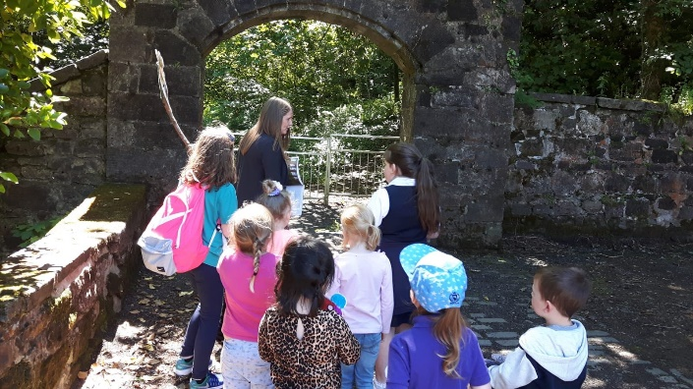
P6 worked with our pre-5 children at Darroch Park as part of their outdoor transition programme.

Once the children have started school, parents will have the opportunity to come along to the classroom to hear about their children’s learning activities in school and how they can help at home. Parents are kept closely informed of all school events through regular newsletters from the Head Teacher.

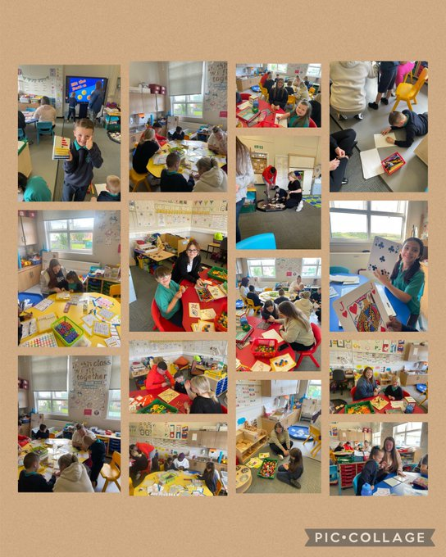
P3 PATPALS (Pupils As Teachers Parents As Learners)

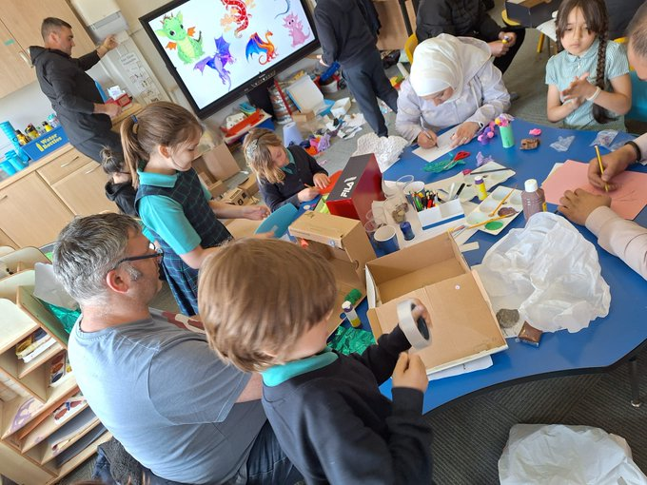
P3 PATPALS
Parent afternoons/evenings are held when parents are invited to come into school to discuss children’s work with class teachers. Should parents be unable to attend the parents’ evening, we will readily arrange for a meeting with the class teacher at a suitable time to both.

As part of the Attainment Challenge we have a Barnardo’s Family Support Worker, Kirsty McCullagh, who offers a variety of services to our parents including a Parent Drop-in, Sleep Scotland Training and Seasons for Growth.

We encourage parents to become actively involved in the life of the school. We have valued their help at our Book Fayre, classroom activities, sports clubs, on school trips and at concerts.

The Head Teacher is usually available to parents in the event of a problem but an appointment can be made if necessary. IF YOU HAVE ANY CONCERNS WHATSOEVER REGARDING YOUR CHILD, PLEASE CONTACT THE SCHOOL AS SOON AS POSSIBLE SO THAT WE MAY WORK THINGS OUT.

SCHOOL IMPROVEMENT
Her Majesties Inspectorate of Schools (HMIEs) visited and undertook a full inspection of St. Joseph’s Primary School in February 2014. A copy of the report to parents can be found on Education Scotland’s website.

Also, on the school website are copies of the Standards & Qualities Handbook and St. Joseph’s School Improvement Plan.

CHILD PROTECTION
Inverclyde Council Education Services has Child Protection Guidelines and Procedures which all schools are required to follow. Education Services work very closely with other agencies namely Strathclyde Police, Social Work Services, NHS Greater Glasgow and Clyde and the Children’s Reporter to support children. Common responsibilities of all staff are to protect children from abuse and exploitation, to respond appropriately when abuse is identified, and to ensure whenever possible
that all children are able to exercise their right to be raised in a warm, stimulating and safe environment with the support of staff, their families and carers.

SCHOOL AND COMMUNITY
We impress upon our children that they are “Ambassadors” for St. Joseph’s and that people in the neighbourhood make judgements about the school when they come into contact with them.

The pupils and staff of the school are working hard to become a Rights Respecting School and have achieved Level 1 Accreditation.

We think of others who are less fortunate than ourselves and regularly donate to local and national charities such as Inverclyde Food Bank, SCIAF, MISSIO, Help the Aged, Children First, Ardgowan Hospice etc.

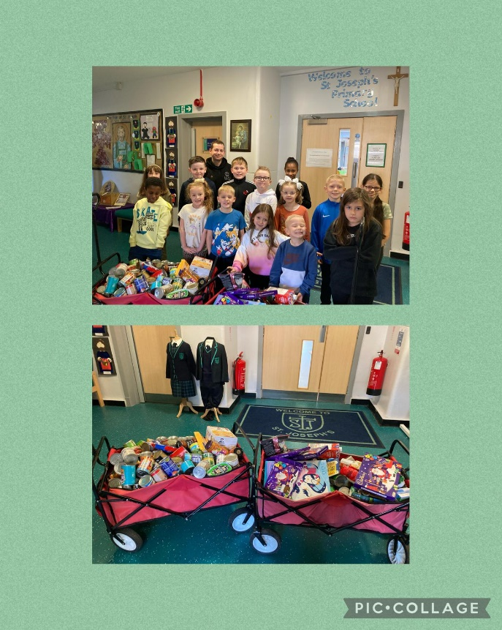
Our generous community donated to the Inverclyde Food Bank through a Come As You Please.
We enlist the help of members of community to talk to us about their specialist subjects – e.g. community police, health centre staff, coastguard, book authors and representatives of charity organisations, visiting the school as part of a series of events within our World of Work Week, which was hugely successful and will be repeated in future years.

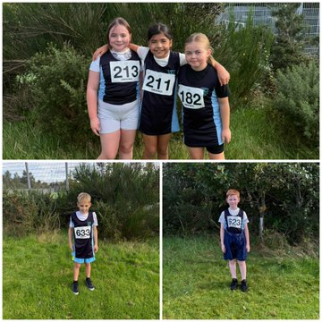
Lots of fun and success at our Cross Country running events

EXTRA CURRICULAR ACTIVITES
All classes are involved in outside “field trips” linked to topic-based learning e.g.
- Museums/Art Gallery
- Edinburgh/Stirling
- Finlaystone Estate/Cornalees
- Sports Centres
- Vikingar
- Residential visit to PGL Dalguise (P7)
- Residential Visit to Sports Scotland Centre, Largs (P6)
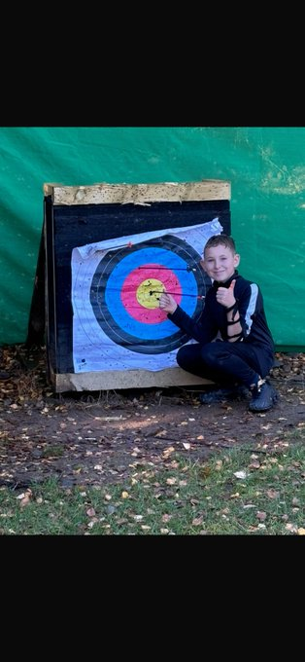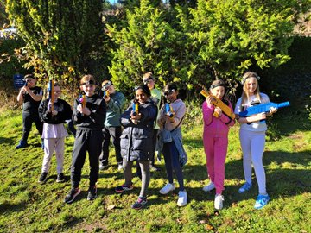
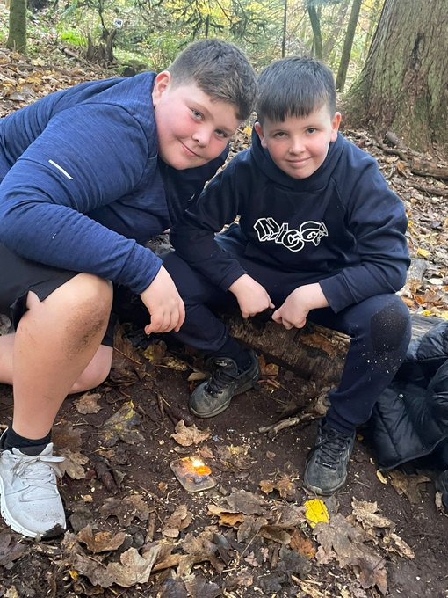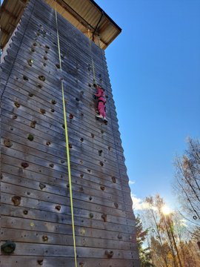
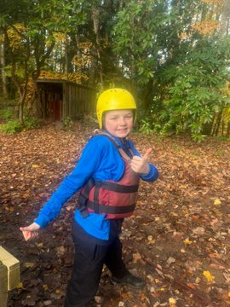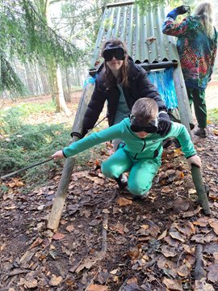

P7 at PGL Dalguise

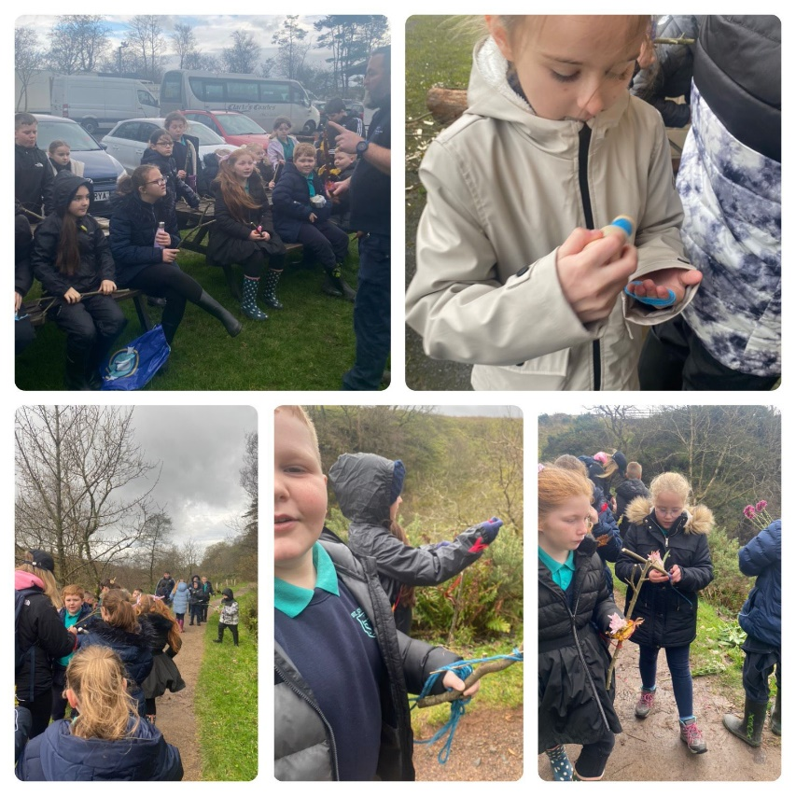
At the Greenock Cut

Team work is encouraged through:
- football training for boys and girls (P5 – P7)
- basketball training
- jogging club
- athletics training and competitions
- Bikeability training is given at P5-6
- enterprise activities

Our football team were winners of the inaugural Cloch Cup Competition.

Parents should note that the activities the pupils may become involved in may be restricted because health and safety requirements state that jewellery of any kind must not be worn where pupils are undertaking games or physical activities. This includes jewellery worn as a result of body piercing. Physical activities include activities undertaken within physical education (P.E.) classes.
We operate a House system in St. Joseph’s. The houses were researched and chosen by the pupils. Every year pupils elect a House Captain and a Vice-Captain. Regular house meetings give pupils a voice and their views are then communicated from the Captains and Vice Captains to the Senior Management Team.
We also have pupil representation on our Eco Committee and Rights Respecting School Steering Group

Along with events such as Parents’ evenings, Hallowe’en party, Sponsored events, Book Fayre, Sports Day, termly fun sessions and school shows, life is never dull in St. Joseph’s Primary School.

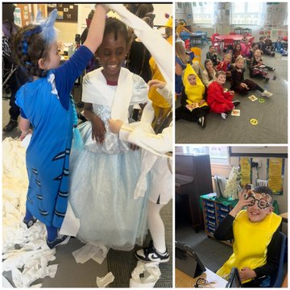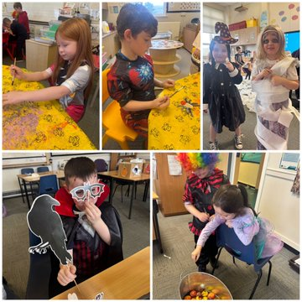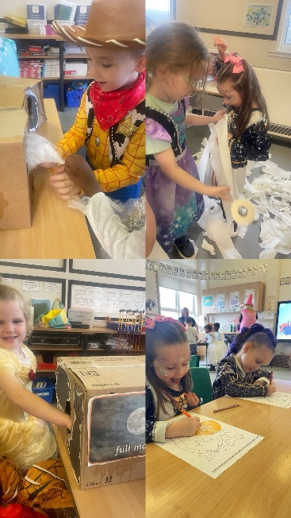
Halloween Fun in St. Joseph’s Primary
DISCIPLINE
In St. Joseph’s, we do our best to foster in the children positive values of friendship, respect, honesty and kindness. Each class will also negotiate and establish classroom charters at the start of each new session. This helps to create an atmosphere in which your child will feel secure and happy and can learn in peace. Teachers operate classroom reward systems to encourage effort. Points, stars and stickers are issued. Sanctions such as privileges being withdrawn following warnings are used as appropriate. If any child’s behaviour is giving cause for concern, we will consult with parents immediately. Where discipline problems arise, it is essential that parents and teachers work together to solve them.

In line with Inverclyde’s Positive Relationships Policy, the school operates a more restorative, solution oriented approach to dealing with incidents of indiscipline.

We want St. Joseph’s to continue to have a well-disciplined working environment.

PLAYGROUND SUPERVISION
An adult presence is provided in playgrounds at break times of the schools (Safety and Supervision of Pupils [Scotland] Regulations, 1990). The Janitor and Support Staff will supervise our playgrounds.

MEDICAL AND HEALTH CARE
During your child’s time in primary school, routine medical examinations are carried out for all children at 5 years of age and some at eleven years. You will be informed in advance about these and are invited to be present. Routine hygiene examinations as well as hearing and eyesight tests go on throughout the school, each session. The school dentist visits the school annually and communicates to parents any need for treatment.

EMERGENCY CONTACT
If your child is unwell or has an accident, every effort is made to contact you. It is very important that we have an emergency contact number. In the case of minor accidents or sickness at school, the child will receive attention from our First Aider. Should a serious accident occur in school and immediate hospital attention is required, the Head Teacher or, if necessary, an ambulance will take the child to hospital, at the same time, the school will notify parents of what is happening.

It is most important that you inform the school of any medical problems which may affect your child’s progress at school or make it necessary for him/her to be excused from strenuous activities.

MEDICATION
If parents wish medicine to be administered during the school day, they must complete relevant paperwork in the school and all medication and dosage should be clearly marked. Medication will be stored in a secure location. If there is a difficulty with the administration of any medication school will seek to work with health partners and parents to find a solution.

INHALERS
If your child has been prescribed an inhaler, please ensure that one is available to be kept at school at all times with your child’s name on it. These will be stored in the classroom and made available to the child immediately when required. This is especially important when children are leaving the building to go on outings or to take part in sport events. From time to time, please ask your child to bring their school inhaler home to allow you to check that it is still working properly.

ALLERGIES/PEANUT FREE ZONE
As some of our pupils are allergic to peanuts and peanut products and could suffer an anaphylactic reaction if exposed to them, we ask that children do not bring peanuts/peanut products to school.

APPOINTMENTS
If your son/daughter has a dental/doctor/hospital appointment, please let the school know by sending a note or appointment card. You must collect your child from school as no child can be allowed to leave the school unaccompanied unless permission from you to leave the school to meet you elsewhere is clearly stated in writing.

CLOTHING AND UNIFORM
St. Joseph’s has an attractive uniform with a tie and badge designed by pupils. Pupils are encouraged to wear uniform in school to promote the positive ethos of the school.

girls – navy skirt or trousers, white blouse, school tie, navy blazer
boys – navy trousers, white shirt, school tie, navy blazer.

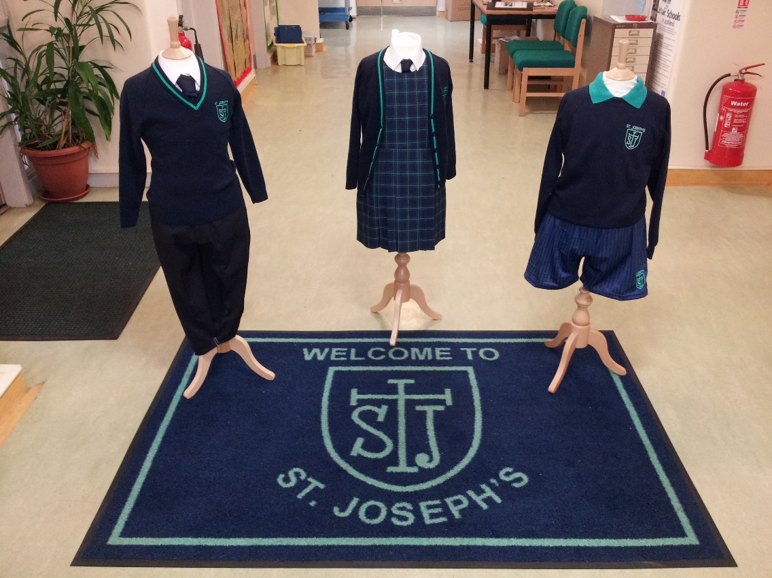

Navy sweaters/cardigans, jackets, hats, blazers, ties and badges along with P.E. Kit are available from Smith’s Clothing. There is also a St. Joseph’s Tartan pinafore or skirt available for girls which is an acceptable option but not mandatory. (Please mark your child’s name on all clothing).

Parents should note that the activities the children may become involved in may be restricted because health and safety requirements state that jewellery of any kind must not be worn where children are undertaking physical activities. This includes jewellery worn as a result of body piercing.

Given that there is substantial parental and public approval of uniform, schools in Inverclyde are free to encourage the wearing of school uniform. In encouraging the wearing of uniform account is taken in any proposals to prevent any direct or indirect discrimination on the grounds of race or gender. Any proposals will be the subject of widespread consultation with the parents and pupils. Against this background it
should be noted that it is the policy of the Education & Lifelong Learning Committee not to insist on pupils wearing uniform or having specialist items of clothing as a prerequisite of their attending and engaging in all of the activities of the curriculum.

There are forms of dress which are unacceptable in school, such as items of clothing which:
· potentially encourage faction (such as football colours);
· could cause offence (such as anti-religious symbolism or political slogans);
· could cause health and safety difficulties, such as loose fitting clothing, or clothing made from flammable material for example shell suits in practical classes;
· could cause damage to flooring
· carry advertising, particularly for alcohol or tobacco;
and could be used to inflict damage on other pupils or be used by others to do so.

In addition jewellery such as dangling earrings and large rings could cause health and safety difficulties and are unacceptable to be worn in school.

Parents are asked to ensure that valuable items and unnecessarily expensive items of clothing are not brought to the school. It should be noted that the authority does not carry insurance to cover the loss of such items and any claims submitted are likely to be met only where the authority can be shown to have been negligent. Parents should also note that the activities the children may become involved in may be restricted because health & safety requirements state that jewellery of any kind must not be worn where children are undertaking physical activities. This includes jewellery worn as a result of body piercing.
You may qualify for a clothing grant if one of the following statements apply to your family circumstance.
You are currently in receipt of:
- Income Support (IS);
- Income Based Job Seekers Allowance (JSA);
- Any income related element of Employment and Support Allowance (ESA);
- Universal Credit (UC), where your take home pay does not exceed £1,244;
or
- you are seeking asylum and receiving support under part VI of the Immigration and Asylum Act 1999;
or
- you look after a child/children as part of a formal Kinship Care agreement, registered by Social Work Services.
- INCOME SUPPORT (IS)
- INCOME BASED EMPLOYMENT AND SUPPORT ALLOWANCE (ESA)
- INCOME RELATED JOB SEEKERS ALLOWANCE (JSA)
- PENSION CREDIT
Evidence that you are in receipt of one of the benefits mentioned above, can be obtained using the link for DWP's website in the Other Websites section or by calling:-
- 0800 169 0310 (freephone)
Please note you will be asked for your National Insurance Number before you can obtain the evidence.
If you do not have your National Insurance Number to hand it can be found:-
- On your payslip.
- On your P60 or P60U (a form you get at the end of each tax year).
- On letters from DWP or HMRC about your tax, pension, or benefits.
- Using the link to the National Insurance section of your personal tax account at HMRC in the Other Websites section.
UNIVERSAL CREDIT (UC)
Sign in to your Universal Credit journal using the link shown in the Other Websites section of this web page.
Please note you will need the sign-in details for your UC journal.
ASYLUM SEEKERS EVIDENCE
Please provide a 'share code' to your eVisa to allow Education Services to access your residency status information. This can be obtained using the link shown in the Other Websites section of this web page.
KINSHIP CARE
If you have a registered Kinship Care agreement overseen by Inverclyde Council, we will have access to this information. You will not need to attach a copy of your confirmation letter. However, if the agreement if overseen by a different Local Authority you will need to contact that Local Authority for written confirmation that you are the registered Kinship Carer.

Approval of requests for such grants made by parents in different circumstances is at the discretion of the Corporate Director Education, Communities and Organisational Development.

Information and application forms may be obtained from schools and from
The Customer Contact Centre, Clyde Square, Greenock, PA15 1NA.

The council is concerned at the level of claims being received regarding the loss of pupils’ clothing and/or personal belongings. Parents are asked to assist in this area by ensuring that valuable items and unnecessarily expensive items of clothing are not brought to school.
Parents should note that the authority does not carry insurance to cover the loss of such items and any claims submitted are likely to be met only where the authority can be shown to have been negligent.

SCHOOL MEALS
Meals are provided by Inverclyde Council Environmental & Consumer Services Catering Division whose mission statement is:
“Our aim is to provide a menu system, freshly prepared with health and cost a priority”
The menus are compiled with Scottish Diet Action Plan as a Priority and the menu is changed daily.
All children in P1-P7 automatically qualify for free school meals.
However, if you wish to be considered for the clothing grant, or your child is or will be in S1 – S6, you must submit an application form.

Children can choose soup and a main course or main course and pudding. A drink, salad and fruit are included in this cost.
Those children who bring packed lunches have their meals along with the other children who remain at school during lunch time.

Menus are displayed in the dining hall and sent home so that parents are informed about daily/weekly choices. They can also be found on the school app. Children bringing packed lunches eat them in the dining hall.

If a child requires a special diet on medical grounds, please contact the Head Teacher to discuss this.

ATTENDANCE
Parents should inform the school by telephone on the first morning of an absence and provide a reason for the pupil’s absence. The school will contact the pupil’s family and thereafter other emergency contacts if no explanation is given for the pupil’s absence. This contact will be made before 10.am on the first morning of an absence and early after the restart after lunch in the case of an afternoon absence.
Other agencies may be contacted if no contact with the pupil’s family can be achieved and if there are continuing or emerging concerns about a pupil’s safety or wellbeing.

On returning to school, parents should provide a note explaining the reason for absence.

Parents should keep the school informed of any changes of address or telephone numbers, both their own and those of the emergency contacts.

Section 30 of the 1980 Education Act lays a duty on every parent of a child of ‘school age’ to ensure that their child attends school regularly. Attendance must be recorded twice a day, morning and afternoon.

Regulation 7 of The Education (School and Placing Information) (Scotland) Amendment, etc Regulations 1993 requires each child’s absence from school to be recorded in the school register as authorised: i.e. approved by the authority and unauthorised: i.e. unexplained by the parent (truancy) or temporarily excluded from school.

The Scottish Government has provided guidance on the management of attendance and absence in Scottish schools in its publication Included, Engaged and Involved-part1: Attendance in Scottish Schools. Every effort should be made to avoid family holidays during term time as this both disrupts the child’s education and reduces learning time. It has been clarified that family holidays should not be recorded as authorised absence, except in exceptional domestic circumstances, where a family needs time together to recover from distress, or where a parent’s employment is of a nature where school-holiday leave cannot be accommodated (e.g. armed services or emergency services). It is for local authorities and schools to judge where these circumstances apply and authorise absence, accordingly.

The categorisation of most term time holidays as unauthorised absence has been a contentious issue for some families, many of whom are concerned at the higher cost of holidays during school holiday periods. The Scottish Government has no control over the pricing decisions of holiday companies or flight operators. Our main focus is to encourage parents and pupils to recognise the value of learning and the pitfalls of disrupting learning for the pupil, the rest of the class and the teacher.

Clearly where an absence occurs with no explanation from the parent, the absence is unauthorised.

Schools investigate unexplained absence, and Education Services has the power to write to, interview or prosecute parents, or to refer pupils to the Children’s Reporter if necessary.
Young people of school age may be unable to attend school for a wide range of reasons including illness, accidents or long term medical conditions. In general there will be an automatic referral by the school for education out with school after 15 days of continuous or 20 working days of intermittent absence, within a single session, for verifiable medical reasons.

TRANSFERRING EDUCATIONAL DATA ABOUT PUPILS
Data on each pupil is collected by schools, Inverclyde Council and the Scottish Government Education Department. Data is held securely and no information on individual pupils can or would be published. The data collected and transferred covers areas such as date of birth, Scottish Candidate Number (SCN), postcode, registration for free school meals, whether a pupil is looked after by his /her local authority, is looked after at home or has an additional support needs including disability and English as an Additional Language (EAL) and attendance, absence and exclusions from school. Pupil names and addresses are not passed to the Scottish Government Education Department. Postcode is the only part of your address that is transferred and these are grouped to identify ‘localities’ rather than specific addresses. Dates of birth are passed on as ‘month and year’ only, to ensure that individuals are never identified.
General Data Protection Regulations and Data Protection Act 2018
Information on children, parents and guardian is stored on a computer system and may be used for teaching, registration, assessment and other administrative duties. In processing personal information, Inverclyde Council must comply with the General Data Protection Regulation and Data Protection Act 2018
For further information please refer to https://www.inverclyde.gov.uk/site-basics/privacy or click on the following: Privacy page link
INFORMATION IN EMERGENCIES
We make every effort to maintain a full educational service, but on some occasions circumstances arise which lead to disruption.

Schools may be affected by, for example, severe weather, temporary interruption of transport, power failures or difficulties with fuel supply. In such cases we shall do all we can to let you know about the details of closure or re-opening. We shall keep you in touch by using letters, notices in local shops and community centres, announcements in local churches and announcements on Social Media, in the press and on local radio.

TRANSPORT
The Council has a policy of providing free transport to all primary pupils who live more than one mile from their local school by the recognised shortest walking route. This policy is more generous than the law requires. This means that the provision of transport could be reviewed at any time.
Parents who consider they are eligible should obtain an application form from the school or Education Services at 105 Dalrymple Street, Greenock, PA15 1HU. These forms should be completed and returned before the end of February for those pupils beginning school in August to enable the appropriate arrangements to be made.
Applications may be submitted at any time throughout the year but may be subject to delay whilst arrangements are made. The appropriate officer has discretion in special circumstances to grant permission for pupils to travel in transport provided by the authority, where spare places are available and no additional costs are incurred

Pick up Points
Where free transport is provided it may be necessary for pupils to walk a certain distance to the vehicle pick-up point. Walking distance in total including the distance from home to the pick-up point and from the drop-off point to the school in any one direction will not exceed the authority’s limits (see above paragraph). It is the parent’s responsibility to ensure that their child arrives at the pick-up point in time. It
is also the parent’s responsibility to ensure the child behaves in a safe and acceptable manner while boarding, travelling in and alighting from the vehicle. Misbehaviour could result in a child losing the right to free transport.

Placing Requests
Education Services does not provide transport for those pupils in receipt of a placing request other than in exceptional circumstances. In the case of under-age placing requests, if the child is offered a place in his/her catchment area school, transport will be provided in accordance with Council policy stated above.

PARENT FORUM AND PARENTS’ GROUP
All Parents are members of the Parent Forum.

Scottish Schools (Parental Involvement) Act 2006 led to the establishment of Parent Councils in primary, secondary and special schools. The Act recognises the vital role that parents play in the supporting their children’s learning. It places a duty on authorities to promote the involvement of parents in children’s education and the wider life of the school. It aims to help parents to be:-
- Involved with their child’s education and learning
- Welcomed as an active participant in the life of the school
- Encouraged to express their views on school education generally

The Parent’s Group (Parent Council), as a statutory body, has the right to information and advice on matters which affect children’s education

Parents who are involved on a regular basis in schools should undertake an enhanced disclosure through Disclosure Scotland

Changes have recently been made to the law to help parents and schools work together as partners in children’s learning. The Scottish Parliament has passed the Scottish Schools (Parental Involvement) Act 2006 to encourage and support more parents to become involved.

All parents who have a child attending the school are automatically members of the Parent Forum for our school. Membership of the forum allows parents to have a say in the local arrangements to enable their collective view to be represented on matters such as quality and standards of education at the school and other matters of interest to parents. These views can be represented, as appropriate, to the head teacher of the school, The Council and HMIe.

The Act makes provision for Parent Councils to play an active role in supporting parental involvement in the work and the life of the school, while also providing opportunities for parents to express their views on children’s education and learning. The Parent Council, as a statutory body, has the right to information and advice on matters which affect children’s education.

The present Parent Council Office Holders are:
Ashley McLean (Chair)
Nicole Dorrian (Treasurer)
Miss Andrea Bryceland (Secretary)

Minutes of meetings from Parents’ Group are displayed on the Parents’ Group notice board at the entrance to the school and are available on request. Plans are in place to add minutes of meetings to the school website.

Parentzone Scotland

Parentzone Scotland is a unique website for parents and carers in Scotland, from early years to beyond school. The website provides up-to-date information about learning in Scotland, and practical advice and ideas to support children’s learning at home in literacy, numeracy, health and wellbeing and science. Information is also available on Parentzone Scotland regarding additional support needs, how parents can get involved in their child’s school and education. Parentzone Scotland also has details about schools, including performance data for school leavers from S4-S6 and links to the national, local authority and school level data on the achievement of Curriculum for Excellence levels.

TRANSFER TO SECONDARY SCHOOL
Pupils are normally transferred between the ages of 11½ and 12½ so that they will have the opportunity to complete at least 4 years of secondary education. Parents will be informed of the arrangements no later than December of the year preceding the date of transfer at the start of the new session.
The school to which children from St. Joseph’s normally transfer to is:

St. Columba’s High School
Fletcher Avenue
Gourock
PA19 1TP.
Tel: 01475 - 715250
Head Teacher: Mrs. Nicola Devine

Useful Addresses and Telephone Numbers

Education Offices
Wallace Place
Greenock. Tel 712842

Michael Roach
Head of Schools
Education Office
Wallace Place
Greenock Tel 712842

Ruth Binks
Corporate Director of Education, Communities & Organisational Development
Municipal Buildings
Clyde Square,
GREENOCK Tel 712761

Cllr Jim Clocherty
Convenor of Life Long Learning
Inverclyde Council
Municipal Buildings
Greenock Tel 717171

Local Councillors Ward 7
Cllr John Crowther, Cllr Tommy McVey & Cllr Natasha McGuire
Inverclyde Council
Municipal Buildings
GREENOCK Tel 717171

Mr Stuart McMillan MSP
Constituency Office
Union Street
GREENOCK Tel 791820

Useful Web Sites
www.inverclyde.gov.uk - Inverclyde Council Web Site
www.educationscotland.gov.uk- School and Local Authority Inspection Reports
www.parentszonescotland.gov.uk - Very useful site for parents
www.scottishschoolsonline.gov.uk - About individual schools

GLOSSARY OF TERMS

HT Head Teacher

DHT Depute Head Teacher

Curriculum Courses of Study

Extra-curricular Out with normal school curriculum
e.g. during lunchtime and after school
during evenings or weekends.

Enrolment Registering children for school (Usually in January before starting P1)

Catchment Local area associated with the school.

Literacy Listening, talking, reading, writing.

Numeracy Counting, mathematics, working with numbers.

Social Studies History, geography, social development.

Expressive Arts Music, art, drama, dance.

Health and Wellbeing Encompasses social, emotional, mental and physical health.

Please note that although the information contained in this handbook is correct at the time of presenting, there could be changes affecting any of the matters dealt with in this document:
- Before commencement or during the school year in question.
- In relation to subsequent years.

