
St. Joseph’s Primary & Nursery Class
Standards and Quality 2024-25

Context of the Establishment

Our Establishment
St Joseph’s Primary School is a denominational school and is situated in the Southwest of Greenock. The current roll is 129 pupils across 7 classes from P1-P7. The school’s Senior Management Team consists of 1 FTE Head Teacher and 1 FTE Depute Head. There are 4 full time teachers and 5 part time teachers, one of whom is 0.8 NQT. We have used PEF funding to employ an additional teacher specifically to provide additional support and input. The school is supported by seven Pupil Support Assistants, two clerical staff members split over 37 hours, a janitor, and the school chaplain Father Maurice Callaghan.
The % of pupils in the school living in SIMD 1 and 2 is 73.8% with a PEF allocation to the school of approximately £89,000. 47.7% of pupils are identified with Additional Support Needs, a further 5.4% with English as an Addition Language and 5.3% of pupils are Care Experienced.
The current roll in our nursery class is 39 in the 3-5 room and 13 in the 2-3 room with room to accommodate more within specific patterns. There is one nursery Depute, one Senior Early Years Education and Childcare Officer (SEYECO), five full-time EYECOs, three part-time EYECOs, two Early Years Support Assistants and one clerical staff member. The % of pupils in the nursery living in SIMD 1 and 2 is approximately 62%.
Vision
St. Joseph’s Primary aspires to develop as a community of faith and learning, through the faith, tradition and sacramental life of the Catholic Church.
We believe that all children have the right to be safe, healthy, achieving, nurtured, active, respected, responsible and included. We value all members of the school community and believe that the Christian values of the Gospel should permeate the life of the school. We continue to develop as a Laudato Si school and care for Our Common Home.
All stakeholders were consulted and adopted the key values of Friendship, Respect, Honesty and Kindness.

Our Aims
We aim to:
- work in partnership with parents and community to enable all children to develop their capacities as successful learners, confident individuals, responsible citizens and effective contributors to society.
- provide the highest quality learning activities and educational programmes suited to individual needs and attributes.
- maintain the highest possible levels of attainment and achievement.
- encourage all pupils to aim high and reach their full potential.
- provide a happy, secure, welcoming environment which promotes well-being and respect.
- develop leadership at all levels – in staff and in pupils.
- value and develop our staff.

Establishment priority 1

NIF Priority  Improvements in attainment, particularly in literacy and numeracy  Closing the attainment gap between the most and least disadvantaged children and young people  NIF Driver  School Improvement  Assessment of children's progress | HGIOS/ELC QIs  3.2 Raising attainment and achievement  3.2 Securing Children's Progress  UNCRC  Article 28: (Right to education):  Article 29 (Goals of education):
Outcome:
- By June 25 Attendance will increase from 91% to 92.5%.
- By June 2025 pupils impacted by poverty who currently have less than 90% attendance will reduce from 6.67% to 3.33%
- By June 2025 reading attainment will increase from 78.5% to 81% across the school
- By June 2025 the number of learners impacted by poverty in P2 and not on track in Reading will decrease from 9 to 6.
- By June 2025 the number of learners impacted by poverty in P2 and who are not on track and gain a year for a year progress will increase by at least 3
- By June 25 almost all learners will be able identify their next steps in learning and create or co-create their own targets. (Baseline to be gathered in Term 1 and measured termly)
- By June 25 all staff will utilise pre-prepared data and evidence to inform tracking meetings, will have entered data into the Progress & Achievement section of SEEMIS and will have accessed and be able to speak to the data dashboard.
PEF used to support closing the gap:
CT - £58,000 – 1.0 temp Teacher
Clerical - £7000 – 14 hours per week for 39 weeks

Progress and impact of outcomes for learners:
- Our attendance has increased from 91% to 91.4%. While this increase is not in line with the target set last year, it is an improving picture.
- The percentage of pupils impacted by poverty who currently have less than 90% attendance and are behind expectation are 4.7%.
- Reading attainment across the school increased by 3.7% to 82.2% which exceeded the target set.
- The target of reducing the number of pupils in P2 impacted by poverty and not achieving reading was met.
- The target for P2 pupils to make a year’s progress in a year was met.
- SLT and Peer Observations took place with a particular focus on Learning Intentions and pupil created and co-creation of success criteria. Almost all children’s jotters contain evidence of pupil involvement in creation and co-creation of success criteria.
- A shared decision by staff and SLT was taken to continue the current practice of SLT entering data into Progress and Achievement. It was felt that this was useful in generating robust, professional discussion around every child’s attainment journey.
There was minimal collegiate involvement with the data dashboard due to other development areas taking precedence and staff movement. It is agreed that this will be a focus area for training and development in the next academic year.
Next steps
- Improving attendance will form a significant part of the school improvement plan next year. SLT and PEF funded Barnardo’s Family Support Worker will work closely to support identified families in improving pupil attendance.
- Staff have agreed to look at thematic events across the curriculum in order to maximise the “Pull to School.” Whole school “Fabulous Friday” events will be organised to encourage better attendance.
- Increase pupil voice in all areas of school life, including curricular activities, to increase engagement and ownership in order to improve attendance and attainment.
- While seeking to maintain our levels of attainment across the school, we will continue to identify areas where marginal gains can be made and focus on reducing the attainment gap between the most and least well-off pupils.
- Protect specific collegiate time in order to train staff in effective utilisation of data dashboard to enhance planning for improvement and attainment.

Establishment priority 2

NIF Priority  Improvement in skills and sustained, positive school-leaver destinations for all young people  Improvement in children and young people's health and wellbeing  NIF Driver  Teacher professionalism  School Improvement | HGIOS/ELC QIs  3.3 Increasing creativity and employability  1.2 Leadership of learning  UNCRC  Article 28: (Right to education):  Article 12 (Respect for the views of the child):
Outcome:
- By June 2025 almost all pupils will be able to name meta- skills and be able to exemplify them in their daily lives.
- By June 2025 most pupils within a targeted group of learners impacted by poverty who struggle to identify and articulate successes will be able to do so. (baselines to be gathered)
- By June 2025 almost all families of identified learners will have successful engagement with the child’s learning, acknowledging achievements and next steps (baseline and engagement method to be identified).
- Almost all pupils will be able to identify and set appropriate targets for their academic and skills development (see priority 1).
- By June 2025 all pupils will routinely experience digital technologies embedded across the curriculum.
- After each pre-topic trip all pupils will be able to more effectively contribute to a floorbook/KWL planner

PEF used to support closing the gap:
Tree of Knowledge Training £1500
Tree of Knowledge Resources £500 (for 3 years)
Resources to support implementation of skills development £5k
Learning Beyond Classroom (Transport & costs) £5000

Progress and impact of outcomes for learners:
- Excerpt from Pre-Assessment Questionnaire
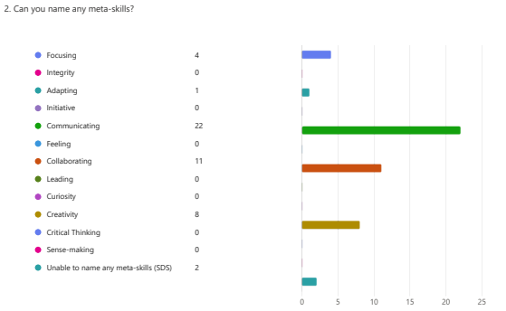

Excerpt from Post-Assessment Questionnaire
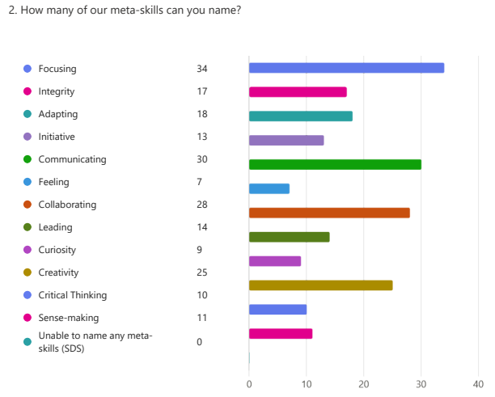

- This action was not taken forward due to fluctuations in staffing and will be addressed in the next academic year. All pupils did engage with the learning around meta-skills and the impact they can have upon learning, however, the measurement of this was not completed.
- This action was to be carried out in tandem with Action 2 and for the same reason did not progress. It will addressed in the next academic year.
- All staff participated in collegiate work reviewing Learning Intentions and Success Criteria. The specific focus of this work was to empower pupils to take increased ownership of their learning through engagement with and co-creation of learning intentions and success criteria. SLT observations and staff peer observations focussing on LI and SC demonstrated that almost all children were able to successfully participate in the co-creation of learning intentions and success criteria.
- The experience of utilising digital technology to support learning across the curriculum was enhanced across the entire school. This was successful, in large part, due to the very good provision of laptops and enhancement of the Wi-Fi network across the entire school estate. Teachers developed greater confidence in planning for and effectively utilising technology as integral parts of the learning process across most areas of the curriculum.
- This action was overtaken in the nursery class and across every class in the school.
Next steps
- Continue to develop meta-skills and increase knowledge of parents around development of these skills.
- Roll out DYA to P6 and explore the possibility of creating links with high school through DYA as a transition project in future years.
- Use development of meta-skills as a focus for revisiting Play, enquiry based learning and outdoor learning across all stages of the school and nursery class.
- New DHT will take responsibility for developing an effective method for recognizing, recording and sharing pupil achievement within and out with school.
- Continue to progress towards Digital Schools accreditation.

Establishment priority 3

NIF Priority  Placing the human rights and needs of every child and young person at the centre of education  Improvement in children and young people's health and wellbeing  NIF Driver  Performance information  Choose an item. | HGIOS/ELC QIs  3.1 Ensuring wellbeing, equality and inclusion  Choose an item.  UNCRC  Article 42 (Knowledge of rights):  Choose an item.
Outcome:
- By December 2024 pupils will have created a plan to improve playground play and will be empowered to implement that plan. This will, also, engender an increased sense of responsibility for materials and playground conduct and support pupils to more fully explore learning opportunities in the playground environment.
- By June 25 all learners will have the opportunity to read books that they can see themselves in and relate to the characteristics and cultural experiences of the main characters.
- By June 25 all pupil voice group participants will experience empowered decision making that contributes to the wider school plans.
- By June 25 all pupils will experience empowered decision making, contributing to wider school plans, through participation in House activities.
- By June 25 all pupils will have enhanced their knowledge and understanding of the UNCRC. The RRS Steering group will have developed and made significant progress in implementing a planned approach to gaining Gold accreditation, primarily through awareness raising and education of parents and the wider community.
- By Feb 25 all pupils in P6 & P7, in particular those impacted by poverty will see an increase in meta-skills of at least 12% (baselines for individual pupils to be gathered)

PEF used to support closing the gap:
Pupil participatory budgeting - £2000 - Playground equipment and materials
Building Racial Literacy - £1500 – Novels and associated learning materials
P6 & P7 Residential Experience - £7000 – P6 1 night/2 day residential to Largs – P7 4 night/5 day residential to Dalguise.

Progress and impact of outcomes for learners:
- Playground pals were elected by their class mates. They created a plan for utilising toys and loose parts materials in the playground. They took responsibility for putting games out and collecting them and storing them. They also trained other pupils in correct storage of playground toys. Pupils applied for and were successful in securing funding to develop the playground by putting roofs on reading sheds. They were consulted in allocation of PEF funding to improve playgrounds in the next year.
- In line with our Cluster priorities, all P6 & P7 pupils participated in novel studies relating to developing racial literacy. We extended this approach across the entire school, including our nursery class, and every class participated in a novel study relating to developing racial literacy. Additional resources were purchased in order to ensure that appropriate novels (class sets) were purchased which related to equalities and identified protected characteristics. Our Diversity Group were inspired by this to look at signage across the school and undertake a project to create signs in all the languages represented in our school community.
- While our pupil voice groups were more clearly established and protected time was built into the timetable, our success was limited due to fluctuations in staffing. The process will be reviewed for next year and a more rigorous plan, which takes account of changes in staff, will be created in order to ensure pupil agency in the life of the school.
- We were successful in re-introducing our house meetings and House Captains and Vice-Captains were very diligent in carrying out their duties of gathering views and communicating between pupils and SLT.
- Again, due to numerous changes in staffing, we did not manage to achieve our goal of accreditation in RRS. In fact, we had to take a step backwards as we did not achieve silver accreditation due to bureaucratic time frames not being met due to frequent staff changes. Work has continued with learning relating to the UNCRC across the school. All learning displays contain links to appropriate articles in the UNCRC. Every class presented an assembly to the rest of the school around specific articles from the UNCRC. The steering group has enacted the entirety of the plan for silver accreditation and a date for assessment will be set for early in the new school term.
- All pupils in P6 & P7, in particular those impacted by poverty saw an increase in meta-skills of at least 12% through a joined approach of specific learning in class about meta-skills and the opportunity to utilise and develop those skills through a residential outdoor learning experience. This was evidenced by pre and post activity questionnaires and by reviewing individual meta-skills profiles.

Next steps
- Continue to develop the play opportunities in our grounds as per pupil voice recommendations and give enhanced opportunities for more pupils to take responsibility for managing and developing play experiences. Revisit the Playground charter in relation to UNCRC and adapt as pupils recommend.
- Reading ambassadors and Diversity group will conduct an in-depth review of library materials in school library and class libraries. They will visit other establishments to observe good practice, coordinate with Inverclyde Library Services and will make recommendations to SLT around additional reading resources which will create additional opportunities for developing understanding of equalities and protected characteristics. Our Equality Co-ordinator will work with peers across the cluster to establish a baseline of cluster provision, develop a cluster plan for progressing equalities education and implement it.
- Pupil Voice will be accommodated in a more rigorous manner in order to ensure that barriers, such as changes to staff, are mitigated and pupil agency is enhanced and has a visceral impact upon the life of the school.
- House Captains and Vice-Captains will continue to build on the processes which have been introduced this year. A review, incorporating the views of the entire school community, will be carried out into the role of the House system and it’s effectiveness and a plan to implement appropriate change will be devised.
- RRS accreditation will progress with careful attention being given to mitigating the effect of staff changes to the process. Something as simple as appointing 2 staff co-ordinators would be helpful but may not be possible with a small staff like ours. Enhancing pupil ownership and leadership of the process may be the most effective mitigation of staff changes and this will be explored early in the new academic year.
- Meta-Skills will be embedded throughout all areas of the curriculum. Information sessions will be organised to develop parents’ understanding of meta-skills and the importance of these in their children’s learning and life journeys.

Data

Key Strengths:
School/Nursery class/

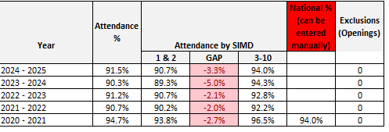

The table above shows that we have improved our attendance on last year and have closed the gap between SIMD 1&2 and SIMD 3&10. However, we failed to reach our attendance target of 92.5%. Improving attendance will be a priority in our school improvement plan next year.

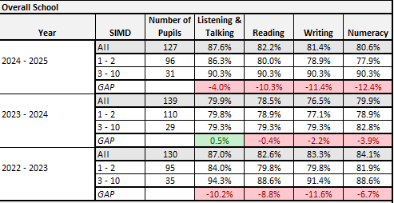
The table above shows that our attainment across all areas of literacy and numeracy has increased from last academic year. However, attainment is still below the 22-23 levels. This may be explained by differences in cohorts and changes in staffing and the work being carried out to ensure greater rigour in measuring progress and achievement. The table also demonstrates an increase in the poverty related attainment gap.

Key Priorities:
School/ Nursery class/

- The school will continue to seek out areas where pupils can be supported to improve their attainment through targeted support and input. There will be an ongoing focus to provide support and challenge for those pupils who are attaining a level and could move onto “Beyond Expectation”.
- There will be a continued focus to ensure that children who are not attaining a level are gaining a year’s progress in a year or attaining their individual goals and milestones.
- Staff will be reviewing resources and approaches within Literacy and Numeracy to ensure a consistency of approach across every level in teaching, learning and assessment.
- Continuing partnership work between the nursery class and Primary 1 will ensure that all children are given every possible support to be ready for school and achieve early level by the end of Primary 1.
- Nursery staff will continue to engage with the new tracking tool in order to ensure that gaps in skills development for every child are identified and mitigated effectively.
- Nursery staff will engage with the new Self- Evaluation Framework.

National Improvement Framework Quality Indicators
1.3 Leadership of change
Good

Key Strengths:
School/ELC Nursery class

- School values understood and demonstrated implicitly and explicitly by all stakeholders across school and nursery class.
- Rigorous approach to self-evaluation embedded with all staff in school and nursery class.
- All staff fully involved in identifying required change and planning for implementation through SIP.

Key Priorities:
School/ELC Nursery class

- Pupil approach to self-evaluation continues to be under development
- Review of vision and aims with all stakeholders across school and nursery class.
- Further develop practitioner enquiry approach among staff.
- New DHT in school to be supported in familiarisation and ownership of new role.
- Increase opportunities for Senior EYECO to lead and develop staff, policy and procedures.
- Support EYECOs and EYSAs to take increased responsibility for curriculum delivery.

2.3 Learning, teaching and assessment
Good

Key Strengths:
School/ Nursery class

- A more systematic approach for children to lead and voices to be heard has been implemented. This will be fully embedded in the coming academic year.
- More opportunities for children to effectively lead their learning within the classroom have been created. This will be continued as we develop our understanding of meta-skills and review the curriculum offer.
- Alternative routes to achievement, Dynamic Youth Award, has been undertaken by all P7 pupils and has been a very effective vehicle for development of meta-skills.
- More consistent quality assurance procedures between the school and nursery and the alignment of quality calendars have taken place and will continue to be reviewed and developed.
- All children’s engagement in using, and where appropriate, co-constructing success criteria throughout lessons within the school.
- Increased provision of laptops and I-pads has allowed more effective use of digital technologies to enrich learning across the school.
- Collegiate development time has resulted in more effective use of floor-books and allowed us to develop the responsive planning approach in the nursery and maximise the use of learning Journals.

Key Priorities:
School/ELC Nursery class

- Continue with explicit teaching and learning of Meta-skills across every stage from Nursery to P7
- Roll out Dynamic Youth award to P6 with view to further roll out across the school in the following academic year.
- All staff will engage with Inverclyde Literacy Framework, Numeracy Strategy and PASE to ensure high quality literacy and numeracy teaching, learning and attainment is continued.
- All staff will engage in training by SAC Lead to develop data literacy and utilise data to ensure L&T in all areas is of appropriate high quality and continues to address the PRAG.
- Embed the use of new skills tracker at Early Level and develop use of Early Years Dashboard if it comes on-line.
- All Early Years staff to engage in development to produce consistently high-level environments.

3.1 Ensuring wellbeing, equity and inclusion
Good

Key Strengths:
School/ Nursery class
• The inclusive and nurturing environment where relationships are valued, leading to engaged children
• Effective leadership by the Depute Head Teacher and Nursery Depute which ensures children’s needs are met effectively using systems and policies, which have been reviewed and developed
• Strong partnerships with outside agencies which enhance and support the provision for children and families
• The development of outdoor areas and the development of the outdoor learning progressive skills framework
• A shared approach to GIRFEC has been developed and implemented across the school and nursery
• A review of the school and nursery values with all stakeholders has resulted in shared values which have been embedded into daily practice

Key Priorities:
School/ELC Nursery class
- Continue to plan progressive curriculum opportunities to explore diversity, inclusion, equality and children’s rights in line with LA improvement plan
- New Depute Head (Acting) to further develop Trauma Informed Practice across the school and nursery
- Fully implement the outdoor learning progressive skills framework across every stage.

3.2 Raising attainment and achievement/Securing children’s progress
Choose an item.
Very Good

Key Strengths:
School/ Nursery class

• Career Long Professional Learning and strategies to support the teaching of Reading, Writing and Listening & Talking which have shown the desired impact of increased attainment, are embedded. Teacher confidence is strong.
• High quality Targeted Interventions in place ensure children are continuing to make very good progress from previous levels of attainment.
• Improvements to attainment over time in literacy and numeracy.
• Staff have a very good knowledge of children and school has an effective Pupil Equity Funding (PEF) strategy which has raised attainment across the school.
• The robust use of data and research and how this informs improvement and interventions.
The “St. Joseph’s Way” has been developed demonstrating clear expectations of what a good literacy and numeracy lesson should consist of.

Key Priorities:
School/ELC Nursery class
• While attendance levels are not falling a robust policy will be developed and implemented to ensure increased attendance for all pupils. This will mirror the LAs new attendance policy and take advantage of the new Inverclyde Attendance Support Worker.
• Continue to expand on opportunities for leadership of learning throughout the school and nursery.
• Continue to develop approaches in tracking children’s attainment and progress across the curriculum.
• Continue to develop robust tracking systems for the nursery class, drawing on establishment systems already utilised.
Continue to embed knowledge and understanding of “The St. Joseph’s Way” for every stakeholder.

Key Achievements of the Establishment

- All Primary 7 pupils participated in the Dynamic Youth Award and achieved certification at SCQF Level 3.
- All primary 6 and primary 7 pupils enjoyed a fantastic experience on their residential trips to Largs and Dalguise.
- School choir performed at Christmas for residents in local care home and at other community venues.
- Enhanced partnership working between nursery class and P1 staff resulted in effective learning across the whole of early level.
- Transition programme from Nursery-Primary 1 further developed this year and parents have reported as being successful.
- The school successfully applied for a grant which resulted in the purchase of an additional 15 I-pads which will support an enhanced digital experience to enrich pupil learning.
- Partnership work with Inverclyde Libraries resulted in every class visiting our local library every term. Every child in St. Joseph’s has a library membership.

